Quarterly Adjusted Other Expense Model

Stationarity of adjusted expense
Quarterly Adj_Other is the sum of three smoothed monthly expense amounts. Through 2023 Q3, the level showed evidence of nonstationarity. The first difference passed both tests and measures the change in expense from one quarter to the next, in millions.
Transform | N | ADF stat. | ADF p | KPSS stat. | KPSS p | Joint rule
Level | 51 | −0.814 | 0.8148 | 0.827 | <0.01 | Fail
First difference | 50 | −6.563 | <0.0001 | 0.051 | >0.10 | Pass
QoQ log change | 50 | −6.390 | <0.0001 | 0.053 | >0.10 | Pass
YoY log change | 47 | −4.134 | 0.0009 | 0.110 | >0.10 | Pass
At the 5% threshold, a transform passes when ADF rejects a unit root and KPSS does not reject level stationarity. All tests use the in-sample history from 2011 Q1 through 2023 Q3, with early observations lost to differencing.

Why use quarterly expense
From 2011 through 2022, adjusted expense rose in 41 of 48 quarter-end months, by 5.13 million on average. It fell the following month in 42 of 47 observable cases, by 5.00 million on average. Other expense accounted for 5.09 million of the quarter-end rise and the Cardfee deduction for 0.04 million.
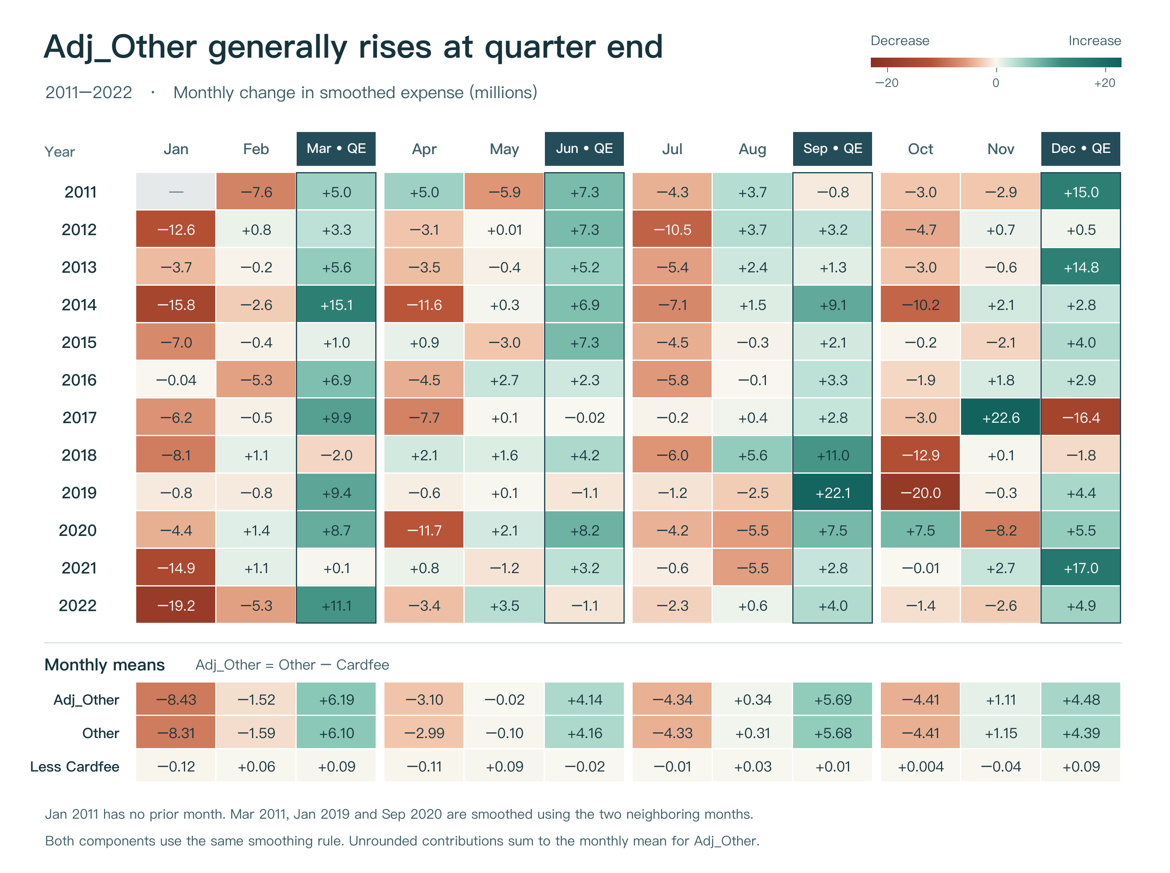
Figure 1. Monthly changes in millions. Outlined columns mark quarter-end months. Summing monthly amounts measures expense recognized within each reporting quarter.

Macro stationarity tests
All 15 macro series come from Sheet2 of Other_Macro_Qtr_S1.xls, the August 2026 Moody’s baseline. The sheet contains a quarterly level for each series. The model uses those values at their published two-decimal precision, then computes each transformation.
The workbook covers 2011 Q1–2028 Q1. The expense history ends in 2025 Q4. Stationarity testing uses the 51 quarters through 2023 Q3. The nine quarters from 2023 Q4 through 2025 Q4 form the holdout.
The augmented Dickey–Fuller (ADF) test uses an intercept and selects up to four lags by AIC. The KPSS test uses a constant and a bandwidth of four. Levels have 51 observations. Arithmetic first differences and quarter-on-quarter (QoQ) log changes have 50. Year-on-year (YoY) log changes have 47. Log changes equal 100 times the difference in natural logs.

Banking and bankruptcy series
Macro series | Test | Level | First diff. | QoQ log | YoY log | Screen input
Commercial bank total assets | ADF | 0.9653 | 0.0024 | 0.0020 | 0.1000 | QoQ log
Commercial bank total assets | KPSS | <0.01 | >0.10 | >0.10 | >0.10 | QoQ log
Commercial bank deposits | ADF | 0.8852 | 0.0662 | 0.0469 | 0.0779 | QoQ log
Commercial bank deposits | KPSS | <0.01 | >0.10 | >0.10 | >0.10 | QoQ log
Commercial bank loans and leases | ADF | 0.9893 | 0.0015 | 0.0012 | 0.1100 | QoQ log
Commercial bank loans and leases | KPSS | <0.01 | >0.10 | >0.10 | >0.10 | QoQ log
Consumer credit outstanding | ADF | 0.8645 | 0.0509 | 0.1287 | 0.4953 | None
Consumer credit outstanding | KPSS | <0.01 | >0.10 | >0.10 | >0.10 | None
Credit card delinquency rate, top 100 banks | ADF | 0.0735 | 0.7118 | 0.5912 | 0.1221 | None
Credit card delinquency rate, top 100 banks | KPSS | 0.0397 | 0.0819 | >0.10 | >0.10 | None
C&I loan delinquency rate, top 100 banks | ADF | 0.0129 | 0.0066 | 0.0124 | 0.1342 | Level
C&I loan delinquency rate, top 100 banks | KPSS | >0.10 | >0.10 | >0.10 | >0.10 | Level
Credit card charge-off rate, all banks | ADF | 0.1357 | 0.1688 | 0.0779 | 0.0009 | None
Credit card charge-off rate, all banks | KPSS | 0.0363 | 0.0858 | >0.10 | >0.10 | None
Business bankruptcies | ADF | 0.0298 | 0.3717 | 0.4909 | 0.0008 | None
Business bankruptcies | KPSS | <0.01 | 0.0458 | >0.10 | >0.10 | None
Personal bankruptcies | ADF | 0.2281 | 0.0021 | 0.0027 | 0.4552 | QoQ log
Personal bankruptcies | KPSS | <0.01 | >0.10 | >0.10 | >0.10 | QoQ log
Entries are p-values. Bold pairs meet the joint 5% rule. The last column gives the transform screened for the primary model. KPSS values outside the tabulated range are shown as bounds.

Market and price series and macro selection
Macro series | Test | Level | First diff. | QoQ log | YoY log | Screen input
CBOE Volatility Index (VIX) | ADF | 0.0955 | <0.0001 | 0.0003 | 0.1255 | QoQ log
CBOE Volatility Index (VIX) | KPSS | >0.10 | >0.10 | >0.10 | >0.10 | QoQ log
High-yield bond option-adjusted spread | ADF | 0.0183 | 0.0002 | 0.0003 | 0.0950 | Level
High-yield bond option-adjusted spread | KPSS | 0.0856 | >0.10 | >0.10 | >0.10 | Level
Federal funds rate | ADF | 0.3046 | 0.0385 | 0.0052 | 0.0251 | First diff.
Federal funds rate | KPSS | 0.0368 | >0.10 | >0.10 | >0.10 | First diff.
10-year Treasury yield | ADF | 0.6429 | 0.0077 | 0.0003 | 0.0323 | First diff.
10-year Treasury yield | KPSS | >0.10 | >0.10 | >0.10 | >0.10 | First diff.
PPI for final demand services | ADF | 1.0000 | 0.0535 | 0.0356 | 0.8598 | QoQ log
PPI for final demand services | KPSS | <0.01 | 0.0499 | 0.0775 | 0.0486 | QoQ log
CPI excluding food and energy | ADF | 0.9995 | 0.4702 | 0.3915 | 0.6973 | None
CPI excluding food and energy | KPSS | <0.01 | 0.0210 | 0.0305 | 0.0262 | None
Bold p-value pairs meet the 5% stationarity rule. Business bankruptcies (FBKBQ_B.IUSA) and credit card charge-offs qualified only in YoY log changes. Neither entered the primary screen. Personal bankruptcies qualified in both first differences and QoQ log changes.

Forward selection
Ten of 15 series had an eligible transform. For rates and spreads, the screen prioritized the level and then the first difference. For the other series it prioritized the level, the QoQ log change and then the first difference. Each chosen transform was tested at lags 1, 2 and 4. Expense-change lags 1 and 2 were fixed.
A term qualified when its two-sided p-value was below 0.05, maximum VIF was below 10, and Durbin–Watson was between 1.5 and 2.5. The lowest qualifying p-value determined entry. Jarque–Bera was evaluated only after selection.
Round | Tested | Passed | Terms qualifying (p-value) | Entered
1 | 30 | 2 | Bank loans and leases log growth L2 (0.0019), Bank assets log growth L4 (0.0424) | Bank loans and leases log growth L2
2 | 27 | 0 | None | Stop
Bank loans and leases log growth at lag 2 entered in round one. Bank asset growth at lag 4 also qualified individually. No additional variable passed after conditioning on loans.

Final model specification
Monthly Adj_Other equals reported Other expense less the signed Cardfee amount. The peaks in March 2011, January 2019, September 2020, July 2023 and November 2023 use the mean of the adjacent months. Y is the sum of the three smoothed monthly values in a calendar quarter, in millions.
The model uses the same 39 quarters for estimation, 2014 Q1 through 2023 Q3. The nine quarters from 2023 Q4 through 2025 Q4 are reserved for out-of-time (OOT) evaluation.

Quarterly expense and loans
$d_{t} = Y_{t} − Y_{t−1}$
L is commercial bank loans and leases in bank credit, in seasonally adjusted USD billions. The Moody’s quarterly series is FBBABLLCBQ_B.IUSA, column D of Sheet2. G is its quarter-on-quarter log growth multiplied by 100.
$G_{t} = 100 ln (L_{t} / L_{t−1})$

Final equation
${d̂}_{t} = −4.8953 − 0.7262d_{t−1} − 0.3940d_{t−2} + 4.4327G_{t−2}$
Term | Coefficient | Std. error | p-value
Intercept | −4.8953 | 2.3524 | 0.0448
Expense change L1 | −0.7262 | 0.1359 | <0.0001
Expense change L2 | −0.3940 | 0.1363 | 0.0066
Loan log growth L2 | 4.43268 | 1.31840 | 0.0019
Adjusted R² = 0.474, Durbin–Watson = 2.13, maximum VIF = 1.35. Final residual Jarque–Bera p = 0.000029. The normality test rejects at 5%.
For the 2025 Q4 forecast, the two-quarter lag uses loan growth in 2025 Q2. The calculation is 100 × ln(12,862.08 / 12,685.78) = 1.3802. Holding prior expense changes fixed, one extra log-growth point is associated with 4.43 million more expense change.
$Ŷ_{t} = Y_{t−1} + {d̂}_{t}$

Out of time forecast performance
Coefficients are frozen at 2023 Q3. One-step forecasts use expense observed through the previous quarter. Recursive forecasts feed their own predictions back into the model. Both use the realized path of lagged quarterly loan balances.
Method | Model | MAE | RMSE | MAPE | Mean error
One-step | Primary | 7.48 | 10.65 | 8.28% | −4.08
Recursive | Primary | 7.46 | 11.09 | 8.14% | −4.89
Error is forecast minus actual. Amounts are in millions. MAPE is mean absolute percentage error.
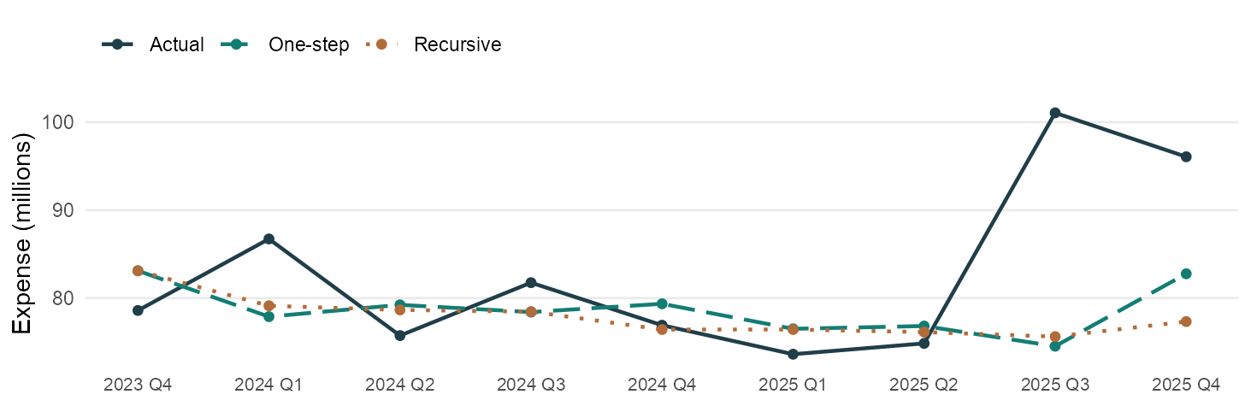
Figure 2. Both forecasts use the same starting history for 2023 Q4.
Quarter | Actual | One-step | Recursive | Recursive error
2023 Q4 | 78.59 | 83.10 | 83.10 | 4.52
2024 Q1 | 86.72 | 77.89 | 79.12 | −7.60
2024 Q2 | 75.73 | 79.23 | 78.65 | 2.92
2024 Q3 | 81.75 | 78.40 | 78.46 | −3.29
2024 Q4 | 76.91 | 79.35 | 76.42 | −0.49
2025 Q1 | 73.62 | 76.50 | 76.42 | 2.81
2025 Q2 | 74.85 | 76.82 | 76.13 | 1.28
2025 Q3 | 101.07 | 74.52 | 75.62 | −25.45
2025 Q4 | 96.07 | 82.76 | 77.33 | −18.74
9-quarter total | 745.30 | 708.58 | 701.25 | −44.05
The largest miss under both methods occurred in 2025 Q3. Actual expense reached 101.07 million. The one-step forecast was 74.52 million and the recursive forecast was 75.62 million. Mean errors were negative for both methods.

Rolling coefficient stability
Each window refits the intercept, two expense lags and one macro term over 20 quarters. The 20 windows run from 2014 Q1–2018 Q4 through 2018 Q4–2023 Q3.
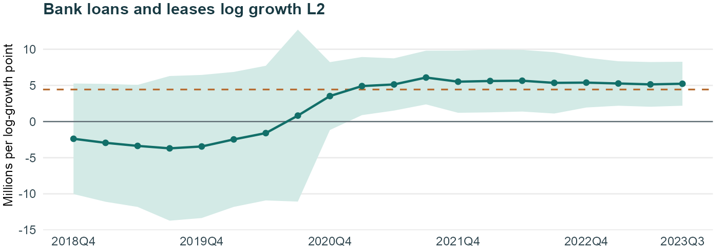
Figure 3. Each point is a 20-quarter estimate at the window end. Shading indicates its pointwise 95% Student-t interval. The dashed line marks the full-sample coefficient.
Term | Full fit | Min | Max | Same sign | p < 0.05
Intercept | −4.90 | −5.37 | 7.38 | 12/20 | 0/20
Expense change L1 | −0.73 | −0.83 | −0.66 | 20/20 | 20/20
Expense change L2 | −0.39 | −0.69 | −0.25 | 20/20 | 18/20
Loan log growth L2 | 4.43 | −3.71 | 6.09 | 13/20 | 11/20
The loan-growth coefficient was negative in the first seven windows and positive in the remaining 13. Its estimate rose from −2.38 in the first window to +5.23 in the last. Their respective 95% intervals were [−10.03, 5.27] and [2.19, 8.27]. The full-fit positive relationship is more evident late in the sample.
The residual CUSUM statistic was 0.645 (p = 0.800). Adjacent windows share 19 quarters, so sign and significance counts are descriptive.

Rolling estimates by window
Each row reports a 20-quarter fit. The Loans L2 coefficient measures the change in quarterly Adj_Other, in millions, associated with a one-point increase in loan log growth two quarters earlier.
Window | Intercept | AR L1 | AR L2 | Loans L2 | Loans p
2014 Q1–2018 Q4 | 3.79 | −0.82 | −0.66 | −2.38 | 0.519
2014 Q2–2019 Q1 | 4.71 | −0.80 | −0.66 | −2.94 | 0.455
2014 Q3–2019 Q2 | 5.79 | −0.82 | −0.69 | −3.37 | 0.410
2014 Q4–2019 Q3 | 7.38 | −0.66 | −0.61 | −3.71 | 0.444
2015 Q1–2019 Q4 | 7.04 | −0.67 | −0.62 | −3.45 | 0.471
2015 Q2–2020 Q1 | 6.49 | −0.69 | −0.60 | −2.47 | 0.582
2015 Q3–2020 Q2 | 5.26 | −0.74 | −0.58 | −1.60 | 0.721
2015 Q4–2020 Q3 | 2.51 | −0.75 | −0.62 | 0.82 | 0.885
2016 Q1–2020 Q4 | −0.85 | −0.76 | −0.63 | 3.53 | 0.131
2016 Q2–2021 Q1 | −3.10 | −0.83 | −0.66 | 4.91 | 0.020
2016 Q3–2021 Q2 | −3.58 | −0.80 | −0.66 | 5.13 | 0.008
2016 Q4–2021 Q3 | −5.27 | −0.72 | −0.44 | 6.09 | 0.003
2017 Q1–2021 Q4 | −3.34 | −0.73 | −0.43 | 5.52 | 0.015
2017 Q2–2022 Q1 | −3.54 | −0.76 | −0.44 | 5.61 | 0.014
2017 Q3–2022 Q2 | −3.33 | −0.76 | −0.43 | 5.65 | 0.013
2017 Q4–2022 Q3 | −3.51 | −0.76 | −0.40 | 5.35 | 0.017
2018 Q1–2022 Q4 | −5.05 | −0.77 | −0.39 | 5.39 | 0.004
2018 Q2–2023 Q1 | −4.21 | −0.66 | −0.33 | 5.27 | 0.002
2018 Q3–2023 Q2 | −4.12 | −0.72 | −0.34 | 5.14 | 0.003
2018 Q4–2023 Q3 | −5.37 | −0.68 | −0.25 | 5.23 | 0.002

Data sources and timing
Monthly expense comes from NonIE_Other_SNV. Each calendar quarter sums three smoothed months. For every macro, the sole model input is the final quarterly value in Sheet2 of Other_Macro_Qtr_S1.xls. Quarterly dates are matched across the 60 periods with expense observations. Forecasts use realized lagged macro values.

Challenger model with macro first differences
The challenger uses the same target, expense lags and 39-quarter estimation sample as the primary model. Its macro candidates must pass both stationarity tests in arithmetic first differences. It selected the change in quarterly commercial bank loans and leases.

Forward selection
Eight series met the joint ADF and KPSS criterion. The screen tested each at lags 1, 2 and 4, using the same significance, collinearity and Durbin–Watson rules as the primary model.
Round | Tested | Passed | Terms qualifying (p-value) | Entered
1 | 24 | 2 | Bank loans and leases change L2 (0.0012), High-yield spread change L2 (0.0080) | Bank loans and leases change L2
2 | 21 | 0 | None | Stop
Loan amount change L2 had the lowest qualifying p-value. Spread change L2 also passed in round one, but no second term qualified after loan amount change entered.

Variables and estimated equation
L is the supplied quarterly loan balance in USD billions (FBBABLLCBQ_B.IUSA). The macro term is the change in that balance two quarters earlier. Expense is measured in millions.
$d_{t} = Y_{t} − Y_{t−1}$
${ΔL}_{t} = L_{t} − L_{t−1}$
${d̂}_{t} = −4.3866 − 0.7330d_{t−1} − 0.4033d_{t−2} + 0.04355{ΔL}_{t−2}$
Term | Coefficient | Std. error | p-value
Intercept | −4.3866 | 2.1789 | 0.0518
Expense change L1 | −0.7330 | 0.1345 | <0.0001
Expense change L2 | −0.4033 | 0.1348 | 0.0051
Loan amount change L2 | 0.04355 | 0.01239 | 0.0012
Adjusted R² = 0.485, Durbin–Watson = 2.15, maximum VIF = 1.35. Final residual Jarque–Bera p = 0.000024. The normality test rejects at 5%.
For the 2025 Q4 forecast, loan balances in 2025 Q2 and 2025 Q1 give a lagged change of 176.30 billion. A 100 billion increase in loans is associated with 4.35 million more expense change, holding the two expense lags fixed.

Challenger out of time performance
The challenger’s coefficients are fixed at 2023 Q3. Both forecast methods use lagged quarterly loan changes. The one-step forecast uses observed expense lags and the recursive forecast feeds its own expense estimates back into the equation.
Method | Model | MAE | RMSE | MAPE | Mean error
One-step | Challenger | 7.54 | 10.09 | 8.49% | −2.80
Recursive | Challenger | 7.20 | 9.11 | 8.24% | −1.70
Errors are forecast minus actual, in millions except for MAPE.
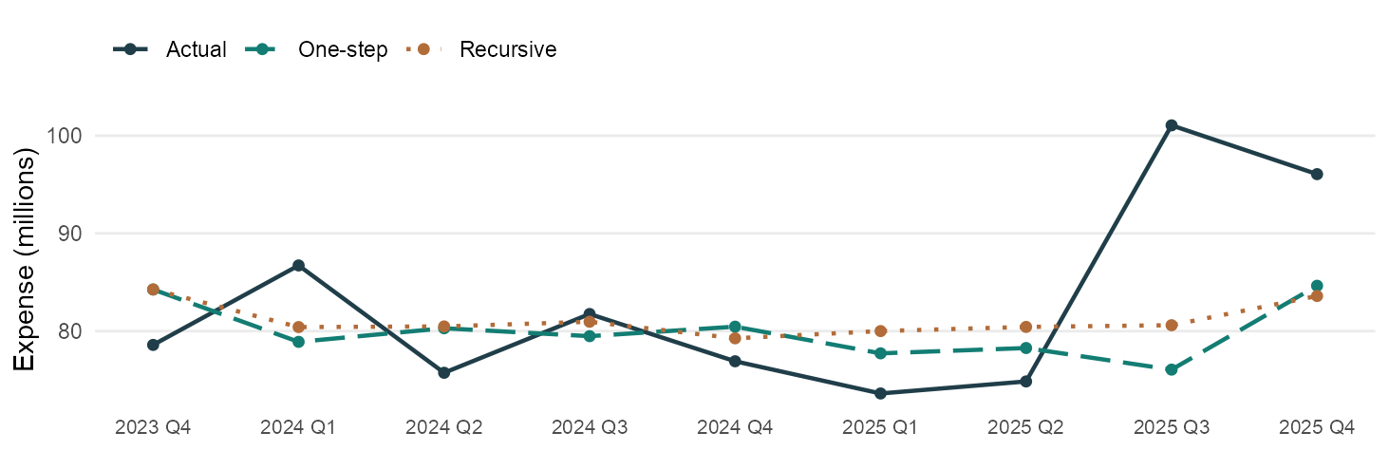
Figure 4. Both methods start in 2023 Q4 with the same expense history.
Quarter | Actual | One-step | Recursive | Recursive error
2023 Q4 | 78.59 | 84.26 | 84.26 | 5.67
2024 Q1 | 86.72 | 78.90 | 80.41 | −6.31
2024 Q2 | 75.73 | 80.29 | 80.48 | 4.74
2024 Q3 | 81.75 | 79.48 | 80.96 | −0.79
2024 Q4 | 76.91 | 80.45 | 79.26 | 2.35
2025 Q1 | 73.62 | 77.72 | 80.00 | 6.39
2025 Q2 | 74.85 | 78.27 | 80.43 | 5.58
2025 Q3 | 101.07 | 76.06 | 80.60 | −20.46
2025 Q4 | 96.07 | 84.64 | 83.59 | −12.47
9-quarter total | 745.30 | 720.08 | 730.00 | −15.30
The largest miss was in 2025 Q3. The recursive forecast was 80.60 million against actual expense of 101.07 million. The 20.46 million shortfall is large relative to the nine-quarter recursive MAE of 7.20 million.

Challenger coefficient stability
The 20 rolling estimates use the same windows as the primary model. Each fit has four coefficients and 16 residual degrees of freedom.
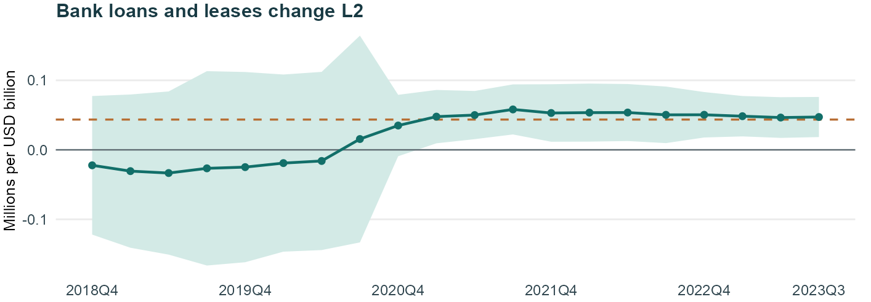
Figure 5. Each point is a 20-quarter estimate at the window end. Shading indicates its pointwise 95% Student-t interval. The dashed line marks the full-sample coefficient.
Term | Full fit | Min | Max | Same sign | p < 0.05
Intercept | −4.39 | −5.06 | 5.37 | 12/20 | 0/20
Expense change L1 | −0.73 | −0.83 | −0.66 | 20/20 | 20/20
Expense change L2 | −0.40 | −0.69 | −0.25 | 20/20 | 17/20
Loan amount change L2 | 0.0435 | −0.0334 | 0.0581 | 13/20 | 11/20

Why retain the challenger designation
The loan coefficient was negative in the first seven windows, ending in 2018 Q4 through 2020 Q2, and positive thereafter. It was significant in 11 of 20 windows. The first estimate was −0.0223 million per USD billion, with a 95% interval of [−0.1219, 0.0774]. The last was +0.0472, with an interval of [0.0184, 0.0761].
The 2025 Q3 shortfall, the seven early negative loan estimates and rejection of residual normality limit confidence in a stable positive response to loan growth. The nine-quarter backtest covers one realized macro path.

Challenger rolling estimates by window
Loans L2 measures the change in expense, in millions, for each additional USD billion of loan growth in dollar terms. The full-sample estimate is +0.04355. The rolling estimates range from −0.0334 to +0.0581.
Window | Intercept | AR L1 | AR L2 | Loans L2 | Loans p
2014 Q1–2018 Q4 | 3.01 | −0.81 | −0.65 | −0.0223 | 0.642
2014 Q2–2019 Q1 | 4.12 | −0.80 | −0.65 | −0.0306 | 0.564
2014 Q3–2019 Q2 | 4.96 | −0.82 | −0.69 | −0.0334 | 0.555
2014 Q4–2019 Q3 | 5.32 | −0.66 | −0.60 | −0.0266 | 0.692
2015 Q1–2019 Q4 | 5.21 | −0.66 | −0.61 | −0.0249 | 0.705
2015 Q2–2020 Q1 | 5.37 | −0.69 | −0.59 | −0.0191 | 0.755
2015 Q3–2020 Q2 | 5.00 | −0.74 | −0.58 | −0.0160 | 0.794
2015 Q4–2020 Q3 | 1.78 | −0.76 | −0.62 | 0.0155 | 0.827
2016 Q1–2020 Q4 | −0.46 | −0.76 | −0.63 | 0.0350 | 0.113
2016 Q2–2021 Q1 | −2.51 | −0.83 | −0.66 | 0.0478 | 0.018
2016 Q3–2021 Q2 | −3.06 | −0.79 | −0.66 | 0.0500 | 0.007
2016 Q4–2021 Q3 | −4.65 | −0.71 | −0.43 | 0.0581 | 0.003
2017 Q1–2021 Q4 | −2.89 | −0.73 | −0.42 | 0.0530 | 0.015
2017 Q2–2022 Q1 | −3.12 | −0.76 | −0.44 | 0.0536 | 0.015
2017 Q3–2022 Q2 | −2.93 | −0.76 | −0.43 | 0.0537 | 0.014
2017 Q4–2022 Q3 | −3.13 | −0.76 | −0.40 | 0.0504 | 0.018
2018 Q1–2022 Q4 | −4.70 | −0.76 | −0.39 | 0.0504 | 0.005
2018 Q2–2023 Q1 | −3.85 | −0.66 | −0.33 | 0.0484 | 0.003
2018 Q3–2023 Q2 | −3.76 | −0.72 | −0.34 | 0.0465 | 0.004
2018 Q4–2023 Q3 | −5.06 | −0.68 | −0.25 | 0.0472 | 0.003
The residual CUSUM statistic was 0.504 (p = 0.962). Pointwise intervals and p-values are conditional on the selected specification.
The adjacent windows share 19 quarters. The seven early negative estimates all have intervals that include zero. Their signs illustrate sensitivity to the estimation period without establishing a negative effect.

