PNFP Bonus Ratio ARDL Model Report
  - Macro Screening Rolling Diagnostics and S4 Forecasts
In-sample: 2012Q2 to 2022Q4. Out-of-time: 2023Q1 to 2025Q4. Updated 5 October 2026.

Executive Summary
Initial forward selection admits unemployment and HY from 18 eligible macro families. HY then fails the rolling significance review and is excluded from the final model; unemployment remains the sole macro term. The inventory retains all 22 series. The intercept, own first lag and pandemic dummy for 2020Q1–2021Q1 remain fixed throughout. No acquisition split or acquisition dummy is applied.
Training adjusted R² is 0.278. OOT one-step RMSE is 4.360 percentage points, versus 5.056 for AR(1) with the same dummy. Unemployment is positive in all 32 six-year rolling windows and significant in 27. However, its significance disappears when the five pandemic-response quarters are removed. This supports a conditional historical association, not a fully stable causal relationship.

Data and Target Definition
Sample | Dates | Quarters
Raw PNFP history | 2011Q1 to 2025Q4 | 60
Common training estimation | 2012Q2 to 2022Q4 | 43
OOT backtest | 2023Q1 to 2025Q4 | 12
Fixed structure full refit | 2012Q2 to 2025Q4 | 55

$R(t) = \frac{Bonus(t)}{Compensation(t) − Bonus(t)}; y(t) = 100 × R(t)$
The target is a ratio level, not YoY growth or bonus divided by total compensation. All model errors are percentage points of this ratio. The common start accommodates the separate lagged bonus-growth challenge, which needs five prior quarters. Earlier observations are retained as lag inputs.
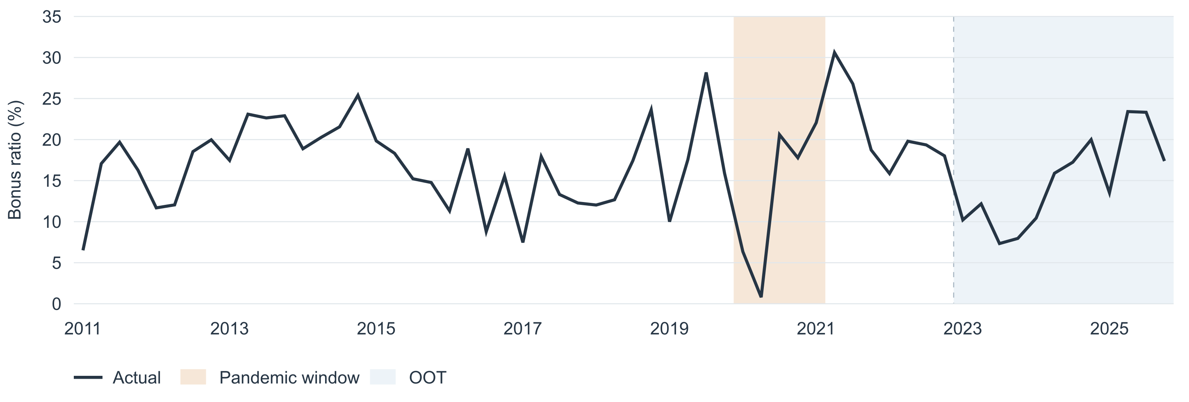
Figure 1 Quarterly bonus ratio. Tan marks the pandemic dummy period; blue marks OOT.

Macro Inventory
The updated inventory contains 22 quarterly macro series with August 2026 baseline definitions. HY participates in initial forward selection, but is excluded from the final model after rolling significance review. All codes in the next two tables have the suffix _B.IUSA.
Code | Variable definition | Unit and adjustment | Final pool
FAHEFI | Financial activities average hourly earnings | USD per hour; SA | Candidate
FPCNBULC | Nonfarm business unit labor costs | Index 2017=100; SA | Candidate
FECICPQ | Private industry total compensation ECI | Index Dec 2005=100; SA | Candidate
FRFED | Federal funds rate | Percent per annum; NSA | Candidate
FRGT2Y | Two year Treasury constant maturity rate | Percent per annum; NSA | Candidate
FRGT10Y | Ten year Treasury constant maturity rate | Percent per annum; NSA | Candidate
FLBR | Unemployment rate | Percent; SA | Candidate
FCBC | Consumer confidence index | Index 1985=100; SA | Candidate
FSBINQ | Small business normalized optimism index | Index 1986=100; SA | Candidate
FGDP$ | Real gross domestic product | Billion chained 2017 USD; SAAR | Candidate
FGAP | Real GDP versus potential GDP output gap | Percent; SA | Candidate
FBBACBQ | Commercial banks total assets | Billion USD; SA | Candidate
FBBABLLCBQ | Commercial banks loans and leases in bank credit | Billion USD; SA | Candidate
FCBOEVIXQ | CBOE S&P 500 volatility index period average | Index; NSA | Candidate
FIRHYBOASQ | High yield bond option adjusted spread | Percentage points; NSA | Excluded

Quarterly Source Basis
The updated quarterly dataset supplies the macro levels used in this rerun. These values are used directly without monthly reaggregation, interpolation or further annualization. A quarterly log change or point difference is subsequently calculated for stationarity screening; that transformation is separate from the within-quarter aggregation used to construct a level.
SA means seasonally adjusted; NSA means not seasonally adjusted; SAAR means seasonally adjusted at an annual rate. A percent rate and a percentage-point spread remain distinct from relative percentage growth.

Additional Macro Definitions
The following seven series complete the updated macro inventory. Their positive-valued amounts and indices use the growth-transformation policy below. Quarterly values are retained without averaging them again or applying an additional annualization factor.
Code | Variable definition | Unit and adjustment
FPCNBCPH | Nonfarm business hourly compensation | Index 2017=100; SA
FLBOPQ | Total nonfarm job openings | Million jobs; SA
FYPEW52Q | Finance and insurance wages and salaries | Billion USD; SAAR
FGDP52Q | Finance and insurance gross product originating | Billion USD; SAAR
FE52 | Finance and insurance employment | Million; SA
FYPCPIQ | Per capita income | USD; SAAR
FECICCQ | All civilian workers total compensation ECI | Index Dec 2005=100; SA

Within-quarter aggregation is not independently re-estimated in this analysis, so the input levels are not all relabeled as simple quarterly means. Each economic series is included once. The two ECI families are not duplicates: one covers private industry and the other all civilian workers. SAAR series are already annualized and are not summed across months or multiplied by four.
FYPCPIQ is per capita income, not CPI. FGDP52Q is finance-and-insurance industry value added in USD, not whole-economy real GDP. Financial hourly earnings, nonfarm hourly compensation and total finance-industry wages measure different populations and quantities.

HY Retention and Model Exclusion
HY is FIRHYBOASQ_B.IUSA, the USD high-yield bond option-adjusted spread, measured in percentage points. Its level passes stationarity screening, and its first lag passes round 2 of initial forward selection: OLS p = 0.0184 and HAC p = 0.0143, with all entry diagnostics satisfied.
In the initial two-macro model, HY is negative in all 32 rolling 24-quarter windows but significant at 5% in only 1 under OLS and 7 under HAC. The final window has OLS p = 0.1959 and HAC p = 0.1212. These results are recalculated using the same updated data. HY is excluded from the final model because significance is insufficiently persistent, not because it failed forward selection. The concluding HY review shows window sensitivity and the decision limitations.

Transformation Policy
Positive amounts, compensation indices, employment and job openings try quarterly log growth, then four-quarter log growth. Rates, confidence indices and the signed output gap try levels, then quarterly point changes. VIX tries level, log level and quarterly log growth. The first form passing the training stationarity rule is retained; model fit does not choose the transformation.
$Quarterly log growth(t) = 100 × ln(\frac{X(t)}{X(t − 1)})$
$YoY log growth(t) = 100 × ln(\frac{X(t)}{X(t − 4)})$
The seven newly defined series use the positive-quantity growth rule. After HY exclusion, a separate rerun using levels then differences for these seven series selects the same final model and produces identical final-model coefficients and forecasts.

Stationarity and Transformation Eligibility
Both tests include a constant and no trend. ADF uses at most four lags selected by AIC; KPSS uses automatic bandwidth. A form is eligible only if ADF p < 0.05 and KPSS p > 0.05. Tests use training data only. The target passes in levels.
Target test | Statistic | p value | Lags | Effective n
ADF | -4.4166 | 0.0003 | 0 | 42
KPSS | 0.1443 | >0.100 | 2 | 43

Macro family | Displayed form | ADF p | KPSS p | Status
Financial hourly earnings | QoQ log growth | 0.0116 | >0.100 | Eligible
Unit labor costs | QoQ log growth | 1.53e-15 | >0.100 | Eligible
Private compensation ECI | QoQ log growth | 0.9247 | 0.0153 | Fails gate
Federal funds rate | Level | 0.4322 | >0.100 | Fails gate
Two year Treasury | Level | 0.1113 | >0.100 | Fails gate
Ten year Treasury | QoQ difference | 0.0006 | >0.100 | Eligible
Unemployment | Level | 0.0319 | 0.0874 | Selected
Consumer confidence | QoQ difference | 0.0002 | >0.100 | Eligible
Small business optimism | QoQ difference | 1.35e-08 | >0.100 | Eligible
Real GDP | QoQ log growth | 1.27e-13 | >0.100 | Eligible
Output gap | QoQ difference | 2.65e-13 | >0.100 | Eligible
Bank assets | QoQ log growth | 1.84e-06 | >0.100 | Eligible
Bank loans and leases | QoQ log growth | 0.0001 | >0.100 | Eligible
VIX | QoQ log growth | 0.0011 | >0.100 | Eligible
High yield OAS | Level | 0.0061 | >0.100 | Removed later
Nonfarm hourly compensation | QoQ log growth | 3.88e-13 | >0.100 | Eligible
Nonfarm job openings | QoQ log growth | 0.0016 | >0.100 | Eligible
Finance wages and salaries | QoQ log growth | 4.03e-18 | >0.100 | Eligible
Finance industry value added | QoQ log growth | 1.88e-06 | >0.100 | Eligible
Finance employment | QoQ log growth | 0.0001 | >0.100 | Eligible
Per capita income | QoQ log growth | 1.46e-12 | >0.100 | Eligible
Civilian compensation ECI | QoQ log growth | 0.8949 | 0.0137 | Fails gate

Macro tests use lagged input dates, 2012Q1–2022Q3: 43 observations before ADF lag loss. Initially, 25 of 45 tested forms pass, yielding 18 eligible families. HY passes in levels but is removed after rolling review; 17 families remain for final-model selection. Failed families display their first preferred form; every fallback also fails. A failure does not establish a particular integration order.

Final Model Selection and Estimation
After HY exclusion following rolling review, forward selection is rerun. The intercept, own first lag and pandemic dummy are fixed. Additions require OLS Student-t p < 0.05, maximum nonconstant VIF < 10, 1.5 ≤ DW ≤ 2.5 and Jarque–Bera p > 0.05. Rank passing terms by lowest p, then highest adjusted R²; stop if none passes or two macros enter. There is no backward deletion or lag search; all trials use the same 43 quarters.
Round | Result | Added term p | Adjusted R² | Trials
1 | Unemployment level at lag 1 | 0.0030 | 0.277676 | 17
2 | No further macro passes | Minimum 0.1806 | Not applicable | 16

$y(t) = 4.944700 + 0.329160 × y(t − 1)$
$+ 1.328645 × U(t − 1) − 5.041203 × D(t) + e(t)$
U is the quarterly unemployment rate in percent, not a decimal fraction or its growth rate. D equals 1 in 2020Q1–2021Q1 and 0 otherwise. No HY term appears. The closest second-round addition is financial hourly earnings growth at p = 0.1806; all 16 additions fail the significance gate.
Term | Coefficient | OLS SE | OLS p | HAC p | HAC 95% interval
Intercept | 4.944700 | 3.4439 | 0.1590 | 0.1555 | [-1.960, 11.850]
Own ratio lag 1 | 0.329160 | 0.1364 | 0.0206 | 0.0108 | [0.080, 0.578]
Unemployment lag 1 | 1.328645 | 0.4198 | 0.0030 | 0.0050 | [0.425, 2.232]
Pandemic dummy | -5.041203 | 2.6249 | 0.0621 | 0.0672 | [-10.458, 0.375]

HAC uses a Bartlett kernel, four lags, finite-sample correction and t probabilities. The OLS entry rule is unchanged. The own lag and dummy remain regardless of their p values. The pandemic dummy is not significant at 5% in the training model. Reported inference is conditional on the selected specification and is not adjusted for model selection.

Model Diagnostics
Statistic | Value | Statistic | Value
Observations | 43 | Residual degrees of freedom | 39
R² | 0.329271 | Adjusted R² | 0.277676
AIC | 264.590 | BIC | 271.635
Durbin–Watson | 1.9536 | Maximum nonconstant VIF | 1.2080
Jarque–Bera p | 0.6905 | Breusch–Pagan p | 0.6749
BG lag 1 F p | 0.9190 | BG lag 4 F p | 0.9175

DW is retained as the established screening convention, not used as a standalone test with a lagged dependent variable. BG tests do not reject their no-serial-correlation nulls at 5%. The own-lag coefficient is below one in absolute value. The stationary dynamic regression does not establish cointegration or justify an error-correction interpretation.

IS and OOT Fitted Results
Evaluation | n | RMSE | MAE
IS fitted | 43 | 4.781 | 3.797
OOT one step | 12 | 4.360 | 3.760
OOT conditional recursive | 12 | 5.026 | 4.405
OOT expanding window | 12 | 4.435 | 3.781

Errors are percentage points of the bonus-to-nonbonus ratio. One-step OOT freezes coefficients at 2022Q4 and uses the actual preceding-quarter ratio and unemployment. No OOT outcome enters numerical transformation or forward selection within this rerun.
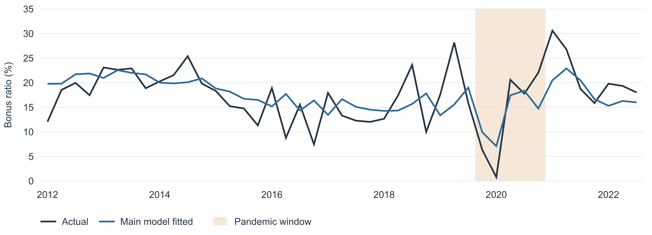
Figure 2 Training fit, 2012Q2–2022Q4. Coefficients are estimated using those 43 quarters.
Conditional recursive OOT replaces the own-ratio lag with its previous prediction, starting from actual 2022Q4, but retains the realized unemployment path. Expanding-window forecasts refit coefficients using only prior observations and keep the selected structure fixed.
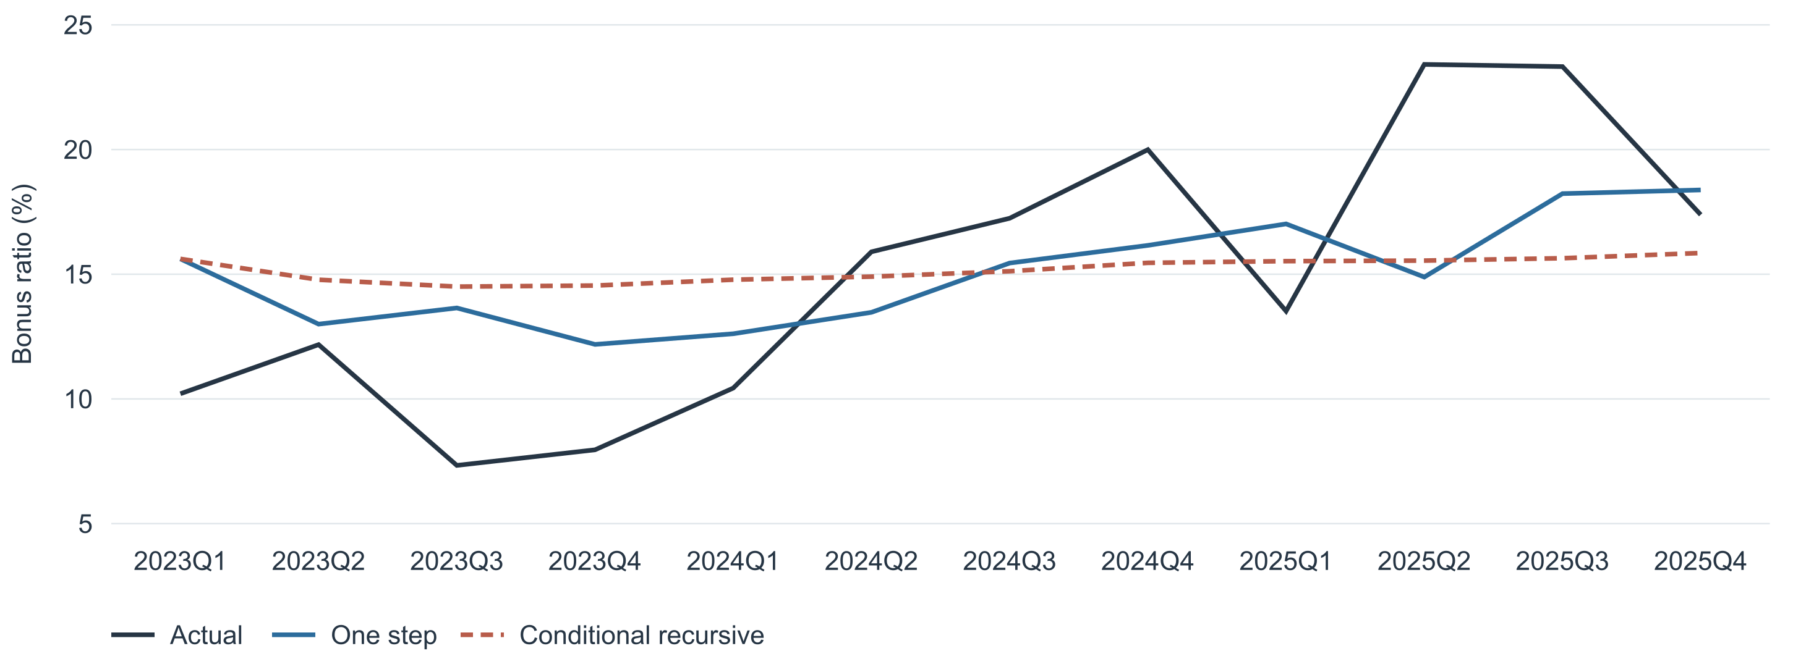
Figure 3 OOT actuals and predictions, 2023Q1–2025Q4. All 12 quarters have D = 0.
This is a revised-data historical backtest. Earlier work and the rolling evidence used to exclude HY have already inspected OOT outcomes, so this segment is not untouched prospective validation. Conditional recursion also assumes knowledge of the subsequent macro path.

Benchmark Comparisons and Sensitivity
Specification | IS BIC | OOT RMSE | OOT MAE
Main ARDL with pandemic dummy | 271.635 | 4.360 | 3.760
Unemployment ARDL without dummy | 271.759 | 4.336 | 3.656
AR(1) with pandemic dummy | 277.705 | 5.056 | 4.274
AR(1) without dummy | 274.888 | 4.851 | 4.154
Previous quarter ratio | Not fitted | 5.076 | 4.140
Same quarter last year | Not fitted | 7.651 | 6.712
Training mean ratio | Not fitted | 5.893 | 4.942

The main model reduces one-step RMSE by 13.8% relative to AR(1) with the same dummy. The HY-free no-dummy search also selects unemployment only and has slightly lower OOT RMSE, but the pandemic dummy remains part of the specified default. Neither the dummy interval nor its inclusion is optimized against OOT errors.

Bonus Growth Challenge
$BonusGrowth(t − 1) = 100 × ln(\frac{Bonus(t − 1)}{Bonus(t − 5)})$
The optional lagged bonus-growth term passes the stationarity rule, with ADF p = 0.0267 and KPSS p >0.100. It is tested separately because bonus is already in the target numerator. Excluding contemporaneous bonus growth avoids same-quarter overlap, but lagged bonus growth is still not an exogenous instrument.
Bonus coefficient | OLS p | HAC p | OOT RMSE
0.002894 | 0.8237 | 0.8368 | 4.302

The bonus term fails the 5% training significance rule and is not adopted. Its slightly smaller OOT RMSE does not override that rule. The challenge and the main model use the same 43-quarter training sample.

Alternative Transformations
After HY exclusion, changing only the seven added series from the growth preference to level-then-difference again produces 17 eligible families and selects unemployment only. Final coefficients and OOT predictions are identical. This is a specific policy comparison, not an exhaustive search over transformations.

Economic Interpretation
A one-percentage-point increase in the preceding-quarter unemployment rate is associated with a 1.329-percentage-point higher current bonus-to-nonbonus compensation ratio, conditional on the own lag and dummy. This is an association with a ratio, not an estimated increase in bonus dollars. The numerator, denominator, payment timing and omitted common factors may all contribute. It should not be read as a causal countercyclical bonus policy.

Rolling Coefficient Diagnostics
The fixed final structure is re-estimated in 24-quarter windows, moving one quarter at a time across 2012Q2–2025Q4. The 32 windows end from 2018Q1 to 2025Q4. Twenty- and 28-quarter windows are sensitivity checks. Variables, transformations and lags are not reselected. Windows extending beyond 2022Q4 use OOT outcomes and are descriptive diagnostics, not new OOT forecasts.
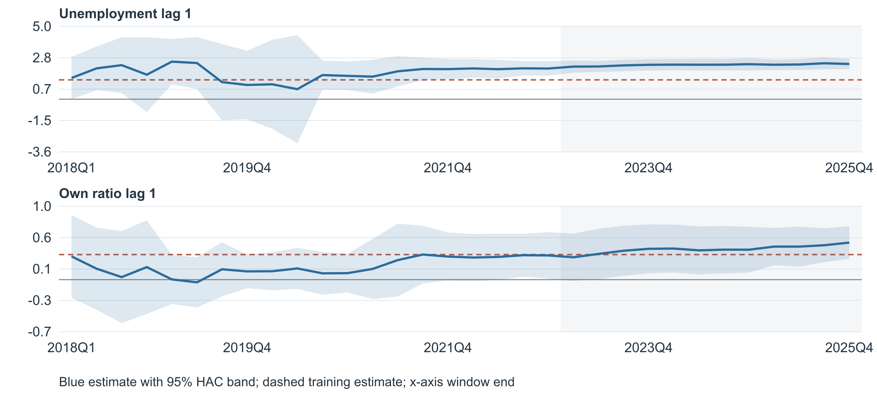
Figure 4 Rolling unemployment and own-lag coefficients with pointwise 95% HAC intervals.
Term | Coefficient range | Pos / neg | OLS sig | HAC sig
Intercept | -1.343 to 10.640 | 29 / 3 | 0/32 | 0/32
Own ratio lag 1 | -0.035 to 0.486 | 31 / 1 | 10/32 | 13/32
Unemployment lag 1 | 0.688 to 2.580 | 32 / 0 | 27/32 | 27/32
Pandemic dummy | -11.266 to -5.611 | 0 / 24 | 18/24 | 23/24

Significance counts use 5%. Unemployment is positive in all 32 windows, ranging from 0.688 to 2.580, and is significant in 27 under both OLS and HAC. The own-lag coefficient is negative in one window but remains below one in absolute value throughout. Directional consistency does not establish a constant coefficient magnitude.
Final six year window | Coefficient | OLS p | HAC p
Own ratio lag 1 | 0.4863 | 0.0019 | 0.0001
Unemployment lag 1 | 2.4196 | 0.0001 | 5.63e-12
Pandemic dummy | -8.5379 | 0.0056 | 1.14e-05

Intervals use four-lag Bartlett HAC with finite-sample correction and t probabilities. They are pointwise and not adjusted for selection or multiple windows. Adjacent windows overlap heavily; 27 significant windows are not 27 independent replications, and very small short-window HAC p values should be interpreted cautiously.

Rolling Controls and Window Sensitivity
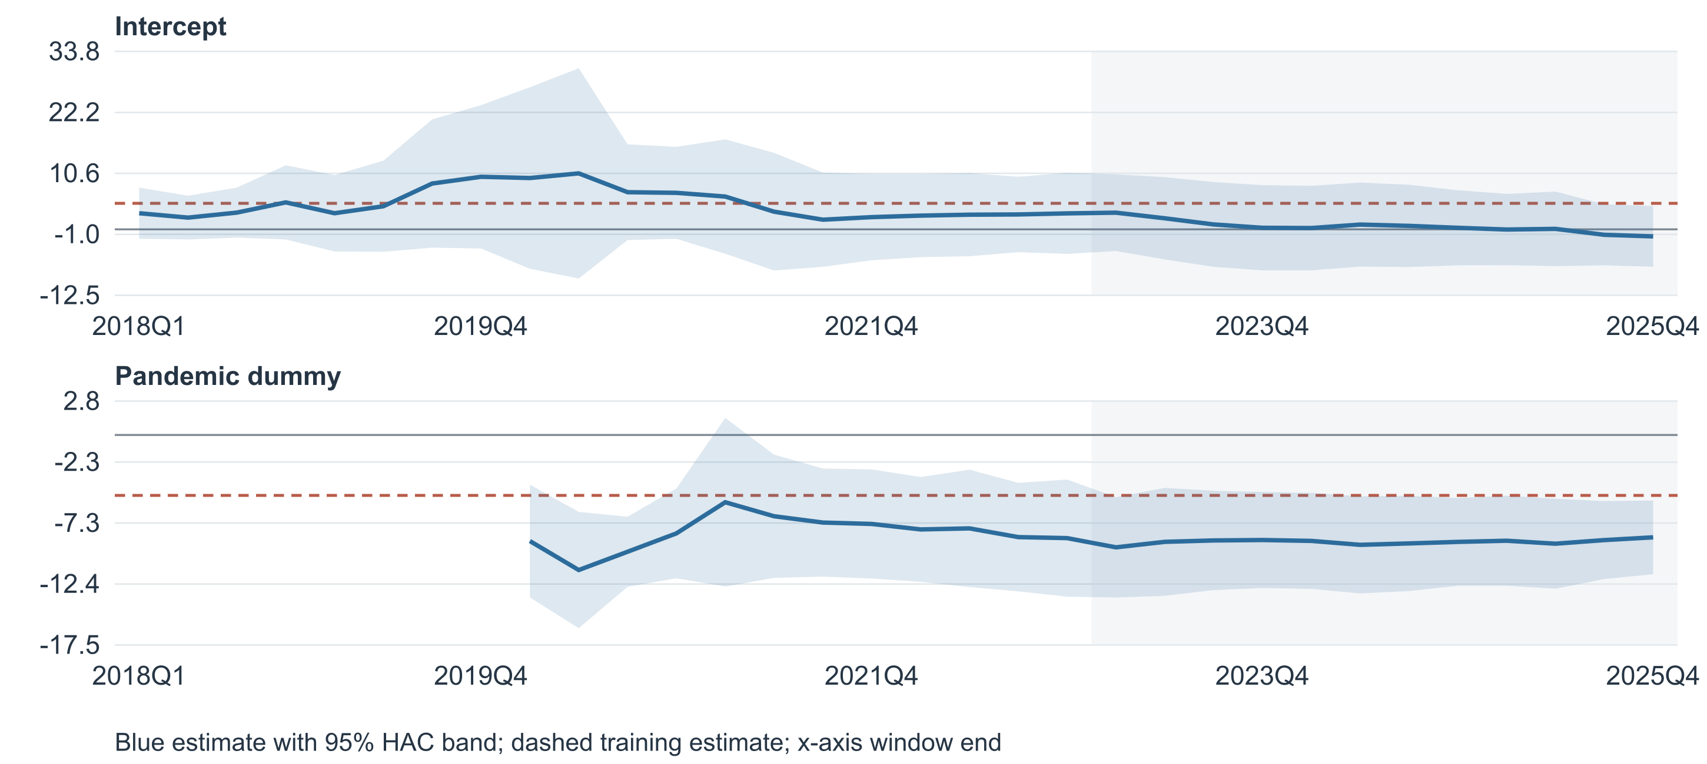
Figure 5 Rolling intercept and pandemic coefficients. The dummy is unavailable in all-zero windows.
When the dummy is zero throughout a window, it is omitted and its coefficient is unavailable, not zero. For the 24-quarter analysis, this occurs in eight windows ending before 2020Q1. The dummy is negative in all 24 identifiable windows, from −11.266 to −5.611 percentage points, but its training-model p value remains above 0.05.
Window | Term | Coefficient range | Positive | OLS sig | HAC sig
20 | Unemployment | -4.110 to 4.671 | 33/36 | 24/36 | 28/36
20 | Own lag | -0.167 to 0.533 | 28/36 | 7/36 | 9/36
24 | Unemployment | 0.688 to 2.580 | 32/32 | 27/32 | 27/32
24 | Own lag | -0.035 to 0.486 | 31/32 | 10/32 | 13/32
28 | Unemployment | 1.206 to 2.406 | 28/28 | 24/28 | 24/28
28 | Own lag | 0.076 to 0.417 | 28/28 | 10/28 | 15/28

Unemployment changes sign in three of 36 five-year windows but is positive in every six- and seven-year window. The five-year coefficient range is much wider. Stability is therefore sensitive to the amount and composition of data in a window.
The first identifiable dummy windows contain only one or two D = 1 observations. In the last 20-quarter window only 2021Q1 remains dummy-on. Such sparse support can create extreme leverage and unreliable short-window uncertainty estimates. Windows are not discarded because their original screening diagnostics fail. Rolling paths are not a formal global test of coefficient equality.

Influence Checks and Full History Refit
Influence checks keep the final unemployment structure fixed. Rows are removed only as a post-selection sensitivity, with original calendar lags preserved. They do not redefine the main estimation sample. Because the remaining observations have calendar gaps, these checks report classical OLS p values rather than treating adjacent retained rows as adjacent quarters in HAC.
Sensitivity | n | Unemployment coefficient | OLS p
Main training model | 43 | 1.3286 | 0.0030
Remove 2020Q1–2021Q1 | 38 | 0.7414 | 0.1825
Remove 2020Q2 | 42 | 1.1135 | 0.0148

Removing the five dummy-on response quarters reduces the unemployment coefficient to 0.7414 and raises p to 0.1825. Its significance is therefore sensitive to those observations. This does not remove every pandemic-related lagged input: 2021Q2 still uses unemployment from 2021Q1. Removing 2020Q2 alone leaves unemployment significant, with coefficient 1.1135 and p = 0.0148.
Highest influence quarters | Cook distance | Leverage | Studentized residual
2020Q2 | 0.2503 | 0.3064 | -1.531
2020Q3 | 0.2364 | 0.5290 | 0.916
2021Q1 | 0.1961 | 0.2235 | 1.690

Fixed Structure Refit Through 2025Q4
The full-history refit uses 55 observations and the same selected terms. It is a descriptive estimate using all available outcomes, not the model that generated the reported OOT predictions. No new variables are selected in this refit.
Term | Coefficient | OLS p | HAC p | HAC 95% interval
Intercept | 4.057658 | 0.1437 | 0.1541 | [-1.573, 9.688]
Own ratio lag 1 | 0.361785 | 0.0029 | 0.0009 | [0.156, 0.567]
Unemployment lag 1 | 1.386414 | 0.0007 | 0.0015 | [0.555, 2.218]
Pandemic dummy | -4.970885 | 0.0536 | 0.0521 | [-9.989, 0.047]

The full refit has adjusted R² 0.314, DW 1.970 and JB p 0.569. The pandemic dummy remains just above the 5% threshold under both OLS and HAC. It stays in the model by design.

Model Limitations
The sample is small, the dummy has only five active quarters, and model selection is data-dependent. No acquisition adjustment is applied, so any residual structural changes remain unmodeled. The ratio does not identify bonus-dollar behavior without its denominator. No bounds test, error-correction equation, causal design, simultaneous stability test or prospective validation is claimed. Point forecasts are not prediction intervals.

Quarterly OOT Results
The table reports all 12 held-out response quarters. Values are 100 times the bonus-to-nonbonus ratio. Error equals actual minus one-step prediction. Display rounding does not enter any metric calculation.
Quarter | Actual | One step | Recursive | Expanding | Error
2023Q1 | 10.208 | 15.615 | 15.615 | 15.615 | -5.407
2023Q2 | 12.177 | 12.999 | 14.779 | 12.746 | -0.822
2023Q3 | 7.335 | 13.647 | 14.504 | 13.352 | -6.313
2023Q4 | 7.960 | 12.186 | 14.546 | 11.407 | -4.227
2024Q1 | 10.435 | 12.614 | 14.782 | 11.544 | -2.178
2024Q2 | 15.900 | 13.473 | 14.903 | 12.448 | 2.427
2024Q3 | 17.245 | 15.449 | 15.121 | 14.856 | 1.796
2024Q4 | 19.996 | 16.157 | 15.458 | 15.716 | 3.839
2025Q1 | 13.522 | 17.018 | 15.525 | 16.801 | -3.497
2025Q2 | 23.414 | 14.887 | 15.546 | 14.341 | 8.527
2025Q3 | 23.326 | 18.232 | 15.642 | 18.150 | 5.094
2025Q4 | 17.386 | 18.380 | 15.851 | 18.557 | -0.994

Input Series and Quarterly Handling
PNFP_Monthly_Quarterly.xlsx supplies quarterly compensation and bonus. These reconcile to the sums of the corresponding three monthly observations. The updated macro dataset contains 60 quarterly levels for each of the 22 listed series, from 2011Q1 through 2025Q4. HY enters the initial selection audit and is excluded from final-model screening after rolling significance review.
Macro inputs use the supplied quarterly levels and stated units. The analysis neither mixes them with earlier macro versions nor reconstructs monthly observations. Only data through 2025Q4 are used. Growth rates are calculated from the quarterly levels; point differences preserve the original rate or index units. Calculations use the available input precision without rounding intermediate results.

Verification
Independent least-squares, OLS and statsmodels ARDL calculations reproduce the final coefficients to numerical precision. Transformations and OOT one-step forecasts were recalculated independently. The 96 final-model and 96 initial-model rolling fits were checked against RollingOLS. Full-history coefficients reconcile. The dummy has exactly five active quarters. HY is absent from final-model regressors. All 60 quarterly input rows are complete.
The four macro-entry gates follow the established PNFP implementation of the Cardfee screening convention. The report preserves its common sample, fixed lag orders and joint ADF/KPSS rule. It does not import the separate Commercial Card model’s OOT partial-correlation screen, overlay or error-correction structure.

Initial Forward Selection Audit
Before the rolling review, round 1 adds each candidate to the intercept, own lag and dummy; round 2 adds each remaining candidate to that base plus unemployment. The p columns are OLS Student-t probabilities for the added term. All 35 initial trials are shown. HY is selected in round 2, then removed after rolling review.
Candidate at lag 1 | Form | Round 1 p | Round 2 p | Outcome
Unemployment | Level | 0.0030 | Not retested | Selected round 1
Finance employment | QoQ log growth | 0.0272 | 0.5030 | Not selected
Financial hourly earnings | QoQ log growth | 0.0272 | 0.1806 | Not selected
Bank assets | QoQ log growth | 0.0352 | 0.4074 | Not selected
VIX | QoQ log growth | 0.0745 | 0.2668 | Not selected
Per capita income | QoQ log growth | 0.1040 | 0.2096 | Not selected
Unit labor costs | QoQ log growth | 0.2899 | 0.4950 | Not selected
Nonfarm job openings | QoQ log growth | 0.3896 | 0.2900 | Not selected
Real GDP | QoQ log growth | 0.4675 | 0.9508 | Not selected
Consumer confidence | QoQ difference | 0.4900 | 0.8657 | Not selected
Output gap | QoQ difference | 0.5031 | 0.9525 | Not selected
Small business optimism | QoQ difference | 0.5758 | 0.6354 | Not selected
Finance wages and salaries | QoQ log growth | 0.7671 | 0.7711 | Not selected
High yield OAS | Level | 0.7892 | 0.0184 | Selected round 2
Bank loans and leases | QoQ log growth | 0.7961 | 0.7360 | Not selected
Nonfarm hourly compensation | QoQ log growth | 0.8901 | 0.7060 | Not selected
Ten year Treasury | QoQ difference | 0.8906 | 0.5785 | Not selected
Finance industry value added | QoQ log growth | 0.9331 | 0.7951 | Not selected

HY passes all four gates in round 2. After its rolling-based exclusion, the 33 remaining trials select unemployment only: no other second-round candidate passes p < 0.05. This is greedy forward selection, not a globally optimal subset search. Failed stationarity families never enter these trials.

Failed Stationarity Families
Family | First form ADF / KPSS p | Fallback ADF / KPSS p
Private compensation ECI | 0.9247 / 0.0153 | 0.9970 / 0.0109
Federal funds rate | 0.4322 / >0.100 | 0.5283 / >0.100
Two year Treasury | 0.1113 / >0.100 | 0.2094 / >0.100
Civilian compensation ECI | 0.8949 / 0.0137 | 0.9944 / <0.010

For the two ECI indices, the first form is quarterly log growth and the fallback is YoY log growth. For federal funds and the two-year Treasury rate, they are level and quarterly point difference. KPSS values at the tabulated limits are shown as bounds, not exact probabilities.

HY Forward Selection and Rolling Review
The initial model adds lagged unemployment and HY to the fixed intercept, own lag and pandemic dummy. Using the same 43 training quarters and updated inputs, both additions pass every forward-entry gate:
Round / addition | OLS p | Max VIF | DW | JB p
1 / Unemployment | 0.0030 | 1.208 | 1.954 | 0.6905
2 / HY | 0.0184 | 1.711 | 1.899 | 0.3196

Initial Two-Macro Training Coefficients
Term | Coefficient | OLS p | HAC p
Intercept | 14.0550 | 0.0069 | 0.0048
Own ratio lag 1 | 0.1723 | 0.2364 | 0.1467
Unemployment lag 1 | 1.9318 | 0.0002 | 0.0001
High yield OAS lag 1 | -2.1903 | 0.0184 | 0.0143
Pandemic dummy | -5.5548 | 0.0309 | 0.0282

Rolling Significance Review
Fixed-structure 24-quarter refits yield 32 windows ending 2018Q1–2025Q4. HY remains negative throughout, but significance is infrequent under OLS and four-lag Bartlett HAC, both using t probabilities.
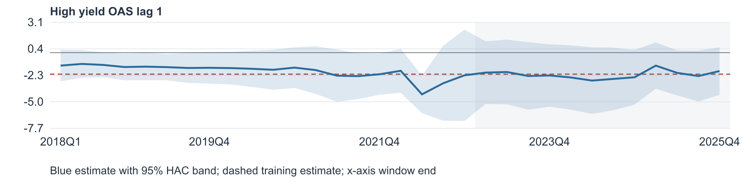
Figure 6 Initial-model HY coefficient and pointwise 95% HAC band; gray marks OOT window ends.
Window | HY coefficient range | Negative | OLS sig | HAC sig
20 | -5.167 to 0.559 | 34/36 | 1/36 | 7/36
24 | -4.245 to -1.145 | 32/32 | 1/32 | 7/32
28 | -3.328 to -1.587 | 28/28 | 2/28 | 20/28

Significance uses 5%. In the final 24-quarter window, HY = −1.8725, OLS p = 0.1959 and HAC p = 0.1212. Results depend on window length: 20 of 28 seven-year windows are HAC-significant, so HY does not fail in every window or under every inference choice.
Decision: HY passes forward selection but fails rolling significance review and is excluded from the final model. This is a judgment about weak persistence of significance, not a predeclared pass-rate rule, formal coefficient-equality rejection or proof of zero effect. Overlapping windows include OOT outcomes, so the review is descriptive, not independent validation.

S4 Nine Quarter Conditional Forecast
Under the supplied S4 unemployment path, the predicted bonus-to-nonbonus compensation ratio rises from 16.5802% in 2026Q1 to 26.0425% in 2028Q1. Its nine-quarter arithmetic mean is 23.1513%. These are conditional point forecasts from the final HY-free model.

Forecast Method
Coefficients remain fixed at the 2012Q2–2022Q4 training estimates used by the report’s main model. The full-history refit is not substituted. The pandemic dummy remains in the specification but equals zero in every forecast quarter. Future own-ratio lags use preceding predictions; no future ratio actuals enter the recursion.
$ŷ(t) = 4.944700 + 0.329160 × ŷ(t − 1) + 1.328645 × U(t − 1)$
Here y = 100 × R, R = Bonus / (Compensation − Bonus), and U is unemployment in percent. The first own lag is actual y(2025Q4) = 17.385772; the first unemployment lag is U(2025Q4) = 4.450273224%. Calculations retain full coefficient and input precision; only displayed values are rounded.
Quarter | S4 unemployment % | Unemployment lag 1 % | Predicted ratio %
2026Q1 | 6.565449 | 4.450273 | 16.5802
2026Q2 | 7.899902 | 6.565449 | 19.1254
2026Q3 | 8.566341 | 7.899902 | 21.7362
2026Q4 | 8.936377 | 8.566341 | 23.4810
2027Q1 | 9.191204 | 8.936377 | 24.5470
2027Q2 | 9.358607 | 9.191204 | 25.2364
2027Q3 | 9.428866 | 9.358607 | 25.6858
2027Q4 | 9.455956 | 9.428866 | 25.9271
2028Q1 | 9.427875 | 9.455956 | 26.0425

The supplied path is FLBR_S4.IUSA, S4 Alternative Scenario 4 Downside, January 2026, seasonally adjusted. Its first nine entries are assigned to 2026Q1–2028Q1. The model uses lag 1: the 2028Q1 rate of 9.427875% first affects 2028Q2, beyond this horizon. Extra later entries are not used.

Nine Quarter Summary
Measure | Value | Interpretation
Mean predicted ratio | 23.1513% | Unweighted mean of nine quarterly ratios
Sum of predicted ratios | 2.083616 | Sum of unscaled R values; not an aggregate ratio
Total bonus amount | Not calculated | Requires quarterly nonbonus compensation levels

A nine-quarter bonus total requires multiplying each predicted R by that quarter’s nonbonus compensation and adding the nine amounts. An aggregate period ratio would then divide total bonus by total nonbonus compensation. Neither quantity is identified by the unemployment path alone.

Interpretation and Limits
The rise reflects the positive unemployment coefficient and lag propagation, not a causal increase in bonus dollars during a downturn. Prediction intervals are not estimated. The January 2026 scenario is combined with the existing August 2026 historical-data vintage, so this is not a real-time forecast made with only information available in January 2026. The earlier rolling and pandemic-sensitivity limitations still apply.

