Commercial and Small Business Card Two Step Model Report
  - Model Estimation Historical Fits and Scenario Forecasts
In-sample: Jan 2011 to Sep 2023. Out-of-time: Oct 2023 to Dec 2025. Forecast: Jan 2026 to Mar 2028.

Executive Summary
CPI is the sole selected long-run driver of combined Commercial Card and Small Business fee revenue. The short-run model explains year-over-year fee growth using adjusted error correction at lag 12, own growth at lags 1 and 6, and corporate profit growth at lag 2. Its adjusted R² is 0.736.
The final model has IS level MAPE of 5.39%. OOT static and dynamic-growth-lag MAPE are 8.76% and 16.16%. The 27-month forecast totals $65.92 million under Baseline and $56.50 million under S4.

Data and Target Definition
Sample | Dates | Monthly observations
Long-run estimation | Jan 2011 to Sep 2023 | 153
Final short-run estimation | Jul 2012 to Sep 2023 | 135
OOT backtest | Oct 2023 to Dec 2025 | 27
Forecast per scenario | Jan 2026 to Mar 2028 | 27

$$Combined2(t) = Commercial Card(t) + Small Business(t)$$
$$y(t) = 100 × (\frac{Combined2(t)}{Combined2(t - 12)} - 1)$$
Combined2 is the combined fee series, named Combined in the code. Fees are measured in $000. Growth and scaled EC are in percentage units. Quarterly and cumulative forecasts are presented in $MM. Revenue and macro series are joined by month without interpolation or missing-value filling.
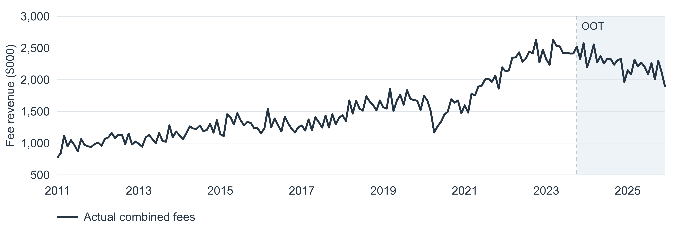
Figure 1 Combined fee revenue over the full historical sample. The shaded period is OOT.

Step One Long Run Model
The long-run regression uses fee levels and IS macro levels. The candidate pool is CPI, DPI, GDP_Wholesale, CorpProfits and DJ_TotalMkt; SBOpt is excluded. Each forward-selection trial requires the added term to have p < 0.05, maximum VIF < 10 and ordinary residual ADF p < 0.05. Among eligible trials, the highest adjusted R² wins. Each trial uses its own complete cases.
Round | Variable added | Adjusted R² | p value | n
1 | CPI | 0.926685 | <0.001 | 153
2 | None passes | — | — | —

$$Combined2(t) = -3,386.960717 + 19.419549 × CPI(t) + u(t)$$
fitted_lr(t) is the fitted long-run fee level, excluding u(t). CPI is selected in the first round, and no further candidate meets all entry criteria. The fitted equation includes an intercept.
Term | Coefficient | Std error | t statistic | p value | VIF
Intercept | -3,386.960717 | 111.7174 | -30.317 | <0.001 | —
CPI | 19.419549 | 0.4429 | 43.844 | <0.001 | 1.000

R² | Adjusted R² | Observations
0.927168 | 0.926685 | 153

Residual test | Statistic | p value | Lags
ADF | -3.4575 | 0.0091 | 12
KPSS | 0.0714 | ≥0.100 | 7

ADF includes a constant and chooses lags by AIC. KPSS includes a constant and uses automatic bandwidth selection. The residual tests support IS stationarity under these specifications.
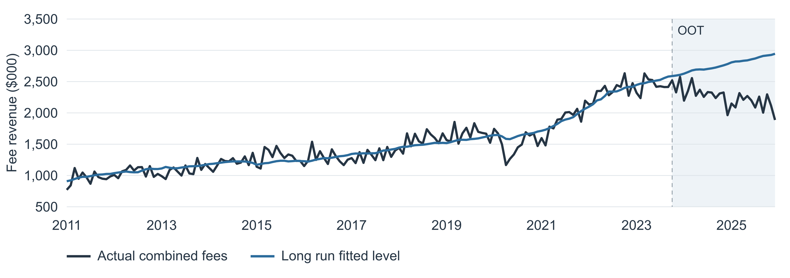
Figure 2 Historical relationship and OOT drift. The same IS-estimated long-run equation is evaluated across both windows; the OOT segment is not refitted.

Error Correction Scaling and Overlay
The long-run residual is scaled by its contemporaneous fitted level. A linear trend fitted to the 27 realized OOT scaled residuals defines the overlay. Subtracting it gives the adjusted EC used by the short-run model.
$$EC(t) = Combined2(t) - fitted_lr(t)$$
$$EC_scaled(t) = 100 × \frac{EC(t)}{fitted_lr(t)}$$
$$EC_scaled_adj(t) = EC_scaled(t) - Overlay(t)$$
$$EC_scaled_adj_lag12(t) = EC_scaled_adj(t - 12)$$
Apply the 12-month lag after subtracting the contemporaneous overlay.
IS scaled EC test | Statistic | p value | Lags
ADF | -3.2120 | 0.0193 | 12
KPSS | 0.0874 | ≥0.100 | 7

The scaled EC tests use 153 IS observations. The ADF effective sample is 140 after lag adjustment. KPSS values at the table boundary are shown as bounds.
$$EC_scaled(t) = a + b × t; t = 1, …, 27$$
Overlay estimate | Value
Intercept a | -5.592975
Monthly slope b in percentage points | -0.909254
Slope p value | 1.324663e-08
Trend R² | 0.731524
Held value from Jan 2026 | -30.142832

The equation above describes the fitted trend. Overlay(t) is zero before Oct 2023, a + b × t during Oct 2023-Dec 2025 (t = 1, …, 27), and a + b × 27 from Jan 2026 onward. The overlay is held flat without further extrapolation.

Step Two Macro Screening
All macro series except unemployment are transformed to 12-month percentage changes. Unemployment uses a 12-month percentage-point difference. A macro family is eligible if IS ADF p < 0.05 or IS KPSS p > 0.05. Note that either test can qualify a family; agreement between both tests is not required.
Macro family | ADF p | KPSS p | Eligible
Unrate | 0.080 | ≥0.100 | Yes
CPI | 0.371 | ≤0.010 | No
DPI | 0.007 | 0.042 | Yes
SBOpt | 0.281 | 0.042 | No
GDP_Wholesale | 0.315 | ≥0.100 | Yes
IP | 0.038 | ≥0.100 | Yes
CorpProfits | 0.219 | ≥0.100 | Yes
DJ_TotalMkt | 0.006 | ≥0.100 | Yes

Each transformed family has 141 IS observations before ADF lag adjustment. CPI and SBOpt fail this short-run eligibility rule.

Dual Window Partial Correlations
For macro lags 0 through 12, both fee growth and each candidate are residualized on an intercept and adjusted EC lag 12. The two residual series are correlated separately in IS and OOT. Terms must have matching signs and p < 0.20 in both windows. The screen calculates two-sided t probabilities with n−2 degrees of freedom after residualization.
Candidate | ρ IS | p IS | ρ OOT | p OOT
Unrate_lag1 | -0.554 | <0.001 | -0.332 | 0.090
Unrate_lag3 | -0.372 | <0.001 | -0.315 | 0.110
Unrate_lag4 | -0.296 | <0.001 | -0.373 | 0.055
Unrate_lag5 | -0.253 | 0.003 | -0.423 | 0.028
Unrate_lag6 | -0.258 | 0.003 | -0.475 | 0.012
Unrate_lag7 | -0.244 | 0.005 | -0.418 | 0.030
Unrate_lag8 | -0.267 | 0.002 | -0.579 | 0.002
Unrate_lag9 | -0.164 | 0.061 | -0.353 | 0.071
DPI_lag9 | 0.146 | 0.094 | 0.355 | 0.069
GDP_Wholesale_lag9 | 0.235 | 0.007 | 0.261 | 0.189
GDP_Wholesale_lag10 | 0.150 | 0.088 | 0.445 | 0.020
CorpProfits_lag2 | 0.555 | <0.001 | 0.298 | 0.131
CorpProfits_lag3 | 0.497 | <0.001 | 0.300 | 0.129
CorpProfits_lag10 | 0.415 | <0.001 | 0.270 | 0.174

All 14 passing macro terms enter forward selection together with own-growth lags 1 through 12. The macro partial-correlation samples range from 131 to 140 IS observations; each OOT correlation uses 27.

Final Short Run Model
Adjusted EC lag 12 is retained as a base regressor. Forward selection estimates each eligible candidate on IS data, requires added-term p < 0.05 and maximum VIF < 10, and selects the highest adjusted R². It stops when no remaining candidate meets the criteria.
Round | Variable added | Adjusted R² | p value | n
1 | y_lag1 | 0.658301 | <0.001 | 140
2 | y_lag6 | 0.694414 | <0.001 | 135
3 | CorpProfits_lag2 | 0.735654 | <0.001 | 135
4 | None passes | — | — | —

$$y(t) = 1.783143 - 0.653518 × EC_scaled_adj_lag12(t)$$
$$+ 0.296379 × y_lag1(t) + 0.250188 × y_lag6(t)$$
$$+ 0.422022 × CorpProfits_lag2(t) + e(t)$$
y(t) is Combined2 fee YoY growth in percent. EC_scaled_adj_lag12 is adjusted EC lagged 12 months; y_lag1 and y_lag6 are own-growth lags; CorpProfits_lag2 is corporate profit YoY growth lagged two months. Coefficients are displayed to six decimals; calculations retain full precision.
Term | Coefficient | Std error | t statistic | p value | VIF
Intercept | 1.783143 | 0.8536 | 2.089 | 0.039 | —
Adjusted EC lag 12 | -0.653518 | 0.0829 | -7.883 | <0.001 | 1.234
Fee YoY lag 1 | 0.296379 | 0.0667 | 4.442 | <0.001 | 2.250
Fee YoY lag 6 | 0.250188 | 0.0501 | 4.996 | <0.001 | 1.291
Profit YoY lag 2 | 0.422022 | 0.0911 | 4.630 | <0.001 | 2.156

Term | 95 percent lower | 95 percent upper
const | 0.094470 | 3.471817
EC_scaled_adj_lag12 | -0.817538 | -0.489498
y_lag1 | 0.164378 | 0.428380
y_lag6 | 0.151111 | 0.349266
CorpProfits_lag2 | 0.241693 | 0.602351

Model Diagnostics
Statistic | Value | Statistic | Value
Observations | 135 | Residual degrees of freedom | 130
R² | 0.743545 | Adjusted R² | 0.735654
AIC | 929.497 | Durbin Watson | 2.032086
Jarque Bera | 0.555923 | Jarque Bera p | 0.757326
Ljung Box at lag 12 | 13.734130 | Ljung Box p | 0.318008

Inference uses nonrobust OLS standard errors. Ljung-Box uses model_df = 0. The largest VIF is 2.250. Jarque-Bera and Ljung-Box do not reject their respective nulls at 5%.

IS and OOT Fitted Results
Final short-run level results | n | MAPE | RMSE | MAE
IS fitted | 135 | 5.39% | 105.88 | 82.89
OOT static | 27 | 8.76% | 231.43 | 190.86
OOT dynamic growth lags | 27 | 16.16% | 380.68 | 354.73

RMSE and MAE are in $000. Fee-level predictions equal the observed fee level 12 months earlier multiplied by one plus predicted YoY growth divided by 100.
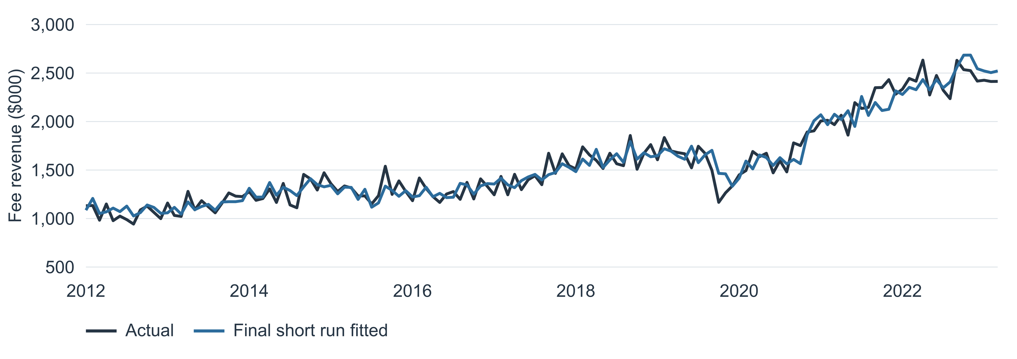
Figure 4 Final short-run model IS fitted fee levels, Jul 2012 to Sep 2023.
Static OOT uses actual own-growth lags. Dynamic OOT replaces those lags with predicted growth while retaining observed year-ago fee levels and observed adjusted EC.
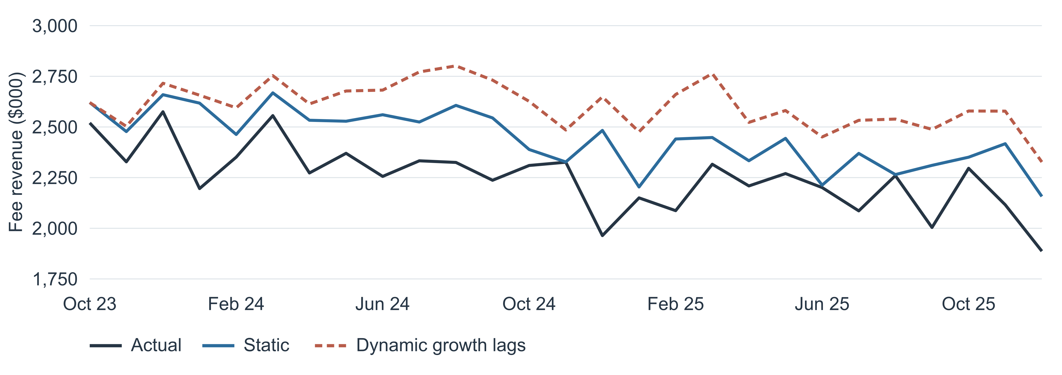
Figure 5 Final short-run model OOT fitted fee levels, Oct 2023 to Dec 2025. Both backtest variants are shown against actual fees.

S1 Baseline and S4 Forecasts
Both scenarios forecast monthly fee revenue from Jan 2026 through Mar 2028 (27 months). Long-run and short-run coefficients remain at their IS estimates, and the estimated overlay is held constant. S1 (Baseline) uses the supplied future macro path; S4 replaces future CPI and corporate profit levels with the S4 path.
For each month, the model predicts YoY growth, reconstructs the fee level using the actual or predicted year-ago level, and updates the growth and adjusted EC series.
$$\hat{Combined2}(t) = Combined2*(t - 12) × (1 + \frac{ŷ(t)}{100})$$
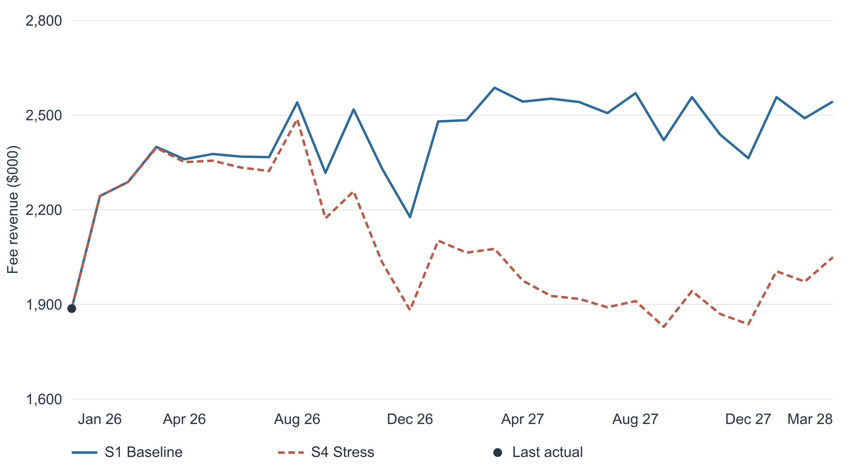
Figure 6 S1 (Baseline) and S4 monthly fee forecasts, Jan 2026 to Mar 2028.

Quarterly and Cumulative Forecasts
Each quarter is the sum of its three monthly fee predictions. The 2026 total covers Jan through Dec 2026; the nine-quarter total covers Jan 2026 through Mar 2028. Dec 2025 is the forecast starting point and is excluded from every total.
Period | Months | Baseline $MM | S4 $MM
2026Q1 | 3 | 6.93 | 6.93
2026Q2 | 3 | 7.11 | 7.04
2026Q3 | 3 | 7.22 | 6.98
2026Q4 | 3 | 7.03 | 6.18
2027Q1 | 3 | 7.55 | 6.24
2027Q2 | 3 | 7.64 | 5.82
2027Q3 | 3 | 7.50 | 5.63
2027Q4 | 3 | 7.36 | 5.65
2028Q1 | 3 | 7.59 | 6.03
2026 total | 12 | 28.29 | 27.13
9-quarter total | 27 | 65.92 | 56.50

Amounts are converted from $000 to $MM by dividing by 1,000. Totals are calculated from unrounded predictions and may not equal the sum of displayed rounded quarters.

Scenario Comparison
S4 revenue is $1.16 million below Baseline for 2026, a 4.10% difference. Across all nine quarters, the difference is $9.42 million, or 14.29% of Baseline.
The scenario difference develops through the corporate profit growth input and the CPI-linked long-run fitted level. The latter enters future adjusted EC and affects growth after the prescribed EC lag. The same estimated coefficients and overlay are used in both scenarios.

Model Assumptions and Limitations
The forecast assumes that the estimated relationships remain applicable and that the Dec 2025 overlay remains appropriate throughout the forecast horizon.

Monthly Forecast Detail
The table reports all 27 forecast months for both scenarios. Revenue is in $000; YoY is the model-predicted 12-month percentage change. Rows are displayed to two decimals and are not rounded before quarterly aggregation.
Month | Baseline $000 | Baseline YoY | S4 $000 | S4 YoY
Jan 2026 | 2,243.55 | 4.35% | 2,243.55 | 4.35%
Feb 2026 | 2,288.36 | 9.65% | 2,288.36 | 9.65%
Mar 2026 | 2,399.32 | 3.60% | 2,396.41 | 3.47%
Apr 2026 | 2,360.33 | 6.85% | 2,351.08 | 6.43%
May 2026 | 2,376.93 | 4.71% | 2,355.71 | 3.78%
Jun 2026 | 2,368.57 | 7.61% | 2,333.94 | 6.04%
Jul 2026 | 2,366.95 | 13.47% | 2,323.03 | 11.36%
Aug 2026 | 2,540.57 | 12.41% | 2,487.68 | 10.07%
Sep 2026 | 2,317.27 | 15.63% | 2,173.14 | 8.44%
Oct 2026 | 2,518.10 | 9.67% | 2,258.62 | -1.63%
Nov 2026 | 2,331.90 | 10.20% | 2,035.13 | -3.82%
Dec 2026 | 2,176.89 | 15.36% | 1,882.15 | -0.26%
Jan 2027 | 2,480.02 | 10.54% | 2,102.15 | -6.30%
Feb 2027 | 2,484.11 | 8.55% | 2,064.23 | -9.79%
Mar 2027 | 2,586.91 | 7.82% | 2,076.24 | -13.36%
Apr 2027 | 2,542.88 | 7.73% | 1,975.41 | -15.98%
May 2027 | 2,552.26 | 7.38% | 1,927.07 | -18.20%
Jun 2027 | 2,541.63 | 7.31% | 1,917.55 | -17.84%
Jul 2027 | 2,506.52 | 5.90% | 1,891.07 | -18.59%
Aug 2027 | 2,569.67 | 1.15% | 1,910.67 | -23.19%
Sep 2027 | 2,420.70 | 4.46% | 1,829.20 | -15.83%
Oct 2027 | 2,557.00 | 1.55% | 1,942.49 | -14.00%
Nov 2027 | 2,438.42 | 4.57% | 1,869.98 | -8.12%
Dec 2027 | 2,363.62 | 8.58% | 1,837.39 | -2.38%
Jan 2028 | 2,557.03 | 3.11% | 2,005.33 | -4.61%
Feb 2028 | 2,490.27 | 0.25% | 1,972.29 | -4.45%
Mar 2028 | 2,543.35 | -1.68% | 2,049.76 | -1.28%

Input Series
Historical fees come from Cardfee.csv, combining Commercial Card and Small Business. Historical and Baseline macro levels come from Macro_Data_201001-202803.csv. S4_Macro_Path.csv supplies the 27 monthly CPI and corporate profit levels for the S4 scenario. Future macro observations are used only for forecasting, not for historical estimation or backtesting.

