Quarterly Adjusted Other Expense Relative to SNV Assets

1 Target and transformation stationarity
The chart shows quarterly adjusted Other expense as a share of average SNV assets from 2011 Q1 through 2025 Q4.
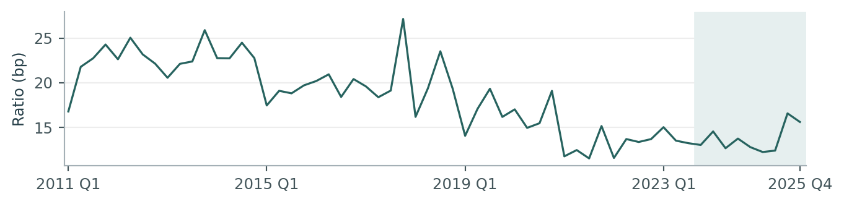
Figure 1. The shaded period, 2023 Q4–2025 Q4, covers the nine quarters held out for evaluation.
E is the sum of three smoothed monthly Adj_Other amounts. B is the arithmetic mean of the corresponding three monthly Asset_SNV balances. Both use the same monetary unit. R is the unannualized quarterly ratio in basis points and y is its log change in log points.
$R_{t} = 10,000 × \frac{E_{t}}{B_{t}} y_{t} = 100 ln (\frac{R_{t}}{R_{t−1}})$

Testing the level and three transformations
Target series | Start | N | ADF stat. | ADF p | KPSS stat. | KPSS p | Joint test
Level | 2011 Q1 | 51 | −0.665 | 0.8536 | 0.932 | <0.01 | Fail
First difference | 2011 Q2 | 50 | −7.300 | <0.0001 | 0.146 | >0.10 | Pass
QoQ log change | 2011 Q2 | 50 | −7.406 | <0.0001 | 0.156 | >0.10 | Pass
YoY log change | 2012 Q1 | 47 | −4.183 | 0.0007 | 0.140 | >0.10 | Pass
The level fails both criteria. All three changes pass. We use the quarter-on-quarter log difference because it measures proportional change over a single forecast quarter. A first difference measures a change in basis points, while a year-over-year difference spans four quarters.
All tests end in 2023 Q3. The joint rule requires ADF to reject a unit root and KPSS to retain level stationarity at 5%. ADF includes an intercept and chooses up to four lags by AIC. KPSS uses an intercept and bandwidth four.

2 Macro candidate stationarity
The 15 Moody’s quarterly macro series were tested on the pre-holdout history ending in 2023 Q3. Every transform that passes the joint ADF and KPSS rule enters the candidate pool. Each bold cell below is one eligible series–transformation pair.
Macro series | Level | First diff. | QoQ log | YoY log
Commercial bank assets | 0.9653 / <0.01 | 0.0024 / >0.10 | 0.0020 / >0.10 | 0.1000 / >0.10
Commercial bank deposits | 0.8852 / <0.01 | 0.0662 / >0.10 | 0.0469 / >0.10 | 0.0779 / >0.10
Bank loans and leases | 0.9893 / <0.01 | 0.0015 / >0.10 | 0.0012 / >0.10 | 0.1100 / >0.10
Consumer credit outstanding | 0.8645 / <0.01 | 0.0509 / >0.10 | 0.1287 / >0.10 | 0.4953 / >0.10
Credit card delinquency, top 100 banks | 0.0735 / 0.0397 | 0.7118 / 0.0819 | 0.5912 / >0.10 | 0.1221 / >0.10
C&I loan delinquency, top 100 banks | 0.0129 / >0.10 | 0.0066 / >0.10 | 0.0124 / >0.10 | 0.1342 / >0.10
Credit card charge-offs, all banks | 0.1357 / 0.0363 | 0.1688 / 0.0858 | 0.0779 / >0.10 | 0.0009 / >0.10
Business bankruptcies | 0.0298 / <0.01 | 0.3717 / 0.0458 | 0.4909 / >0.10 | 0.0008 / >0.10
Personal bankruptcies | 0.2281 / <0.01 | 0.0021 / >0.10 | 0.0027 / >0.10 | 0.4552 / >0.10
VIX | 0.0955 / >0.10 | <0.0001 / >0.10 | 0.0003 / >0.10 | 0.1255 / >0.10
High-yield option-adjusted spread | 0.0183 / 0.0856 | 0.0002 / >0.10 | 0.0003 / >0.10 | 0.0950 / >0.10
Federal funds rate | 0.3046 / 0.0368 | 0.0385 / >0.10 | 0.0052 / >0.10 | 0.0251 / >0.10
10-year Treasury yield | 0.6429 / >0.10 | 0.0077 / >0.10 | 0.0003 / >0.10 | 0.0323 / >0.10
Final demand services PPI | 1.0000 / <0.01 | 0.0535 / 0.0499 | 0.0356 / 0.0775 | 0.8598 / 0.0486
Core CPI | 0.9995 / <0.01 | 0.4702 / 0.0210 | 0.3915 / 0.0305 | 0.6973 / 0.0262
Each cell shows ADF p / KPSS p. There are 51 levels, 50 quarterly changes and 47 year-over-year changes. A first difference is the current level less the prior level. Log changes use 100 times the difference between log levels one or four quarters apart.

Candidate pool
Twelve of the 15 series have an eligible transformation. The 24 eligible pairs comprise two levels, eight arithmetic first differences, ten QoQ log changes and four YoY log changes. Testing each at one, two and four quarters gives 72 initial candidates.

3 Forward selection

Starting equation and entry criteria
An intercept and the target’s own first lag enter every regression. Their coefficients are re-estimated in each trial. All trials use the same 39 quarters from 2014 Q1 to 2023 Q3. Before adding a macro, the fitted equation is
$ŷ_{t} = −2.3169 − 0.4578 y_{t−1}$
An added term must have a two-sided p-value below 0.05, a maximum variance inflation factor (VIF) below 10 and a Durbin–Watson (DW) statistic between 1.5 and 2.5 inclusive. The smallest qualifying p-value wins, with BIC as a tie-breaker. Once a macro enters, all its other transformations and lags leave the pool.

Decisions by round
Round | Tested | Passed | Term added | Entry p | Macro terms after decision
1 | 72 | 4 | Loans, first diff. L2 | 0.0196 | Loans
2 | 66 | 1 | VIX, QoQ log L4 | 0.0480 | Loans and VIX
3 | 60 | 0 | None | — | Loans and VIX

Round one qualifying terms
Series | Input | Lag | Estimate | p-value | DW | Max VIF
Bank loans and leases | First diff. | 2 | 0.0499 | 0.0196 | 2.318 | 1.010
VIX | QoQ log | 4 | −0.2695 | 0.0211 | 2.430 | 1.009
Bank loans and leases | QoQ log | 2 | 5.1826 | 0.0216 | 2.317 | 1.010
VIX | First diff. | 4 | −1.3373 | 0.0298 | 2.438 | 1.013
Round two assessed 66 additions conditional on the loan change. VIX QoQ log growth L4 alone qualified (p = 0.0480, DW = 2.453, maximum VIF = 1.053). In round three the smallest p-value was 0.2603, for business bankruptcies YoY log growth L1. Selection stopped with two macro terms.
Appendix C reports every candidate p-value, DW and maximum VIF for all 198 trials. Selection used training observations only.

Stability review and final retention
We evaluated the two selected terms together in 20 overlapping training windows of 20 quarters each. Each fit included an intercept, target growth L1, the two-quarter lag of the arithmetic change in national bank loans and leases, and the four-quarter lag of VIX log growth.
Term in joint fit | Estimate | Full-fit p | Roll min | Roll max | Same sign | Roll p < 0.05
Loan change L2 | 0.0417 | 0.0446 | −0.0571 | 0.0457 | 17/20 | 1/20
VIX log growth L4 | −0.2236 | 0.0480 | −0.3487 | 0.1800 | 19/20 | 3/20
The loan coefficient was positive in 17 windows, but only one window showed a statistically significant effect at 5%. The stability review judged that evidence insufficient to retain the loan term. This judgment was made after forward selection.
The loan input is the change in seasonally adjusted U.S. commercial bank loans and leases in bank credit, measured in billions of dollars (Moody’s FBBABLLCBQ_B.IUSA). A positive coefficient in the joint fit associates a larger increase in lending two quarters earlier with higher current target growth.

Refit after removing loan growth
We re-estimated the intercept, AR(1) and VIX QoQ log growth L4 on the same 39 quarters. The VIX estimate moved from −0.2236 in the joint fit (p = 0.0480) to −0.2695 in the final fit (p = 0.0211). In this refit, VIX was negative in 19 of 20 windows and significant in nine. Section 4 gives the refitted equation and Section 5 evaluates its nine held-out quarters.

4 Final model specification

Selected macro variable
V is the quarterly period-average Cboe Volatility Index (VIX), reported in index points without seasonal adjustment in Moody’s series FCBOEVIXQ_B.IUSA. VIX measures expected S&P 500 volatility over the next 30 days, implied by S&P 500 option prices. The model uses its QoQ log change four quarters earlier.
Series values and units are from Other_Macro_Qtr_S1.xls, Sheet2, August 2026 baseline. Index definition from Cboe’s VIX FAQ.

Equation and parameter estimates
$y_{t} = 100 ln (\frac{R_{t}}{R_{t−1}}) G_{t} = 100 ln (\frac{V_{t}}{V_{t−1}})$
$y_{t} = α + φ y_{t−1} + β G_{t−4} + ε_{t}$
$ŷ_{t} = −2.0071 − 0.4265 y_{t−1} − 0.2695 G_{t−4}$
${R̂}_{t} = R_{t−1} × exp (ŷ_{t} / 100)$
Term | Estimate | Std. error | t statistic | p-value | 95% interval
Intercept (α) | −2.0071 | 2.5405 | −0.790 | 0.4347 | −7.1594 to 3.1452
Target growth L1 (φ) | −0.4265 | 0.1364 | −3.126 | 0.0035 | −0.7032 to −0.1498
VIX growth L4 (β) | −0.2695 | 0.1117 | −2.412 | 0.0211 | −0.4960 to −0.0429
At a given prior-quarter target growth, 10 extra log points of VIX growth four quarters earlier correspond to 2.69 log points less predicted growth in the expense ratio. The coefficient tests use conventional OLS standard errors and 36 residual degrees of freedom.

Dispersion and residual diagnostics
Target growth SD | Target L1 SD | VIX L4 SD | Residual std. deviation
18.700 | 18.880 | 23.059 | 15.807
The first three values are sample standard deviations across the estimation quarters. The residual standard deviation is the regression standard error. All are in log points.
Adjusted R² | Durbin–Watson | Maximum VIF | Jarque–Bera | JB p-value
0.285 | 2.430 | 1.009 | 1.100 | 0.5770

5 Out of time performance
The final VIX-only macro specification is scored on the last nine quarters (2023 Q4–2025 Q4) in basis points. The one-step forecast updates the previous ratio each quarter. The recursive path starts from 2023 Q3 and feeds back predicted levels. Coefficients are fixed at their refitted in-sample values.
The four-quarter VIX lag makes the first four recursive inputs available by the origin. The last five use subsequently realized VIX values from the supplied vintage. The recursive errors are conditional on that macro path.
Forecast | MAE (bp) | RMSE (bp) | MAPE | Mean error (bp)
One-step | 1.223 | 1.932 | 8.29% | −0.545
Recursive | 1.391 | 1.884 | 9.59% | −0.414
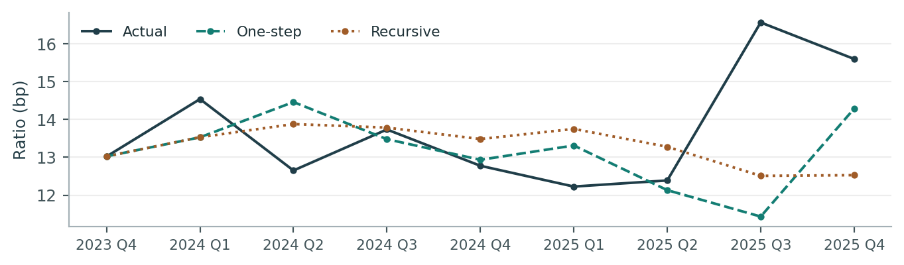
Figure 2. Quarterly errors in the table equal forecast minus actual. Negative values indicate underprediction.
Quarter | Actual (bp) | One-step | Recursive | One-step error | Recursive error
2023 Q4 | 13.02 | 13.02 | 13.02 | 0.00 | 0.00
2024 Q1 | 14.54 | 13.53 | 13.53 | −1.01 | −1.01
2024 Q2 | 12.65 | 14.46 | 13.88 | 1.81 | 1.23
2024 Q3 | 13.73 | 13.48 | 13.78 | −0.26 | 0.05
2024 Q4 | 12.77 | 12.93 | 13.48 | 0.16 | 0.71
2025 Q1 | 12.23 | 13.31 | 13.75 | 1.08 | 1.52
2025 Q2 | 12.39 | 12.13 | 13.28 | −0.26 | 0.89
2025 Q3 | 16.56 | 11.43 | 12.51 | −5.13 | −4.05
2025 Q4 | 15.59 | 14.28 | 12.53 | −1.31 | −3.07
The largest miss occurred in 2025 Q3. The ratio rose to 16.56 bp and the one-step and recursive forecasts fell short by 5.13 and 4.05 bp. Across all nine quarters, the average errors were −0.54 and −0.41 bp, respectively.

Appendix A Monthly expense and quarterly timing
Other_Monthly_to_Quarterly.xls contains 180 months, January 2011–December 2025. Monthly Adj_Other equals Other_Month_Actual_num less signed Card_Month_Actual_num. Five specified peaks use the mean of the immediately preceding and following raw monthly amounts. The affected months are March 2011, January 2019, September 2020, July 2023 and November 2023.
The quarterly expense numerator sums the smoothed monthly amounts. For 2025 Q4 it was 96.06926 million. Dividing by average assets of 61,603.649402 million gives 15.5947 bp. Average monthly Asset_SNV is sourced from column D of the Comp quarterly occupancy workbook.
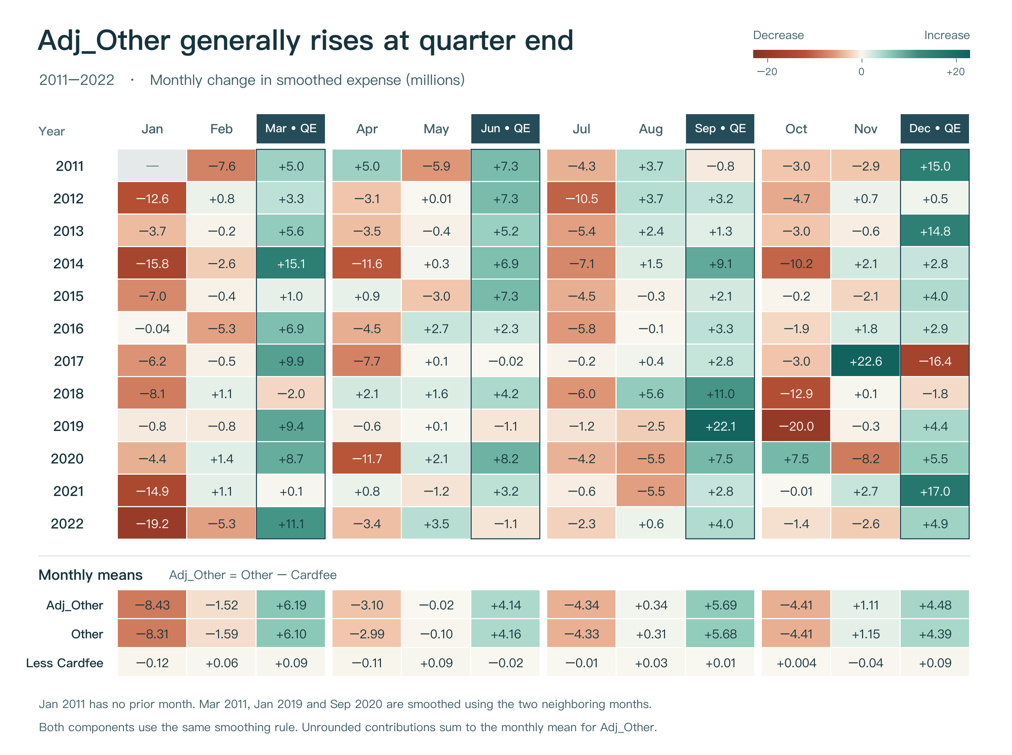
Figure A1. Expense rose in 41 of 48 quarter-end months during 2011–2022 and fell in 42 of the 47 observable following months. The outlined columns mark March, June, September and December.
If the quarter’s last month is a smoothing peak, a one-step forecast uses the raw last-month amount in the prior ratio until the following month is observable. The macro workbook includes nine quarters beyond 2025 Q4. Those dates have no matching expense observations.

Appendix B Rolling coefficient stability
The final equation with an intercept, target growth L1 and VIX QoQ log growth L4 is re-estimated in 20 overlapping windows of 20 training quarters. Each regression has 17 residual degrees of freedom. Adjacent windows share 19 observations.
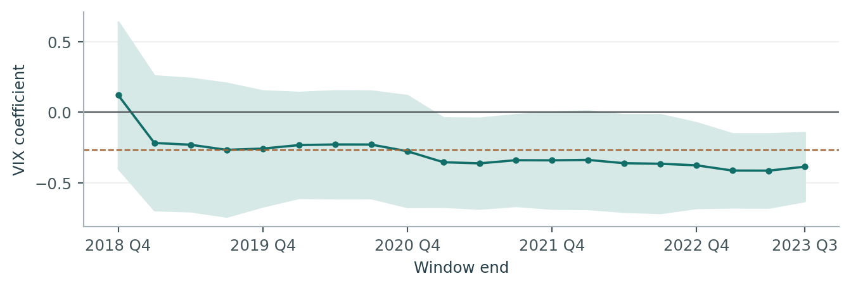
Figure B1. Shading shows pointwise 95% intervals. The dashed line is the full-estimation-sample VIX coefficient.
Term | Full fit | Minimum | Maximum | Same sign | p < 0.05
Intercept | −2.007 | −3.690 | 0.169 | 19/20 | 0/20
Target growth L1 | −0.427 | −0.499 | −0.311 | 20/20 | 6/20
VIX growth L4 | −0.269 | −0.415 | 0.121 | 19/20 | 9/20
VIX had a negative coefficient in 19 of 20 windows and was significant at 5% in nine. The last estimate was −0.3870 (95% interval −0.6312 to −0.1429, p = 0.0038). The residual CUSUM statistic was 0.369 (p = 0.9992). Window-level p-values are conditional on the selected specification.

Appendix B Estimates by window
Window | Intercept | AR L1 | VIX L4 | 95% lower | 95% upper | VIX p
2014 Q1–2018 Q4 | −1.048 | −0.499 | 0.1213 | −0.4005 | 0.6430 | 0.6301
2014 Q2–2019 Q1 | −2.730 | −0.403 | −0.2183 | −0.6962 | 0.2595 | 0.3485
2014 Q3–2019 Q2 | −2.435 | −0.431 | −0.2308 | −0.7038 | 0.2422 | 0.3177
2014 Q4–2019 Q3 | −1.873 | −0.384 | −0.2672 | −0.7419 | 0.2075 | 0.2513
2015 Q1–2019 Q4 | −1.652 | −0.377 | −0.2583 | −0.6693 | 0.1527 | 0.2024
2015 Q2–2020 Q1 | −0.664 | −0.384 | −0.2333 | −0.6087 | 0.1420 | 0.2071
2015 Q3–2020 Q2 | −1.079 | −0.408 | −0.2290 | −0.6114 | 0.1534 | 0.2235
2015 Q4–2020 Q3 | −1.260 | −0.414 | −0.2295 | −0.6112 | 0.1522 | 0.2217
2016 Q1–2020 Q4 | −0.745 | −0.402 | −0.2769 | −0.6734 | 0.1195 | 0.1588
2016 Q2–2021 Q1 | −1.653 | −0.436 | −0.3551 | −0.6717 | −0.0385 | 0.0301
2016 Q3–2021 Q2 | −1.982 | −0.388 | −0.3631 | −0.6852 | −0.0410 | 0.0294
2016 Q4–2021 Q3 | −2.902 | −0.404 | −0.3408 | −0.6655 | −0.0161 | 0.0407
2017 Q1–2021 Q4 | −1.768 | −0.414 | −0.3416 | −0.6853 | 0.0021 | 0.0513
2017 Q2–2022 Q1 | −3.127 | −0.470 | −0.3386 | −0.6876 | 0.0105 | 0.0565
2017 Q3–2022 Q2 | −2.455 | −0.467 | −0.3620 | −0.7071 | −0.0170 | 0.0408
2017 Q4–2022 Q3 | −1.872 | −0.455 | −0.3660 | −0.7161 | −0.0159 | 0.0415
2018 Q1–2022 Q4 | −3.690 | −0.475 | −0.3770 | −0.6807 | −0.0732 | 0.0180
2018 Q2–2023 Q1 | 0.169 | −0.311 | −0.4143 | −0.6764 | −0.1522 | 0.0039
2018 Q3–2023 Q2 | −0.111 | −0.311 | −0.4149 | −0.6777 | −0.1521 | 0.0040
2018 Q4–2023 Q3 | −1.965 | −0.366 | −0.3870 | −0.6312 | −0.1429 | 0.0038
Each row reports one refit of the VIX model. The confidence interval and p-value refer to its VIX coefficient.

Appendix C Round 1 candidate trials
The initial controls are the intercept and target growth L1. Each cell reports the tested term’s p-value / DW / maximum VIF. Bold cells meet the three entry criteria.
Series | Transform | Lag 1 | Lag 2 | Lag 4
Commercial bank assets | First diff. | 0.5356 / 2.37 / 1.01 | 0.1068 / 2.24 / 1.00 | 0.3476 / 2.45 / 1.11
 | QoQ log | 0.5154 / 2.37 / 1.01 | 0.1287 / 2.25 / 1.00 | 0.2957 / 2.46 / 1.11
Commercial bank deposits | QoQ log | 0.7785 / 2.40 / 1.01 | 0.2437 / 2.26 / 1.00 | 0.3548 / 2.44 / 1.12
Bank loans and leases | First diff. | 0.5536 / 2.48 / 1.00 | 0.0196 / 2.32 / 1.01 | 0.4015 / 2.44 / 1.07
 | QoQ log | 0.5700 / 2.48 / 1.01 | 0.0216 / 2.32 / 1.01 | 0.4194 / 2.44 / 1.07
C&I loan delinquency, top 100 banks | Level | 0.6694 / 2.42 / 1.00 | 0.7441 / 2.41 / 1.00 | 0.9343 / 2.41 / 1.00
 | First diff. | 0.8439 / 2.42 / 1.01 | 0.5552 / 2.41 / 1.00 | 0.5113 / 2.41 / 1.00
 | QoQ log | 0.7956 / 2.42 / 1.01 | 0.3674 / 2.41 / 1.01 | 0.5445 / 2.41 / 1.00
Credit card charge-offs, all banks | YoY log | 0.7193 / 2.41 / 1.00 | 0.8589 / 2.41 / 1.00 | 0.4291 / 2.43 / 1.01
Business bankruptcies | YoY log | 0.7181 / 2.39 / 1.00 | 0.9318 / 2.41 / 1.01 | 0.2988 / 2.41 / 1.01
Personal bankruptcies | First diff. | 0.4341 / 2.38 / 1.01 | 0.3614 / 2.31 / 1.00 | 0.8040 / 2.44 / 1.07
 | QoQ log | 0.5599 / 2.39 / 1.02 | 0.3210 / 2.32 / 1.00 | 0.8220 / 2.43 / 1.07
VIX | First diff. | 0.1280 / 2.33 / 1.03 | 0.2332 / 2.48 / 1.02 | 0.0298 / 2.44 / 1.01
 | QoQ log | 0.1103 / 2.35 / 1.05 | 0.2402 / 2.47 / 1.02 | 0.0211 / 2.43 / 1.01
High-yield option-adjusted spread | Level | 0.8496 / 2.41 / 1.00 | 0.6512 / 2.39 / 1.00 | 0.5809 / 2.41 / 1.01
 | First diff. | 0.7100 / 2.37 / 1.00 | 0.0934 / 2.35 / 1.00 | 0.3870 / 2.43 / 1.03
 | QoQ log | 0.6933 / 2.37 / 1.00 | 0.1545 / 2.36 / 1.00 | 0.4130 / 2.41 / 1.02
Federal funds rate | First diff. | 0.4457 / 2.40 / 1.01 | 0.8490 / 2.40 / 1.00 | 0.9301 / 2.41 / 1.02
 | QoQ log | 0.3403 / 2.37 / 1.02 | 0.2888 / 2.25 / 1.00 | 0.5313 / 2.45 / 1.13
 | YoY log | 0.3540 / 2.44 / 1.02 | 0.4961 / 2.45 / 1.00 | 0.6863 / 2.41 / 1.01
10-year Treasury yield | First diff. | 0.8084 / 2.41 / 1.00 | 0.9157 / 2.40 / 1.00 | 0.4522 / 2.39 / 1.08
 | QoQ log | 0.4123 / 2.42 / 1.00 | 0.6349 / 2.37 / 1.01 | 0.1967 / 2.40 / 1.12
 | YoY log | 0.4112 / 2.42 / 1.01 | 0.4818 / 2.44 / 1.01 | 0.7439 / 2.41 / 1.01
Final demand services PPI | QoQ log | 0.5945 / 2.40 / 1.00 | 0.9709 / 2.41 / 1.00 | 0.4857 / 2.44 / 1.01
72 trials. The smallest passing p-value was 0.0196 for the two-quarter lag of the arithmetic change in bank loans and leases.

Appendix C Round 2 candidate trials
Every trial also includes loan change L2, the winner of round one. Each cell reports the tested term’s p-value / DW / maximum VIF. Bold cells meet the three entry criteria.
Series | Transform | Lag 1 | Lag 2 | Lag 4
Commercial bank assets | First diff. | 0.9084 / 2.32 / 1.07 | 0.5111 / 2.31 / 1.28 | 0.7050 / 2.33 / 1.20
 | QoQ log | 0.8771 / 2.32 / 1.06 | 0.5853 / 2.31 / 1.29 | 0.6770 / 2.34 / 1.22
Commercial bank deposits | QoQ log | 0.8980 / 2.32 / 1.05 | 0.5295 / 2.30 / 1.08 | 0.8576 / 2.32 / 1.27
C&I loan delinquency, top 100 banks | Level | 0.6315 / 2.33 / 1.01 | 0.5196 / 2.34 / 1.02 | 0.4766 / 2.35 / 1.08
 | First diff. | 0.7358 / 2.32 / 1.06 | 0.8539 / 2.32 / 1.14 | 0.6900 / 2.32 / 1.03
 | QoQ log | 0.8215 / 2.32 / 1.06 | 0.8327 / 2.32 / 1.12 | 0.7048 / 2.32 / 1.02
Credit card charge-offs, all banks | YoY log | 0.5341 / 2.33 / 1.20 | 0.5391 / 2.33 / 1.04 | 0.9977 / 2.32 / 1.15
Business bankruptcies | YoY log | 0.1202 / 2.26 / 1.23 | 0.8405 / 2.33 / 1.03 | 0.6830 / 2.32 / 1.11
Personal bankruptcies | First diff. | 0.6571 / 2.32 / 1.04 | 0.8404 / 2.32 / 1.31 | 0.6953 / 2.29 / 1.15
 | QoQ log | 0.9053 / 2.32 / 1.07 | 0.9668 / 2.32 / 1.27 | 0.7052 / 2.30 / 1.15
VIX | First diff. | 0.2145 / 2.31 / 1.05 | 0.6339 / 2.33 / 1.16 | 0.0699 / 2.46 / 1.06
 | QoQ log | 0.1435 / 2.31 / 1.06 | 0.5016 / 2.32 / 1.08 | 0.0480 / 2.45 / 1.05
High-yield option-adjusted spread | Level | 0.4556 / 2.32 / 1.17 | 0.6910 / 2.33 / 1.16 | 0.6167 / 2.32 / 1.25
 | First diff. | 0.6503 / 2.31 / 1.01 | 0.9700 / 2.32 / 2.10 | 0.3893 / 2.39 / 1.04
 | QoQ log | 0.4800 / 2.31 / 1.02 | 0.7758 / 2.33 / 2.03 | 0.3970 / 2.38 / 1.03
Federal funds rate | First diff. | 0.9446 / 2.32 / 1.17 | 0.7658 / 2.32 / 1.01 | 0.7807 / 2.31 / 1.04
 | QoQ log | 0.6282 / 2.31 / 1.07 | 0.5702 / 2.29 / 1.07 | 0.8725 / 2.31 / 1.28
 | YoY log | 0.8296 / 2.32 / 1.14 | 0.9708 / 2.32 / 1.12 | 0.6807 / 2.33 / 1.14
10-year Treasury yield | First diff. | 0.7012 / 2.31 / 1.01 | 0.8864 / 2.33 / 1.02 | 0.8548 / 2.32 / 1.15
 | QoQ log | 0.6130 / 2.31 / 1.03 | 0.7332 / 2.34 / 1.15 | 0.5167 / 2.32 / 1.24
 | YoY log | 0.3468 / 2.34 / 1.02 | 0.5864 / 2.33 / 1.02 | 0.4772 / 2.33 / 1.22
Final demand services PPI | QoQ log | 0.4238 / 2.34 / 1.02 | 0.7256 / 2.33 / 1.03 | 0.8608 / 2.32 / 1.18
66 trials. The only passing candidate was VIX QoQ log change L4 (conditional p = 0.0480).

Appendix C Round 3 candidate trials
Every trial also includes loan change L2 and VIX growth L4, the winners of the first two rounds. Each cell reports the tested term’s p-value / DW / maximum VIF. Bold cells meet the three entry criteria.
Series | Transform | Lag 1 | Lag 2 | Lag 4
Commercial bank assets | First diff. | 0.8058 / 2.45 / 1.11 | 0.7307 / 2.45 / 1.31 | 0.7477 / 2.45 / 1.20
 | QoQ log | 0.7680 / 2.45 / 1.11 | 0.8209 / 2.45 / 1.32 | 0.7042 / 2.45 / 1.22
Commercial bank deposits | QoQ log | 0.9649 / 2.45 / 1.09 | 0.5737 / 2.45 / 1.12 | 0.7702 / 2.44 / 1.27
C&I loan delinquency, top 100 banks | Level | 0.5772 / 2.48 / 1.05 | 0.5056 / 2.48 / 1.07 | 0.8107 / 2.46 / 1.16
 | First diff. | 0.8236 / 2.45 / 1.11 | 0.9766 / 2.45 / 1.20 | 0.7290 / 2.44 / 1.07
 | QoQ log | 0.9262 / 2.45 / 1.10 | 0.7011 / 2.48 / 1.18 | 0.7340 / 2.44 / 1.06
Credit card charge-offs, all banks | YoY log | 0.7149 / 2.46 / 1.27 | 0.6882 / 2.46 / 1.09 | 0.8778 / 2.45 / 1.21
Business bankruptcies | YoY log | 0.2603 / 2.38 / 1.34 | 0.7040 / 2.43 / 1.15 | 0.7654 / 2.45 / 1.14
Personal bankruptcies | First diff. | 0.7320 / 2.47 / 1.08 | 0.6346 / 2.45 / 1.33 | 0.5392 / 2.44 / 1.16
 | QoQ log | 0.9992 / 2.45 / 1.09 | 0.7266 / 2.44 / 1.29 | 0.5271 / 2.45 / 1.16
High-yield option-adjusted spread | Level | 0.7662 / 2.45 / 1.27 | 0.9002 / 2.45 / 1.26 | 0.5758 / 2.46 / 1.28
 | First diff. | 0.5879 / 2.47 / 1.05 | 0.9458 / 2.45 / 2.13 | 0.6058 / 2.44 / 1.79
 | QoQ log | 0.4856 / 2.48 / 1.07 | 0.7710 / 2.47 / 2.07 | 0.5136 / 2.44 / 1.94
Federal funds rate | First diff. | 0.7478 / 2.45 / 1.25 | 0.9605 / 2.45 / 1.09 | 0.6152 / 2.46 / 1.07
 | QoQ log | 0.6481 / 2.45 / 1.10 | 0.8600 / 2.45 / 1.11 | 0.8200 / 2.46 / 1.28
 | YoY log | 0.8733 / 2.45 / 1.17 | 0.9972 / 2.45 / 1.17 | 0.7973 / 2.46 / 1.20
10-year Treasury yield | First diff. | 0.8206 / 2.45 / 1.06 | 0.8962 / 2.45 / 1.07 | 0.8782 / 2.45 / 1.15
 | QoQ log | 0.7127 / 2.44 / 1.07 | 0.9551 / 2.45 / 1.23 | 0.6189 / 2.43 / 1.25
 | YoY log | 0.5365 / 2.45 / 1.09 | 0.8426 / 2.45 / 1.09 | 0.4502 / 2.50 / 1.26
Final demand services PPI | QoQ log | 0.5835 / 2.47 / 1.07 | 0.6643 / 2.45 / 1.07 | 0.9121 / 2.45 / 1.25
60 trials. The smallest p-value was 0.2603. The next step was a rolling stability review of the joint fit.

Appendix D S1 and S4 scenario forecasts
The nine-quarter projections start from the 2025 Q4 observed ratio of 15.59 bp. S1 uses the August 2026 Moody’s baseline. S4 uses the January 2026 Moody’s downside scenario (96th percentile). Both use the same model coefficients and pre-2026 VIX history.
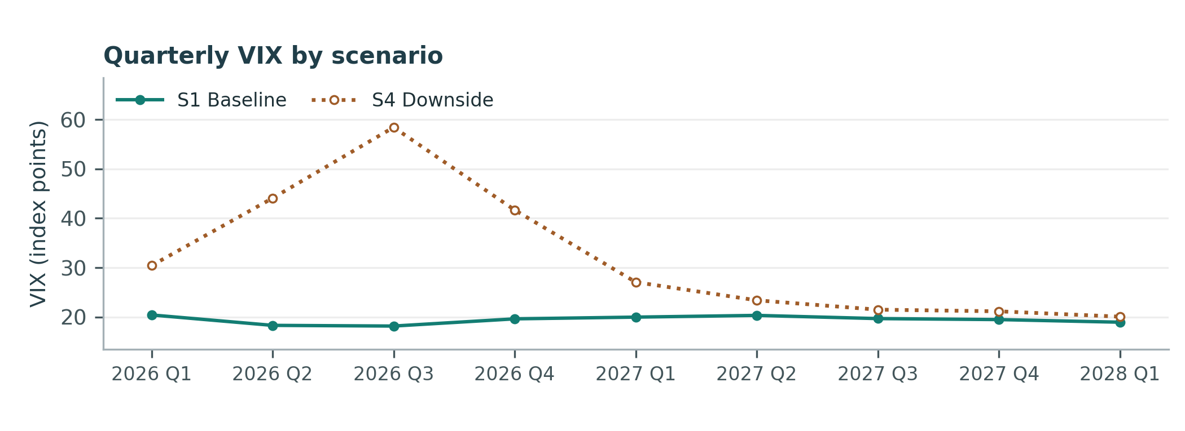
Figure D1. At the largest separation in 2026 Q3, the S4 quarterly average VIX is 58.43 and the S1 value is 18.17.
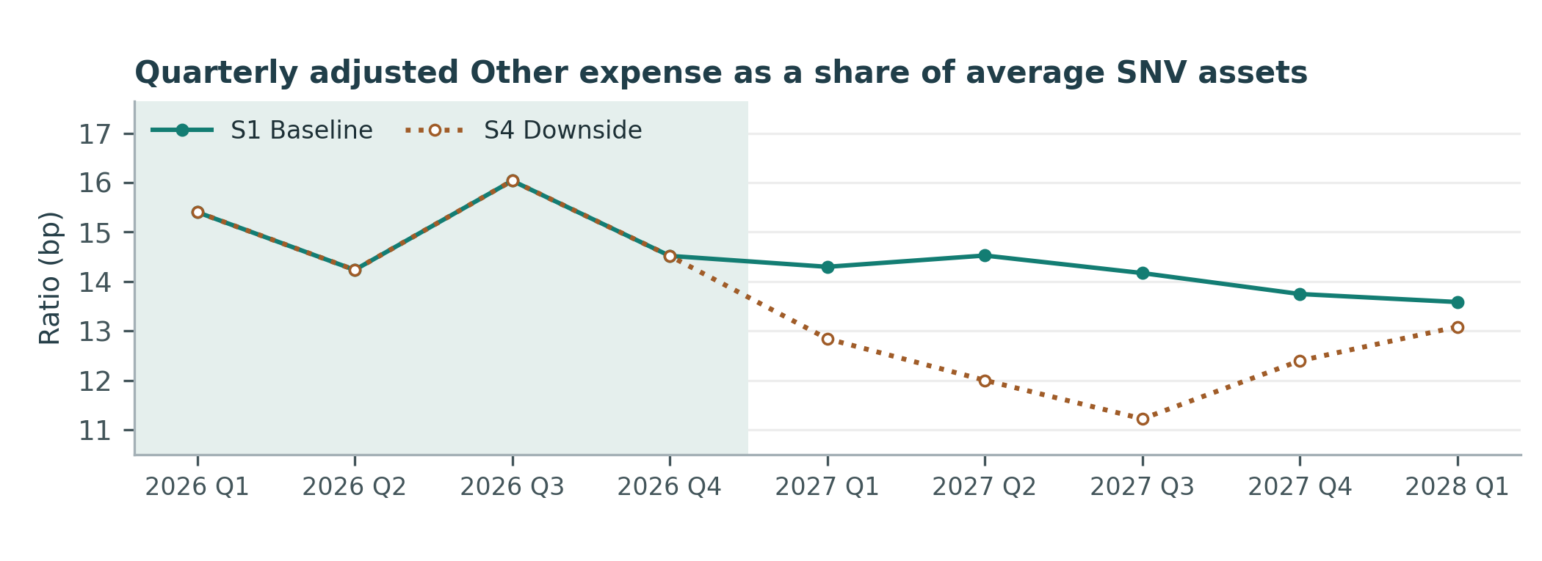
Figure D2. Shading marks the first four forecasts, which coincide because the model uses VIX growth lagged four quarters. The first scenario-specific input enters in 2027 Q1.
The largest forecast gap occurs in 2027 Q3. The S1 ratio is 14.17 bp and the S4 ratio is 11.22 bp, a difference of 2.95 bp. By 2028 Q1 the gap narrows to 0.50 bp.

