6 Model Testing

6.1 Testing Philosophy
Model testing evaluates the statistical adequacy, stability, forecast accuracy and economic reasonableness of the Noncomp Efficiency Ratio model. The assessment combines historical fit, coefficient inference, residual diagnostics, out-of-time forecasts, challenger models and scenario sensitivity. The results support retaining the reduced ARDL specification, with forecast bias and observation influence included in the ongoing review framework.
The development sample contains 49 usable quarters from 2011Q3 through 2023Q3. The out-of-time evaluation covers nine quarters from 2023Q4 through 2025Q4. The final specification is subsequently re-estimated using 58 usable quarters through 2025Q4 for forward scenario forecasting. EF is expressed as a decimal ratio; multiplying by 100 gives EF percent. Forecast errors are reported in EF percentage points where indicated.

6.2 In-Sample Performance Assessment
The development model achieves an adjusted R² of 0.8265 and a fitted-value RMSE of 0.02833. The full-history refit achieves an adjusted R² of 0.8212 and an RMSE of 0.02822. Actual and fitted values show that the model captures the broad historical movement in EF while allowing for quarterly variation. Similar fit across the two samples supports the consistency of the selected specification.
Table 6.1 In-Sample Performance Metrics
Metric | Development | Full history
Observations | 49 | 58
R-squared | 0.8373 | 0.8306
Adjusted R-squared | 0.8265 | 0.8212
RMSE in EF ratio units | 0.02833 | 0.02822
Residual standard error | 0.02956 | 0.02924
AIC | −202.205 | −241.279
BIC | −194.638 | −233.038
Both estimates contain an intercept and three explanatory terms. Full-history fit includes the nine OOT quarters and is reported separately from OOT performance.
Figure 6.1 Actual versus Fitted Values
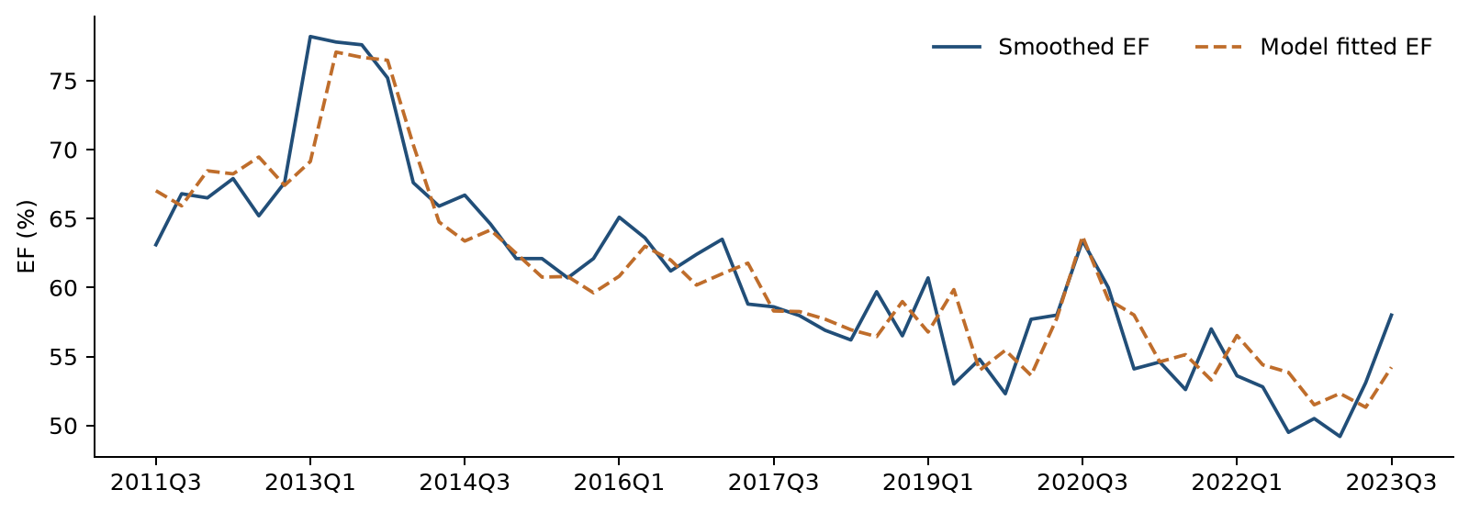
Smoothed actual EF and fitted EF over the development period. The fitted series uses observed lagged EF and the development coefficients.

6.3 Coefficient Significance Testing
The initial ARDL includes the post-TARP indicator, a linear trend, lagged EF and the lagged quarterly change in FLBR_B.IUSA. The trend coefficient has p = 0.1719 and is removed. The remaining specification is re-estimated on the same development observations. No transition pulse is included at either stage.
All retained terms are significant at the 5% level in the development model and the full-history refit. The unemployment coefficient is positive, consistent with higher costs relative to income during weakening labor-market conditions. The coefficient on lagged EF is positive and below one, indicating persistence with a declining response to a temporary disturbance. The post-TARP indicator captures the historical level difference associated with the fixed 2014Q1 boundary.
Table 6.2 Development Coefficient Estimates
Variable | Coefficient | Std error | t statistic | p value | 95% CI
Intercept | 0.193795 | 0.053801 | 3.602 | 0.0008 | [0.085434, 0.302155]
D | −0.043633 | 0.013267 | −3.289 | 0.0020 | [−0.070354, −0.016912]
EF lag 1 | 0.738292 | 0.076265 | 9.681 | < 0.0001 | [0.584685, 0.891898]
ΔFLBR_B.IUSA lag 1 | 0.006417 | 0.002844 | 2.257 | 0.0289 | [0.000689, 0.012144]
Table 6.3 Full-History Coefficient Estimates
Variable | Coefficient | Std error | t statistic | p value | 95% CI
Intercept | 0.194684 | 0.050779 | 3.834 | 0.0003 | [0.092879, 0.296489]
D | −0.045338 | 0.012983 | −3.492 | 0.0010 | [−0.071368, −0.019308]
EF lag 1 | 0.736985 | 0.071876 | 10.254 | < 0.0001 | [0.592882, 0.881088]
ΔFLBR_B.IUSA lag 1 | 0.006314 | 0.002810 | 2.247 | 0.0288 | [0.000680, 0.011947]
D equals zero before 2014Q1 and one from 2014Q1 onward. ΔFLBR_B.IUSA is the quarterly unemployment-rate change in percentage points, lagged one quarter. Standard errors, two-sided Student-t p values and confidence intervals use conventional OLS covariance, with 45 and 54 residual degrees of freedom, respectively. The coefficient p values are conditional on the selected specification and do not adjust for the macro screening process.

6.4 Multicollinearity Assessment
Variance Inflation Factors assess shared information among the explanatory variables. The maximum nonconstant VIF is 1.6114 in development and 1.6414 after the full-history refit, well below the screening limit of 10. These results indicate limited multicollinearity in the retained specification.
Table 6.4 Variance Inflation Factors
Variable | Development | Full history
D | 1.6032 | 1.6315
EF lag 1 | 1.6114 | 1.6414
ΔFLBR_B.IUSA lag 1 | 1.0065 | 1.0078
The intercept is excluded from the VIF assessment.

6.5 Residual Diagnostics
Residual diagnostics assess serial dependence and distributional shape. Ljung-Box tests at four and eight quarterly lags do not reject the absence of residual autocorrelation at the 5% level in either sample. Jarque-Bera p values are 0.2744 and 0.3849. These results support the assessed residual properties of the final model.
Table 6.5 Residual Diagnostic Statistics
Diagnostic | Development statistic | Development p | Full-history statistic | Full-history p
Ljung Box 4 | 5.2946 | 0.1515 | 6.7614 | 0.0799
Ljung Box 8 | 9.0562 | 0.2486 | 10.3557 | 0.1693
Jarque Bera | 2.5865 | 0.2744 | 1.9093 | 0.3849
Durbin Watson | 2.1954 | — | 2.1631 | —
Ljung-Box reference degrees of freedom are three and seven after allowing for one fitted autoregressive term. The full-history four-lag p value of 0.0799 warrants monitoring. Durbin-Watson values of 2.1954 and 2.1631 are within the development screening range of 1.5 to 2.5. Durbin-Watson is interpreted descriptively because lagged EF is an explanatory variable; no DW p value is assigned.
Figure 6.2 Residual Plots and Normal Q–Q Plot
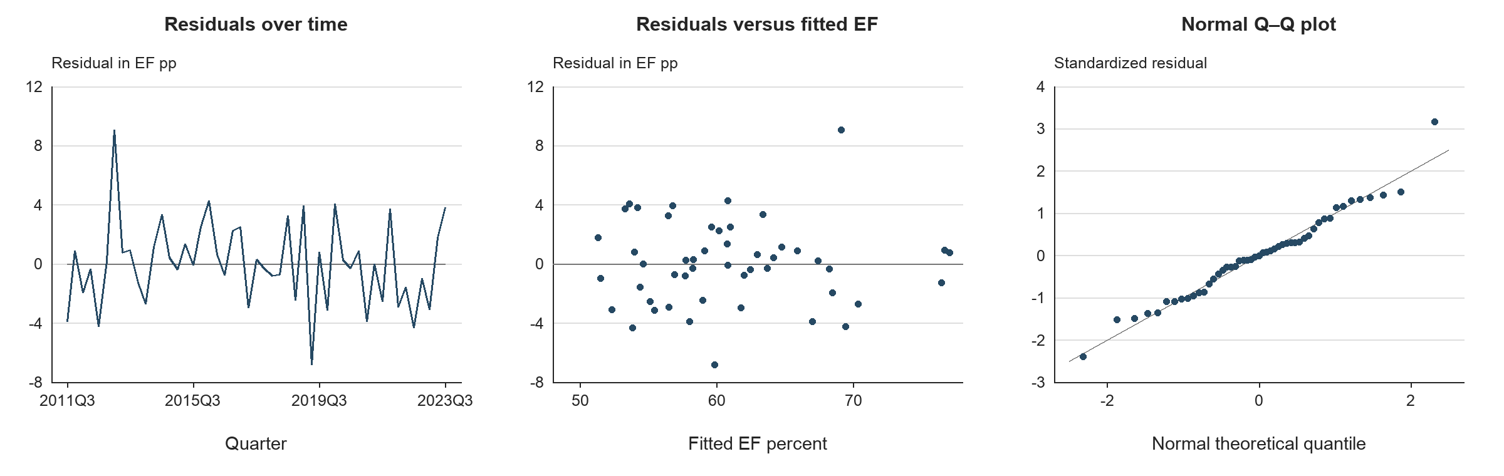
Development residuals over time, against fitted EF and against normal theoretical quantiles. The largest positive residual occurs in 2013Q1. Individual-observation sensitivity is discussed in Section 6.17.

6.5.1 Evaluation of Statistical Assumptions
The assessment considers the time-series specification, collinearity, serial dependence, residual normality and dynamic behavior together. The preliminary segmented-trend analysis produces residual ADF and KPSS results consistent with stationary deviations around a trend with a level and slope break. These are ordinary residual diagnostics; their p values do not incorporate first-stage breakpoint detrending. The final ARDL is also assessed directly through its residual diagnostics and forecast behavior.
Table 6.6 Statistical Assumption Assessment
Assessment area | Evidence | Interpretation
Time-series behavior | Final residual ADF p < 0.0001 and KPSS p > 0.10 in both samples | Supportive residual diagnostics
Multicollinearity | Maximum nonconstant VIF of 1.6114 and 1.6414 | Limited shared information
Serial dependence | Ljung-Box p > 0.05 at lags 4 and 8 | No rejection at 5%; monitor lag 4
Residual normality | JB p = 0.2744 and 0.3849 | No rejection at 5%
Dynamic persistence | Lagged EF coefficients of 0.7383 and 0.7370 | Temporary effects decay
Economic interpretation | Positive coefficient on lagged unemployment change | Consistent with cost-to-income pressure
These checks address the properties reported above. They do not establish exogeneity or constant error variance. Conventional OLS inference remains conditional on the regression assumptions, and monitoring should consider residual plots and business changes alongside formal test results.

6.6 Stability Testing Framework
Stability testing examines whether the estimated relationships remain consistent as the observation set changes and whether cumulative residual behavior indicates a shift in the fitted relationship. The completed assessment uses OLS-residual CUSUM, comparison of development and full-history estimates, and leave-one-out estimation. These checks complement the historical forecast evaluation.
Table 6.7 CUSUM Stability Results
Sample | CUSUM statistic | p value
Development | 0.7016 | 0.7086
Full history | 0.8039 | 0.5379
CUSUM does not reject coefficient stability at the 5% level in either sample. The result is considered together with coefficient comparisons and forecast errors because a single stability test cannot rule out every form of parameter change.

6.7 Rolling Coefficient Stability
A sequential rolling-window coefficient analysis remains a further monitoring test. The completed development evidence compares the original estimation period with the full-history refit and assesses sensitivity to individual observations. The two estimation samples produce the same coefficient signs and similar coefficient magnitudes.
Table 6.8 Coefficient Comparison Across Estimation Samples
Variable | Development | Full history
Intercept | 0.193795 | 0.194684
D | −0.043633 | −0.045338
EF lag 1 | 0.738292 | 0.736985
ΔFLBR_B.IUSA lag 1 | 0.006417 | 0.006314
The lagged-EF coefficient changes from 0.738292 to 0.736985, and the unemployment coefficient changes from 0.006417 to 0.006314. The latter remains significant at 5% in both samples. These results support consistency across the two samples. A future rolling exercise should track coefficient signs and uncertainty using a documented window convention, with particular care when the window no longer contains pre-2014 observations needed to identify D separately from the intercept.

6.8 Rolling Prediction Error Analysis
The available sequential forecast assessment updates observed lagged EF each quarter while holding the development coefficients fixed. This produces nine one-step forecast errors. A second path uses recursive EF forecasts throughout the same period. The evaluation therefore measures the value of updating the EF state as new observations arrive; rolling-window coefficient re-estimation has not been performed.
One-step errors include both overprediction and underprediction. Recursive forecasts exceed actual EF in each quarter from 2024Q2 through 2025Q4. This pattern is reflected in the signed mean errors reported in Section 6.10 and is relevant to the model’s use for an uninterrupted multi-quarter forecast.

6.9 Out-of-Time Testing Framework
Out-of-time testing uses 2023Q4 through 2025Q4. Coefficients are frozen at their development estimates through 2023Q3. One-step forecasts use the actual EF from the preceding quarter. Recursive forecasts begin with actual 2023Q3 EF and then substitute the previous forecast into the lagged-EF term. The first-quarter predictions are identical under the two methods.
Both methods use observed historical macro inputs, so the scores evaluate EF forecasts conditional on the realized macro path. The nine-quarter window was reviewed during model selection. It provides development validation evidence, while an additional future period is needed for a fresh confirmation assessment. Full-history coefficients are reserved for future S1 and S4 projections.

6.10 OOT Results and Interpretation
The final model produces one-step RMSE of 0.02783 and recursive RMSE of 0.03728, equivalent to 2.783 and 3.728 EF percentage points. Both improve on their corresponding persistence benchmarks. Updating actual lagged EF reduces forecast error relative to a fully recursive path.
Table 6.9 OOT Forecast Performance
Forecast method | RMSE in EF pp | MAE in EF pp | Mean error in EF pp
Final ARDL one step | 2.783 | 2.304 | −0.837
Final ARDL recursive | 3.728 | 3.481 | −2.319
Persistence one step | 3.001 | — | —
Persistence recursive | 3.962 | — | —
Development mean | 6.241 | — | —
Error is actual EF minus forecast EF. Negative mean errors indicate average overprediction. Persistence uses the previous actual EF for one-step forecasts and fixed 2023Q3 EF for recursive forecasts.
Figure 6.3 Out-of-Time Actual and Forecast EF
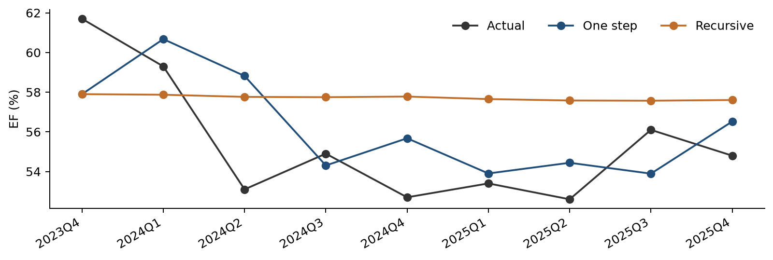
Quarterly actual EF compared with frozen-coefficient one-step and recursive forecasts over the nine-quarter OOT period.
The mean error is −0.837 EF percentage points for one-step forecasts and −2.319 for recursive forecasts. The recursive path is smoother and remains close to 57.6% late in the evaluation period, whereas most corresponding actual values are lower. This indicates a tendency to overpredict over the observed multi-quarter horizon.

6.11 Root Cause Assessment
The difference between one-step and recursive performance is consistent with the model’s forecast mechanism. One-step forecasts incorporate each newly observed EF level. Recursive forecasts propagate the previous prediction, so an initial level discrepancy can persist through the lagged-EF coefficient. Small subsequent unemployment changes provide limited additional movement in the recursive path.
The observed error pattern identifies a forecasting limitation that requires monitoring. It does not, by itself, establish a change in accounting, pricing, expense management or other business behavior. A business attribution would require a review of the underlying income and expense components. CUSUM and the full-history coefficient comparison provide supporting stability evidence, but neither identifies the business cause of a forecast error.

6.12 Overlay Support Analysis
No management overlay is applied to the historical forecasts or the S1 and S4 projections. The current outputs retain the estimated model response. The nine-quarter bias assessment does not provide a sufficient basis for a permanent additive or multiplicative correction without further calibration and business support.
If a recurring bias leads to a proposed overlay, its rationale should identify the relevant business development, quantify its expected EF impact and distinguish that adjustment from model re-estimation. Approval should specify the adjustment method, application period, monitoring criteria and conditions for withdrawal. Unadjusted model forecasts should remain available for comparison.

6.13 Scenario Testing
Scenario testing uses the fixed final specification re-estimated through 2025Q4. S1 is the original Baseline unemployment path. S4 is maintained as a separate unemployment path. Forecasts cover 2026Q1 through 2028Q1, begin with actual 2025Q4 EF of 0.548, hold D at one and recursively use each predicted EF in the following quarter.
The macro input is the lagged quarterly percentage-point change in FLBR_B.IUSA. Both scenarios therefore produce the same EF forecast in 2026Q1 because that quarter uses the shared unemployment change from 2025Q3 to 2025Q4. Scenario-specific changes first affect EF in 2026Q2. The 2028Q1 unemployment input would enter EF in 2028Q2, beyond the displayed horizon.

6.14 Scenario Results and Reasonableness Assessment
Both scenarios begin at EF of 55.395%. S4 produces higher EF from 2026Q2 onward as larger unemployment increases enter the model. S4 EF peaks at 57.994% in 2026Q4 and then moderates as the unemployment increases become smaller and earlier effects decay. By 2028Q1, EF is 56.790% under S1 and 57.287% under S4, a difference of approximately 0.50 percentage points.
Table 6.10 Scenario Inputs and Recursive EF Forecasts
Quarter | S1 FLBR_B.IUSA % | S4 FLBR_B.IUSA % | S1 EF % | S4 EF %
2026Q1 | 4.333 | 6.565 | 55.395 | 55.395
2026Q2 | 4.267 | 7.900 | 55.686 | 57.096
2026Q3 | 4.170 | 8.566 | 55.933 | 57.856
2026Q4 | 4.303 | 8.936 | 56.095 | 57.994
2027Q1 | 4.513 | 9.191 | 56.360 | 57.909
2027Q2 | 4.623 | 9.359 | 56.604 | 57.774
2027Q3 | 4.703 | 9.429 | 56.720 | 57.619
2027Q4 | 4.710 | 9.456 | 56.787 | 57.443
2028Q1 | 4.680 | 9.428 | 56.790 | 57.287
Figure 6.4 S1 and S4 Macro Paths and EF Forecasts
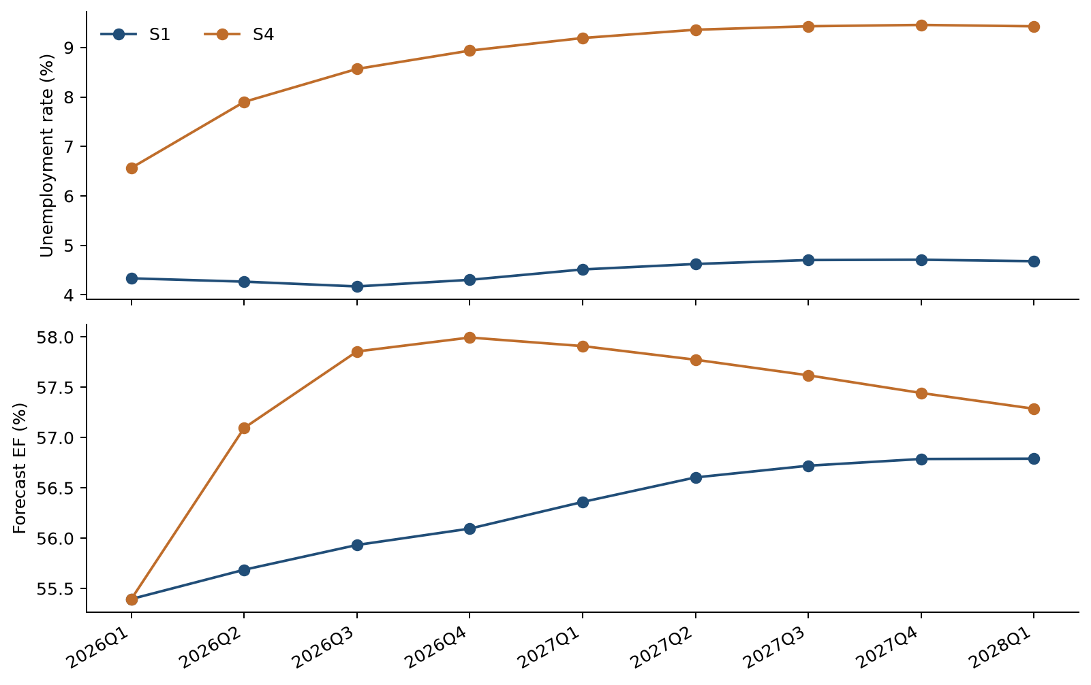
The unemployment paths are shown above the corresponding recursive EF forecasts. Higher EF represents greater costs relative to income. Scenario separation follows the timing of lagged unemployment changes.
The paths remain within the historical EF range and exhibit bounded responses under the supplied scenarios. The positive unemployment coefficient gives an economically interpretable direction of stress. The later narrowing of the paths follows from using unemployment changes together with a lagged-EF coefficient below one. Scenario forecasts are conditional point estimates and carry no assigned scenario probabilities.

6.15 Benchmarking Against Literature
Published Federal Reserve PPNR methodology provides a methodological reference for linking bank performance to macroeconomic conditions and recent performance measures. Its 2025 model descriptions include autoregressive and panel-regression specifications for revenue and expense ratios. The Noncomp EF specification follows the general practice of combining persistence with a macroeconomic driver. Differences in targets, data and model design preclude treating that comparison as a quantitative ranking of forecast accuracy.
Source: Federal Reserve, 2025 Supervisory Stress Test Methodology, Descriptions of Supervisory Models, Pre-provision Net Revenue.
Quantitative benchmarking uses alternative models estimated on the same development sample and evaluated over the same OOT quarters. The FLBR_B.IUSA, FGAP_B.IUSA and FGDP$_B.IUSA specifications have closely comparable adjusted R² values. FLBR_B.IUSA has the lowest one-step RMSE, while FGDP$_B.IUSA has the lowest recursive RMSE.
Table 6.11 Internal Challenger Model Comparison
Macro | Adjusted R² | One-step RMSE | Recursive RMSE | Selection
FLBR_B.IUSA | 0.8265 | 0.02783 | 0.03728 | Selected
FGAP_B.IUSA | 0.8270 | 0.02906 | 0.03643 | Challenger
FGDP$_B.IUSA | 0.8267 | 0.02878 | 0.03501 | Challenger
RMSE values are in EF ratio units. Each model contains an intercept, D, lagged EF and one lagged transformed macro variable.
FLBR_B.IUSA is retained based on its comparable historical fit, lower one-step validation error and direct labor-market interpretation. The GDP and output-gap models remain useful challengers for monitoring multi-quarter forecasting performance.

6.16 User Review and Acceptance
User review should address the EF accounting definition, preprocessing of the two 2017 observations, the interpretation of FLBR_B.IUSA, the distinction between one-step and recursive forecasts, and the labeling of S1 and S4. Business users should also assess the materiality of the historical recursive forecast bias before approving the model’s operational use.
Formal production User Acceptance Testing and business sign-off remain pending. The development package passed 16 automated tests and numerical reconciliation of 4,413 reported values across 47 verification checks, with a maximum absolute difference of approximately 1.72 × 10⁻¹². These checks establish reproducibility of the packaged calculations. Production UAT should additionally confirm input ingestion, scenario handling, output reconciliation, access controls and the documented operating process.

6.17 Sensitivity Analysis
Sensitivity testing applies a parallel increase or decrease of one percentage point to every future FLBR_B.IUSA level, separately for S1 and S4. Historical levels remain unchanged. Quarterly changes and their one-quarter lags are recalculated before the recursive forecasts are generated. This isolates the response to a higher or lower unemployment path while preserving the model coefficients and all other inputs.
Table 6.12 Sensitivity to a Parallel Unemployment Level Shift
Quarter | EF effect of +1 pp | EF effect of −1 pp
2026Q1 | 0.0000 | 0.0000
2026Q2 | 0.6314 | −0.6314
2026Q3 | 0.4653 | −0.4653
2026Q4 | 0.3429 | −0.3429
2028Q1 | 0.0746 | −0.0746
Effects are in EF percentage points. Incremental effects are identical around S1 and S4 because the forecasting equation is linear.
The first EF effect occurs in 2026Q2 and equals 0.6314 percentage points for an upward unemployment shift. It then decays at the estimated autoregressive factor of 0.736985 per quarter, reaching 0.0746 percentage points in 2028Q1. A downward shift has the same magnitude and opposite sign. A parallel permanent level shift creates an additional unemployment change at the forecast boundary; subsequent quarterly changes return to those of the original path.
Figure 6.5 Unemployment Path Sensitivity
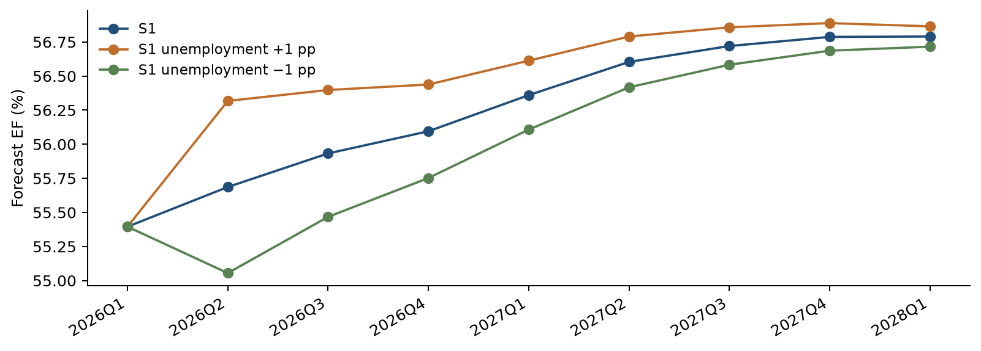
S1 EF forecasts under the original unemployment path and parallel level shifts of plus or minus one percentage point. Forecast separation begins after the model’s one-quarter macro lag.
An additional impulse calculation uses one development-sample standard deviation of unemployment changes, equal to 1.5054 percentage points. The initial EF response is 0.9505 percentage points when the shock enters the equation, followed by the same geometric decay.

Preprocessing and Observation Sensitivity
The same final specification was also estimated using original EF values. Relative to the original-data sensitivity, the smoothed EF series produces higher adjusted R² and lower one-step and recursive OOT RMSE. This check retains the same variables and documents the effect of preprocessing without repeating macro selection.
Table 6.13 Sensitivity to EF Preprocessing
EF series | Adjusted R² | One-step RMSE | Recursive RMSE
Smoothed | 0.8265 | 0.02783 | 0.03728
Original | 0.7188 | 0.02827 | 0.03919
RMSE values are in EF ratio units. Both original 2017 observations remain in the original-data sensitivity.
Leave-one-out estimation keeps the unemployment coefficient positive, with estimates ranging from 0.005680 to 0.007907. Its p values range from 0.0132 to 0.2392, showing that coefficient significance is sensitive to individual observations. The largest Cook’s distance occurs in 2013Q1, while 2020Q3 has high leverage because of its unusual macro input. All observations remain in the principal estimation sample.

6.18 Testing Conclusions
The testing results support the reduced ARDL as the retained Noncomp EF forecasting specification. Historical fit is similar in development and full history, retained coefficients are significant under conventional OLS inference, and VIF, Ljung-Box, Jarque-Bera and CUSUM results support the assessed model properties. Forecast responses to S1, S4 and the unemployment sensitivity tests are bounded and consistent with the estimated lag structure.
OOT accuracy exceeds the corresponding persistence benchmarks, and FLBR_B.IUSA has the lowest one-step error among the three principal macro alternatives. Recursive overprediction, the GDP challenger’s lower recursive RMSE and individual-observation sensitivity define specific areas for continued monitoring. The next implementation stage should complete rolling-window analysis, production UAT and business approval before operational reliance on the forecasts.

