Federal Funds and Bank Assets in the Quarterly Other Expense Model
The final model uses the federal funds rate and the quarterly change in total U.S. commercial bank assets to predict year-over-year growth in adjusted Other expense. Bank assets ranked first in round two. The asset coefficient is positive in all 14 rolling windows of 30 quarters and significant in 12. Over the nine holdout quarters, mean absolute error is $14.76 million one step ahead and $18.56 million on the recursive path.

Quarterly expense from 2011 to 2025
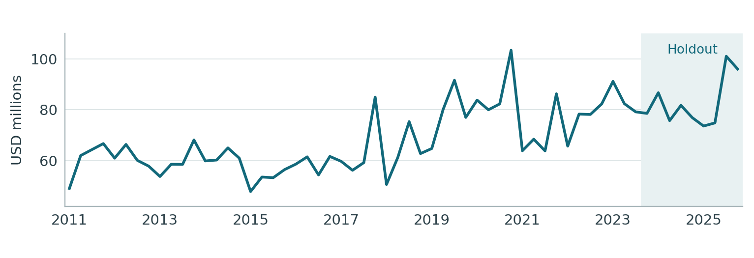
Figure 1. Smoothed quarterly expense in USD millions. The shaded holdout begins in 2023 Q4.
Monthly Adj_Other equals Other_Month_Actual_num less the signed Card_Month_Actual_num. March 2011, January 2019, September 2020, July 2023 and November 2023 each use the mean of the two neighboring months. The quarterly amount sums the three smoothed monthly values.

Stationarity of the target
The expense level fails the joint stationarity criterion. All three changes pass. The year-over-year log change measures growth against the same quarter of the prior year and is the dependent variable in this specification.
Target form | N | ADF stat. | ADF p | KPSS stat. | KPSS p
Level | 51 | −0.814 | 0.8148 | 0.827 | <0.01
First difference | 50 | −6.563 | <0.0001 | 0.051 | >0.10
QoQ log change | 50 | −6.390 | <0.0001 | 0.053 | >0.10
YoY log change | 47 | −4.134 | 0.0009 | 0.110 | >0.10
Both tests use an intercept. ADF chooses up to four lags by AIC. KPSS uses bandwidth four. A form passes when ADF rejects a unit root at 5% and KPSS does not reject level stationarity at 5%.

Expense growth and the estimation sample
Yₜ is quarterly smoothed Adj_Other expense in USD millions. The model predicts gₜ, the log change from the same quarter of the preceding year.
$g_{t} = 100 ln(Y_{t} / Y_{t−4})$
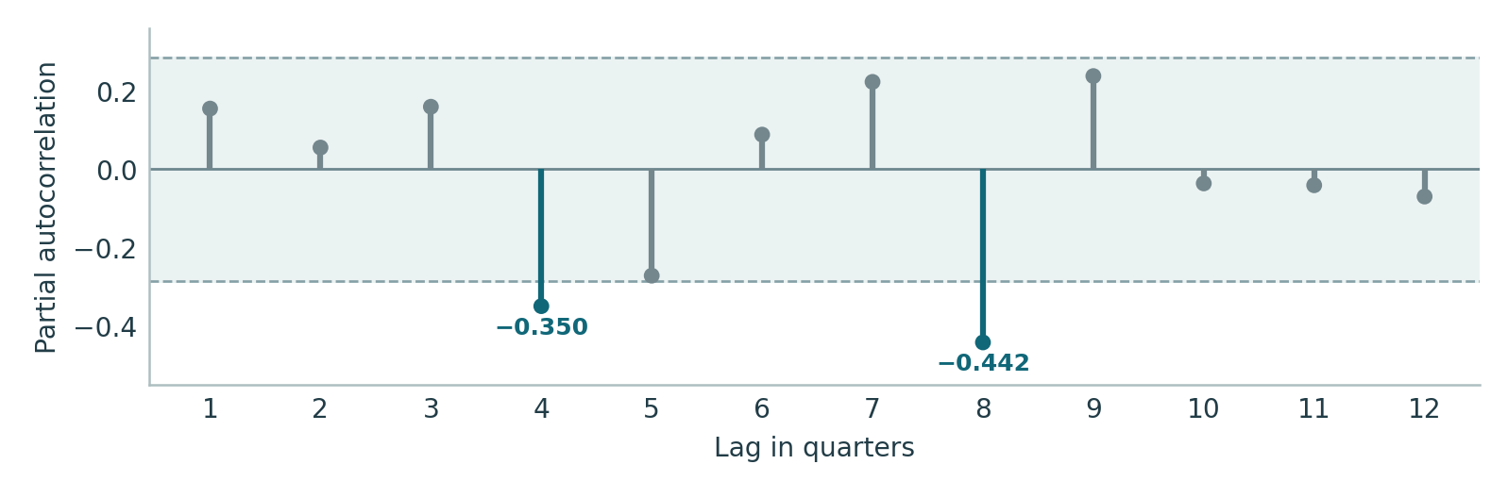
Figure 2. Yule–Walker partial autocorrelations use 47 in-sample expense-growth observations. Shading marks approximate pointwise 95% white-noise bounds of ±0.286.
The partial autocorrelations at lag 4 (−0.350) and lag 8 (−0.442) cross the pointwise bounds. The starting specification retains the intercept and lag 4, which measures expense growth one year earlier.

Quarter coverage
Use | Period | Quarters
Target and macro stationarity tests | 2011 Q1–2023 Q3 | 51 in levels
Expense growth available for the PACF | 2012 Q1–2023 Q3 | 47
Common estimation sample for every trial | 2013 Q1–2023 Q3 | 43
Out-of-time forecast evaluation | 2023 Q4–2025 Q4 | 9
For the first regression observation in 2013 Q1, lagged expense growth compares 2012 Q1 with 2011 Q1. The same 43 outcomes are available in every round.
Target source. Other_Monthly_to_Quarterly.xls, Quarterly Output, smoothed Adj_Other. All 60 quarterly amounts match Other_Quarterly_Target_List.xlsx.

Stationarity of the macro candidates
The 15 supplied quarterly series were tested in level, first difference, quarter-over-quarter log change and year-over-year log change. Each statistic uses the 51 transformed observations dated 2011 Q1–2023 Q3. Earlier quarterly levels initialize the changes. A form qualifies when ADF p < 0.05 and KPSS p ≥ 0.05.
Macro series | Level | First difference | QoQ log | YoY log
Bank assets | .965 / <.01 | .002 / >.10 | .002 / >.10 | .319 / >.10
Bank deposits | .885 / <.01 | .061 / >.10 | .042 / >.10 | .061 / >.10
Bank loans and leases | .989 / <.01 | .001 / >.10 | .001 / >.10 | .063 / >.10
Consumer credit outstanding | .865 / <.01 | .045 / >.10 | .122 / >.10 | .087 / >.10
Credit card delinquency, top 100 banks | .074 / .040 | .693 / .057 | .588 / >.10 | .156 / .094
C&I delinquency, top 100 banks | .013 / >.10 | .008 / >.10 | .013 / >.10 | .247 / >.10
Credit card charge-offs | .136 / .036 | .197 / .062 | .336 / >.10 | .110 / >.10
Business bankruptcies | .030 / <.01 | .506 / .035 | .493 / >.10 | .178 / >.10
Personal bankruptcies | .228 / <.01 | .004 / >.10 | .002 / >.10 | .410 / >.10
VIX | .095 / >.10 | <.001 / >.10 | <.001 / >.10 | .146 / >.10
High-yield spread | .018 / .086 | <.001 / >.10 | <.001 / >.10 | .078 / >.10
Federal funds rate | .305 / .037 | .035 / >.10 | .005 / >.10 | .017 / >.10
10-year Treasury yield | .643 / >.10 | .008 / >.10 | <.001 / >.10 | .015 / >.10
Final demand services PPI | 1.000 / <.01 | .049 / .052 | .035 / .082 | .819 / .052
Core CPI | 1.000 / <.01 | .477 / .020 | .393 / .029 | .718 / .022
Cells show ADF p / KPSS p. Bold cells pass both tests. ADF uses an intercept with AIC lag selection up to four quarters. KPSS tests level stationarity with bandwidth four. Decisions use full precision.

Eligible transformations
Eleven series contributed 24 eligible forms, comprising two levels, ten first differences, ten quarterly log changes and two annual log changes. Testing each at lags 1, 2 and 4 produced 72 first-round candidates.
Macro source. Other_Quarterly_Macro_List.xlsx, Quarterly Macro, Moody’s Scenario Consistent Baseline (August 2026). The worksheet covers 2009 Q1–2028 Q1. Services PPI first appears in 2010 Q1. All macro values enter at their published quarterly frequency.

Forward selection
The intercept and expense growth L4 stay in every regression. An added term needs a two-sided p < 0.05, maximum VIF < 10 and Durbin–Watson between 1.5 and 2.5 inclusive. The smallest qualifying p-value wins, with BIC breaking a tie. After a series enters, its remaining transformations and lags leave the pool. Jarque–Bera is evaluated on the final fit.
Round | Trials | Passed | Decision | Model R²
Start | — | — | Intercept and expense growth L4 | 8.95%
1 | 72 | 9 | Federal funds rate, YoY log change L4 | 26.39%
2 | 63 | 5 | Commercial bank assets, first difference L2 | 37.29%
3 | 57 | 0 | Stop. Lowest remaining p = 0.23831. | 37.29%

Candidates that passed all entry criteria
Round | Rank | Macro series | Form | Lag | Entry p
1 | 1 | Federal funds rate | YoY log | L4 | 0.00375
1 | 2 | Bank loans and leases | First diff. | L2 | 0.00466
1 | 3 | Bank loans and leases | QoQ log | L2 | 0.01240
1 | 4 | 10-year Treasury yield | QoQ log | L2 | 0.02528
1 | 5 | High-yield spread | First diff. | L2 | 0.02932
1 | 6 | High-yield spread | QoQ log | L2 | 0.03485
1 | 7 | 10-year Treasury yield | YoY log | L4 | 0.03619
1 | 8 | Bank assets | QoQ log | L4 | 0.04305
1 | 9 | Bank deposits | QoQ log | L4 | 0.04378
2 | 1 | Bank assets | First diff. | L2 | 0.01299
2 | 2 | Bank assets | QoQ log | L2 | 0.02450
2 | 3 | 10-year Treasury yield | QoQ log | L2 | 0.03348
2 | 4 | Bank loans and leases | First diff. | L2 | 0.03364
2 | 5 | Personal bankruptcies | QoQ log | L2 | 0.04787
The bank asset first difference at L2 ranked first in round two (p = 0.01299). It is retained following the 30-quarter rolling review. Treasury yield quarterly log growth L2 ranked third (p = 0.03348). After fitting the asset term, none of the 57 remaining candidates qualified. The minimum p-value was 0.23831 for personal bankruptcies, first difference L1.

Final model specification
Fₜ is the U.S. federal funds rate (FRFED_B.IUSA), expressed as an annual percentage, seasonally unadjusted. Aₜ is total U.S. commercial bank assets (FBBACBQ_B.IUSA), in billions of U.S. dollars, seasonally adjusted. Both series come directly from the supplied quarterly workbook.
$f_{t} = 100 ln(F_{t} / F_{t−4})$
$d_{t} = A_{t} − A_{t−1}$
$ĝ_{t} = −1.63163 − 0.41662 g_{t−4} + 0.07634 f_{t−4} + 0.02006 d_{t−2}$
$Ŷ_{t} = Y_{t−4} exp(ĝ_{t} / 100)$
A ten-log-point increase in the lagged federal funds change corresponds to 0.76 additional log points of predicted expense growth. A $100 billion larger quarterly increase in bank assets two quarters earlier corresponds to 2.01 additional log points, holding other terms fixed.
Term | Estimate | Std. error | 95% interval | p-value
Intercept | −1.63163 | 2.84781 | [−7.3919, 4.1286] | 0.56997
Expense growth (one year earlier) | −0.41662 | 0.13107 | [−0.6817, −0.1515] | 0.00290
Federal funds rate (one year earlier) | 0.07634 | 0.01889 | [0.0381, 0.1145] | 0.00024
Commercial bank assets (two quarters earlier) | 0.02006 | 0.00771 | [0.0045, 0.0356] | 0.01299

Fit and residual diagnostics
Training N | R² | Adjusted R² | DW | Max. VIF | Final JB p | BG(1) p
43 | 0.3729 | 0.3247 | 2.055 | 1.193 | 0.3311 | 0.7911
Conventional OLS standard errors, Student-t p-values and pointwise intervals use 39 residual degrees of freedom. BG(1) is the lag-one Breusch–Godfrey F-test. Coefficient p-values are conditional on the selected specification.

Performance in the final nine quarters
Coefficients are fixed at their 2023 Q3 estimates. The one-step forecasts update the expense history each quarter. The recursive path feeds its predicted expense amounts into later lags. Both use lagged macro observations from the August 2026 vintage, which postdates the holdout.
Forecast | MAE | RMSE | MAPE | Mean error
One-step | 14.76 | 17.14 | 17.93% | 7.52
Recursive | 18.56 | 20.09 | 23.15% | 15.30
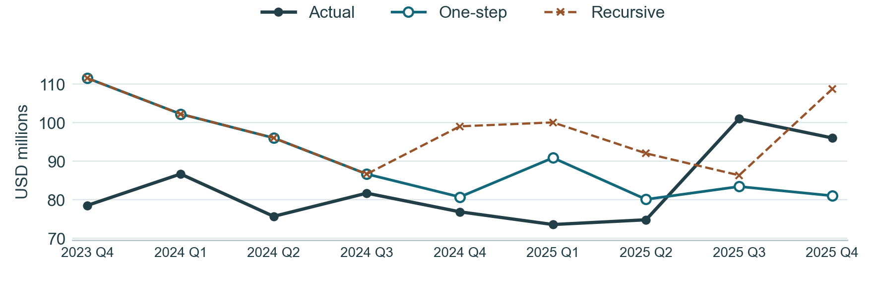
Figure 3. The two paths coincide through 2024 Q3. Beginning in 2024 Q4, the recursive path uses its forecast from the same quarter of the preceding year.
Quarter | Actual | One-step | Error | Recursive | Error
2023Q4 | 78.59 | 111.56 | 32.97 | 111.56 | 32.97
2024Q1 | 86.72 | 102.28 | 15.56 | 102.28 | 15.56
2024Q2 | 75.73 | 96.07 | 20.34 | 96.07 | 20.34
2024Q3 | 81.75 | 86.71 | 4.96 | 86.71 | 4.96
2024Q4 | 76.91 | 80.77 | 3.86 | 99.08 | 22.17
2025Q1 | 73.62 | 90.91 | 17.30 | 100.10 | 26.49
2025Q2 | 74.85 | 80.14 | 5.29 | 92.07 | 17.22
2025Q3 | 101.07 | 83.47 | −17.60 | 86.39 | −14.68
2025Q4 | 96.07 | 81.08 | −14.99 | 108.76 | 12.69
Error equals forecast minus actual. Amounts, MAE, RMSE and mean error are in USD millions. MAPE is the mean absolute percentage error.
Both paths had their largest absolute error in 2023 Q4, overpredicting by $32.97 million. The recursive path overpredicted eight of nine quarters and its mean error was +$15.30 million.

Rolling coefficient stability over 30 quarters
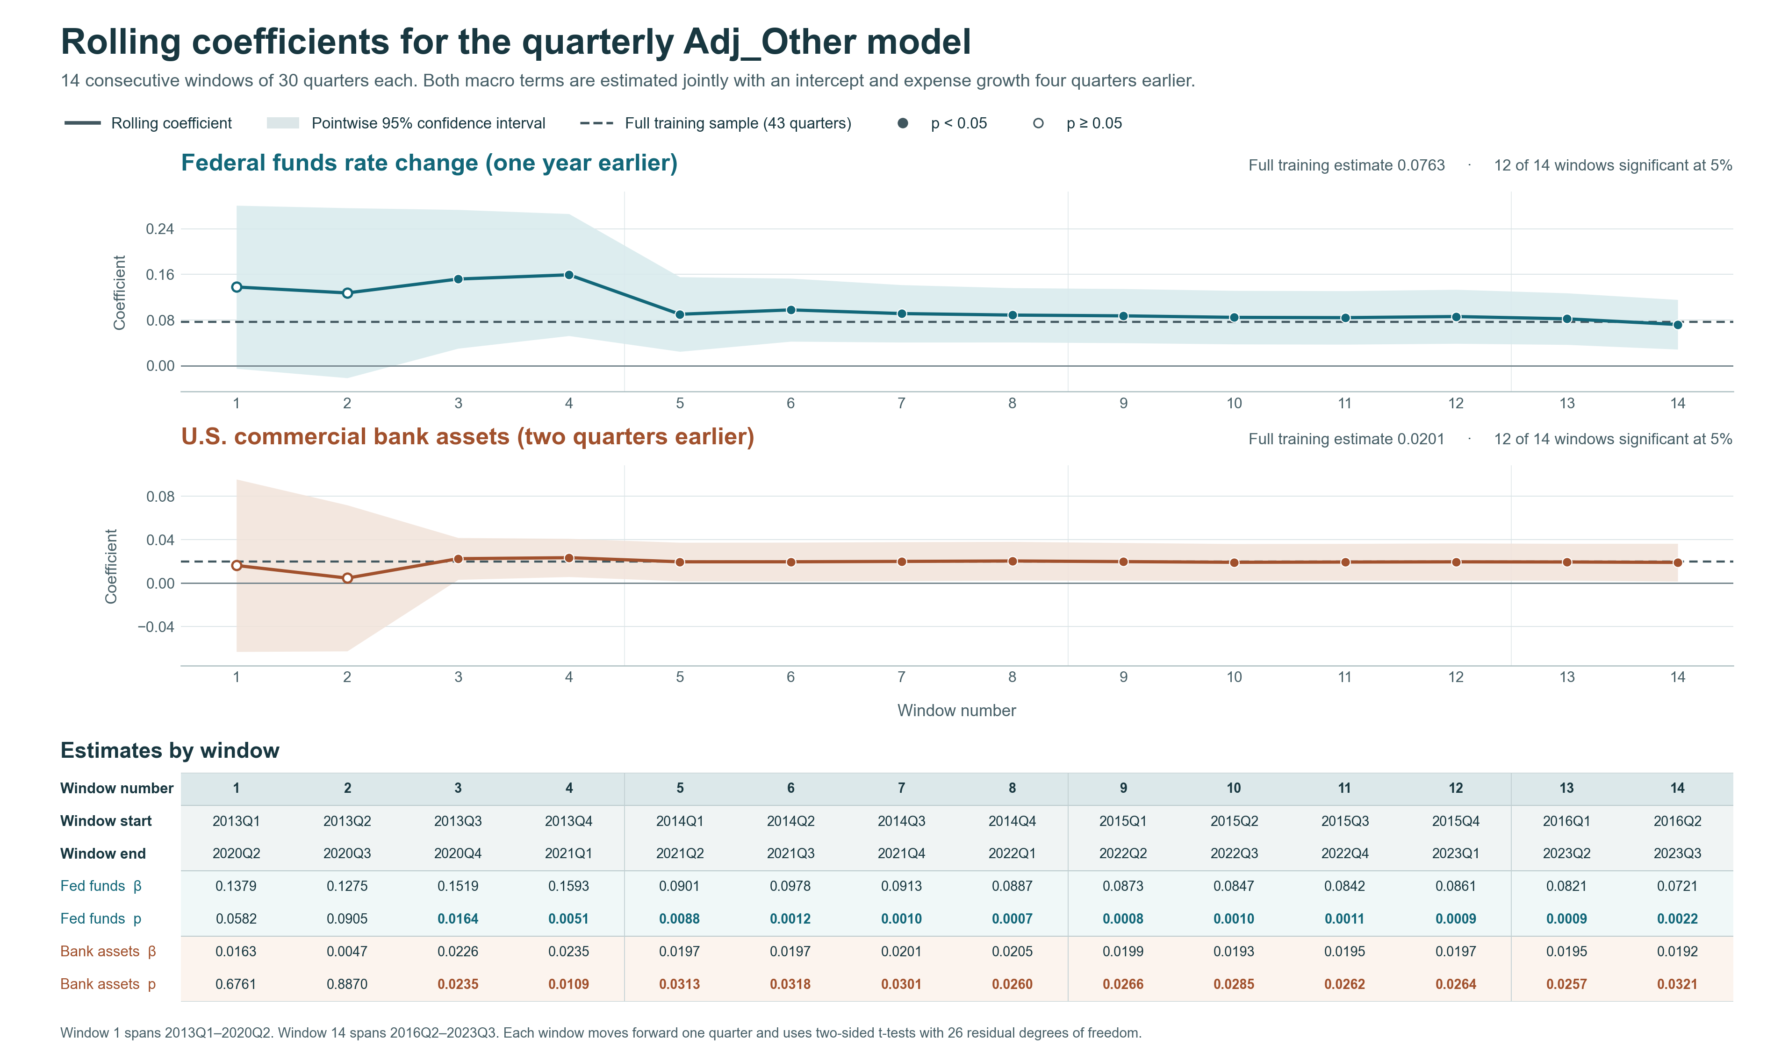
Figure 4. Window numbers 1–14 follow chronological order. The table gives each window’s start and end quarters. Shading shows pointwise 95% confidence intervals, filled points mark p < 0.05, and dashed lines show the full-training estimates.

Estimates for all 14 rolling windows
The 43 training quarters yield 14 rolling windows of 30 quarters. Each fit estimates four coefficients with 26 residual degrees of freedom. Adjacent windows share 29 quarters. Both macro coefficients are positive in all 14 windows and significant in windows 3 through 14.
No. | Window dates | Fed funds  coef. | 95% interval | p | Assets  coef. | 95% interval | p
1 | 2013Q1–2020Q2 | 0.1379 | [−0.0051, 0.2810] | 0.0582 | 0.0163 | [−0.0631, 0.0958] | 0.6761
2 | 2013Q2–2020Q3 | 0.1275 | [−0.0216, 0.2767] | 0.0905 | 0.0047 | [−0.0626, 0.0720] | 0.8870
3 | 2013Q3–2020Q4 | 0.1519 | [0.0302, 0.2736] | 0.0164 | 0.0226 | [0.0033, 0.0419] | 0.0235
4 | 2013Q4–2021Q1 | 0.1593 | [0.0523, 0.2663] | 0.0051 | 0.0235 | [0.0059, 0.0411] | 0.0109
5 | 2014Q1–2021Q2 | 0.0901 | [0.0247, 0.1555] | 0.0088 | 0.0197 | [0.0019, 0.0375] | 0.0313
6 | 2014Q2–2021Q3 | 0.0978 | [0.0425, 0.1531] | 0.0012 | 0.0197 | [0.0019, 0.0376] | 0.0318
7 | 2014Q3–2021Q4 | 0.0913 | [0.0409, 0.1417] | 0.0010 | 0.0201 | [0.0021, 0.0380] | 0.0301
8 | 2014Q4–2022Q1 | 0.0887 | [0.0410, 0.1364] | 0.0007 | 0.0205 | [0.0026, 0.0383] | 0.0260
9 | 2015Q1–2022Q2 | 0.0873 | [0.0398, 0.1348] | 0.0008 | 0.0199 | [0.0025, 0.0372] | 0.0266
10 | 2015Q2–2022Q3 | 0.0847 | [0.0377, 0.1316] | 0.0010 | 0.0193 | [0.0022, 0.0363] | 0.0285
11 | 2015Q3–2022Q4 | 0.0842 | [0.0373, 0.1311] | 0.0011 | 0.0195 | [0.0025, 0.0364] | 0.0262
12 | 2015Q4–2023Q1 | 0.0861 | [0.0387, 0.1335] | 0.0009 | 0.0197 | [0.0025, 0.0368] | 0.0264
13 | 2016Q1–2023Q2 | 0.0821 | [0.0368, 0.1273] | 0.0009 | 0.0195 | [0.0026, 0.0365] | 0.0257
14 | 2016Q2–2023Q3 | 0.0721 | [0.0286, 0.1157] | 0.0022 | 0.0192 | [0.0018, 0.0365] | 0.0321
Bold p-values are below 0.05. Confidence intervals and two-sided tests use the Student-t distribution within each window.
The full-training asset coefficient is 0.02006 (p = 0.01299). Its 30-quarter estimates range from 0.00470 to 0.02349. In the last window, 2016 Q2–2023 Q3, the estimate is 0.01916 (p = 0.03211).

Round two choice on matched samples
Second macro | R² | 30Q windows p < 0.05 | One-step MAE | Recursive MAE
Bank assets | 37.29% | 12 / 14 | 14.76 | 18.56
10-year Treasury yield | 34.55% | 6 / 14 | 13.97 | 16.37
The two specifications share the intercept, expense growth L4 and federal funds term. The rolling count applies to the second macro. MAE is in USD millions for 2023 Q4–2025 Q4.
Bank assets reached 5% significance in 3 of 24 shorter, 20-quarter windows. In the 30-quarter review the asset term clears that threshold more often than Treasury. The Treasury specification retains the lower holdout MAE under both forecast protocols.

Appendix First round candidate tests
Each row is a qualifying transformation. Each cell reports the p-value for adding one lag to the intercept and year-over-year expense growth L4. All 72 trials use 2013 Q1–2023 Q3.
Macro | Transformation | R1 L1 | R1 L2 | R1 L4
Bank assets | First diff. | 0.0585 | 0.3413 | 0.0691
Bank assets | QoQ log | 0.0687 | 0.3891 | 0.0430
Bank deposits | QoQ log | 0.1625 | 0.7623 | 0.0438
Bank loans and leases | First diff. | 0.9089 | 0.0047 | 0.3783
Bank loans and leases | QoQ log | 0.8964 | 0.0124 | 0.4753
Consumer credit outstanding | First diff. | 0.8468 | 0.4862 | 0.0669
C&I delinquency, top 100 banks | Level | 0.3875 | 0.5082 | 0.9653
C&I delinquency, top 100 banks | First diff. | 0.6708 | 0.2952 | 0.8073
C&I delinquency, top 100 banks | QoQ log | 0.7345 | 0.2551 | 0.9542
Personal bankruptcies | First diff. | 0.1647 | 0.4848 | 0.1064
Personal bankruptcies | QoQ log | 0.1683 | 0.4213 | 0.2068
VIX | First diff. | 0.9105 | 0.2290 | 0.9596
VIX | QoQ log | 0.9801 | 0.2311 | 0.8502
High-yield spread | Level | 0.7024 | 0.6510 | 0.1175
High-yield spread | First diff. | 0.9074 | 0.0293 | 0.6152
High-yield spread | QoQ log | 0.8509 | 0.0349 | 0.6274
Federal funds rate | First diff. | 0.3088 | 0.6779 | 0.1731
Federal funds rate | QoQ log | 0.3185 | 0.1553 | 0.2047
Federal funds rate | YoY log | 0.2719 | 0.1758 | 0.0037
10-year Treasury yield | First diff. | 0.9386 | 0.1574 | 0.1127
10-year Treasury yield | QoQ log | 0.5440 | 0.0253 | 0.1111
10-year Treasury yield | YoY log | 0.8111 | 0.6061 | 0.0362
Final demand services PPI | First diff. | 0.4594 | 0.5475 | 0.2793
Final demand services PPI | QoQ log | 0.4186 | 0.4772 | 0.3172
Bold entries pass all entry criteria. Decisions use unrounded statistics.

Appendix Second and third round candidate tests
Round two adds candidates to the federal funds term. Round three also includes the bank asset term. These columns give all 63 second-round and 57 third-round p-values. L1, L2 and L4 denote lags in quarters.
Macro | Transformation | R2 L1 | R2 L2 | R2 L4 | R3 L1 | R3 L2 | R3 L4
Bank assets | First diff. | 0.3565 | 0.0130 | 0.6102 | — | — | —
Bank assets | QoQ log | 0.3338 | 0.0245 | 0.4649 | — | — | —
Bank deposits | QoQ log | 0.7851 | 0.0534 | 0.8919 | 0.4340 | 0.6352 | 0.9128
Bank loans and leases | First diff. | 0.7228 | 0.0336 | 0.8693 | 0.9494 | 0.5281 | 0.5090
Bank loans and leases | QoQ log | 0.5342 | 0.0752 | 0.9667 | 0.8456 | 0.8461 | 0.6250
Consumer credit outstanding | First diff. | 0.9550 | 0.2046 | 0.8409 | 0.6941 | 0.6957 | 0.3673
C&I delinquency, top 100 banks | Level | 0.3902 | 0.4273 | 0.7993 | 0.5719 | 0.5231 | 0.6723
C&I delinquency, top 100 banks | First diff. | 0.8812 | 0.3730 | 0.9160 | 0.8850 | 0.8927 | 0.8847
C&I delinquency, top 100 banks | QoQ log | 0.9640 | 0.3183 | 0.9844 | 0.8440 | 0.7358 | 0.8100
Personal bankruptcies | First diff. | 0.3192 | 0.1026 | 0.7628 | 0.2383 | 0.4305 | 0.9831
Personal bankruptcies | QoQ log | 0.4348 | 0.0479 | 0.7472 | 0.3459 | 0.7781 | 0.4593
VIX | First diff. | 0.8337 | 0.2946 | 0.7976 | 0.8384 | 0.5495 | 0.8187
VIX | QoQ log | 0.9916 | 0.2781 | 0.7147 | 0.8584 | 0.3966 | 0.9053
High-yield spread | Level | 0.6540 | 0.9294 | 0.1409 | 0.3831 | 0.3640 | 0.2952
High-yield spread | First diff. | 0.6226 | 0.0503 | 0.9676 | 0.9500 | 0.3890 | 0.6696
High-yield spread | QoQ log | 0.7746 | 0.0776 | 0.9011 | 0.9251 | 0.4043 | 0.7189
10-year Treasury yield | First diff. | 0.9182 | 0.0994 | 0.2806 | 0.7289 | 0.4466 | 0.3758
10-year Treasury yield | QoQ log | 0.8326 | 0.0335 | 0.2448 | 0.7780 | 0.4096 | 0.4219
10-year Treasury yield | YoY log | 0.9033 | 0.9787 | 0.5682 | 0.5108 | 0.6047 | 0.5159
Final demand services PPI | First diff. | 0.3804 | 0.6711 | 0.4605 | 0.5517 | 0.3364 | 0.4131
Final demand services PPI | QoQ log | 0.3995 | 0.7276 | 0.4992 | 0.5689 | 0.3482 | 0.4402
Bold entries pass all entry criteria. Decisions use unrounded statistics. A dash marks a previously selected series.

Sensitivity to the stationarity test start
Extending the stationarity tests to the first available quarter in 2009 (2010 for services PPI) increases the pool from 72 to 81 candidates. On the same 43 regression observations, that screen selects business bankruptcies (YoY log L2), bank assets (first difference L2) and the 10-year Treasury yield (YoY log L4). The primary results use the prespecified 2011 Q1 test start.

