Noncomp EF Model Development Report
  - Full experiment on smoothed quarterly data
We evaluate a level and trend break in EF, screen 22 macroeconomic candidates, and estimate an ARDL forecasting model. The final model uses the postbreak dummy, lagged EF and the lagged quarterly change in unemployment. It contains neither a linear trend nor a transition pulse.
The unrate, gap and GDP models have very similar in-sample fit. Unrate has the lowest one-step validation RMSE and a direct economic interpretation. GDP has the lowest recursive RMSE. We select unrate using this combined assessment, rather than presenting it as the winner of every statistical ranking.

1 Data and experiment design
EF is supplied as a decimal efficiency ratio. For example, 0.55 means 55 percent. A higher cost-to-income ratio indicates more expense per unit of income. We model the supplied ratio and do not reconstruct its accounting components. All macro series begin at 2011Q1, dated March 31, 2011. No earlier macro observations are used.
Table 1 Samples and forecast windows
Purpose | Period | Observations
Static trend break development | 2011Q1–2023Q3 | 51
Static trend break full history | 2011Q1–2025Q4 | 60
ARDL selection and estimation | 2011Q3–2023Q3 | 49
Historical out of time validation | 2023Q4–2025Q4 | 9
Final specification full history refit | 2011Q3–2025Q4 | 58
S1 and S4 forecasts | 2026Q1–2028Q1 | 9
The 2017Q3 EF value is replaced by the average of the original 2017Q2, 2017Q3 and 2017Q4 values: 0.586000. The 2017Q4 value is replaced by the average of original 2017Q3, 2017Q4 and 2018Q1: 0.579667. Both averages use original values, and both smoothed quarters remain in every applicable estimation sample. The 2020Q3 value is 0.634.
Six macro variables use quarterly log changes: earnings, ulc, eci, gdp, assets and loans. The other 16 use quarterly level differences. Every transformed macro is lagged one quarter. Differences first exist in 2011Q2, so their lagged values first exist in 2011Q3. All candidates therefore use the same 49 development observations.
All coefficient standard errors and p values use conventional OLS covariance. We apply no heteroskedasticity or autocorrelation adjustment to the coefficient estimates. The 5 percent level governs macro entry and the conditional trend assessment. Source data and preprocessing rules remain fixed throughout the experiment.

2 Level and trend break analysis
$\begin{aligned}{EF}_{t} = α + θD_{t} + βt + γD_{t}t + u_{t}\end{aligned}$
The time index starts at t = 1 in 2011Q1. D equals 0 before 2014Q1 and 1 from 2014Q1 onward. The same D appears in both terms. The interaction D × t is zero before the break and equals t afterward. The break date is a fixed modeling convention, not an estimated date or a statement of the exact TARP repayment date.
$\begin{aligned}D_{t} = 0: {EF}_{t} = α + βt + u_{t} \\ D_{t} = 1: {EF}_{t} = (α + θ) + (β + γ)t + u_{t}\end{aligned}$
Table 2 Full history OLS estimates using all 60 quarters
Term | Coefficient | Std error | t statistic | p value
Constant α | 0.603727 | 0.019710 | 30.630 | 1.143e-36
Intercept difference θ | 0.066791 | 0.023626 | 2.827 | 0.0065
Prebreak slope β | 0.014080 | 0.002678 | 5.258 | 2.364e-06
Slope change γ | −0.016607 | 0.002699 | −6.154 | 8.542e-08
Table 3 Development OLS estimates using 51 quarters
Term | Coefficient | Std error | t statistic | p value
Constant α | 0.603727 | 0.017666 | 34.174 | 7.580e-35
Intercept difference θ | 0.094401 | 0.022450 | 4.205 | 0.0001
Prebreak slope β | 0.014080 | 0.002400 | 5.866 | 4.292e-07
Slope change γ | −0.017650 | 0.002435 | −7.249 | 3.429e-09
The fitted slope is positive before the break and negative afterward. In full history, β = 0.014080 and β + γ = −0.002527. These correspond to 1.4080 and −0.2527 EF percentage points per quarter. The postbreak slope has p = 3.909e−10. In development, the postbreak slope is −0.003570 with p = 2.040e−11.
The intercept difference θ compares the two lines at t = 0. It is not the jump at the break. At 2014Q1, t = 13, so the fitted jump relative to the extrapolated prebreak line is θ + 13γ. This is −0.149105 in full history and −0.135054 in development. Neither quantity is the observed quarter-to-quarter EF change.

3 Residual stationarity diagnostics
We test whether deviations from the fitted segmented trend behave like a stationary process. ADF has a unit-root null. AIC chooses 0–4 lagged residual differences, with no additional constant or trend. KPSS has a level-stationarity null and uses a constant with an automatic long-run variance bandwidth. [1, 2]
Table 4 Residual ADF and KPSS results
Sample | Test | Statistic | Nominal p | Lag or bandwidth
Development | ADF | −5.2240 | 3.806e-07 | 2
Development | KPSS | 0.0446 | > 0.10 | 1
Full history | ADF | −4.7569 | 3.116e-06 | 2
Full history | KPSS | 0.1044 | > 0.10 | 3
In both samples, the ordinary ADF result rejects a unit root and KPSS does not reject stationarity. Both ADF regressions select two lags, leaving 48 effective observations in development and 57 in full history. We use the two diagnostics together, not an OR rule.
These results are consistent with stationary deviations around a deterministic trend with a level and slope break. The reported p values are ordinary residual diagnostics. They are not calibrated for first-stage estimation of the segmented trend and are not reported as a formal Perron breakpoint-test p value. [3]
Figure 1 Smoothed EF and the full history segmented trend
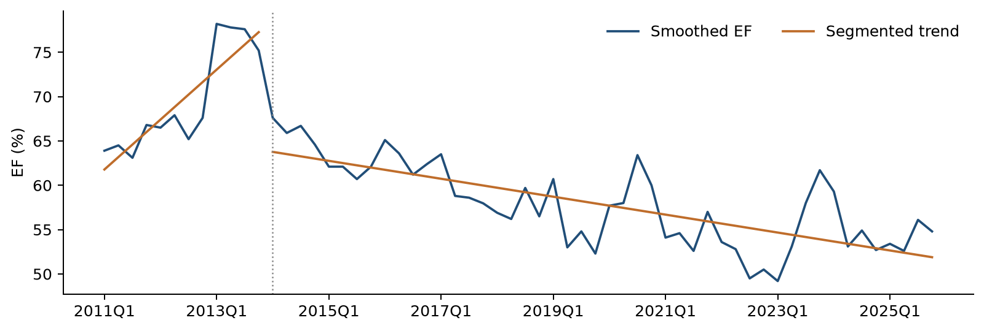
A common-slope regression with D and t has adjusted R² of 0.6389 in full history. Adding D × t increases this to 0.7807. This supports a changing deterministic slope as a description of the history. The dynamic forecasting equation below is evaluated separately; it is not an algebraic restatement of this regression.

4 Macro selection and ARDL with trend
Strict forward selection starts with a constant, D, t and EF lag 1. In each round, we add the remaining macro with the smallest two-sided conditional p value below 0.05. The search stops when no additional variable qualifies. No backward removal occurs. All 22 candidates use identical observations, transformations and one-quarter macro lags. Appendix A lists every first-round result.
$\begin{aligned}{EF}_{t} = c + δD_{t} + bt + φ{EF}_{t−1} + λΔU_{t−1} + ε_{t}\end{aligned}$
U denotes the unemployment rate in percent. The data column is named unemp; we refer to it as unrate in the report. ΔU is a percentage-point change. The equation uses smoothed EF in levels and includes no transition pulse.
Table 5 Strict forward selection paths
Base specification | Round | Best candidate | Entry p | Decision
With trend | 1 | unrate | 0.0330 | Enter
With trend | 2 | FGDP52Q_B.IUSA | 0.2229 | Stop
No trend | 1 | gap | 0.0267 | Enter
No trend | 2 | eci | 0.0788 | Stop
Table 6 Selected ARDL with trend using 49 observations
Term | Coefficient | Std error | t statistic | p value
Constant | 0.271984 | 0.077499 | 3.510 | 0.0010
Postbreak dummy D | −0.034941 | 0.014548 | −2.402 | 0.0206
Linear trend t | −0.000807 | 0.000581 | −1.389 | 0.1719
EF lag 1 | 0.634474 | 0.106243 | 5.972 | 3.711e-07
Δunrate lag 1 | 0.006204 | 0.002819 | 2.201 | 0.0330
With trend included, unrate enters and no second macro qualifies. The trend coefficient is −0.000807 with p = 0.1719. We remove t and reestimate the same unrate specification. This is a conditional simplification of the forecasting equation; it does not negate the historical trend detected by the static regression. The analysis of the trend model stops at parameter significance.
A separate strict search starting without trend selects gap. We therefore distinguish the mechanical selection path from the final judgment-based choice among the unrate, gap and GDP models. Coefficient p values after screening are descriptive and are not adjusted for searching across 22 candidates.

5 Final ARDL and alternative macro models
$\begin{aligned}{EF}_{t} = c + δD_{t} + φ{EF}_{t−1} + λΔU_{t−1} + ε_{t}\end{aligned}$
Table 7 Final unrate model estimated through 2023Q3
Term | Coefficient | Std error | t statistic | p value
Constant | 0.193795 | 0.053801 | 3.602 | 0.0008
Postbreak dummy D | −0.043633 | 0.013267 | −3.289 | 0.0020
EF lag 1 | 0.738292 | 0.076265 | 9.681 | 1.424e-12
Δunrate lag 1 | 0.006417 | 0.002844 | 2.257 | 0.0289
$\begin{aligned}{EF}_{t} = 0.193795 − 0.043633D_{t} + 0.738292{EF}_{t−1} \\ + 0.006417ΔU_{t−1} + ε_{t}\end{aligned}$
Table 8 Same sample comparison of no trend models
Macro | Macro p | Adjusted R² | Fit RMSE | AIC | BIC
unrate | 0.0289 | 0.826462 | 0.02833 | −202.205 | −194.638
gap | 0.0267 | 0.826998 | 0.02828 | −202.357 | −194.790
gdp | 0.0277 | 0.826748 | 0.02830 | −202.286 | −194.719
All three models use 49 observations and four coefficients. Adjusted R² ranges from 0.826462 to 0.826998. The largest AIC difference is 0.152. These are small descriptive differences in fit; they are not a formal statistical equivalence result. The GDP regressor is a log change, while gap and unrate are level differences, so their coefficient magnitudes are not directly comparable.
Gap, GDP and unrate are the three lowest-p no-trend candidates. ECI also passes the single-macro screen at p = 0.0473, but its conditional p value after unrate is 0.1122. No additional macro qualifies once unrate is retained.
Table 9 Selected diagnostic p values for the three alternatives
Macro | BG 4 | Koenker BP | Jarque Bera | CUSUM
unrate | 0.1816 | 0.5432 | 0.2744 | 0.7086
gap | 0.1971 | 0.6784 | 0.4824 | 0.7726
gdp | 0.1975 | 0.6725 | 0.4806 | 0.7801
We retain unrate because the statistical fit is comparable, its one-step validation error is lowest, and unemployment provides a clear interpretation for macroeconomic scenarios. A positive unemployment-change coefficient is consistent with higher costs relative to income during weaker labor-market conditions. This is an economic interpretation of a conditional association, not a causal estimate. Recursive forecast performance remains part of the comparison in Section 7.

6 Final model diagnostics
The following checks apply to the final unrate specification. Development results use the fixed 49-observation sample. The full-history column checks the same specification after refitting through 2025Q4, with 58 observations. No observations are removed in response to these diagnostics.
Table 10 Residual and specification diagnostics
Diagnostic | Development statistic | Development p | Full history p
Breusch Godfrey LM 1 | 1.2644 | 0.2608 | 0.3703
Breusch Godfrey LM 4 | 6.2444 | 0.1816 | 0.1012
Ljung Box 4 | 5.2946 | 0.1515 | 0.0799
Ljung Box 8 | 9.0562 | 0.2486 | 0.1693
Koenker Breusch Pagan | 2.1431 | 0.5432 | 0.5797
ARCH LM 4 | 0.9926 | 0.9109 | 0.8204
Jarque Bera | 2.5865 | 0.2744 | 0.3849
RESET squared fit | 0.0001 | 0.9937 | 0.9169
CUSUM | 0.7016 | 0.7086 | 0.5379
Durbin Watson | 2.1954 | Not a p test | Not a p test
At 5 percent, the tests do not reject no residual serial correlation, constant variance, no ARCH effects, normality, the tested functional form or coefficient stability. These are non-rejections, not guarantees. The full-history Ljung–Box lag 4 p value is 0.0799, so that particular check is less comfortable at a 10 percent threshold.
Breusch–Godfrey tests use one and four residual lags. Ljung–Box checks use lags 4 and 8 with one fitted autoregressive degree of freedom removed. Koenker–Breusch–Pagan tests variance against the model regressors. ARCH uses four lags with a four-parameter degrees-of-freedom adjustment. RESET adds the squared fitted value. CUSUM uses OLS residuals with the regression degrees of freedom.
Table 11 Final ARDL residual stationarity diagnostics
Sample | ADF statistic | ADF p | ADF lag | KPSS statistic | KPSS p
Development | −7.9090 | 5.294e-13 | 0 | 0.1697 | > 0.10
Full history | −5.4416 | 1.381e-07 | 2 | 0.2068 | > 0.10
These ADF and KPSS values retain the ordinary residual-diagnostic interpretation from Section 3. The development maximum VIF is 1.611 and the full-history maximum is 1.641, excluding the intercept. The autoregressive coefficient is below one in both estimates, so the fitted response to a temporary regressor shock decays over time.

7 Historical out of time forecasts
Coefficients are frozen at the development estimates through 2023Q3. One-step forecasts use observed EF from the preceding quarter. Recursive forecasts start from actual 2023Q3 EF and then use the previous forecast. Both use observed historical macro inputs. This is a conditional historical evaluation, not a forecast using macro information available only at the original forecast date.
Table 12 Nine quarter validation errors in EF ratio units
Macro | One step RMSE | One step MAE | Recursive RMSE | Recursive MAE
unrate | 0.02783 | 0.02304 | 0.03728 | 0.03481
gap | 0.02906 | 0.02394 | 0.03643 | 0.03403
gdp | 0.02878 | 0.02367 | 0.03501 | 0.03264
Unrate has the lowest one-step RMSE, 0.02783, versus 0.02906 for gap and 0.02878 for GDP. Its recursive RMSE is 0.03728, versus 0.03643 and 0.03501. A persistence benchmark gives 0.03001 one-step and 0.03962 recursive RMSE. The nine-quarter window has been reviewed during model development and is not a new untouched confirmation sample.
Figure 2 Final unrate model validation forecasts
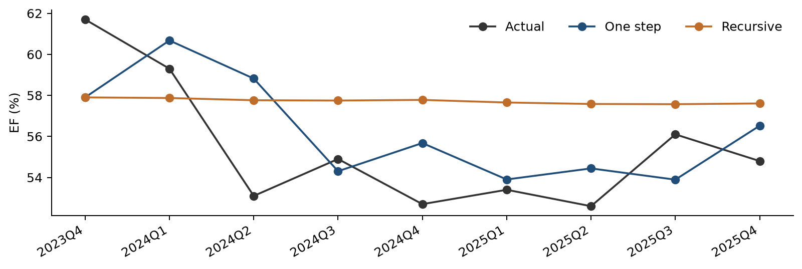
Table 13 Quarterly validation forecasts for the final unrate model
Quarter | Actual EF | One step EF | Recursive EF
2023Q4 | 0.61700 | 0.57901 | 0.57901
2024Q1 | 0.59300 | 0.60676 | 0.57871
2024Q2 | 0.53100 | 0.58818 | 0.57763
2024Q3 | 0.54900 | 0.54305 | 0.57748
2024Q4 | 0.52700 | 0.55677 | 0.57779
2025Q1 | 0.53400 | 0.53903 | 0.57653
2025Q2 | 0.52600 | 0.54441 | 0.57581
2025Q3 | 0.56100 | 0.53893 | 0.57570
2025Q4 | 0.54800 | 0.56520 | 0.57605

8 Full history refit and robustness checks
After comparing the development models, we refit the fixed unrate specification through 2025Q4. This uses all 58 lag-eligible historical observations. We do not rerun selection on these additional quarters. The resulting coefficients are used for the forward S1 and S4 forecasts, not for the historical validation scores.
Table 14 Unrate model refitted through 2025Q4
Term | Coefficient | Std error | t statistic | p value
Constant | 0.194684 | 0.050779 | 3.834 | 0.0003
Postbreak dummy D | −0.045338 | 0.012983 | −3.492 | 0.0010
EF lag 1 | 0.736985 | 0.071876 | 10.254 | 2.797e-14
Δunrate lag 1 | 0.006314 | 0.002810 | 2.247 | 0.0288
$\begin{aligned}{EF}_{t} = 0.194684 − 0.045338D_{t} + 0.736985{EF}_{t−1} \\ + 0.006314ΔU_{t−1} + ε_{t}\end{aligned}$
Adjusted R² is 0.8212 and the residual standard error is 0.02924. The unemployment-change coefficient remains positive and significant at 5 percent. Its estimate changes from 0.006417 in development to 0.006314 after the refit.
Table 15 Largest development Cook distances without deleting rows
Quarter | Cook distance | Leverage | Studentized residual
2013Q1 | 0.2990 | 0.1025 | 3.653
2020Q3 | 0.0709 | 0.8169 | −0.250
2014Q1 | 0.0689 | 0.2031 | −1.040
Cook distances are screening indicators, not deletion rules. In a leave-one-out check with the same specification, the unemployment coefficient ranges from 0.005680 to 0.007907. Its p value ranges from 0.0132 to 0.2392. This records dependence on individual observations without changing the main estimation sample.
Table 16 Sensitivity to EF smoothing using the same specification
EF input | Adjusted R² | One step RMSE | Recursive RMSE
Smoothed | 0.8265 | 0.02783 | 0.03728
Original | 0.7188 | 0.02827 | 0.03919
The original-data sensitivity retains both original 2017 observations and the confirmed 2020Q3 value of 0.634. It changes EF and its lag, but does not repeat macro selection. The requested smoothed series remains the main model input.

9 S1 and S4 scenario forecasts
S1 is the original Baseline unemployment path. S4 is the separate supplied unemployment path. Both are conditional inputs, not estimated by this model. Forecasts begin from actual 2025Q4 EF of 0.548, use the full-history coefficients, set D = 1 and feed each forecast into the next quarter. The macro paths are not merged or relabeled.
Table 17 Scenario inputs and recursive EF forecasts
Quarter | S1 unrate % | S4 unrate % | S1 EF % | S4 EF %
2026Q1 | 4.333 | 6.565 | 55.395 | 55.395
2026Q2 | 4.267 | 7.900 | 55.686 | 57.096
2026Q3 | 4.170 | 8.566 | 55.933 | 57.856
2026Q4 | 4.303 | 8.936 | 56.095 | 57.994
2027Q1 | 4.513 | 9.191 | 56.360 | 57.909
2027Q2 | 4.623 | 9.359 | 56.604 | 57.774
2027Q3 | 4.703 | 9.429 | 56.720 | 57.619
2027Q4 | 4.710 | 9.456 | 56.787 | 57.443
2028Q1 | 4.680 | 9.428 | 56.790 | 57.287
Figure 3 S1 and S4 unemployment paths and nine quarter EF forecasts
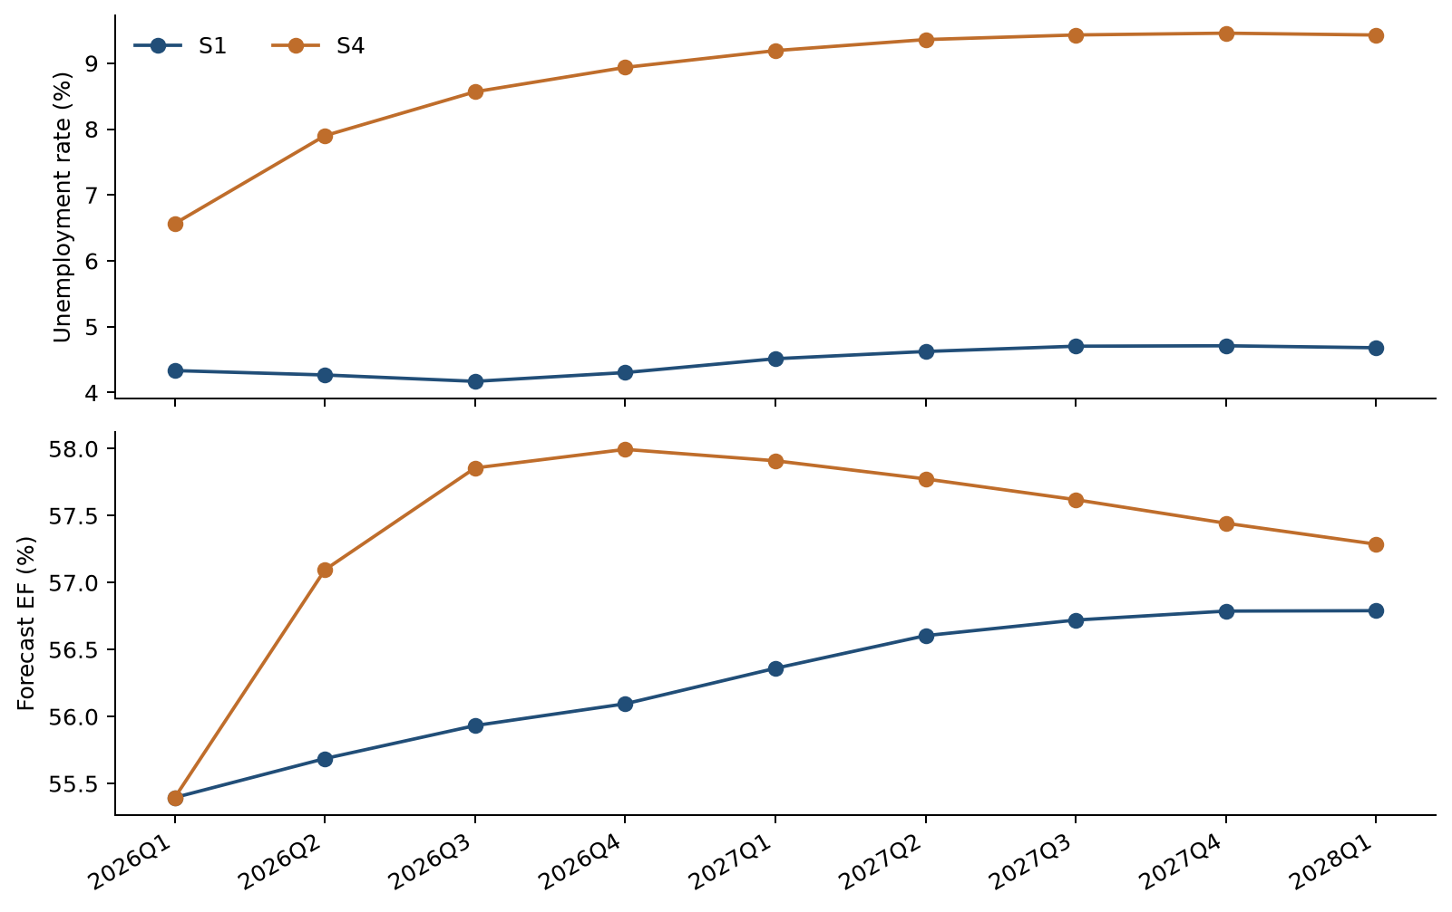
Both EF forecasts equal 55.395 percent in 2026Q1 because that quarter uses the common historical unemployment change from 2025Q3 to 2025Q4. Scenario effects first enter in 2026Q2. The 2028Q1 unemployment input would first affect EF in 2028Q2, beyond this forecast horizon. These are conditional point forecasts, not probability bounds.

10 Unemployment sensitivity
We shift every future unemployment level up or down by one percentage point and leave historical levels unchanged. This is a parallel level shift, not a one percent relative change and not an extra one percentage point increase each quarter. We recompute quarterly differences and their lags before forecasting. The same test is applied separately to S1 and S4.
Table 18 S1 unemployment level sensitivity
Quarter | EF at U minus 1 pp % | Baseline EF % | EF at U plus 1 pp %
2026Q1 | 55.395 | 55.395 | 55.395
2026Q2 | 55.055 | 55.686 | 56.318
2026Q3 | 55.467 | 55.933 | 56.398
2026Q4 | 55.752 | 56.095 | 56.438
2027Q1 | 56.107 | 56.360 | 56.613
2027Q2 | 56.418 | 56.604 | 56.790
2027Q3 | 56.583 | 56.720 | 56.858
2027Q4 | 56.686 | 56.787 | 56.888
2028Q1 | 56.716 | 56.790 | 56.865
Figure 4 EF response to a parallel shift in the S1 unemployment path
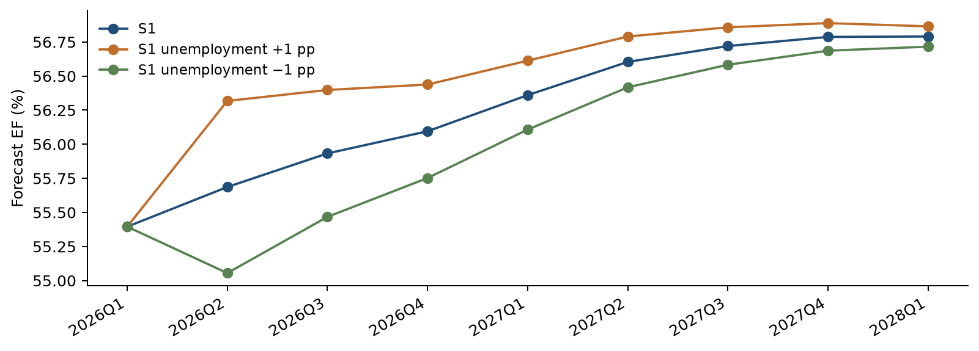
The effect is zero in 2026Q1. A one percentage point upward shift raises EF by 0.6314 percentage points in 2026Q2. Thereafter, the effect decays at the estimated autoregressive factor of 0.736985 per quarter. The downward shift produces the same magnitude with the opposite sign. The incremental sensitivity around S4 is identical because the model is linear.
$\begin{aligned}{ΔEF}_{2026Q2} = λ × 1 = 0.006314 \\ {ΔEF}_{2026Q3} = φ × 0.006314\end{aligned}$
This decay is expected for a model driven by changes in unemployment. A permanently higher future unemployment level creates an initial change at the forecast boundary, but not a repeated additional change every quarter. A separate one-development-standard-deviation shock to the transformed input has size 1.5054 percentage points and an immediate EF response of 0.9505 percentage points.

Appendix A Complete macro candidate screen
All entries below are first-round conditional p values from the same 49 observations. The trend screen conditions on constant, D, t and EF lag 1. The no-trend screen omits t. L denotes a quarterly log change and Δ a quarterly level difference; all transformed inputs are lagged one quarter. Provider identifiers are retained where no descriptive label is supplied.
Table 19 All 22 candidate variables
Candidate | Transform | With trend p | No trend p
earnings | L | 0.0832 | 0.4811
ulc | L | 0.4092 | 0.4072
eci | L | 0.1455 | 0.0473
fed | Δ | 0.1077 | 0.0756
t2y | Δ | 0.1104 | 0.0770
t10y | Δ | 0.3984 | 0.1839
unrate (unemp) | Δ | 0.0330 | 0.0289
confidence | Δ | 0.3444 | 0.3969
optimism | Δ | 0.4743 | 0.4813
gdp | L | 0.0372 | 0.0277
gap | Δ | 0.0344 | 0.0267
assets | L | 0.1108 | 0.1613
loans | L | 0.1477 | 0.1072
vix | Δ | 0.5231 | 0.4135
hy | Δ | 0.4122 | 0.2863
FPCNBCPH_B.IUSA | Δ | 0.1046 | 0.1655
FLBOPQ_B.IUSA | Δ | 0.3242 | 0.3320
FYPEW52Q_B.IUSA | Δ | 0.7491 | 0.7032
FGDP52Q_B.IUSA | Δ | 0.1698 | 0.2203
FE52_B.IUSA | Δ | 0.2432 | 0.2830
FYPCPIQ_B.IUSA | Δ | 0.1610 | 0.1604
FECICCQ_B.IUSA | Δ | 0.3887 | 0.1135
The final choice of unrate is not presented as a strict no-trend forward-selection victory. Gap has the lowest entry p value in that search. The final decision combines close fit, validation performance and the interpretability of the unemployment driver, as documented in Sections 5 and 7.

Appendix B Smoothed EF and method references
Table 20 Complete EF series used in the analysis
Year | Q1 | Q2 | Q3 | Q4
2011 | 0.639000 | 0.645000 | 0.631000 | 0.668000
2012 | 0.665000 | 0.679000 | 0.652000 | 0.676000
2013 | 0.782000 | 0.778000 | 0.776000 | 0.752000
2014 | 0.676000 | 0.659000 | 0.667000 | 0.646000
2015 | 0.621000 | 0.621000 | 0.607000 | 0.621000
2016 | 0.651000 | 0.636000 | 0.612000 | 0.624000
2017 | 0.635000 | 0.588000 | 0.586000 | 0.579667
2018 | 0.569000 | 0.562000 | 0.597000 | 0.565000
2019 | 0.607000 | 0.530000 | 0.548000 | 0.523000
2020 | 0.577000 | 0.580000 | 0.634000 | 0.600000
2021 | 0.541000 | 0.546000 | 0.526000 | 0.570000
2022 | 0.536000 | 0.528000 | 0.495000 | 0.505000
2023 | 0.492000 | 0.531000 | 0.580000 | 0.617000
2024 | 0.593000 | 0.531000 | 0.549000 | 0.527000
2025 | 0.534000 | 0.526000 | 0.561000 | 0.548000
All 60 EF levels are retained. The static regression uses every level in its designated window. The first two levels remain available as history even though transformed macro lags make 2011Q3 the first ARDL dependent-variable observation. Ratios, differences and forecasts are calculated at full precision; tables show rounded values.

Method references
[1] statsmodels documentation for the Augmented Dickey Fuller test
[2] statsmodels documentation for the KPSS test and p value bounds
[3] EViews unit root testing and estimated residual reference distributions
ADF uses AIC over lags 0–4 and no additional deterministic term for residual diagnostics. KPSS uses a constant and an automatic bandwidth. A reported KPSS p > 0.10 is a tabulation bound, not an exact p value. S1 and S4 are supplied scenario assumptions and have no probabilities attached.

