Occupancy Cost

Methodology
Occupancy cost is modeled as an annualized ratio of quarterly occupancy expense to average bank asset size. Occupancy expense is the sum of the three monthly values in each quarter. Bank asset size is the average of the three month-end balances in each quarter (for example, 2025Q4 is the average of the October, November and December 2025 balances).
Occupancy Cost Ratio = Quarterly Occupancy Expense / Average Bank Asset Size × 4
Under the stress scenario, quarterly occupancy expense is the projected average asset size multiplied by the stress ratio and divided by 4.

Historical Data and Calibration
The stress ratio is set at 0.351%, the post-2019 average of 0.315% plus two standard deviations. The history covers 60 quarters, 2011Q1 through 2025Q4.
Average bank asset size was broadly flat at $26B to $33B through 2018, then shifted from $32.5B in 2018Q4 to $46.1B in 2019Q1 within a single quarter. Assets grew steadily through mid-2023 and have since stayed near $60B, ending 2025Q4 at $61.6B.
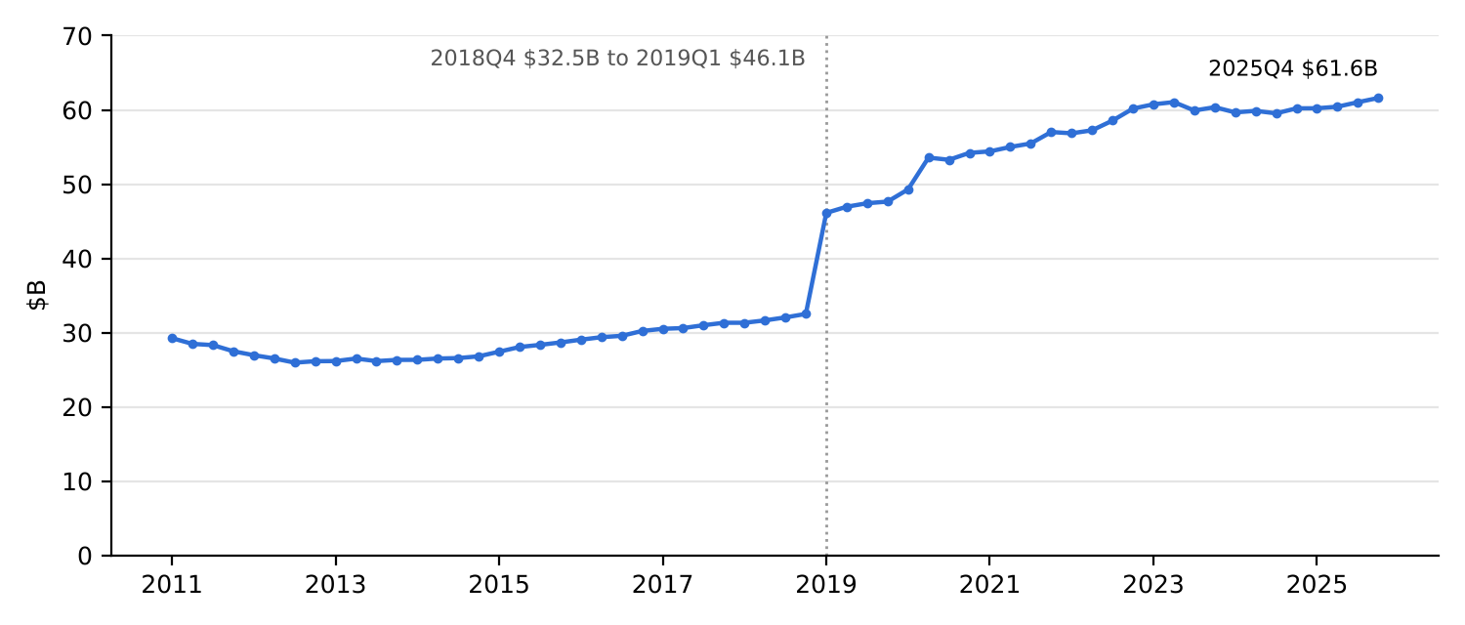
Figure 1 Historical Average Bank Asset Size
The ratio ranged from 0.365% to 0.422% before 2019 and dropped sharply in 2019Q1, as the asset base expanded much faster than occupancy expense. Since then it has ranged from 0.280% (2023Q2) to 0.358% (2019Q4) and has held near 0.321% over 2025. Because the 2019Q1 shift is a change in level rather than normal variation, the ratio is calibrated on the post-2019 window only (2019Q1 through 2025Q4, 28 quarters).
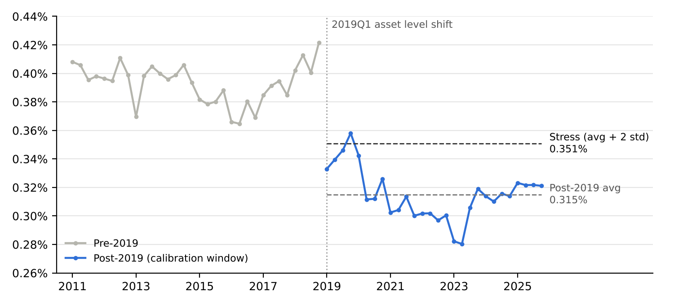
Figure 2 Historical Occupancy Cost to Average Bank Asset Size Ratio
Table 1 Occupancy Cost Calibration Statistics
Metric | Value
Calibration window | 2019Q1 – 2025Q4 (28 quarters)
Post-2019 average ratio | 0.315%
Post-2019 standard deviation | 0.018%
Stress ratio (average + 2 std) | 0.351%

Stress Projection
Stress occupancy expense applies the 0.351% stress ratio to the stressed average asset path for each forecast quarter:
Stress Occupancy Expense = Stressed Average Asset Size × 0.351% / 4
The ratio is set above its average because occupancy costs are largely fixed in the short term. Leases, premises and equipment do not shrink with the balance sheet, so a contracting asset base pushes the cost-to-asset ratio up. Using average plus two standard deviations produces higher expense, and therefore lower PPNR, than the historical average, which is the conservative direction for stress testing.

Key Assumptions and Limitations
- The 2019Q1 level shift reflects a structural change in the balance sheet, so only post-2019 data are used to calibrate the ratio.
- Occupancy expense is assumed to move with average asset size at a stable ratio over the forecast horizon.
- The two-standard-deviation buffer is statistical rather than tied to macroeconomic scenario variables, and the 28-quarter window contains no severe asset contraction.
- The ratio is not separated into fixed and variable cost components, so a sharp asset decline could push the true ratio above 0.351%.

