Card Fee Model Development Documentation
卡业务手续费模型开发文档
  - Commercial and Small Business Card
Consumer Card and Debit Card
商业卡及小企业卡
消费者信用卡及借记卡
Version 6
第6版
Historical data through December 2025
Quantitative projection horizon January 2026 through March 2028
历史数据截至2025年12月
定量预测期间为2026年1月至2028年3月
  - Document date October 14 2026
文档日期 2026年10月14日
The Card Fee Model provides a component-specific framework for forecasting Commercial Card and Small Business, Consumer Card, and Debit Card revenue. This document describes the business rationale, development data, model estimation, testing, implementation, monitoring and governance of that framework. Commercial and Consumer use regression models, while Debit uses historical quarterly calibration. The following sections explain each methodology and its supporting evidence.
卡业务手续费模型分别预测商业卡与小企业卡、消费卡及借记卡收入。本文说明该框架的业务依据、开发数据、模型估计、测试、实施、监控及治理。商业卡和消费卡采用回归模型，借记卡采用历史季度校准方法。以下各节介绍各项方法及其支持证据。
Document control
文档控制
Field  字段 | Record  记录
Model name  模型名称 | Card Fee Model Suite  卡业务手续费模型体系
Model inventory IDs and risk tier  模型清单编号及风险等级 | [confirm suite and component IDs and risk classification]  [确认体系与各组成部分编号及风险分级]
Model owner and developer  模型所有人与开发人员 | [insert names, titles and business units]  [填写姓名、职位及业务单位]
Business users  业务用户 | [confirm Strategic Finance, Capital Planning and other users]  [确认战略财务、资本规划及其他用户]
Version and approval  版本与批准 | Version 6; [approval authority, date and status]  第6版；[批准机构、日期及状态]
All fee-revenue amounts are in $000 (thousands of US dollars), with no rescaling applied.
所有手续费收入金额均以 $000（千美元）表示，未进行额外缩放。
Source notation: key statistical and forecast-error values are followed by the component, actual file name and CSV row and column, for example [consumer/​model_​diagnostics.csv/​row 3 col 6]. CSV headers count as row 1 and columns are counted from the left. Component source locations are listed in Appendix G. Other numerical information is supported by the relevant table or figure source caption. Fee-revenue amounts are in $000; display rounding is for presentation only.
来源标注规则：关键统计量和预测误差数值之后注明模型组成部分、实际文件名以及CSV行列位置，例如[consumer/​model_​diagnostics.csv/​row 3 col 6]。CSV表头计为第1行，列从左向右编号。各组成部分的来源目录见附录G。其他数字由相应表格或图形的来源说明支持。手续费收入单位为$000；显示时的四舍五入仅用于呈现。

Contents
目录
1. Executive Summary
1. 执行摘要
2. Model Theory and Design
2. 模型理论与设计
3. Model Estimation
3. 模型估计
4. Development Data
4. 开发数据
5. Linkages with Other Models
5. 与其他模型的关联
6. Model Testing
6. 模型测试
7. Model Implementation
7. 模型实施
8. Model Monitoring
8. 模型监控
9. Procedures
9. 操作程序
10. Governance
10. 治理
11. Appendix Information
11. 附录信息

1. Executive Summary
1. 执行摘要

1.1 Model Overview
1.1 模型概述
The Card Fee Model was developed to forecast card fee revenue for Comprehensive Capital Analysis and Review (CCAR), stress testing, capital planning, budgeting, and Pre-Provision Net Revenue (PPNR) forecasting. The model provides a quantitative framework for translating historical revenue behavior, relevant macroeconomic conditions and documented business assumptions into forward-looking projections. It covers Commercial Card and Small Business, Consumer Card, and Debit Card through component-specific regression and historical calibration approaches. Development used monthly observations spanning January 2011 through December 2025, with separate estimation windows and transformations for each component. The framework was designed to remain transparent, economically interpretable, operationally practical and consistent with Model Risk Management expectations.
卡业务手续费模型旨在预测手续费收入，用于全面资本分析与审查（CCAR）、压力测试、资本规划、预算及拨备前净收入（PPNR）预测。模型提供定量框架，将历史收入表现、相关宏观条件和已记录业务假设转化为前瞻预测。商业卡与小企业卡、消费卡和借记卡分别采用回归或历史校准方法。开发使用2011年1月至2025年12月月度观测，各部分分别确定估计窗口和转换。框架注重透明、经济可解释、操作可行及符合模型风险管理要求。

1.2 Business Purpose
1.2 业务目的
Card fee revenue represents an important component of non-interest income generation across Commercial Card and Small Business, Consumer Card, and Debit Card activities.
商业卡与小企业卡、消费卡及借记卡业务产生的手续费收入是非利息收入的重要组成部分。
Forecasting card fee revenue is inherently challenging because customer spending, payment preferences, transaction activity, product mix, pricing and business initiatives can affect realized outcomes. These influences are not fully represented by aggregate revenue and macroeconomic data. The objective is therefore to identify recurring revenue dynamics and economically meaningful relationships that can be projected within planning and stress-testing environments. Separate component approaches accommodate differences in seasonal behavior, adjustment dynamics and the statistical support for a regression relationship.
卡业务手续费收入预测具有固有难度，因为客户消费、支付偏好、交易活动、产品组合、定价及业务举措均可能影响实际结果。汇总收入和宏观数据无法完全代表这些影响。因此，目标是识别可在规划和压力测试环境中预测的重复性收入动态及有经济意义的关系。各组成部分采用不同方法，以适应季节行为、调整动态及回归关系统计支持程度的差异。

1.3 Intended Use
1.3 预期用途
Model outputs support CCAR forecasting and capital planning. Forecasts are intended to inform management decision-making and provide a disciplined framework for evaluating prospective changes in card fee revenue under alternative economic and business conditions. The model is not intended to evaluate individual customers, determine card pricing or fee structures, or replace management judgment.
模型输出用于支持CCAR预测和资本规划。预测旨在为管理决策提供信息，并为评估不同经济和业务条件下未来卡业务手续费收入的变化提供规范框架。模型不用于评估个别客户、决定卡产品定价或收费结构，也不替代管理层判断。

1.4 Development Summary
1.4 开发概述
Model development followed a structured process that moved from component-specific candidate variables through transformation, statistical screening, specification selection and forecast testing. The candidate sets included revenue lags, growth rates, seasonal indicators and moving averages. For the combined Commercial Card and Small Business model, short-run macroeconomic candidates were pre-screened using partial-correlation significance and sign consistency across the development and out-of-time periods. Subsequent short-run variable selection and coefficient estimation used development-period observations. Consumer Card selection used the development sample before later-period testing. Debit Card regression candidates did not satisfy the complete acceptance criteria, leading to a historical quarterly calibration. The process sought a balance of statistical evidence, economic interpretability and forecasting practicality rather than the highest in-sample fit alone.
模型开发遵循结构化过程，从各组成部分候选变量出发，依次完成转换、统计筛选、设定选择及预测测试。候选集合包含收入滞后、增长率、季节性指标和移动平均。合并商业卡与小企业卡的短期宏观候选，依据开发期及OOT期的偏相关显著性和符号一致性预筛选，后续短期变量选择与系数估计使用开发期观测。消费卡先用开发样本选择，再开展后期测试。借记卡回归候选未满足全部接受标准，因此采用历史季度校准。流程注重统计证据、经济可解释性和预测实用性的平衡，而非仅追求最高样本内拟合。

1.5 Final Model
1.5 最终模型

Commercial Card and Small Business
商业卡与小企业卡
The final Commercial Card and Small Business specification combines a CPI-based long-run revenue reference with a short-run equation for year-over-year fee growth. The adjusted error-correction term represents the relationship between a prior deviation from the reference and subsequent growth. Lagged fee-growth terms represent persistence, while lagged Corporate Profits growth captures a business-conditions association. Each term has a distinct role within the forecasting mechanism. The specification assumes that the nominal reference, historical adjustment relationships and calibrated EC treatment remain relevant over the projection horizon.
最终商业卡与小企业卡设定结合CPI长期收入参照和手续费同比增长短期方程。调整后误差修正项表示先前偏离参照与后续增长的关系；手续费增长滞后项代表持续性，企业利润增长滞后项反映商业环境关联。各项在预测机制中承担不同作用。该设定假设名义参照、历史调整关系和已校准EC处理在预测期间持续适用。
Table 1.1 Commercial Card and Small Business Final Model Variable Summary
表1.1 商业卡与小企业卡最终模型变量汇总
Variable  变量 | Description  描述 | Construction  构造
consumer_​price_​index | Long-run nominal revenue reference  长期名义收入参照 | CPI level from M_​FCPIU_​B.IUSA; no growth transformation or lag in the long-run equation.  取M_​FCPIU_​B.IUSA的CPI水平；长期方程不作增长转换或滞后。
ec_​scaled_​adjusted_​pct_​lag_​12m | Lagged adjusted error-correction term  滞后调整后误差修正项 | Fee deviation from its fitted long-run reference, divided by that reference and expressed as a percentage; subtract the contemporaneous trend adjustment, then lag 12 months.  手续费与长期拟合参照之差除以参照，以百分数表示；减去同期趋势调整，再滞后12个月。
commercial_​small_​business_​fee_​pct_​change_​12m_​lag_​1m | Lagged annual fee growth  滞后年度手续费增长 | Year-over-year percentage change in combined fees, lagged 1 month.  合并手续费同比百分比变化，滞后1个月。
commercial_​small_​business_​fee_​pct_​change_​12m_​lag_​6m | Lagged annual fee growth  滞后年度手续费增长 | Year-over-year percentage change in combined fees, lagged 6 months.  合并手续费同比百分比变化，滞后6个月。
corporate_​profits_​pct_​change_​12m_​lag_​2m | Business-conditions driver  商业环境驱动因素 | Year-over-year percentage change in Corporate Profits, lagged 2 months.  企业利润同比百分比变化，滞后2个月。
Sources: commercial/​commercial_​card_​model.py, lines 51–60 and 280–319; commercial/​short_​run_​coefficients.csv. CPI belongs to the long-run equation; the other terms belong to the short-run equation. Intercepts are reported in the detailed regression tables.
来源：commercial/​commercial_​card_​model.py，第51–60行及280–319行；commercial/​short_​run_​coefficients.csv。CPI属于长期方程，其余变量属于短期方程。截距在详细回归结果表中列示。

Consumer Card
消费卡
The final Consumer Card specification models monthly logarithmic fee changes using lagged revenue changes, January and December indicators, and smoothed Retail Sales growth. The lagged terms represent short-term adjustment, the calendar indicators represent recurring seasonal effects, and Retail Sales provides a spending-related macroeconomic driver. Together, these terms explain different aspects of monthly revenue behavior within a parsimonious equation. Forecasting assumes that these dynamic, seasonal and spending relationships remain relevant beyond the estimation sample.
最终消费卡设定通过收入变化滞后项、1月和12月指标及平滑零售销售增长，对月度手续费对数变化建模。滞后项代表短期调整，日历指标代表重复季节效应，零售销售提供消费支出相关的宏观驱动因素。各项在简约方程中解释月度收入行为的不同方面。预测假设这些动态、季节和支出关系在估计样本之后仍有效。
Table 1.2 Consumer Card Final Model Variable Summary
表1.2 消费卡最终模型变量汇总
Variable  变量 | Description  描述 | Construction  构造
consumer_​card_​fee_​log_​change_​1m_​pct_​lag_​1m | Lagged monthly fee log change  滞后月度手续费对数变化 | Monthly log difference in Consumer fees, multiplied by 100 and lagged 1 month.  消费卡手续费月度对数差分乘以100，滞后1个月。
consumer_​card_​fee_​log_​change_​1m_​pct_​lag_​2m | Lagged monthly fee log change  滞后月度手续费对数变化 | Monthly log difference in Consumer fees, multiplied by 100 and lagged 2 months.  消费卡手续费月度对数差分乘以100，滞后2个月。
is_​january | January seasonal indicator  1月季节性指标 | Equals 1 in January and 0 otherwise.  1月为1，其余月份为0。
is_​december | December seasonal indicator  12月季节性指标 | Equals 1 in December and 0 otherwise.  12月为1，其余月份为0。
retail_​sales_​pct_​change_​1m_​ma_​3m | Smoothed spending-growth driver  平滑支出增长驱动因素 | Arithmetic mean of current and prior two monthly Retail Sales percentage changes.  当月及前两个月零售销售月度百分比变化的算术平均。
Sources: consumer/​consumer_​card_​model.py, lines 49–52 and 107–118; consumer/​coefficients.csv. The table excludes the intercept, which is reported in the detailed regression tables.
来源：consumer/​consumer_​card_​model.py，第49–52行及107–118行；consumer/​coefficients.csv。本表不含截距；截距在详细回归结果表中列示。

Debit Card
借记卡
Debit Card uses a historical quarterly calibration rather than a selected macroeconomic regression. The baseline is the mean revenue of the latest 8 complete quarters and represents the recent run rate. The stress floor is the quarterly mean from January 2015 onward less 2 sample standard deviations and provides a historically calibrated downside reference. This method separates the recent operating level from the longer-period severity assessment. Its usefulness depends on the representativeness of the retained history and the appropriateness of the selected severity rule for the intended application.
借记卡采用历史季度校准，而非选定宏观回归。基准为最近8个完整季度收入均值，代表近期运行水平。压力下限为2015年1月起季度均值减去2倍样本标准差，提供历史校准下行参照。该方法区分近期经营水平与较长期严重程度评估。其有效性取决于保留历史的代表性和严重程度规则对预期用途的适当性。
Figure 1.1 Component forecasting framework
图1.1 各组成部分预测框架
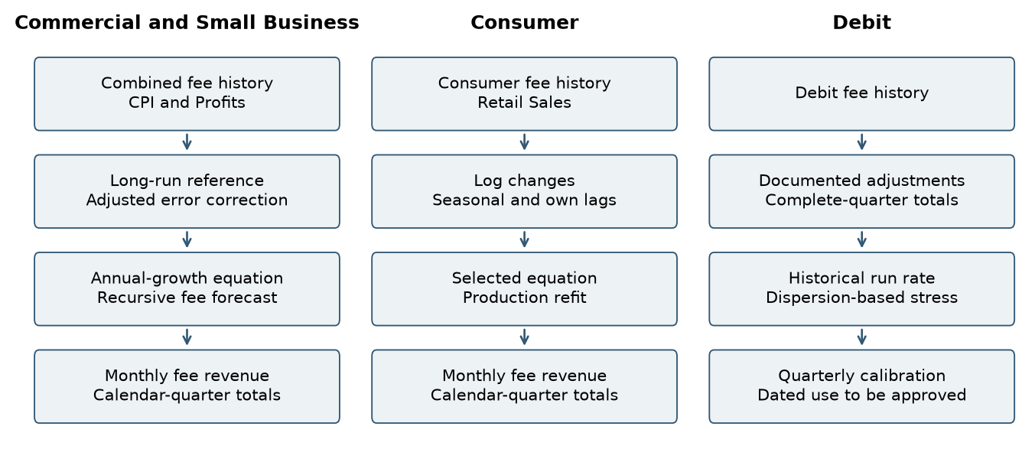
Methodology diagram based on the component code. Separate lanes preserve differences in target, frequency and judgment. The Debit output is a calibration level, not a generated monthly trajectory. Data sources: commercial/​commercial_​card_​model.py; commercial/​commercial_​card_​model.py; consumer/​consumer_​card_​model.py; debit/​debit_​card_​model.py.
方法流程图依据各组成部分的代码绘制。独立分支保留了目标变量、频率和判断方式的差异。借记卡输出为校准水平，而非生成的月度路径。数据来源：commercial/​commercial_​card_​model.py；consumer/​consumer_​card_​model.py；debit/​debit_​card_​model.py。

1.6 Performance Summary
1.6 表现概述
In-sample testing assessed explanatory power, coefficient significance, multicollinearity and residual behavior for the selected regression components. Commercial Card and Small Business and Consumer Card both retained statistically significant coefficients, with limited multicollinearity in their final development equations. The table below presents the principal results; the detailed testing discussion distinguishes equation-scale diagnostics from fee-level forecast accuracy.
样本内测试评估所选回归部分的解释力、系数显著性、多重共线性和残差表现。商业卡与小企业卡及消费卡最终开发方程的系数均有统计显著性，多重共线性有限。下表列出主要结果；详细测试讨论区分方程尺度诊断和手续费水平预测准确性。
Table 1.3 Regression Performance Summary
表1.3 回归表现汇总
Metric  指标 | Commercial Card and Small Business  商业卡与小企业卡 | Consumer Card  消费卡
Adjusted R-squared  调整后R平方 | 73.57% [commercial/​short_​run_​diagnostics.csv/​row 2 col 3] | 61.14% [consumer/​model_​diagnostics.csv/​row 3 col 6]
Coefficient significance  系数显著性 | All final coefficients have p < 0.05 [commercial/​short_​run_​coefficients.csv/​row 2–6 col 6]  所有最终系数均满足 p < 0.05 [commercial/​short_​run_​coefficients.csv/​row 2–6 col 6] | All final coefficients have p < 0.05 [consumer/​coefficients.csv/​row 7–12 col 6]  所有最终系数均满足 p < 0.05 [consumer/​coefficients.csv/​row 7–12 col 6]
Maximum VIF  最大VIF | 2.25 [commercial/​short_​run_​diagnostics.csv/​row 2 col 11] | 1.70 [consumer/​model_​diagnostics.csv/​row 3 col 12]
Durbin-Watson statistic  Durbin–Watson统计量 | 2.032 [commercial/​short_​run_​diagnostics.csv/​row 2 col 5] | 2.356 [consumer/​model_​diagnostics.csv/​row 3 col 7]
Sources: commercial/​short_​run_​diagnostics.csv; commercial/​short_​run_​coefficients.csv; consumer/​model_​diagnostics.csv; consumer/​coefficients.csv. Consumer results refer to the selected development model, not the production refit.
来源：commercial/​short_​run_​diagnostics.csv；commercial/​short_​run_​coefficients.csv；consumer/​model_​diagnostics.csv；consumer/​coefficients.csv。消费卡结果对应选定的开发模型，而非生产预测重估模型。
Stability evidence is component-specific. Consumer Card rolling estimates retained the signs of all final explanatory variables, although their magnitudes changed across windows. Debit Card did not retain a regression because no tested specification met all acceptance criteria. Its performance assessment therefore focuses on the transparency and reasonableness of the adopted historical calibration.
稳定性证据因组成部分而异。消费卡滚动估计中所有最终解释变量符号不变，但幅度随窗口变化。借记卡没有测试设定满足全部接受标准，因此未保留回归，其表现评估转而关注所采用历史校准的透明性和合理性。
For Debit Card, the baseline and stress floor summarize different aspects of the historical distribution. The baseline measures the recent quarterly revenue run rate, while the floor reflects the selected downside-severity rule. The following table reports calibration outputs rather than regression fit or forecast-error statistics.
借记卡基准及压力下限概括历史分布的不同方面：基准衡量近期季度收入运行水平，下限反映选定下行严重程度规则。下表报告校准输出，而非回归拟合或预测误差统计量。
Table 1.4 Debit Card Historical Calibration Summary
表1.4 借记卡历史校准汇总
Measure  衡量项目 | Value  数值
Quarterly baseline revenue ($000)  季度基准收入（$000） | 4,747.625
Quarterly stress floor ($000)  季度压力下限（$000） | 3,813.653
Decline from baseline to stress floor  基准至压力下限降幅 | 19.67%
Data source: debit/​qualitative_​scenarios.csv. These are historical calibration outputs, not OOT forecast-accuracy statistics.
数据来源：debit/​qualitative_​scenarios.csv。这些数值是历史校准结果，不是样本外预测准确性统计量。

1.7 Out-of-Time Results
1.7 样本外结果
Out-of-time assessment used October 2023 through December 2025 to examine later-period forecasting behavior of the regression components.
样本外评估使用2023年10月至2025年12月，考察回归组成部分的后期预测表现。
Commercial Card and Small Business testing evaluated static forecasts and Full Recursive OOT forecasts. Full Recursive OOT initializes endogenous states with actual history through September 2023 and then updates fee levels, own-growth lags and adjusted error-correction states using prior predictions. Historical macroeconomic inputs and the calibrated EC trend adjustment are retained.
商业卡及小企业卡测试包括静态预测和完全递归OOT预测。完全递归OOT使用截至2023年9月的实际历史数据初始化内生状态，随后利用先前预测值更新手续费水平、自身增长率滞后项和调整后的误差修正状态。宏观输入及已校准的EC趋势调整保持不变。
Consumer Card testing retained the selected development-period coefficients and evaluated both static and recursive forecasts. The recursive procedure updated revenue levels and lagged revenue changes using model predictions, while using observed macroeconomic inputs.
消费卡测试保留选定的开发期系数，并评估静态和递归预测。递归程序使用模型预测更新收入水平及收入变化滞后项，同时使用实际宏观经济输入。
Debit Card uses a historical quarterly calibration approach; regression-based OOT testing is not applicable.
借记卡采用历史季度校准方法；基于回归的样本外（OOT）测试不适用。
Table 1.5 Out-of-Time Results by Component
表1.5 各组成部分样本外结果
Component  组成部分 | Test method  测试方法 | MAPE | RMSE ($000)
Commercial Card and Small Business  商业卡与小企业卡 | Static OOT  静态OOT | 8.76% [commercial/​forecast_​accuracy.csv/​row 3 col 5] | 231.43 [commercial/​forecast_​accuracy.csv/​row 3 col 3]
Commercial Card and Small Business  商业卡与小企业卡 | Full Recursive OOT  完全递归OOT | 16.95% [commercial/​forecast_​accuracy.csv/​row 4 col 5] | 399.13 [commercial/​forecast_​accuracy.csv/​row 4 col 3]
Consumer Card  消费卡 | Static OOT  静态OOT | 5.05% [consumer/​forecast_​accuracy.csv/​row 3 col 3] | 45.89 [consumer/​forecast_​accuracy.csv/​row 3 col 4]
Consumer Card  消费卡 | Recursive OOT  递归OOT | 5.96% [consumer/​forecast_​accuracy.csv/​row 4 col 3] | 53.34 [consumer/​forecast_​accuracy.csv/​row 4 col 4]
Debit Card  借记卡 | Historical quarterly calibration  历史季度校准 | N/​A  不适用 | N/​A  不适用
Sources: commercial/​forecast_​accuracy.csv; commercial/​fully_​recursive_​oot.csv; consumer/​forecast_​accuracy.csv; debit/​debit_​card_​model.py. Commercial and Consumer recursive tests update their respective endogenous fee states under fixed development coefficients. Commercial also retains its calibrated EC trend adjustment. N/​A means that OOT testing is not applicable to the adopted Debit methodology.
来源：commercial/​forecast_​accuracy.csv；commercial/​fully_​recursive_​oot.csv；consumer/​forecast_​accuracy.csv；debit/​debit_​card_​model.py。商业卡和消费卡递归测试均在固定开发系数下更新各自的内生手续费状态，商业卡还保留已校准的EC趋势调整。N/​A表示OOT测试不适用于所采用的借记卡方法。

1.8 Overlay Summary
1.8 调整项概述
The Commercial Card and Small Business model compares actual fee revenue with the fitted value from the CPI-based long-run model. It expresses the gap as a percentage of the fitted value. This percentage gap is called scaled EC.
商业卡及小企业卡模型将实际手续费收入与基于 CPI 的长期模型拟合值进行比较。两者的差额除以拟合值，得到百分比偏差。这个偏差称为 scaled EC。
The model estimates a time trend in scaled EC during the OOT period. It subtracts this trend to obtain adjusted EC. The short-run equation uses adjusted EC from twelve months earlier.
模型估计 OOT 期间 scaled EC 的时间趋势。扣除该趋势后，得到调整后的 EC。短期方程使用十二个月前的调整后 EC。
For future forecasts, the trend adjustment stays at its December 2025 value. The model updates EC each month using forecast revenue.
未来预测中，趋势调整项固定在 2025 年 12 月的数值。模型根据预测收入逐月更新 EC。
Consumer Card forecasts do not include a separate management overlay in the current implementation.
当前消费卡实现未采用单独的管理层调整。
Debit Card uses a historical quarterly calibration approach. Its baseline and stress-floor calculations constitute the forecasting methodology rather than an overlay applied to regression forecasts.
借记卡采用历史季度校准方法。其基准值和压力下限计算构成预测方法本身，并非在回归预测上叠加的调整。
Table 1.6 Overlay Summary by Component
表1.6 各组成部分调整项汇总
Component  组成部分 | Treatment  处理 | Implementation  实施
Commercial Card and Small Business  商业卡与小企业卡 | Trend adjustment to scaled error correction  标准化误差修正趋势调整 | Trend intercept −5.5930 percentage points; monthly slope −0.9093 percentage points; held future adjustment −30.1428 percentage points. Subtracted before constructing the lagged EC input.  趋势截距−5.5930个百分点；每月斜率−0.9093个百分点；未来固定调整−30.1428个百分点。构造滞后EC输入前扣除。
Consumer Card  消费卡 | No separate management overlay  无单独管理层调整 | Forecasts follow the selected recursive equation and the applicable scenario inputs.  预测遵循选定递归方程及适用情景输入。
Debit Card  借记卡 | No separate management overlay  无单独管理层调整 | Historical baseline and stress-floor calculations are the forecasting methodology.  历史基准及压力下限计算构成预测方法。
Sources: commercial/​overlay_​trend.csv; commercial/​commercial_​card_​model.py; consumer/​consumer_​card_​model.py; debit/​qualitative_​scenarios.csv. Commercial adjustment values are percentage points on the scaled EC state, not direct percentage changes in fee revenue.
来源：commercial/​overlay_​trend.csv；commercial/​commercial_​card_​model.py；consumer/​consumer_​card_​model.py；debit/​qualitative_​scenarios.csv。商业卡调整数值为标准化EC状态的百分点，而非手续费收入的直接百分比变化。

1.9 Key Assumptions
1.9 主要假设
The model assumes that historical fee definitions remain comparable and that the selected business relationships continue to provide useful forecasting information. Commercial Card and Small Business relies on the CPI-based revenue reference, lagged fee dynamics, Corporate Profits growth and the held EC adjustment. Consumer Card relies on recurring seasonal patterns, short-term revenue adjustment and the Retail Sales association. Debit Card relies on the recent-quarter mean as a run-rate measure and the retained historical distribution as a downside-calibration reference. The regression components also assume approximately linear relationships in the specified transformations, sufficiently stable coefficients and residual properties appropriate for estimation and inference. These assumptions depend on complete and consistently defined source data.
模型假设历史手续费定义可比，且选定业务关系继续提供有用预测信息。商业卡与小企业卡依赖CPI收入参照、滞后手续费动态、企业利润增长和固定EC调整。消费卡依赖重复季节模式、短期收入调整和零售销售关联。借记卡依赖近期季度均值作为运行水平衡量，并以保留历史分布作为下行校准参照。回归部分还假设设定转换下关系近似线性、系数足够稳定、残差性质适合估计和推断。这些假设均依赖完整且定义一致的源数据。

1.10 Key Strengths
1.10 主要优势
The principal strength of the framework is its separation of distinct revenue mechanisms into interpretable component methods. Commercial Card and Small Business combines a nominal revenue reference with short-run persistence, error correction and business conditions. Consumer Card combines spending growth with seasonal and lagged revenue effects, supported by consistent coefficient signs in the reported rolling exercise. Debit Card provides an explicit calculation of the recent run rate and historical downside reference. Retained inputs, equations, calibration rules and source-linked exhibits make these mechanisms reproducible and open to review.
框架的主要优势在于将不同收入机制分解为可解释的组成部分方法。商业卡与小企业卡结合名义收入参照、短期持续性、误差修正及商业条件。消费卡结合支出增长、季节性及滞后收入效应，报告的滚动分析支持系数符号一致。借记卡明确计算近期运行水平和历史下行参照。保留的输入、方程、校准规则和标注来源的图表使这些机制可复现、可审阅。

1.11 Key Limitations
1.11 主要局限
The framework does not explicitly model future pricing actions, new products or services, regulatory developments or one-time management initiatives. Such changes may weaken historical relationships or produce forecast bias. Commercial Card and Small Business is sensitive to the continued relevance of its long-run reference and fixed EC adjustment. Consumer Card is sensitive to changes in spending behavior, portfolio mix and seasonality. Debit Card does not respond directly to macroeconomic scenario paths, and its stress floor is a judgmental downside reference rather than a probability quantile. Monitoring, review of the Commercial adjustment and Debit calibration, and recalibration or redevelopment when warranted are the proposed mitigants.
框架未明确建模未来定价行动、新产品或服务、监管变化及一次性管理举措。这些变化可能削弱历史关系或造成预测偏差。商业卡与小企业卡依赖长期参照和固定EC调整持续适用；消费卡对消费行为、组合结构及季节性变化敏感；借记卡不直接响应宏观情景路径，其压力下限是判断性下行参照而非概率分位数。拟议缓释措施包括监控、审阅商业卡调整和借记卡校准，以及必要时重新校准或开发。

1.12 Governance and Ownership
1.12 治理与所有权
The model is governed under applicable Model Risk Management standards and SR 26-2 guidance. Performance is subject to periodic review, monitoring, and validation. Material changes to methodology, assumptions, inputs, implementation, or intended use require review and approval through established governance processes.
模型遵循适用的模型风险管理标准及SR 26-2指引进行治理。模型表现接受定期审阅、监控和验证。方法、假设、输入、实施方式或预期用途的重大变更，须通过既定治理程序进行审阅和批准。
The table identifies the governance and ownership information to be completed for each responsible role.
本表列示各责任角色需要完善的治理与模型归属信息。
Table 1.7 Governance and Ownership
表1.7 治理与所有权
Field  字段 | Information  信息
Model Name
模型名称
Model Owner
模型所有人
Model Developer
模型开发人员
Model Users
模型用户
Primary Use
主要用途
Governance Review
治理审阅

1.13 Executive Conclusion
1.13 执行结论
The selected Card Fee framework combines revenue dynamics and economically interpretable drivers without imposing a single model form on all card activities. Commercial Card and Small Business uses a CPI reference, error correction, revenue persistence and Corporate Profits growth. Consumer Card uses lagged fee changes, seasonal indicators and Retail Sales growth. Debit Card uses quarterly historical calibration. Development and testing provide a documented basis for assessing these methods for CCAR forecasting, stress testing, capital planning and related applications. Continued use and eventual production approval remain subject to the component-specific limitations, additional evidence and governance requirements described in this document.
选定卡业务手续费框架结合收入动态和有经济解释的驱动因素，不对所有卡业务强行采用单一形式。商业卡与小企业卡使用CPI参照、误差修正、收入持续性及企业利润增长；消费卡使用滞后手续费变化、季节指标和零售销售增长；借记卡使用季度历史校准。开发和测试为评估这些方法用于CCAR预测、压力测试、资本规划及相关应用提供记录依据。持续使用及最终生产批准仍须满足本文所述各组成部分局限、补充证据及治理要求。

2. Model Theory and Design
2. 模型理论与设计

2.1 Business Purpose and Conceptual Framework
2.1 业务目的与概念框架
The Card Fee Model translates historical fee behavior and economic conditions into revenue projections for planning and stress testing. Fee generation reflects customer activity, pricing, portfolio composition and service utilization. The objective is to identify interpretable relationships that explain recurring movements in fee revenue and can be projected under alternative economic conditions.
卡业务手续费模型将历史手续费表现和经济条件转化为用于规划及压力测试的收入预测。手续费产生反映客户活动、定价、组合构成及服务使用情况。模型旨在识别可解释的关系，用于说明手续费收入的重复性变化，并在不同经济条件下进行预测。
The design follows a component-specific modeling philosophy. Commercial Card and Small Business uses a nominal long-run reference and a short-run growth equation. Consumer Card uses monthly log changes to represent adjustment and calendar effects. Debit Card uses historical quarterly levels after the tested regressions failed the complete selection criteria.
设计遵循各组成部分的建模特点。商业卡与小企业卡使用名义长期参照和短期增长方程。消费卡使用月度对数变化刻画调整和日历效应。借记卡在所测试回归未满足完整选择标准后，采用历史季度水平。

2.2 Business Context and Component Segmentation
2.2 业务背景与组成部分划分
The historical revenue series display different operating patterns and require separate treatment. Commercial Card and Small Business form the combined target implemented in the source data mapping. Consumer Card remains separate because recurring year-end movements are central to its monthly dynamics. Debit Card history includes a substantial 2011 discontinuity, isolated 2012 reversals, 2014 anomalies and a sustained 2015 level shift. Segmentation preserves those differences and allows data treatment, estimation and monitoring to be explained within the relevant business series.
历史收入序列呈现不同经营模式，需要分别处理。商业卡与小企业卡按照源数据映射形成合并目标。消费卡单独建模，因为重复年末变化是其月度动态的重要部分。借记卡历史包含2011年重大断点、2012年个别冲回、2014年异常及2015年持续水平变化。分组保留这些差异，使数据处理、估计和监控可以结合相关业务序列解释。

2.3 Commercial Long-Run Relationship
2.3 商业卡长期关系
The Commercial Card and Small Business model integrates a long-run revenue relationship with a short-run growth equation through an explicit error-correction mechanism. The long-run component uses CPI to establish a reference level for combined fee revenue. This reference is not the final revenue forecast; instead, it provides the basis for measuring how actual or projected revenue differs from the model’s longer-term relationship.
商业卡及小企业卡模型通过明确的误差修正机制，将长期收入关系与短期增长方程结合起来。长期部分使用 CPI 建立合并手续费收入的参考水平。该参考水平并不是最终的收入预测，而是用于衡量实际或预测收入相对于模型长期关系的偏离程度。
The connection between the two components is the adjusted error-correction term. The difference between fee revenue and the long-run fitted level is expressed as a percentage of that fitted level, adjusted for the EC trend overlay, and lagged twelve months. This term is retained as a required component throughout short-run variable selection, ensuring that the selected growth equation remains explicitly linked to the long-run relationship.
连接两部分的是调整后的误差修正项。模型首先计算手续费收入与长期拟合水平之间的差额，将其除以长期拟合水平并转换为百分比，再扣除 EC 趋势调整项，最后取十二个月滞后。该变量在短期变量筛选过程中始终作为必选项保留，确保最终的增长方程与长期关系保持明确联系。
The positive CPI coefficient is consistent with the relationship between nominal revenue and the general price level. The actual-versus-reference exhibit illustrates historical alignment and the later-period divergence used in EC calibration.
CPI 正系数与名义收入和总体价格水平之间的关系一致。实际收入与长期参考水平的比较图展示了历史拟合情况，以及用于 EC 校准的后续期间偏离。
Figure 2.1 Commercial fees and the long-run reference
图2.1 商业卡手续费与长期参照
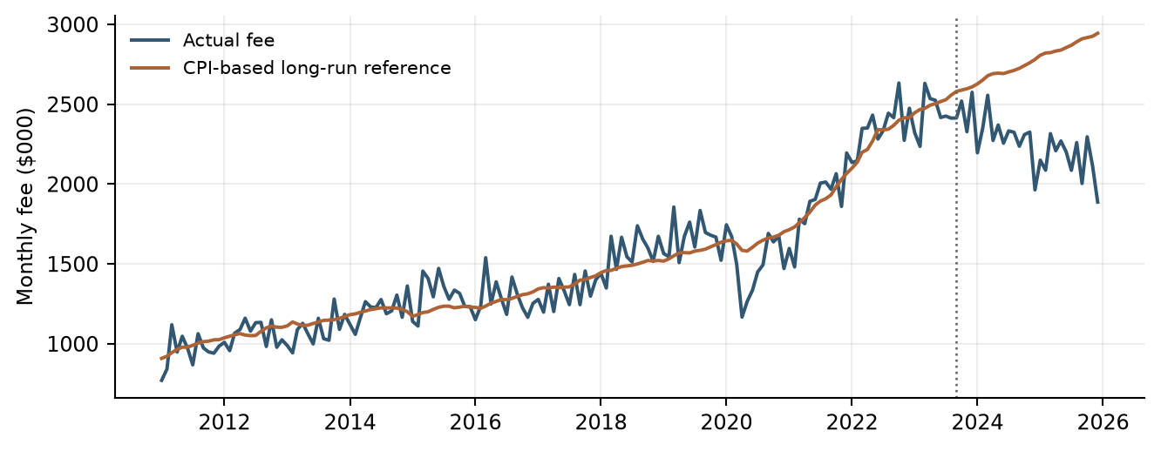
The dotted line marks the end of coefficient estimation. The later-period reference uses the same long-run coefficients; it is not an independently refitted relationship. Data sources: commercial/​long_​run_​history.csv; commercial/​commercial_​card_​model.py.
虚线标示系数估计期结束。后期参照使用相同的长期系数，并非独立重估关系。数据来源：commercial/​long_​run_​history.csv；commercial/​commercial_​card_​model.py。
$\begin{aligned}fitted_lr(t) = −3386.960717 + 19.419549 × CPI(t)\end{aligned}$
Coefficient sources: commercial/​long_​run_​coefficients.csv/​row 2 col 3 (intercept); commercial/​long_​run_​coefficients.csv/​row 3 col 3 (CPI slope).
系数来源：commercial/​long_​run_​coefficients.csv/​row 2 col 3（截距）；commercial/​long_​run_​coefficients.csv/​row 3 col 3（CPI 系数）。
fitted_​lr(t) is the fitted long-run Commercial Card and Small Business fee revenue (long_​run_​fitted_​fee), in $000. CPI(t) is the contemporaneous Consumer Price Index level (consumer_​price_​index). Coefficients are displayed to six decimal places; calculations retain full precision.
fitted_​lr(t)表示拟合的商业卡及小企业卡长期手续费收入（long_​run_​fitted_​fee），单位为$000。CPI(t)表示当期消费者价格指数水平（consumer_​price_​index）。公式中的系数显示至小数点后六位，实际计算保留完整精度。
Combined2(t) denotes combined Commercial Card and Small Business fee revenue (commercial_​small_​business_​fee), in $000. EC(t) measures its deviation from fitted_​lr(t). Dividing this deviation by the fitted level and multiplying by 100 gives EC_​scaled(t). The contemporaneous Overlay(t) is subtracted before the adjusted EC state is lagged 12 months.
Combined2(t)表示商业卡及小企业卡合并手续费收入（commercial_​small_​business_​fee），单位为$000。EC(t)衡量其相对于fitted_​lr(t)的偏离。将该偏离除以拟合水平并乘以100，得到EC_​scaled(t)。先减去当期Overlay(t)，再对调整后EC取12个月滞后。
$\begin{aligned}EC(t) = Combined2(t) − fitted_lr(t) \\ EC_scaled(t) = 100 × \frac{EC(t)}{fitted_lr(t)} \\ EC_scaled_adj(t) = EC_scaled(t) − Overlay(t) \\ EC_scaled_adj_lag12(t) = EC_scaled_adj(t − 12)\end{aligned}$
Formula definitions: EC = ec_​residual; EC_​scaled = ec_​scaled_​pct; Overlay = ec_​trend_​overlay_​pct; EC_​scaled_​adj = ec_​scaled_​adjusted_​pct. Source: commercial/​commercial_​card_​model.py, lines 278–297; commercial/​historical_​data_​and_​features.csv.
公式变量对应关系：EC = ec_​residual；EC_​scaled = ec_​scaled_​pct；Overlay = ec_​trend_​overlay_​pct；EC_​scaled_​adj = ec_​scaled_​adjusted_​pct。来源：commercial/​commercial_​card_​model.py，第278–297行；commercial/​historical_​data_​and_​features.csv。

2.4 Short-Run Growth and Adjustment Dynamics
2.4 短期增长与调整动态
The Commercial short-run equation models annual fee growth from monthly observations. It combines the twelve-month-lagged adjustment mechanism with recent fee-growth dynamics and Corporate Profits growth. Its negative error-correction coefficient means that a positive adjusted deviation reduces predicted year-over-year fee growth, while a negative adjusted deviation increases predicted growth, holding the other inputs constant. The one-month and six-month lags of annual fee growth capture persistence, while Corporate Profits annual growth, lagged two months, captures additional business-cycle variation. Together, these terms describe how revenue growth responds to the longer-term reference, recent revenue performance, and changing business conditions. The annual growth transformation and the monthly timing lag have separate economic and computational meanings.
商业卡短期方程使用月度观测建立手续费同比增长模型，将滞后十二个月的调整机制与近期手续费增长动态及企业利润增长结合起来。误差修正项的负系数意味着，在其他输入保持不变时，正的调整后偏离会降低预测的手续费同比增长率，负的调整后偏离则会提高预测增长率。手续费同比增长率的一期和六期滞后用于反映增长持续性，滞后两个月的企业利润同比增长则反映额外的商业周期变化。这些变量共同描述收入增长如何响应长期参考水平、近期收入表现及业务环境变化。同比增长转换与月度时间滞后具有不同的经济及计算含义。
$\begin{aligned}y(t) = 100 × [\frac{Combined2(t)}{Combined2(t − 12)} − 1]\end{aligned}$
Formula definition and parameter mapping: commercial/​commercial_​card_​model.py; commercial/​short_​run_​coefficients.csv.
公式定义及参数映射：commercial/​commercial_​card_​model.py; commercial/​short_​run_​coefficients.csv.
$\begin{aligned}y(t) = 1.783143 − 0.653518 × EC_scaled_adj_lag12(t) \\ + 0.296379 × y_lag1(t) + 0.250188 × y_lag6(t) \\ + 0.422022 × CorpProfits_lag2(t) + ε(t)\end{aligned}$
Formula definition and parameter mapping: commercial/​commercial_​card_​model.py; commercial/​short_​run_​coefficients.csv/​rows 2–6 col 3. All regressors in the displayed equation are evaluated at month t after their named lag transformations.
公式定义及参数映射：commercial/​commercial_​card_​model.py；commercial/​short_​run_​coefficients.csv/​rows 2–6 col 3。所示方程中所有解释变量均先执行变量名所标识的滞后转换，再在月份t取值。
y(t) is annual fee growth (commercial_​small_​business_​fee_​pct_​change_​12m). y_​lag1(t) and y_​lag6(t) are its one-month and six-month lags, exported as commercial_​small_​business_​fee_​pct_​change_​12m_​lag_​1m and commercial_​small_​business_​fee_​pct_​change_​12m_​lag_​6m. CorpProfits_​lag2(t) is Corporate Profits annual percentage growth lagged two months (corporate_​profits_​pct_​change_​12m_​lag_​2m). EC_​scaled_​adj_​lag12(t) corresponds to ec_​scaled_​adjusted_​pct_​lag_​12m. ε(t) is the equation error; its value is set to zero when calculating point forecasts. Growth and scaled EC terms use percentage units. Displayed coefficients are rounded; calculations retain the full output precision.
y(t)为手续费同比增长率（commercial_​small_​business_​fee_​pct_​change_​12m）。y_​lag1(t)和y_​lag6(t)分别为其1个月及6个月滞后，导出变量名分别为commercial_​small_​business_​fee_​pct_​change_​12m_​lag_​1m和commercial_​small_​business_​fee_​pct_​change_​12m_​lag_​6m。CorpProfits_​lag2(t)为企业利润同比百分比增长的2个月滞后（corporate_​profits_​pct_​change_​12m_​lag_​2m）。EC_​scaled_​adj_​lag12(t)对应ec_​scaled_​adjusted_​pct_​lag_​12m。ε(t)为方程误差项，计算点预测时取零。增长率及标准化EC使用百分比单位。展示系数经过四舍五入，计算保留输出的完整精度。

2.5 Commercial Overlay and Recursion
2.5 商业卡调整项与递归
The EC adjustment addresses a pattern observed in the later historical period through an explicit calibration rule. The script sets the development overlay to zero, fits a linear trend to OOT month indices 1 through 27, subtracts the contemporaneous trend from scaled EC, and then forms the 12-month lag.
商业卡调整通过明确的校准规则处理标准化EC的后期趋势。脚本将开发期调整设为零，对OOT月份索引1至27拟合线性趋势，从标准化EC中减去当期趋势，再构造12个月滞后。
The future forecasting process initializes with actual history through December 2025. Commercial development coefficients remain fixed in this future projection process. Predicted annual growth is applied to the actual or previously forecast fee revenue level from twelve months earlier to obtain the current revenue forecast.
未来预测以截至2025年12月的实际历史数据初始化，并在预测过程中保持商业卡开发期系数不变。模型将预测的同比增长率应用于十二个月前的实际或此前预测的手续费收入水平，得到当期收入预测。
That forecast is then compared with the contemporaneous CPI-based long-run reference to calculate a new adjusted error-correction state. The updated revenue, growth, and error-correction states become inputs to later forecasts through their respective lags. Consequently, the long-run component provides the reference, the short-run component determines the growth response, and recursive updating links both components throughout the forecast horizon.
随后，模型将当期预测收入与当期基于 CPI 的长期参考水平比较，重新计算调整后的误差修正状态。更新后的收入水平、增长率和误差修正状态，再通过各自的滞后项进入后续预测。因此，长期部分提供参考水平，短期部分决定增长调整，而递归更新使两者在整个预测期内持续联动。

2.6 Consumer Target and Seasonal Structure
2.6 消费卡目标与季节性结构
Consumer Card is modeled in monthly logarithmic changes because its revenue history contains recurring month-to-month adjustment and year-end seasonality. Modeling changes separates these movements from the level of the revenue series. The log representation expresses proportional movement and permits a multiplicative reconstruction of fee levels, subject to positive historical fee values.
消费卡以月度对数变化建模，因为收入历史存在重复性月度调整和年末季节性。变化建模将这些变动与收入水平区分。对数形式表达比例变化，并在历史手续费为正时允许以乘法还原水平。
The lagged revenue-change terms represent short-run dynamics, while January and December indicators represent recurring calendar effects. Negative lag coefficients indicate partial reversal in the transformed target after controlling for the other terms. The seasonal exhibit provides descriptive context; the regression estimates calendar effects jointly with revenue dynamics and Retail Sales rather than treating monthly averages as fitted coefficients.
收入变化滞后项代表短期动态，1月和12月指标代表重复日历效应。在控制其他变量后，负滞后系数表示转换目标存在部分反转。季节图提供描述性背景；回归将日历效应与收入动态及零售销售共同估计，而非把月度均值当作拟合系数。
Figure 2.2 Consumer development-period calendar pattern
图2.2 消费卡开发期日历模式
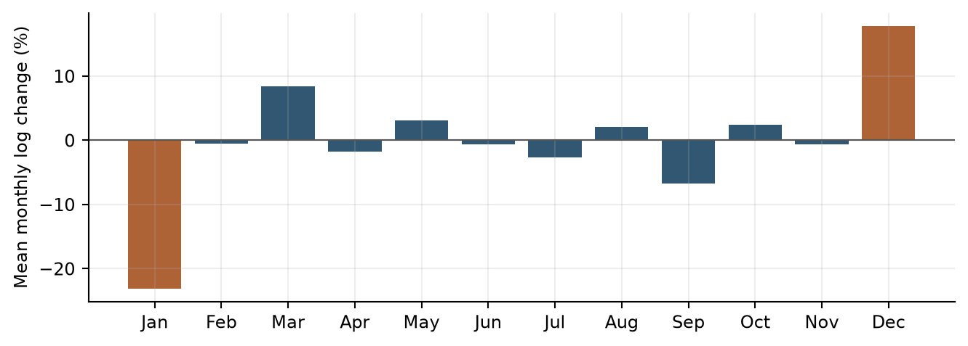
Derived display: arithmetic mean of exported monthly fee log changes grouped by calendar month. These unconditional averages motivate examination of calendar effects; they are not the fitted seasonal coefficients. Data sources: consumer/​historical_​data_​and_​features.csv.
派生图形：按日历月份分组，对输出的月度手续费对数变化计算算术平均。这些无条件均值用于说明考察日历效应的动机，并非拟合的季节性系数。数据来源：consumer/​historical_​data_​and_​features.csv。
$z_{t} = 100 [ln(Y_{t}) − ln(Y_{t−1})]$
Formula definition and parameter mapping: consumer/​consumer_​card_​model.py.
公式定义及参数映射：consumer/​consumer_​card_​model.py.

2.7 Consumer Retail Sales Effect
2.7 消费卡零售销售效应
Retail Sales provides the Consumer model with a spending-related macroeconomic explanation. The input is the arithmetic average of current and prior two monthly percentage changes, which smooths short-term variation. Its positive coefficient links stronger retail spending growth to stronger fee log growth conditional on seasonality and own lags. In the production equation, a one-percentage-point increase in this MA3 input increases the predicted monthly log change by approximately 2.50685 percentage points before recursive effects.
零售销售为消费卡模型提供消费支出相关宏观解释。输入是当月和前两个月百分比变化的算术平均，用以平滑短期变化。正系数表示控制季节性和自身滞后后，较强零售增长与较高手续费对数增长相关。生产方程中，MA3输入增加1个百分点，在递归影响前使预测月度对数变化约增加2.50685个百分点。
$z_{t} = κ + φ_{1}z_{t−1} + φ_{2}z_{t−2} + δ_{J}J_{t} + δ_{D}D_{t} + θ r_{t}$
Formula definition and parameter mapping: consumer/​consumer_​card_​model.py; consumer/​coefficients.csv.
公式定义及参数映射：consumer/​consumer_​card_​model.py; consumer/​coefficients.csv.
J and D are January and December indicators; r is Retail Sales MoM growth MA3. The production coefficients above are refitted through December 2025. A future fee level equals the prior actual or predicted fee multiplied by the exponential of predicted log change divided by 100.
J和D分别为1月及12月指标；r为零售销售环比增长MA3。上述生产系数重估至2025年12月。未来手续费水平等于前一期实际或预测手续费乘以预测对数变化除以100后的指数值。

2.8 Debit Qualitative Method
2.8 借记卡定性方法
The Debit methodology separates recent revenue expectations from downside severity. Baseline uses the latest eight complete actual quarters, currently 2024Q1–2025Q4. Stress uses the mean of complete quarters from 2015Q1–2025Q4 less twice the sample standard deviation. The first window represents the current run rate; the second provides a longer post-break distribution. The two-standard-deviation multiplier remains a judgmental rule, not a model-estimated probability or a guaranteed bound.
借记卡方法区分近期收入预期与下行严重程度。基准使用最近8个完整实际季度，当前为2024年第一季度至2025年第四季度。压力值为2015年第一季度至2025年第四季度完整季度均值减去2倍样本标准差。前一窗口代表当前运行水平，后一窗口提供较长断点后分布。2倍标准差乘数仍是判断性规则，而非模型估计概率或有保证的界限。
The current stress floor is below every observed post-2015 quarter, which provides a useful historical comparison of severity.
当前压力下限低于所有已观察的2015年以来季度值，为评估压力程度提供历史比较。

2.9 Assumptions and Mitigating Review
2.9 假设及缓释审阅
The model assumes that historical reporting definitions remain materially comparable and that the selected economic relationships remain relevant during the forecast horizon. Recursive forecasts use previously projected fee values to construct the subsequent period's lagged inputs. Monitoring therefore evaluates both short-horizon accuracy and the behavior of the complete forecast path.
模型假设历史报告定义保持实质可比，且选定经济关系在预测期内持续相关。递归预测使用此前预测的手续费值构造后续期间的滞后输入。因此，监控同时评估短期准确性与完整预测路径的表现。
Commercial assumes that the CPI reference and EC adjustment remain relevant to fee dynamics. Consumer assumes that seasonal patterns, own-growth dynamics and the Retail Sales relationship persist. Debit assumes that the recent-quarter average represents the current run rate and that the post-2015 history is appropriate for downside calibration. These assumptions are reviewed through performance monitoring and periodic reassessment.
商业卡假设CPI参照和EC调整与手续费动态持续相关。消费卡假设季节模式、自身增长动态及零售销售关系保持有效。借记卡假设近期季度均值代表当前收入水平，且2015年以来的历史适合下行情景校准。这些假设通过表现监控及定期复核进行评估。

2.10 Design Limitations and Conclusions
2.10 设计局限与结论
The selected design combines economically interpretable regression relationships with a transparent historical calibration for Debit Card. Aggregate fee histories do not separately represent every future pricing initiative, product change or shift in customer mix. Debit calibration does not include a direct macroeconomic response, and its historical windows require periodic review. These limitations are addressed through scenario analysis, monitoring and reassessment of model assumptions.
所选设计结合了经济可解释的回归关系与透明的借记卡历史校准方法。汇总手续费历史不能单独反映未来每项定价举措、产品变化或客户组合转变。借记卡校准不包含直接宏观经济响应，其历史窗口需要定期复核。上述局限通过情景分析、监控及模型假设复核予以管理。

3. Model Estimation
3. 模型估计

3.1 Overview of the Estimation Process
3.1 估计过程概述
Model estimation followed a staged framework intended to balance statistical evidence, economic interpretation and forecasting suitability. Target construction and date alignment preceded candidate screening, multivariate selection and evaluation. The objective was to reduce each candidate set to a small number of understandable forecasting inputs while preserving the evidence behind selection decisions.
模型估计采用分阶段框架，旨在平衡统计证据、经济解释及预测适用性。目标构造和日期对齐先于候选筛选、多元选择和评估。目标是将各候选集合缩减为少量可理解预测输入，同时保留选择决策背后的证据。
Commercial Card and Small Business estimation follows an integrated two-stage process. The first stage estimates a long-run relationship between combined fee revenue and macroeconomic levels. The resulting fitted revenue provides the reference for constructing the adjusted error-correction term. The second stage incorporates this term into a short-run equation for year-over-year fee growth and evaluates additional revenue-growth lags and macroeconomic drivers. This sequence establishes a direct connection between the long-run revenue relationship and the short-run adjustment dynamics.
商业卡及小企业卡的估计采用相互衔接的两阶段流程。第一阶段估计合并手续费收入与宏观经济水平变量之间的长期关系，并以拟合收入作为构造调整后误差修正项的参考。第二阶段将该误差修正项纳入手续费同比增长的短期方程，并进一步评估收入增长滞后项及宏观经济驱动变量。这一估计顺序在长期收入关系与短期调整动态之间建立了直接联系。
Consumer tests macroeconomic additions to a fixed lag-and-seasonal base, evaluates the selected development equation on later data and then refits the retained structure. Debit records each regression-screening outcome before calibrating its historical rule. The flow diagram makes these differences explicit.
消费卡将宏观新增变量与固定的动态季节性基础模型进行比较，在后续数据上测试选定的开发设定，并为未来预测重估保留结构。借记卡记录各回归路径的结果后采用透明的历史规则。流程图区分上述开发阶段。
Figure 3.1 Component estimation and selection process
图3.1 各组成部分估计与选择流程
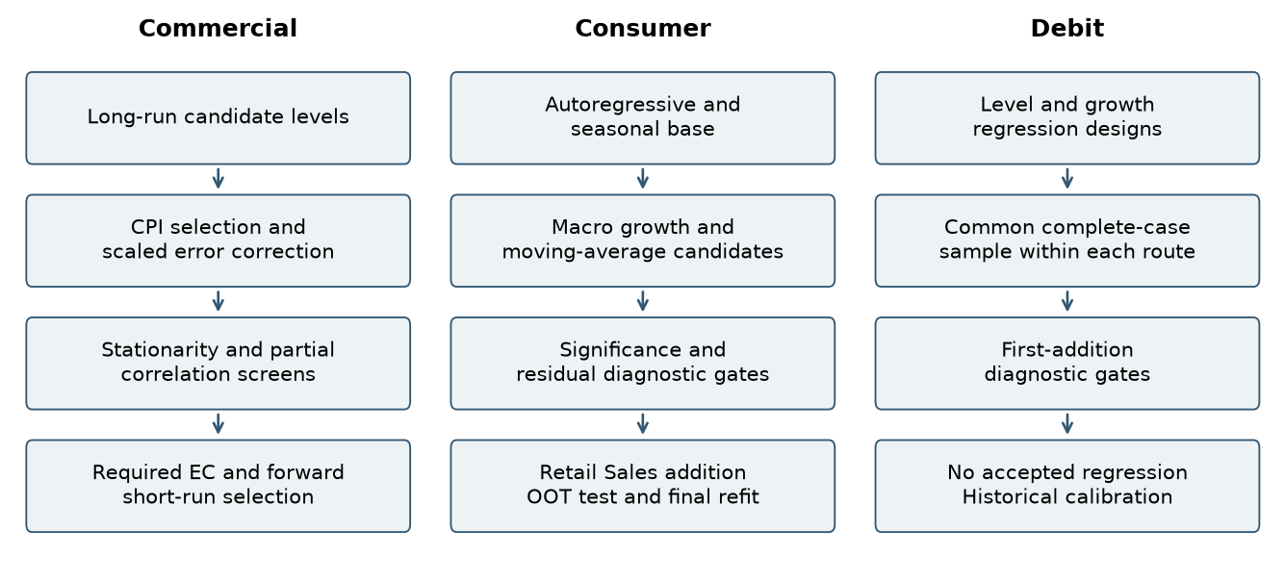
Selection stages follow the component procedures, including Commercial partial-correlation screening across development and OOT periods. Data sources: commercial/​long_​run_​trials.csv; commercial/​short_​run_​screen_​all.csv; consumer/​macro_​screening.csv; debit/​regression_​summary.csv.
选择阶段遵循各组成部分程序，包括商业卡在开发期和OOT期间进行的偏相关筛选。数据来源：commercial/​long_​run_​trials.csv；commercial/​short_​run_​screen_​all.csv；consumer/​macro_​screening.csv；debit/​regression_​summary.csv。

3.2 Candidate Variable Universe
3.2 候选变量集合
Commercial’s long-run pool contains CPI, disposable income, wholesale-trade GDP, Corporate Profits and the total-market index in levels. Its transformed short-run pool spans eight macro families, plus own annual-growth lags 1–12. Macro lags cover 0–12 months. Consumer considers unemployment, CPI, disposable income, Retail Sales and consumer confidence, each in current monthly change and a trailing three-month average. Debit considers 14 macro families under four target and frequency treatments. The data inventory and exact source mappings are retained in Appendix A.
商业卡长期候选池包含CPI、可支配收入、批发贸易GDP、企业利润及全市场指数的水平值。其短期转换候选池涵盖8个宏观类别，以及自身年度增长的1–12个月滞后项。宏观滞后范围为0–12个月。消费卡考虑失业率、CPI、可支配收入、零售销售及消费者信心，分别采用当期月度变化和过去3个月平均。借记卡在4种目标与频率处理下考虑14类宏观变量。数据清单及准确来源映射见附录A。

3.3 Transformations and Alignment
3.3 转换与对齐
Fee and macro records are joined by a monthly date key. Growth calculations use percentage changes multiplied by 100, except Consumer fee growth, which uses log differences multiplied by 100. Unemployment uses percentage-point differences. Lags are applied after transformations, and moving averages are calculated on already transformed growth. Debit quarterly revenue sums three monthly fees, while its quarterly macro variables use the quarter-end monthly observation. Design-specific complete-case alignment explains effective sample reductions; those losses should not be labeled raw missing source data.
手续费与宏观记录通过月度日期键连接。除消费卡手续费增长采用对数差分乘以100外，增长计算均使用百分比变化乘以100。失业率采用百分点差分。先转换后滞后，移动平均在已转换的增长率上计算。借记卡季度收入为3个月手续费之和，季度宏观变量则取季末月度观测。各设定按完整记录对齐导致有效样本减少；不应将这种损失称为原始来源数据缺失。

3.4 Commercial Long Run Estimation and Error Correction Construction
3.4 商业卡长期模型估计与误差修正项构建
Long-run estimation establishes the revenue reference used in the subsequent short-run model. Candidate macroeconomic level variables are evaluated using development-period observations. Each proposed addition must satisfy the implemented Student-t significance, multicollinearity, and residual-stationarity criteria. Eligible additions are ranked by adjusted R-squared. CPI is selected as the final long-run explanatory variable.
长期估计用于建立后续短期模型所依赖的收入参考水平。候选宏观经济水平变量使用开发期观测进行评估。每个拟新增变量均须满足代码设定的 Student-t 显著性、多重共线性及残差平稳性标准，符合条件的新增变量再按照调整后 R² 排序。最终选定 CPI 作为长期解释变量。
The selected CPI relationship is then carried forward into feature construction. Fee revenue is compared with the fitted long-run level, and the resulting deviation is scaled relative to that level. After applying the EC trend adjustment, the adjusted deviation is lagged twelve months to form the error-correction input for the short-run equation. Long-run estimation therefore supplies both a revenue reference and a directly linked explanatory variable for the next estimation stage.
选定的 CPI 关系随后用于特征构造。模型将手续费收入与长期拟合水平进行比较，并将偏离程度除以该拟合水平进行标准化。在应用 EC 趋势调整后，将调整后的偏离滞后十二个月，形成短期方程中的误差修正输入。因此，长期估计不仅提供收入参考水平，也为下一阶段估计提供与该长期关系直接关联的解释变量。
The selected CPI relationship has a coefficient of 19.41955 and standard error of 0.44293 in $000 per CPI index point. Its ordinary residual ADF p-value is 0.00915 [commercial/​long_​run_​residual_​stationarity.csv/​row 2 col 3].
选定的CPI系数为19.41955，标准误为0.44293，单位为每个CPI指数点对应的$000。普通残差ADF的p值为0.00915 [commercial/​long_​run_​residual_​stationarity.csv/​row 2 col 3]。
The comparison below shows why the largest unqualified fit statistic does not automatically determine the selected driver. Wholesale-trade GDP has a higher initial adjusted fit but fails the residual ADF gate. CPI is the highest-ranked eligible initial addition. Subsequent additions are evaluated conditional on CPI.
以下比较展示长期驱动选择如何同时考虑拟合和筛选标准。批发贸易GDP具有更高的初始调整后拟合度，但未通过残差ADF筛选。CPI是符合条件的初始新增变量中排名最高者。后续新增变量在包含CPI的条件下进行评估。
Table 3.1 Commercial initial long-run candidate comparison
表3.1 商业卡初始长期候选比较
Candidate  候选变量 | Adjusted fit  调整后拟合 | Residual ADF p  残差ADF p值 | Eligible  合格 | Outcome  结果
CPI  消费者价格指数 | 0.9267 [commercial/​long_​run_​trials.csv/​row 2 col 10] | 0.0091 [commercial/​long_​run_​trials.csv/​row 2 col 7] | Yes  是 | Selected  已选中
Disposable income  可支配收入 | 0.8164 [commercial/​long_​run_​trials.csv/​row 3 col 10] | 0.0029 [commercial/​long_​run_​trials.csv/​row 3 col 7] | Yes  是 | Not selected  未选中
Wholesale GDP  批发贸易GDP | 0.9326 [commercial/​long_​run_​trials.csv/​row 4 col 10] | 0.0626 [commercial/​long_​run_​trials.csv/​row 4 col 7] | No  否 | Not selected  未选中
Corporate Profits  企业利润 | 0.8921 [commercial/​long_​run_​trials.csv/​row 5 col 10] | 0.0400 [commercial/​long_​run_​trials.csv/​row 5 col 7] | Yes  是 | Not selected  未选中
Equity index  股票指数 | 0.7941 [commercial/​long_​run_​trials.csv/​row 6 col 10] | 0.0013 [commercial/​long_​run_​trials.csv/​row 6 col 7] | Yes  是 | Not selected  未选中
Data source: commercial/​long_​run_​trials.csv.
数据来源：commercial/​long_​run_​trials.csv.
Source: commercial/​long_​run_​trials.csv. The table shows initial single-driver trials; later conditional trials remain in the source file.
来源：commercial/​long_​run_​trials.csv。本表列示初始单驱动因素试验；后续条件试验保留在来源文件中。

3.5 Commercial Short Run Macroeconomic Prescreening
3.5 商业卡短期宏观变量预筛选
Short-run macroeconomic screening is conducted conditional on the error-correction mechanism established from the long-run model. Transformed macroeconomic families first undergo development-period stationarity screening using the implemented ADF/KPSS eligibility rule. For eligible families, partial correlations are calculated between annual fee growth and each candidate macroeconomic lag after controlling for an intercept and the twelve-month-lagged adjusted error-correction term. This approach evaluates whether a candidate provides additional information about fee growth beyond the adjustment mechanism already represented by the long-run relationship.
短期宏观变量筛选以长期模型所建立的误差修正机制为控制条件。经过转换的宏观变量组首先按照代码设定的 ADF/KPSS 准入规则接受开发期平稳性筛选。对于符合条件的变量组，模型在控制截距项及滞后十二个月的调整后误差修正项后，计算手续费同比增长与各候选宏观滞后变量之间的偏相关关系。这一方法用于评估候选变量是否在长期关系所体现的调整机制之外，为手续费增长提供额外信息。
Short-run macroeconomic candidates were pre-screened for partial-correlation significance and sign consistency across the development and OOT periods. Subsequent variable selection and coefficient estimation used development-period observations.
短期宏观候选变量根据其在开发期和 OOT 期间的偏相关显著性及符号一致性进行预筛选。后续变量选择和系数估计均使用开发期观测。
Eligibility uses an OR rule: ADF p < 0.05 or KPSS p > 0.05. Partial-correlation screening requires p < 0.20 in both development and OOT and matching signs. Fourteen macro-lag terms pass.
准入采用 OR 规则：ADF p < 0.05 或 KPSS p > 0.05。偏相关筛选要求开发期和 OOT 的 p 值均小于0.20且符号一致。十四个宏观滞后项通过筛选。
Table 3.2 Commercial transformed-family stationarity results
表3.2 商业卡转换类别平稳性结果
Family  类别 | ADF p  ADF p值 | KPSS p  KPSS p值 | KPSS bound  KPSS边界 | OR rule  OR规则
Unemployment Rate  失业率 | 0.0796 [commercial/​macro_​stationarity.csv/​row 2 col 4] | 0.1000 [commercial/​macro_​stationarity.csv/​row 2 col 9] | >=0.10 [commercial/​macro_​stationarity.csv/​row 2 col 12] | Eligible  合格
Consumer Price Index  消费者价格指数 | 0.3712 [commercial/​macro_​stationarity.csv/​row 3 col 4] | 0.0100 [commercial/​macro_​stationarity.csv/​row 3 col 9] | <=0.01 [commercial/​macro_​stationarity.csv/​row 3 col 12] | Excluded  已排除
Disposable Personal Income  个人可支配收入 | 0.0072 [commercial/​macro_​stationarity.csv/​row 4 col 4] | 0.0418 [commercial/​macro_​stationarity.csv/​row 4 col 9] | interpolated [commercial/​macro_​stationarity.csv/​row 4 col 12]  插值 [commercial/​macro_​stationarity.csv/​row 4 col 12] | Eligible  合格
Small Business Optimism  小企业乐观指数 | 0.2813 [commercial/​macro_​stationarity.csv/​row 5 col 4] | 0.0417 [commercial/​macro_​stationarity.csv/​row 5 col 9] | interpolated [commercial/​macro_​stationarity.csv/​row 5 col 12]  插值 [commercial/​macro_​stationarity.csv/​row 5 col 12] | Excluded  已排除
Wholesale Trade Gdp  批发贸易GDP | 0.3152 [commercial/​macro_​stationarity.csv/​row 6 col 4] | 0.1000 [commercial/​macro_​stationarity.csv/​row 6 col 9] | >=0.10 [commercial/​macro_​stationarity.csv/​row 6 col 12] | Eligible  合格
Industrial Production  工业生产 | 0.0384 [commercial/​macro_​stationarity.csv/​row 7 col 4] | 0.1000 [commercial/​macro_​stationarity.csv/​row 7 col 9] | >=0.10 [commercial/​macro_​stationarity.csv/​row 7 col 12] | Eligible  合格
Corporate Profits  企业利润 | 0.2191 [commercial/​macro_​stationarity.csv/​row 8 col 4] | 0.1000 [commercial/​macro_​stationarity.csv/​row 8 col 9] | >=0.10 [commercial/​macro_​stationarity.csv/​row 8 col 12] | Eligible  合格
Dow Jones Total Market Index  道琼斯全市场指数 | 0.0060 [commercial/​macro_​stationarity.csv/​row 9 col 4] | 0.1000 [commercial/​macro_​stationarity.csv/​row 9 col 9] | >=0.10 [commercial/​macro_​stationarity.csv/​row 9 col 12] | Eligible  合格
Data source: commercial/​macro_​stationarity.csv.
数据来源：commercial/​macro_​stationarity.csv.
Source: commercial/​macro_​stationarity.csv. Eligibility follows the code OR rule; bounded KPSS values are displayed with their exported bounds. These are transformed-family tests, not tests of raw level series.
来源：commercial/​macro_​stationarity.csv。资格按代码OR规则判断；有界KPSS值按输出边界显示。这些检验针对转换后的宏观类别，而非原始水平序列。

3.6 Commercial Short Run Forward Selection and Coefficient Estimation
3.6 商业卡短期模型前向选择与系数估计
Short-run forward selection begins with an intercept and the twelve-month-lagged adjusted error-correction term. The error-correction term remains a required explanatory variable throughout the selection process, preserving the connection to the previously estimated long-run relationship. Its coefficient is estimated jointly with the other short-run coefficients rather than fixed in advance.
短期前向选择从截距项及滞后十二个月的调整后误差修正项开始。误差修正项在整个筛选过程中始终作为必选解释变量保留，从而维持短期方程与此前估计的长期关系之间的联系。该项系数与其他短期系数共同估计，而不是事先固定。
Additional candidates comprise the macroeconomic terms that pass pre-screening and lags 1–12 of annual fee growth. Each proposed addition is evaluated conditional on the required error-correction term and the variables already selected. Eligible additions must meet Student-t p < 0.05 and maximum VIF < 10 and are ranked by adjusted R-squared with a fixed tie order. The final specification combines adjusted error correction with the one-month and six-month lags of annual fee growth and the two-month lag of Corporate Profits annual growth.
新增候选变量包括通过预筛选的宏观变量及手续费同比增长的1至12个月滞后项。每个拟新增变量均在保留误差修正项和已选变量的条件下进行评估。符合条件的新增变量须满足 Student-t p < 0.05 及最大 VIF < 10，并按照调整后 R² 及固定并列顺序排序。最终设定将调整后的误差修正项、手续费同比增长的一期及六期滞后，以及企业利润同比增长的两期滞后结合起来。
This specification assigns complementary roles to the two estimation stages. The long-run model establishes the revenue reference, while the short-run model estimates how annual fee growth responds to deviations from that reference, recent growth dynamics, and business-cycle conditions. The resulting equations operate together within the recursive forecasting framework described in Section 2.5.
这一设定使两个估计阶段承担互补职责：长期模型建立收入参考水平，短期模型则估计手续费同比增长如何响应相对于该参考水平的偏离、近期增长动态及商业周期变化。两组方程随后在第 2.5 节所述的递归预测框架中共同运行。
Table 3.3 Commercial short-run development progression
表3.3 商业卡短期开发过程
Round  轮次 | Added term  新增项 | Effective n  有效样本数 | Adjusted fit  调整后拟合
1 | Fee YoY growth, lag 1  手续费同比增长，滞后1个月 | 140 | 0.6583 [commercial/​short_​run_​rounds.csv/​row 2 col 3]
2 | Fee YoY growth, lag 6  手续费同比增长，滞后6个月 | 135 | 0.6944 [commercial/​short_​run_​rounds.csv/​row 3 col 3]
3 | Profits YoY growth, lag 2  利润同比增长，滞后2个月 | 135 | 0.7357 [commercial/​short_​run_​rounds.csv/​row 4 col 3]
Data source: commercial/​short_​run_​rounds.csv.
数据来源：commercial/​short_​run_​rounds.csv.
Source: commercial/​short_​run_​rounds.csv. Adjusted EC is required before these additions. Effective samples differ when additional lags reduce available observations, so fit changes are not pure same-sample incremental comparisons.
来源：commercial/​short_​run_​rounds.csv。在这些新增变量之前，调整后EC已作为必选项。新增滞后可能减少有效观测，因此各轮拟合变化并非纯粹的同样本增量比较。
The final short-run estimates combine a negative error-correction response with positive fee-growth persistence and Corporate Profits exposure. The reported standard errors and Student-t results document inference for the jointly estimated equation.
最终短期模型估计将负向误差修正作用与正向手续费增长持续性、企业利润关联结合起来。表中的标准误和Student-t检验结果列示联合估计方程的统计推断。
Table 3.4 Commercial final short-run coefficients
表3.4 商业卡最终短期系数
Term  变量项 | Estimate  估计值 | Std error  标准误 | t statistic  t统计量 | p value  p值
Intercept  截距 | 1.78314 | 0.85356 | 2.089 [commercial/​short_​run_​coefficients.csv/​row 2 col 5] | 0.039 [commercial/​short_​run_​coefficients.csv/​row 2 col 6]
Adjusted EC, lag 12  调整后EC，滞后12个月 | -0.65352 | 0.08291 | -7.883 [commercial/​short_​run_​coefficients.csv/​row 3 col 5] | <0.001 [commercial/​short_​run_​coefficients.csv/​row 3 col 6]
Fee YoY growth, lag 1  手续费同比增长，滞后1个月 | 0.29638 | 0.06672 | 4.442 [commercial/​short_​run_​coefficients.csv/​row 4 col 5] | <0.001 [commercial/​short_​run_​coefficients.csv/​row 4 col 6]
Fee YoY growth, lag 6  手续费同比增长，滞后6个月 | 0.25019 | 0.05008 | 4.996 [commercial/​short_​run_​coefficients.csv/​row 5 col 5] | <0.001 [commercial/​short_​run_​coefficients.csv/​row 5 col 6]
Profits YoY growth, lag 2  利润同比增长，滞后2个月 | 0.42202 | 0.09115 | 4.630 [commercial/​short_​run_​coefficients.csv/​row 6 col 5] | <0.001 [commercial/​short_​run_​coefficients.csv/​row 6 col 6]
Source: commercial/​short_​run_​coefficients.csv. Classical nonrobust OLS covariance; coefficient scale is annual percentage growth.
来源：commercial/​short_​run_​coefficients.csv。使用经典非稳健OLS协方差；系数对应年度百分比增长尺度。

3.7 Consumer Base and Forward Selection
3.7 消费卡基础模型与前向选择
The fixed base comprises an intercept, fee log-growth lags 1 and 2, and January and December indicators. Forward selection tests the ten macro transformations. An added term must have a two-sided Student-t p-value < 0.05, maximum VIF < 10, DW between 1.5 and 2.5 inclusive, and JB p-value > 0.05. At most one feature per macro family is admitted. Passing candidates are ranked by the smallest Student-t p-value, then the highest adjusted R-squared and a fixed tie order. Student-t probabilities use residual degrees of freedom n − k, where k includes the intercept and all regressors. Retail Sales monthly-growth MA3 is selected. The exported p_​normal field is retained for reference only and is not used for eligibility or ranking.
固定基础模型包括截距、手续费对数增长的1个月及2个月滞后项，以及1月和12月指标。前向选择测试10个宏观转换。新增变量须满足双侧Student-t p值 < 0.05、最大VIF < 10、DW在1.5至2.5之间（含边界），且JB p值 > 0.05。每个宏观类别最多纳入一个特征。合格候选按Student-t p值从小到大、调整后R平方从高到低及固定并列顺序排序。Student-t概率采用残差自由度n − k，其中k包括截距及全部解释变量。最终选中零售销售月度增长MA3。导出的p_​normal字段仅供参考，不用于资格判断或排序。
MA3 means a three-month moving average. For Retail Sales, it averages the monthly percentage changes for the current month and the previous two months. This smooths short-term fluctuations.
MA3 指三个月移动平均值。对于 Retail Sales，它取当月及前两个月的月度百分比变化的平均值，以平滑短期波动。
Figure 3.2 Consumer initial macro additions
图3.2 消费卡初始宏观新增变量
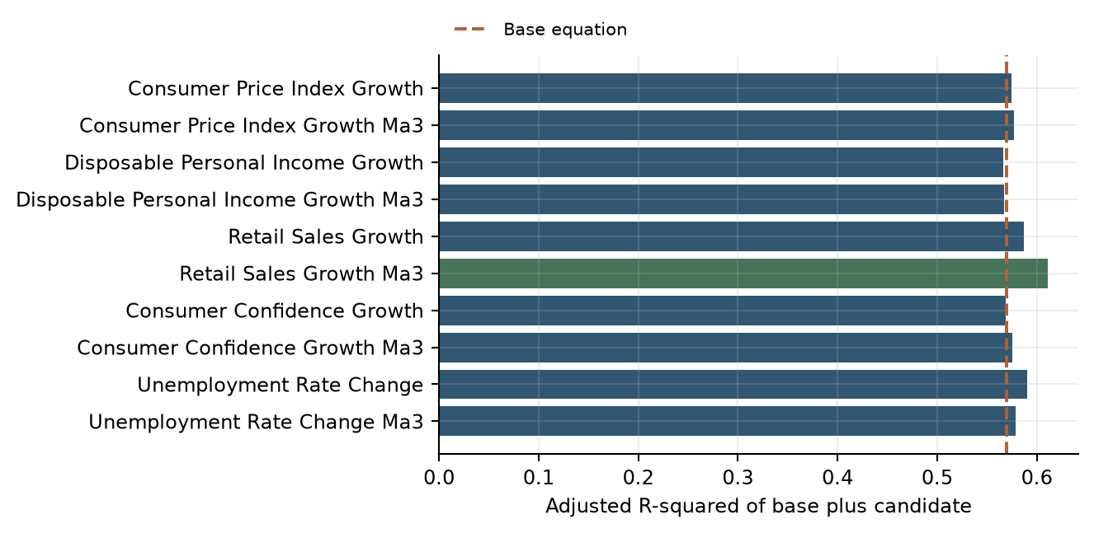
Green identifies the selected addition. The dashed line is the base equation. Selection also requires the documented statistical gates and ranking rule; adjusted fit alone is not the selection criterion. Data sources: consumer/​macro_​screening.csv; consumer/​model_​diagnostics.csv.
绿色表示选中的新增变量。虚线表示基础方程。选择还须满足记录的统计门槛和排序规则；调整后拟合并非唯一标准。数据来源：consumer/​macro_​screening.csv；consumer/​model_​diagnostics.csv。
The development estimates associate lagged fee changes with short-run reversal, January with lower growth and December with higher growth. The positive Retail Sales term represents the spending-related contribution after controlling for these dynamics and calendar effects.
开发期估计中，手续费变化滞后项反映短期反转，一月对应较低增长，十二月对应较高增长。正向零售销售项反映控制这些动态和日历效应后的消费支出关联。
Table 3.5 Consumer development coefficients
表3.5 消费卡开发系数
Term  变量项 | Estimate  估计值 | Std error  标准误 | t statistic  t统计量 | p value  p值
Intercept  截距 | -1.98312 | 0.82447 | -2.405 [consumer/​coefficients.csv/​row 7 col 4] | 0.017 [consumer/​coefficients.csv/​row 7 col 6]
Fee log growth, lag 1  手续费对数增长，滞后1个月 | -0.62166 | 0.06568 | -9.464 [consumer/​coefficients.csv/​row 8 col 4] | <0.001 [consumer/​coefficients.csv/​row 8 col 6]
Fee log growth, lag 2  手续费对数增长，滞后2个月 | -0.33883 | 0.06070 | -5.583 [consumer/​coefficients.csv/​row 9 col 4] | <0.001 [consumer/​coefficients.csv/​row 9 col 6]
January indicator  1月指标 | -11.15312 | 2.87904 | -3.874 [consumer/​coefficients.csv/​row 10 col 4] | <0.001 [consumer/​coefficients.csv/​row 10 col 6]
December indicator  12月指标 | 19.65826 | 2.59864 | 7.565 [consumer/​coefficients.csv/​row 11 col 4] | <0.001 [consumer/​coefficients.csv/​row 11 col 6]
Retail Sales MoM growth, MA3  零售销售环比增长，MA3 | 2.57529 | 0.63128 | 4.079 [consumer/​coefficients.csv/​row 12 col 4] | <0.001 [consumer/​coefficients.csv/​row 12 col 6]
Data source: consumer/​coefficients.csv.
数据来源：consumer/​coefficients.csv.

3.8 Consumer Production Refit
3.8 消费卡生产重估
The selected structure is retained and re-estimated through December 2025. This refit uses 177 effective observations and produces adjusted R-squared of 0.6091 [consumer/​model_​diagnostics.csv/​row 4 col 6]. Retail Sales’ coefficient is 2.50685, compared with 2.57529 in development.
所选结构保留并重估至2025年12月。该重估使用177个有效观测，调整后R平方为0.6091 [consumer/​model_​diagnostics.csv/​row 4 col 6]。零售销售系数为2.50685，开发期为2.57529。
Table 3.6 Consumer production coefficients
表3.6 消费卡生产系数
Term  变量项 | Estimate  估计值 | Std error  标准误 | t statistic  t统计量 | p value  p值
Intercept  截距 | -1.72062 | 0.73073 | -2.355 [consumer/​coefficients.csv/​row 13 col 4] | 0.020 [consumer/​coefficients.csv/​row 13 col 6]
Fee log growth, lag 1  手续费对数增长，滞后1个月 | -0.60242 | 0.06023 | -10.002 [consumer/​coefficients.csv/​row 14 col 4] | <0.001 [consumer/​coefficients.csv/​row 14 col 6]
Fee log growth, lag 2  手续费对数增长，滞后2个月 | -0.33981 | 0.05610 | -6.057 [consumer/​coefficients.csv/​row 15 col 4] | <0.001 [consumer/​coefficients.csv/​row 15 col 6]
January indicator  1月指标 | -11.86259 | 2.53369 | -4.682 [consumer/​coefficients.csv/​row 16 col 4] | <0.001 [consumer/​coefficients.csv/​row 16 col 6]
December indicator  12月指标 | 18.72925 | 2.24148 | 8.356 [consumer/​coefficients.csv/​row 17 col 4] | <0.001 [consumer/​coefficients.csv/​row 17 col 6]
Retail Sales MoM growth, MA3  零售销售环比增长，MA3 | 2.50685 | 0.60023 | 4.177 [consumer/​coefficients.csv/​row 18 col 4] | <0.001 [consumer/​coefficients.csv/​row 18 col 6]
Data source: consumer/​coefficients.csv.
数据来源：consumer/​coefficients.csv.

3.9 Debit Regression Screening
3.9 借记卡回归筛选
The Level and MoM routes consider own lags 1–12 and macro lags 0–12. The YoY route is a contemporaneous transformed-macro screen and does not estimate an ECM afterward. Quarterly QoQ uses own lags 1–4 and macro lags 0–4. Each route starts with an intercept-only specification on its common complete-case sample. Proposed first additions require Student-t p < 0.05, DW from 1.5 to 2.5 inclusive, JB p > 0.05 and maximum nonconstant VIF < 10. No forced term or joint first-step addition is used.
水平和环比路径考虑自身1–12个月滞后及宏观0–12个月滞后。同比路径为同期转换宏观变量筛选，之后不估计ECM。季度环比使用自身1–4季度滞后和宏观0–4季度滞后。各路径在共同完整记录样本上从仅含截距的设定开始。首轮新增变量须满足Student-t p < 0.05、DW介于1.5和2.5（含边界）、JB p > 0.05，以及非常数项最大VIF < 10。没有强制纳入项，也不在首轮同时加入多个变量。
The screening table reports the sample size, candidate count and combined acceptance outcome for each Debit regression route. No route retained a specification satisfying all required gates, supporting the documented move to historical calibration.
筛选表按借记卡回归路径列示样本量、候选数量和综合准入结果。各路径均未保留同时满足全部标准的设定，因此后续采用已记录的历史校准方法。
Table 3.7 Debit candidate screening outcome
表3.7 借记卡候选筛选结果
Approach  方法 | Effective n  有效样本数 | Candidates  候选数 | All gates passed  全部门槛通过数 | Accepted model  接受模型
Level  水平 | 129 | 194 | 0 | No  否
YoY_​static_​screen  同比静态筛选 | 129 | 14 | 0 | No  否
MoM  环比 | 128 | 194 | 0 | No  否
QoQ_​quarterly  季度环比 | 42 | 74 | 0 | No  否
Data source: debit/​regression_​summary.csv.
数据来源：debit/​regression_​summary.csv.

3.10 Debit Scenario Calibration
3.10 借记卡情景校准
Quarterly actual fees are calculated after the documented revenue adjustments and require three monthly observations. The baseline mean is 4,747.625 $000 per quarter. The post-2015 mean is 4,553.09091 and sample standard deviation is 369.71874, yielding a stress floor of 3,813.65343. The difference from Baseline is 19.67%.
季度实际手续费在完成记录的收入调整后计算，并要求每季有3个月观测。基准均值为每季度4,747.625 $000。2015年起均值为4,553.09091，样本标准差为369.71874，得到压力下限3,813.65343。相对基准下降19.67%。

3.11 Estimation Conclusion
3.11 估计结论
The estimation process produced a reproducible Commercial specification, a Consumer structure with separately identified development and production estimates, and a documented rejection outcome for each tested Debit regression route. The selected forecasting framework is parsimonious relative to the candidate sets and retains the calculations needed for independent reproduction.
估计过程形成可复现商业卡设定、明确区分开发与生产估计的消费卡结构，以及各借记卡回归路径的排除记录。相对于候选集合，选定框架较为简约，并保留独立复现所需计算。
The estimation results provide the basis for the testing framework in Section 6. That framework evaluates in-sample fit, residual diagnostics, coefficient stability, OOT accuracy and scenario response. Together, estimation and testing connect the selected specification to the model's intended forecasting use.
估计结果为第6节测试框架提供基础。该框架评估样本内拟合、残差诊断、系数稳定性、OOT准确性及情景响应。估计和测试共同将选定设定与模型的预期预测用途联系起来。

4. Development Data
4. 开发数据

4.1 Commercial Card and Small Business Model Data
4.1 商业卡及小企业卡模型数据

4.1.1 Purpose and Development Sample
4.1.1 目的及开发样本
The development data provide the foundation for estimating, testing and forecasting Commercial Card and Small Business fee revenue. Data preparation focuses on relevance, completeness, consistent definitions and traceability from source observations to model inputs.
开发数据为商业卡及小企业卡手续费收入的估计、测试及预测提供基础。数据准备重点关注相关性、完整性、定义一致性及从源观测到模型输入的可追溯性。
Monthly fee history spans January 2011 through December 2025. Long-run and short-run coefficient development uses observations through September 2023; the October 2023–December 2025 period supports OOT evaluation and EC trend calibration. Monthly frequency preserves the annual-growth transformations and monthly lags used in the selected equations.
月度手续费历史覆盖2011年1月至2025年12月。长期及短期系数开发使用截至2023年9月的观测，2023年10月至2025年12月用于OOT评估和EC趋势校准。月度频率保留所选方程使用的同比增长转换及月度滞后。

4.1.2 Internal Data Sources
4.1.2 内部数据来源
Internal data consist of monthly fee revenue in fee_​history.csv. All fee-history amounts are in $000, representing thousands of US dollars, and are used without rescaling. Calculated growth rates and other model features are kept separate from the source fields.
内部数据为fee_​history.csv中的月度手续费收入。所有历史手续费金额单位均为$000，即千美元，使用时不重新缩放。计算得到的增长率及其他模型特征与源字段分别列示。
Table 4.1 Commercial Card and Small Business Internal Data Inventory
表4.1 商业卡及小企业卡内部数据清单
Data Element  数据元素 | Description  描述 | Source Dataset  来源数据集 | Model Usage  模型用途
date | Monthly observation date  月度观测日期 | commercial/​data/​fee_​history.csv | Monthly alignment and calendar key  月度对齐及日历键
Commercial Card | Monthly Commercial Card fee revenue ($000)  商业卡月度手续费收入（$000） | commercial/​data/​fee_​history.csv | Source fee series for model preparation  用于模型准备的原始手续费序列
Small Business | Monthly Small Business card fee revenue ($000)  小企业卡月度手续费收入（$000） | commercial/​data/​fee_​history.csv | Source fee series for model preparation  用于模型准备的原始手续费序列
Data sources: commercial/​data/​fee_​history.csv; commercial/​commercial_​card_​model.py.
数据来源：commercial/​data/​fee_​history.csv; commercial/​commercial_​card_​model.py.

4.1.3 External Data Sources and Appropriateness
4.1.3 外部数据来源及适当性
Macroeconomic history contains eight price, employment, income, business-activity, profitability and financial-market variables. Table 4.2 inventories every raw macroeconomic input in the Commercial code package, including candidates not retained in the final equations. CPI and Corporate Profits are the selected drivers. Baseline and S4 files supply the selected monthly scenario paths from January 2026 through March 2028. The model uses CPI levels for the long-run reference and lagged Corporate Profits annual growth for short-run fee growth. Derived growth rates and lags are documented separately in the transformation table.
宏观历史数据包含八个价格、就业、收入、业务活动、盈利及金融市场变量。表4.2列示商业卡代码包中的全部原始宏观输入，包括未进入最终方程的候选变量。CPI和企业利润为最终选定驱动。基准和S4文件提供2026年1月至2028年3月所选驱动的月度情景路径。模型使用CPI水平构造长期参照，使用滞后的企业利润同比增长解释短期手续费增长。派生增长率及滞后项在转换表中另行列示。
Table 4.2 Commercial Card and Small Business External Data Inventory
表4.2 商业卡及小企业卡外部数据清单
Data Element  数据元素 | Description  描述 | Source Dataset  来源数据集 | Model Usage  模型用途
M_​FLBR_​B.IUSA  unemployment_​rate | Unemployment rate  失业率 | commercial/​data/​macro_​history.csv | Short-run candidate: annual percentage-point change and monthly lags; not retained.  短期候选：年度百分点变化及月度滞后；未入选。
M_​FCPIU_​B.IUSA  consumer_​price_​index | Consumer Price Index  消费者价格指数 | commercial/​data/​macro_​history.csv | Selected long-run level driver. Annual growth and lags also enter the short-run candidate screen.  选定长期水平驱动。同比增长及滞后也参与短期候选筛选。
M_​FYPDPIQ_​B.IUSA  disposable_​personal_​income | Disposable personal income  个人可支配收入 | commercial/​data/​macro_​history.csv | Long-run level and short-run annual-growth candidate; not retained.  长期水平及短期同比增长候选；未入选。
M_​FSBINQ_​B.IUSA  small_​business_​optimism | Small business optimism  小企业乐观指数 | commercial/​data/​macro_​history.csv | Short-run annual-growth and lag candidate; not retained.  短期同比增长及滞后候选；未入选。
M_​FGDP42Q_​B.IUSA  wholesale_​trade_​gdp | Wholesale trade GDP  批发贸易GDP | commercial/​data/​macro_​history.csv | Long-run level and short-run annual-growth candidate; not retained.  长期水平及短期同比增长候选；未入选。
M_​FIP_​B.IUSA  industrial_​production | Industrial production  工业生产 | commercial/​data/​macro_​history.csv | Short-run annual-growth and lag candidate; not retained.  短期同比增长及滞后候选；未入选。
M_​FZA_​B.IUSA  corporate_​profits | Corporate Profits  企业利润 | commercial/​data/​macro_​history.csv | Selected short-run annual-growth driver at a two-month lag. Also considered as a long-run level candidate.  选定短期同比增长驱动，滞后两个月。也作为长期水平候选参与筛选。
M_​FDJMIIUSDD_​WCFTDQ_​B.IUSA  dow_​jones_​total_​market_​index | Dow Jones total market index  道琼斯全市场指数 | commercial/​data/​macro_​history.csv | Long-run level and short-run annual-growth candidate; not retained.  长期水平及短期同比增长候选；未入选。
Data sources: commercial/​data/​macro_​history.csv; commercial/​data/​macro_​baseline.csv; commercial/​data/​macro_​s4.csv.
数据来源：commercial/​data/​macro_​history.csv; commercial/​data/​macro_​baseline.csv; commercial/​data/​macro_​s4.csv.

4.1.4 Data Lineage and Preparation
4.1.4 数据血缘及准备
Preparation imports the source files, maps field names, orders and aligns dates, constructs the specified transformations and selects the relevant estimation or calibration period. Original inputs remain separate from exported features and results. No random sampling is applied.
准备过程包括导入源文件、映射字段、排序并对齐日期、构造指定转换，以及选择相关估计或校准期间。原始输入与导出特征和结果分开保存，不进行随机抽样。
Table 4.3 Commercial Card and Small Business Data Lineage
表4.3 商业卡及小企业卡数据血缘
Input Source  输入来源 | Output File  输出文件 | Purpose  用途
commercial/​data/​fee_​history.csv | commercial/​historical_​data_​and_​features.csv | Preserve mapped fee history and derived model features.  保留映射后的手续费历史及派生模型特征。
commercial/​data/​macro_​history.csv | commercial/​historical_​data_​and_​features.csv | Align and transform historical economic candidates.  对齐并转换历史经济候选变量。
commercial/​data/​macro_​baseline.csv; commercial/​data/​macro_​s4.csv | commercial/​forecast_​monthly.csv | Generate future scenario paths.  生成未来情景路径。
This table connects each Commercial model variable to its transformation steps and final formula. The sequence from combined fees to the long-run reference and adjusted error correction makes the link between the level and growth equations explicit.
本表将各商业卡模型变量与转换步骤及最终公式逐一对应。从合并手续费到长期参照、再到调整后误差修正项的构建顺序，明确展示水平值方程与增长方程之间的联系。
Table 4.4 Commercial Card and Small Business Transformations and Final Formulas
表4.4 商业卡及小企业卡转换步骤及最终公式
Model Element  模型元素 | Transformation Steps  转换步骤 | Final Formula  最终计算公式
commercial_​small_​business_​fee | 1. Read the two fee fields. 2. Add their monthly amounts. Preserve $000.  1. 读取两个手续费字段。2. 按月相加，保留$000单位。 | = commercial_​card_​fee(t)  + small_​business_​card_​fee(t)
commercial_​small_​business_​fee_​pct_​change_​12m | 1. Aggregate fees. 2. Divide by the year-ago amount. 3. Subtract one and multiply by 100.  1. 汇总手续费。2. 除以上年同月金额。3. 减一并乘以100。 | = 100 × [commercial_​small_​business_​fee(t)  ÷ commercial_​small_​business_​fee(t − 12) − 1]
long_​run_​fitted_​fee | 1. Map CPI. 2. Apply the estimated long-run intercept and slope.  1. 映射CPI。2. 应用估计的长期截距及斜率。 | = long_​run_​intercept  + long_​run_​CPI_​coefficient  × consumer_​price_​index(t)
ec_​scaled_​adjusted_​pct_​lag_​12m | 1. Subtract the long-run reference from fees. 2. Divide by the reference and multiply by 100. 3. Subtract the contemporaneous overlay. 4. Lag 12 months.  1. 手续费减去长期参照。2. 除以参照并乘以100。3. 减去当期调整项。4. 滞后12个月。 | = 100 × [commercial_​small_​business_​fee(t − 12)  − long_​run_​fitted_​fee(t − 12)]  ÷ long_​run_​fitted_​fee(t − 12)  − ec_​trend_​overlay_​pct(t − 12)
commercial_​small_​business_​fee_​pct_​change_​12m_​lag_​1m; commercial_​small_​business_​fee_​pct_​change_​12m_​lag_​6m | 1. Calculate annual fee growth. 2. Shift by 1 or 6 monthly observations.  1. 计算手续费同比增长。2. 分别向后移动1或6个月度观测。 | = commercial_​small_​business_​fee_​pct_​change_​12m  (t − k), k = 1 or 6
corporate_​profits_​pct_​change_​12m_​lag_​2m | 1. Map Corporate Profits. 2. Calculate annual percentage growth. 3. Lag two months.  1. 映射企业利润。2. 计算同比百分比增长。3. 滞后两个月。 | = 100 × [corporate_​profits(t − 2)  ÷ corporate_​profits(t − 14) − 1]
Data sources: commercial/​commercial_​card_​model.py; commercial/​historical_​data_​and_​features.csv.
数据来源：commercial/​commercial_​card_​model.py; commercial/​historical_​data_​and_​features.csv.

4.1.5 Data Quality Assessment
4.1.5 数据质量评估
Data-quality assessment reviews completeness, date consistency, duplicates, alignment and transformation accuracy. Required source fields are reconciled to the mapped series and exported features. Initial observations unavailable solely because of growth calculations or lags are distinguished from missing source observations.
数据质量评估检查完整性、日期一致性、重复、对齐及转换准确性。必要源字段与映射序列及导出特征核对。仅因增长计算或滞后而不可用的初始观测，与源观测缺失分别处理。
Table 4.5 Commercial Card and Small Business Data Quality Review
表4.5 商业卡及小企业卡数据质量审阅
Review Area  审阅领域 | Assessment Performed  已进行评估 | Result  结果
Date consistency  日期一致性 | Check monthly dates and duplicate keys.  检查月度日期及重复键。 | Unique monthly source dates.  来源月度日期唯一。
Transformation accuracy  转换准确性 | Trace features to original fields and code.  将特征追溯至原始字段和代码。 | Aggregation, growth and lag rules are reproducible.  汇总、增长及滞后规则可复现。
Sample alignment  样本对齐 | Apply defined windows and complete-case alignment.  应用已定义窗口及完整案例对齐。 | Estimation and calibration samples follow the component specification.  估计及校准样本遵循模型设定。

4.1.6 Missing Data Review and Inclusion Exclusion Decisions
4.1.6 缺失数据审阅及纳入排除决策
Missing-data assessment covers the fee history, required historical inputs, selected forecast drivers where applicable, and aligned development sample.
缺失数据评估覆盖手续费历史、必要历史输入、适用的选定预测驱动及对齐后的开发样本。
Table 4.6 Commercial Card and Small Business Missing Data Assessment
表4.6 商业卡及小企业卡缺失数据评估
Assessment Area  评估范围 | Missing Observations  缺失观测数 | Result  结果
Fee revenue history  手续费收入历史 | 0 | No missing values identified in the assessed fields.  评估字段未发现缺失值。
Required historical model inputs  必要历史模型输入 | 0 | No missing values identified in the assessed fields.  评估字段未发现缺失值。
Selected Baseline and S4 drivers  选定基准及S4驱动 | 0 | No missing values identified in the assessed fields.  评估字段未发现缺失值。
Aligned development dataset  对齐后的开发数据集 | 0 | No missing values identified in the assessed fields.  评估字段未发现缺失值。
Data sources: commercial/​data/​fee_​history.csv; commercial/​data/​macro_​history.csv; commercial/​data/​macro_​baseline.csv; commercial/​data/​macro_​s4.csv; commercial/​historical_​data_​and_​features.csv. Assessment scope is limited to the required model fields.
数据来源：commercial/​data/​fee_​history.csv；commercial/​data/​macro_​history.csv；commercial/​data/​macro_​baseline.csv；commercial/​data/​macro_​s4.csv；commercial/​historical_​data_​and_​features.csv。评估范围仅限模型必要字段。

4.1.7 Outlier Assessment and Adjustments
4.1.7 异常值评估及调整
Historical fee observations are retained without manual outlier replacement. Commercial Card and Small Business fees are aggregated before growth rates are calculated. The EC trend adjustment is applied to a derived model state, not to the original fee observations.
历史手续费观测不进行人工异常值替换。先汇总商业卡与小企业卡手续费，再计算增长率。EC趋势调整作用于派生模型状态，不改变原始手续费观测。

4.1.8 Data Relevance and Assumptions
4.1.8 数据相关性及假设
The target directly measures the fee revenue being forecast. Historical coverage provides observations across different operating environments. Data preparation assumes consistent fee definitions, component mappings and reporting units over time. Source-system lineage, accounting reconciliation and data-vintage records support ongoing data governance.
目标直接衡量所预测的手续费收入。历史覆盖不同经营环境。数据准备假设手续费定义、组成部分映射及报告单位随时间保持一致。源系统血缘、会计核对及数据版本记录支持持续数据治理。
Pricing actions, product changes and shifts in customer behavior are reviewed alongside aggregate fee history. Periodic review considers the continuing relevance of the input definitions, selected transformations and calibration periods.
定价措施、产品变化及客户行为转变与汇总手续费历史一并审阅。定期评估输入定义、选定转换及校准期间的持续相关性。

4.1.9 Development Data Conclusions
4.1.9 开发数据结论
The Commercial Card and Small Business development data provide a consistent foundation for the documented model methodology. Source files, derived features and calculation rules preserve traceability and support estimation, testing and forecasting. Ongoing review of data quality and business developments maintains the relevance of this foundation.
商业卡及小企业卡开发数据为已记录的模型方法提供一致基础。源文件、派生特征及计算规则保留可追溯性，支持估计、测试和预测。通过持续审阅数据质量与业务发展，维持该数据基础的相关性。

4.2 Consumer Card Model Data
4.2 消费者信用卡模型数据

4.2.1 Purpose and Development Sample
4.2.1 目的及开发样本
The development data provide the foundation for estimating, testing and forecasting Consumer Card fee revenue. Data preparation focuses on relevance, completeness, consistent definitions and traceability from source observations to model inputs.
开发数据为消费者信用卡手续费收入的估计、测试及预测提供基础。数据准备重点关注相关性、完整性、定义一致性及从源观测到模型输入的可追溯性。
Monthly fee history spans January 2011 through December 2025. Macroeconomic history starts in January 2010 and supplies prior observations for transformations. Development runs through September 2023, followed by October 2023–December 2025 OOT evaluation. The selected structure is refitted through December 2025 for future scenarios. Monthly frequency preserves the calendar indicators and short-run fee dynamics.
月度手续费历史覆盖2011年1月至2025年12月。宏观历史始于2010年1月，为转换提供先前观测。开发期截至2023年9月，随后使用2023年10月至2025年12月进行OOT评估。所选结构重估至2025年12月，用于未来情景。月度频率保留日历指标及短期手续费动态。

4.2.2 Internal Data Sources
4.2.2 内部数据来源
Internal data consist of monthly fee revenue in fee_​history.csv. All fee-history amounts are in $000, representing thousands of US dollars, and are used without rescaling. Calculated growth rates and other model features are kept separate from the source fields.
内部数据为fee_​history.csv中的月度手续费收入。所有历史手续费金额单位均为$000，即千美元，使用时不重新缩放。计算得到的增长率及其他模型特征与源字段分别列示。
Table 4.7 Consumer Card Internal Data Inventory
表4.7 消费者信用卡内部数据清单
Data Element  数据元素 | Description  描述 | Source Dataset  来源数据集 | Model Usage  模型用途
date | Monthly observation date  月度观测日期 | consumer/​data/​fee_​history.csv | Monthly alignment and calendar key  月度对齐及日历键
Consumer Card | Monthly Consumer Card fee revenue ($000)  消费者信用卡月度手续费收入（$000） | consumer/​data/​fee_​history.csv | Source fee series for model preparation  用于模型准备的原始手续费序列
Data sources: consumer/​data/​fee_​history.csv; consumer/​consumer_​card_​model.py.
数据来源：consumer/​data/​fee_​history.csv; consumer/​consumer_​card_​model.py.

4.2.3 External Data Sources and Appropriateness
4.2.3 外部数据来源及适当性
Table 4.8 inventories all five raw macroeconomic inputs, including candidates not retained in the final equation. Each variable is screened using monthly changes and trailing three-month averages. The final equation retains Retail Sales monthly-growth MA3, including the current month. Baseline inputs contain all five series; S4 supplies Retail Sales. Scenario inputs cover January 2026 through March 2028.
表4.8列示全部五个原始宏观输入，包括未进入最终方程的候选变量。各变量通过月度变化及过去三个月平均值参与筛选。最终方程保留零售销售月度增长MA3，其中包括当月。基准输入包含全部五个序列，S4提供零售销售。情景输入覆盖2026年1月至2028年3月。
Table 4.8 Consumer Card External Data Inventory
表4.8 消费者信用卡外部数据清单
Data Element  数据元素 | Description  描述 | Source Dataset  来源数据集 | Model Usage  模型用途
M_​FLBR_​B.IUSA  unemployment_​rate | Unemployment rate  失业率 | consumer/​data/​macro_​history.csv | Monthly percentage-point change and its three-month average; candidate only.  月度百分点变化及其三个月平均值；仅作为候选。
M_​FCPIU_​B.IUSA  consumer_​price_​index | Consumer Price Index  消费者价格指数 | consumer/​data/​macro_​history.csv | Monthly percentage growth and its three-month average; candidate only.  月度百分比增长及其三个月平均值；仅作为候选。
M_​FYPDPIQ_​B.IUSA  disposable_​personal_​income | Disposable personal income  个人可支配收入 | consumer/​data/​macro_​history.csv | Monthly percentage growth and its three-month average; candidate only.  月度百分比增长及其三个月平均值；仅作为候选。
M_​FRT_​B.IUSA (Retail Sales Total_​Bil.USD,CDASAAR)  retail_​sales | Total Retail Sales  零售销售总额 | consumer/​data/​macro_​history.csv | Monthly percentage growth and its three-month average; the average is selected.  月度百分比增长及其三个月平均值；平均值入选。
M_​FCBC_​B.IUSA(Consumer confidence index)  consumer_​confidence | Consumer confidence index  消费者信心指数 | consumer/​data/​macro_​history.csv | Monthly percentage growth and its three-month average; candidate only.  月度百分比增长及其三个月平均值；仅作为候选。
Data sources: consumer/​data/​macro_​history.csv; consumer/​data/​macro_​baseline.csv; consumer/​data/​macro_​s4.csv; consumer/​consumer_​card_​model.py, MACRO_​COLUMNS and engineer. Source-field names retain the exact CSV headers.
数据来源：consumer/​data/​macro_​history.csv；consumer/​data/​macro_​baseline.csv；consumer/​data/​macro_​s4.csv；consumer/​consumer_​card_​model.py中的MACRO_​COLUMNS及engineer。来源字段名称保留CSV原始表头。

4.2.4 Data Lineage and Preparation
4.2.4 数据血缘及准备
Preparation imports the source files, maps field names, orders and aligns dates, constructs the specified transformations and selects the relevant estimation or calibration period. Original inputs remain separate from exported features and results. No random sampling is applied.
准备过程包括导入源文件、映射字段、排序并对齐日期、构造指定转换，以及选择相关估计或校准期间。原始输入与导出特征和结果分开保存，不进行随机抽样。
Table 4.9 Consumer Card Data Lineage
表4.9 消费者信用卡数据血缘
Input Source  输入来源 | Output File  输出文件 | Purpose  用途
consumer/​data/​fee_​history.csv | consumer/​historical_​data_​and_​features.csv | Preserve mapped fee history and derived model features.  保留映射后的手续费历史及派生模型特征。
consumer/​data/​macro_​history.csv | consumer/​historical_​data_​and_​features.csv | Align and transform historical economic candidates.  对齐并转换历史经济候选变量。
consumer/​data/​macro_​baseline.csv; consumer/​data/​macro_​s4.csv | consumer/​forecast_​monthly.csv | Generate future scenario paths.  生成未来情景路径。
This table documents how Consumer fee levels become monthly log changes, lagged terms and calendar indicators, together with the smoothed Retail Sales driver. The formulas distinguish the change calculation from the subsequent lag or moving-average operation.
本表记录消费者卡手续费水平值如何转换为月度对数变化、滞后项及日历指示变量，并列示平滑后的零售销售驱动变量。公式明确区分变化率计算与后续滞后或移动平均处理。
Table 4.10 Consumer Card Transformations and Final Formulas
表4.10 消费者信用卡转换步骤及最终公式
Model Element  模型元素 | Transformation Steps  转换步骤 | Final Formula  最终计算公式
consumer_​card_​fee | Read Consumer Card and map the source field without rescaling.  读取Consumer Card并映射字段，不改变金额尺度。 | = Consumer Card source amount(t)
consumer_​card_​fee_​log_​change_​1m_​pct | 1. Take natural logarithms of monthly fees. 2. Difference consecutive months. 3. Multiply by 100.  1. 对月度手续费取自然对数。2. 相邻月份作差。3. 乘以100。 | = 100 × [ln(consumer_​card_​fee(t))  − ln(consumer_​card_​fee(t − 1))]
consumer_​card_​fee_​log_​change_​1m_​pct_​lag_​1m; consumer_​card_​fee_​log_​change_​1m_​pct_​lag_​2m | Calculate fee log changes, then shift by 1 or 2 months.  先计算手续费对数变化，再分别滞后1或2个月。 | = consumer_​card_​fee_​log_​change_​1m_​pct  (t − k), k = 1 or 2
is_​january; is_​december | Extract the calendar month and create binary indicators.  提取自然月份并构造二元指标。 | is_​january(t) = 1 if month(t) = 1; else 0  is_​december(t) = 1 if month(t) = 12; else 0
retail_​sales_​pct_​change_​1m_​ma_​3m | 1. Calculate monthly Retail Sales growth in percent. 2. Average current and preceding two growth rates.  1. 计算零售销售环比百分比增长。2. 对当期及前两期增长率取平均。 | = [retail_​sales_​pct_​change_​1m(t)  + retail_​sales_​pct_​change_​1m(t − 1)  + retail_​sales_​pct_​change_​1m(t − 2)] ÷ 3  retail_​sales_​pct_​change_​1m(t)  = 100 × [retail_​sales(t)  ÷ retail_​sales(t − 1) − 1]
Data sources: consumer/​consumer_​card_​model.py; consumer/​historical_​data_​and_​features.csv.
数据来源：consumer/​consumer_​card_​model.py; consumer/​historical_​data_​and_​features.csv.

4.2.5 Data Quality Assessment
4.2.5 数据质量评估
Data-quality assessment reviews completeness, date consistency, duplicates, alignment and transformation accuracy. Required source fields are reconciled to the mapped series and exported features. Initial observations unavailable solely because of growth calculations or lags are distinguished from missing source observations.
数据质量评估检查完整性、日期一致性、重复、对齐及转换准确性。必要源字段与映射序列及导出特征核对。仅因增长计算或滞后而不可用的初始观测，与源观测缺失分别处理。
Table 4.11 Consumer Card Data Quality Review
表4.11 消费者信用卡数据质量审阅
Review Area  审阅领域 | Assessment Performed  已进行评估 | Result  结果
Date consistency  日期一致性 | Check monthly dates and duplicate keys.  检查月度日期及重复键。 | Unique monthly source dates.  来源月度日期唯一。
Transformation accuracy  转换准确性 | Trace features to original fields and code.  将特征追溯至原始字段和代码。 | Aggregation, growth and lag rules are reproducible.  汇总、增长及滞后规则可复现。
Sample alignment  样本对齐 | Apply defined windows and complete-case alignment.  应用已定义窗口及完整案例对齐。 | Estimation and calibration samples follow the component specification.  估计及校准样本遵循模型设定。

4.2.6 Missing Data Review and Inclusion Exclusion Decisions
4.2.6 缺失数据审阅及纳入排除决策
Missing-data assessment covers the fee history, required historical inputs, selected forecast drivers where applicable, and aligned development sample.
缺失数据评估覆盖手续费历史、必要历史输入、适用的选定预测驱动及对齐后的开发样本。
Table 4.12 Consumer Card Missing Data Assessment
表4.12 消费者信用卡缺失数据评估
Assessment Area  评估范围 | Missing Observations  缺失观测数 | Result  结果
Fee revenue history  手续费收入历史 | 0 | No missing values identified in the assessed fields.  评估字段未发现缺失值。
Required historical model inputs  必要历史模型输入 | 0 | No missing values identified in the assessed fields.  评估字段未发现缺失值。
Selected Baseline and S4 drivers  选定基准及S4驱动 | 0 | No missing values identified in the assessed fields.  评估字段未发现缺失值。
Aligned development dataset  对齐后的开发数据集 | 0 | No missing values identified in the assessed fields.  评估字段未发现缺失值。
Data sources: consumer/​data/​fee_​history.csv; consumer/​data/​macro_​history.csv; consumer/​data/​macro_​baseline.csv; consumer/​data/​macro_​s4.csv; consumer/​historical_​data_​and_​features.csv. Assessment scope is limited to the required model fields.
数据来源：consumer/​data/​fee_​history.csv；consumer/​data/​macro_​history.csv；consumer/​data/​macro_​baseline.csv；consumer/​data/​macro_​s4.csv；consumer/​historical_​data_​and_​features.csv。评估范围仅限模型必要字段。

4.2.7 Outlier Assessment and Adjustments
4.2.7 异常值评估及调整
Historical Consumer Card fee observations are retained without manual outlier replacement. Monthly logarithmic changes, own lags and January and December indicators represent the observed dynamics and calendar pattern within the model. Raw fee amounts remain unchanged.
消费者信用卡历史手续费观测不进行人工异常值替换。月度对数变化、自身滞后及1月和12月指标在模型中刻画观测动态和日历模式，原始手续费金额保持不变。

4.2.8 Data Relevance and Assumptions
4.2.8 数据相关性及假设
The target directly measures the fee revenue being forecast. Historical coverage provides observations across different operating environments. Data preparation assumes consistent fee definitions, component mappings and reporting units over time. Source-system lineage, accounting reconciliation and data-vintage records support ongoing data governance.
目标直接衡量所预测的手续费收入。历史覆盖不同经营环境。数据准备假设手续费定义、组成部分映射及报告单位随时间保持一致。源系统血缘、会计核对及数据版本记录支持持续数据治理。
Pricing actions, product changes and shifts in customer behavior are reviewed alongside aggregate fee history. Periodic review considers the continuing relevance of the input definitions, selected transformations and calibration periods.
定价措施、产品变化及客户行为转变与汇总手续费历史一并审阅。定期评估输入定义、选定转换及校准期间的持续相关性。

4.2.9 Development Data Conclusions
4.2.9 开发数据结论
The Consumer Card development data provide a consistent foundation for the documented model methodology. Source files, derived features and calculation rules preserve traceability and support estimation, testing and forecasting. Ongoing review of data quality and business developments maintains the relevance of this foundation.
消费者信用卡开发数据为已记录的模型方法提供一致基础。源文件、派生特征及计算规则保留可追溯性，支持估计、测试和预测。通过持续审阅数据质量与业务发展，维持该数据基础的相关性。

4.3 Debit Card Model Data
4.3 借记卡模型数据

4.3.1 Purpose and Development Sample
4.3.1 目的及开发样本
The development data provide the foundation for estimating, testing and forecasting Debit Card fee revenue. Data preparation focuses on relevance, completeness, consistent definitions and traceability from source observations to model inputs.
开发数据为借记卡手续费收入的估计、测试及预测提供基础。数据准备重点关注相关性、完整性、定义一致性及从源观测到模型输入的可追溯性。
Raw monthly fee history spans January 2011 through December 2025. Development uses observations from January 2012 onward after the documented adjustments. Complete quarterly revenue is the sum of three monthly adjusted observations. Baseline calibration uses the latest eight complete actual quarters; stress calibration uses complete quarters from 2015 onward.
原始月度手续费历史覆盖2011年1月至2025年12月。完成已记录的调整后，开发使用2012年1月起的观测。完整季度收入为三个调整后月度观测之和。基准校准使用最近八个完整实际季度，压力校准使用2015年起的完整季度。

4.3.2 Internal Data Sources
4.3.2 内部数据来源
Internal data consist of monthly fee revenue in fee_​history.csv. All fee-history amounts are in $000, representing thousands of US dollars, and are used without rescaling. Calculated growth rates and other model features are kept separate from the source fields.
内部数据为fee_​history.csv中的月度手续费收入。所有历史手续费金额单位均为$000，即千美元，使用时不重新缩放。计算得到的增长率及其他模型特征与源字段分别列示。
Table 4.13 Debit Card Internal Data Inventory
表4.13 借记卡内部数据清单
Data Element  数据元素 | Description  描述 | Source Dataset  来源数据集 | Model Usage  模型用途
date | Monthly observation date  月度观测日期 | debit/​data/​fee_​history.csv | Monthly alignment and calendar key  月度对齐及日历键
Debit Card | Monthly Debit Card fee revenue ($000)  借记卡月度手续费收入（$000） | debit/​data/​fee_​history.csv | Source fee series for model preparation  用于模型准备的原始手续费序列
Data sources: debit/​data/​fee_​history.csv; debit/​debit_​card_​model.py.
数据来源：debit/​data/​fee_​history.csv; debit/​debit_​card_​model.py.

4.3.3 External Data Sources and Appropriateness
4.3.3 外部数据来源及适当性
Table 4.14 inventories all fourteen historical macroeconomic variables considered during development. Regression screening covers monthly levels, monthly and annual changes, and quarterly changes with applicable lags. Quarterly candidates use quarter-end observations. The adopted historical calibration uses actual quarterly fee revenue, with no direct macroeconomic inputs or future macroeconomic paths.
表4.14列示开发阶段考虑的全部十四个历史宏观变量。回归筛选涵盖月度水平、月度及年度变化、季度变化和适用滞后项。季度候选采用季度末观测值。最终采用的历史校准以实际季度手续费收入为基础，不直接使用宏观输入或未来宏观路径。
Table 4.14 Debit Card External Data Inventory
表4.14 借记卡外部数据清单
Data Element  数据元素 | Description  描述 | Source Dataset  来源数据集 | Model Usage  模型用途
M_​FLBR_​B.IUSA  unemployment_​rate | Unemployment rate  失业率 | debit/​data/​macro_​history.csv | Development regression screening.  开发阶段回归筛选。
M_​FCPIU_​B.IUSA  consumer_​price_​index | Consumer Price Index  消费者价格指数 | debit/​data/​macro_​history.csv | Development regression screening.  开发阶段回归筛选。
M_​FYPDPIQ_​B.IUSA  disposable_​personal_​income | Disposable personal income  个人可支配收入 | debit/​data/​macro_​history.csv | Development regression screening.  开发阶段回归筛选。
M_​FRT_​B.IUSA (Retail Sales Total_​Bil.USD,CDASAAR)  retail_​sales | Total Retail Sales  零售销售总额 | debit/​data/​macro_​history.csv | Development regression screening.  开发阶段回归筛选。
M_​FCBC_​B.IUSA(Consumer confidence index)  consumer_​confidence | Consumer confidence index  消费者信心指数 | debit/​data/​macro_​history.csv | Development regression screening.  开发阶段回归筛选。
M_​FSBINQ_​B.IUSA  small_​business_​optimism | Small business optimism  小企业乐观指数 | debit/​data/​macro_​history.csv | Development regression screening.  开发阶段回归筛选。
M_​FGDP42Q_​B.IUSA  wholesale_​trade_​gdp | Wholesale trade GDP  批发贸易GDP | debit/​data/​macro_​history.csv | Development regression screening.  开发阶段回归筛选。
M_​FIP_​B.IUSA  industrial_​production | Industrial production  工业生产 | debit/​data/​macro_​history.csv | Development regression screening.  开发阶段回归筛选。
M_​FZA_​B.IUSA  corporate_​profits | Corporate Profits  企业利润 | debit/​data/​macro_​history.csv | Development regression screening.  开发阶段回归筛选。
M_​FDJMIIUSDD_​WCFTDQ_​B.IUSA  dow_​jones_​total_​market_​index | Dow Jones total market index  道琼斯全市场指数 | debit/​data/​macro_​history.csv | Development regression screening.  开发阶段回归筛选。
M_​FRT4451_​B.IUSA  grocery_​sales | Grocery sales  食品杂货销售 | debit/​data/​macro_​history.csv | Development regression screening.  开发阶段回归筛选。
M_​FRT447_​B.IUSA  gasoline_​sales | Gasoline sales  汽油销售 | debit/​data/​macro_​history.csv | Development regression screening.  开发阶段回归筛选。
M_​FRT454_​B.IUSA  nonstore_​sales | Nonstore retail sales  无店铺零售销售 | debit/​data/​macro_​history.csv | Development regression screening.  开发阶段回归筛选。
M_​FETP_​B.IUSA  private_​employment | Private employment  私营部门就业 | debit/​data/​macro_​history.csv | Development regression screening.  开发阶段回归筛选。
Data sources: debit/​data/​macro_​history.csv; debit/​debit_​card_​model.py, MACRO_​COLUMNS, make_​design and regression_​designs. Source-field names retain the exact CSV headers. Non-unemployment changes are percentage changes; unemployment changes are in percentage points.
数据来源：debit/​data/​macro_​history.csv；debit/​debit_​card_​model.py中的MACRO_​COLUMNS、make_​design及regression_​designs。来源字段名称保留CSV原始表头。失业率以外的变量使用百分比变化，失业率使用百分点变化。

4.3.4 Data Lineage and Preparation
4.3.4 数据血缘及准备
Preparation imports the source files, maps field names, orders and aligns dates, constructs the specified transformations and selects the relevant estimation or calibration period. Original inputs remain separate from exported features and results. No random sampling is applied.
准备过程包括导入源文件、映射字段、排序并对齐日期、构造指定转换，以及选择相关估计或校准期间。原始输入与导出特征和结果分开保存，不进行随机抽样。
Table 4.15 Debit Card Data Lineage
表4.15 借记卡数据血缘
Input Source  输入来源 | Output File  输出文件 | Purpose  用途
debit/​data/​fee_​history.csv | debit/​monthly_​revenue.csv; debit/​quarterly_​revenue.csv | Preserve mapped fee history and derived model features.  保留映射后的手续费历史及派生模型特征。
debit/​data/​macro_​history.csv | debit/​regression_​summary.csv | Align and transform historical economic candidates.  对齐并转换历史经济候选变量。
debit/​quarterly_​revenue.csv | debit/​qualitative_​scenarios.csv | Calculate historical baseline and stress calibration.  计算历史基准及压力校准。
This table traces the Debit calculation from adjusted monthly observations to complete-quarter revenue and the baseline and stress-floor measures. It separates the recent run-rate calculation from the longer-history downside calibration.
本表展示借记卡从调整后月度观测到完整季度收入，再到基准和压力下限的计算过程。近期经营水平计算与较长历史期间的下行校准分别列示。
Table 4.16 Debit Card Transformations and Final Formulas
表4.16 借记卡转换步骤及最终公式
Model Element  模型元素 | Transformation Steps  转换步骤 | Final Formula  最终计算公式
debit_​card_​fee_​adjusted | Retain raw fees except the two documented 2012 replacements, calculated from adjacent raw months.  保留原始手续费，仅对已记录的两项2012年观测使用相邻原始月份均值替换。 | = [debit_​card_​fee_​raw(t − 1)  + debit_​card_​fee_​raw(t + 1)] ÷ 2  for the two replacement months;  = debit_​card_​fee_​raw(t) otherwise
Quarterly adjusted fee revenue | Sum three monthly adjusted observations. Exclude incomplete quarters.  汇总三个调整后月度观测，排除不完整季度。 | = sum of debit_​card_​fee_​adjusted(t)  for the three months in quarter q
baseline_​quarterly | Identify the most recent eight complete actual quarters and calculate their arithmetic mean.  确定最近八个完整实际季度并计算算术平均值。 | = mean(quarterly adjusted fee revenue  over the latest eight complete quarters)
stress_​floor_​quarterly | Use complete quarters from 2015 onward. Calculate the mean and sample standard deviation, then subtract twice the standard deviation.  使用2015年起完整季度，计算均值及样本标准差，再用均值减去两倍标准差。 | = stress_​mean − 2 × stress_​sd_​sample  sample standard deviation uses n − 1
Data sources: debit/​debit_​card_​model.py; debit/​monthly_​revenue.csv; debit/​quarterly_​revenue.csv.
数据来源：debit/​debit_​card_​model.py; debit/​monthly_​revenue.csv; debit/​quarterly_​revenue.csv.

4.3.5 Data Quality Assessment
4.3.5 数据质量评估
Data-quality assessment reviews completeness, date consistency, duplicates, alignment and transformation accuracy. Required source fields are reconciled to the mapped series and exported features. Initial observations unavailable solely because of growth calculations or lags are distinguished from missing source observations.
数据质量评估检查完整性、日期一致性、重复、对齐及转换准确性。必要源字段与映射序列及导出特征核对。仅因增长计算或滞后而不可用的初始观测，与源观测缺失分别处理。
Table 4.17 Debit Card Data Quality Review
表4.17 借记卡数据质量审阅
Review Area  审阅领域 | Assessment Performed  已进行评估 | Result  结果
Date consistency  日期一致性 | Check monthly dates and duplicate keys.  检查月度日期及重复键。 | Unique monthly source dates.  来源月度日期唯一。
Transformation accuracy  转换准确性 | Trace features to original fields and code.  将特征追溯至原始字段和代码。 | Aggregation, growth and lag rules are reproducible.  汇总、增长及滞后规则可复现。
Sample alignment  样本对齐 | Apply defined windows and complete-case alignment.  应用已定义窗口及完整案例对齐。 | Estimation and calibration samples follow the component specification.  估计及校准样本遵循模型设定。

4.3.6 Missing Data Review and Inclusion Exclusion Decisions
4.3.6 缺失数据审阅及纳入排除决策
Missing-data assessment covers the fee history, required historical inputs, selected forecast drivers where applicable, and aligned development sample.
缺失数据评估覆盖手续费历史、必要历史输入、适用的选定预测驱动及对齐后的开发样本。
Table 4.18 Debit Card Missing Data Assessment
表4.18 借记卡缺失数据评估
Assessment Area  评估范围 | Missing Observations  缺失观测数 | Result  结果
Fee revenue history  手续费收入历史 | 0 | No missing values identified in the assessed fields.  评估字段未发现缺失值。
Required historical model inputs  必要历史模型输入 | 0 | No missing values identified in the assessed fields.  评估字段未发现缺失值。
Aligned development dataset  对齐后的开发数据集 | 0 | No missing values identified in the assessed fields.  评估字段未发现缺失值。
Data sources: debit/​data/​fee_​history.csv; debit/​data/​macro_​history.csv; debit/​monthly_​revenue.csv; debit/​quarterly_​revenue.csv. Assessment scope is limited to the required model fields.
数据来源：debit/​data/​fee_​history.csv；debit/​data/​macro_​history.csv；debit/​monthly_​revenue.csv; debit/​quarterly_​revenue.csv。评估范围仅限模型必要字段。

4.3.7 Outlier Assessment and Adjustments
4.3.7 异常值评估及调整
The March and December 2012 observations are replaced with the average of the immediately preceding and following raw monthly values. Both raw and adjusted series are retained. The 2014 anomalies and 2015 level shift remain in the working history. The 2011 period is excluded before constructing development lags.
2012年3月和12月观测替换为紧邻前后月份原始值的均值，同时保留原始及调整后序列。2014年异常和2015年水平变化保留在工作历史中。构造开发滞后前排除2011年。
Figure 4.1 Debit Raw and Adjusted Observations
图4.1 借记卡原始及调整后观测
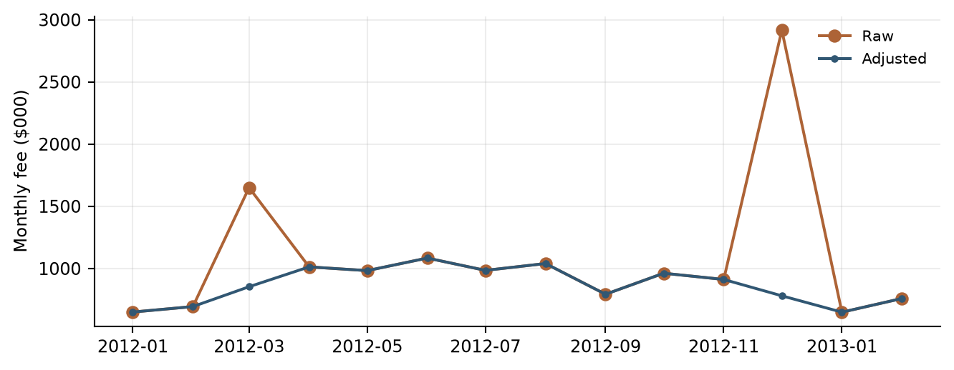
Data sources: debit/​monthly_​revenue.csv; debit/​debit_​card_​model.py.
数据来源：debit/​monthly_​revenue.csv; debit/​debit_​card_​model.py.
The adjustment table places each affected raw Debit observation beside its replacement value. These entries provide a direct reconciliation of the documented adjacent-month averaging treatment.
调整表将受影响的借记卡原始观测与替代值并列展示，便于直接核对已记录的相邻月份平均值替换处理。
Table 4.19 Debit Adjusted Observations
表4.19 借记卡调整后观测
Month  月份 | Raw fee ($000)  原始手续费（$000） | Adjusted fee ($000)  调整后手续费（$000） | Treatment  处理
2012-03-01 | 1,650.00 | 853.50 | Mean of adjacent raw months  相邻原始月份均值
2012-12-01 | 2,916.00 | 780.50 | Mean of adjacent raw months  相邻原始月份均值
Data sources: debit/​monthly_​revenue.csv; debit/​debit_​card_​model.py, prepare_​revenue function.
数据来源：debit/​monthly_​revenue.csv; debit/​debit_​card_​model.py, prepare_​revenue function.

4.3.8 Data Relevance and Assumptions
4.3.8 数据相关性及假设
The target directly measures the fee revenue being forecast. Historical coverage provides observations across different operating environments. Data preparation assumes consistent fee definitions, component mappings and reporting units over time. Source-system lineage, accounting reconciliation and data-vintage records support ongoing data governance.
目标直接衡量所预测的手续费收入。历史覆盖不同经营环境。数据准备假设手续费定义、组成部分映射及报告单位随时间保持一致。源系统血缘、会计核对及数据版本记录支持持续数据治理。
Pricing actions, product changes and shifts in customer behavior are reviewed alongside aggregate fee history. Periodic review considers the continuing relevance of the input definitions, selected transformations and calibration periods.
定价措施、产品变化及客户行为转变与汇总手续费历史一并审阅。定期评估输入定义、选定转换及校准期间的持续相关性。

4.3.9 Development Data Conclusions
4.3.9 开发数据结论
The Debit Card development data provide a consistent foundation for the documented model methodology. Source files, derived features and calculation rules preserve traceability and support estimation, testing and forecasting. Ongoing review of data quality and business developments maintains the relevance of this foundation.
借记卡开发数据为已记录的模型方法提供一致基础。源文件、派生特征及计算规则保留可追溯性，支持估计、测试和预测。通过持续审阅数据质量与业务发展，维持该数据基础的相关性。

5. Linkages with Other Models
5. 与其他模型的关联

6. Model Testing
6. 模型测试

6.1 Commercial Card and Small Business Model Testing
6.1 商业卡及小企业卡模型测试

6.1.1 Testing Philosophy
6.1.1 测试理念
Model testing was designed to evaluate statistical validity, model stability, forecasting performance, economic reasonableness, and regulatory suitability. Testing was not limited to traditional goodness-of-fit measures. Instead, the framework emphasized whether the model remained interpretable, stable, and useful under changing business and economic conditions. All testing results were reviewed collectively because no individual metric is sufficient to determine model suitability.
模型测试旨在评估统计有效性、模型稳定性、预测表现、经济合理性及监管适用性。测试不限于传统拟合优度指标，而是强调模型在业务及经济条件变化时是否仍具有可解释性、稳定性和实用性。所有测试结果均综合审阅，因为任何单一指标都不足以确定模型适用性。

6.1.2 In Sample Performance Assessment
6.1.2 样本内表现评估
The selected equation achieved an adjusted R-squared of 0.7357 [commercial/​short_​run_​diagnostics.csv/​row 2 col 3]. In-sample assessment reviews both the transformed target and reconstructed fee-revenue levels. The fitted-versus-actual comparison shows how the estimated equation represents observed monthly behavior, while the fit statistics summarize explanatory power on the estimation scale.
所选方程的调整后R平方为0.7357 [commercial/​short_​run_​diagnostics.csv/​row 2 col 3]。样本内评估同时审阅转换后的目标及重构的手续费收入水平。拟合值与实际值比较展示估计方程如何反映月度观测表现，拟合统计量概括估计尺度上的解释能力。
Table 6.1 Commercial Card and Small Business In Sample Performance Metrics
表6.1 商业卡及小企业卡样本内表现指标
Metric  指标 | Value  数值
Number of observations  观测数 | 135 [commercial/​short_​run_​diagnostics.csv/​row 2 col 1]
R-squared  R平方 | 0.7435 [commercial/​short_​run_​diagnostics.csv/​row 2 col 2]
Adjusted R-squared  调整后R平方 | 0.7357 [commercial/​short_​run_​diagnostics.csv/​row 2 col 3]
Fee-level RMSE ($000)  手续费水平RMSE（$000） | 105.88 [commercial/​forecast_​accuracy.csv/​row 2 col 3]
Fee-level MAPE (%)  手续费水平MAPE（%） | 5.39 [commercial/​forecast_​accuracy.csv/​row 2 col 5]
AIC  AIC | 929.50 [commercial/​short_​run_​diagnostics.csv/​row 2 col 4]
Data sources: commercial/​short_​run_​diagnostics.csv; commercial/​forecast_​accuracy.csv.
数据来源：commercial/​short_​run_​diagnostics.csv; commercial/​forecast_​accuracy.csv.
The fitted fee levels follow the broad historical rise and many of the month-to-month movements in Commercial and Small Business revenue. The separation between the lines highlights individual months with larger estimation errors.
商业卡及小企业卡手续费拟合值跟随历史收入的总体上升趋势及许多月度波动。两条曲线之间的差距标示估计误差较大的具体月份。
Figure 6.1 Commercial Card and Small Business Actual and Fitted Values
图6.1 商业卡及小企业卡实际值与拟合值
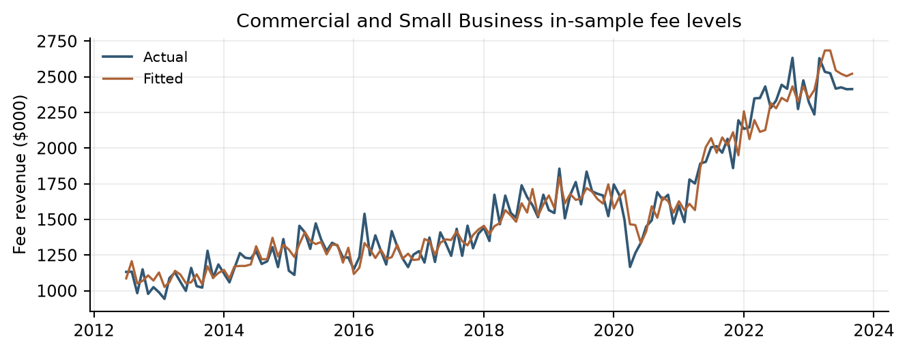
Data sources: commercial/​static_​in_​sample.csv. Fee amounts are in $000.
数据来源：commercial/​static_​in_​sample.csv. Fee amounts are in $000.

6.1.3 Coefficient Significance Testing
6.1.3 系数显著性检验
Final coefficients were evaluated for statistical significance and economic plausibility. The retained terms have statistically significant Student-t p-values at the conventional five-percent level. Coefficient signs are interpreted in the context of the target transformation, selected lag and other variables in the equation.
最终系数根据统计显著性及经济合理性进行评估。保留项的Student-t p值在常用的5%水平下显著。系数符号结合目标转换、选定滞后及方程中其他变量解释。
The negative adjusted-EC coefficient captures the subsequent growth response to a prior deviation from the long-run reference. The positive own-growth terms represent persistence, while the positive Corporate Profits term links business profitability to fee growth.
负向调整后EC系数刻画前期偏离长期参照后的增长响应。正向自身增长项反映持续性，正向企业利润项将企业盈利与手续费增长联系起来。
Table 6.2 Commercial Card and Small Business Coefficient Estimates and Inference
表6.2 商业卡及小企业卡系数估计及推断
Term  变量项 | Estimate  估计值 | Std error  标准误 | t statistic  t统计量 | p value  p值
Intercept  截距 | 1.78314 | 0.85356 | 2.089 [commercial/​short_​run_​coefficients.csv/​row 2 col 5] | 0.039 [commercial/​short_​run_​coefficients.csv/​row 2 col 6]
Adjusted EC, lag 12  调整后EC，滞后12个月 | -0.65352 | 0.08291 | -7.883 [commercial/​short_​run_​coefficients.csv/​row 3 col 5] | <0.001 [commercial/​short_​run_​coefficients.csv/​row 3 col 6]
Fee YoY growth, lag 1  手续费同比增长，滞后1个月 | 0.29638 | 0.06672 | 4.442 [commercial/​short_​run_​coefficients.csv/​row 4 col 5] | <0.001 [commercial/​short_​run_​coefficients.csv/​row 4 col 6]
Fee YoY growth, lag 6  手续费同比增长，滞后6个月 | 0.25019 | 0.05008 | 4.996 [commercial/​short_​run_​coefficients.csv/​row 5 col 5] | <0.001 [commercial/​short_​run_​coefficients.csv/​row 5 col 6]
Profits YoY growth, lag 2  利润同比增长，滞后2个月 | 0.42202 | 0.09115 | 4.630 [commercial/​short_​run_​coefficients.csv/​row 6 col 5] | <0.001 [commercial/​short_​run_​coefficients.csv/​row 6 col 6]
Data sources: commercial/​short_​run_​coefficients.csv.
数据来源：commercial/​short_​run_​coefficients.csv.

6.1.4 Multicollinearity Assessment
6.1.4 多重共线性评估
Variance Inflation Factors were evaluated to determine whether explanatory variables contained excessive shared information. The maximum nonconstant VIF is 2.2501 [commercial/​short_​run_​diagnostics.csv/​row 2 col 11], below the implemented threshold of 10. The results indicate that multicollinearity is limited within the selected specification.
通过方差膨胀因子评估解释变量是否包含过多共享信息。最大非截距VIF为2.2501 [commercial/​short_​run_​diagnostics.csv/​row 2 col 11]，低于代码使用的阈值10。结果表明所选设定中的多重共线性有限。
Table 6.3 Commercial Card and Small Business Variance Inflation Factors
表6.3 商业卡及小企业卡方差膨胀因子
Variable  变量 | VIF  VIF
ec_​scaled_​adjusted_​pct_​lag_​12m | 1.2343 [commercial/​short_​run_​coefficients.csv/​row 3 col 7]
commercial_​small_​business_​fee_​pct_​change_​12m_​lag_​1m | 2.2501 [commercial/​short_​run_​coefficients.csv/​row 4 col 7]
commercial_​small_​business_​fee_​pct_​change_​12m_​lag_​6m | 1.2914 [commercial/​short_​run_​coefficients.csv/​row 5 col 7]
corporate_​profits_​pct_​change_​12m_​lag_​2m | 2.1560 [commercial/​short_​run_​coefficients.csv/​row 6 col 7]
Data sources: commercial/​short_​run_​coefficients.csv.
数据来源：commercial/​short_​run_​coefficients.csv.

6.1.5 Residual Diagnostics and Statistical Assumptions
6.1.5 残差诊断及统计假设
Residual diagnostics evaluate distributional shape, serial correlation and overall equation adequacy. The Durbin-Watson statistic is 2.0321 [commercial/​short_​run_​diagnostics.csv/​row 2 col 5]. The Jarque-Bera p-value is 0.7573 [commercial/​short_​run_​diagnostics.csv/​row 2 col 7], above the five-percent reference level. The residual time series, fitted-value comparison and normal-reference plot complement these numerical results.
残差诊断评估分布形态、序列相关及整体方程适当性。Durbin-Watson统计量为2.0321 [commercial/​short_​run_​diagnostics.csv/​row 2 col 5]，Jarque-Bera p值为0.7573 [commercial/​short_​run_​diagnostics.csv/​row 2 col 7]，高于5%参考水平。残差时间序列、与拟合值的比较及正态参考图补充这些数值结果。
The lag-12 Ljung-Box test has a p-value of 0.3180 [commercial/​short_​run_​diagnostics.csv/​row 2 col 9], providing additional support for the residual serial-correlation assessment. Transformed macroeconomic candidates were also assessed using the ADF and KPSS screens described in Section 3.
12期Ljung-Box检验p值为0.3180 [commercial/​short_​run_​diagnostics.csv/​row 2 col 9]，为残差序列相关评估提供进一步依据。转换后的宏观候选变量亦采用第3章所述ADF和KPSS筛选进行评估。
Table 6.4 Commercial Card and Small Business Residual Diagnostic Statistics
表6.4 商业卡及小企业卡残差诊断统计量
Diagnostic Statistic  诊断统计量 | Value  数值
Durbin-Watson  Durbin-Watson | 2.0321 [commercial/​short_​run_​diagnostics.csv/​row 2 col 5]
Jarque-Bera statistic  Jarque-Bera统计量 | 0.5559 [commercial/​short_​run_​diagnostics.csv/​row 2 col 6]
Jarque-Bera p-value  Jarque-Bera p值 | 0.7573 [commercial/​short_​run_​diagnostics.csv/​row 2 col 7]
Ljung-Box lag 12 statistic  12期Ljung-Box统计量 | 13.7341 [commercial/​short_​run_​diagnostics.csv/​row 2 col 8]
Ljung-Box lag 12 p-value  12期Ljung-Box p值 | 0.3180 [commercial/​short_​run_​diagnostics.csv/​row 2 col 9]
Data sources: commercial/​short_​run_​diagnostics.csv.
数据来源：commercial/​short_​run_​diagnostics.csv.
The upper panel shows residual fluctuations around zero over time. In the lower panel, residuals lie on both sides of zero without a pronounced curved pattern or clear funnel-shaped dispersion, providing visual support for the selected functional form.
上图展示残差随时间在零线附近的波动。下图的残差分布于零线两侧，未呈现明显的曲线规律或漏斗状散布，为所选模型函数形式提供视觉支持。
Figure 6.2 Commercial Card and Small Business Residual Diagnostics
图6.2 商业卡及小企业卡残差诊断
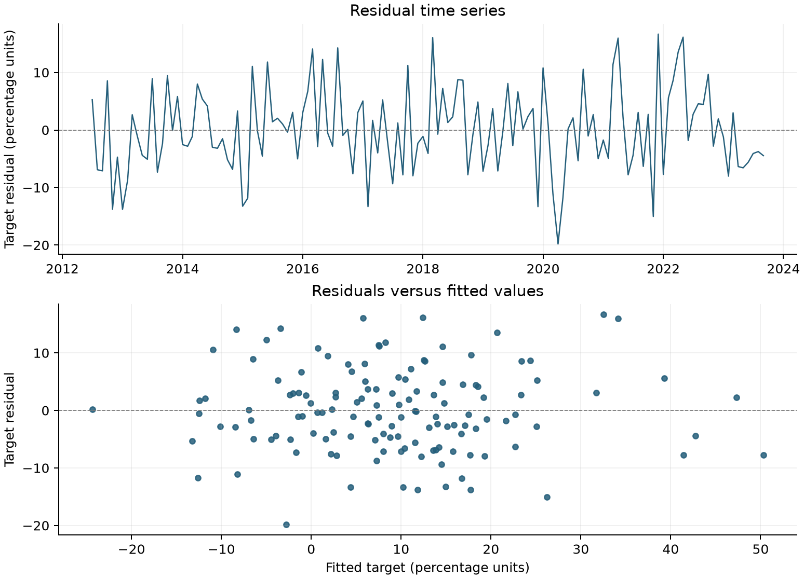
Data sources: commercial/​short_​run_​estimation_​sample.csv.
数据来源：commercial/​short_​run_​estimation_​sample.csv.
The standardized Commercial residual quantiles broadly follow the normal-reference line, with smaller departures near the tails. This visual pattern is consistent with the accompanying Jarque-Bera assessment.
标准化商业卡残差分位数总体沿正态参考线分布，在尾部存在一些偏离。该视觉特征与前述Jarque-Bera检验结果一致。
Figure 6.3 Commercial Card and Small Business Normal Reference Plot
图6.3 商业卡及小企业卡正态参考图
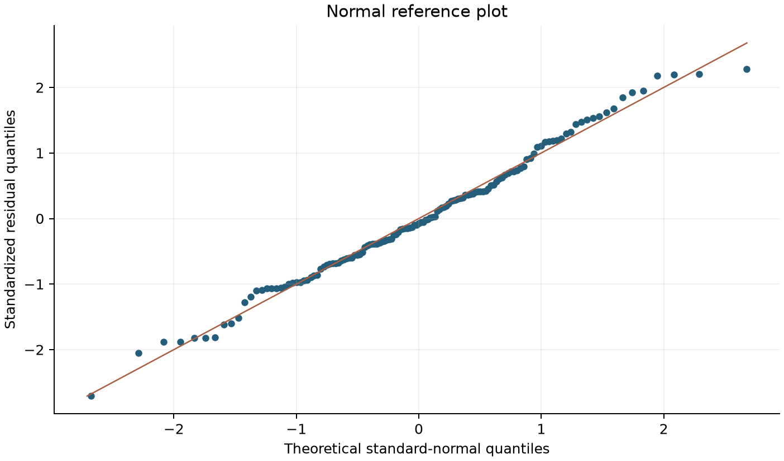
Data sources: commercial/​short_​run_​estimation_​sample.csv. Exported target residuals standardized using the sample mean and standard deviation; midpoint normal plotting positions.
数据来源：commercial/​short_​run_​estimation_​sample.csv. Exported target residuals standardized using the sample mean and standard deviation; midpoint normal plotting positions.

6.1.6 Stability Testing
6.1.6 稳定性测试
Stability assessment considers forecast-error behavior under fixed development coefficients and the response of recursive projections to changing macroeconomic inputs. Static and Full Recursive OOT exercises use the same fitted equation. Full Recursive OOT updates fee levels, own-growth lags and adjusted EC states throughout the evaluation period, while scenario and sensitivity tests evaluate model behavior under alternative future paths. These exercises preserve a common coefficient basis for comparison.
稳定性评估关注固定开发系数下的预测误差表现，以及递归预测对宏观输入变化的响应。静态及完全递归OOT测试使用相同拟合方程。完全递归OOT在整个评估期间更新手续费水平、自身增长率滞后项及调整后的EC状态；情景和敏感性测试评估不同未来路径下的模型表现。各项测试保留共同系数基础，便于比较。

6.1.7 Out of Time Testing Framework and Results
6.1.7 OOT测试方法及结果
Out-of-time testing uses October 2023 through December 2025 to assess forecast performance beyond the coefficient-development period. Results are compared with realized fee revenue on the original $000 scale. Static and recursive exercises are reported separately so that the role of forecast-state updating is explicit.
OOT测试使用2023年10月至2025年12月，评估系数开发期之后的预测表现。结果在原始$000尺度上与实际手续费收入比较。静态和递归测试分别报告，以明确预测状态更新的作用。
Short-run macroeconomic candidates were pre-screened for partial-correlation significance and sign consistency across the development and OOT periods. Subsequent variable selection and coefficient estimation used development-period observations.
短期宏观候选变量根据开发期与OOT期间的偏相关显著性及符号一致性进行预筛选。后续变量选择和系数估计使用开发期观测数据。
Full Recursive OOT initializes fee levels, annual fee growth and adjusted EC using actual history through September 2023. From October 2023 onward, predicted growth is applied to the fee level from 12 months earlier, using the forecast value whenever that anchor falls within OOT. Predicted fees are then used to recalculate scaled EC and adjusted EC; subsequent own-growth lags and the 12-month adjusted-EC lag use these recursively generated states. Realized OOT fee values are used to evaluate forecast accuracy, not to reset these endogenous states. The exercise retains fixed development coefficients, historical macroeconomic paths and the calibrated OOT EC trend adjustment. Month-level results and lag inputs are exported in fully_​recursive_​oot.csv.
完全递归OOT使用截至2023年9月的实际历史数据初始化手续费水平、手续费同比增长率及调整后的EC。自2023年10月起，将预测增长率应用于12个月前的手续费水平；若该锚点位于OOT期间，则使用此前的预测水平。随后用预测手续费重新计算标准化EC和调整后的EC，后续自身增长率滞后项及12个月调整后EC滞后项采用这些递归生成的状态。OOT期间的实际手续费用于评估预测准确性，不用于重置上述内生状态。测试保留固定开发系数、历史宏观路径及已校准的OOT EC趋势调整。逐月结果及滞后输入导出至fully_​recursive_​oot.csv。
This table compares fee-level forecast errors under static and Full Recursive OOT evaluation. The comparison quantifies the difference between using observed lagged states and allowing predicted fee and error-correction states to evolve throughout the test.
本表比较静态与完全递归OOT测试下的手续费水平值预测误差，量化使用实际滞后状态与在整个测试期持续更新预测手续费及误差修正状态之间的差异。
Table 6.5 Commercial Card and Small Business OOT Forecast Accuracy
表6.5 商业卡及小企业卡 OOT预测准确性
Method  方法 | MAPE (%)  MAPE（%） | RMSE ($000)  RMSE（$000）
Static OOT  静态OOT | 8.76 [commercial/​forecast_​accuracy.csv/​row 3 col 5] | 231.43 [commercial/​forecast_​accuracy.csv/​row 3 col 3]
Full Recursive OOT  完全递归OOT | 16.95 [commercial/​forecast_​accuracy.csv/​row 4 col 5] | 399.13 [commercial/​forecast_​accuracy.csv/​row 4 col 3]
Data sources: commercial/​forecast_​accuracy.csv.
数据来源：commercial/​forecast_​accuracy.csv.
The figure places actual Commercial fees beside the static and Full Recursive OOT paths. The separation between the forecast lines shows how their different state-updating procedures affect the projected revenue path over time.
本图将实际商业卡手续费与静态、完全递归OOT路径并列展示。两条预测曲线的差距体现不同状态更新方式对收入预测路径随时间演变的影响。
Figure 6.4 Commercial Card and Small Business OOT Forecast Results
图6.4 商业卡及小企业卡 OOT预测结果
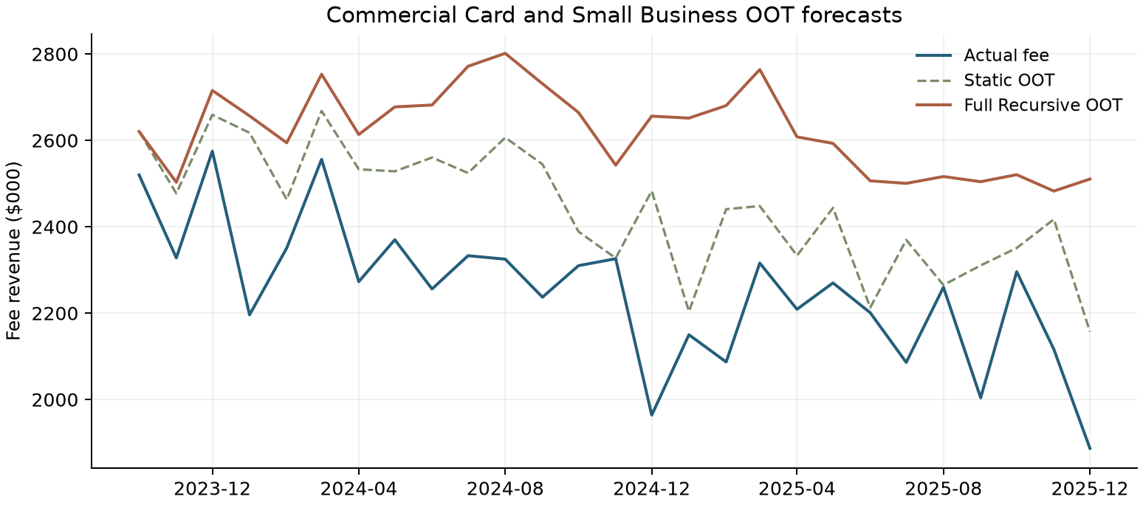
Data sources: commercial/​static_​oot.csv; commercial/​fully_​recursive_​oot.csv. Full Recursive OOT updates fee levels, own-growth lags and adjusted EC states. Fee amounts are in $000.
数据来源：commercial/​static_​oot.csv；commercial/​fully_​recursive_​oot.csv。完全递归OOT更新手续费水平、自身增长率滞后项及调整后的EC状态。手续费金额单位为$000。
Figure 6.4A Commercial Card and Small Business OOT Forecasts With and Without Overlay
图6.4A 商业卡及小企业卡应用与未应用Overlay的OOT预测
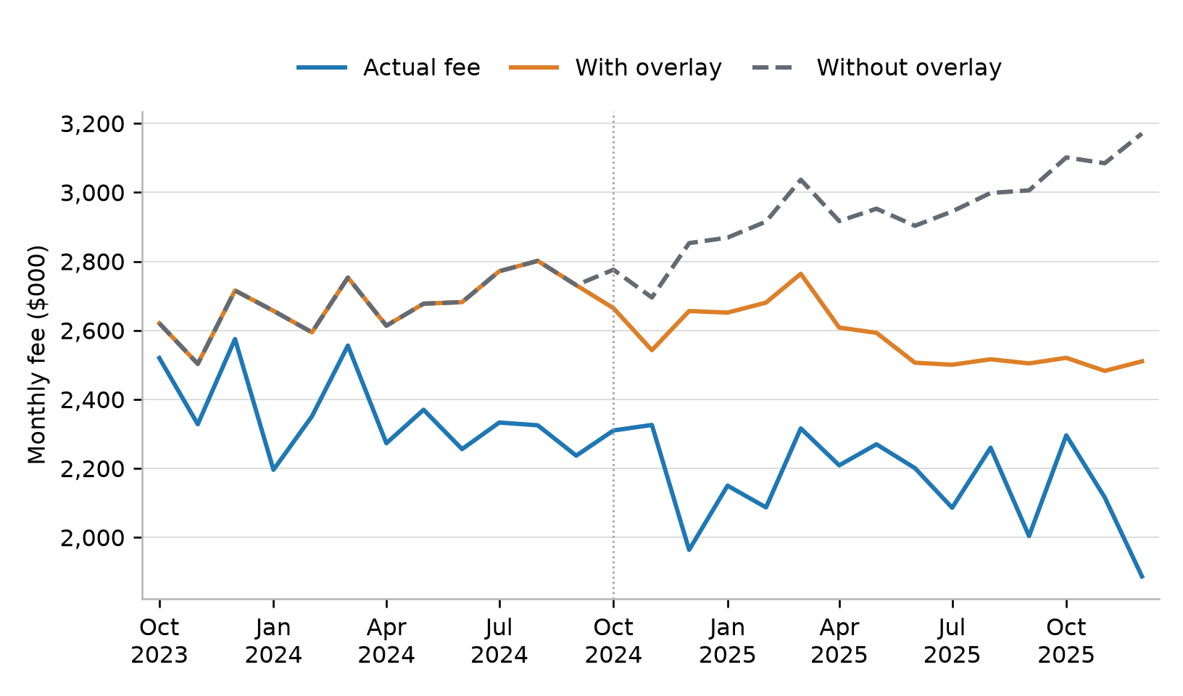
Figure 6.4A shows actual fee revenue and Full Recursive OOT forecasts with and without the overlay. Both forecasts use the same model coefficients, macroeconomic inputs and starting history. In this comparison, the overlay lowers forecasts and brings them closer to actual revenue. The paths begin to differ in October 2024 because the adjusted error-correction term enters the model with a 12-month lag.
图6.4A展示实际手续费收入，以及应用和未应用overlay的完全递归OOT预测。两条预测使用相同的模型系数、宏观输入和初始历史数据。在本次比较中，overlay降低了预测值，使其更接近实际收入。两条预测线从2024年10月开始分开，因为调整后的误差修正项滞后12个月进入模型。
Data source: commercial/​fully_​recursive_​oot_​overlay_​comparison.csv, rows 2-28, columns 1-4. Row 1 contains column headers. Fee amounts are in $000.
数据来源：commercial/​fully_​recursive_​oot_​overlay_​comparison.csv，第2-28行，第1-4列。第1行为列标题。手续费金额单位为$000。
The signed-error plot shows the timing and magnitude of forecast deviations for both Commercial OOT methods. Values above the zero line indicate forecasts above actual fees, while the distance from zero measures the relative error.
带符号误差图展示两种商业卡OOT方法的预测偏差出现时间及幅度。零线上方表示预测高于实际手续费，距离零线的大小表示相对误差。
Figure 6.5 Commercial Card and Small Business OOT Prediction Errors
图6.5 商业卡及小企业卡 OOT预测误差
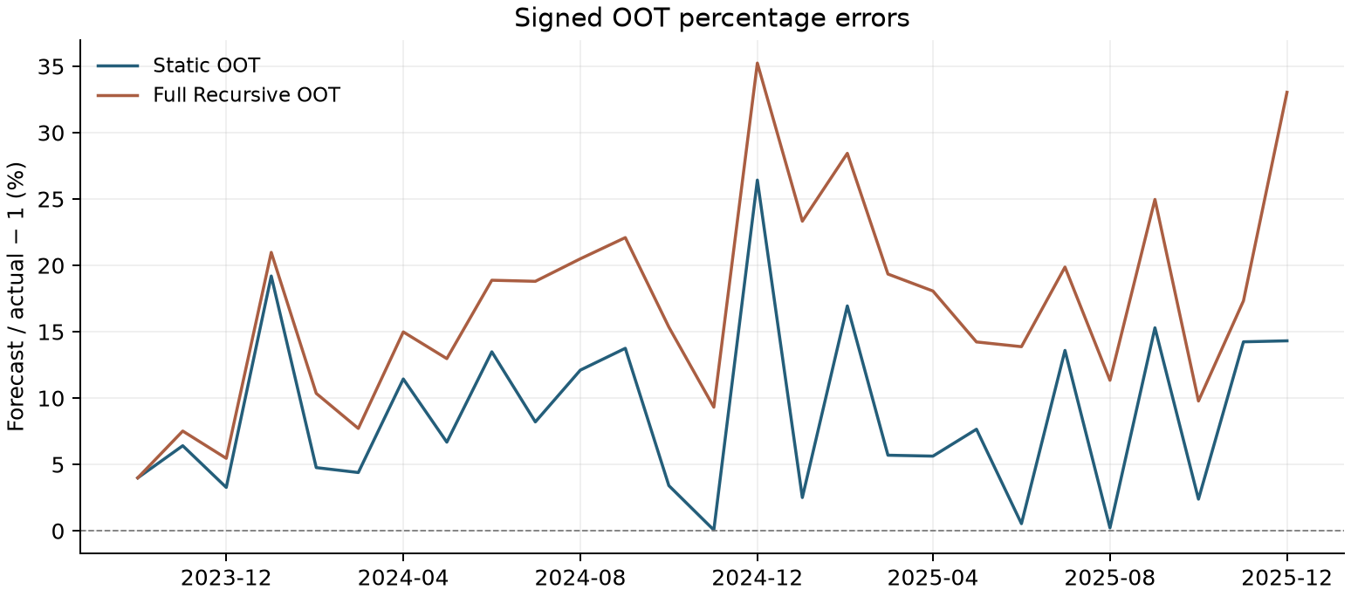
Data sources: commercial/​static_​oot.csv; commercial/​fully_​recursive_​oot.csv. Signed percentage error = 100 × (predicted fee /​ actual fee − 1).
数据来源：commercial/​static_​oot.csv；commercial/​fully_​recursive_​oot.csv。有符号百分比误差 = 100 ×（预测手续费 /​ 实际手续费 − 1）。

6.1.8 Root Cause Assessment
6.1.8 原因分析
Root-cause review evaluates forecast deviations alongside fee history, model inputs, lagged states and relevant business developments. Review considers pricing, customer mix, product and service changes, and the timing of economic drivers. Static and recursive results help identify how forecast-state updates affect the observed error pattern.
原因分析结合手续费历史、模型输入、滞后状态及相关业务发展评估预测偏差。审阅考虑定价、客户结构、产品及服务变化和经济驱动的时点。静态及递归结果有助于识别预测状态更新对观测误差模式的影响。
Commercial's EC trend summarizes the persistent difference between observed fees and the long-run reference during the calibration period. The implemented overlay incorporates that pattern into the adjusted EC state used by the short-run model. The business rationale and approval record for the overlay will be documented through the governance process.
商业卡EC趋势概括校准期间已观察手续费与长期参照之间的持续差异。已实现的调整将该模式纳入短期模型使用的调整后EC状态。调整的业务依据及审批记录将在治理流程中予以记录。

6.1.9 Overlay Support Analysis
6.1.9 调整项支持分析
The Commercial OOT trend has 27 observations, R-squared 0.7315 [commercial/​overlay_​trend.csv/​row 2 col 4] and slope p approximately 1.32×10⁻⁸ [commercial/​overlay_​trend.csv/​row 2 col 3]. Its held value is -30.1428 on the scaled EC percentage scale. Because the adjustment is subtracted before a lagged EC term enters the short-run equation, its effect is not equivalent to multiplying every forecast by a fixed revenue factor.
商业卡OOT趋势使用27个观测，R平方为0.7315 [commercial/​overlay_​trend.csv/​row 2 col 4]，斜率p值约为1.32×10⁻⁸ [commercial/​overlay_​trend.csv/​row 2 col 3]。其固定值在标准化EC百分比尺度上为-30.1428。调整在滞后EC项进入短期方程前扣除，因此其作用不同于将所有预测乘以固定收入因子。
The observed scaled EC series and fitted trend both move downward during the calibration period. The horizontal extension shows the terminal trend value held constant as the future EC adjustment.
校准期间，实际缩放EC序列与拟合趋势均呈下降方向。水平延长线表示将趋势终值保持不变，作为未来EC调整项。
Figure 6.6 Commercial Overlay Calibration
图6.6 商业卡调整项校准
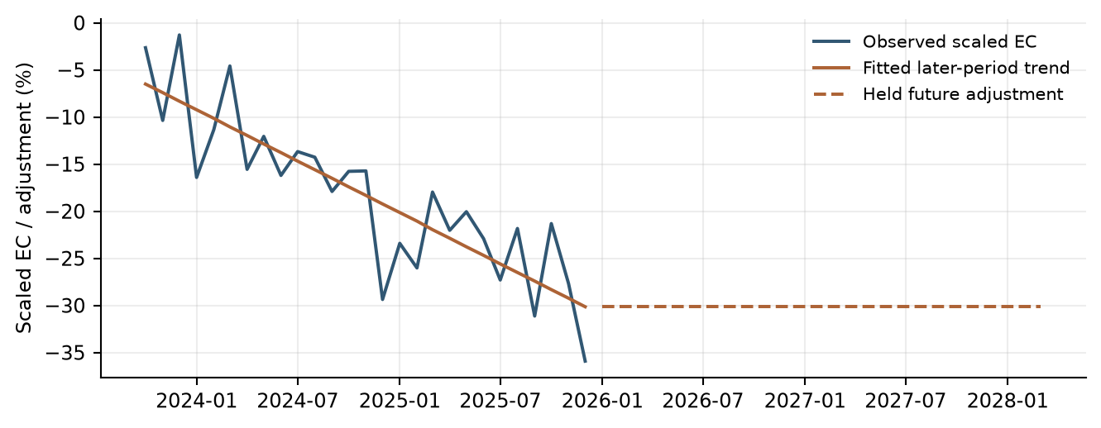
Data sources: commercial/​historical_​data_​and_​features.csv; commercial/​forecast_​monthly.csv.
数据来源：commercial/​historical_​data_​and_​features.csv; commercial/​forecast_​monthly.csv.
The parameter table records the calibration window, fitted trend and held future EC adjustment. These values define the adjustment applied within the error-correction calculation rather than a direct revenue multiplier.
参数表记录校准窗口、拟合趋势及未来固定EC调整值。这些参数定义误差修正计算内部的调整，而非直接作用于收入的乘数。
Table 6.6 Commercial Overlay Parameters
表6.6 商业卡调整项参数
Item  项目 | Value  数值
Calibration period  校准期间 | Oct 2023–Dec 2025  2023年10月至2025年12月
Intercept  截距 | -5.592975
Slope per month  每月斜率 | -0.909254 percentage points  -0.909254 个百分点
Held future state adjustment  固定未来状态调整 | -30.142832 percentage points  -30.142832 个百分点
Future treatment  未来处理 | Constant; no continued linear extrapolation  保持常数，不继续线性外推
Data sources: commercial/​overlay_​trend.csv; commercial/​commercial_​card_​model.py.
数据来源：commercial/​overlay_​trend.csv; commercial/​commercial_​card_​model.py.

6.1.10 Scenario Testing and Reasonableness Assessment
6.1.10 情景测试及合理性评估
Scenario testing evaluates forecast direction, magnitude and persistence through March 2028. Baseline and S4 runs share the same historical fee anchor, transformations and model structure. Monthly forecast revenue is also aggregated into calendar quarters for planning review.
情景测试评估截至2028年3月的预测方向、幅度及持续性。基准和S4运行使用相同历史手续费锚点、转换及模型结构。月度预测收入亦汇总为自然季度，供规划审阅。
Commercial scenarios vary CPI and Corporate Profits while retaining development coefficients and the held EC trend adjustment. The long-run reference, growth transformations and future fee and EC states are recalculated along each scenario path.
商业卡情景改变CPI及企业利润，同时保留开发系数和固定EC趋势调整。每条情景路径均重新计算长期参照、增长转换，以及未来手续费和EC状态。
The input panels compare the CPI and Corporate Profits paths supplied to the Commercial scenario runs. S4 shows weaker Corporate Profits and a lower CPI level later in the horizon, which enter the short-run growth and long-run reference mechanisms respectively.
输入图比较商业卡情景预测采用的CPI和企业利润路径。S4的企业利润较弱，预测期后段CPI水平较低，两者分别通过短期增长机制和长期参照机制进入模型。
Figure 6.7 Commercial Card and Small Business Scenario Inputs
图6.7 商业卡及小企业卡情景输入
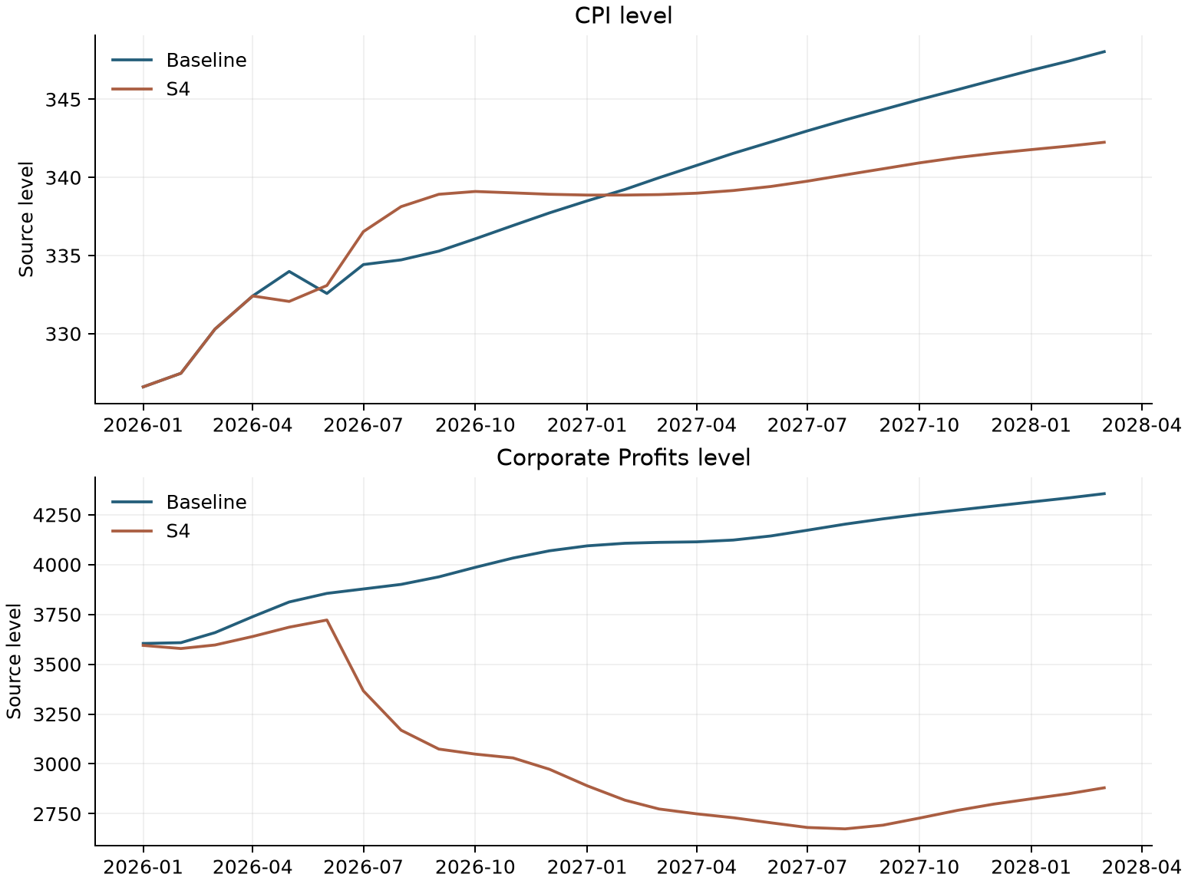
Data sources: commercial/​data/​macro_​baseline.csv; commercial/​data/​macro_​s4.csv. Original source units.
数据来源：commercial/​data/​macro_​baseline.csv; commercial/​data/​macro_​s4.csv. Original source units.
The Commercial scenario paths begin close together and separate as the macroeconomic differences pass through the model’s lagged dynamics. S4 revenue remains below Baseline later in the projection, with some recovery toward the end.
商业卡情景路径初期接近，随后宏观差异通过模型滞后动态传导，路径逐渐分离。预测期后段S4收入低于基准，并在期末出现一定回升。
Figure 6.8 Commercial Card and Small Business Baseline and S4 Forecast Paths
图6.8 商业卡及小企业卡基准及S4预测路径
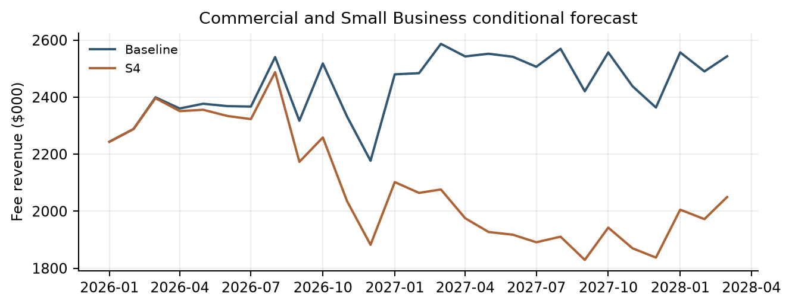
Data sources: commercial/​forecast_​monthly.csv. Fee revenue in $000.
数据来源：commercial/​forecast_​monthly.csv. Fee revenue in $000.
The totals translate the monthly Commercial scenario paths into planning-period revenue comparisons. The larger relative shortfall over the full horizon than in the first year reflects the later separation of the scenario paths.
汇总表将商业卡月度情景路径转换为规划期间的收入比较。全预测期相对缺口大于首年，反映情景路径在后期进一步分离。
Table 6.7 Commercial Card and Small Business Scenario Revenue Totals
表6.7 商业卡及小企业卡情景收入合计
Period  期间 | Baseline ($000)  基准（$000） | S4 ($000) | S4 vs Base  S4相对基准
2026 total  2026年总额 | 28,288.73 | 27,128.81 | -4.10%
9-quarter total  9季度总额 | 65,923.13 | 56,499.62 | -14.29%
Data sources: commercial/​forecast_​quarterly_​summary.csv.
数据来源：commercial/​forecast_​quarterly_​summary.csv.

6.1.11 Model Development Progression
6.1.11 模型开发过程
The Commercial short-run model was developed in stages. Adjusted EC was retained throughout to connect short-run fee growth with the CPI-based long-run model. The first selected specification included fee growth from one month earlier. A six-month lag of fee growth was then added. Finally, Corporate Profits growth from two months earlier was included to capture broader business conditions. These steps produced the final short-run model.
商业卡短期模型分阶段构建。各阶段均保留调整后的 EC，将短期手续费增长与基于 CPI 的长期模型连接起来。第一个选定模型包含手续费同比增长的一个月滞后项。随后加入手续费同比增长的六个月滞后项。最后加入企业利润同比增长的两个月滞后项，以反映更广泛的经营环境。这些步骤形成了最终短期模型。
Table 6.8 Commercial Short-Run Model Development Progression
表6.8 商业卡短期模型开发过程
Model Stage  模型阶段 | Variables Included  包含变量 | Adjusted R²  调整后 R²
Initial Model  初始模型 | Adjusted EC, lag 12 + fee YoY growth, lag 1  调整后 EC，滞后12个月 + 手续费同比增长，滞后1个月 | 65.83% [commercial/​short_​run_​rounds.csv/​row 2 col 3]
Enhanced Model  增强模型 | Adjusted EC, lag 12 + fee YoY growth, lags 1 and 6  调整后 EC，滞后12个月 + 手续费同比增长，滞后1及6个月 | 69.44% [commercial/​short_​run_​rounds.csv/​row 3 col 3]
Final Model  最终模型 | Adjusted EC, lag 12 + fee YoY growth, lags 1 and 6 + Corporate Profits YoY growth, lag 2  调整后 EC，滞后12个月 + 手续费同比增长，滞后1及6个月 + 企业利润同比增长，滞后2个月 | 73.57% [commercial/​short_​run_​rounds.csv/​row 4 col 3]
Table 6.8 shows the selected specifications at each stage of Commercial short-run model development. It lists the variables retained and the adjusted R-squared reported for each specification. All specifications include an intercept. Sample sizes follow the lag requirements at each stage.
表 6.8 展示商业卡短期模型各开发阶段的选定设定，列明保留的变量及对应的调整后 R²。所有设定均包含截距项。各阶段的样本量根据所用变量的滞后要求确定。
Data sources: commercial/​short_​run_​rounds.csv; commercial/​commercial_​card_​model.py.
数据来源：commercial/​short_​run_​rounds.csv；commercial/​commercial_​card_​model.py。

6.1.12 User Review and Acceptance
6.1.12 用户审阅及验收
Model results, assumptions, forecast behavior, and testing outcomes were reviewed with Strategic Finance and relevant lines of business during model development. Review sessions focused on economic intuition, reasonableness of the selected drivers, forecast behavior under changing economic conditions, and consistency with observed business performance. Feedback from these reviews supported the conclusion that the model appropriately captures the primary drivers of Commercial Card and Small Business Fee Revenue and produces forecasts that are directionally consistent with business expectations.
在模型开发期间，模型结果、假设、预测表现及测试结果已与战略财务部门和相关业务条线进行审阅。审阅会议重点关注经济直觉、所选驱动因素的合理性、经济条件变化下的预测表现，以及与实际业务表现的一致性。审阅反馈支持以下结论：该模型恰当地捕捉了商业卡及小企业卡手续费收入的主要驱动因素，且预测方向与业务预期一致。
Because the model has not yet been deployed into a production forecasting environment, final User Acceptance Testing (UAT) has not been completed. Prior to production implementation, final UAT will be performed to verify that the implemented model reproduces approved development results, correctly incorporates required inputs, generates expected outputs, and operates in accordance with documented procedures and governance requirements.
由于模型尚未部署至生产预测环境，最终用户验收测试（UAT）尚未完成。在生产实施之前，将开展最终UAT，以验证实施后的模型能够复现已批准的开发结果，正确纳入所需输入，生成预期输出，并按照已记录的操作程序及治理要求运行。

6.1.13 Sensitivity Analysis
6.1.13 敏感性分析
Commercial’s default sensitivity grid changes one driver at a time around Baseline. It calibrates sigma from in-sample YoY growth over January 2012–September 2023, using 141 observations and sample SD. CPI sigma is 2.17458 and Profits sigma is 10.45377 percentage points. The grid uses -2, -1, +1 and +2 sigma. CPI applies that scale as a relative level shift for all future months, whereas Corporate Profits adds it to YoY growth and reconstructs levels from historical or shocked year-ago anchors. These are different shock definitions and should not be described as the same percentage growth shock.
商业卡默认敏感性网格围绕Baseline逐一改变驱动因素。sigma根据2012年1月至2023年9月样本内同比增长计算，使用141个观测及样本标准差。CPI的sigma为2.17458个百分点，利润为10.45377个百分点。网格采用−2、−1、+1和+2倍sigma。CPI将该尺度应用为所有未来月份的相对水平偏移；企业利润则将其加至同比增长，并从历史或受冲击的上年同期基准重构水平。这些是不同冲击定义，不应描述为同一种百分比增长冲击。
The Commercial sensitivity exercise holds coefficients, historical observations, other inputs and the overlay constant, allowing each driver’s effect to be isolated. Timing follows the selected lags: CPI first changes predicted fees in January 2027 through the 12-month EC lag, while Corporate Profits first affects March 2026 fees through its two-month lag. A zero CPI fee effect during 2026 therefore reflects delayed transmission, not the absence of a CPI relationship.
商业卡敏感性分析固定系数、历史观测、其他输入及调整，从而单独识别各驱动作用。时点遵循选定滞后：CPI通过12个月EC滞后首先改变2027年1月预测手续费，企业利润通过2个月滞后首先影响2026年3月手续费。因此，2026年CPI手续费影响为零反映延迟传递，而非不存在CPI关系。
Table 6.9 Commercial One Driver Sensitivities
表6.9 商业卡单驱动敏感性
Driver  驱动因素 | Sigma  标准差倍数 | Shock size  冲击幅度 | Year impact  年度影响 | Horizon impact  全预测期影响 | Terminal impact  期末影响
CPI level  CPI水平 | -2 | -4.35% | 0.00% | -4.79% | -11.88%
CPI level  CPI水平 | -1 | -2.17% | 0.00% | -2.30% | -5.86%
CPI level  CPI水平 | +1 | 2.17% | 0.00% | 2.14% | 5.70%
CPI level  CPI水平 | +2 | 4.35% | 0.00% | 4.12% | 11.23%
Profits YoY  利润同比 | -2 | -20.91 pp  -20.91 个百分点 | -10.20% | -15.54% | -21.50%
Profits YoY  利润同比 | -1 | -10.45 pp  -10.45 个百分点 | -5.10% | -7.90% | -11.00%
Profits YoY  利润同比 | +1 | 10.45 pp  10.45 个百分点 | 5.10% | 8.14% | 11.42%
Profits YoY  利润同比 | +2 | 20.91 pp  20.91 个百分点 | 10.20% | 16.53% | 23.18%
Year impact measures the percentage change in total forecast revenue for 2026 compared with Baseline. Horizon impact measures the percentage change in total forecast revenue from January 2026 through March 2028. Terminal impact measures the percentage change in forecast revenue for March 2028 alone. All three measures compare the shocked forecast with Baseline over the same period.
Year impact 衡量 2026 年全年预测收入合计相对 Baseline 的百分比变化。Horizon impact 衡量 2026 年 1 月至 2028 年 3 月整个预测期间收入合计的百分比变化。Terminal impact 衡量 2028 年 3 月单月预测收入的百分比变化。三个指标均将冲击情景与同一期间的 Baseline 进行比较。
Data sources: commercial/​stress_​summary.csv.
数据来源：commercial/​stress_​summary.csv.
The bars summarize total-horizon revenue effects from the specified one-driver shocks. Positive shocks increase revenue and negative shocks reduce it; under these calibrated shock definitions, Corporate Profits produces larger total-horizon movements than CPI.
条形图汇总所设单一驱动变量冲击对全预测期收入的影响。正向冲击提高收入，负向冲击降低收入；在这些已校准的冲击定义下，企业利润引起的全预测期收入变化大于CPI。
Figure 6.9 Commercial Sensitivity Impacts
图6.9 商业卡敏感性影响
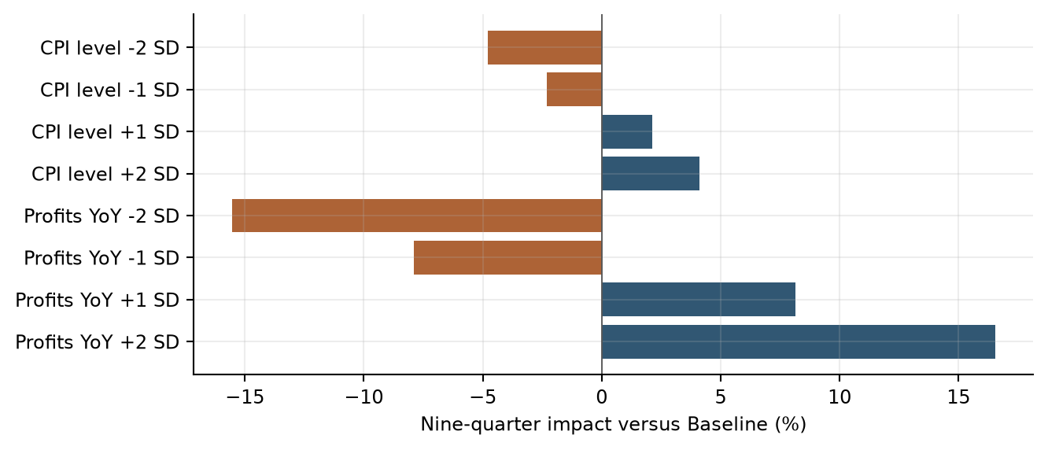
Data sources: commercial/​stress_​summary.csv. Change in summed forecast-period revenue versus Baseline.
数据来源：commercial/​stress_​summary.csv. Change in summed forecast-period revenue versus Baseline.

6.1.14 Testing Conclusions
6.1.14 测试结论
The testing results support the selected Commercial Card and Small Business long-run and short-run framework. Coefficient inference, multicollinearity and residual diagnostics provide statistical support, while OOT, scenario and sensitivity exercises show how the equation behaves across evaluation conditions. The EC adjustment is documented as a distinct calibration component. Together, these results provide the basis for planning forecasts, stress testing and ongoing performance monitoring.
测试结果支持所选商业卡及小企业卡长期和短期框架。系数推断、多重共线性及残差诊断提供统计支持，OOT、情景及敏感性测试展示方程在不同评估条件下的表现。EC调整作为独立校准组成部分记录。上述结果共同为规划预测、压力测试和持续表现监控提供依据。

6.2 Consumer Card Model Testing
6.2 消费者信用卡模型测试

6.2.1 Testing Philosophy
6.2.1 测试理念
Model testing was designed to evaluate statistical validity, model stability, forecasting performance, economic reasonableness, and regulatory suitability. Testing was not limited to traditional goodness-of-fit measures. Instead, the framework emphasized whether the model remained interpretable, stable, and useful under changing business and economic conditions. All testing results were reviewed collectively because no individual metric is sufficient to determine model suitability.
模型测试旨在评估统计有效性、模型稳定性、预测表现、经济合理性及监管适用性。测试不限于传统拟合优度指标，而是强调模型在业务及经济条件变化时是否仍具有可解释性、稳定性和实用性。所有测试结果均综合审阅，因为任何单一指标都不足以确定模型适用性。

6.2.2 In Sample Performance Assessment
6.2.2 样本内表现评估
The selected equation achieved an adjusted R-squared of 0.6114 [consumer/​model_​diagnostics.csv/​row 3 col 6]. In-sample assessment reviews both the transformed target and reconstructed fee-revenue levels. The fitted-versus-actual comparison shows how the estimated equation represents observed monthly behavior, while the fit statistics summarize explanatory power on the estimation scale.
所选方程的调整后R平方为0.6114 [consumer/​model_​diagnostics.csv/​row 3 col 6]。样本内评估同时审阅转换后的目标及重构的手续费收入水平。拟合值与实际值比较展示估计方程如何反映月度观测表现，拟合统计量概括估计尺度上的解释能力。
Table 6.10 Consumer Card In Sample Performance Metrics
表6.10 消费者信用卡样本内表现指标
Metric  指标 | Value  数值
Number of observations  观测数 | 150 [consumer/​model_​diagnostics.csv/​row 3 col 2]
R-squared  R平方 | 0.6244 [consumer/​model_​diagnostics.csv/​row 3 col 5]
Adjusted R-squared  调整后R平方 | 0.6114 [consumer/​model_​diagnostics.csv/​row 3 col 6]
Fee-level RMSE ($000)  手续费水平RMSE（$000） | 55.77 [consumer/​forecast_​accuracy.csv/​row 2 col 4]
Fee-level MAPE (%)  手续费水平MAPE（%） | 6.66 [consumer/​forecast_​accuracy.csv/​row 2 col 3]
Data sources: consumer/​model_​diagnostics.csv; consumer/​forecast_​accuracy.csv.
数据来源：consumer/​model_​diagnostics.csv; consumer/​forecast_​accuracy.csv.
The fitted Consumer fee series follows the broad historical decline and subsequent recovery, together with recurring monthly peaks and troughs. The remaining gaps identify individual observations not fully represented by the fitted equation.
消费者卡手续费拟合序列跟随历史上的总体下降及后续回升，并体现反复出现的月度峰谷。曲线间剩余差距标示拟合方程未完全解释的个别观测。
Figure 6.10 Consumer Card Actual and Fitted Values
图6.10 消费者信用卡实际值与拟合值
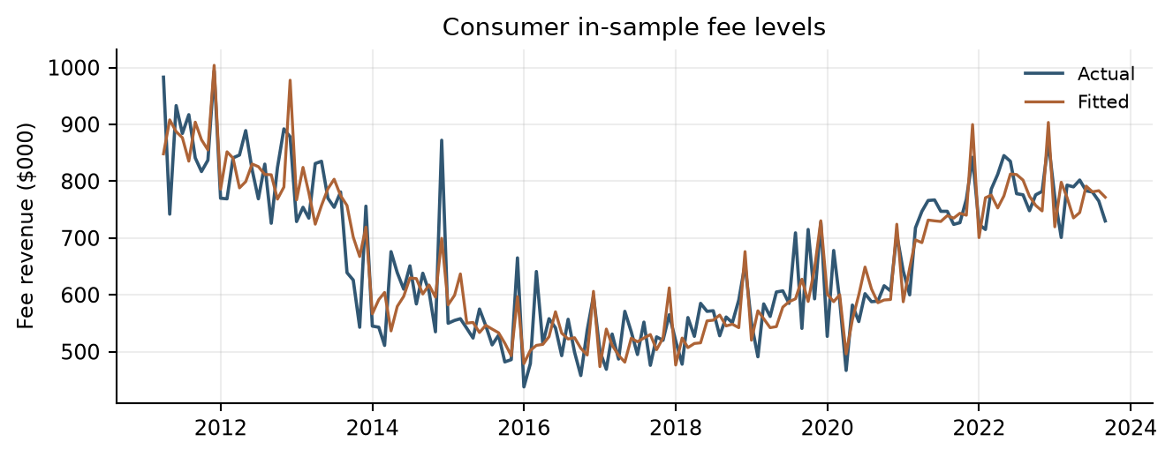
Data sources: consumer/​static_​in_​sample.csv. Fee amounts are in $000.
数据来源：consumer/​static_​in_​sample.csv. Fee amounts are in $000.

6.2.3 Coefficient Significance Testing
6.2.3 系数显著性检验
Final coefficients were evaluated for statistical significance and economic plausibility. The retained terms have statistically significant Student-t p-values at the conventional five-percent level. Coefficient signs are interpreted in the context of the target transformation, selected lag and other variables in the equation.
最终系数根据统计显著性及经济合理性进行评估。保留项的Student-t p值在常用的5%水平下显著。系数符号结合目标转换、选定滞后及方程中其他变量解释。
Negative own-growth lag coefficients capture short-run adjustment. The January and December indicators represent recurring calendar behavior, and the positive Retail Sales coefficient links stronger spending growth with fee log growth. Development and production estimates retain the same selected structure.
负向自身增长滞后系数刻画短期调整。1月及12月指标反映重复出现的日历表现，正向零售销售系数将更强支出增长与手续费对数增长联系起来。开发及生产估计保留相同的所选结构。
Table 6.11 Consumer Card Coefficient Estimates and Inference
表6.11 消费者信用卡系数估计及推断
Term  变量项 | Estimate  估计值 | Std error  标准误 | t statistic  t统计量 | p value  p值
Intercept  截距 | -1.98312 | 0.82447 | -2.405 [consumer/​coefficients.csv/​row 7 col 4] | 0.017 [consumer/​coefficients.csv/​row 7 col 6]
Fee log growth, lag 1  手续费对数增长，滞后1个月 | -0.62166 | 0.06568 | -9.464 [consumer/​coefficients.csv/​row 8 col 4] | <0.001 [consumer/​coefficients.csv/​row 8 col 6]
Fee log growth, lag 2  手续费对数增长，滞后2个月 | -0.33883 | 0.06070 | -5.583 [consumer/​coefficients.csv/​row 9 col 4] | <0.001 [consumer/​coefficients.csv/​row 9 col 6]
January indicator  1月指标 | -11.15312 | 2.87904 | -3.874 [consumer/​coefficients.csv/​row 10 col 4] | <0.001 [consumer/​coefficients.csv/​row 10 col 6]
December indicator  12月指标 | 19.65826 | 2.59864 | 7.565 [consumer/​coefficients.csv/​row 11 col 4] | <0.001 [consumer/​coefficients.csv/​row 11 col 6]
Retail Sales MoM growth, MA3  零售销售环比增长，MA3 | 2.57529 | 0.63128 | 4.079 [consumer/​coefficients.csv/​row 12 col 4] | <0.001 [consumer/​coefficients.csv/​row 12 col 6]
Data sources: consumer/​coefficients.csv, Selected In-sample rows.
数据来源：consumer/​coefficients.csv, Selected In-sample rows.

6.2.4 Multicollinearity Assessment
6.2.4 多重共线性评估
Variance Inflation Factors were evaluated to determine whether explanatory variables contained excessive shared information. The maximum nonconstant VIF is 1.7005 [consumer/​model_​diagnostics.csv/​row 3 col 12], below the implemented threshold of 10. The results indicate that multicollinearity is limited within the selected specification.
通过方差膨胀因子评估解释变量是否包含过多共享信息。最大非截距VIF为1.7005 [consumer/​model_​diagnostics.csv/​row 3 col 12]，低于代码使用的阈值10。结果表明所选设定中的多重共线性有限。
Table 6.12 Consumer Card Variance Inflation Factors
表6.12 消费者信用卡方差膨胀因子
Variable  变量 | VIF  VIF
consumer_​card_​fee_​log_​change_​1m_​pct_​lag_​1m | 1.7005 [consumer/​coefficients.csv/​row 8 col 7]
consumer_​card_​fee_​log_​change_​1m_​pct_​lag_​2m | 1.4523 [consumer/​coefficients.csv/​row 9 col 7]
is_​january | 1.2492 [consumer/​coefficients.csv/​row 10 col 7]
is_​december | 1.0177 [consumer/​coefficients.csv/​row 11 col 7]
retail_​sales_​pct_​change_​1m_​ma_​3m | 1.0115 [consumer/​coefficients.csv/​row 12 col 7]
Data sources: consumer/​coefficients.csv.
数据来源：consumer/​coefficients.csv.

6.2.5 Residual Diagnostics and Statistical Assumptions
6.2.5 残差诊断及统计假设
Residual diagnostics evaluate distributional shape, serial correlation and overall equation adequacy. The Durbin-Watson statistic is 2.3555 [consumer/​model_​diagnostics.csv/​row 3 col 7]. The Jarque-Bera p-value is 0.5320 [consumer/​model_​diagnostics.csv/​row 3 col 9], above the five-percent reference level. The residual time series, fitted-value comparison and normal-reference plot complement these numerical results.
残差诊断评估分布形态、序列相关及整体方程适当性。Durbin-Watson统计量为2.3555 [consumer/​model_​diagnostics.csv/​row 3 col 7]，Jarque-Bera p值为0.5320 [consumer/​model_​diagnostics.csv/​row 3 col 9]，高于5%参考水平。残差时间序列、与拟合值的比较及正态参考图补充这些数值结果。
The selected development specification satisfies the implemented Durbin-Watson, Jarque-Bera and VIF selection criteria. Diagnostics are reviewed together with coefficient stability and forecast results to assess continued model suitability.
所选开发设定满足代码中的Durbin-Watson、Jarque-Bera及VIF选择标准。诊断结果与系数稳定性和预测结果一并审阅，以评估模型的持续适用性。
Table 6.13 Consumer Card Residual Diagnostic Statistics
表6.13 消费者信用卡残差诊断统计量
Diagnostic Statistic  诊断统计量 | Value  数值
Durbin-Watson  Durbin-Watson | 2.3555 [consumer/​model_​diagnostics.csv/​row 3 col 7]
Jarque-Bera statistic  Jarque-Bera统计量 | 1.2621 [consumer/​model_​diagnostics.csv/​row 3 col 8]
Jarque-Bera p-value  Jarque-Bera p值 | 0.5320 [consumer/​model_​diagnostics.csv/​row 3 col 9]
Residual skewness  残差偏度 | 0.2103 [consumer/​model_​diagnostics.csv/​row 3 col 10]
Residual kurtosis  残差峰度 | 3.1583 [consumer/​model_​diagnostics.csv/​row 3 col 11]
Data sources: consumer/​model_​diagnostics.csv.
数据来源：consumer/​model_​diagnostics.csv.
The Consumer residual time series fluctuates on both sides of zero, with occasional larger deviations. The fitted-value scatter does not display a pronounced curved pattern or clear funnel-shaped dispersion across the main concentration of observations.
消费者卡残差时间序列在零线两侧波动，个别时期偏离较大。拟合值散点图中，观测主要集中区域未呈现明显曲线规律或漏斗状散布。
Figure 6.11 Consumer Card Residual Diagnostics
图6.11 消费者信用卡残差诊断
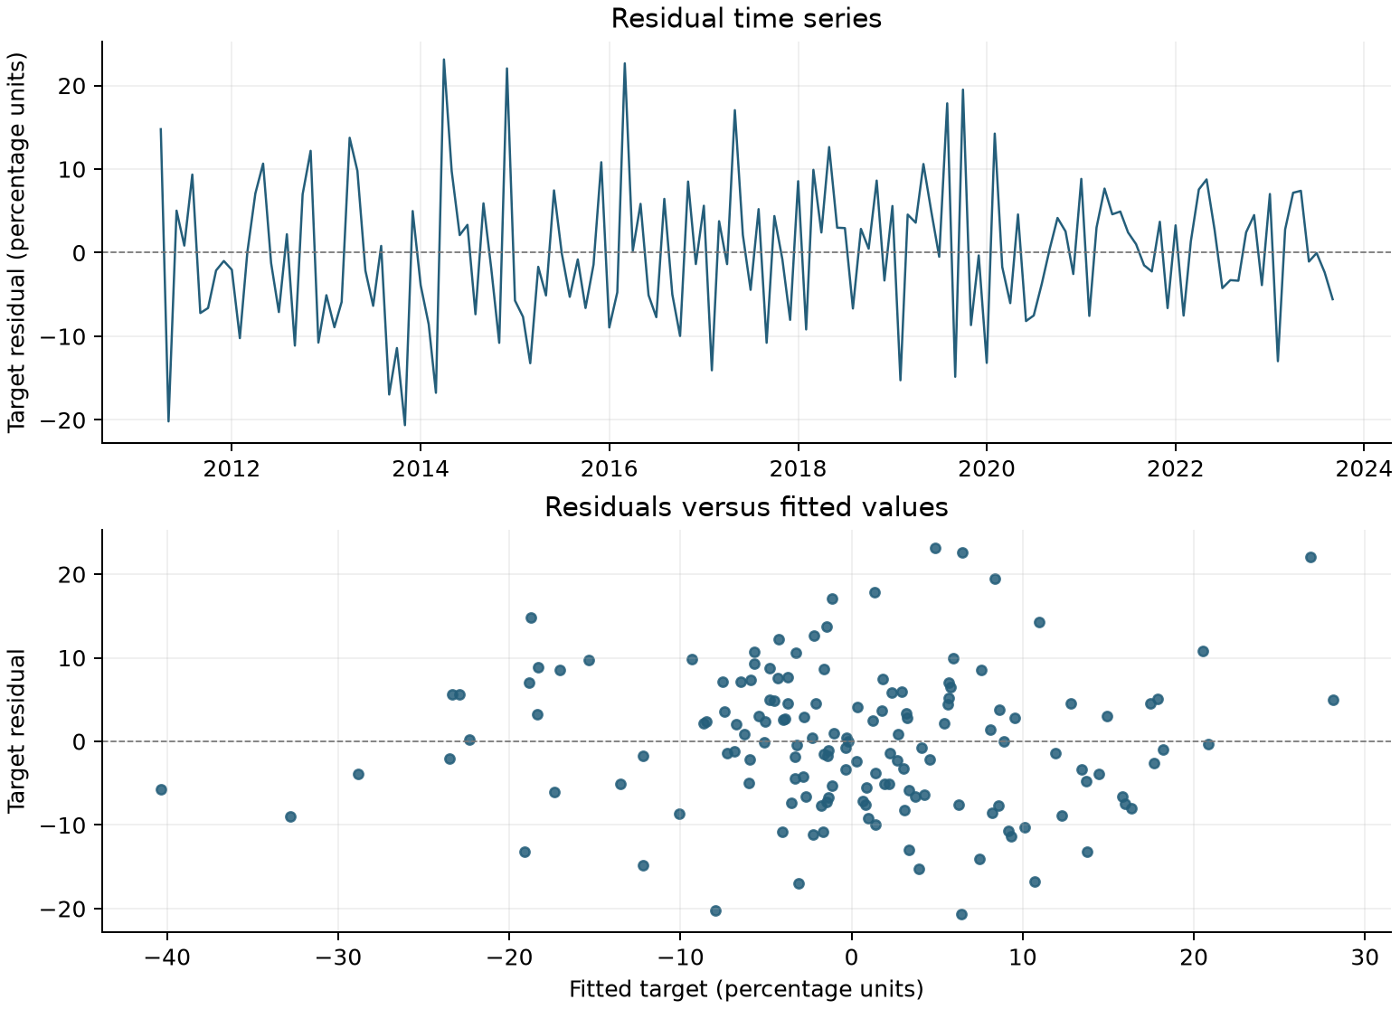
Data sources: consumer/​static_​in_​sample.csv.
数据来源：consumer/​static_​in_​sample.csv.
The Consumer residual quantiles closely follow the normal-reference line through the center of the distribution, with some upper-tail departures. This provides a visual complement to the reported residual-shape statistics.
消费者卡残差分位数在分布中部紧贴正态参考线，上尾存在一定偏离。该图为所报告的残差分布形态统计量提供直观补充。
Figure 6.12 Consumer Card Normal Reference Plot
图6.12 消费者信用卡正态参考图
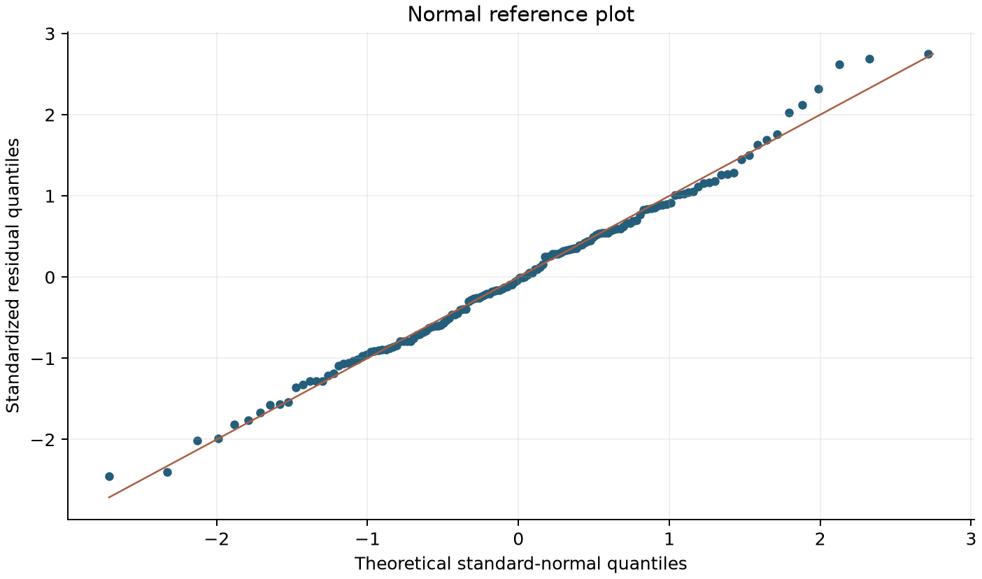
Data sources: consumer/​static_​in_​sample.csv. Exported target residuals standardized using the sample mean and standard deviation; midpoint normal plotting positions.
数据来源：consumer/​static_​in_​sample.csv. Exported target residuals standardized using the sample mean and standard deviation; midpoint normal plotting positions.

6.2.6 Stability Testing
6.2.6 稳定性测试
Consumer runs 118 overlapping 60-observation windows. Both own-growth lag coefficients and January remain negative; December and Retail Sales MA3 remain positive in every window.
消费卡运行118个重叠的60观测窗口。自身增长的两个滞后系数及1月系数始终为负，12月及零售销售MA3系数始终为正。
Table 6.14 Consumer Rolling Coefficient Ranges
表6.14 消费卡滚动系数范围
Term  变量项 | Minimum  最小值 | Maximum  最大值 | Sign changes  符号变化次数
Fee log growth, lag 1  手续费对数增长，滞后1个月 | -0.8737 [consumer/​rolling_​summary.csv/​row 2 col 3] | -0.1945 [consumer/​rolling_​summary.csv/​row 2 col 4] | 0 [consumer/​rolling_​summary.csv/​row 2 col 7]
Fee log growth, lag 2  手续费对数增长，滞后2个月 | -0.4866 [consumer/​rolling_​summary.csv/​row 3 col 3] | -0.2739 [consumer/​rolling_​summary.csv/​row 3 col 4] | 0 [consumer/​rolling_​summary.csv/​row 3 col 7]
January indicator  1月指标 | -19.0167 [consumer/​rolling_​summary.csv/​row 4 col 3] | -5.2670 [consumer/​rolling_​summary.csv/​row 4 col 4] | 0 [consumer/​rolling_​summary.csv/​row 4 col 7]
December indicator  12月指标 | 11.6767 [consumer/​rolling_​summary.csv/​row 5 col 3] | 26.7380 [consumer/​rolling_​summary.csv/​row 5 col 4] | 0 [consumer/​rolling_​summary.csv/​row 5 col 7]
Retail Sales MoM growth, MA3  零售销售环比增长，MA3 | 1.0792 [consumer/​rolling_​summary.csv/​row 6 col 3] | 5.8778 [consumer/​rolling_​summary.csv/​row 6 col 4] | 0 [consumer/​rolling_​summary.csv/​row 6 col 7]
Data sources: consumer/​rolling_​summary.csv.
数据来源：consumer/​rolling_​summary.csv.
The rolling paths retain negative coefficients for the displayed fee-growth lags and a positive coefficient for Retail Sales. Their changing magnitudes show how the estimated strength of these relationships varies across successive estimation windows.
滚动路径中，所展示的手续费增长滞后项系数保持负值，零售销售系数保持正值。系数幅度的变化展示这些关系的估计强度如何随滚动窗口改变。
Figure 6.13 Consumer Rolling Coefficient Stability
图6.13 消费卡滚动系数稳定性
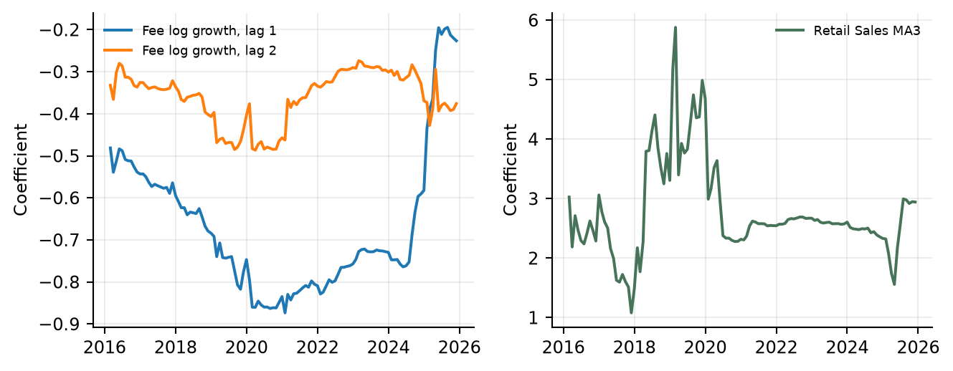
Data sources: consumer/​rolling_​coefficients.csv. Sequential 60-observation estimation windows.
数据来源：consumer/​rolling_​coefficients.csv. Sequential 60-observation estimation windows.

6.2.7 Out of Time Testing Framework and Results
6.2.7 OOT测试方法及结果
Out-of-time testing uses October 2023 through December 2025 to assess forecast performance beyond the coefficient-development period. Results are compared with realized fee revenue on the original $000 scale. Static and recursive exercises are reported separately so that the role of forecast-state updating is explicit.
OOT测试使用2023年10月至2025年12月，评估系数开发期之后的预测表现。结果在原始$000尺度上与实际手续费收入比较。静态和递归测试分别报告，以明确预测状态更新的作用。
The development coefficients remain fixed throughout OOT testing. Static testing uses observed prior fees and fee changes; recursive testing uses previously forecast fee states. Both exercises use historical Retail Sales inputs.
开发系数在整个OOT测试中保持固定。静态测试使用已观察的前期手续费及手续费变化，递归测试使用之前预测的手续费状态，两者均使用历史零售销售输入。
Table 6.15 Consumer Card OOT Forecast Accuracy
表6.15 消费者信用卡 OOT预测准确性
Method  方法 | MAPE (%)  MAPE（%） | RMSE ($000)  RMSE（$000）
Static OOT  静态OOT | 5.05 [consumer/​forecast_​accuracy.csv/​row 3 col 3] | 45.89 [consumer/​forecast_​accuracy.csv/​row 3 col 4]
Recursive OOT  递归OOT | 5.96 [consumer/​forecast_​accuracy.csv/​row 4 col 3] | 53.34 [consumer/​forecast_​accuracy.csv/​row 4 col 4]
Data sources: consumer/​forecast_​accuracy.csv.
数据来源：consumer/​forecast_​accuracy.csv.
The recursive Consumer forecast reproduces the recurring year-end peaks and subsequent declines visible in actual fees. The side-by-side paths also identify periods when the projected revenue level differs from the realized level.
消费者卡递归预测体现实际手续费中反复出现的年末高点及随后回落。并列路径也标示预测收入水平与实际水平存在差异的时期。
Figure 6.14 Consumer Card OOT Forecast Results
图6.14 消费者信用卡 OOT预测结果
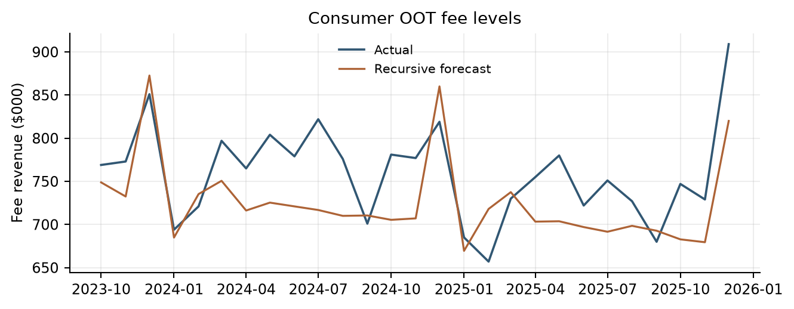
Data sources: consumer/​recursive_​oot.csv. Development coefficients; recursive fee states.
数据来源：consumer/​recursive_​oot.csv. Development coefficients; recursive fee states.
The error series show both positive and negative deviations under static and recursive Consumer testing. Comparing the two lines identifies when updating the lagged fee states with forecasts changes the direction or magnitude of the error.
静态和递归消费者卡测试的误差序列均出现正向及负向偏差。比较两条曲线可识别使用预测值更新手续费滞后状态何时改变误差方向或幅度。
Figure 6.15 Consumer Card OOT Prediction Errors
图6.15 消费者信用卡 OOT预测误差
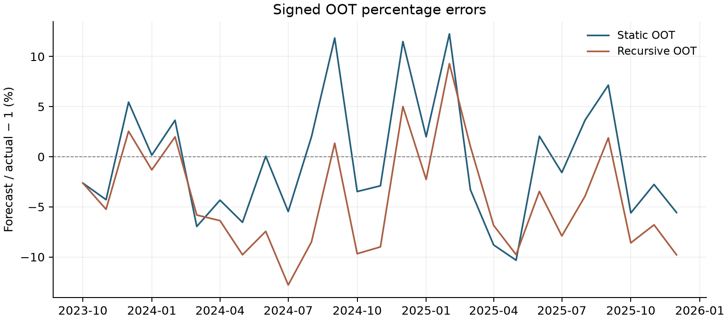
Data sources: consumer/​static_​oot.csv; consumer/​recursive_​oot.csv. Signed percentage error = 100 × (predicted fee /​ actual fee − 1).
数据来源：consumer/​static_​oot.csv; consumer/​recursive_​oot.csv. Signed percentage error = 100 × (predicted fee /​ actual fee − 1).

6.2.8 Root Cause Assessment
6.2.8 原因分析
Root-cause review evaluates forecast deviations alongside fee history, model inputs, lagged states and relevant business developments. Review considers pricing, customer mix, product and service changes, and the timing of economic drivers. Static and recursive results help identify how forecast-state updates affect the observed error pattern.
原因分析结合手续费历史、模型输入、滞后状态及相关业务发展评估预测偏差。审阅考虑定价、客户结构、产品及服务变化和经济驱动的时点。静态及递归结果有助于识别预测状态更新对观测误差模式的影响。
Consumer analysis focuses on calendar effects, Retail Sales dynamics and the distinction between observed and forecast prior-fee states. The selected structure is retained in the production refit, allowing updated historical information to inform subsequent scenario forecasts.
消费卡分析重点关注日历效应、零售销售动态，以及观测和预测前期手续费状态的区别。生产重估保留所选结构，使更新后的历史信息用于后续情景预测。

6.2.9 Overlay Support Analysis
6.2.9 调整项支持分析
No separate management overlay is applied to the Consumer Card forecasts in the current implementation. The January and December indicators are estimated explanatory variables, and the production refit updates model coefficients within the retained specification.
当前实现不对消费者信用卡预测应用独立管理调整项。1月及12月指标属于估计的解释变量，生产重估是在保留设定内更新模型系数。

6.2.10 Scenario Testing and Reasonableness Assessment
6.2.10 情景测试及合理性评估
Scenario testing evaluates forecast direction, magnitude and persistence through March 2028. Baseline and S4 runs share the same historical fee anchor, transformations and model structure. Monthly forecast revenue is also aggregated into calendar quarters for planning review.
情景测试评估截至2028年3月的预测方向、幅度及持续性。基准和S4运行使用相同历史手续费锚点、转换及模型结构。月度预测收入亦汇总为自然季度，供规划审阅。
Consumer scenarios vary Retail Sales while using the production-refit coefficients. Retail Sales monthly growth and its trailing three-month mean are recalculated, and fee revenue is projected recursively from the actual December 2025 level.
消费卡情景改变零售销售并使用生产重估系数。重新计算零售销售月度增长及过去三个月均值，并从2025年12月实际水平递归预测手续费收入。
Retail Sales rises along the Baseline path, while S4 declines after its initial increase and later recovers modestly. These differing level paths generate the monthly growth and moving-average inputs used in the Consumer forecasts.
零售销售在基准路径中上升，S4则在初期增长后下降，随后温和回升。不同水平值路径生成消费者卡预测所使用的月度增长率及移动平均输入。
Figure 6.16 Consumer Card Scenario Inputs
图6.16 消费者信用卡情景输入
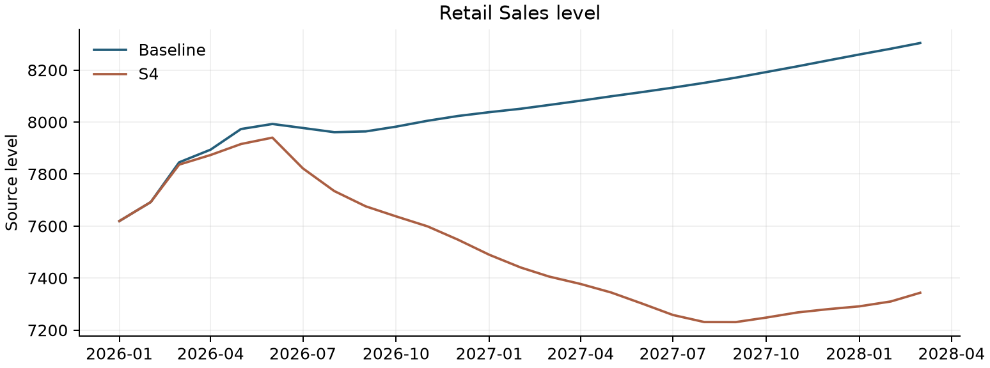
Data sources: consumer/​data/​macro_​baseline.csv; consumer/​data/​macro_​s4.csv. Original source units.
数据来源：consumer/​data/​macro_​baseline.csv; consumer/​data/​macro_​s4.csv. Original source units.
Both Consumer scenario paths retain the recurring calendar pattern implied by the model. S4 moves below Baseline as weaker Retail Sales feeds through the smoothed spending driver and recursive fee dynamics.
消费者卡两条情景路径均保留模型中的周期性日历特征。较弱的零售销售通过平滑支出驱动项及手续费递归动态传导，使S4逐渐低于基准。
Figure 6.17 Consumer Card Baseline and S4 Forecast Paths
图6.17 消费者信用卡基准及S4预测路径
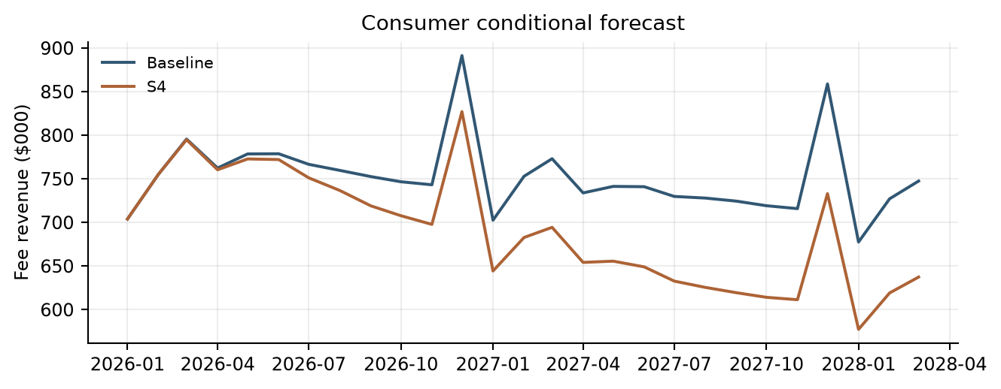
Data sources: consumer/​forecast_​monthly.csv. Fee revenue in $000.
数据来源：consumer/​forecast_​monthly.csv. Fee revenue in $000.
The revenue totals summarize the cumulative Consumer scenario difference over the first year and the full projection horizon. The wider full-horizon shortfall is consistent with the persistent separation of the monthly S4 and Baseline paths.
收入汇总列示消费者卡情景在首年及完整预测期内的累计差异。全预测期缺口扩大，与S4和基准月度路径持续分离的表现一致。
Table 6.16 Consumer Card Scenario Revenue Totals
表6.16 消费者信用卡情景收入合计
Period  期间 | Baseline ($000)  基准（$000） | S4 ($000) | S4 vs Base  S4相对基准
2026 total  2026年总额 | 9,234.65 | 8,998.87 | -2.55%
9-quarter total  9季度总额 | 20,307.65 | 18,649.22 | -8.17%
Data sources: consumer/​forecast_​quarterly_​summary.csv.
数据来源：consumer/​forecast_​quarterly_​summary.csv.

6.2.11 Model Development Progression
6.2.11 模型开发过程
The Consumer model was developed from a base equation that included fee log-growth from one and two months earlier, together with January and December indicators. Retail Sales monthly-growth MA3 was then added to capture changes in consumer spending. This became the selected development model. The same specification was subsequently refitted using history through December 2025 to produce the coefficients used for future forecasts.
消费卡模型从基础方程开始构建。基础方程包含手续费对数增长的一个月和两个月滞后项，以及一月和十二月指示变量。随后加入零售销售月度增长率的三个月移动平均值（MA3），以反映消费支出的变化。该设定成为选定的开发模型。之后，使用截至 2025 年 12 月的历史数据对同一设定重新估计，得到未来预测所用的系数。
Table 6.17 Consumer Model Development Progression
表6.17 消费卡模型开发过程
Model Stage  模型阶段 | Variables Included  包含变量 | Adjusted R²  调整后 R²
Base Model  基础模型 | Fee log-growth, lags 1 and 2 + January and December indicators  手续费对数增长，滞后1及2个月 + 一月及十二月指示变量 | 56.95% [consumer/​model_​diagnostics.csv/​row 2 col 6]
Selected Development Model  选定开发模型 | Fee log-growth, lags 1 and 2 + January and December indicators + Retail Sales monthly-growth MA3  手续费对数增长，滞后1及2个月 + 一月及十二月指示变量 + 零售销售月度增长率 MA3 | 61.14% [consumer/​model_​diagnostics.csv/​row 3 col 6]
Production Refit  生产重估 | Fee log-growth, lags 1 and 2 + January and December indicators + Retail Sales monthly-growth MA3  手续费对数增长，滞后1及2个月 + 一月及十二月指示变量 + 零售销售月度增长率 MA3 | 60.91% [consumer/​model_​diagnostics.csv/​row 4 col 6]
Table 6.17 shows the Consumer base model, selected development model and production refit. The base and selected development models use the same effective sample. The production refit retains the selected variables and extends the estimation period through December 2025. All specifications include an intercept.
表 6.17 展示消费卡基础模型、选定开发模型及生产重估模型。基础模型与选定开发模型使用相同的有效样本。生产重估保留选定变量，并将估计期延长至 2025 年 12 月。所有设定均包含截距项。
Data sources: consumer/​model_​diagnostics.csv; consumer/​consumer_​card_​model.py.
数据来源：consumer/​model_​diagnostics.csv；consumer/​consumer_​card_​model.py。

6.2.12 User Review and Acceptance
6.2.12 用户审阅及验收
Model results, assumptions, forecast behavior, and testing outcomes were reviewed with Strategic Finance and relevant lines of business during model development. Review sessions focused on economic intuition, reasonableness of the selected drivers, forecast behavior under changing economic conditions, and consistency with observed business performance. Feedback from these reviews supported the conclusion that the model appropriately captures the primary drivers of Consumer Card Fee Revenue and produces forecasts that are directionally consistent with business expectations.
在模型开发期间，模型结果、假设、预测表现及测试结果已与战略财务部门和相关业务条线进行审阅。审阅会议重点关注经济直觉、所选驱动因素的合理性、经济条件变化下的预测表现，以及与实际业务表现的一致性。审阅反馈支持以下结论：该模型恰当地捕捉了消费卡手续费收入的主要驱动因素，且预测方向与业务预期一致。
Because the model has not yet been deployed into a production forecasting environment, final User Acceptance Testing (UAT) has not been completed. Prior to production implementation, final UAT will be performed to verify that the implemented model reproduces approved development results, correctly incorporates required inputs, generates expected outputs, and operates in accordance with documented procedures and governance requirements.
由于模型尚未部署至生产预测环境，最终用户验收测试（UAT）尚未完成。在生产实施之前，将开展最终UAT，以验证实施后的模型能够复现已批准的开发结果，正确纳入所需输入，生成预期输出，并按照已记录的操作程序及治理要求运行。

6.2.13 Sensitivity Analysis
6.2.13 敏感性分析
Consumer adds -1.0, -0.5, +0.5 or +1.0 percentage points to monthly Retail Sales growth for 3, 6 or 12 months, beginning January 2026. It rebuilds future levels from the unchanged December 2025 anchor, recomputes monthly growth and MA3, and runs the fixed production equation recursively. Growth returns to Baseline after the active shock, but accumulated Retail Sales and fee-level differences are not reset. All 12 cases are reported. These code-default grids are analytical assumptions; approval as business stress standards remains outstanding.
消费卡从2026年1月开始，对月度零售销售增长增加−1.0、−0.5、+0.5或+1.0个百分点，持续3、6或12个月。程序从不变的2025年12月基准重建未来水平，重新计算月度增长和MA3，并用固定生产方程递归预测。冲击结束后增长回到Baseline，但累积的零售销售和手续费水平差异不会重置。全部12种情景均被报告。这些代码默认网格属于分析假设，是否批准为业务压力标准仍待确认。
Table 6.18 Consumer Retail Sales Growth Sensitivities
表6.18 消费卡零售销售增长敏感性
MoM shock  环比冲击 | Duration  持续时间 | Year impact  年度影响 | Horizon impact  全预测期影响 | Terminal impact  期末影响
-1 pp  -1 个百分点 | 3 months  3 个月 | -3.40% | -3.62% | -3.80%
-1 pp  -1 个百分点 | 6 months  6 个月 | -5.76% | -6.68% | -7.45%
-1 pp  -1 个百分点 | 12 months  12 个月 | -7.64% | -11.30% | -14.35%
-0.5 pp  -0.5 个百分点 | 3 months  3 个月 | -1.72% | -1.83% | -1.92%
-0.5 pp  -0.5 个百分点 | 6 months  6 个月 | -2.93% | -3.40% | -3.80%
-0.5 pp  -0.5 个百分点 | 12 months  12 个月 | -3.92% | -5.85% | -7.45%
+0.5 pp  +0.5 个百分点 | 3 months  3 个月 | 1.75% | 1.86% | 1.95%
+0.5 pp  +0.5 个百分点 | 6 months  6 个月 | 3.03% | 3.53% | 3.95%
+0.5 pp  +0.5 个百分点 | 12 months  12 个月 | 4.13% | 6.27% | 8.05%
+1 pp  +1 个百分点 | 3 months  3 个月 | 3.53% | 3.76% | 3.95%
+1 pp  +1 个百分点 | 6 months  6 个月 | 6.17% | 7.20% | 8.05%
+1 pp  +1 个百分点 | 12 months  12 个月 | 8.49% | 13.00% | 16.75%
Data sources: consumer/​sensitivity_​summary.csv.
数据来源：consumer/​sensitivity_​summary.csv.
The bars show that larger or longer-lasting Retail Sales growth shocks produce greater cumulative Consumer revenue changes. Positive and negative shocks move revenue in the expected directions, with effects persisting through the recursive fee-level calculation.
条形图表明，零售销售增长冲击幅度越大或持续越久，消费者卡累计收入变化越大。正负冲击使收入沿预期方向变化，其影响通过手续费水平值的递归计算持续传导。
Figure 6.18 Consumer Sensitivity Impacts
图6.18 消费卡敏感性影响
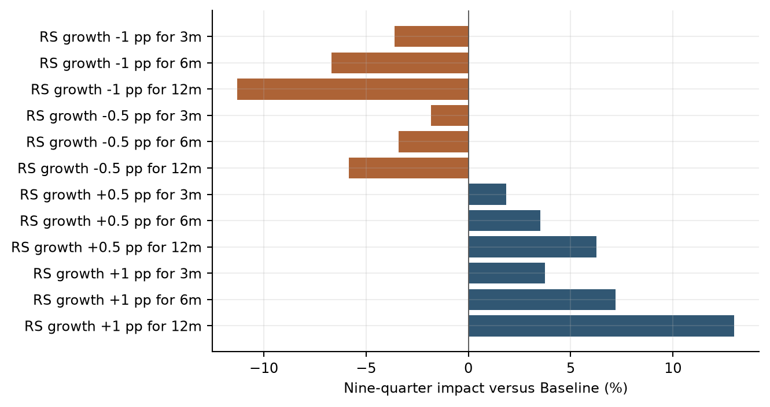
Data sources: consumer/​sensitivity_​summary.csv. Additive percentage-point shocks to Retail Sales monthly growth.
数据来源：consumer/​sensitivity_​summary.csv. Additive percentage-point shocks to Retail Sales monthly growth.

6.2.14 Testing Conclusions
6.2.14 测试结论
The testing results support the selected Consumer Card specification. The Retail Sales addition improves development fit relative to the autoregressive-seasonal base, rolling coefficients retain consistent signs, and static and recursive OOT tests quantify forecasting performance. Scenario and sensitivity testing document the response to alternative spending conditions. These results support the model’s planning and stress-testing applications and its ongoing monitoring framework.
测试结果支持所选消费者信用卡设定。加入零售销售后，开发拟合相对于自回归季节性基础模型改善，滚动系数保持符号一致，静态及递归OOT测试量化预测表现。情景和敏感性测试记录不同支出条件下的响应。这些结果支持模型的规划和压力测试应用及持续监控框架。

6.3 Debit Card Model Testing
6.3 借记卡模型测试

6.3.1 Historical Calibration and Regression Review
6.3.1 历史校准及回归审阅
Debit testing reviews the retained regression-screening outcomes and verifies the adopted historical calibration. Baseline uses the latest eight complete actual quarters; the stress floor uses the post-2015 mean less twice the sample standard deviation. The calibration is reproducible from the adjusted monthly and complete-quarter revenue outputs.
借记卡测试审阅保留的回归筛选结果，并核验最终采用的历史校准。基准使用最近八个完整实际季度，压力下限为2015年以来均值减去两倍样本标准差。校准可根据调整后月度及完整季度收入输出复现。
This table consolidates the Debit regression-screening outcomes across the tested target and frequency treatments. The absence of an accepted specification explains why Debit testing evaluates the historical calibration instead of a final regression equation.
本表汇总借记卡不同目标变量及频率处理下的回归筛选结果。由于未选出符合准入标准的设定，借记卡测试评估的是历史校准，而非最终回归方程。
Table 6.19 Debit Regression Screening Outcomes
表6.19 借记卡回归筛选结果
Approach  方法 | Effective n  有效样本数 | Candidates  候选数 | All gates passed  全部门槛通过数 | Accepted model  接受模型
Level  水平 | 129 | 194 | 0 | No  否
YoY_​static_​screen  同比静态筛选 | 129 | 14 | 0 | No  否
MoM  环比 | 128 | 194 | 0 | No  否
QoQ_​quarterly  季度环比 | 42 | 74 | 0 | No  否
Data sources: debit/​regression_​summary.csv.
数据来源：debit/​regression_​summary.csv.
The baseline summarizes the recent quarterly run rate, while the stress floor provides the separately calibrated downside reference. The reported decline measures the distance between these two quarterly calibration levels.
基准概括近期季度经营水平，压力下限提供单独校准的下行参照。表中降幅衡量两个季度校准水平之间的差距。
Table 6.20 Debit Historical Calibration
表6.20 借记卡历史校准
Measure  衡量项目 | Value  数值
Quarterly baseline revenue ($000)  季度基准收入（$000） | 4,747.625
Quarterly stress floor ($000)  季度压力下限（$000） | 3,813.653
Decline from baseline to stress floor  基准至压力下限降幅 | 19.67%
Data sources: debit/​qualitative_​scenarios.csv; debit/​historical_​statistics.csv.
数据来源：debit/​qualitative_​scenarios.csv; debit/​historical_​statistics.csv.

6.3.2 Scenario Reasonableness
6.3.2 情景合理性
The quarterly Baseline of 4,747.63 and Stress floor of 3,813.65 imply a 19.67% decline. The observed 2020Q2 decline from the average of 2019Q3 and 2019Q4 is approximately 6.88%, so the rule is more severe on that comparison. The floor is below the minimum observed post-2015 quarter, 3,954.00. The Shapiro–Wilk p-value for the post-2015 sample is approximately 0.0534 [debit/​historical_​statistics.csv/​row 14 col 2].
季度基准4,747.63及压力下限3,813.65对应19.67%的降幅。2020年第二季度相对于2019年第三、第四季度均值的实际降幅约为6.88%，因此按该比较，规则所设压力更为严重。压力下限低于2015年以来最低实际季度值3,954.00。2015年以来样本的 Shapiro–Wilk p 值约为0.0534 [debit/​historical_​statistics.csv/​row 14 col 2]。
Figure 6.19 Debit Quarterly History and Calibration Levels
图6.19 借记卡季度历史及校准水平
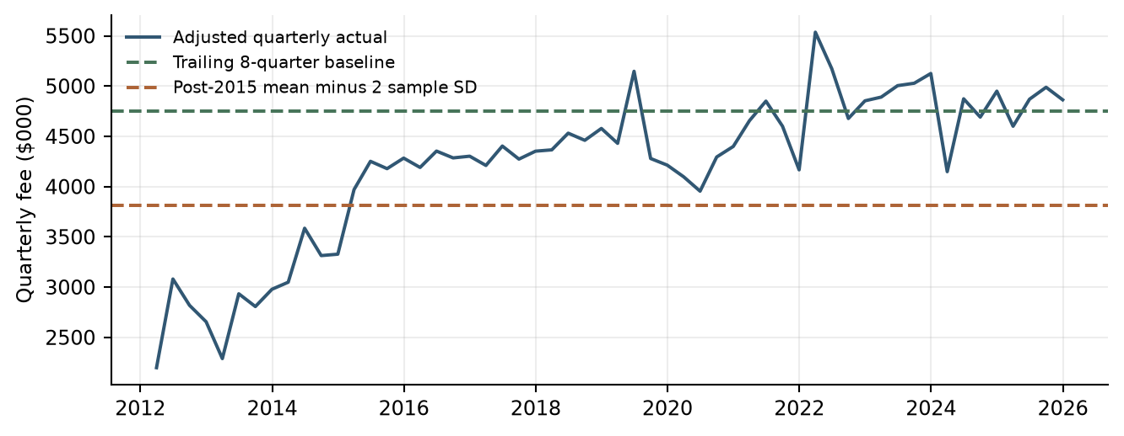
Data sources: debit/​quarterly_​revenue.csv; debit/​qualitative_​scenarios.csv. Calibration levels, not dated forward forecasts.
数据来源：debit/​quarterly_​revenue.csv; debit/​qualitative_​scenarios.csv. Calibration levels, not dated forward forecasts.

6.3.3 Sensitivity and Assumption Review
6.3.3 敏感性及假设审阅
Debit sensitivity review focuses on the recent-quarter baseline, the stress-calibration window and the standard-deviation multiplier. These are the key assumptions governing its historical calibration. Review of any dated forecast application also considers transition and recovery assumptions.
借记卡敏感性审阅重点关注近期季度基准、压力校准窗口及标准差倍数。这些是其历史校准的关键假设。对于任何按日期应用的预测，还应审阅过渡与恢复假设。

6.3.4 Out of Time Testing
6.3.4 OOT测试
OOT testing is not applicable to the adopted Debit Card historical calibration method.
最终采用的借记卡历史校准方法不适用OOT测试。

6.3.5 User Review and Acceptance
6.3.5 用户审阅及验收
Model results, assumptions, baseline and stress calibration levels, and testing outcomes were reviewed with Strategic Finance and relevant lines of business during model development. Review sessions focused on economic intuition, reasonableness of the historical calibration assumptions, baseline and stress behavior under changing economic conditions, and consistency with observed business performance. Feedback from these reviews supported the conclusion that the model appropriately reflects historical Debit Card Fee Revenue behavior and provides baseline and stress calibration levels that are consistent with business expectations.
在模型开发期间，模型结果、假设、基准及压力校准水平和测试结果已与战略财务部门和相关业务条线进行审阅。审阅会议重点关注经济直觉、历史校准假设的合理性、经济条件变化下的基准及压力表现，以及与实际业务表现的一致性。审阅反馈支持以下结论：该模型恰当地反映了借记卡手续费收入的历史表现，且所提供的基准及压力校准水平与业务预期一致。
Because the model has not yet been deployed into a production forecasting environment, final User Acceptance Testing (UAT) has not been completed. Prior to production implementation, final UAT will be performed to verify that the implemented model reproduces approved development results, correctly incorporates required inputs, generates expected outputs, and operates in accordance with documented procedures and governance requirements.
由于模型尚未部署至生产预测环境，最终用户验收测试（UAT）尚未完成。在生产实施之前，将开展最终UAT，以验证实施后的模型能够复现已批准的开发结果，正确纳入所需输入，生成预期输出，并按照已记录的操作程序及治理要求运行。

6.3.6 Testing Conclusions
6.3.6 测试结论
The retained historical statistics and scenario calculations support a transparent calibration framework for Debit Card. Monitoring focuses on the recent quarterly run rate, the relevance of the stress-calibration population and dispersion, and the approved application of the baseline and stress levels.
保留的历史统计及情景计算支持透明的借记卡校准框架。监控重点包括近期季度收入水平、压力校准样本及离散程度的相关性，以及基准和压力水平经批准后的应用。

7. Model Implementation
7. 模型实施

8. Model Monitoring
8. 模型监控

8.1 Purpose of Monitoring
8.1 监控目的
The purpose of ongoing model monitoring is to ensure the Card Fee Model continues to perform as intended after implementation and remains appropriate for its stated use in CCAR forecasting, stress testing, capital planning, and PPNR forecasting.
持续模型监控旨在确保卡手续费模型实施后持续按预期运行，并继续适用于其既定CCAR预测、压力测试、资本规划及PPNR预测用途。
Monitoring is intended to identify model deterioration, changes in business conditions, shifts in underlying revenue drivers, breaches of key assumptions, implementation issues, forecast bias, and other factors that could materially affect model outputs.
监控旨在识别模型表现恶化、业务条件变化、基础收入驱动转变、关键假设失效、实施问题、预测偏差及其他可能实质影响模型输出的因素。
Monitoring activities evaluate the continued appropriateness of model inputs, assumptions, methodologies, outputs, overlays, and operational processes. Results are used to determine whether the model remains fit for purpose, requires recalibration, requires modification of overlay assumptions, or requires redevelopment.
监控活动评估模型输入、假设、方法、输出、调整项及操作流程的持续适当性。结果用于确定模型是否仍适合其用途，是否需要重新校准、修改调整项假设或重新开发。

8.2 Monitoring Philosophy
8.2 监控理念
The Card Fee Model combines statistically estimated relationships for Commercial Card and Small Business and Consumer Card with a historical calibration framework for Debit Card. Commercial forecasts also incorporate an EC trend adjustment. Because card fee revenue is influenced by changing customer behavior, spending activity, service utilization, pricing decisions, business initiatives, and other factors that may evolve over time, monitoring focuses on:
卡手续费模型将商业卡及小企业卡、消费者信用卡的统计估计关系与借记卡历史校准框架相结合。商业卡预测还纳入EC趋势调整。由于卡手续费收入受到客户行为、支出活动、服务使用、定价决策、业务举措及其他随时间变化因素影响，监控重点包括：
- Stability and quality of inputs.
输入的稳定性及质量。
- Accuracy and reasonableness of projected Card Fee Revenue forecasts.
卡手续费收入预测的准确性及合理性。
- Continued validity of key assumptions.
关键假设的持续有效性。
- Stability of model coefficients and underlying relationships.
模型系数及基础关系的稳定性。
- Evaluation of model limitations.
模型局限性评估。
- Review of overlays and expert judgment.
调整项及专家判断审阅。
Monitoring seeks to identify both gradual deterioration and sudden structural changes in business conditions. Particular attention will be given to:
监控力求识别业务条件的渐进恶化及突然结构变化，特别关注：
- Changes in Commercial Card and Small Business fee growth, the CPI reference, Corporate Profits growth and the adjusted EC state.
商业卡及小企业卡手续费增长、CPI参照、企业利润增长和调整后EC状态的变化。
- Changes in Consumer Card fee dynamics, Retail Sales growth and calendar effects.
消费者信用卡手续费动态、零售销售增长及日历效应的变化。
- Changes in Debit Card quarterly revenue, the recent baseline and post-2015 dispersion.
借记卡季度收入、近期基准及2015年以来离散程度的变化。
- Structural shifts in pricing practices, products and service offerings.
定价实践、产品及服务的结构变化。
- Material deviations between projected and realized Card Fee Revenue.
预测与实际卡手续费收入之间的重大偏差。
- Persistent forecast bias.
持续预测偏差。
- Significant changes in customer behavior affecting fee generation.
影响手续费产生的重大客户行为变化。

8.3 Monitoring Roles and Responsibilities
8.3 监控角色及职责

Model Owner
模型所有者
The Model Owner is responsible for overall model performance oversight and ensuring monitoring activities are completed timely.
模型所有者负责整体模型表现监督，并确保监控活动及时完成。
Responsibilities include:
职责包括：
- Reviewing monitoring results.
审阅监控结果。
- Assessing significance of identified issues.
评估已识别问题的重要性。
- Approving remediation actions.
批准整改措施。
- Maintaining model documentation.
维护模型文档。
- Escalating material issues to management and MRM.
向管理层及MRM上报重大问题。

Model Developer
模型开发者
The Model Developer is responsible for performing the monitoring activities and producing monitoring reports.
模型开发者负责执行监控活动并编制监控报告。
Responsibilities include:
职责包括：
- Collecting monitoring data.
收集监控数据。
- Performing monitoring calculations and tests.
执行监控计算及测试。
- Investigating threshold breaches.
调查阈值突破。
- Recommending remediation actions.
建议整改措施。
- Updating model assumptions when appropriate.
在适当情况下更新模型假设。
- Reporting any observed data, processing, or output anomalies.
报告发现的数据、处理或输出异常。

Model User
模型使用者
Strategic Finance and Capital Planning are responsible for reviewing monitoring results.
战略财务及资本规划部门负责审阅监控结果。

Independent Reviewer
独立审阅者
Model Risk Management (MRM) is responsible for reviewing monitoring results and evaluating whether the model remains fit for purpose.
模型风险管理部门（MRM）负责审阅监控结果，并评估模型是否继续适合其用途。
The matrix distinguishes responsibility for producing monitoring results from responsibility for ownership, business review and independent challenge. This allocation supports a documented review and escalation process.
职责矩阵区分监测结果编制、模型归属、业务审阅及独立质询的责任，为有记录的审阅和升级处理流程提供基础。
Table 8.1 Roles and Responsibilities Matrix
表8.1 角色及职责矩阵
Role  角色 | Responsibilities  职责
Model Owner  模型所有者 | Ensures monitoring activities are performed, documented, and completed in accordance with governance requirements.  确保监控活动按治理要求执行、记录和完成。
Model Developer  模型开发者 | Produces monitoring analyses, maintains supporting documentation, investigates performance anomalies, and recommends remediation when necessary.  编制监控分析、维护支持文档、调查表现异常并在必要时提出整改建议。
Model User (Strategic Finance)  模型使用者（战略财务） | Reviews monitoring results and determines whether governance actions are required.  审阅监控结果并确定是否需要采取治理行动。
MRM  模型风险管理部门 | Independently reviews monitoring results and continued fitness for purpose.  独立审阅监控结果及模型用途适当性。

8.4 Monitoring Frequency
8.4 监控频率
Monitoring will be performed at least semi-annually.
监控至少每半年执行一次。
Certain monitoring activities may be performed more frequently when new CCAR forecasts are produced or when material economic, business, or operational changes occur.
在形成新的CCAR预测或出现重大经济、业务及操作变化时，部分监控活动可更频繁执行。
The standard monitoring cycle consists of:
标准监控周期包括：
- Semi-annual monitoring review.
半年度监控审阅。
- Annual comprehensive monitoring assessment.
年度全面监控评估。
- Ad hoc reviews following material business, regulatory, data, methodology, or overlay changes.
重大业务、监管、数据、方法或调整项变化后的专项审阅。
Monitoring results will be documented and retained in accordance with Model Risk Management standards.
监控结果按模型风险管理标准记录并保存。

8.5 Components of Monitoring
8.5 监控内容
During monitoring, input and output stability, model output accuracy, model robustness, overlay, assumptions and limitations will be vetted.
监控将评估输入及输出稳定性、模型输出准确性、模型稳健性、调整项、假设及局限。

8.5.1 Input Stability Monitoring
8.5.1 输入稳定性监控
Input monitoring evaluates whether key model drivers remain consistent with historical behavior.
输入监控评估关键模型驱动是否与历史表现保持一致。
Key inputs include:
关键输入包括：
- Commercial Card and Small Business fee revenue, CPI, Corporate Profits and the derived EC and annual-growth inputs.
商业卡及小企业卡手续费收入、CPI、企业利润，以及派生EC和同比增长输入。
- Consumer Card fee revenue, Retail Sales monthly growth and its trailing average, lagged fee log changes and calendar indicators.
消费者信用卡手续费收入、零售销售环比增长及移动平均、手续费对数变化滞后项和日历指标。
- Debit Card raw and adjusted fee revenue and complete-quarter observations used for calibration.
借记卡原始及调整后手续费收入，以及用于校准的完整季度观测。
- Moody's macroeconomic scenario inputs used by the regression components.
回归组成部分使用的穆迪宏观情景输入。
Monitoring tests include:
监控测试包括：
- Growth trend analysis.
增长趋势分析。
- Historical range comparison.
历史范围比较。
- Volatility analysis.
波动性分析。
- Identification of structural breaks.
结构性断点识别。
- Reconciliation against source systems and financial reporting data.
与源系统及财务报告数据核对。
Significant deviations from historical behavior will be investigated to determine whether model assumptions remain appropriate.
对于明显偏离历史表现的情况，将调查模型假设是否仍然适当。

8.5.2 Output Stability Monitoring
8.5.2 输出稳定性监控
Output monitoring evaluates changes in projected Card Fee Revenue estimates over time.
输出监控评估卡手续费收入预测随时间的变化。
Monitoring will assess:
监控将评估：
- Baseline and stress Card Fee Revenue forecasts by component.
各组成部分的基准及压力卡手续费收入预测。
- Commercial overlay-adjusted forecasts and Consumer production-refit forecasts.
商业卡调整后预测及消费卡生产重估预测。
- Debit baseline and stress calibration levels.
借记卡基准及压力校准水平。
- Baseline-to-stress forecast differences.
基准与压力预测差异。
- Forecast consistency across forecast vintages.
不同预测版本之间的一致性。
Outputs will be compared against:
输出将与以下内容比较：
- Prior forecast vintages.
先前预测版本。
- Historical Card Fee Revenue observations.
历史卡手续费收入观测。
- Business expectations.
业务预期。
- Strategic Finance planning assumptions.
战略财务规划假设。
Large unexplained forecast movements may indicate changes in model behavior or underlying business conditions requiring review.
无法解释的大幅预测变化可能表明模型表现或基础业务条件发生变化，需要审阅。

8.5.3 Forecast Accuracy Monitoring
8.5.3 预测准确性监控
Forecast accuracy will be assessed by comparing projected Card Fee Revenue against realized outcomes for each component and for the combined forecast.
预测准确性通过比较各组成部分及合并预测的卡手续费收入与实际结果进行评估。
Actual results will be compared with:
实际结果将与以下内容比较：
- Baseline forecast estimates.
基准预测估计。
- Prior year forecast projections.
上年度预测。
- Overlay-adjusted forecasts, where applicable.
适用时的调整后预测。
Monitoring metrics include:
监控指标包括：
- Absolute Percent Error (APE).
绝对百分比误差（APE）。
- Mean Absolute Percentage Error (MAPE).
平均绝对百分比误差（MAPE）。
- Forecast variance analysis.
预测差异分析。
- Directional accuracy.
方向准确性。
Where forecast errors exceed established thresholds, root cause analysis will be performed.
当预测误差超过既定阈值时，将进行原因分析。
Particular attention will be given to sustained underprediction or overprediction, with comparisons made on consistent forecast horizons and vintages.
特别关注持续低估或高估，并在一致预测期限和版本下进行比较。

8.5.4 Assumption Monitoring
8.5.4 假设监控
The model contains several statistical and judgmental assumptions which require periodic review.
模型包含若干需要定期审阅的统计及判断性假设。
Key assumptions include:
关键假设包括：
- Commercial CPI and Corporate Profits relationships and the adjusted EC mechanism remain relevant to fee-revenue behavior.
商业卡CPI及企业利润关系、调整后EC机制继续适用于手续费收入表现。
- Consumer fee dynamics, calendar effects and the Retail Sales relationship remain relevant.
消费卡手续费动态、日历效应及零售销售关系继续适用。
- Debit recent-quarter and post-2015 calibration windows remain representative of the intended baseline and stress conditions.
借记卡近期季度及2015年以来校准窗口继续代表预期基准和压力条件。
- Historical directional relationships remain reasonably stable throughout the forecast horizon.
历史方向关系在预测期内保持合理稳定。
- Development-period relationships remain representative of future operating conditions.
开发期关系继续代表未来经营条件。
Monitoring will evaluate whether observed business performance continues to support these assumptions.
监控将评估观测业务表现是否继续支持上述假设。

8.5.5 Coefficient and Parameter Stability Monitoring
8.5.5 系数及参数稳定性监控
Estimated regression coefficients and historical calibration parameters will be monitored for stability. Parameters include:
将监控估计回归系数及历史校准参数的稳定性。参数包括：
- Commercial long-run CPI coefficient and intercept; short-run adjusted EC, own-growth lags, Corporate Profits and intercept; EC trend adjustment.
商业卡长期CPI系数及截距；短期调整后EC、自身增长滞后、企业利润及截距；EC趋势调整。
- Consumer fee log-growth lag coefficients, January and December coefficients, Retail Sales coefficient and intercept.
消费卡手续费对数增长滞后系数、1月及12月系数、零售销售系数及截距。
- Debit baseline mean, stress-period mean and sample standard deviation, calibration windows and stress multiplier.
借记卡基准均值、压力期间均值及样本标准差、校准窗口和压力乘数。
Monitoring will assess:
监控将评估：
- Coefficient sign stability.
系数符号稳定性。
- Magnitude changes over time.
数值随时间的变化。
- Statistical significance.
统计显著性。
- Rolling coefficient behavior for applicable regression models.
适用回归模型的滚动系数表现。
- Stability of model explanatory power.
模型解释能力稳定性。
Observed parameter behavior will be compared against development-period results to determine whether recalibration may be warranted.
观测参数表现将与开发期结果比较，以确定是否需要重新校准。

8.5.6 Overlay Monitoring
8.5.6 调整项监控
Commercial Card and Small Business forecasts utilize an EC trend adjustment calibrated from the later historical period. Consumer Card has no separate management overlay in the current implementation. Debit historical calibration assumptions are monitored as judgmental parameters. Monitoring of the Commercial adjustment will evaluate:
商业卡及小企业卡预测使用根据后续历史期间校准的EC趋势调整。当前消费者信用卡实现不包含独立管理调整项。借记卡历史校准假设作为判断性参数监控。商业卡调整项监控将评估：
- Continued need for the overlay.
调整项的持续必要性。
- Magnitude of the overlay.
调整项的幅度。
- Actual-to-forecast performance after application of the overlay.
应用调整项后的实际与预测表现。
- Whether business conditions supporting the overlay remain applicable.
支持调整项的业务条件是否仍然适用。
- Whether redevelopment or recalibration would be preferable to continued overlay usage.
重新开发或校准是否优于继续使用调整项。
The overlay will remain subject to governance review, documentation, approval, and ongoing challenge.
调整项将持续接受治理审阅、文档记录、批准及质询。

8.5.7 Limitation Monitoring
8.5.7 局限性监控
Known model limitations identified in Section 2 will be reviewed during each monitoring cycle.
第2章识别的已知模型局限将在每个监控周期审阅。
Particular attention will be given to:
特别关注：
- Future pricing actions not explicitly captured by the model.
模型未明确捕捉的未来定价措施。
- New products and service offerings not represented in development data.
开发数据未反映的新产品及服务。
- Structural shifts in customer behavior and monetization practices.
客户行为及收入实现方式的结构变化。
- Forecast bias associated with changing business environments.
业务环境变化相关的预测偏差。
- Changes in the relevance of Commercial EC calibration and Consumer calendar or spending relationships.
商业卡EC校准及消费卡日历或支出关系相关性的变化。
- Changes in the representativeness of Debit historical calibration windows and stress severity.
借记卡历史校准窗口及压力程度代表性的变化。
If limitations become more significant due to changing business conditions, corrective action may be required.
若业务条件变化使局限性更加显著，可能需要采取纠正措施。

8.6 Monitoring Metrics and Thresholds
8.6 监控指标及阈值
Monitoring metrics should be associated with predefined thresholds that distinguish expected behavior from behavior requiring investigation. Exceeding a threshold does not automatically indicate model failure but should trigger review and documentation.
监控指标应对应预先定义的阈值，以区分预期表现与需要调查的表现。超过阈值不自动表示模型失效，但应触发审阅及记录。
The following monitoring measures identify potentially significant performance issues. Component-specific numerical thresholds, evaluation windows and escalation timelines will be approved and documented before implementation.
下列监控指标用于识别潜在重大表现问题。各组成部分的数值阈值、评估窗口及上报时限将在实施前批准并记录。
Table 8.2 Monitoring Metrics and Thresholds
表8.2 监控指标及阈值
Monitoring Area  监控领域 | Metric  指标 | Threshold  阈值
Forecast Accuracy  预测准确性 | Actual versus forecast Card Fee Revenue by component; APE and rolling annual MAPE  各组成部分实际与预测卡手续费收入；APE及滚动年度MAPE | Component thresholds to be approved  各组成部分阈值待批准
Input Stability  输入稳定性 | Commercial CPI, Corporate Profits and EC; Consumer Retail Sales and fee changes; Debit quarterly revenue  商业卡CPI、企业利润及EC；消费卡零售销售及手续费变化；借记卡季度收入 | Historical-range and volatility thresholds to be approved  历史范围及波动阈值待批准
Data Integrity  数据完整性 | Source reconciliation against financial reporting data  源数据与财务报告数据核对 | Reconciliation tolerance to be approved  核对容差待批准
Coefficient Stability  系数稳定性 | Sign reversal or material magnitude change in final regression coefficients  最终回归系数符号反转或幅度重大变化 | Investigation required  需要调查
Statistical Stability  统计稳定性 | Material decline in adjusted R-squared relative to development performance  调整后R平方相对于开发表现显著下降 | Management review required  需要管理层审阅
Overlay Performance  调整项表现 | Persistent bias in Commercial overlay-adjusted forecasts  商业卡调整后预测持续出现偏差 | Management review required  需要管理层审阅
Debit Calibration  借记卡校准 | Material changes in recent-quarter mean, post-2015 dispersion or stress severity  近期季度均值、2015年以来离散程度或压力程度重大变化 | Management review required  需要管理层审阅
Assumption Stability  假设稳定性 | Material assumption invalidated by observed experience  观测经验使重大假设失效 | Management review required  需要管理层审阅
Data Quality  数据质量 | Missing or incomplete required source data  必要源数据缺失或不完整 | Investigation and remediation required  需要调查及整改
Breaches do not automatically indicate model failure but require investigation and documented explanation.
阈值突破不自动表示模型失效，但需要调查并记录解释。

8.7 Escalation Process
8.7 问题上报及处置流程
When monitoring identifies a threshold breach or significant performance issue, the following escalation process will be followed:
监控识别阈值突破或重大表现问题时，将遵循以下上报流程：
- Model Developer investigates the issue and documents root cause analysis.
模型开发者调查问题并记录原因分析。
- Results are reviewed by the Model Owner.
模型所有者审阅结果。
- If remediation is required, an action plan is developed and documented.
若需要整改，制定并记录行动计划。
- Material findings are communicated to Strategic Finance management.
将重大发现传达给战略财务管理层。
- Material model performance issues are reported to Model Risk Management.
向模型风险管理部门报告重大模型表现问题。
- Where appropriate, a recalibration, redevelopment, modification of the overlay, model overlay enhancement, or model retirement recommendation will be submitted.
适用时提交重新校准、重新开发、修改或完善调整项，或者模型退役建议。

8.8 Monitoring Conclusion
8.8 监控总结
The Card Fee Model relies on statistically estimated relationships, economically intuitive business drivers, a Commercial EC adjustment and historical Debit calibration. Accordingly, the monitoring framework focuses on ensuring the ongoing validity of model assumptions, stability of key explanatory variables and coefficients, forecast accuracy, overlay and calibration appropriateness, and consistency of model outputs with observed business performance.
卡手续费模型依赖统计估计关系、具有经济直觉的业务驱动、商业卡EC调整及借记卡历史校准。因此，监控框架重点确保模型假设的持续有效性、关键解释变量及系数稳定性、预测准确性、调整项和校准适当性，以及模型输出与观测业务表现的一致性。
Monitoring results will be reviewed semi-annually by the Model Owner and Strategic Finance management. Findings, threshold breaches, remediation actions, overlay assessments, and material model changes will be documented. Material changes to model methodology, assumptions, coefficients, data sources, overlay methodology, monitoring thresholds, or model use will be communicated to Model Risk Management and recorded in the model change control log in accordance with Model Risk Management Policy.
监控结果由模型所有者及战略财务管理层每半年审阅。发现、阈值突破、整改措施、调整项评估及重大模型变更均将记录。模型方法、假设、系数、数据来源、调整项方法、监控阈值或用途的重大变化将传达给模型风险管理部门，并按模型风险管理政策记录在模型变更控制日志中。

9. Procedures
9. 操作程序
[Document model Procedures which contains instructions on how to run, use, and update the model. This should allow someone who does not run the model on a day-to-day basis to update and run the model. The procedures should include frequency of when the model is run, who receives the output, and any control checks.
[记录模型操作程序，包括如何运行、使用和更新模型的说明。程序应使非日常运行人员也能够更新并运行模型，并包含运行频率、输出接收方及各项控制检查。
If the procedures are detailed in a separate document, please include reference to that document here.
如操作程序详见独立文档，请在此提供该文档的引用。
Where applicable, include an operating checklist which lays out step-by-step procedures for executing the model. The intent is this will be used by the model owner / model user when the model is updated to ensure no steps are missed.]
如适用，应包括逐步列明模型执行程序的操作检查清单。该清单供模型所有人或用户在模型更新时使用，确保不遗漏步骤。]
Model is yet to be implemented. During implementation stage, this section will be addressed.
模型尚未实施。本节将在实施阶段完善。

10. Governance
10. 治理

10.1 Purpose of Governance
10.1 治理目的
The purpose of the governance framework is to ensure that the Card Fee Model is developed, implemented, monitored, maintained, and retired in a controlled manner consistent with Model Risk Management requirements and supervisory expectations. Effective governance establishes accountability, supports independent challenge, promotes transparency, and ensures that model outputs are used appropriately throughout the model lifecycle.
治理框架旨在确保卡手续费模型以符合模型风险管理要求及监管预期的受控方式开发、实施、监控、维护及退役。有效治理明确责任、支持独立质询、促进透明度，并确保模型输出在整个生命周期内得到适当使用。

10.2 Roles and Responsibilities
10.2 角色及职责

Model Owner
模型所有者
The Model Owner is responsible for the overall governance, maintenance, and performance oversight of the Card Fee Model. Responsibilities include ensuring monitoring activities are completed, documentation remains current, model assumptions remain appropriate, change-control records are maintained, and material issues are escalated in accordance with Model Risk Management requirements. The Model Owner is also responsible for coordinating validation activities, reviewing monitoring results, assessing model limitations, and approving any overlays or expert judgment adjustments applied to model outputs.
模型所有者负责卡手续费模型的整体治理、维护及表现监督。职责包括确保完成监控活动、及时更新文档、维持模型假设适当性、保存变更控制记录，并按模型风险管理要求上报重大问题。模型所有者还负责协调验证活动、审阅监控结果、评估模型局限，并批准应用于模型输出的调整项或专家判断调整。

Model Developer
模型开发者
The Model Developer is responsible for maintaining model methodology documentation, executing approved model updates, supporting monitoring activities, investigating identified issues, performing analyses related to model performance, and supporting validation reviews. Model Developers may recommend methodology enhancements but do not independently approve material model changes.
模型开发者负责维护模型方法文档、执行已批准更新、支持监控活动、调查已识别问题、进行模型表现分析及支持验证审阅。模型开发者可以建议方法改进，但不能独立批准重大模型变更。

Governance Review
治理审阅
Monitoring results, model performance assessments, material issues, and proposed model changes are reviewed by Strategic Finance management. Material model issues, material changes, or significant performance deterioration are communicated to MRM in accordance with the Bank's MRM policy.
战略财务管理层审阅监控结果、模型表现评估、重大问题及拟议模型变更。重大模型问题、重大变更或显著表现恶化按银行MRM政策传达给MRM。

Model Validation
模型验证
Independent validation is performed in accordance with the Model Risk Management Policy and applicable validation schedules. Validation activities provide effective challenge of model design, assumptions, implementation, performance monitoring, limitations, controls, and governance processes. Validation findings, recommendations, and remediation plans are documented and tracked through completion.
独立验证按模型风险管理政策及适用验证计划执行。验证活动对模型设计、假设、实施、表现监控、局限、控制及治理流程提供有效质询。验证发现、建议及整改计划将记录并跟踪至完成。

Internal Audit
内部审计
Internal Audit may periodically assess compliance with Model Risk Management requirements, governance controls, monitoring processes, documentation standards, and change-management practices. Audit recommendations are documented and addressed through established remediation procedures.
内部审计可定期评估对模型风险管理要求、治理控制、监控流程、文档标准及变更管理实践的遵循情况。审计建议将记录，并通过既定整改流程处理。

10.3 Change Management Governance
10.3 变更管理治理
Changes to methodology, assumptions, implementation logic, source data, monitoring thresholds, or intended use should be documented and evaluated through formal change-management procedures. Proposed changes should be assessed for materiality and reviewed by appropriate stakeholders before implementation. Governance review helps ensure that modifications do not introduce unintended consequences or unrecognized model risk.
方法、假设、实施逻辑、源数据、监控阈值或预期用途的变化应通过正式变更管理流程记录并评估。拟议变更应在实施前评估重要性并由相关利益方审阅。治理审阅有助于确保修改不会引入意外后果或未识别的模型风险。

Material Change Definition
重大变更定义
Material changes are defined in accordance with the Model Risk Management Policy and include, but are not limited to, changes in model purpose, scope, methodology, assumptions, source data, implementation logic, monitoring framework, deployment platform, or intended use. Material changes require notification to MRM, appropriate approvals, and corresponding updates to model documentation and monitoring procedures prior to implementation.
重大变更按模型风险管理政策定义，包括但不限于模型目的、范围、方法、假设、源数据、实施逻辑、监控框架、部署平台或预期用途的变化。重大变更要求在实施前通知MRM、取得适当批准，并相应更新模型文档及监控程序。
All model changes shall be documented within the model change-control log, including change description, rationale, implementation date, approval evidence, and materiality assessment.
所有模型变更均应记录在模型变更控制日志中，包括变更描述、理由、实施日期、批准证据及重要性评估。

10.4 Governance Conclusion
10.4 治理总结
The Card Fee Model is governed through a framework of defined ownership, independent validation, performance monitoring, change management, and oversight review. Governance activities are intended to ensure that the model remains fit for its intended use in CCAR stress testing, capital planning, and related forecasting applications. Material issues, performance deterioration, and model changes are subject to escalation and review under the Bank's Model Risk Management framework to promote transparency, accountability, and effective management of model risk throughout the model lifecycle.
卡手续费模型通过明确所有权、独立验证、表现监控、变更管理及监督审阅的框架进行治理。治理活动旨在确保模型持续适用于CCAR压力测试、资本规划及相关预测用途。重大问题、表现恶化及模型变更按银行模型风险管理框架上报和审阅，以促进整个模型生命周期内的透明度、问责及有效风险管理。

11. Appendix Information
11. 附录信息

11.1 Appendix A Variable Dictionary
11.1 附录A 变量字典
The appendices retain the detailed evidence needed to understand and reproduce the Card Fee methods. The variable dictionary defines targets, selected explanatory terms and judgmental calibration measures, including source fields, transformations and timing. Growth horizons, subsequent lags and moving-average windows have different meanings and should be interpreted separately. Fee levels remain in $000, with the documented percentage conventions applied only to transformed variables.
附录保留理解及复现卡业务手续费方法所需详细证据。变量字典定义目标、选定解释项及判断性校准指标，包括源字段、转换及时点。增长期限、后续滞后及移动平均窗口含义不同，应分别解释。手续费水平保持$000单位，记录的百分比惯例仅用于转换变量。
The supporting materials include macroeconomic mappings, data and code inventories, feature-selection records, regression outputs and diagnostics. Together with the source-address register, they connect the narrative and exhibits to the relevant input or output files. Source-system lineage and accounting definitions remain separate evidence requirements.
支持材料包括宏观映射、数据及代码清单、特征选择记录、回归输出及诊断。结合源地址登记表，可将正文及图表连接至相关输入或输出文件。源系统血缘及会计定义仍属独立证据要求。
Table 11.1 Selected variables and constructions
表11.1 选定变量及构造
Label  符号 | Definition and units  定义及单位 | Code field or source  代码字段或来源
F | Commercial Card plus Small Business monthly revenue; $000  商业卡加小企业卡月度收入；$000。 | commercial_​small_​business_​fee
C; L | CPI level; fitted long-run fee level  CPI水平；拟合长期手续费水平。 | consumer_​price_​index; long_​run_​fitted_​fee
g | 100 × (F /​ fee 12 months earlier − 1); percentage growth  100 ×（F／12个月前手续费 − 1）；百分比增长。 | commercial_​small_​business_​fee_​pct_​change_​12m
e | 100 × (F − L) /​ L; percentage-scale deviation  100 ×（F − L）／L；百分比尺度偏差。 | ec_​scaled_​pct
a | e less contemporaneous trend overlay; lag 12 enters equation  e减同期趋势调整；滞后12个月进入方程。 | ec_​scaled_​adjusted_​pct_​lag_​12m
q | Corporate Profits YoY percentage growth; lag 2 enters  企业利润同比百分比增长；滞后2个月进入。 | corporate_​profits_​pct_​change_​12m_​lag_​2m
Y; z | Consumer fee level; 100 × monthly log difference  消费卡手续费水平；100 × 月度对数差分。 | consumer_​card_​fee; consumer_​card_​fee_​log_​change_​1m_​pct
r | Current and prior two Retail Sales MoM percentage changes, arithmetic average  当期及前两期零售销售月度百分比变化的算术平均。 | retail_​sales_​pct_​change_​1m_​ma_​3m
J; D | January and December indicators, 0 or 1  1月及12月指标，取0或1。 | is_​january; is_​december
Debit adjusted fee  借记卡调整后手续费 | Raw fee except March and December 2012 adjacent-month replacements  除2012年3月及12月以相邻月份替换外，保留原始手续费。 | debit_​card_​fee_​adjusted
Debit quarterly fee  借记卡季度手续费 | Sum of 3 adjusted monthly observations; $000  3个调整后月度观测之和；$000。 | debit_​card_​fee_​quarterly
Debit baseline  借记卡基准 | Mean of latest 8 complete actual quarters  最近8个完整实际季度均值。 | baseline_​quarterly
Debit Stress floor  借记卡压力下限 | Post-2015 complete-quarter mean − 2 sample SD  2015年起完整季度均值减2倍样本标准差。 | stress_​floor_​quarterly
Data sources: commercial/​commercial_​card_​model.py; consumer/​consumer_​card_​model.py; debit/​debit_​card_​model.py.
数据来源：commercial/​commercial_​card_​model.py; consumer/​consumer_​card_​model.py; debit/​debit_​card_​model.py.
The macro dictionary maps source-series codes to their business meanings and identifies the components that consider each series. It supports reconciliation between the component inventories and the supplied macroeconomic files.
宏观变量字典将源序列代码对应到业务含义，并标明哪些模型板块考察该序列，便于核对各板块数据清单与所提供的宏观数据文件。
Table 11.2 Macro source dictionary
表11.2 宏观来源字典
Source code  来源代码 | Business concept  业务概念 | Components  适用组成部分
M_​FCPIU_​B.IUSA | Consumer price index  消费者价格指数 | Commercial, Consumer, Debit  商业卡、消费卡、借记卡
M_​FZA_​B.IUSA | Corporate Profits  企业利润 | Commercial, Debit  商业卡、借记卡
M_​FRT_​B.IUSA | Retail Sales; supplied header includes unit annotation  零售销售；提供的表头包含单位注释。 | Consumer, Debit  消费卡、借记卡
M_​FLBR_​B.IUSA | Unemployment rate; percent  失业率；百分比。 | All  全部
M_​FYPDPIQ_​B.IUSA | Disposable personal income  个人可支配收入 | All  全部
M_​FCBC_​B.IUSA | Consumer confidence; supplied header includes annotation  消费者信心；提供的表头包含注释。 | Consumer, Debit  消费卡、借记卡
M_​FSBINQ_​B.IUSA | Small-business optimism  小企业乐观指数 | Commercial, Debit  商业卡、借记卡
M_​FGDP42Q_​B.IUSA | Wholesale-trade GDP  批发贸易GDP | Commercial, Debit  商业卡、借记卡
M_​FIP_​B.IUSA | Industrial production  工业生产 | Commercial, Debit  商业卡、借记卡
M_​FDJMIIUSDD_​WCFTDQ_​B.IUSA | Total-market equity index  全市场股票指数 | Commercial, Debit  商业卡、借记卡
M_​FRT4451_​B.IUSA | Grocery sales  杂货销售 | Debit  借记卡
M_​FRT447_​B.IUSA | Gasoline sales  汽油销售 | Debit  借记卡
M_​FRT454_​B.IUSA | Nonstore sales  无店铺销售 | Debit  借记卡
M_​FETP_​B.IUSA | Private employment  私营部门就业 | Debit  借记卡
Data sources: commercial/​data/​macro_​history.csv; consumer/​data/​macro_​history.csv; debit/​data/​macro_​history.csv.
数据来源：commercial/​data/​macro_​history.csv; consumer/​data/​macro_​history.csv; debit/​data/​macro_​history.csv.
Source: MACRO_COLUMNS mappings in each component script. CPI and equity/confidence/activity indices retain their index units; revenue and other macro level units require the source metadata where not explicitly labeled. Exact annotated CSV headers are preserved in inputs.
来源：各组成部分脚本中的MACRO_​COLUMNS映射。CPI及股票、信心、活动指数保留指数单位；未明确标注的收入及其他宏观水平单位须由来源元数据确认。输入保留准确的带注释CSV表头。

11.2 Appendix B Data and Code Inventory
11.2 附录B 数据与代码清单
The inventory identifies the Commercial Full Recursive OOT release, the Consumer Student-t forward-selection release and the standardized Debit package. Tables and figures use the retained execution outputs of those releases. The Commercial package retains its scenario and sensitivity functionality, and the Consumer package retains its scenario, rolling and sensitivity outputs. Exact locations and code hashes support reproduction of the development evidence. Approved document-management locations should replace local technical references when the materials are formally released.
清单列明商业卡完全递归OOT版本、消费卡Student-t前向选择版本及标准化借记卡程序包。表格和图片采用这些版本保留的运行输出。商业卡程序包保留情景和敏感性功能，消费卡程序包保留情景、滚动及敏感性输出。精确路径及代码哈希支持开发证据复现。正式发布材料时，应以获批文档管理位置替换本地技术引用。
Commercial: outputs/​commercial_​card_​full_​recursive_​20261013/​commercial_​card_​model
商业卡： outputs/​commercial_​card_​full_​recursive_​20261013/​commercial_​card_​model
Code SHA-256: dbf83e1c2681f2207420b9342da46d338979cfd2a8e302488591cad905a34cc1
代码SHA-256： dbf83e1c2681f2207420b9342da46d338979cfd2a8e302488591cad905a34cc1
Consumer: .consumer_​student_​t_​build_​20261013/​consumer_​card_​model
消费卡： .consumer_​student_​t_​build_​20261013/​consumer_​card_​model
Code SHA-256: 7b3187c992a99909be2eb5006d0e79de207089e5cf8b7a8dde08ac9d2a0c5b65
代码SHA-256： 7b3187c992a99909be2eb5006d0e79de207089e5cf8b7a8dde08ac9d2a0c5b65
Debit: outputs/cardfee_standardized_20261001/debit_card_model
借记卡： outputs/​cardfee_​standardized_​20261001/​debit_​card_​model
Code SHA-256: 9af38af4202e8e87fbb304202e423b2a74cf7ebbb8db748c4682ca73c22faa3b
代码SHA-256： 9af38af4202e8e87fbb304202e423b2a74cf7ebbb8db748c4682ca73c22faa3b
The evidence inventory links each input or output file group to its role in development, testing or forecasting. It provides a practical file-level guide for reproducing the results and locating supporting records.
证据清单将各类输入或输出文件与其在开发、测试或预测中的用途对应，为复现结果和查找支持记录提供文件级指引。
Table 11.3 Evidence files and purpose
表11.3 证据文件与用途
Artifact  文件 | Purpose  用途
fee_​history.csv; macro_​history.csv | Raw monthly historical inputs per component  各组成部分原始月度历史输入。
macro_​baseline.csv; macro_​s4.csv | Future paths for Commercial and Consumer only  仅适用于商业卡和消费卡的未来路径。
historical_​data_​and_​features.csv | Derived historical features for quantitative components  定量组成部分的派生历史特征。
long_​run_​trials.csv; short_​run_​trials.csv; macro_​screening.csv | Candidate and selection records, as applicable  按适用情况保留候选及选择记录。
short_​run_​coefficients.csv; coefficients.csv | Final estimates and inference  最终估计与统计推断。
forecast_​accuracy.csv; static_​oot.csv; fully_​recursive_​oot.csv or recursive_​oot.csv  forecast_​accuracy.csv；static_​oot.csv；fully_​recursive_​oot.csv或recursive_​oot.csv | Historical test metrics and month-level predictions  历史测试指标及月度预测。
forecast_​monthly.csv; forecast_​quarterly_​summary.csv | Baseline/​S4 monthly predictions and calendar-quarter sums  Baseline／S4月度预测及日历季度加总。
stress_​summary.csv; sensitivity_​summary.csv | Commercial and Consumer sensitivity impacts  商业卡和消费卡敏感性影响。
regression_​summary.csv; regression_​candidates.csv | Debit four-route screening detail  借记卡4条路径筛选明细。
monthly_​revenue.csv; quarterly_​revenue.csv; qualitative_​scenarios.csv | Debit treatment history and calibration  借记卡历史处理及校准。

11.3 Appendix C Feature Selection Evidence
11.3 附录C 特征选择证据
Feature-selection records document the progression from candidate variables to the selected method. Commercial retains long-run trials, transformed-family stationarity screens, partial correlations and short-run additions. Consumer retains macro candidates, Student-t p-values, diagnostic gates, eligibility and selection status; its Student-t p-value determines significance eligibility and the primary ranking of eligible candidates. Debit retains diagnostics for each regression route. Candidate- and round-level records explain the decision process more fully than a final-variable list alone.
特征选择记录展示候选变量到最终方法的筛选过程。商业卡保留长期试验、转换后宏观类别平稳性筛选、偏相关及短期新增项记录。消费卡保留宏观候选、Student-t p值、诊断条件、资格判断及选中状态；Student-t p值用于显著性资格判断及合格候选的首要排序。借记卡保留每条回归路径的诊断。候选及轮次层面的记录比单独的最终变量清单更充分地解释决策过程。
The body summarizes the principal selection evidence, while the inventory identifies the complete supporting files. The original input vintage and software environment should be retained with those outputs. Business challenge notes and approval of the specification provide complementary evidence and remain to be completed.
正文概括主要选择证据，清单标明完整支持文件。原始输入版本及软件环境应随输出保留。业务质询记录及设定批准提供补充证据，目前仍待完成。
Table 11.4 Selection criteria by component
表11.4 各组成部分选择标准
Stage  阶段 | Required numerical criteria  所需数值标准 | Information used  使用信息
Commercial long run  商业卡长期 | Added p < .05; VIF < 10; residual ADF p < .05  新增变量p < .05；VIF < 10；残差ADF p < .05。 | Development  开发期
Commercial macro pre-screen  商业卡宏观预筛选 | ADF p < .05 OR KPSS p > .05; partial-correlation p < .20 in both windows; same sign  ADF p < .05或KPSS p > .05；两个窗口偏相关p均 < .20；符号相同。 | Development plus OOT  开发期加OOT
Commercial short run  商业卡短期 | EC lag 12 required; added p < .05; VIF < 10  EC滞后12个月为必选；新增p < .05；VIF < 10。 | Development coefficients; OOT-informed candidate pool  开发期系数；候选池使用OOT信息。
Consumer  消费卡 | Student-t p < .05; VIF < 10; DW 1.5–2.5; JB p > .05  Student-t p < .05；VIF < 10；DW 1.5–2.5；JB p > .05 | Development; at most one term per family  开发期；每类最多一个变量。
Debit all four routes  借记卡全部4条路径 | Student-t p < .05; VIF < 10; DW 1.5–2.5; JB p > .05 | Design-specific development samples  各设定对应的开发样本。
Data sources: commercial/​commercial_​card_​model.py; consumer/​consumer_​card_​model.py; debit/​debit_​card_​model.py.
数据来源：commercial/​commercial_​card_​model.py; consumer/​consumer_​card_​model.py; debit/​debit_​card_​model.py.

11.4 Appendix D Regression Outputs
11.4 附录D 回归输出
Detailed regression output supports the coefficient and performance discussion in the body. Tables 3.4–3.6 contain estimates, standard errors, t-statistics and Student-t p-values. Tables 11.5 and 11.6 report Commercial’s long-run and short-run estimates separately. Consumer development and production estimates remain separately identified because they use different estimation periods. No final Debit regression is reported because none was accepted.
详细回归输出支持正文的系数及表现讨论。表3.4至3.6包含估计、标准误、t统计量及Student-t p值。表11.5和表11.6分别报告商业卡长期和短期估计。消费卡开发与生产估计使用不同估计期，继续分别标识。由于没有回归获接受，不报告最终借记卡回归。
Table 11.5 Commercial long-run coefficients
表11.5 商业卡长期系数
Term  变量项 | Estimate  估计值 | Std error  标准误 | t statistic  t统计量 | p value  p值
Intercept  截距 | -3,386.96072 | 111.71744 | -30.317 [commercial/​long_​run_​coefficients.csv/​row 2 col 5] | <0.001 [commercial/​long_​run_​coefficients.csv/​row 2 col 6]
CPI level  CPI水平 | 19.41955 | 0.44293 | 43.844 [commercial/​long_​run_​coefficients.csv/​row 3 col 5] | <0.001 [commercial/​long_​run_​coefficients.csv/​row 3 col 6]
Data source: commercial/​long_​run_​coefficients.csv.
数据来源：commercial/​long_​run_​coefficients.csv.
Table 11.6 Commercial short-run coefficients
表11.6 商业卡短期系数
Term  变量项 | Estimate  估计值 | Std error  标准误 | t statistic  t统计量 | p value  p值
Intercept  截距 | 1.78314 | 0.85356 | 2.089 [commercial/​short_​run_​coefficients.csv/​row 2 col 5] | 0.039 [commercial/​short_​run_​coefficients.csv/​row 2 col 6]
Adjusted EC, lag 12  调整后EC，滞后12个月 | -0.65352 | 0.08291 | -7.883 [commercial/​short_​run_​coefficients.csv/​row 3 col 5] | <0.001 [commercial/​short_​run_​coefficients.csv/​row 3 col 6]
Fee YoY growth, lag 1  手续费同比增长，滞后1个月 | 0.29638 | 0.06672 | 4.442 [commercial/​short_​run_​coefficients.csv/​row 4 col 5] | <0.001 [commercial/​short_​run_​coefficients.csv/​row 4 col 6]
Fee YoY growth, lag 6  手续费同比增长，滞后6个月 | 0.25019 | 0.05008 | 4.996 [commercial/​short_​run_​coefficients.csv/​row 5 col 5] | <0.001 [commercial/​short_​run_​coefficients.csv/​row 5 col 6]
Profits YoY growth, lag 2  利润同比增长，滞后2个月 | 0.42202 | 0.09115 | 4.630 [commercial/​short_​run_​coefficients.csv/​row 6 col 5] | <0.001 [commercial/​short_​run_​coefficients.csv/​row 6 col 6]
Table 11.6 shows the estimates, standard errors, t-statistics and Student-t p-values for the Commercial Card and Small Business short-run model. The adjusted error-correction term links the CPI-based long-run relationship to fee growth, alongside lagged fee growth and corporate profits growth.
表11.6列示商业卡及小企业卡短期模型的系数估计值、标准误、t统计量及Student-t p值。调整后的误差修正项将基于CPI的长期关系与手续费增长联系起来，并与滞后手续费增长和企业利润增长共同进入短期模型。
Source: commercial/​short_​run_​coefficients.csv. Classical nonrobust OLS covariance; coefficient scale is annual percentage growth.
来源：commercial/​short_​run_​coefficients.csv。使用经典非稳健OLS协方差；系数对应年度百分比增长尺度。

11.5 Appendix E Scenario Detail
11.5 附录E 情景明细
The quarterly scenario table aggregates unrounded monthly Commercial and Consumer forecasts. It excludes Debit from the combined quantitative totals because the adopted script supplies calibration levels rather than a dated nine-quarter path. Adding Debit to a suite forecast requires prior approval of its trajectory and the reporting perimeter, so that quarterly levels are not mistaken for a complete scenario projection.
季度情景表汇总未舍入商业卡及消费卡月度预测。合并定量总额不含借记卡，因为采用的脚本提供校准水平而非有日期的9季度路径。将借记卡加入体系预测前须批准其路径及报告范围，避免把季度水平误认为完整情景预测。
Table 11.7 Quarterly quantitative component forecasts
表11.7 定量组成部分季度预测
Quarter  季度 | Commercial Base ($000)  商业卡基准（$000） | Commercial S4 ($000)  商业卡S4（$000） | Consumer Base ($000)  消费卡基准（$000） | Consumer S4 ($000)  消费卡S4（$000）
2026Q1 | 6,931.23 | 6,928.32 | 2,254.81 | 2,254.06
2026Q2 | 7,105.83 | 7,040.73 | 2,319.69 | 2,305.35
2026Q3 | 7,224.79 | 6,983.85 | 2,278.93 | 2,206.91
2026Q4 | 7,026.88 | 6,175.91 | 2,381.22 | 2,232.55
2027Q1 | 7,551.04 | 6,242.62 | 2,228.62 | 2,021.44
2027Q2 | 7,636.77 | 5,820.03 | 2,216.19 | 1,958.80
2027Q3 | 7,496.89 | 5,630.94 | 2,182.21 | 1,877.66
2027Q4 | 7,359.05 | 5,649.86 | 2,293.84 | 1,958.55
2028Q1 | 7,590.66 | 6,027.37 | 2,152.13 | 1,833.90
Data sources: commercial/​forecast_​quarterly_​summary.csv; consumer/​forecast_​quarterly_​summary.csv.
数据来源：commercial/​forecast_​quarterly_​summary.csv; consumer/​forecast_​quarterly_​summary.csv.

11.6 Appendix F Technical References
11.6 附录F 技术参考
The following technical references describe the diagnostic statistics used in the model. Component code, input files and exported results provide the implementation and numerical evidence.
以下技术参考资料说明模型使用的诊断统计量。各组成部分代码、输入文件及导出结果提供实现及数值依据。
[R2] statsmodels, durbin_watson documentation. Definition and interpretation of the Durbin-Watson residual statistic. https://www.statsmodels.org/stable/generated/statsmodels.stats.stattools.durbin_watson.html
[R2] statsmodels的durbin_​watson文档。Durbin–Watson残差统计量的定义及解释。https:/​/​www.statsmodels.org/​stable/​generated/​statsmodels.stats.stattools.durbin_​watson.html
[R3] statsmodels, acorr_ljungbox documentation. Lag specification and model degrees-of-freedom adjustment. https://www.statsmodels.org/stable/generated/statsmodels.stats.diagnostic.acorr_ljungbox.html
[R3] statsmodels的acorr_​ljungbox文档。滞后设定及模型自由度调整。https:/​/​www.statsmodels.org/​stable/​generated/​statsmodels.stats.diagnostic.acorr_​ljungbox.html
Component-specific software requirements are in the reviewed package READMEs; the Commercial Full Recursive OOT release specifies statsmodels 0.15.0.
各组成部分的软件要求见审阅模型包的README；支持压力分析的商业卡版本指定statsmodels 0.15.0。

11.7 Appendix G Source File Locations
11.7 附录G 来源文件位置
Statistical result annotations identify the component, actual file name and one-based CSV row and column. The header is row 1 and the first observation is row 2. For example, consumer/​rolling_​summary.csv/​row 6 col 3 identifies the Consumer rolling-summary minimum in that exact cell. File names in captions identify the inputs or outputs underlying the whole table or figure. Dates, years, forecast amounts and configured assumptions are not individually annotated. Display rounding does not change the underlying calculation.
统计结果标注包含组成部分、实际文件名及从1开始计数的CSV行列。表头为第1行，首条观测为第2行。例如consumer/​rolling_​summary.csv/​row 6 col 3指向消费卡滚动汇总中该准确单元格的最小值。图表说明中的文件名表示整张图表的基础输入或输出。日期、年份、预测金额和配置假设不逐项标注。显示时的四舍五入不改变基础计算。
Component prefixes distinguish identically named files. The locations below resolve each prefix to its retained local directory. The file name following the prefix is unchanged. Code references use the actual Python file name and line numbers.
组成部分前缀用于区分同名文件。以下位置将前缀映射至保留的本地目录，前缀后的文件名保持不变。代码引用使用实际Python文件名和行号。

Commercial source locations
商业卡来源位置
commercial/​data/​ → /​Users/​hyx/​Documents/​ChatGPT/​Cardfee/​outputs/​commercial_​card_​full_​recursive_​20261013/​commercial_​card_​model/​data
commercial/​ CSV outputs → /​Users/​hyx/​Documents/​ChatGPT/​Cardfee/​.commercial_​card_​full_​recursive_​20261013/​results
commercial/​ CSV输出 → /​Users/​hyx/​Documents/​ChatGPT/​Cardfee/​.commercial_​card_​full_​recursive_​20261013/​results
commercial/​commercial_​card_​model.py → /​Users/​hyx/​Documents/​ChatGPT/​Cardfee/​outputs/​commercial_​card_​full_​recursive_​20261013/​commercial_​card_​model/​commercial_​card_​model.py

Consumer source locations
消费卡来源位置
consumer/​data/​ → /​Users/​hyx/​Documents/​ChatGPT/​Cardfee/​.consumer_​student_​t_​build_​20261013/​consumer_​card_​model/​data
consumer/​ CSV outputs → /​Users/​hyx/​Documents/​ChatGPT/​Cardfee/​outputs/​consumer_​card_​student_​t_​20261013/​results
consumer/​ CSV输出 → /​Users/​hyx/​Documents/​ChatGPT/​Cardfee/​outputs/​consumer_​card_​student_​t_​20261013/​results
consumer/​consumer_​card_​model.py → /​Users/​hyx/​Documents/​ChatGPT/​Cardfee/​.consumer_​student_​t_​build_​20261013/​consumer_​card_​model/​consumer_​card_​model.py

Debit source locations
借记卡来源位置
debit/​data/​ → /​Users/​hyx/​Documents/​ChatGPT/​Cardfee/​outputs/​cardfee_​standardized_​20261001/​debit_​card_​model/​data
debit/​ CSV outputs → /​Users/​hyx/​Documents/​ChatGPT/​Cardfee/​.card_​fee_​mdd_​20261009/​results/​debit
debit/​ CSV输出 → /​Users/​hyx/​Documents/​ChatGPT/​Cardfee/​.card_​fee_​mdd_​20261009/​results/​debit
debit/​debit_​card_​model.py → /​Users/​hyx/​Documents/​ChatGPT/​Cardfee/​outputs/​cardfee_​standardized_​20261001/​debit_​card_​model/​debit_​card_​model.py

