Card Fee Model Development Documentation
  - Commercial and Small Business Card
Consumer Card and Debit Card
Version 6
Historical data through December 2025
Quantitative projection horizon January 2026 through March 2028
  - Document date October 14 2026
The Card Fee Model provides a component-specific framework for forecasting Commercial Card and Small Business, Consumer Card, and Debit Card revenue. This document describes the business rationale, development data, model estimation, testing, implementation, monitoring and governance of that framework. Commercial and Consumer use regression models, while Debit uses historical quarterly calibration. The following sections explain each methodology and its supporting evidence.
Document control
Field | Record
Model name | Card Fee Model Suite
Model inventory IDs and risk tier | [confirm suite and component IDs and risk classification]
Model owner and developer | [insert names, titles and business units]
Business users | [confirm Strategic Finance, Capital Planning and other users]
Version and approval | Version 6; [approval authority, date and status]
All fee-revenue amounts are in $000 (thousands of US dollars), with no rescaling applied.
Source notation: key statistical and forecast-error values are followed by the component, actual file name and CSV row and column, for example [consumer/​model_​diagnostics.csv/​row 3 col 6]. CSV headers count as row 1 and columns are counted from the left. Component source locations are listed in Appendix G. Other numerical information is supported by the relevant table or figure source caption. Fee-revenue amounts are in $000; display rounding is for presentation only.

Contents
1. Executive Summary
2. Model Theory and Design
3. Model Estimation
4. Development Data
5. Linkages with Other Models
6. Model Testing
7. Model Implementation
8. Model Monitoring
9. Procedures
10. Governance
11. Appendix Information

1. Executive Summary

1.1 Model Overview
The Card Fee Model was developed to forecast card fee revenue for Comprehensive Capital Analysis and Review (CCAR), stress testing, capital planning, budgeting, and Pre-Provision Net Revenue (PPNR) forecasting. The model provides a quantitative framework for translating historical revenue behavior, relevant macroeconomic conditions and documented business assumptions into forward-looking projections. It covers Commercial Card and Small Business, Consumer Card, and Debit Card through component-specific regression and historical calibration approaches. Development used monthly observations spanning January 2011 through December 2025, with separate estimation windows and transformations for each component. The framework was designed to remain transparent, economically interpretable, operationally practical and consistent with Model Risk Management expectations.

1.2 Business Purpose
Card fee revenue represents an important component of non-interest income generation across Commercial Card and Small Business, Consumer Card, and Debit Card activities.
Forecasting card fee revenue is inherently challenging because customer spending, payment preferences, transaction activity, product mix, pricing and business initiatives can affect realized outcomes. These influences are not fully represented by aggregate revenue and macroeconomic data. The objective is therefore to identify recurring revenue dynamics and economically meaningful relationships that can be projected within planning and stress-testing environments. Separate component approaches accommodate differences in seasonal behavior, adjustment dynamics and the statistical support for a regression relationship.

1.3 Intended Use
Model outputs support CCAR forecasting and capital planning. Forecasts are intended to inform management decision-making and provide a disciplined framework for evaluating prospective changes in card fee revenue under alternative economic and business conditions. The model is not intended to evaluate individual customers, determine card pricing or fee structures, or replace management judgment.

1.4 Development Summary
Model development followed a structured process that moved from component-specific candidate variables through transformation, statistical screening, specification selection and forecast testing. The candidate sets included revenue lags, growth rates, seasonal indicators and moving averages. For the combined Commercial Card and Small Business model, short-run macroeconomic candidates were pre-screened using partial-correlation significance and sign consistency across the development and out-of-time periods. Subsequent short-run variable selection and coefficient estimation used development-period observations. Consumer Card selection used the development sample before later-period testing. Debit Card regression candidates did not satisfy the complete acceptance criteria, leading to a historical quarterly calibration. The process sought a balance of statistical evidence, economic interpretability and forecasting practicality rather than the highest in-sample fit alone.

1.5 Final Model

Commercial Card and Small Business
The final Commercial Card and Small Business specification combines a CPI-based long-run revenue reference with a short-run equation for year-over-year fee growth. The adjusted error-correction term represents the relationship between a prior deviation from the reference and subsequent growth. Lagged fee-growth terms represent persistence, while lagged Corporate Profits growth captures a business-conditions association. Each term has a distinct role within the forecasting mechanism. The specification assumes that the nominal reference, historical adjustment relationships and calibrated EC treatment remain relevant over the projection horizon.
Table 1.1 Commercial Card and Small Business Final Model Variable Summary
Variable | Description | Construction
consumer_​price_​index | Long-run nominal revenue reference | CPI level from M_​FCPIU_​B.IUSA; no growth transformation or lag in the long-run equation.
ec_​scaled_​adjusted_​pct_​lag_​12m | Lagged adjusted error-correction term | Fee deviation from its fitted long-run reference, divided by that reference and expressed as a percentage; subtract the contemporaneous trend adjustment, then lag 12 months.
commercial_​small_​business_​fee_​pct_​change_​12m_​lag_​1m | Lagged annual fee growth | Year-over-year percentage change in combined fees, lagged 1 month.
commercial_​small_​business_​fee_​pct_​change_​12m_​lag_​6m | Lagged annual fee growth | Year-over-year percentage change in combined fees, lagged 6 months.
corporate_​profits_​pct_​change_​12m_​lag_​2m | Business-conditions driver | Year-over-year percentage change in Corporate Profits, lagged 2 months.
Sources: commercial/​commercial_​card_​model.py, lines 51–60 and 280–319; commercial/​short_​run_​coefficients.csv. CPI belongs to the long-run equation; the other terms belong to the short-run equation. Intercepts are reported in the detailed regression tables.

Consumer Card
The final Consumer Card specification models monthly logarithmic fee changes using lagged revenue changes, January and December indicators, and smoothed Retail Sales growth. The lagged terms represent short-term adjustment, the calendar indicators represent recurring seasonal effects, and Retail Sales provides a spending-related macroeconomic driver. Together, these terms explain different aspects of monthly revenue behavior within a parsimonious equation. Forecasting assumes that these dynamic, seasonal and spending relationships remain relevant beyond the estimation sample.
Table 1.2 Consumer Card Final Model Variable Summary
Variable | Description | Construction
consumer_​card_​fee_​log_​change_​1m_​pct_​lag_​1m | Lagged monthly fee log change | Monthly log difference in Consumer fees, multiplied by 100 and lagged 1 month.
consumer_​card_​fee_​log_​change_​1m_​pct_​lag_​2m | Lagged monthly fee log change | Monthly log difference in Consumer fees, multiplied by 100 and lagged 2 months.
is_​january | January seasonal indicator | Equals 1 in January and 0 otherwise.
is_​december | December seasonal indicator | Equals 1 in December and 0 otherwise.
retail_​sales_​pct_​change_​1m_​ma_​3m | Smoothed spending-growth driver | Arithmetic mean of current and prior two monthly Retail Sales percentage changes.
Sources: consumer/​consumer_​card_​model.py, lines 49–52 and 107–118; consumer/​coefficients.csv. The table excludes the intercept, which is reported in the detailed regression tables.

Debit Card
Debit Card uses a historical quarterly calibration rather than a selected macroeconomic regression. The baseline is the mean revenue of the latest 8 complete quarters and represents the recent run rate. The stress floor is the quarterly mean from January 2015 onward less 2 sample standard deviations and provides a historically calibrated downside reference. This method separates the recent operating level from the longer-period severity assessment. Its usefulness depends on the representativeness of the retained history and the appropriateness of the selected severity rule for the intended application.
Figure 1.1 Component forecasting framework
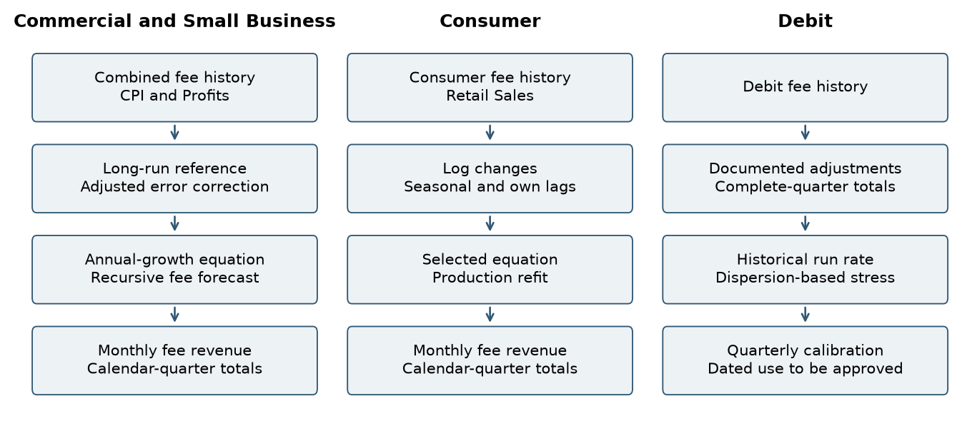
Methodology diagram based on the component code. Separate lanes preserve differences in target, frequency and judgment. The Debit output is a calibration level, not a generated monthly trajectory. Data sources: commercial/​commercial_​card_​model.py; commercial/​commercial_​card_​model.py; consumer/​consumer_​card_​model.py; debit/​debit_​card_​model.py.

1.6 Performance Summary
In-sample testing assessed explanatory power, coefficient significance, multicollinearity and residual behavior for the selected regression components. Commercial Card and Small Business and Consumer Card both retained statistically significant coefficients, with limited multicollinearity in their final development equations. The table below presents the principal results; the detailed testing discussion distinguishes equation-scale diagnostics from fee-level forecast accuracy.
Table 1.3 Regression Performance Summary
Metric | Commercial Card and Small Business | Consumer Card
Adjusted R-squared | 73.57% [commercial/​short_​run_​diagnostics.csv/​row 2 col 3] | 61.14% [consumer/​model_​diagnostics.csv/​row 3 col 6]
Coefficient significance | All final coefficients have p < 0.05 [commercial/​short_​run_​coefficients.csv/​row 2–6 col 6] | All final coefficients have p < 0.05 [consumer/​coefficients.csv/​row 7–12 col 6]
Maximum VIF | 2.25 [commercial/​short_​run_​diagnostics.csv/​row 2 col 11] | 1.70 [consumer/​model_​diagnostics.csv/​row 3 col 12]
Durbin-Watson statistic | 2.032 [commercial/​short_​run_​diagnostics.csv/​row 2 col 5] | 2.356 [consumer/​model_​diagnostics.csv/​row 3 col 7]
Sources: commercial/​short_​run_​diagnostics.csv; commercial/​short_​run_​coefficients.csv; consumer/​model_​diagnostics.csv; consumer/​coefficients.csv. Consumer results refer to the selected development model, not the production refit.
Stability evidence is component-specific. Consumer Card rolling estimates retained the signs of all final explanatory variables, although their magnitudes changed across windows. Debit Card did not retain a regression because no tested specification met all acceptance criteria. Its performance assessment therefore focuses on the transparency and reasonableness of the adopted historical calibration.
For Debit Card, the baseline and stress floor summarize different aspects of the historical distribution. The baseline measures the recent quarterly revenue run rate, while the floor reflects the selected downside-severity rule. The following table reports calibration outputs rather than regression fit or forecast-error statistics.
Table 1.4 Debit Card Historical Calibration Summary
Measure | Value
Quarterly baseline revenue ($000) | 4,747.625
Quarterly stress floor ($000) | 3,813.653
Decline from baseline to stress floor | 19.67%
Data source: debit/​qualitative_​scenarios.csv. These are historical calibration outputs, not OOT forecast-accuracy statistics.

1.7 Out-of-Time Results
Out-of-time assessment used October 2023 through December 2025 to examine later-period forecasting behavior of the regression components.
Commercial Card and Small Business testing evaluated static forecasts and Full Recursive OOT forecasts. Full Recursive OOT initializes endogenous states with actual history through September 2023 and then updates fee levels, own-growth lags and adjusted error-correction states using prior predictions. Historical macroeconomic inputs and the calibrated EC trend adjustment are retained.
Consumer Card testing retained the selected development-period coefficients and evaluated both static and recursive forecasts. The recursive procedure updated revenue levels and lagged revenue changes using model predictions, while using observed macroeconomic inputs.
Debit Card uses a historical quarterly calibration approach; regression-based OOT testing is not applicable.
Table 1.5 Out-of-Time Results by Component
Component | Test method | MAPE | RMSE ($000)
Commercial Card and Small Business | Static OOT | 8.76% [commercial/​forecast_​accuracy.csv/​row 3 col 5] | 231.43 [commercial/​forecast_​accuracy.csv/​row 3 col 3]
Commercial Card and Small Business | Full Recursive OOT | 16.95% [commercial/​forecast_​accuracy.csv/​row 4 col 5] | 399.13 [commercial/​forecast_​accuracy.csv/​row 4 col 3]
Consumer Card | Static OOT | 5.05% [consumer/​forecast_​accuracy.csv/​row 3 col 3] | 45.89 [consumer/​forecast_​accuracy.csv/​row 3 col 4]
Consumer Card | Recursive OOT | 5.96% [consumer/​forecast_​accuracy.csv/​row 4 col 3] | 53.34 [consumer/​forecast_​accuracy.csv/​row 4 col 4]
Debit Card | Historical quarterly calibration | N/​A | N/​A
Sources: commercial/​forecast_​accuracy.csv; commercial/​fully_​recursive_​oot.csv; consumer/​forecast_​accuracy.csv; debit/​debit_​card_​model.py. Commercial and Consumer recursive tests update their respective endogenous fee states under fixed development coefficients. Commercial also retains its calibrated EC trend adjustment. N/​A means that OOT testing is not applicable to the adopted Debit methodology.

1.8 Overlay Summary
The Commercial Card and Small Business model compares actual fee revenue with the fitted value from the CPI-based long-run model. It expresses the gap as a percentage of the fitted value. This percentage gap is called scaled EC.
The model estimates a time trend in scaled EC during the OOT period. It subtracts this trend to obtain adjusted EC. The short-run equation uses adjusted EC from twelve months earlier.
For future forecasts, the trend adjustment stays at its December 2025 value. The model updates EC each month using forecast revenue.
Consumer Card forecasts do not include a separate management overlay in the current implementation.
Debit Card uses a historical quarterly calibration approach. Its baseline and stress-floor calculations constitute the forecasting methodology rather than an overlay applied to regression forecasts.
Table 1.6 Overlay Summary by Component
Component | Treatment | Implementation
Commercial Card and Small Business | Trend adjustment to scaled error correction | Trend intercept −5.5930 percentage points; monthly slope −0.9093 percentage points; held future adjustment −30.1428 percentage points. Subtracted before constructing the lagged EC input.
Consumer Card | No separate management overlay | Forecasts follow the selected recursive equation and the applicable scenario inputs.
Debit Card | No separate management overlay | Historical baseline and stress-floor calculations are the forecasting methodology.
Sources: commercial/​overlay_​trend.csv; commercial/​commercial_​card_​model.py; consumer/​consumer_​card_​model.py; debit/​qualitative_​scenarios.csv. Commercial adjustment values are percentage points on the scaled EC state, not direct percentage changes in fee revenue.

1.9 Key Assumptions
The model assumes that historical fee definitions remain comparable and that the selected business relationships continue to provide useful forecasting information. Commercial Card and Small Business relies on the CPI-based revenue reference, lagged fee dynamics, Corporate Profits growth and the held EC adjustment. Consumer Card relies on recurring seasonal patterns, short-term revenue adjustment and the Retail Sales association. Debit Card relies on the recent-quarter mean as a run-rate measure and the retained historical distribution as a downside-calibration reference. The regression components also assume approximately linear relationships in the specified transformations, sufficiently stable coefficients and residual properties appropriate for estimation and inference. These assumptions depend on complete and consistently defined source data.

1.10 Key Strengths
The principal strength of the framework is its separation of distinct revenue mechanisms into interpretable component methods. Commercial Card and Small Business combines a nominal revenue reference with short-run persistence, error correction and business conditions. Consumer Card combines spending growth with seasonal and lagged revenue effects, supported by consistent coefficient signs in the reported rolling exercise. Debit Card provides an explicit calculation of the recent run rate and historical downside reference. Retained inputs, equations, calibration rules and source-linked exhibits make these mechanisms reproducible and open to review.

1.11 Key Limitations
The framework does not explicitly model future pricing actions, new products or services, regulatory developments or one-time management initiatives. Such changes may weaken historical relationships or produce forecast bias. Commercial Card and Small Business is sensitive to the continued relevance of its long-run reference and fixed EC adjustment. Consumer Card is sensitive to changes in spending behavior, portfolio mix and seasonality. Debit Card does not respond directly to macroeconomic scenario paths, and its stress floor is a judgmental downside reference rather than a probability quantile. Monitoring, review of the Commercial adjustment and Debit calibration, and recalibration or redevelopment when warranted are the proposed mitigants.

1.12 Governance and Ownership
The model is governed under applicable Model Risk Management standards and SR 26-2 guidance. Performance is subject to periodic review, monitoring, and validation. Material changes to methodology, assumptions, inputs, implementation, or intended use require review and approval through established governance processes.
The table identifies the governance and ownership information to be completed for each responsible role.
Table 1.7 Governance and Ownership
Field | Information
Model Name
Model Owner
Model Developer
Model Users
Primary Use
Governance Review

1.13 Executive Conclusion
The selected Card Fee framework combines revenue dynamics and economically interpretable drivers without imposing a single model form on all card activities. Commercial Card and Small Business uses a CPI reference, error correction, revenue persistence and Corporate Profits growth. Consumer Card uses lagged fee changes, seasonal indicators and Retail Sales growth. Debit Card uses quarterly historical calibration. Development and testing provide a documented basis for assessing these methods for CCAR forecasting, stress testing, capital planning and related applications. Continued use and eventual production approval remain subject to the component-specific limitations, additional evidence and governance requirements described in this document.

2. Model Theory and Design

2.1 Business Purpose and Conceptual Framework
The Card Fee Model translates historical fee behavior and economic conditions into revenue projections for planning and stress testing. Fee generation reflects customer activity, pricing, portfolio composition and service utilization. The objective is to identify interpretable relationships that explain recurring movements in fee revenue and can be projected under alternative economic conditions.
The design follows a component-specific modeling philosophy. Commercial Card and Small Business uses a nominal long-run reference and a short-run growth equation. Consumer Card uses monthly log changes to represent adjustment and calendar effects. Debit Card uses historical quarterly levels after the tested regressions failed the complete selection criteria.

2.2 Business Context and Component Segmentation
The historical revenue series display different operating patterns and require separate treatment. Commercial Card and Small Business form the combined target implemented in the source data mapping. Consumer Card remains separate because recurring year-end movements are central to its monthly dynamics. Debit Card history includes a substantial 2011 discontinuity, isolated 2012 reversals, 2014 anomalies and a sustained 2015 level shift. Segmentation preserves those differences and allows data treatment, estimation and monitoring to be explained within the relevant business series.

2.3 Commercial Long-Run Relationship
The Commercial Card and Small Business model integrates a long-run revenue relationship with a short-run growth equation through an explicit error-correction mechanism. The long-run component uses CPI to establish a reference level for combined fee revenue. This reference is not the final revenue forecast; instead, it provides the basis for measuring how actual or projected revenue differs from the model’s longer-term relationship.
The connection between the two components is the adjusted error-correction term. The difference between fee revenue and the long-run fitted level is expressed as a percentage of that fitted level, adjusted for the EC trend overlay, and lagged twelve months. This term is retained as a required component throughout short-run variable selection, ensuring that the selected growth equation remains explicitly linked to the long-run relationship.
The positive CPI coefficient is consistent with the relationship between nominal revenue and the general price level. The actual-versus-reference exhibit illustrates historical alignment and the later-period divergence used in EC calibration.
Figure 2.1 Commercial fees and the long-run reference
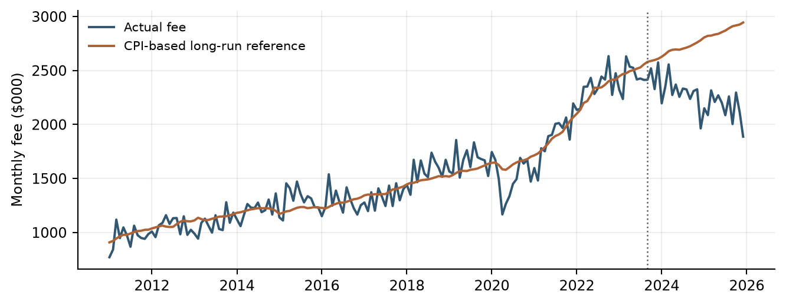
The dotted line marks the end of coefficient estimation. The later-period reference uses the same long-run coefficients; it is not an independently refitted relationship. Data sources: commercial/​long_​run_​history.csv; commercial/​commercial_​card_​model.py.
$\begin{aligned}fitted_lr(t) = −3386.960717 + 19.419549 × CPI(t)\end{aligned}$
Coefficient sources: commercial/​long_​run_​coefficients.csv/​row 2 col 3 (intercept); commercial/​long_​run_​coefficients.csv/​row 3 col 3 (CPI slope).
fitted_​lr(t) is the fitted long-run Commercial Card and Small Business fee revenue (long_​run_​fitted_​fee), in $000. CPI(t) is the contemporaneous Consumer Price Index level (consumer_​price_​index). Coefficients are displayed to six decimal places; calculations retain full precision.
Combined2(t) denotes combined Commercial Card and Small Business fee revenue (commercial_​small_​business_​fee), in $000. EC(t) measures its deviation from fitted_​lr(t). Dividing this deviation by the fitted level and multiplying by 100 gives EC_​scaled(t). The contemporaneous Overlay(t) is subtracted before the adjusted EC state is lagged 12 months.
$\begin{aligned}EC(t) = Combined2(t) − fitted_lr(t) \\ EC_scaled(t) = 100 × \frac{EC(t)}{fitted_lr(t)} \\ EC_scaled_adj(t) = EC_scaled(t) − Overlay(t) \\ EC_scaled_adj_lag12(t) = EC_scaled_adj(t − 12)\end{aligned}$
Formula definitions: EC = ec_​residual; EC_​scaled = ec_​scaled_​pct; Overlay = ec_​trend_​overlay_​pct; EC_​scaled_​adj = ec_​scaled_​adjusted_​pct. Source: commercial/​commercial_​card_​model.py, lines 278–297; commercial/​historical_​data_​and_​features.csv.

2.4 Short-Run Growth and Adjustment Dynamics
The Commercial short-run equation models annual fee growth from monthly observations. It combines the twelve-month-lagged adjustment mechanism with recent fee-growth dynamics and Corporate Profits growth. Its negative error-correction coefficient means that a positive adjusted deviation reduces predicted year-over-year fee growth, while a negative adjusted deviation increases predicted growth, holding the other inputs constant. The one-month and six-month lags of annual fee growth capture persistence, while Corporate Profits annual growth, lagged two months, captures additional business-cycle variation. Together, these terms describe how revenue growth responds to the longer-term reference, recent revenue performance, and changing business conditions. The annual growth transformation and the monthly timing lag have separate economic and computational meanings.
$\begin{aligned}y(t) = 100 × [\frac{Combined2(t)}{Combined2(t − 12)} − 1]\end{aligned}$
Formula definition and parameter mapping: commercial/​commercial_​card_​model.py; commercial/​short_​run_​coefficients.csv.
$\begin{aligned}y(t) = 1.783143 − 0.653518 × EC_scaled_adj_lag12(t) \\ + 0.296379 × y_lag1(t) + 0.250188 × y_lag6(t) \\ + 0.422022 × CorpProfits_lag2(t) + ε(t)\end{aligned}$
Formula definition and parameter mapping: commercial/​commercial_​card_​model.py; commercial/​short_​run_​coefficients.csv/​rows 2–6 col 3. All regressors in the displayed equation are evaluated at month t after their named lag transformations.
y(t) is annual fee growth (commercial_​small_​business_​fee_​pct_​change_​12m). y_​lag1(t) and y_​lag6(t) are its one-month and six-month lags, exported as commercial_​small_​business_​fee_​pct_​change_​12m_​lag_​1m and commercial_​small_​business_​fee_​pct_​change_​12m_​lag_​6m. CorpProfits_​lag2(t) is Corporate Profits annual percentage growth lagged two months (corporate_​profits_​pct_​change_​12m_​lag_​2m). EC_​scaled_​adj_​lag12(t) corresponds to ec_​scaled_​adjusted_​pct_​lag_​12m. ε(t) is the equation error; its value is set to zero when calculating point forecasts. Growth and scaled EC terms use percentage units. Displayed coefficients are rounded; calculations retain the full output precision.

2.5 Commercial Overlay and Recursion
The EC adjustment addresses a pattern observed in the later historical period through an explicit calibration rule. The script sets the development overlay to zero, fits a linear trend to OOT month indices 1 through 27, subtracts the contemporaneous trend from scaled EC, and then forms the 12-month lag.
The future forecasting process initializes with actual history through December 2025. Commercial development coefficients remain fixed in this future projection process. Predicted annual growth is applied to the actual or previously forecast fee revenue level from twelve months earlier to obtain the current revenue forecast.
That forecast is then compared with the contemporaneous CPI-based long-run reference to calculate a new adjusted error-correction state. The updated revenue, growth, and error-correction states become inputs to later forecasts through their respective lags. Consequently, the long-run component provides the reference, the short-run component determines the growth response, and recursive updating links both components throughout the forecast horizon.

2.6 Consumer Target and Seasonal Structure
Consumer Card is modeled in monthly logarithmic changes because its revenue history contains recurring month-to-month adjustment and year-end seasonality. Modeling changes separates these movements from the level of the revenue series. The log representation expresses proportional movement and permits a multiplicative reconstruction of fee levels, subject to positive historical fee values.
The lagged revenue-change terms represent short-run dynamics, while January and December indicators represent recurring calendar effects. Negative lag coefficients indicate partial reversal in the transformed target after controlling for the other terms. The seasonal exhibit provides descriptive context; the regression estimates calendar effects jointly with revenue dynamics and Retail Sales rather than treating monthly averages as fitted coefficients.
Figure 2.2 Consumer development-period calendar pattern
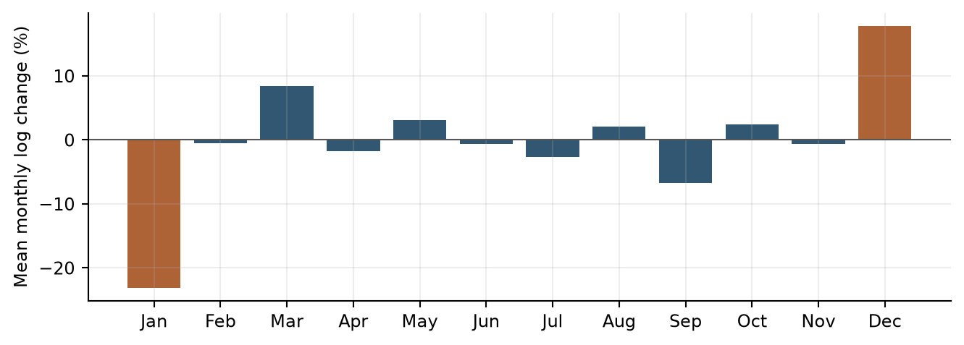
Derived display: arithmetic mean of exported monthly fee log changes grouped by calendar month. These unconditional averages motivate examination of calendar effects; they are not the fitted seasonal coefficients. Data sources: consumer/​historical_​data_​and_​features.csv.
$z_{t} = 100 [ln(Y_{t}) − ln(Y_{t−1})]$
Formula definition and parameter mapping: consumer/​consumer_​card_​model.py.

2.7 Consumer Retail Sales Effect
Retail Sales provides the Consumer model with a spending-related macroeconomic explanation. The input is the arithmetic average of current and prior two monthly percentage changes, which smooths short-term variation. Its positive coefficient links stronger retail spending growth to stronger fee log growth conditional on seasonality and own lags. In the production equation, a one-percentage-point increase in this MA3 input increases the predicted monthly log change by approximately 2.50685 percentage points before recursive effects.
$z_{t} = κ + φ_{1}z_{t−1} + φ_{2}z_{t−2} + δ_{J}J_{t} + δ_{D}D_{t} + θ r_{t}$
Formula definition and parameter mapping: consumer/​consumer_​card_​model.py; consumer/​coefficients.csv.
J and D are January and December indicators; r is Retail Sales MoM growth MA3. The production coefficients above are refitted through December 2025. A future fee level equals the prior actual or predicted fee multiplied by the exponential of predicted log change divided by 100.

2.8 Debit Qualitative Method
The Debit methodology separates recent revenue expectations from downside severity. Baseline uses the latest eight complete actual quarters, currently 2024Q1–2025Q4. Stress uses the mean of complete quarters from 2015Q1–2025Q4 less twice the sample standard deviation. The first window represents the current run rate; the second provides a longer post-break distribution. The two-standard-deviation multiplier remains a judgmental rule, not a model-estimated probability or a guaranteed bound.
The current stress floor is below every observed post-2015 quarter, which provides a useful historical comparison of severity.

2.9 Assumptions and Mitigating Review
The model assumes that historical reporting definitions remain materially comparable and that the selected economic relationships remain relevant during the forecast horizon. Recursive forecasts use previously projected fee values to construct the subsequent period's lagged inputs. Monitoring therefore evaluates both short-horizon accuracy and the behavior of the complete forecast path.
Commercial assumes that the CPI reference and EC adjustment remain relevant to fee dynamics. Consumer assumes that seasonal patterns, own-growth dynamics and the Retail Sales relationship persist. Debit assumes that the recent-quarter average represents the current run rate and that the post-2015 history is appropriate for downside calibration. These assumptions are reviewed through performance monitoring and periodic reassessment.

2.10 Design Limitations and Conclusions
The selected design combines economically interpretable regression relationships with a transparent historical calibration for Debit Card. Aggregate fee histories do not separately represent every future pricing initiative, product change or shift in customer mix. Debit calibration does not include a direct macroeconomic response, and its historical windows require periodic review. These limitations are addressed through scenario analysis, monitoring and reassessment of model assumptions.

3. Model Estimation

3.1 Overview of the Estimation Process
Model estimation followed a staged framework intended to balance statistical evidence, economic interpretation and forecasting suitability. Target construction and date alignment preceded candidate screening, multivariate selection and evaluation. The objective was to reduce each candidate set to a small number of understandable forecasting inputs while preserving the evidence behind selection decisions.
Commercial Card and Small Business estimation follows an integrated two-stage process. The first stage estimates a long-run relationship between combined fee revenue and macroeconomic levels. The resulting fitted revenue provides the reference for constructing the adjusted error-correction term. The second stage incorporates this term into a short-run equation for year-over-year fee growth and evaluates additional revenue-growth lags and macroeconomic drivers. This sequence establishes a direct connection between the long-run revenue relationship and the short-run adjustment dynamics.
Consumer tests macroeconomic additions to a fixed lag-and-seasonal base, evaluates the selected development equation on later data and then refits the retained structure. Debit records each regression-screening outcome before calibrating its historical rule. The flow diagram makes these differences explicit.
Figure 3.1 Component estimation and selection process
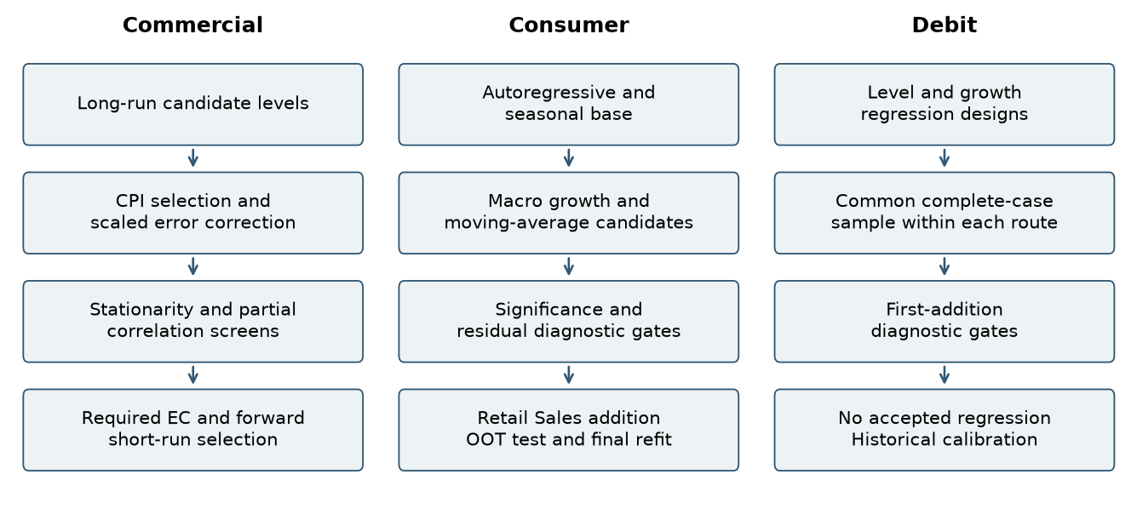
Selection stages follow the component procedures, including Commercial partial-correlation screening across development and OOT periods. Data sources: commercial/​long_​run_​trials.csv; commercial/​short_​run_​screen_​all.csv; consumer/​macro_​screening.csv; debit/​regression_​summary.csv.

3.2 Candidate Variable Universe
Commercial’s long-run pool contains CPI, disposable income, wholesale-trade GDP, Corporate Profits and the total-market index in levels. Its transformed short-run pool spans eight macro families, plus own annual-growth lags 1–12. Macro lags cover 0–12 months. Consumer considers unemployment, CPI, disposable income, Retail Sales and consumer confidence, each in current monthly change and a trailing three-month average. Debit considers 14 macro families under four target and frequency treatments. The data inventory and exact source mappings are retained in Appendix A.

3.3 Transformations and Alignment
Fee and macro records are joined by a monthly date key. Growth calculations use percentage changes multiplied by 100, except Consumer fee growth, which uses log differences multiplied by 100. Unemployment uses percentage-point differences. Lags are applied after transformations, and moving averages are calculated on already transformed growth. Debit quarterly revenue sums three monthly fees, while its quarterly macro variables use the quarter-end monthly observation. Design-specific complete-case alignment explains effective sample reductions; those losses should not be labeled raw missing source data.

3.4 Commercial Long Run Estimation and Error Correction Construction
Long-run estimation establishes the revenue reference used in the subsequent short-run model. Candidate macroeconomic level variables are evaluated using development-period observations. Each proposed addition must satisfy the implemented Student-t significance, multicollinearity, and residual-stationarity criteria. Eligible additions are ranked by adjusted R-squared. CPI is selected as the final long-run explanatory variable.
The selected CPI relationship is then carried forward into feature construction. Fee revenue is compared with the fitted long-run level, and the resulting deviation is scaled relative to that level. After applying the EC trend adjustment, the adjusted deviation is lagged twelve months to form the error-correction input for the short-run equation. Long-run estimation therefore supplies both a revenue reference and a directly linked explanatory variable for the next estimation stage.
The selected CPI relationship has a coefficient of 19.41955 and standard error of 0.44293 in $000 per CPI index point. Its ordinary residual ADF p-value is 0.00915 [commercial/​long_​run_​residual_​stationarity.csv/​row 2 col 3].
The comparison below shows why the largest unqualified fit statistic does not automatically determine the selected driver. Wholesale-trade GDP has a higher initial adjusted fit but fails the residual ADF gate. CPI is the highest-ranked eligible initial addition. Subsequent additions are evaluated conditional on CPI.
Table 3.1 Commercial initial long-run candidate comparison
Candidate | Adjusted fit | Residual ADF p | Eligible | Outcome
CPI | 0.9267 [commercial/​long_​run_​trials.csv/​row 2 col 10] | 0.0091 [commercial/​long_​run_​trials.csv/​row 2 col 7] | Yes | Selected
Disposable income | 0.8164 [commercial/​long_​run_​trials.csv/​row 3 col 10] | 0.0029 [commercial/​long_​run_​trials.csv/​row 3 col 7] | Yes | Not selected
Wholesale GDP | 0.9326 [commercial/​long_​run_​trials.csv/​row 4 col 10] | 0.0626 [commercial/​long_​run_​trials.csv/​row 4 col 7] | No | Not selected
Corporate Profits | 0.8921 [commercial/​long_​run_​trials.csv/​row 5 col 10] | 0.0400 [commercial/​long_​run_​trials.csv/​row 5 col 7] | Yes | Not selected
Equity index | 0.7941 [commercial/​long_​run_​trials.csv/​row 6 col 10] | 0.0013 [commercial/​long_​run_​trials.csv/​row 6 col 7] | Yes | Not selected
Data source: commercial/​long_​run_​trials.csv.
Source: commercial/​long_​run_​trials.csv. The table shows initial single-driver trials; later conditional trials remain in the source file.

3.5 Commercial Short Run Macroeconomic Prescreening
Short-run macroeconomic screening is conducted conditional on the error-correction mechanism established from the long-run model. Transformed macroeconomic families first undergo development-period stationarity screening using the implemented ADF/KPSS eligibility rule. For eligible families, partial correlations are calculated between annual fee growth and each candidate macroeconomic lag after controlling for an intercept and the twelve-month-lagged adjusted error-correction term. This approach evaluates whether a candidate provides additional information about fee growth beyond the adjustment mechanism already represented by the long-run relationship.
Short-run macroeconomic candidates were pre-screened for partial-correlation significance and sign consistency across the development and OOT periods. Subsequent variable selection and coefficient estimation used development-period observations.
Eligibility uses an OR rule: ADF p < 0.05 or KPSS p > 0.05. Partial-correlation screening requires p < 0.20 in both development and OOT and matching signs. Fourteen macro-lag terms pass.
Table 3.2 Commercial transformed-family stationarity results
Family | ADF p | KPSS p | KPSS bound | OR rule
Unemployment Rate | 0.0796 [commercial/​macro_​stationarity.csv/​row 2 col 4] | 0.1000 [commercial/​macro_​stationarity.csv/​row 2 col 9] | >=0.10 [commercial/​macro_​stationarity.csv/​row 2 col 12] | Eligible
Consumer Price Index | 0.3712 [commercial/​macro_​stationarity.csv/​row 3 col 4] | 0.0100 [commercial/​macro_​stationarity.csv/​row 3 col 9] | <=0.01 [commercial/​macro_​stationarity.csv/​row 3 col 12] | Excluded
Disposable Personal Income | 0.0072 [commercial/​macro_​stationarity.csv/​row 4 col 4] | 0.0418 [commercial/​macro_​stationarity.csv/​row 4 col 9] | interpolated [commercial/​macro_​stationarity.csv/​row 4 col 12] | Eligible
Small Business Optimism | 0.2813 [commercial/​macro_​stationarity.csv/​row 5 col 4] | 0.0417 [commercial/​macro_​stationarity.csv/​row 5 col 9] | interpolated [commercial/​macro_​stationarity.csv/​row 5 col 12] | Excluded
Wholesale Trade Gdp | 0.3152 [commercial/​macro_​stationarity.csv/​row 6 col 4] | 0.1000 [commercial/​macro_​stationarity.csv/​row 6 col 9] | >=0.10 [commercial/​macro_​stationarity.csv/​row 6 col 12] | Eligible
Industrial Production | 0.0384 [commercial/​macro_​stationarity.csv/​row 7 col 4] | 0.1000 [commercial/​macro_​stationarity.csv/​row 7 col 9] | >=0.10 [commercial/​macro_​stationarity.csv/​row 7 col 12] | Eligible
Corporate Profits | 0.2191 [commercial/​macro_​stationarity.csv/​row 8 col 4] | 0.1000 [commercial/​macro_​stationarity.csv/​row 8 col 9] | >=0.10 [commercial/​macro_​stationarity.csv/​row 8 col 12] | Eligible
Dow Jones Total Market Index | 0.0060 [commercial/​macro_​stationarity.csv/​row 9 col 4] | 0.1000 [commercial/​macro_​stationarity.csv/​row 9 col 9] | >=0.10 [commercial/​macro_​stationarity.csv/​row 9 col 12] | Eligible
Data source: commercial/​macro_​stationarity.csv.
Source: commercial/​macro_​stationarity.csv. Eligibility follows the code OR rule; bounded KPSS values are displayed with their exported bounds. These are transformed-family tests, not tests of raw level series.

3.6 Commercial Short Run Forward Selection and Coefficient Estimation
Short-run forward selection begins with an intercept and the twelve-month-lagged adjusted error-correction term. The error-correction term remains a required explanatory variable throughout the selection process, preserving the connection to the previously estimated long-run relationship. Its coefficient is estimated jointly with the other short-run coefficients rather than fixed in advance.
Additional candidates comprise the macroeconomic terms that pass pre-screening and lags 1–12 of annual fee growth. Each proposed addition is evaluated conditional on the required error-correction term and the variables already selected. Eligible additions must meet Student-t p < 0.05 and maximum VIF < 10 and are ranked by adjusted R-squared with a fixed tie order. The final specification combines adjusted error correction with the one-month and six-month lags of annual fee growth and the two-month lag of Corporate Profits annual growth.
This specification assigns complementary roles to the two estimation stages. The long-run model establishes the revenue reference, while the short-run model estimates how annual fee growth responds to deviations from that reference, recent growth dynamics, and business-cycle conditions. The resulting equations operate together within the recursive forecasting framework described in Section 2.5.
Table 3.3 Commercial short-run development progression
Round | Added term | Effective n | Adjusted fit
1 | Fee YoY growth, lag 1 | 140 | 0.6583 [commercial/​short_​run_​rounds.csv/​row 2 col 3]
2 | Fee YoY growth, lag 6 | 135 | 0.6944 [commercial/​short_​run_​rounds.csv/​row 3 col 3]
3 | Profits YoY growth, lag 2 | 135 | 0.7357 [commercial/​short_​run_​rounds.csv/​row 4 col 3]
Data source: commercial/​short_​run_​rounds.csv.
Source: commercial/​short_​run_​rounds.csv. Adjusted EC is required before these additions. Effective samples differ when additional lags reduce available observations, so fit changes are not pure same-sample incremental comparisons.
The final short-run estimates combine a negative error-correction response with positive fee-growth persistence and Corporate Profits exposure. The reported standard errors and Student-t results document inference for the jointly estimated equation.
Table 3.4 Commercial final short-run coefficients
Term | Estimate | Std error | t statistic | p value
Intercept | 1.78314 | 0.85356 | 2.089 [commercial/​short_​run_​coefficients.csv/​row 2 col 5] | 0.039 [commercial/​short_​run_​coefficients.csv/​row 2 col 6]
Adjusted EC, lag 12 | -0.65352 | 0.08291 | -7.883 [commercial/​short_​run_​coefficients.csv/​row 3 col 5] | <0.001 [commercial/​short_​run_​coefficients.csv/​row 3 col 6]
Fee YoY growth, lag 1 | 0.29638 | 0.06672 | 4.442 [commercial/​short_​run_​coefficients.csv/​row 4 col 5] | <0.001 [commercial/​short_​run_​coefficients.csv/​row 4 col 6]
Fee YoY growth, lag 6 | 0.25019 | 0.05008 | 4.996 [commercial/​short_​run_​coefficients.csv/​row 5 col 5] | <0.001 [commercial/​short_​run_​coefficients.csv/​row 5 col 6]
Profits YoY growth, lag 2 | 0.42202 | 0.09115 | 4.630 [commercial/​short_​run_​coefficients.csv/​row 6 col 5] | <0.001 [commercial/​short_​run_​coefficients.csv/​row 6 col 6]
Source: commercial/​short_​run_​coefficients.csv. Classical nonrobust OLS covariance; coefficient scale is annual percentage growth.

3.7 Consumer Base and Forward Selection
The fixed base comprises an intercept, fee log-growth lags 1 and 2, and January and December indicators. Forward selection tests the ten macro transformations. An added term must have a two-sided Student-t p-value < 0.05, maximum VIF < 10, DW between 1.5 and 2.5 inclusive, and JB p-value > 0.05. At most one feature per macro family is admitted. Passing candidates are ranked by the smallest Student-t p-value, then the highest adjusted R-squared and a fixed tie order. Student-t probabilities use residual degrees of freedom n − k, where k includes the intercept and all regressors. Retail Sales monthly-growth MA3 is selected. The exported p_​normal field is retained for reference only and is not used for eligibility or ranking.
MA3 means a three-month moving average. For Retail Sales, it averages the monthly percentage changes for the current month and the previous two months. This smooths short-term fluctuations.
Figure 3.2 Consumer initial macro additions
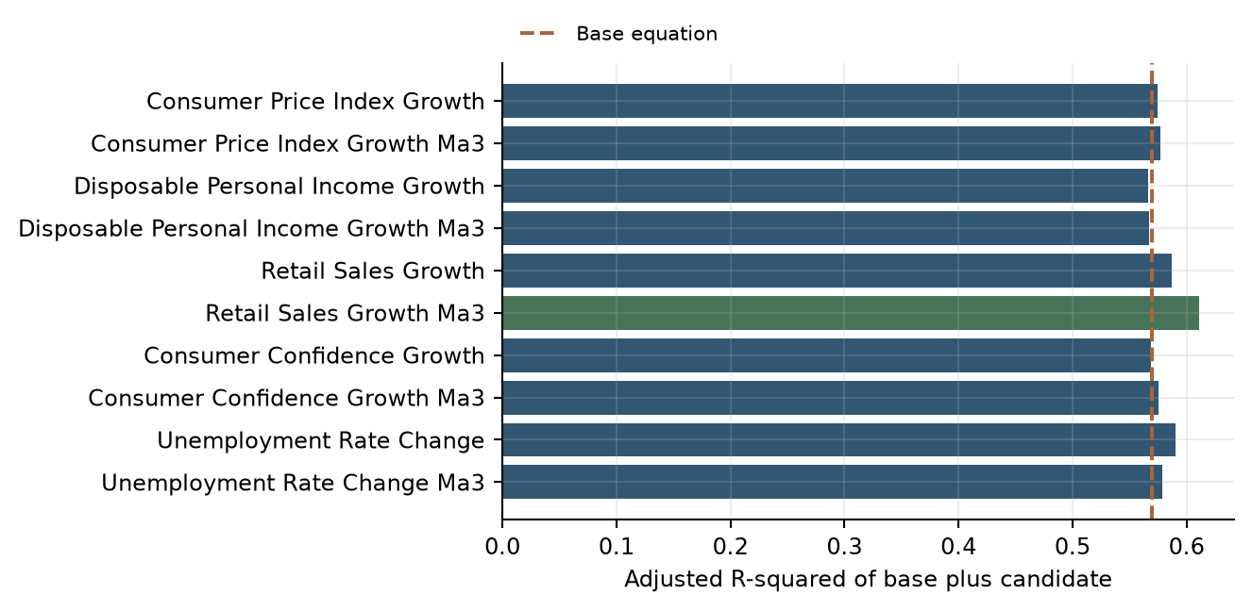
Green identifies the selected addition. The dashed line is the base equation. Selection also requires the documented statistical gates and ranking rule; adjusted fit alone is not the selection criterion. Data sources: consumer/​macro_​screening.csv; consumer/​model_​diagnostics.csv.
The development estimates associate lagged fee changes with short-run reversal, January with lower growth and December with higher growth. The positive Retail Sales term represents the spending-related contribution after controlling for these dynamics and calendar effects.
Table 3.5 Consumer development coefficients
Term | Estimate | Std error | t statistic | p value
Intercept | -1.98312 | 0.82447 | -2.405 [consumer/​coefficients.csv/​row 7 col 4] | 0.017 [consumer/​coefficients.csv/​row 7 col 6]
Fee log growth, lag 1 | -0.62166 | 0.06568 | -9.464 [consumer/​coefficients.csv/​row 8 col 4] | <0.001 [consumer/​coefficients.csv/​row 8 col 6]
Fee log growth, lag 2 | -0.33883 | 0.06070 | -5.583 [consumer/​coefficients.csv/​row 9 col 4] | <0.001 [consumer/​coefficients.csv/​row 9 col 6]
January indicator | -11.15312 | 2.87904 | -3.874 [consumer/​coefficients.csv/​row 10 col 4] | <0.001 [consumer/​coefficients.csv/​row 10 col 6]
December indicator | 19.65826 | 2.59864 | 7.565 [consumer/​coefficients.csv/​row 11 col 4] | <0.001 [consumer/​coefficients.csv/​row 11 col 6]
Retail Sales MoM growth, MA3 | 2.57529 | 0.63128 | 4.079 [consumer/​coefficients.csv/​row 12 col 4] | <0.001 [consumer/​coefficients.csv/​row 12 col 6]
Data source: consumer/​coefficients.csv.

3.8 Consumer Production Refit
The selected structure is retained and re-estimated through December 2025. This refit uses 177 effective observations and produces adjusted R-squared of 0.6091 [consumer/​model_​diagnostics.csv/​row 4 col 6]. Retail Sales’ coefficient is 2.50685, compared with 2.57529 in development.
Table 3.6 Consumer production coefficients
Term | Estimate | Std error | t statistic | p value
Intercept | -1.72062 | 0.73073 | -2.355 [consumer/​coefficients.csv/​row 13 col 4] | 0.020 [consumer/​coefficients.csv/​row 13 col 6]
Fee log growth, lag 1 | -0.60242 | 0.06023 | -10.002 [consumer/​coefficients.csv/​row 14 col 4] | <0.001 [consumer/​coefficients.csv/​row 14 col 6]
Fee log growth, lag 2 | -0.33981 | 0.05610 | -6.057 [consumer/​coefficients.csv/​row 15 col 4] | <0.001 [consumer/​coefficients.csv/​row 15 col 6]
January indicator | -11.86259 | 2.53369 | -4.682 [consumer/​coefficients.csv/​row 16 col 4] | <0.001 [consumer/​coefficients.csv/​row 16 col 6]
December indicator | 18.72925 | 2.24148 | 8.356 [consumer/​coefficients.csv/​row 17 col 4] | <0.001 [consumer/​coefficients.csv/​row 17 col 6]
Retail Sales MoM growth, MA3 | 2.50685 | 0.60023 | 4.177 [consumer/​coefficients.csv/​row 18 col 4] | <0.001 [consumer/​coefficients.csv/​row 18 col 6]
Data source: consumer/​coefficients.csv.

3.9 Debit Regression Screening
The Level and MoM routes consider own lags 1–12 and macro lags 0–12. The YoY route is a contemporaneous transformed-macro screen and does not estimate an ECM afterward. Quarterly QoQ uses own lags 1–4 and macro lags 0–4. Each route starts with an intercept-only specification on its common complete-case sample. Proposed first additions require Student-t p < 0.05, DW from 1.5 to 2.5 inclusive, JB p > 0.05 and maximum nonconstant VIF < 10. No forced term or joint first-step addition is used.
The screening table reports the sample size, candidate count and combined acceptance outcome for each Debit regression route. No route retained a specification satisfying all required gates, supporting the documented move to historical calibration.
Table 3.7 Debit candidate screening outcome
Approach | Effective n | Candidates | All gates passed | Accepted model
Level | 129 | 194 | 0 | No
YoY_​static_​screen | 129 | 14 | 0 | No
MoM | 128 | 194 | 0 | No
QoQ_​quarterly | 42 | 74 | 0 | No
Data source: debit/​regression_​summary.csv.

3.10 Debit Scenario Calibration
Quarterly actual fees are calculated after the documented revenue adjustments and require three monthly observations. The baseline mean is 4,747.625 $000 per quarter. The post-2015 mean is 4,553.09091 and sample standard deviation is 369.71874, yielding a stress floor of 3,813.65343. The difference from Baseline is 19.67%.

3.11 Estimation Conclusion
The estimation process produced a reproducible Commercial specification, a Consumer structure with separately identified development and production estimates, and a documented rejection outcome for each tested Debit regression route. The selected forecasting framework is parsimonious relative to the candidate sets and retains the calculations needed for independent reproduction.
The estimation results provide the basis for the testing framework in Section 6. That framework evaluates in-sample fit, residual diagnostics, coefficient stability, OOT accuracy and scenario response. Together, estimation and testing connect the selected specification to the model's intended forecasting use.

4. Development Data

4.1 Commercial Card and Small Business Model Data

4.1.1 Purpose and Development Sample
The development data provide the foundation for estimating, testing and forecasting Commercial Card and Small Business fee revenue. Data preparation focuses on relevance, completeness, consistent definitions and traceability from source observations to model inputs.
Monthly fee history spans January 2011 through December 2025. Long-run and short-run coefficient development uses observations through September 2023; the October 2023–December 2025 period supports OOT evaluation and EC trend calibration. Monthly frequency preserves the annual-growth transformations and monthly lags used in the selected equations.

4.1.2 Internal Data Sources
Internal data consist of monthly fee revenue in fee_​history.csv. All fee-history amounts are in $000, representing thousands of US dollars, and are used without rescaling. Calculated growth rates and other model features are kept separate from the source fields.
Table 4.1 Commercial Card and Small Business Internal Data Inventory
Data Element | Description | Source Dataset | Model Usage
date | Monthly observation date | commercial/​data/​fee_​history.csv | Monthly alignment and calendar key
Commercial Card | Monthly Commercial Card fee revenue ($000) | commercial/​data/​fee_​history.csv | Source fee series for model preparation
Small Business | Monthly Small Business card fee revenue ($000) | commercial/​data/​fee_​history.csv | Source fee series for model preparation
Data sources: commercial/​data/​fee_​history.csv; commercial/​commercial_​card_​model.py.

4.1.3 External Data Sources and Appropriateness
Macroeconomic history contains eight price, employment, income, business-activity, profitability and financial-market variables. Table 4.2 inventories every raw macroeconomic input in the Commercial code package, including candidates not retained in the final equations. CPI and Corporate Profits are the selected drivers. Baseline and S4 files supply the selected monthly scenario paths from January 2026 through March 2028. The model uses CPI levels for the long-run reference and lagged Corporate Profits annual growth for short-run fee growth. Derived growth rates and lags are documented separately in the transformation table.
Table 4.2 Commercial Card and Small Business External Data Inventory
Data Element | Description | Source Dataset | Model Usage
M_​FLBR_​B.IUSA  unemployment_​rate | Unemployment rate | commercial/​data/​macro_​history.csv | Short-run candidate: annual percentage-point change and monthly lags; not retained.
M_​FCPIU_​B.IUSA  consumer_​price_​index | Consumer Price Index | commercial/​data/​macro_​history.csv | Selected long-run level driver. Annual growth and lags also enter the short-run candidate screen.
M_​FYPDPIQ_​B.IUSA  disposable_​personal_​income | Disposable personal income | commercial/​data/​macro_​history.csv | Long-run level and short-run annual-growth candidate; not retained.
M_​FSBINQ_​B.IUSA  small_​business_​optimism | Small business optimism | commercial/​data/​macro_​history.csv | Short-run annual-growth and lag candidate; not retained.
M_​FGDP42Q_​B.IUSA  wholesale_​trade_​gdp | Wholesale trade GDP | commercial/​data/​macro_​history.csv | Long-run level and short-run annual-growth candidate; not retained.
M_​FIP_​B.IUSA  industrial_​production | Industrial production | commercial/​data/​macro_​history.csv | Short-run annual-growth and lag candidate; not retained.
M_​FZA_​B.IUSA  corporate_​profits | Corporate Profits | commercial/​data/​macro_​history.csv | Selected short-run annual-growth driver at a two-month lag. Also considered as a long-run level candidate.
M_​FDJMIIUSDD_​WCFTDQ_​B.IUSA  dow_​jones_​total_​market_​index | Dow Jones total market index | commercial/​data/​macro_​history.csv | Long-run level and short-run annual-growth candidate; not retained.
Data sources: commercial/​data/​macro_​history.csv; commercial/​data/​macro_​baseline.csv; commercial/​data/​macro_​s4.csv.

4.1.4 Data Lineage and Preparation
Preparation imports the source files, maps field names, orders and aligns dates, constructs the specified transformations and selects the relevant estimation or calibration period. Original inputs remain separate from exported features and results. No random sampling is applied.
Table 4.3 Commercial Card and Small Business Data Lineage
Input Source | Output File | Purpose
commercial/​data/​fee_​history.csv | commercial/​historical_​data_​and_​features.csv | Preserve mapped fee history and derived model features.
commercial/​data/​macro_​history.csv | commercial/​historical_​data_​and_​features.csv | Align and transform historical economic candidates.
commercial/​data/​macro_​baseline.csv; commercial/​data/​macro_​s4.csv | commercial/​forecast_​monthly.csv | Generate future scenario paths.
This table connects each Commercial model variable to its transformation steps and final formula. The sequence from combined fees to the long-run reference and adjusted error correction makes the link between the level and growth equations explicit.
Table 4.4 Commercial Card and Small Business Transformations and Final Formulas
Model Element | Transformation Steps | Final Formula
commercial_​small_​business_​fee | 1. Read the two fee fields. 2. Add their monthly amounts. Preserve $000. | = commercial_​card_​fee(t)  + small_​business_​card_​fee(t)
commercial_​small_​business_​fee_​pct_​change_​12m | 1. Aggregate fees. 2. Divide by the year-ago amount. 3. Subtract one and multiply by 100. | = 100 × [commercial_​small_​business_​fee(t)  ÷ commercial_​small_​business_​fee(t − 12) − 1]
long_​run_​fitted_​fee | 1. Map CPI. 2. Apply the estimated long-run intercept and slope. | = long_​run_​intercept  + long_​run_​CPI_​coefficient  × consumer_​price_​index(t)
ec_​scaled_​adjusted_​pct_​lag_​12m | 1. Subtract the long-run reference from fees. 2. Divide by the reference and multiply by 100. 3. Subtract the contemporaneous overlay. 4. Lag 12 months. | = 100 × [commercial_​small_​business_​fee(t − 12)  − long_​run_​fitted_​fee(t − 12)]  ÷ long_​run_​fitted_​fee(t − 12)  − ec_​trend_​overlay_​pct(t − 12)
commercial_​small_​business_​fee_​pct_​change_​12m_​lag_​1m; commercial_​small_​business_​fee_​pct_​change_​12m_​lag_​6m | 1. Calculate annual fee growth. 2. Shift by 1 or 6 monthly observations. | = commercial_​small_​business_​fee_​pct_​change_​12m  (t − k), k = 1 or 6
corporate_​profits_​pct_​change_​12m_​lag_​2m | 1. Map Corporate Profits. 2. Calculate annual percentage growth. 3. Lag two months. | = 100 × [corporate_​profits(t − 2)  ÷ corporate_​profits(t − 14) − 1]
Data sources: commercial/​commercial_​card_​model.py; commercial/​historical_​data_​and_​features.csv.

4.1.5 Data Quality Assessment
Data-quality assessment reviews completeness, date consistency, duplicates, alignment and transformation accuracy. Required source fields are reconciled to the mapped series and exported features. Initial observations unavailable solely because of growth calculations or lags are distinguished from missing source observations.
Table 4.5 Commercial Card and Small Business Data Quality Review
Review Area | Assessment Performed | Result
Date consistency | Check monthly dates and duplicate keys. | Unique monthly source dates.
Transformation accuracy | Trace features to original fields and code. | Aggregation, growth and lag rules are reproducible.
Sample alignment | Apply defined windows and complete-case alignment. | Estimation and calibration samples follow the component specification.

4.1.6 Missing Data Review and Inclusion Exclusion Decisions
Missing-data assessment covers the fee history, required historical inputs, selected forecast drivers where applicable, and aligned development sample.
Table 4.6 Commercial Card and Small Business Missing Data Assessment
Assessment Area | Missing Observations | Result
Fee revenue history | 0 | No missing values identified in the assessed fields.
Required historical model inputs | 0 | No missing values identified in the assessed fields.
Selected Baseline and S4 drivers | 0 | No missing values identified in the assessed fields.
Aligned development dataset | 0 | No missing values identified in the assessed fields.
Data sources: commercial/​data/​fee_​history.csv; commercial/​data/​macro_​history.csv; commercial/​data/​macro_​baseline.csv; commercial/​data/​macro_​s4.csv; commercial/​historical_​data_​and_​features.csv. Assessment scope is limited to the required model fields.

4.1.7 Outlier Assessment and Adjustments
Historical fee observations are retained without manual outlier replacement. Commercial Card and Small Business fees are aggregated before growth rates are calculated. The EC trend adjustment is applied to a derived model state, not to the original fee observations.

4.1.8 Data Relevance and Assumptions
The target directly measures the fee revenue being forecast. Historical coverage provides observations across different operating environments. Data preparation assumes consistent fee definitions, component mappings and reporting units over time. Source-system lineage, accounting reconciliation and data-vintage records support ongoing data governance.
Pricing actions, product changes and shifts in customer behavior are reviewed alongside aggregate fee history. Periodic review considers the continuing relevance of the input definitions, selected transformations and calibration periods.

4.1.9 Development Data Conclusions
The Commercial Card and Small Business development data provide a consistent foundation for the documented model methodology. Source files, derived features and calculation rules preserve traceability and support estimation, testing and forecasting. Ongoing review of data quality and business developments maintains the relevance of this foundation.

4.2 Consumer Card Model Data

4.2.1 Purpose and Development Sample
The development data provide the foundation for estimating, testing and forecasting Consumer Card fee revenue. Data preparation focuses on relevance, completeness, consistent definitions and traceability from source observations to model inputs.
Monthly fee history spans January 2011 through December 2025. Macroeconomic history starts in January 2010 and supplies prior observations for transformations. Development runs through September 2023, followed by October 2023–December 2025 OOT evaluation. The selected structure is refitted through December 2025 for future scenarios. Monthly frequency preserves the calendar indicators and short-run fee dynamics.

4.2.2 Internal Data Sources
Internal data consist of monthly fee revenue in fee_​history.csv. All fee-history amounts are in $000, representing thousands of US dollars, and are used without rescaling. Calculated growth rates and other model features are kept separate from the source fields.
Table 4.7 Consumer Card Internal Data Inventory
Data Element | Description | Source Dataset | Model Usage
date | Monthly observation date | consumer/​data/​fee_​history.csv | Monthly alignment and calendar key
Consumer Card | Monthly Consumer Card fee revenue ($000) | consumer/​data/​fee_​history.csv | Source fee series for model preparation
Data sources: consumer/​data/​fee_​history.csv; consumer/​consumer_​card_​model.py.

4.2.3 External Data Sources and Appropriateness
Table 4.8 inventories all five raw macroeconomic inputs, including candidates not retained in the final equation. Each variable is screened using monthly changes and trailing three-month averages. The final equation retains Retail Sales monthly-growth MA3, including the current month. Baseline inputs contain all five series; S4 supplies Retail Sales. Scenario inputs cover January 2026 through March 2028.
Table 4.8 Consumer Card External Data Inventory
Data Element | Description | Source Dataset | Model Usage
M_​FLBR_​B.IUSA  unemployment_​rate | Unemployment rate | consumer/​data/​macro_​history.csv | Monthly percentage-point change and its three-month average; candidate only.
M_​FCPIU_​B.IUSA  consumer_​price_​index | Consumer Price Index | consumer/​data/​macro_​history.csv | Monthly percentage growth and its three-month average; candidate only.
M_​FYPDPIQ_​B.IUSA  disposable_​personal_​income | Disposable personal income | consumer/​data/​macro_​history.csv | Monthly percentage growth and its three-month average; candidate only.
M_​FRT_​B.IUSA (Retail Sales Total_​Bil.USD,CDASAAR)  retail_​sales | Total Retail Sales | consumer/​data/​macro_​history.csv | Monthly percentage growth and its three-month average; the average is selected.
M_​FCBC_​B.IUSA(Consumer confidence index)  consumer_​confidence | Consumer confidence index | consumer/​data/​macro_​history.csv | Monthly percentage growth and its three-month average; candidate only.
Data sources: consumer/​data/​macro_​history.csv; consumer/​data/​macro_​baseline.csv; consumer/​data/​macro_​s4.csv; consumer/​consumer_​card_​model.py, MACRO_​COLUMNS and engineer. Source-field names retain the exact CSV headers.

4.2.4 Data Lineage and Preparation
Preparation imports the source files, maps field names, orders and aligns dates, constructs the specified transformations and selects the relevant estimation or calibration period. Original inputs remain separate from exported features and results. No random sampling is applied.
Table 4.9 Consumer Card Data Lineage
Input Source | Output File | Purpose
consumer/​data/​fee_​history.csv | consumer/​historical_​data_​and_​features.csv | Preserve mapped fee history and derived model features.
consumer/​data/​macro_​history.csv | consumer/​historical_​data_​and_​features.csv | Align and transform historical economic candidates.
consumer/​data/​macro_​baseline.csv; consumer/​data/​macro_​s4.csv | consumer/​forecast_​monthly.csv | Generate future scenario paths.
This table documents how Consumer fee levels become monthly log changes, lagged terms and calendar indicators, together with the smoothed Retail Sales driver. The formulas distinguish the change calculation from the subsequent lag or moving-average operation.
Table 4.10 Consumer Card Transformations and Final Formulas
Model Element | Transformation Steps | Final Formula
consumer_​card_​fee | Read Consumer Card and map the source field without rescaling. | = Consumer Card source amount(t)
consumer_​card_​fee_​log_​change_​1m_​pct | 1. Take natural logarithms of monthly fees. 2. Difference consecutive months. 3. Multiply by 100. | = 100 × [ln(consumer_​card_​fee(t))  − ln(consumer_​card_​fee(t − 1))]
consumer_​card_​fee_​log_​change_​1m_​pct_​lag_​1m; consumer_​card_​fee_​log_​change_​1m_​pct_​lag_​2m | Calculate fee log changes, then shift by 1 or 2 months. | = consumer_​card_​fee_​log_​change_​1m_​pct  (t − k), k = 1 or 2
is_​january; is_​december | Extract the calendar month and create binary indicators. | is_​january(t) = 1 if month(t) = 1; else 0  is_​december(t) = 1 if month(t) = 12; else 0
retail_​sales_​pct_​change_​1m_​ma_​3m | 1. Calculate monthly Retail Sales growth in percent. 2. Average current and preceding two growth rates. | = [retail_​sales_​pct_​change_​1m(t)  + retail_​sales_​pct_​change_​1m(t − 1)  + retail_​sales_​pct_​change_​1m(t − 2)] ÷ 3  retail_​sales_​pct_​change_​1m(t)  = 100 × [retail_​sales(t)  ÷ retail_​sales(t − 1) − 1]
Data sources: consumer/​consumer_​card_​model.py; consumer/​historical_​data_​and_​features.csv.

4.2.5 Data Quality Assessment
Data-quality assessment reviews completeness, date consistency, duplicates, alignment and transformation accuracy. Required source fields are reconciled to the mapped series and exported features. Initial observations unavailable solely because of growth calculations or lags are distinguished from missing source observations.
Table 4.11 Consumer Card Data Quality Review
Review Area | Assessment Performed | Result
Date consistency | Check monthly dates and duplicate keys. | Unique monthly source dates.
Transformation accuracy | Trace features to original fields and code. | Aggregation, growth and lag rules are reproducible.
Sample alignment | Apply defined windows and complete-case alignment. | Estimation and calibration samples follow the component specification.

4.2.6 Missing Data Review and Inclusion Exclusion Decisions
Missing-data assessment covers the fee history, required historical inputs, selected forecast drivers where applicable, and aligned development sample.
Table 4.12 Consumer Card Missing Data Assessment
Assessment Area | Missing Observations | Result
Fee revenue history | 0 | No missing values identified in the assessed fields.
Required historical model inputs | 0 | No missing values identified in the assessed fields.
Selected Baseline and S4 drivers | 0 | No missing values identified in the assessed fields.
Aligned development dataset | 0 | No missing values identified in the assessed fields.
Data sources: consumer/​data/​fee_​history.csv; consumer/​data/​macro_​history.csv; consumer/​data/​macro_​baseline.csv; consumer/​data/​macro_​s4.csv; consumer/​historical_​data_​and_​features.csv. Assessment scope is limited to the required model fields.

4.2.7 Outlier Assessment and Adjustments
Historical Consumer Card fee observations are retained without manual outlier replacement. Monthly logarithmic changes, own lags and January and December indicators represent the observed dynamics and calendar pattern within the model. Raw fee amounts remain unchanged.

4.2.8 Data Relevance and Assumptions
The target directly measures the fee revenue being forecast. Historical coverage provides observations across different operating environments. Data preparation assumes consistent fee definitions, component mappings and reporting units over time. Source-system lineage, accounting reconciliation and data-vintage records support ongoing data governance.
Pricing actions, product changes and shifts in customer behavior are reviewed alongside aggregate fee history. Periodic review considers the continuing relevance of the input definitions, selected transformations and calibration periods.

4.2.9 Development Data Conclusions
The Consumer Card development data provide a consistent foundation for the documented model methodology. Source files, derived features and calculation rules preserve traceability and support estimation, testing and forecasting. Ongoing review of data quality and business developments maintains the relevance of this foundation.

4.3 Debit Card Model Data

4.3.1 Purpose and Development Sample
The development data provide the foundation for estimating, testing and forecasting Debit Card fee revenue. Data preparation focuses on relevance, completeness, consistent definitions and traceability from source observations to model inputs.
Raw monthly fee history spans January 2011 through December 2025. Development uses observations from January 2012 onward after the documented adjustments. Complete quarterly revenue is the sum of three monthly adjusted observations. Baseline calibration uses the latest eight complete actual quarters; stress calibration uses complete quarters from 2015 onward.

4.3.2 Internal Data Sources
Internal data consist of monthly fee revenue in fee_​history.csv. All fee-history amounts are in $000, representing thousands of US dollars, and are used without rescaling. Calculated growth rates and other model features are kept separate from the source fields.
Table 4.13 Debit Card Internal Data Inventory
Data Element | Description | Source Dataset | Model Usage
date | Monthly observation date | debit/​data/​fee_​history.csv | Monthly alignment and calendar key
Debit Card | Monthly Debit Card fee revenue ($000) | debit/​data/​fee_​history.csv | Source fee series for model preparation
Data sources: debit/​data/​fee_​history.csv; debit/​debit_​card_​model.py.

4.3.3 External Data Sources and Appropriateness
Table 4.14 inventories all fourteen historical macroeconomic variables considered during development. Regression screening covers monthly levels, monthly and annual changes, and quarterly changes with applicable lags. Quarterly candidates use quarter-end observations. The adopted historical calibration uses actual quarterly fee revenue, with no direct macroeconomic inputs or future macroeconomic paths.
Table 4.14 Debit Card External Data Inventory
Data Element | Description | Source Dataset | Model Usage
M_​FLBR_​B.IUSA  unemployment_​rate | Unemployment rate | debit/​data/​macro_​history.csv | Development regression screening.
M_​FCPIU_​B.IUSA  consumer_​price_​index | Consumer Price Index | debit/​data/​macro_​history.csv | Development regression screening.
M_​FYPDPIQ_​B.IUSA  disposable_​personal_​income | Disposable personal income | debit/​data/​macro_​history.csv | Development regression screening.
M_​FRT_​B.IUSA (Retail Sales Total_​Bil.USD,CDASAAR)  retail_​sales | Total Retail Sales | debit/​data/​macro_​history.csv | Development regression screening.
M_​FCBC_​B.IUSA(Consumer confidence index)  consumer_​confidence | Consumer confidence index | debit/​data/​macro_​history.csv | Development regression screening.
M_​FSBINQ_​B.IUSA  small_​business_​optimism | Small business optimism | debit/​data/​macro_​history.csv | Development regression screening.
M_​FGDP42Q_​B.IUSA  wholesale_​trade_​gdp | Wholesale trade GDP | debit/​data/​macro_​history.csv | Development regression screening.
M_​FIP_​B.IUSA  industrial_​production | Industrial production | debit/​data/​macro_​history.csv | Development regression screening.
M_​FZA_​B.IUSA  corporate_​profits | Corporate Profits | debit/​data/​macro_​history.csv | Development regression screening.
M_​FDJMIIUSDD_​WCFTDQ_​B.IUSA  dow_​jones_​total_​market_​index | Dow Jones total market index | debit/​data/​macro_​history.csv | Development regression screening.
M_​FRT4451_​B.IUSA  grocery_​sales | Grocery sales | debit/​data/​macro_​history.csv | Development regression screening.
M_​FRT447_​B.IUSA  gasoline_​sales | Gasoline sales | debit/​data/​macro_​history.csv | Development regression screening.
M_​FRT454_​B.IUSA  nonstore_​sales | Nonstore retail sales | debit/​data/​macro_​history.csv | Development regression screening.
M_​FETP_​B.IUSA  private_​employment | Private employment | debit/​data/​macro_​history.csv | Development regression screening.
Data sources: debit/​data/​macro_​history.csv; debit/​debit_​card_​model.py, MACRO_​COLUMNS, make_​design and regression_​designs. Source-field names retain the exact CSV headers. Non-unemployment changes are percentage changes; unemployment changes are in percentage points.

4.3.4 Data Lineage and Preparation
Preparation imports the source files, maps field names, orders and aligns dates, constructs the specified transformations and selects the relevant estimation or calibration period. Original inputs remain separate from exported features and results. No random sampling is applied.
Table 4.15 Debit Card Data Lineage
Input Source | Output File | Purpose
debit/​data/​fee_​history.csv | debit/​monthly_​revenue.csv; debit/​quarterly_​revenue.csv | Preserve mapped fee history and derived model features.
debit/​data/​macro_​history.csv | debit/​regression_​summary.csv | Align and transform historical economic candidates.
debit/​quarterly_​revenue.csv | debit/​qualitative_​scenarios.csv | Calculate historical baseline and stress calibration.
This table traces the Debit calculation from adjusted monthly observations to complete-quarter revenue and the baseline and stress-floor measures. It separates the recent run-rate calculation from the longer-history downside calibration.
Table 4.16 Debit Card Transformations and Final Formulas
Model Element | Transformation Steps | Final Formula
debit_​card_​fee_​adjusted | Retain raw fees except the two documented 2012 replacements, calculated from adjacent raw months. | = [debit_​card_​fee_​raw(t − 1)  + debit_​card_​fee_​raw(t + 1)] ÷ 2  for the two replacement months;  = debit_​card_​fee_​raw(t) otherwise
Quarterly adjusted fee revenue | Sum three monthly adjusted observations. Exclude incomplete quarters. | = sum of debit_​card_​fee_​adjusted(t)  for the three months in quarter q
baseline_​quarterly | Identify the most recent eight complete actual quarters and calculate their arithmetic mean. | = mean(quarterly adjusted fee revenue  over the latest eight complete quarters)
stress_​floor_​quarterly | Use complete quarters from 2015 onward. Calculate the mean and sample standard deviation, then subtract twice the standard deviation. | = stress_​mean − 2 × stress_​sd_​sample  sample standard deviation uses n − 1
Data sources: debit/​debit_​card_​model.py; debit/​monthly_​revenue.csv; debit/​quarterly_​revenue.csv.

4.3.5 Data Quality Assessment
Data-quality assessment reviews completeness, date consistency, duplicates, alignment and transformation accuracy. Required source fields are reconciled to the mapped series and exported features. Initial observations unavailable solely because of growth calculations or lags are distinguished from missing source observations.
Table 4.17 Debit Card Data Quality Review
Review Area | Assessment Performed | Result
Date consistency | Check monthly dates and duplicate keys. | Unique monthly source dates.
Transformation accuracy | Trace features to original fields and code. | Aggregation, growth and lag rules are reproducible.
Sample alignment | Apply defined windows and complete-case alignment. | Estimation and calibration samples follow the component specification.

4.3.6 Missing Data Review and Inclusion Exclusion Decisions
Missing-data assessment covers the fee history, required historical inputs, selected forecast drivers where applicable, and aligned development sample.
Table 4.18 Debit Card Missing Data Assessment
Assessment Area | Missing Observations | Result
Fee revenue history | 0 | No missing values identified in the assessed fields.
Required historical model inputs | 0 | No missing values identified in the assessed fields.
Aligned development dataset | 0 | No missing values identified in the assessed fields.
Data sources: debit/​data/​fee_​history.csv; debit/​data/​macro_​history.csv; debit/​monthly_​revenue.csv; debit/​quarterly_​revenue.csv. Assessment scope is limited to the required model fields.

4.3.7 Outlier Assessment and Adjustments
The March and December 2012 observations are replaced with the average of the immediately preceding and following raw monthly values. Both raw and adjusted series are retained. The 2014 anomalies and 2015 level shift remain in the working history. The 2011 period is excluded before constructing development lags.
Figure 4.1 Debit Raw and Adjusted Observations
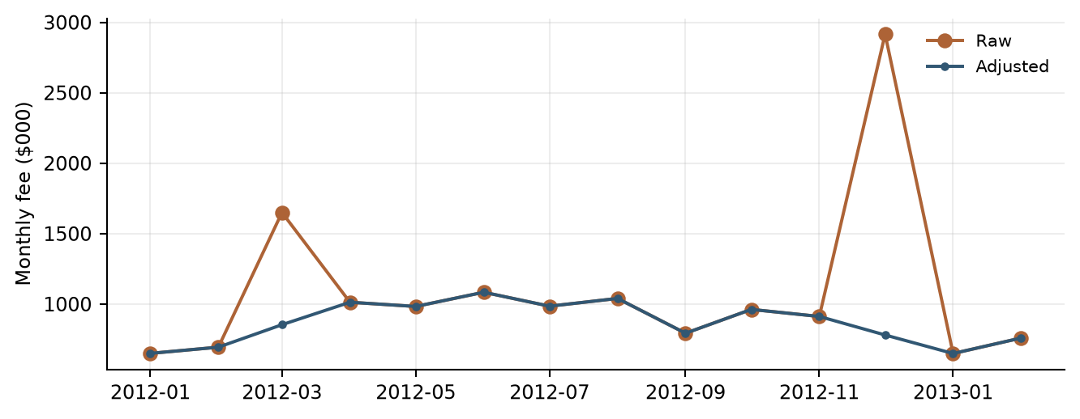
Data sources: debit/​monthly_​revenue.csv; debit/​debit_​card_​model.py.
The adjustment table places each affected raw Debit observation beside its replacement value. These entries provide a direct reconciliation of the documented adjacent-month averaging treatment.
Table 4.19 Debit Adjusted Observations
Month | Raw fee ($000) | Adjusted fee ($000) | Treatment
2012-03-01 | 1,650.00 | 853.50 | Mean of adjacent raw months
2012-12-01 | 2,916.00 | 780.50 | Mean of adjacent raw months
Data sources: debit/​monthly_​revenue.csv; debit/​debit_​card_​model.py, prepare_​revenue function.

4.3.8 Data Relevance and Assumptions
The target directly measures the fee revenue being forecast. Historical coverage provides observations across different operating environments. Data preparation assumes consistent fee definitions, component mappings and reporting units over time. Source-system lineage, accounting reconciliation and data-vintage records support ongoing data governance.
Pricing actions, product changes and shifts in customer behavior are reviewed alongside aggregate fee history. Periodic review considers the continuing relevance of the input definitions, selected transformations and calibration periods.

4.3.9 Development Data Conclusions
The Debit Card development data provide a consistent foundation for the documented model methodology. Source files, derived features and calculation rules preserve traceability and support estimation, testing and forecasting. Ongoing review of data quality and business developments maintains the relevance of this foundation.

5. Linkages with Other Models

6. Model Testing

6.1 Commercial Card and Small Business Model Testing

6.1.1 Testing Philosophy
Model testing was designed to evaluate statistical validity, model stability, forecasting performance, economic reasonableness, and regulatory suitability. Testing was not limited to traditional goodness-of-fit measures. Instead, the framework emphasized whether the model remained interpretable, stable, and useful under changing business and economic conditions. All testing results were reviewed collectively because no individual metric is sufficient to determine model suitability.

6.1.2 In Sample Performance Assessment
The selected equation achieved an adjusted R-squared of 0.7357 [commercial/​short_​run_​diagnostics.csv/​row 2 col 3]. In-sample assessment reviews both the transformed target and reconstructed fee-revenue levels. The fitted-versus-actual comparison shows how the estimated equation represents observed monthly behavior, while the fit statistics summarize explanatory power on the estimation scale.
Table 6.1 Commercial Card and Small Business In Sample Performance Metrics
Metric | Value
Number of observations | 135 [commercial/​short_​run_​diagnostics.csv/​row 2 col 1]
R-squared | 0.7435 [commercial/​short_​run_​diagnostics.csv/​row 2 col 2]
Adjusted R-squared | 0.7357 [commercial/​short_​run_​diagnostics.csv/​row 2 col 3]
Fee-level RMSE ($000) | 105.88 [commercial/​forecast_​accuracy.csv/​row 2 col 3]
Fee-level MAPE (%) | 5.39 [commercial/​forecast_​accuracy.csv/​row 2 col 5]
AIC | 929.50 [commercial/​short_​run_​diagnostics.csv/​row 2 col 4]
Data sources: commercial/​short_​run_​diagnostics.csv; commercial/​forecast_​accuracy.csv.
The fitted fee levels follow the broad historical rise and many of the month-to-month movements in Commercial and Small Business revenue. The separation between the lines highlights individual months with larger estimation errors.
Figure 6.1 Commercial Card and Small Business Actual and Fitted Values
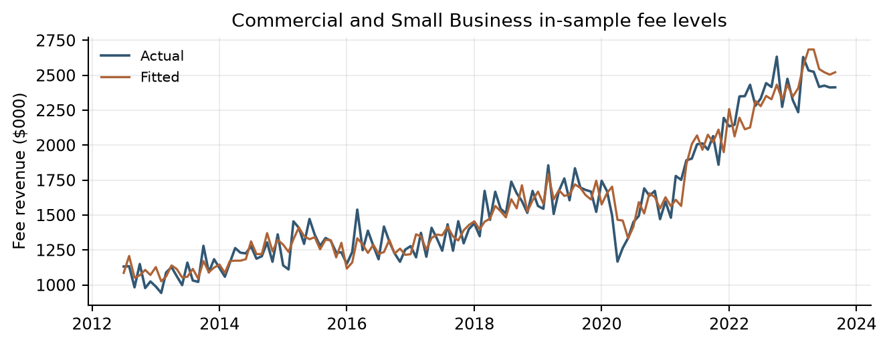
Data sources: commercial/​static_​in_​sample.csv. Fee amounts are in $000.

6.1.3 Coefficient Significance Testing
Final coefficients were evaluated for statistical significance and economic plausibility. The retained terms have statistically significant Student-t p-values at the conventional five-percent level. Coefficient signs are interpreted in the context of the target transformation, selected lag and other variables in the equation.
The negative adjusted-EC coefficient captures the subsequent growth response to a prior deviation from the long-run reference. The positive own-growth terms represent persistence, while the positive Corporate Profits term links business profitability to fee growth.
Table 6.2 Commercial Card and Small Business Coefficient Estimates and Inference
Term | Estimate | Std error | t statistic | p value
Intercept | 1.78314 | 0.85356 | 2.089 [commercial/​short_​run_​coefficients.csv/​row 2 col 5] | 0.039 [commercial/​short_​run_​coefficients.csv/​row 2 col 6]
Adjusted EC, lag 12 | -0.65352 | 0.08291 | -7.883 [commercial/​short_​run_​coefficients.csv/​row 3 col 5] | <0.001 [commercial/​short_​run_​coefficients.csv/​row 3 col 6]
Fee YoY growth, lag 1 | 0.29638 | 0.06672 | 4.442 [commercial/​short_​run_​coefficients.csv/​row 4 col 5] | <0.001 [commercial/​short_​run_​coefficients.csv/​row 4 col 6]
Fee YoY growth, lag 6 | 0.25019 | 0.05008 | 4.996 [commercial/​short_​run_​coefficients.csv/​row 5 col 5] | <0.001 [commercial/​short_​run_​coefficients.csv/​row 5 col 6]
Profits YoY growth, lag 2 | 0.42202 | 0.09115 | 4.630 [commercial/​short_​run_​coefficients.csv/​row 6 col 5] | <0.001 [commercial/​short_​run_​coefficients.csv/​row 6 col 6]
Data sources: commercial/​short_​run_​coefficients.csv.

6.1.4 Multicollinearity Assessment
Variance Inflation Factors were evaluated to determine whether explanatory variables contained excessive shared information. The maximum nonconstant VIF is 2.2501 [commercial/​short_​run_​diagnostics.csv/​row 2 col 11], below the implemented threshold of 10. The results indicate that multicollinearity is limited within the selected specification.
Table 6.3 Commercial Card and Small Business Variance Inflation Factors
Variable | VIF
ec_​scaled_​adjusted_​pct_​lag_​12m | 1.2343 [commercial/​short_​run_​coefficients.csv/​row 3 col 7]
commercial_​small_​business_​fee_​pct_​change_​12m_​lag_​1m | 2.2501 [commercial/​short_​run_​coefficients.csv/​row 4 col 7]
commercial_​small_​business_​fee_​pct_​change_​12m_​lag_​6m | 1.2914 [commercial/​short_​run_​coefficients.csv/​row 5 col 7]
corporate_​profits_​pct_​change_​12m_​lag_​2m | 2.1560 [commercial/​short_​run_​coefficients.csv/​row 6 col 7]
Data sources: commercial/​short_​run_​coefficients.csv.

6.1.5 Residual Diagnostics and Statistical Assumptions
Residual diagnostics evaluate distributional shape, serial correlation and overall equation adequacy. The Durbin-Watson statistic is 2.0321 [commercial/​short_​run_​diagnostics.csv/​row 2 col 5]. The Jarque-Bera p-value is 0.7573 [commercial/​short_​run_​diagnostics.csv/​row 2 col 7], above the five-percent reference level. The residual time series, fitted-value comparison and normal-reference plot complement these numerical results.
The lag-12 Ljung-Box test has a p-value of 0.3180 [commercial/​short_​run_​diagnostics.csv/​row 2 col 9], providing additional support for the residual serial-correlation assessment. Transformed macroeconomic candidates were also assessed using the ADF and KPSS screens described in Section 3.
Table 6.4 Commercial Card and Small Business Residual Diagnostic Statistics
Diagnostic Statistic | Value
Durbin-Watson | 2.0321 [commercial/​short_​run_​diagnostics.csv/​row 2 col 5]
Jarque-Bera statistic | 0.5559 [commercial/​short_​run_​diagnostics.csv/​row 2 col 6]
Jarque-Bera p-value | 0.7573 [commercial/​short_​run_​diagnostics.csv/​row 2 col 7]
Ljung-Box lag 12 statistic | 13.7341 [commercial/​short_​run_​diagnostics.csv/​row 2 col 8]
Ljung-Box lag 12 p-value | 0.3180 [commercial/​short_​run_​diagnostics.csv/​row 2 col 9]
Data sources: commercial/​short_​run_​diagnostics.csv.
The upper panel shows residual fluctuations around zero over time. In the lower panel, residuals lie on both sides of zero without a pronounced curved pattern or clear funnel-shaped dispersion, providing visual support for the selected functional form.
Figure 6.2 Commercial Card and Small Business Residual Diagnostics
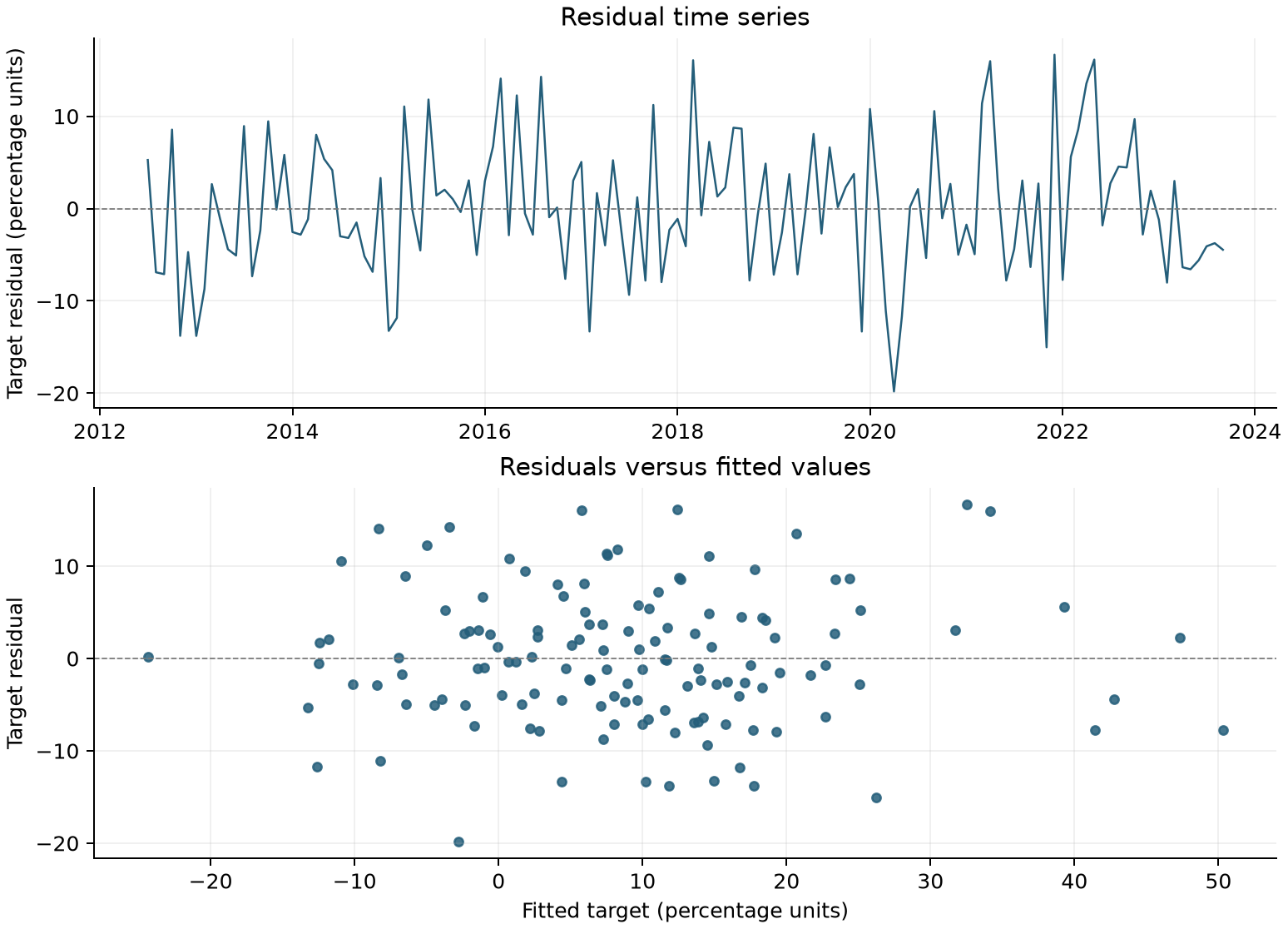
Data sources: commercial/​short_​run_​estimation_​sample.csv.
The standardized Commercial residual quantiles broadly follow the normal-reference line, with smaller departures near the tails. This visual pattern is consistent with the accompanying Jarque-Bera assessment.
Figure 6.3 Commercial Card and Small Business Normal Reference Plot
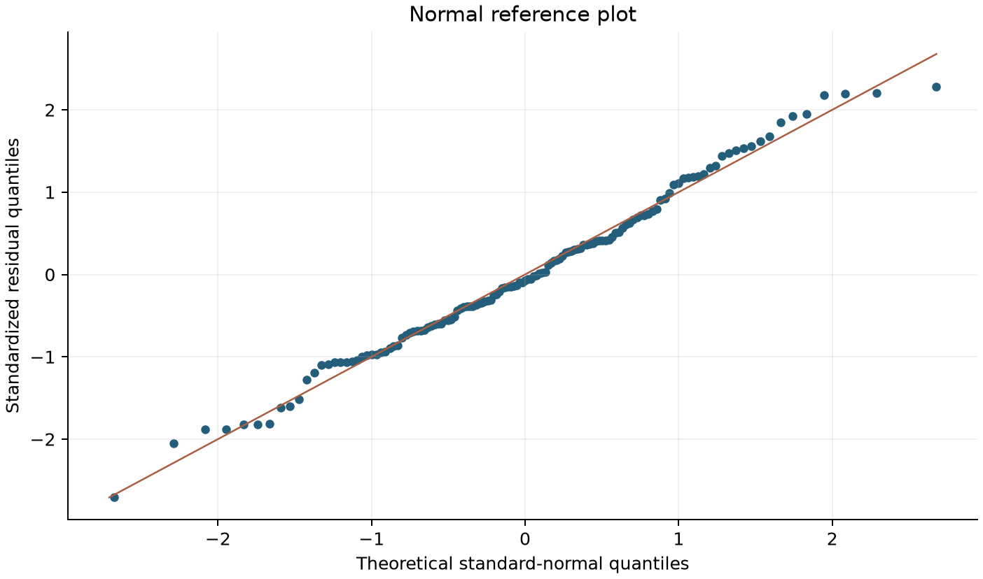
Data sources: commercial/​short_​run_​estimation_​sample.csv. Exported target residuals standardized using the sample mean and standard deviation; midpoint normal plotting positions.

6.1.6 Stability Testing
Stability assessment considers forecast-error behavior under fixed development coefficients and the response of recursive projections to changing macroeconomic inputs. Static and Full Recursive OOT exercises use the same fitted equation. Full Recursive OOT updates fee levels, own-growth lags and adjusted EC states throughout the evaluation period, while scenario and sensitivity tests evaluate model behavior under alternative future paths. These exercises preserve a common coefficient basis for comparison.

6.1.7 Out of Time Testing Framework and Results
Out-of-time testing uses October 2023 through December 2025 to assess forecast performance beyond the coefficient-development period. Results are compared with realized fee revenue on the original $000 scale. Static and recursive exercises are reported separately so that the role of forecast-state updating is explicit.
Short-run macroeconomic candidates were pre-screened for partial-correlation significance and sign consistency across the development and OOT periods. Subsequent variable selection and coefficient estimation used development-period observations.
Full Recursive OOT initializes fee levels, annual fee growth and adjusted EC using actual history through September 2023. From October 2023 onward, predicted growth is applied to the fee level from 12 months earlier, using the forecast value whenever that anchor falls within OOT. Predicted fees are then used to recalculate scaled EC and adjusted EC; subsequent own-growth lags and the 12-month adjusted-EC lag use these recursively generated states. Realized OOT fee values are used to evaluate forecast accuracy, not to reset these endogenous states. The exercise retains fixed development coefficients, historical macroeconomic paths and the calibrated OOT EC trend adjustment. Month-level results and lag inputs are exported in fully_​recursive_​oot.csv.
This table compares fee-level forecast errors under static and Full Recursive OOT evaluation. The comparison quantifies the difference between using observed lagged states and allowing predicted fee and error-correction states to evolve throughout the test.
Table 6.5 Commercial Card and Small Business OOT Forecast Accuracy
Method | MAPE (%) | RMSE ($000)
Static OOT | 8.76 [commercial/​forecast_​accuracy.csv/​row 3 col 5] | 231.43 [commercial/​forecast_​accuracy.csv/​row 3 col 3]
Full Recursive OOT | 16.95 [commercial/​forecast_​accuracy.csv/​row 4 col 5] | 399.13 [commercial/​forecast_​accuracy.csv/​row 4 col 3]
Data sources: commercial/​forecast_​accuracy.csv.
The figure places actual Commercial fees beside the static and Full Recursive OOT paths. The separation between the forecast lines shows how their different state-updating procedures affect the projected revenue path over time.
Figure 6.4 Commercial Card and Small Business OOT Forecast Results
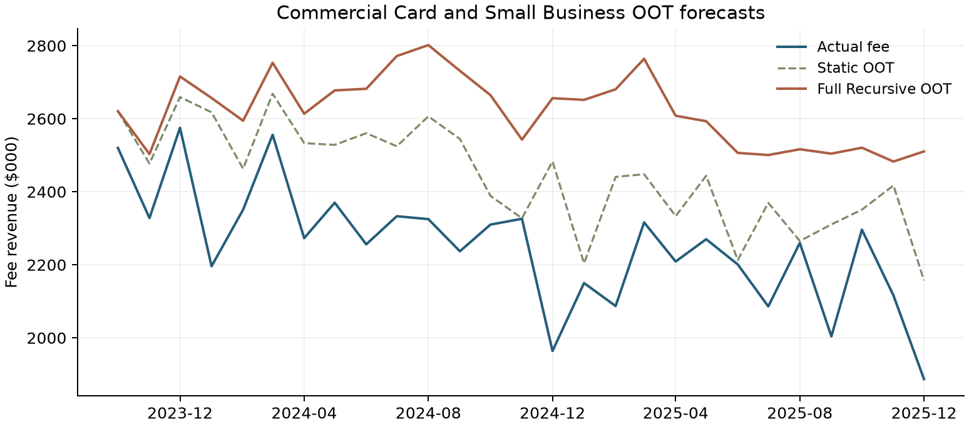
Data sources: commercial/​static_​oot.csv; commercial/​fully_​recursive_​oot.csv. Full Recursive OOT updates fee levels, own-growth lags and adjusted EC states. Fee amounts are in $000.
Figure 6.4A Commercial Card and Small Business OOT Forecasts With and Without Overlay
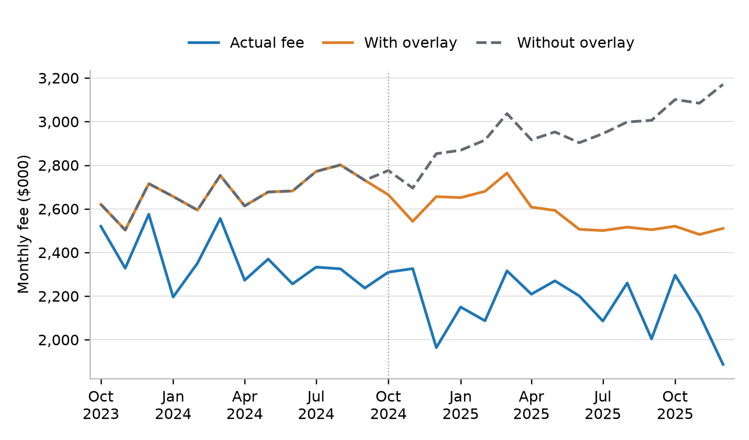
Figure 6.4A shows actual fee revenue and Full Recursive OOT forecasts with and without the overlay. Both forecasts use the same model coefficients, macroeconomic inputs and starting history. In this comparison, the overlay lowers forecasts and brings them closer to actual revenue. The paths begin to differ in October 2024 because the adjusted error-correction term enters the model with a 12-month lag.
Data source: commercial/​fully_​recursive_​oot_​overlay_​comparison.csv, rows 2-28, columns 1-4. Row 1 contains column headers. Fee amounts are in $000.
The signed-error plot shows the timing and magnitude of forecast deviations for both Commercial OOT methods. Values above the zero line indicate forecasts above actual fees, while the distance from zero measures the relative error.
Figure 6.5 Commercial Card and Small Business OOT Prediction Errors
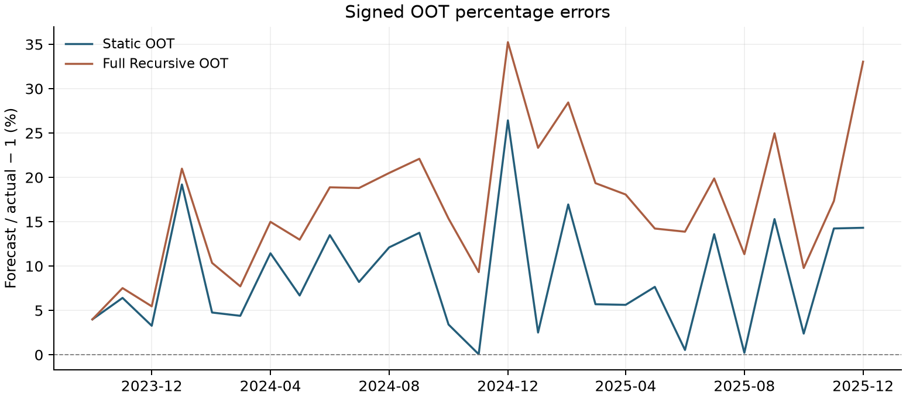
Data sources: commercial/​static_​oot.csv; commercial/​fully_​recursive_​oot.csv. Signed percentage error = 100 × (predicted fee /​ actual fee − 1).

6.1.8 Root Cause Assessment
Root-cause review evaluates forecast deviations alongside fee history, model inputs, lagged states and relevant business developments. Review considers pricing, customer mix, product and service changes, and the timing of economic drivers. Static and recursive results help identify how forecast-state updates affect the observed error pattern.
Commercial's EC trend summarizes the persistent difference between observed fees and the long-run reference during the calibration period. The implemented overlay incorporates that pattern into the adjusted EC state used by the short-run model. The business rationale and approval record for the overlay will be documented through the governance process.

6.1.9 Overlay Support Analysis
The Commercial OOT trend has 27 observations, R-squared 0.7315 [commercial/​overlay_​trend.csv/​row 2 col 4] and slope p approximately 1.32×10⁻⁸ [commercial/​overlay_​trend.csv/​row 2 col 3]. Its held value is -30.1428 on the scaled EC percentage scale. Because the adjustment is subtracted before a lagged EC term enters the short-run equation, its effect is not equivalent to multiplying every forecast by a fixed revenue factor.
The observed scaled EC series and fitted trend both move downward during the calibration period. The horizontal extension shows the terminal trend value held constant as the future EC adjustment.
Figure 6.6 Commercial Overlay Calibration
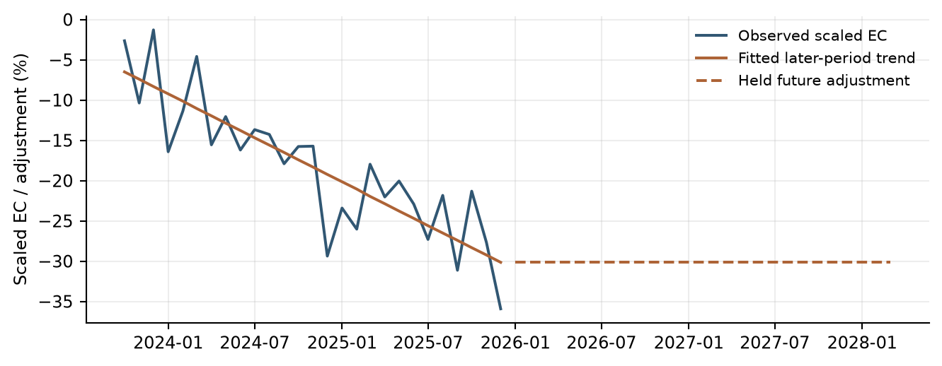
Data sources: commercial/​historical_​data_​and_​features.csv; commercial/​forecast_​monthly.csv.
The parameter table records the calibration window, fitted trend and held future EC adjustment. These values define the adjustment applied within the error-correction calculation rather than a direct revenue multiplier.
Table 6.6 Commercial Overlay Parameters
Item | Value
Calibration period | Oct 2023–Dec 2025
Intercept | -5.592975
Slope per month | -0.909254 percentage points
Held future state adjustment | -30.142832 percentage points
Future treatment | Constant; no continued linear extrapolation
Data sources: commercial/​overlay_​trend.csv; commercial/​commercial_​card_​model.py.

6.1.10 Scenario Testing and Reasonableness Assessment
Scenario testing evaluates forecast direction, magnitude and persistence through March 2028. Baseline and S4 runs share the same historical fee anchor, transformations and model structure. Monthly forecast revenue is also aggregated into calendar quarters for planning review.
Commercial scenarios vary CPI and Corporate Profits while retaining development coefficients and the held EC trend adjustment. The long-run reference, growth transformations and future fee and EC states are recalculated along each scenario path.
The input panels compare the CPI and Corporate Profits paths supplied to the Commercial scenario runs. S4 shows weaker Corporate Profits and a lower CPI level later in the horizon, which enter the short-run growth and long-run reference mechanisms respectively.
Figure 6.7 Commercial Card and Small Business Scenario Inputs
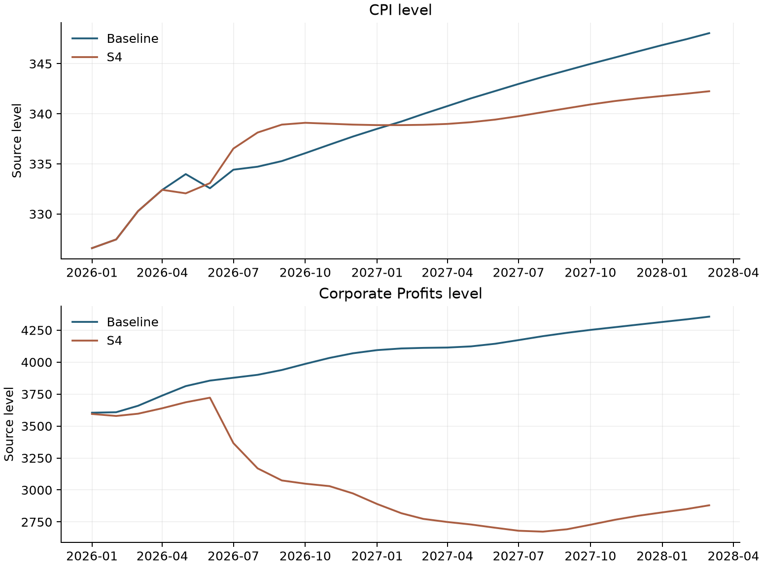
Data sources: commercial/​data/​macro_​baseline.csv; commercial/​data/​macro_​s4.csv. Original source units.
The Commercial scenario paths begin close together and separate as the macroeconomic differences pass through the model’s lagged dynamics. S4 revenue remains below Baseline later in the projection, with some recovery toward the end.
Figure 6.8 Commercial Card and Small Business Baseline and S4 Forecast Paths
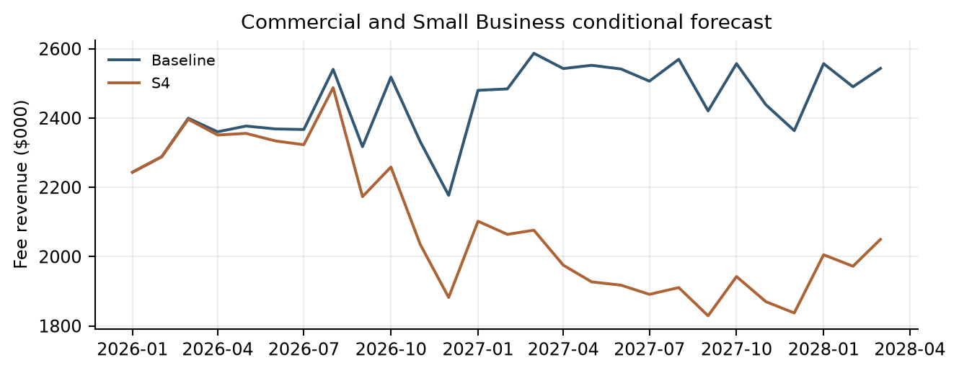
Data sources: commercial/​forecast_​monthly.csv. Fee revenue in $000.
The totals translate the monthly Commercial scenario paths into planning-period revenue comparisons. The larger relative shortfall over the full horizon than in the first year reflects the later separation of the scenario paths.
Table 6.7 Commercial Card and Small Business Scenario Revenue Totals
Period | Baseline ($000) | S4 ($000) | S4 vs Base
2026 total | 28,288.73 | 27,128.81 | -4.10%
9-quarter total | 65,923.13 | 56,499.62 | -14.29%
Data sources: commercial/​forecast_​quarterly_​summary.csv.

6.1.11 Model Development Progression
The Commercial short-run model was developed in stages. Adjusted EC was retained throughout to connect short-run fee growth with the CPI-based long-run model. The first selected specification included fee growth from one month earlier. A six-month lag of fee growth was then added. Finally, Corporate Profits growth from two months earlier was included to capture broader business conditions. These steps produced the final short-run model.
Table 6.8 Commercial Short-Run Model Development Progression
Model Stage | Variables Included | Adjusted R²
Initial Model | Adjusted EC, lag 12 + fee YoY growth, lag 1 | 65.83% [commercial/​short_​run_​rounds.csv/​row 2 col 3]
Enhanced Model | Adjusted EC, lag 12 + fee YoY growth, lags 1 and 6 | 69.44% [commercial/​short_​run_​rounds.csv/​row 3 col 3]
Final Model | Adjusted EC, lag 12 + fee YoY growth, lags 1 and 6 + Corporate Profits YoY growth, lag 2 | 73.57% [commercial/​short_​run_​rounds.csv/​row 4 col 3]
Table 6.8 shows the selected specifications at each stage of Commercial short-run model development. It lists the variables retained and the adjusted R-squared reported for each specification. All specifications include an intercept. Sample sizes follow the lag requirements at each stage.
Data sources: commercial/​short_​run_​rounds.csv; commercial/​commercial_​card_​model.py.

6.1.12 User Review and Acceptance
Model results, assumptions, forecast behavior, and testing outcomes were reviewed with Strategic Finance and relevant lines of business during model development. Review sessions focused on economic intuition, reasonableness of the selected drivers, forecast behavior under changing economic conditions, and consistency with observed business performance. Feedback from these reviews supported the conclusion that the model appropriately captures the primary drivers of Commercial Card and Small Business Fee Revenue and produces forecasts that are directionally consistent with business expectations.
Because the model has not yet been deployed into a production forecasting environment, final User Acceptance Testing (UAT) has not been completed. Prior to production implementation, final UAT will be performed to verify that the implemented model reproduces approved development results, correctly incorporates required inputs, generates expected outputs, and operates in accordance with documented procedures and governance requirements.

6.1.13 Sensitivity Analysis
Commercial’s default sensitivity grid changes one driver at a time around Baseline. It calibrates sigma from in-sample YoY growth over January 2012–September 2023, using 141 observations and sample SD. CPI sigma is 2.17458 and Profits sigma is 10.45377 percentage points. The grid uses -2, -1, +1 and +2 sigma. CPI applies that scale as a relative level shift for all future months, whereas Corporate Profits adds it to YoY growth and reconstructs levels from historical or shocked year-ago anchors. These are different shock definitions and should not be described as the same percentage growth shock.
The Commercial sensitivity exercise holds coefficients, historical observations, other inputs and the overlay constant, allowing each driver’s effect to be isolated. Timing follows the selected lags: CPI first changes predicted fees in January 2027 through the 12-month EC lag, while Corporate Profits first affects March 2026 fees through its two-month lag. A zero CPI fee effect during 2026 therefore reflects delayed transmission, not the absence of a CPI relationship.
Table 6.9 Commercial One Driver Sensitivities
Driver | Sigma | Shock size | Year impact | Horizon impact | Terminal impact
CPI level | -2 | -4.35% | 0.00% | -4.79% | -11.88%
CPI level | -1 | -2.17% | 0.00% | -2.30% | -5.86%
CPI level | +1 | 2.17% | 0.00% | 2.14% | 5.70%
CPI level | +2 | 4.35% | 0.00% | 4.12% | 11.23%
Profits YoY | -2 | -20.91 pp | -10.20% | -15.54% | -21.50%
Profits YoY | -1 | -10.45 pp | -5.10% | -7.90% | -11.00%
Profits YoY | +1 | 10.45 pp | 5.10% | 8.14% | 11.42%
Profits YoY | +2 | 20.91 pp | 10.20% | 16.53% | 23.18%
Year impact measures the percentage change in total forecast revenue for 2026 compared with Baseline. Horizon impact measures the percentage change in total forecast revenue from January 2026 through March 2028. Terminal impact measures the percentage change in forecast revenue for March 2028 alone. All three measures compare the shocked forecast with Baseline over the same period.
Data sources: commercial/​stress_​summary.csv.
The bars summarize total-horizon revenue effects from the specified one-driver shocks. Positive shocks increase revenue and negative shocks reduce it; under these calibrated shock definitions, Corporate Profits produces larger total-horizon movements than CPI.
Figure 6.9 Commercial Sensitivity Impacts
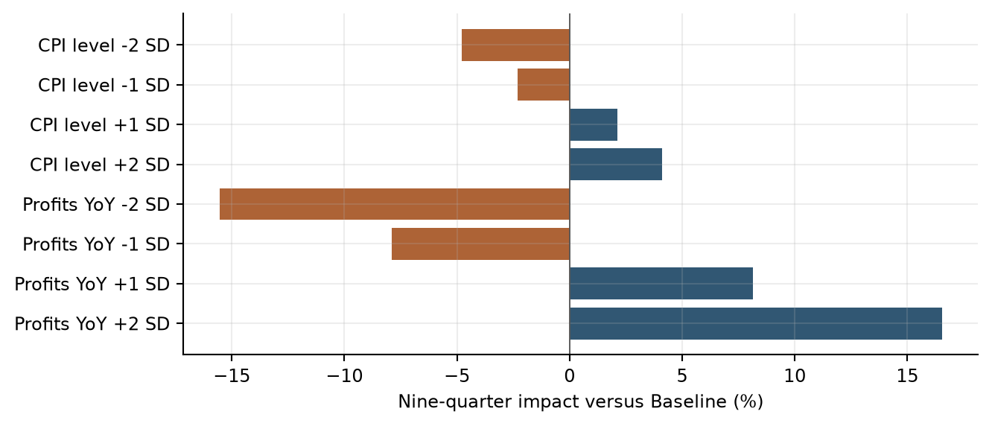
Data sources: commercial/​stress_​summary.csv. Change in summed forecast-period revenue versus Baseline.

6.1.14 Testing Conclusions
The testing results support the selected Commercial Card and Small Business long-run and short-run framework. Coefficient inference, multicollinearity and residual diagnostics provide statistical support, while OOT, scenario and sensitivity exercises show how the equation behaves across evaluation conditions. The EC adjustment is documented as a distinct calibration component. Together, these results provide the basis for planning forecasts, stress testing and ongoing performance monitoring.

6.2 Consumer Card Model Testing

6.2.1 Testing Philosophy
Model testing was designed to evaluate statistical validity, model stability, forecasting performance, economic reasonableness, and regulatory suitability. Testing was not limited to traditional goodness-of-fit measures. Instead, the framework emphasized whether the model remained interpretable, stable, and useful under changing business and economic conditions. All testing results were reviewed collectively because no individual metric is sufficient to determine model suitability.

6.2.2 In Sample Performance Assessment
The selected equation achieved an adjusted R-squared of 0.6114 [consumer/​model_​diagnostics.csv/​row 3 col 6]. In-sample assessment reviews both the transformed target and reconstructed fee-revenue levels. The fitted-versus-actual comparison shows how the estimated equation represents observed monthly behavior, while the fit statistics summarize explanatory power on the estimation scale.
Table 6.10 Consumer Card In Sample Performance Metrics
Metric | Value
Number of observations | 150 [consumer/​model_​diagnostics.csv/​row 3 col 2]
R-squared | 0.6244 [consumer/​model_​diagnostics.csv/​row 3 col 5]
Adjusted R-squared | 0.6114 [consumer/​model_​diagnostics.csv/​row 3 col 6]
Fee-level RMSE ($000) | 55.77 [consumer/​forecast_​accuracy.csv/​row 2 col 4]
Fee-level MAPE (%) | 6.66 [consumer/​forecast_​accuracy.csv/​row 2 col 3]
Data sources: consumer/​model_​diagnostics.csv; consumer/​forecast_​accuracy.csv.
The fitted Consumer fee series follows the broad historical decline and subsequent recovery, together with recurring monthly peaks and troughs. The remaining gaps identify individual observations not fully represented by the fitted equation.
Figure 6.10 Consumer Card Actual and Fitted Values
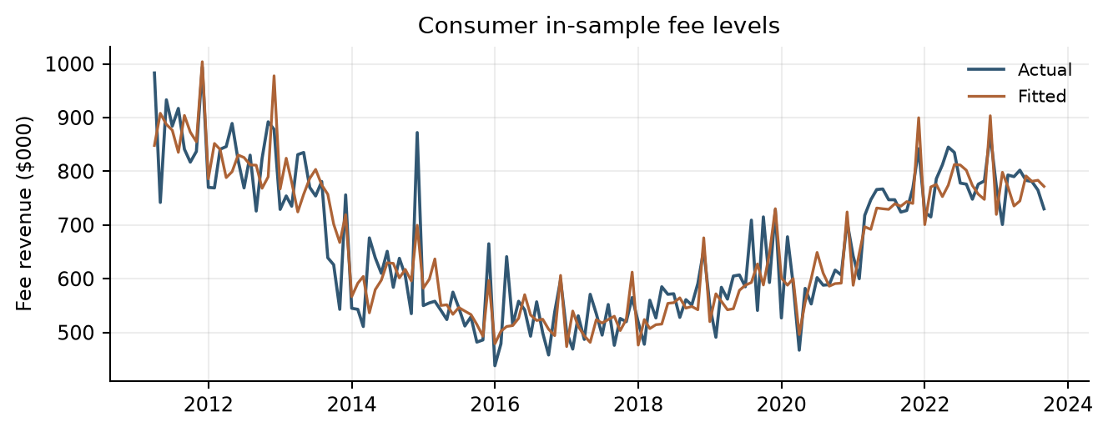
Data sources: consumer/​static_​in_​sample.csv. Fee amounts are in $000.

6.2.3 Coefficient Significance Testing
Final coefficients were evaluated for statistical significance and economic plausibility. The retained terms have statistically significant Student-t p-values at the conventional five-percent level. Coefficient signs are interpreted in the context of the target transformation, selected lag and other variables in the equation.
Negative own-growth lag coefficients capture short-run adjustment. The January and December indicators represent recurring calendar behavior, and the positive Retail Sales coefficient links stronger spending growth with fee log growth. Development and production estimates retain the same selected structure.
Table 6.11 Consumer Card Coefficient Estimates and Inference
Term | Estimate | Std error | t statistic | p value
Intercept | -1.98312 | 0.82447 | -2.405 [consumer/​coefficients.csv/​row 7 col 4] | 0.017 [consumer/​coefficients.csv/​row 7 col 6]
Fee log growth, lag 1 | -0.62166 | 0.06568 | -9.464 [consumer/​coefficients.csv/​row 8 col 4] | <0.001 [consumer/​coefficients.csv/​row 8 col 6]
Fee log growth, lag 2 | -0.33883 | 0.06070 | -5.583 [consumer/​coefficients.csv/​row 9 col 4] | <0.001 [consumer/​coefficients.csv/​row 9 col 6]
January indicator | -11.15312 | 2.87904 | -3.874 [consumer/​coefficients.csv/​row 10 col 4] | <0.001 [consumer/​coefficients.csv/​row 10 col 6]
December indicator | 19.65826 | 2.59864 | 7.565 [consumer/​coefficients.csv/​row 11 col 4] | <0.001 [consumer/​coefficients.csv/​row 11 col 6]
Retail Sales MoM growth, MA3 | 2.57529 | 0.63128 | 4.079 [consumer/​coefficients.csv/​row 12 col 4] | <0.001 [consumer/​coefficients.csv/​row 12 col 6]
Data sources: consumer/​coefficients.csv, Selected In-sample rows.

6.2.4 Multicollinearity Assessment
Variance Inflation Factors were evaluated to determine whether explanatory variables contained excessive shared information. The maximum nonconstant VIF is 1.7005 [consumer/​model_​diagnostics.csv/​row 3 col 12], below the implemented threshold of 10. The results indicate that multicollinearity is limited within the selected specification.
Table 6.12 Consumer Card Variance Inflation Factors
Variable | VIF
consumer_​card_​fee_​log_​change_​1m_​pct_​lag_​1m | 1.7005 [consumer/​coefficients.csv/​row 8 col 7]
consumer_​card_​fee_​log_​change_​1m_​pct_​lag_​2m | 1.4523 [consumer/​coefficients.csv/​row 9 col 7]
is_​january | 1.2492 [consumer/​coefficients.csv/​row 10 col 7]
is_​december | 1.0177 [consumer/​coefficients.csv/​row 11 col 7]
retail_​sales_​pct_​change_​1m_​ma_​3m | 1.0115 [consumer/​coefficients.csv/​row 12 col 7]
Data sources: consumer/​coefficients.csv.

6.2.5 Residual Diagnostics and Statistical Assumptions
Residual diagnostics evaluate distributional shape, serial correlation and overall equation adequacy. The Durbin-Watson statistic is 2.3555 [consumer/​model_​diagnostics.csv/​row 3 col 7]. The Jarque-Bera p-value is 0.5320 [consumer/​model_​diagnostics.csv/​row 3 col 9], above the five-percent reference level. The residual time series, fitted-value comparison and normal-reference plot complement these numerical results.
The selected development specification satisfies the implemented Durbin-Watson, Jarque-Bera and VIF selection criteria. Diagnostics are reviewed together with coefficient stability and forecast results to assess continued model suitability.
Table 6.13 Consumer Card Residual Diagnostic Statistics
Diagnostic Statistic | Value
Durbin-Watson | 2.3555 [consumer/​model_​diagnostics.csv/​row 3 col 7]
Jarque-Bera statistic | 1.2621 [consumer/​model_​diagnostics.csv/​row 3 col 8]
Jarque-Bera p-value | 0.5320 [consumer/​model_​diagnostics.csv/​row 3 col 9]
Residual skewness | 0.2103 [consumer/​model_​diagnostics.csv/​row 3 col 10]
Residual kurtosis | 3.1583 [consumer/​model_​diagnostics.csv/​row 3 col 11]
Data sources: consumer/​model_​diagnostics.csv.
The Consumer residual time series fluctuates on both sides of zero, with occasional larger deviations. The fitted-value scatter does not display a pronounced curved pattern or clear funnel-shaped dispersion across the main concentration of observations.
Figure 6.11 Consumer Card Residual Diagnostics
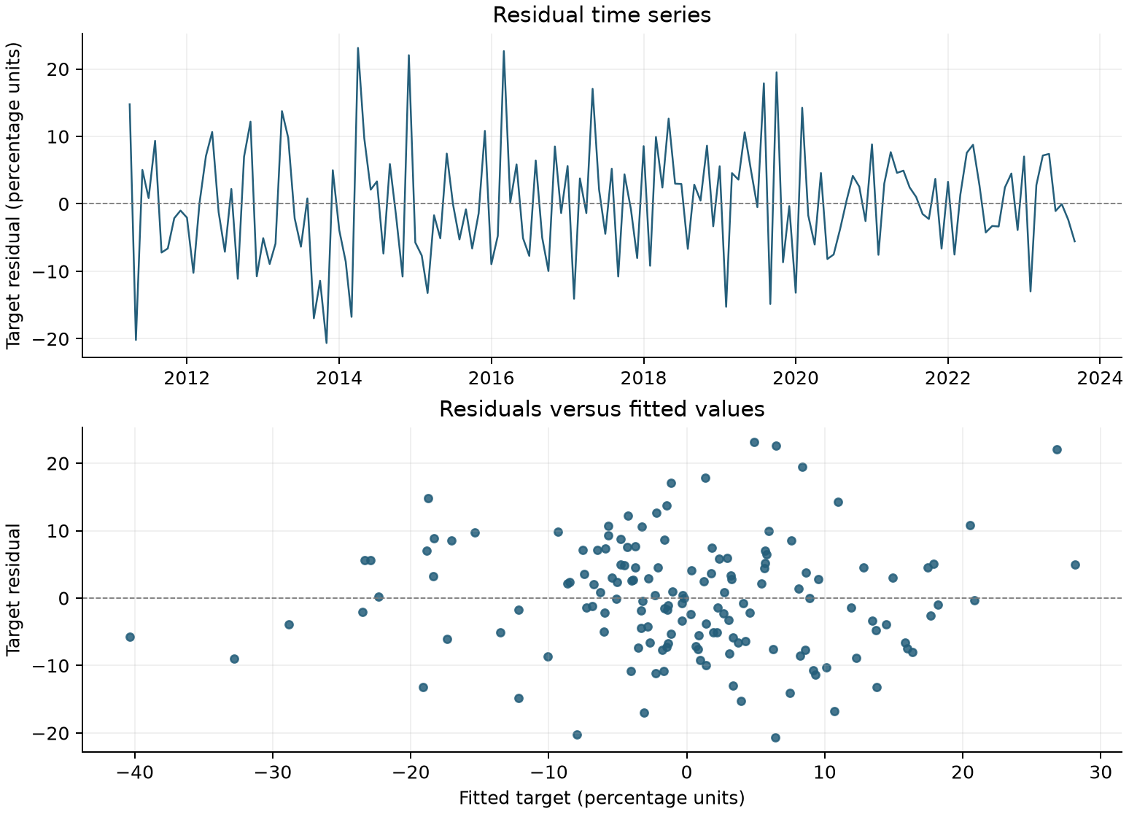
Data sources: consumer/​static_​in_​sample.csv.
The Consumer residual quantiles closely follow the normal-reference line through the center of the distribution, with some upper-tail departures. This provides a visual complement to the reported residual-shape statistics.
Figure 6.12 Consumer Card Normal Reference Plot
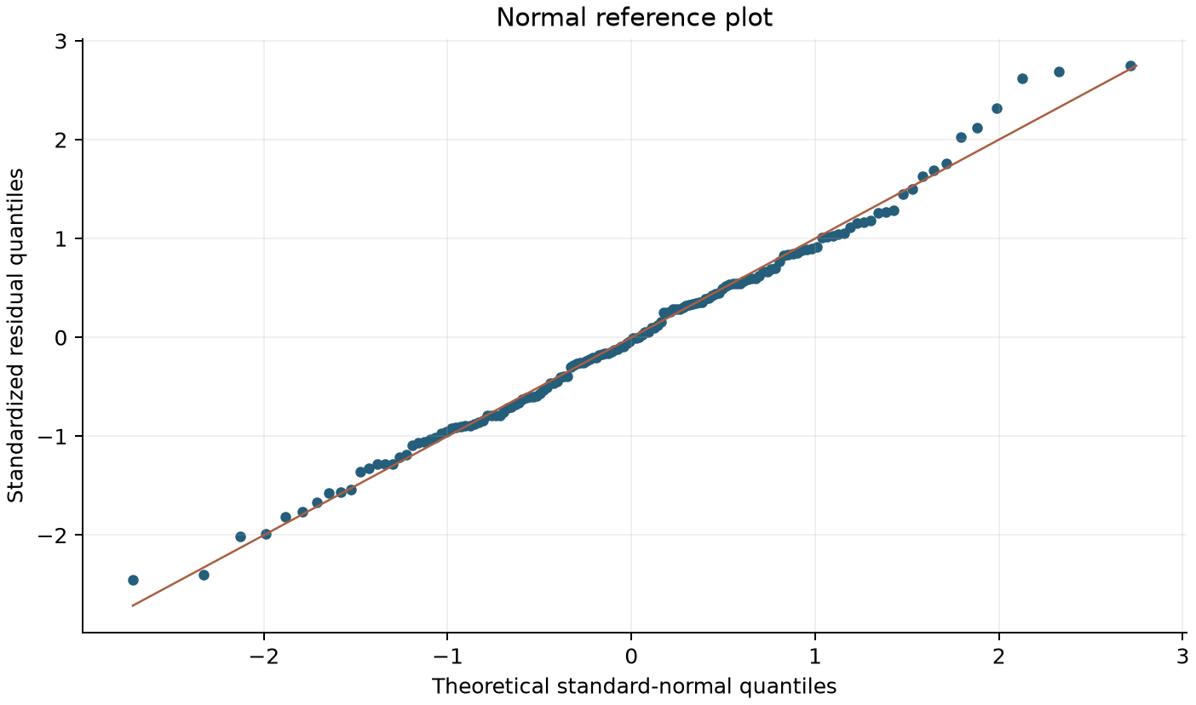
Data sources: consumer/​static_​in_​sample.csv. Exported target residuals standardized using the sample mean and standard deviation; midpoint normal plotting positions.

6.2.6 Stability Testing
Consumer runs 118 overlapping 60-observation windows. Both own-growth lag coefficients and January remain negative; December and Retail Sales MA3 remain positive in every window.
Table 6.14 Consumer Rolling Coefficient Ranges
Term | Minimum | Maximum | Sign changes
Fee log growth, lag 1 | -0.8737 [consumer/​rolling_​summary.csv/​row 2 col 3] | -0.1945 [consumer/​rolling_​summary.csv/​row 2 col 4] | 0 [consumer/​rolling_​summary.csv/​row 2 col 7]
Fee log growth, lag 2 | -0.4866 [consumer/​rolling_​summary.csv/​row 3 col 3] | -0.2739 [consumer/​rolling_​summary.csv/​row 3 col 4] | 0 [consumer/​rolling_​summary.csv/​row 3 col 7]
January indicator | -19.0167 [consumer/​rolling_​summary.csv/​row 4 col 3] | -5.2670 [consumer/​rolling_​summary.csv/​row 4 col 4] | 0 [consumer/​rolling_​summary.csv/​row 4 col 7]
December indicator | 11.6767 [consumer/​rolling_​summary.csv/​row 5 col 3] | 26.7380 [consumer/​rolling_​summary.csv/​row 5 col 4] | 0 [consumer/​rolling_​summary.csv/​row 5 col 7]
Retail Sales MoM growth, MA3 | 1.0792 [consumer/​rolling_​summary.csv/​row 6 col 3] | 5.8778 [consumer/​rolling_​summary.csv/​row 6 col 4] | 0 [consumer/​rolling_​summary.csv/​row 6 col 7]
Data sources: consumer/​rolling_​summary.csv.
The rolling paths retain negative coefficients for the displayed fee-growth lags and a positive coefficient for Retail Sales. Their changing magnitudes show how the estimated strength of these relationships varies across successive estimation windows.
Figure 6.13 Consumer Rolling Coefficient Stability
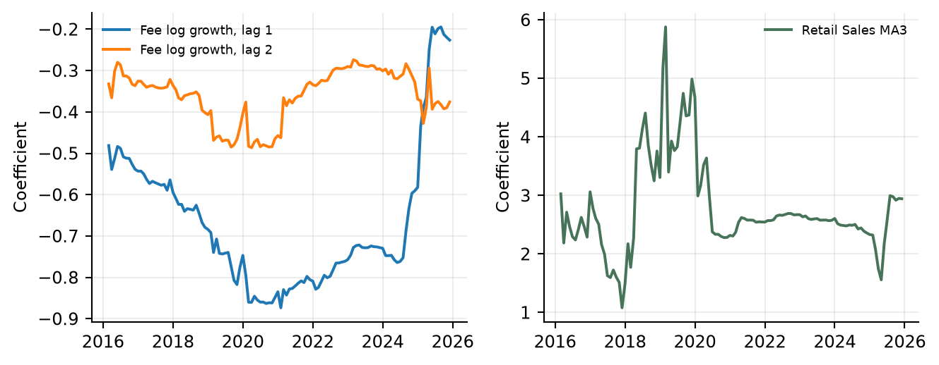
Data sources: consumer/​rolling_​coefficients.csv. Sequential 60-observation estimation windows.

6.2.7 Out of Time Testing Framework and Results
Out-of-time testing uses October 2023 through December 2025 to assess forecast performance beyond the coefficient-development period. Results are compared with realized fee revenue on the original $000 scale. Static and recursive exercises are reported separately so that the role of forecast-state updating is explicit.
The development coefficients remain fixed throughout OOT testing. Static testing uses observed prior fees and fee changes; recursive testing uses previously forecast fee states. Both exercises use historical Retail Sales inputs.
Table 6.15 Consumer Card OOT Forecast Accuracy
Method | MAPE (%) | RMSE ($000)
Static OOT | 5.05 [consumer/​forecast_​accuracy.csv/​row 3 col 3] | 45.89 [consumer/​forecast_​accuracy.csv/​row 3 col 4]
Recursive OOT | 5.96 [consumer/​forecast_​accuracy.csv/​row 4 col 3] | 53.34 [consumer/​forecast_​accuracy.csv/​row 4 col 4]
Data sources: consumer/​forecast_​accuracy.csv.
The recursive Consumer forecast reproduces the recurring year-end peaks and subsequent declines visible in actual fees. The side-by-side paths also identify periods when the projected revenue level differs from the realized level.
Figure 6.14 Consumer Card OOT Forecast Results
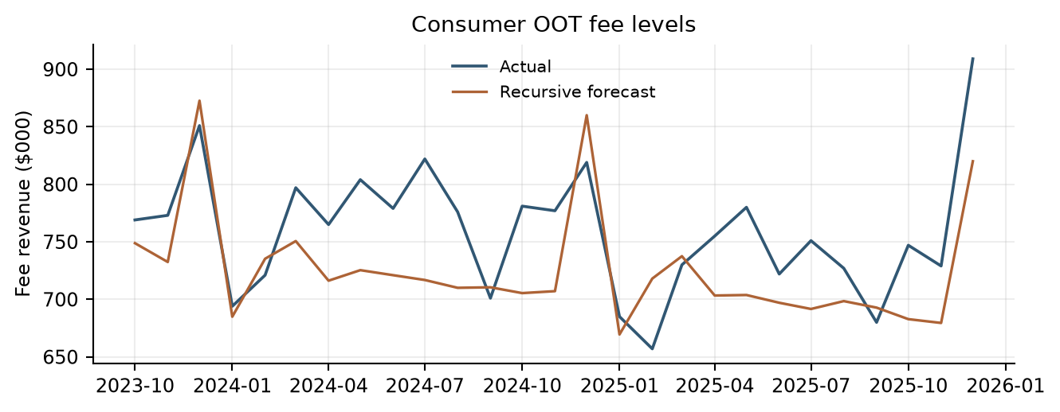
Data sources: consumer/​recursive_​oot.csv. Development coefficients; recursive fee states.
The error series show both positive and negative deviations under static and recursive Consumer testing. Comparing the two lines identifies when updating the lagged fee states with forecasts changes the direction or magnitude of the error.
Figure 6.15 Consumer Card OOT Prediction Errors
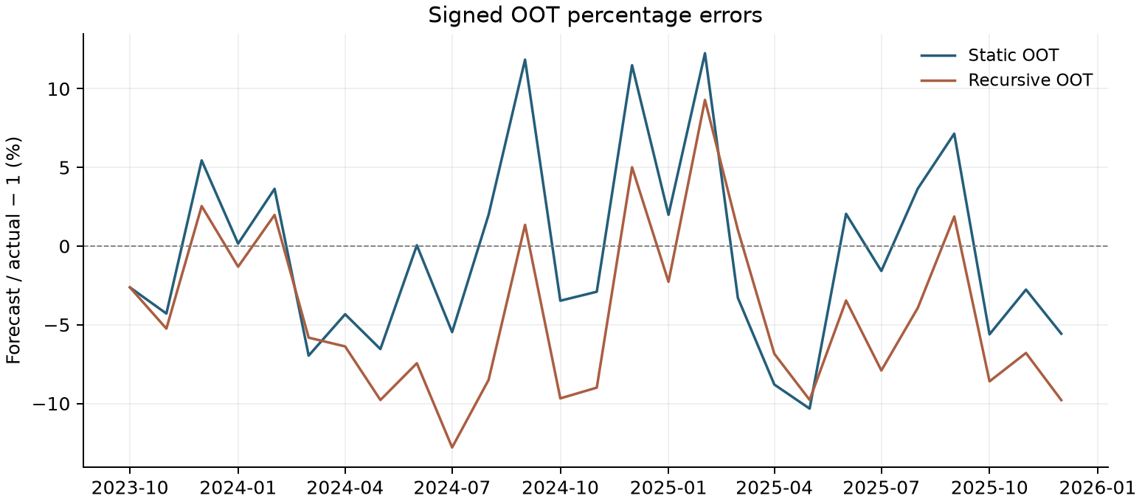
Data sources: consumer/​static_​oot.csv; consumer/​recursive_​oot.csv. Signed percentage error = 100 × (predicted fee /​ actual fee − 1).

6.2.8 Root Cause Assessment
Root-cause review evaluates forecast deviations alongside fee history, model inputs, lagged states and relevant business developments. Review considers pricing, customer mix, product and service changes, and the timing of economic drivers. Static and recursive results help identify how forecast-state updates affect the observed error pattern.
Consumer analysis focuses on calendar effects, Retail Sales dynamics and the distinction between observed and forecast prior-fee states. The selected structure is retained in the production refit, allowing updated historical information to inform subsequent scenario forecasts.

6.2.9 Overlay Support Analysis
No separate management overlay is applied to the Consumer Card forecasts in the current implementation. The January and December indicators are estimated explanatory variables, and the production refit updates model coefficients within the retained specification.

6.2.10 Scenario Testing and Reasonableness Assessment
Scenario testing evaluates forecast direction, magnitude and persistence through March 2028. Baseline and S4 runs share the same historical fee anchor, transformations and model structure. Monthly forecast revenue is also aggregated into calendar quarters for planning review.
Consumer scenarios vary Retail Sales while using the production-refit coefficients. Retail Sales monthly growth and its trailing three-month mean are recalculated, and fee revenue is projected recursively from the actual December 2025 level.
Retail Sales rises along the Baseline path, while S4 declines after its initial increase and later recovers modestly. These differing level paths generate the monthly growth and moving-average inputs used in the Consumer forecasts.
Figure 6.16 Consumer Card Scenario Inputs
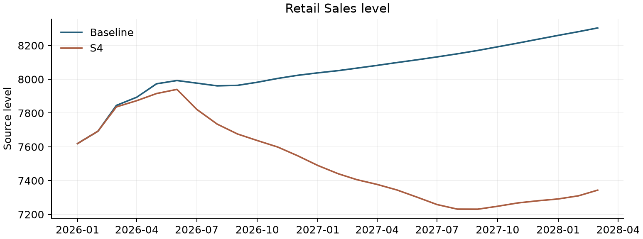
Data sources: consumer/​data/​macro_​baseline.csv; consumer/​data/​macro_​s4.csv. Original source units.
Both Consumer scenario paths retain the recurring calendar pattern implied by the model. S4 moves below Baseline as weaker Retail Sales feeds through the smoothed spending driver and recursive fee dynamics.
Figure 6.17 Consumer Card Baseline and S4 Forecast Paths
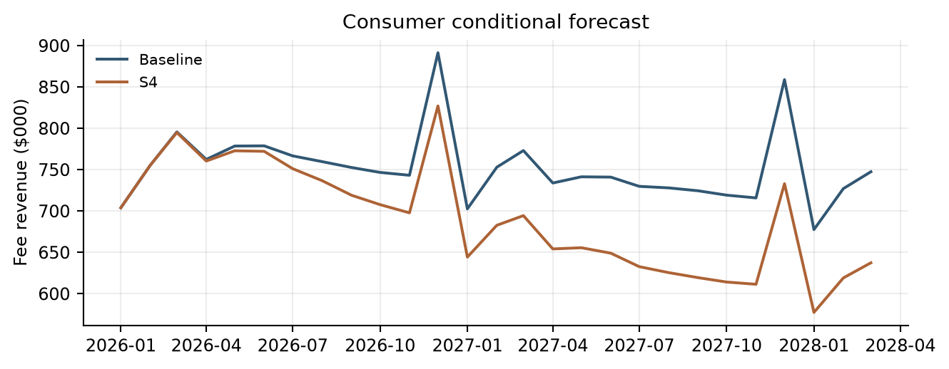
Data sources: consumer/​forecast_​monthly.csv. Fee revenue in $000.
The revenue totals summarize the cumulative Consumer scenario difference over the first year and the full projection horizon. The wider full-horizon shortfall is consistent with the persistent separation of the monthly S4 and Baseline paths.
Table 6.16 Consumer Card Scenario Revenue Totals
Period | Baseline ($000) | S4 ($000) | S4 vs Base
2026 total | 9,234.65 | 8,998.87 | -2.55%
9-quarter total | 20,307.65 | 18,649.22 | -8.17%
Data sources: consumer/​forecast_​quarterly_​summary.csv.

6.2.11 Model Development Progression
The Consumer model was developed from a base equation that included fee log-growth from one and two months earlier, together with January and December indicators. Retail Sales monthly-growth MA3 was then added to capture changes in consumer spending. This became the selected development model. The same specification was subsequently refitted using history through December 2025 to produce the coefficients used for future forecasts.
Table 6.17 Consumer Model Development Progression
Model Stage | Variables Included | Adjusted R²
Base Model | Fee log-growth, lags 1 and 2 + January and December indicators | 56.95% [consumer/​model_​diagnostics.csv/​row 2 col 6]
Selected Development Model | Fee log-growth, lags 1 and 2 + January and December indicators + Retail Sales monthly-growth MA3 | 61.14% [consumer/​model_​diagnostics.csv/​row 3 col 6]
Production Refit | Fee log-growth, lags 1 and 2 + January and December indicators + Retail Sales monthly-growth MA3 | 60.91% [consumer/​model_​diagnostics.csv/​row 4 col 6]
Table 6.17 shows the Consumer base model, selected development model and production refit. The base and selected development models use the same effective sample. The production refit retains the selected variables and extends the estimation period through December 2025. All specifications include an intercept.
Data sources: consumer/​model_​diagnostics.csv; consumer/​consumer_​card_​model.py.

6.2.12 User Review and Acceptance
Model results, assumptions, forecast behavior, and testing outcomes were reviewed with Strategic Finance and relevant lines of business during model development. Review sessions focused on economic intuition, reasonableness of the selected drivers, forecast behavior under changing economic conditions, and consistency with observed business performance. Feedback from these reviews supported the conclusion that the model appropriately captures the primary drivers of Consumer Card Fee Revenue and produces forecasts that are directionally consistent with business expectations.
Because the model has not yet been deployed into a production forecasting environment, final User Acceptance Testing (UAT) has not been completed. Prior to production implementation, final UAT will be performed to verify that the implemented model reproduces approved development results, correctly incorporates required inputs, generates expected outputs, and operates in accordance with documented procedures and governance requirements.

6.2.13 Sensitivity Analysis
Consumer adds -1.0, -0.5, +0.5 or +1.0 percentage points to monthly Retail Sales growth for 3, 6 or 12 months, beginning January 2026. It rebuilds future levels from the unchanged December 2025 anchor, recomputes monthly growth and MA3, and runs the fixed production equation recursively. Growth returns to Baseline after the active shock, but accumulated Retail Sales and fee-level differences are not reset. All 12 cases are reported. These code-default grids are analytical assumptions; approval as business stress standards remains outstanding.
Table 6.18 Consumer Retail Sales Growth Sensitivities
MoM shock | Duration | Year impact | Horizon impact | Terminal impact
-1 pp | 3 months | -3.40% | -3.62% | -3.80%
-1 pp | 6 months | -5.76% | -6.68% | -7.45%
-1 pp | 12 months | -7.64% | -11.30% | -14.35%
-0.5 pp | 3 months | -1.72% | -1.83% | -1.92%
-0.5 pp | 6 months | -2.93% | -3.40% | -3.80%
-0.5 pp | 12 months | -3.92% | -5.85% | -7.45%
+0.5 pp | 3 months | 1.75% | 1.86% | 1.95%
+0.5 pp | 6 months | 3.03% | 3.53% | 3.95%
+0.5 pp | 12 months | 4.13% | 6.27% | 8.05%
+1 pp | 3 months | 3.53% | 3.76% | 3.95%
+1 pp | 6 months | 6.17% | 7.20% | 8.05%
+1 pp | 12 months | 8.49% | 13.00% | 16.75%
Data sources: consumer/​sensitivity_​summary.csv.
The bars show that larger or longer-lasting Retail Sales growth shocks produce greater cumulative Consumer revenue changes. Positive and negative shocks move revenue in the expected directions, with effects persisting through the recursive fee-level calculation.
Figure 6.18 Consumer Sensitivity Impacts
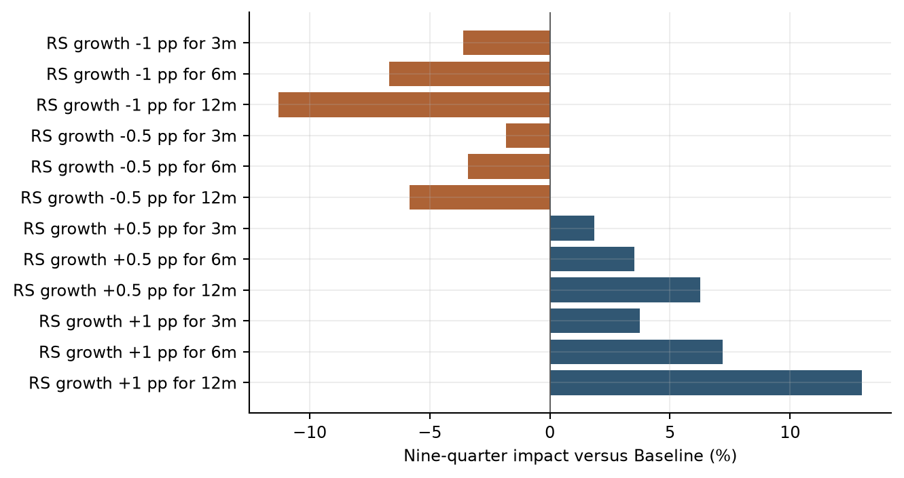
Data sources: consumer/​sensitivity_​summary.csv. Additive percentage-point shocks to Retail Sales monthly growth.

6.2.14 Testing Conclusions
The testing results support the selected Consumer Card specification. The Retail Sales addition improves development fit relative to the autoregressive-seasonal base, rolling coefficients retain consistent signs, and static and recursive OOT tests quantify forecasting performance. Scenario and sensitivity testing document the response to alternative spending conditions. These results support the model’s planning and stress-testing applications and its ongoing monitoring framework.

6.3 Debit Card Model Testing

6.3.1 Historical Calibration and Regression Review
Debit testing reviews the retained regression-screening outcomes and verifies the adopted historical calibration. Baseline uses the latest eight complete actual quarters; the stress floor uses the post-2015 mean less twice the sample standard deviation. The calibration is reproducible from the adjusted monthly and complete-quarter revenue outputs.
This table consolidates the Debit regression-screening outcomes across the tested target and frequency treatments. The absence of an accepted specification explains why Debit testing evaluates the historical calibration instead of a final regression equation.
Table 6.19 Debit Regression Screening Outcomes
Approach | Effective n | Candidates | All gates passed | Accepted model
Level | 129 | 194 | 0 | No
YoY_​static_​screen | 129 | 14 | 0 | No
MoM | 128 | 194 | 0 | No
QoQ_​quarterly | 42 | 74 | 0 | No
Data sources: debit/​regression_​summary.csv.
The baseline summarizes the recent quarterly run rate, while the stress floor provides the separately calibrated downside reference. The reported decline measures the distance between these two quarterly calibration levels.
Table 6.20 Debit Historical Calibration
Measure | Value
Quarterly baseline revenue ($000) | 4,747.625
Quarterly stress floor ($000) | 3,813.653
Decline from baseline to stress floor | 19.67%
Data sources: debit/​qualitative_​scenarios.csv; debit/​historical_​statistics.csv.

6.3.2 Scenario Reasonableness
The quarterly Baseline of 4,747.63 and Stress floor of 3,813.65 imply a 19.67% decline. The observed 2020Q2 decline from the average of 2019Q3 and 2019Q4 is approximately 6.88%, so the rule is more severe on that comparison. The floor is below the minimum observed post-2015 quarter, 3,954.00. The Shapiro–Wilk p-value for the post-2015 sample is approximately 0.0534 [debit/​historical_​statistics.csv/​row 14 col 2].
Figure 6.19 Debit Quarterly History and Calibration Levels
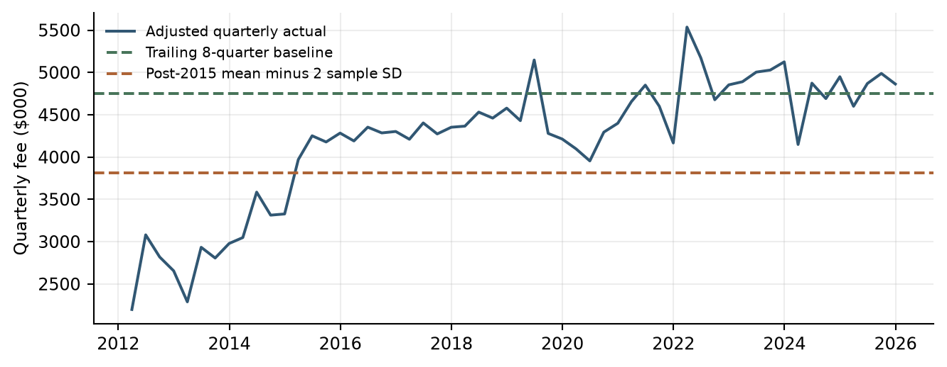
Data sources: debit/​quarterly_​revenue.csv; debit/​qualitative_​scenarios.csv. Calibration levels, not dated forward forecasts.

6.3.3 Sensitivity and Assumption Review
Debit sensitivity review focuses on the recent-quarter baseline, the stress-calibration window and the standard-deviation multiplier. These are the key assumptions governing its historical calibration. Review of any dated forecast application also considers transition and recovery assumptions.

6.3.4 Out of Time Testing
OOT testing is not applicable to the adopted Debit Card historical calibration method.

6.3.5 User Review and Acceptance
Model results, assumptions, baseline and stress calibration levels, and testing outcomes were reviewed with Strategic Finance and relevant lines of business during model development. Review sessions focused on economic intuition, reasonableness of the historical calibration assumptions, baseline and stress behavior under changing economic conditions, and consistency with observed business performance. Feedback from these reviews supported the conclusion that the model appropriately reflects historical Debit Card Fee Revenue behavior and provides baseline and stress calibration levels that are consistent with business expectations.
Because the model has not yet been deployed into a production forecasting environment, final User Acceptance Testing (UAT) has not been completed. Prior to production implementation, final UAT will be performed to verify that the implemented model reproduces approved development results, correctly incorporates required inputs, generates expected outputs, and operates in accordance with documented procedures and governance requirements.

6.3.6 Testing Conclusions
The retained historical statistics and scenario calculations support a transparent calibration framework for Debit Card. Monitoring focuses on the recent quarterly run rate, the relevance of the stress-calibration population and dispersion, and the approved application of the baseline and stress levels.

7. Model Implementation

8. Model Monitoring

8.1 Purpose of Monitoring
The purpose of ongoing model monitoring is to ensure the Card Fee Model continues to perform as intended after implementation and remains appropriate for its stated use in CCAR forecasting, stress testing, capital planning, and PPNR forecasting.
Monitoring is intended to identify model deterioration, changes in business conditions, shifts in underlying revenue drivers, breaches of key assumptions, implementation issues, forecast bias, and other factors that could materially affect model outputs.
Monitoring activities evaluate the continued appropriateness of model inputs, assumptions, methodologies, outputs, overlays, and operational processes. Results are used to determine whether the model remains fit for purpose, requires recalibration, requires modification of overlay assumptions, or requires redevelopment.

8.2 Monitoring Philosophy
The Card Fee Model combines statistically estimated relationships for Commercial Card and Small Business and Consumer Card with a historical calibration framework for Debit Card. Commercial forecasts also incorporate an EC trend adjustment. Because card fee revenue is influenced by changing customer behavior, spending activity, service utilization, pricing decisions, business initiatives, and other factors that may evolve over time, monitoring focuses on:
- Stability and quality of inputs.
- Accuracy and reasonableness of projected Card Fee Revenue forecasts.
- Continued validity of key assumptions.
- Stability of model coefficients and underlying relationships.
- Evaluation of model limitations.
- Review of overlays and expert judgment.
Monitoring seeks to identify both gradual deterioration and sudden structural changes in business conditions. Particular attention will be given to:
- Changes in Commercial Card and Small Business fee growth, the CPI reference, Corporate Profits growth and the adjusted EC state.
- Changes in Consumer Card fee dynamics, Retail Sales growth and calendar effects.
- Changes in Debit Card quarterly revenue, the recent baseline and post-2015 dispersion.
- Structural shifts in pricing practices, products and service offerings.
- Material deviations between projected and realized Card Fee Revenue.
- Persistent forecast bias.
- Significant changes in customer behavior affecting fee generation.

8.3 Monitoring Roles and Responsibilities

Model Owner
The Model Owner is responsible for overall model performance oversight and ensuring monitoring activities are completed timely.
Responsibilities include:
- Reviewing monitoring results.
- Assessing significance of identified issues.
- Approving remediation actions.
- Maintaining model documentation.
- Escalating material issues to management and MRM.

Model Developer
The Model Developer is responsible for performing the monitoring activities and producing monitoring reports.
Responsibilities include:
- Collecting monitoring data.
- Performing monitoring calculations and tests.
- Investigating threshold breaches.
- Recommending remediation actions.
- Updating model assumptions when appropriate.
- Reporting any observed data, processing, or output anomalies.

Model User
Strategic Finance and Capital Planning are responsible for reviewing monitoring results.

Independent Reviewer
Model Risk Management (MRM) is responsible for reviewing monitoring results and evaluating whether the model remains fit for purpose.
The matrix distinguishes responsibility for producing monitoring results from responsibility for ownership, business review and independent challenge. This allocation supports a documented review and escalation process.
Table 8.1 Roles and Responsibilities Matrix
Role | Responsibilities
Model Owner | Ensures monitoring activities are performed, documented, and completed in accordance with governance requirements.
Model Developer | Produces monitoring analyses, maintains supporting documentation, investigates performance anomalies, and recommends remediation when necessary.
Model User (Strategic Finance) | Reviews monitoring results and determines whether governance actions are required.
MRM | Independently reviews monitoring results and continued fitness for purpose.

8.4 Monitoring Frequency
Monitoring will be performed at least semi-annually.
Certain monitoring activities may be performed more frequently when new CCAR forecasts are produced or when material economic, business, or operational changes occur.
The standard monitoring cycle consists of:
- Semi-annual monitoring review.
- Annual comprehensive monitoring assessment.
- Ad hoc reviews following material business, regulatory, data, methodology, or overlay changes.
Monitoring results will be documented and retained in accordance with Model Risk Management standards.

8.5 Components of Monitoring
During monitoring, input and output stability, model output accuracy, model robustness, overlay, assumptions and limitations will be vetted.

8.5.1 Input Stability Monitoring
Input monitoring evaluates whether key model drivers remain consistent with historical behavior.
Key inputs include:
- Commercial Card and Small Business fee revenue, CPI, Corporate Profits and the derived EC and annual-growth inputs.
- Consumer Card fee revenue, Retail Sales monthly growth and its trailing average, lagged fee log changes and calendar indicators.
- Debit Card raw and adjusted fee revenue and complete-quarter observations used for calibration.
- Moody's macroeconomic scenario inputs used by the regression components.
Monitoring tests include:
- Growth trend analysis.
- Historical range comparison.
- Volatility analysis.
- Identification of structural breaks.
- Reconciliation against source systems and financial reporting data.
Significant deviations from historical behavior will be investigated to determine whether model assumptions remain appropriate.

8.5.2 Output Stability Monitoring
Output monitoring evaluates changes in projected Card Fee Revenue estimates over time.
Monitoring will assess:
- Baseline and stress Card Fee Revenue forecasts by component.
- Commercial overlay-adjusted forecasts and Consumer production-refit forecasts.
- Debit baseline and stress calibration levels.
- Baseline-to-stress forecast differences.
- Forecast consistency across forecast vintages.
Outputs will be compared against:
- Prior forecast vintages.
- Historical Card Fee Revenue observations.
- Business expectations.
- Strategic Finance planning assumptions.
Large unexplained forecast movements may indicate changes in model behavior or underlying business conditions requiring review.

8.5.3 Forecast Accuracy Monitoring
Forecast accuracy will be assessed by comparing projected Card Fee Revenue against realized outcomes for each component and for the combined forecast.
Actual results will be compared with:
- Baseline forecast estimates.
- Prior year forecast projections.
- Overlay-adjusted forecasts, where applicable.
Monitoring metrics include:
- Absolute Percent Error (APE).
- Mean Absolute Percentage Error (MAPE).
- Forecast variance analysis.
- Directional accuracy.
Where forecast errors exceed established thresholds, root cause analysis will be performed.
Particular attention will be given to sustained underprediction or overprediction, with comparisons made on consistent forecast horizons and vintages.

8.5.4 Assumption Monitoring
The model contains several statistical and judgmental assumptions which require periodic review.
Key assumptions include:
- Commercial CPI and Corporate Profits relationships and the adjusted EC mechanism remain relevant to fee-revenue behavior.
- Consumer fee dynamics, calendar effects and the Retail Sales relationship remain relevant.
- Debit recent-quarter and post-2015 calibration windows remain representative of the intended baseline and stress conditions.
- Historical directional relationships remain reasonably stable throughout the forecast horizon.
- Development-period relationships remain representative of future operating conditions.
Monitoring will evaluate whether observed business performance continues to support these assumptions.

8.5.5 Coefficient and Parameter Stability Monitoring
Estimated regression coefficients and historical calibration parameters will be monitored for stability. Parameters include:
- Commercial long-run CPI coefficient and intercept; short-run adjusted EC, own-growth lags, Corporate Profits and intercept; EC trend adjustment.
- Consumer fee log-growth lag coefficients, January and December coefficients, Retail Sales coefficient and intercept.
- Debit baseline mean, stress-period mean and sample standard deviation, calibration windows and stress multiplier.
Monitoring will assess:
- Coefficient sign stability.
- Magnitude changes over time.
- Statistical significance.
- Rolling coefficient behavior for applicable regression models.
- Stability of model explanatory power.
Observed parameter behavior will be compared against development-period results to determine whether recalibration may be warranted.

8.5.6 Overlay Monitoring
Commercial Card and Small Business forecasts utilize an EC trend adjustment calibrated from the later historical period. Consumer Card has no separate management overlay in the current implementation. Debit historical calibration assumptions are monitored as judgmental parameters. Monitoring of the Commercial adjustment will evaluate:
- Continued need for the overlay.
- Magnitude of the overlay.
- Actual-to-forecast performance after application of the overlay.
- Whether business conditions supporting the overlay remain applicable.
- Whether redevelopment or recalibration would be preferable to continued overlay usage.
The overlay will remain subject to governance review, documentation, approval, and ongoing challenge.

8.5.7 Limitation Monitoring
Known model limitations identified in Section 2 will be reviewed during each monitoring cycle.
Particular attention will be given to:
- Future pricing actions not explicitly captured by the model.
- New products and service offerings not represented in development data.
- Structural shifts in customer behavior and monetization practices.
- Forecast bias associated with changing business environments.
- Changes in the relevance of Commercial EC calibration and Consumer calendar or spending relationships.
- Changes in the representativeness of Debit historical calibration windows and stress severity.
If limitations become more significant due to changing business conditions, corrective action may be required.

8.6 Monitoring Metrics and Thresholds
Monitoring metrics should be associated with predefined thresholds that distinguish expected behavior from behavior requiring investigation. Exceeding a threshold does not automatically indicate model failure but should trigger review and documentation.
The following monitoring measures identify potentially significant performance issues. Component-specific numerical thresholds, evaluation windows and escalation timelines will be approved and documented before implementation.
Table 8.2 Monitoring Metrics and Thresholds
Monitoring Area | Metric | Threshold
Forecast Accuracy | Actual versus forecast Card Fee Revenue by component; APE and rolling annual MAPE | Component thresholds to be approved
Input Stability | Commercial CPI, Corporate Profits and EC; Consumer Retail Sales and fee changes; Debit quarterly revenue | Historical-range and volatility thresholds to be approved
Data Integrity | Source reconciliation against financial reporting data | Reconciliation tolerance to be approved
Coefficient Stability | Sign reversal or material magnitude change in final regression coefficients | Investigation required
Statistical Stability | Material decline in adjusted R-squared relative to development performance | Management review required
Overlay Performance | Persistent bias in Commercial overlay-adjusted forecasts | Management review required
Debit Calibration | Material changes in recent-quarter mean, post-2015 dispersion or stress severity | Management review required
Assumption Stability | Material assumption invalidated by observed experience | Management review required
Data Quality | Missing or incomplete required source data | Investigation and remediation required
Breaches do not automatically indicate model failure but require investigation and documented explanation.

8.7 Escalation Process
When monitoring identifies a threshold breach or significant performance issue, the following escalation process will be followed:
- Model Developer investigates the issue and documents root cause analysis.
- Results are reviewed by the Model Owner.
- If remediation is required, an action plan is developed and documented.
- Material findings are communicated to Strategic Finance management.
- Material model performance issues are reported to Model Risk Management.
- Where appropriate, a recalibration, redevelopment, modification of the overlay, model overlay enhancement, or model retirement recommendation will be submitted.

8.8 Monitoring Conclusion
The Card Fee Model relies on statistically estimated relationships, economically intuitive business drivers, a Commercial EC adjustment and historical Debit calibration. Accordingly, the monitoring framework focuses on ensuring the ongoing validity of model assumptions, stability of key explanatory variables and coefficients, forecast accuracy, overlay and calibration appropriateness, and consistency of model outputs with observed business performance.
Monitoring results will be reviewed semi-annually by the Model Owner and Strategic Finance management. Findings, threshold breaches, remediation actions, overlay assessments, and material model changes will be documented. Material changes to model methodology, assumptions, coefficients, data sources, overlay methodology, monitoring thresholds, or model use will be communicated to Model Risk Management and recorded in the model change control log in accordance with Model Risk Management Policy.

9. Procedures
[Document model Procedures which contains instructions on how to run, use, and update the model. This should allow someone who does not run the model on a day-to-day basis to update and run the model. The procedures should include frequency of when the model is run, who receives the output, and any control checks.
If the procedures are detailed in a separate document, please include reference to that document here.
Where applicable, include an operating checklist which lays out step-by-step procedures for executing the model. The intent is this will be used by the model owner / model user when the model is updated to ensure no steps are missed.]
Model is yet to be implemented. During implementation stage, this section will be addressed.

10. Governance

10.1 Purpose of Governance
The purpose of the governance framework is to ensure that the Card Fee Model is developed, implemented, monitored, maintained, and retired in a controlled manner consistent with Model Risk Management requirements and supervisory expectations. Effective governance establishes accountability, supports independent challenge, promotes transparency, and ensures that model outputs are used appropriately throughout the model lifecycle.

10.2 Roles and Responsibilities

Model Owner
The Model Owner is responsible for the overall governance, maintenance, and performance oversight of the Card Fee Model. Responsibilities include ensuring monitoring activities are completed, documentation remains current, model assumptions remain appropriate, change-control records are maintained, and material issues are escalated in accordance with Model Risk Management requirements. The Model Owner is also responsible for coordinating validation activities, reviewing monitoring results, assessing model limitations, and approving any overlays or expert judgment adjustments applied to model outputs.

Model Developer
The Model Developer is responsible for maintaining model methodology documentation, executing approved model updates, supporting monitoring activities, investigating identified issues, performing analyses related to model performance, and supporting validation reviews. Model Developers may recommend methodology enhancements but do not independently approve material model changes.

Governance Review
Monitoring results, model performance assessments, material issues, and proposed model changes are reviewed by Strategic Finance management. Material model issues, material changes, or significant performance deterioration are communicated to MRM in accordance with the Bank's MRM policy.

Model Validation
Independent validation is performed in accordance with the Model Risk Management Policy and applicable validation schedules. Validation activities provide effective challenge of model design, assumptions, implementation, performance monitoring, limitations, controls, and governance processes. Validation findings, recommendations, and remediation plans are documented and tracked through completion.

Internal Audit
Internal Audit may periodically assess compliance with Model Risk Management requirements, governance controls, monitoring processes, documentation standards, and change-management practices. Audit recommendations are documented and addressed through established remediation procedures.

10.3 Change Management Governance
Changes to methodology, assumptions, implementation logic, source data, monitoring thresholds, or intended use should be documented and evaluated through formal change-management procedures. Proposed changes should be assessed for materiality and reviewed by appropriate stakeholders before implementation. Governance review helps ensure that modifications do not introduce unintended consequences or unrecognized model risk.

Material Change Definition
Material changes are defined in accordance with the Model Risk Management Policy and include, but are not limited to, changes in model purpose, scope, methodology, assumptions, source data, implementation logic, monitoring framework, deployment platform, or intended use. Material changes require notification to MRM, appropriate approvals, and corresponding updates to model documentation and monitoring procedures prior to implementation.
All model changes shall be documented within the model change-control log, including change description, rationale, implementation date, approval evidence, and materiality assessment.

10.4 Governance Conclusion
The Card Fee Model is governed through a framework of defined ownership, independent validation, performance monitoring, change management, and oversight review. Governance activities are intended to ensure that the model remains fit for its intended use in CCAR stress testing, capital planning, and related forecasting applications. Material issues, performance deterioration, and model changes are subject to escalation and review under the Bank's Model Risk Management framework to promote transparency, accountability, and effective management of model risk throughout the model lifecycle.

11. Appendix Information

11.1 Appendix A Variable Dictionary
The appendices retain the detailed evidence needed to understand and reproduce the Card Fee methods. The variable dictionary defines targets, selected explanatory terms and judgmental calibration measures, including source fields, transformations and timing. Growth horizons, subsequent lags and moving-average windows have different meanings and should be interpreted separately. Fee levels remain in $000, with the documented percentage conventions applied only to transformed variables.
The supporting materials include macroeconomic mappings, data and code inventories, feature-selection records, regression outputs and diagnostics. Together with the source-address register, they connect the narrative and exhibits to the relevant input or output files. Source-system lineage and accounting definitions remain separate evidence requirements.
Table 11.1 Selected variables and constructions
Label | Definition and units | Code field or source
F | Commercial Card plus Small Business monthly revenue; $000 | commercial_​small_​business_​fee
C; L | CPI level; fitted long-run fee level | consumer_​price_​index; long_​run_​fitted_​fee
g | 100 × (F /​ fee 12 months earlier − 1); percentage growth | commercial_​small_​business_​fee_​pct_​change_​12m
e | 100 × (F − L) /​ L; percentage-scale deviation | ec_​scaled_​pct
a | e less contemporaneous trend overlay; lag 12 enters equation | ec_​scaled_​adjusted_​pct_​lag_​12m
q | Corporate Profits YoY percentage growth; lag 2 enters | corporate_​profits_​pct_​change_​12m_​lag_​2m
Y; z | Consumer fee level; 100 × monthly log difference | consumer_​card_​fee; consumer_​card_​fee_​log_​change_​1m_​pct
r | Current and prior two Retail Sales MoM percentage changes, arithmetic average | retail_​sales_​pct_​change_​1m_​ma_​3m
J; D | January and December indicators, 0 or 1 | is_​january; is_​december
Debit adjusted fee | Raw fee except March and December 2012 adjacent-month replacements | debit_​card_​fee_​adjusted
Debit quarterly fee | Sum of 3 adjusted monthly observations; $000 | debit_​card_​fee_​quarterly
Debit baseline | Mean of latest 8 complete actual quarters | baseline_​quarterly
Debit Stress floor | Post-2015 complete-quarter mean − 2 sample SD | stress_​floor_​quarterly
Data sources: commercial/​commercial_​card_​model.py; consumer/​consumer_​card_​model.py; debit/​debit_​card_​model.py.
The macro dictionary maps source-series codes to their business meanings and identifies the components that consider each series. It supports reconciliation between the component inventories and the supplied macroeconomic files.
Table 11.2 Macro source dictionary
Source code | Business concept | Components
M_​FCPIU_​B.IUSA | Consumer price index | Commercial, Consumer, Debit
M_​FZA_​B.IUSA | Corporate Profits | Commercial, Debit
M_​FRT_​B.IUSA | Retail Sales; supplied header includes unit annotation | Consumer, Debit
M_​FLBR_​B.IUSA | Unemployment rate; percent | All
M_​FYPDPIQ_​B.IUSA | Disposable personal income | All
M_​FCBC_​B.IUSA | Consumer confidence; supplied header includes annotation | Consumer, Debit
M_​FSBINQ_​B.IUSA | Small-business optimism | Commercial, Debit
M_​FGDP42Q_​B.IUSA | Wholesale-trade GDP | Commercial, Debit
M_​FIP_​B.IUSA | Industrial production | Commercial, Debit
M_​FDJMIIUSDD_​WCFTDQ_​B.IUSA | Total-market equity index | Commercial, Debit
M_​FRT4451_​B.IUSA | Grocery sales | Debit
M_​FRT447_​B.IUSA | Gasoline sales | Debit
M_​FRT454_​B.IUSA | Nonstore sales | Debit
M_​FETP_​B.IUSA | Private employment | Debit
Data sources: commercial/​data/​macro_​history.csv; consumer/​data/​macro_​history.csv; debit/​data/​macro_​history.csv.
Source: MACRO_COLUMNS mappings in each component script. CPI and equity/confidence/activity indices retain their index units; revenue and other macro level units require the source metadata where not explicitly labeled. Exact annotated CSV headers are preserved in inputs.

11.2 Appendix B Data and Code Inventory
The inventory identifies the Commercial Full Recursive OOT release, the Consumer Student-t forward-selection release and the standardized Debit package. Tables and figures use the retained execution outputs of those releases. The Commercial package retains its scenario and sensitivity functionality, and the Consumer package retains its scenario, rolling and sensitivity outputs. Exact locations and code hashes support reproduction of the development evidence. Approved document-management locations should replace local technical references when the materials are formally released.
Commercial: outputs/​commercial_​card_​full_​recursive_​20261013/​commercial_​card_​model
Code SHA-256: dbf83e1c2681f2207420b9342da46d338979cfd2a8e302488591cad905a34cc1
Consumer: .consumer_​student_​t_​build_​20261013/​consumer_​card_​model
Code SHA-256: 7b3187c992a99909be2eb5006d0e79de207089e5cf8b7a8dde08ac9d2a0c5b65
Debit: outputs/cardfee_standardized_20261001/debit_card_model
Code SHA-256: 9af38af4202e8e87fbb304202e423b2a74cf7ebbb8db748c4682ca73c22faa3b
The evidence inventory links each input or output file group to its role in development, testing or forecasting. It provides a practical file-level guide for reproducing the results and locating supporting records.
Table 11.3 Evidence files and purpose
Artifact | Purpose
fee_​history.csv; macro_​history.csv | Raw monthly historical inputs per component
macro_​baseline.csv; macro_​s4.csv | Future paths for Commercial and Consumer only
historical_​data_​and_​features.csv | Derived historical features for quantitative components
long_​run_​trials.csv; short_​run_​trials.csv; macro_​screening.csv | Candidate and selection records, as applicable
short_​run_​coefficients.csv; coefficients.csv | Final estimates and inference
forecast_​accuracy.csv; static_​oot.csv; fully_​recursive_​oot.csv or recursive_​oot.csv | Historical test metrics and month-level predictions
forecast_​monthly.csv; forecast_​quarterly_​summary.csv | Baseline/​S4 monthly predictions and calendar-quarter sums
stress_​summary.csv; sensitivity_​summary.csv | Commercial and Consumer sensitivity impacts
regression_​summary.csv; regression_​candidates.csv | Debit four-route screening detail
monthly_​revenue.csv; quarterly_​revenue.csv; qualitative_​scenarios.csv | Debit treatment history and calibration

11.3 Appendix C Feature Selection Evidence
Feature-selection records document the progression from candidate variables to the selected method. Commercial retains long-run trials, transformed-family stationarity screens, partial correlations and short-run additions. Consumer retains macro candidates, Student-t p-values, diagnostic gates, eligibility and selection status; its Student-t p-value determines significance eligibility and the primary ranking of eligible candidates. Debit retains diagnostics for each regression route. Candidate- and round-level records explain the decision process more fully than a final-variable list alone.
The body summarizes the principal selection evidence, while the inventory identifies the complete supporting files. The original input vintage and software environment should be retained with those outputs. Business challenge notes and approval of the specification provide complementary evidence and remain to be completed.
Table 11.4 Selection criteria by component
Stage | Required numerical criteria | Information used
Commercial long run | Added p < .05; VIF < 10; residual ADF p < .05 | Development
Commercial macro pre-screen | ADF p < .05 OR KPSS p > .05; partial-correlation p < .20 in both windows; same sign | Development plus OOT
Commercial short run | EC lag 12 required; added p < .05; VIF < 10 | Development coefficients; OOT-informed candidate pool
Consumer | Student-t p < .05; VIF < 10; DW 1.5–2.5; JB p > .05 | Development; at most one term per family
Debit all four routes | Student-t p < .05; VIF < 10; DW 1.5–2.5; JB p > .05 | Design-specific development samples
Data sources: commercial/​commercial_​card_​model.py; consumer/​consumer_​card_​model.py; debit/​debit_​card_​model.py.

11.4 Appendix D Regression Outputs
Detailed regression output supports the coefficient and performance discussion in the body. Tables 3.4–3.6 contain estimates, standard errors, t-statistics and Student-t p-values. Tables 11.5 and 11.6 report Commercial’s long-run and short-run estimates separately. Consumer development and production estimates remain separately identified because they use different estimation periods. No final Debit regression is reported because none was accepted.
Table 11.5 Commercial long-run coefficients
Term | Estimate | Std error | t statistic | p value
Intercept | -3,386.96072 | 111.71744 | -30.317 [commercial/​long_​run_​coefficients.csv/​row 2 col 5] | <0.001 [commercial/​long_​run_​coefficients.csv/​row 2 col 6]
CPI level | 19.41955 | 0.44293 | 43.844 [commercial/​long_​run_​coefficients.csv/​row 3 col 5] | <0.001 [commercial/​long_​run_​coefficients.csv/​row 3 col 6]
Data source: commercial/​long_​run_​coefficients.csv.
Table 11.6 Commercial short-run coefficients
Term | Estimate | Std error | t statistic | p value
Intercept | 1.78314 | 0.85356 | 2.089 [commercial/​short_​run_​coefficients.csv/​row 2 col 5] | 0.039 [commercial/​short_​run_​coefficients.csv/​row 2 col 6]
Adjusted EC, lag 12 | -0.65352 | 0.08291 | -7.883 [commercial/​short_​run_​coefficients.csv/​row 3 col 5] | <0.001 [commercial/​short_​run_​coefficients.csv/​row 3 col 6]
Fee YoY growth, lag 1 | 0.29638 | 0.06672 | 4.442 [commercial/​short_​run_​coefficients.csv/​row 4 col 5] | <0.001 [commercial/​short_​run_​coefficients.csv/​row 4 col 6]
Fee YoY growth, lag 6 | 0.25019 | 0.05008 | 4.996 [commercial/​short_​run_​coefficients.csv/​row 5 col 5] | <0.001 [commercial/​short_​run_​coefficients.csv/​row 5 col 6]
Profits YoY growth, lag 2 | 0.42202 | 0.09115 | 4.630 [commercial/​short_​run_​coefficients.csv/​row 6 col 5] | <0.001 [commercial/​short_​run_​coefficients.csv/​row 6 col 6]
Table 11.6 shows the estimates, standard errors, t-statistics and Student-t p-values for the Commercial Card and Small Business short-run model. The adjusted error-correction term links the CPI-based long-run relationship to fee growth, alongside lagged fee growth and corporate profits growth.
Source: commercial/​short_​run_​coefficients.csv. Classical nonrobust OLS covariance; coefficient scale is annual percentage growth.

11.5 Appendix E Scenario Detail
The quarterly scenario table aggregates unrounded monthly Commercial and Consumer forecasts. It excludes Debit from the combined quantitative totals because the adopted script supplies calibration levels rather than a dated nine-quarter path. Adding Debit to a suite forecast requires prior approval of its trajectory and the reporting perimeter, so that quarterly levels are not mistaken for a complete scenario projection.
Table 11.7 Quarterly quantitative component forecasts
Quarter | Commercial Base ($000) | Commercial S4 ($000) | Consumer Base ($000) | Consumer S4 ($000)
2026Q1 | 6,931.23 | 6,928.32 | 2,254.81 | 2,254.06
2026Q2 | 7,105.83 | 7,040.73 | 2,319.69 | 2,305.35
2026Q3 | 7,224.79 | 6,983.85 | 2,278.93 | 2,206.91
2026Q4 | 7,026.88 | 6,175.91 | 2,381.22 | 2,232.55
2027Q1 | 7,551.04 | 6,242.62 | 2,228.62 | 2,021.44
2027Q2 | 7,636.77 | 5,820.03 | 2,216.19 | 1,958.80
2027Q3 | 7,496.89 | 5,630.94 | 2,182.21 | 1,877.66
2027Q4 | 7,359.05 | 5,649.86 | 2,293.84 | 1,958.55
2028Q1 | 7,590.66 | 6,027.37 | 2,152.13 | 1,833.90
Data sources: commercial/​forecast_​quarterly_​summary.csv; consumer/​forecast_​quarterly_​summary.csv.

11.6 Appendix F Technical References
The following technical references describe the diagnostic statistics used in the model. Component code, input files and exported results provide the implementation and numerical evidence.
[R2] statsmodels, durbin_watson documentation. Definition and interpretation of the Durbin-Watson residual statistic. https://www.statsmodels.org/stable/generated/statsmodels.stats.stattools.durbin_watson.html
[R3] statsmodels, acorr_ljungbox documentation. Lag specification and model degrees-of-freedom adjustment. https://www.statsmodels.org/stable/generated/statsmodels.stats.diagnostic.acorr_ljungbox.html
Component-specific software requirements are in the reviewed package READMEs; the Commercial Full Recursive OOT release specifies statsmodels 0.15.0.

11.7 Appendix G Source File Locations
Statistical result annotations identify the component, actual file name and one-based CSV row and column. The header is row 1 and the first observation is row 2. For example, consumer/​rolling_​summary.csv/​row 6 col 3 identifies the Consumer rolling-summary minimum in that exact cell. File names in captions identify the inputs or outputs underlying the whole table or figure. Dates, years, forecast amounts and configured assumptions are not individually annotated. Display rounding does not change the underlying calculation.
Component prefixes distinguish identically named files. The locations below resolve each prefix to its retained local directory. The file name following the prefix is unchanged. Code references use the actual Python file name and line numbers.

Commercial source locations
commercial/​data/​ → /​Users/​hyx/​Documents/​ChatGPT/​Cardfee/​outputs/​commercial_​card_​full_​recursive_​20261013/​commercial_​card_​model/​data
commercial/​ CSV outputs → /​Users/​hyx/​Documents/​ChatGPT/​Cardfee/​.commercial_​card_​full_​recursive_​20261013/​results
commercial/​commercial_​card_​model.py → /​Users/​hyx/​Documents/​ChatGPT/​Cardfee/​outputs/​commercial_​card_​full_​recursive_​20261013/​commercial_​card_​model/​commercial_​card_​model.py

Consumer source locations
consumer/​data/​ → /​Users/​hyx/​Documents/​ChatGPT/​Cardfee/​.consumer_​student_​t_​build_​20261013/​consumer_​card_​model/​data
consumer/​ CSV outputs → /​Users/​hyx/​Documents/​ChatGPT/​Cardfee/​outputs/​consumer_​card_​student_​t_​20261013/​results
consumer/​consumer_​card_​model.py → /​Users/​hyx/​Documents/​ChatGPT/​Cardfee/​.consumer_​student_​t_​build_​20261013/​consumer_​card_​model/​consumer_​card_​model.py

Debit source locations
debit/​data/​ → /​Users/​hyx/​Documents/​ChatGPT/​Cardfee/​outputs/​cardfee_​standardized_​20261001/​debit_​card_​model/​data
debit/​ CSV outputs → /​Users/​hyx/​Documents/​ChatGPT/​Cardfee/​.card_​fee_​mdd_​20261009/​results/​debit
debit/​debit_​card_​model.py → /​Users/​hyx/​Documents/​ChatGPT/​Cardfee/​outputs/​cardfee_​standardized_​20261001/​debit_​card_​model/​debit_​card_​model.py

