Deposit Month Actual Num
Direct OLS Stationarity Analysis
  - January 2011 to December 2025
Research report dated 3 November 2026

1 Purpose and main findings
We fit the original monthly target directly to a linear time trend, a slope change at January 2020 and a temporary indicator for January 2020 through January 2021. We then test the resulting OLS residuals for stationarity. No autoregressive terms or autoregressive error model enter the target regression.
The estimated temporary effect is a shortfall of 989,171 original units per affected month. The underlying monthly slope increases from 3,743 before the breakpoint to 17,239 afterward. The model explains 59.85% of the full-sample variation.
Ordinary ADF and KPSS diagnostics on the unfiltered OLS residuals are consistent with stationary deviations around the fitted path. Their standard reference distributions are not calibrated for the estimated broken trend and interval indicator, so this finding is preliminary rather than a formal break-adjusted confirmation. Direct tests of the pre-break observations are reported in the final section.

2 Data and regression specification
Item | Definition
Target and sample | Month_Actual_num in original units; 180 monthly observations
Sample dates | January 2011 through December 2025
Time origin and breakpoint | t = 0 in January 2011; t = 108 in January 2020
Temporary indicator | D = 1 from January 2020 through January 2021 inclusive; 0 otherwise
$y_{t} = α + βt + γH_{t} + θD_{t} + u_{t}$
$H_{t} = max(t − 108, 0)$
The pre-break slope is β and the post-break slope is β + γ. The underlying trend is continuous at the breakpoint. There is no permanent level-step regressor. The interval effect θ shifts the mean only while D is active and is fully removed in February 2021.
Data source: deposit_month_actual_num.xlsx, worksheet deposit_input, originally transcribed from the supplied screenshots. The monthly sequence is complete and unique. No logarithms, differences, calendar-month indicators or macroeconomic variables are used.

3 Direct OLS estimates
All four coefficients are estimated together by ordinary least squares, minimizing the sum of squared deviations between the original target and the specified mean path. The fitted equation in original units is
$ŷ_{t} = 6,940,821.01 + 3,742.67t + 13,496.71H_{t} − 989,171.11D_{t}$
Table 1 Coefficient estimates and uncertainty
Parameter | OLS estimate | OLS p | HAC12 p | HAC12 95% interval
Intercept α | 6,940,821.01 | <0.0001 | <0.0001 | 6,763,464 to 7,118,178
Pre-break slope β | 3,742.67 | 0.0029 | 0.0489 | 18 to 7,467
Slope change γ | 13,496.71 | <0.0001 | 0.0139 | 2,778 to 24,215
Interval effect θ | -989,171.11 | <0.0001 | <0.0001 | -1,259,082 to -719,260
Post-break slope β + γ | 17,239.38 | <0.0001 | <0.0001 | 9,489 to 24,989
Slopes measure original units per elapsed month. The interval coefficient is a level difference, not a monthly percentage or a cumulative decline. The post-break slope is a linear contrast of β and γ, with their covariance included.

Covariance estimation
The conventional OLS column assumes the usual homoskedastic and uncorrelated regression errors. The HAC12 column uses a Bartlett-kernel heteroskedasticity and autocorrelation consistent covariance estimate with 12 lags. Both columns use the same OLS coefficients, fitted values and residuals. HAC changes uncertainty estimates only; it does not add an AR term or filter the residuals.
The implementation retains the OLS t-reference distribution with 176 residual degrees of freedom and the default HAC covariance scaling. HAC inference remains conditional on suitable error regularity. It does not establish stationarity or repair a unit-root error process.

Interpretation of the estimates
The pre-break slope is marginally significant using HAC12 (p = 0.0489). Its 95% interval runs from about 18 to 7,467 units per month. The slope increase is 13,497 units per month (p = 0.0139), giving a post-break slope of 17,239 units per month (p < 0.0001). These are full-sample segmented-regression estimates, not a regression estimated only on pre-2020 observations.
The interval effect is negative without imposing a sign restriction. Its HAC12 95% interval is a reduction of 719,260 to 1,259,082 units per month. A constant effect means a constant gap from the underlying trend during the 13 months. It does not mean identical observed monthly values or an independently established causal effect.
Fit statistic | Value
R squared | 0.5985
Adjusted R squared | 0.5917
In-sample root mean squared error | 439,194
Residual standard error with 176 degrees of freedom | 444,157

4 Fitted path and residual construction
Figure 1 Original observations and direct OLS fit with unfiltered residuals
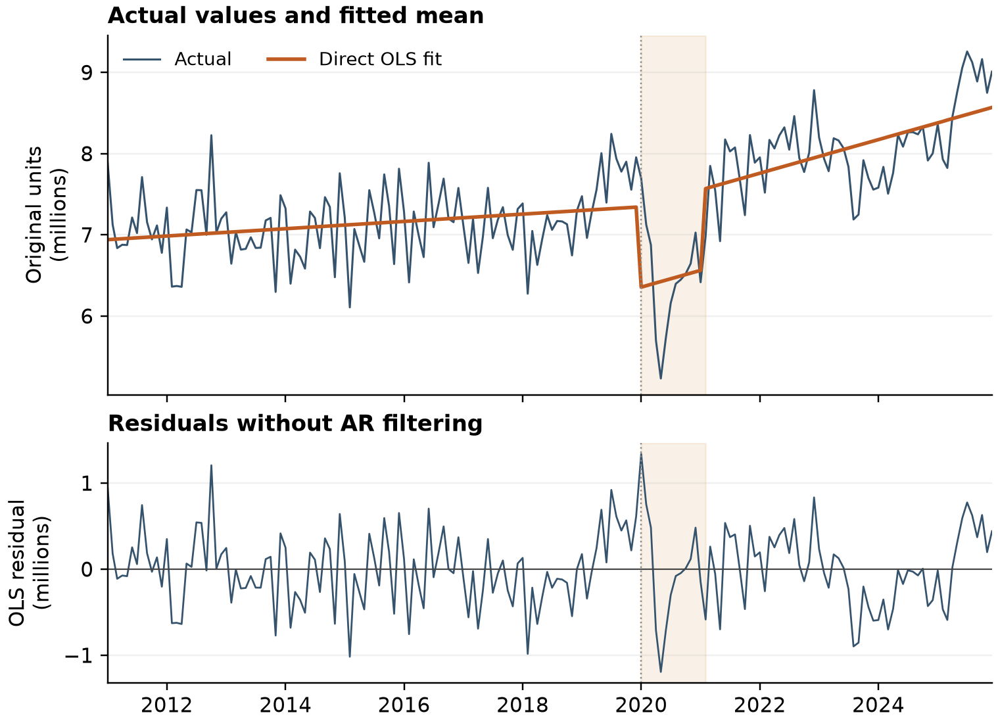
Shading identifies the 13 active dummy months. The orange line is the complete OLS fitted value, not an autoregressive forecast. The vertical dotted line marks January 2020.
$û_{t} = y_{t} − ŷ_{t}$
The residual series contains every monthly observation minus its fitted value. No residuals are discarded for an AR initialization period. The first-stage regression uses all 180 months, and the residual mean is zero up to numerical precision because the regression contains an intercept.
The indicator produces a downward shift at the start of the interval and an upward shift when the interval ends. Within the interval, the fitted path retains the post-break slope. The within-window fall and recovery visible in the data remain in the residuals because this specification imposes a constant gap rather than estimating a separate effect for each month.
For stationarity around the specified mean path, the relevant object is this unfiltered residual series. Serial correlation can remain in a stationary process. The regression therefore does not need an AR specification merely to construct the residuals for the requested diagnostics.

5 Stationarity diagnostics for OLS residuals
ADF tests a unit-root null. We use no additional constant or time trend in the residual test, set the maximum augmentation lag to 12 and choose the lag by AIC. The selected lag is 12, leaving 167 effective observations. Fixing the lag at 12 gives the same statistic. The lagged residual differences belong to the ADF auxiliary test regression; they are not AR terms in the target regression.
KPSS tests a level-stationarity null for the residual series, with a constant and automatic long-run variance bandwidth selection. The selected bandwidth is 7. Both tests operate directly on the OLS residuals shown in Figure 1.
Table 2 Ordinary residual tests using standard reference distributions
Test | Statistic | Nominal p | Lag or bandwidth | Standard 5% decision
ADF | -3.5506 | 0.000403 | 12 | Reject unit root
KPSS | 0.0498 | >0.10 | 7 | Do not reject stationarity
The exact ordinary ADF p-value is 0.0004027417. KPSS reports a tabulated boundary of 0.10 with a warning that the actual p-value is larger; the result is therefore shown as >0.10.

Interpretation and inference limits
Under the ordinary reference distributions, the tests agree with stationary deviations around the fitted mean. However, the mean path and interval coefficient were estimated from the same target. These standard p-values do not reproduce the two-stage detrending procedure with the fixed hinge and interval regressors. They are nominal diagnostics, not a formally calibrated break-adjusted unit-root or stationarity test.
We therefore treat the evidence as preliminary. A test with critical values matched to this deterministic specification, or a validated bootstrap that reproduces estimation and lag selection under the null, would be needed for formal confirmation. No such calibration is included in this report.

Residual autocorrelation
Ljung Box horizon | Statistic | p-value
6 months | 45.428 | 3.85e-08
12 months | 66.153 | 1.67e-09
24 months | 117.923 | 2.27e-14
Residual autocorrelation is detected at all three horizons. This explains the use of HAC uncertainty estimates. It does not by itself contradict residual stationarity, and no AR model is fitted as part of this study.

Reproducibility and method references
The source workbook hash matches both this OLS rerun and the pre-break analysis. OLS coefficients were independently checked with a least-squares solution; fitted values plus residuals reconcile to every observation. Calculations use statsmodels 0.15.0. All reported full-sample results are from the direct OLS specification.
Statsmodels ADF test documentation
Statsmodels KPSS test documentation
Statsmodels robust covariance documentation

6 Stationarity of the pre break observations
This final check uses only the 108 original observations from January 2011 through December 2019. It does not use the full-sample fitted residuals. We evaluate stationarity around a constant and, separately, around a linear trend. The results address the pre-break sample alone and need not match diagnostics of a full-sample fitted residual series.
Figure 2 Original target before the business breakpoint
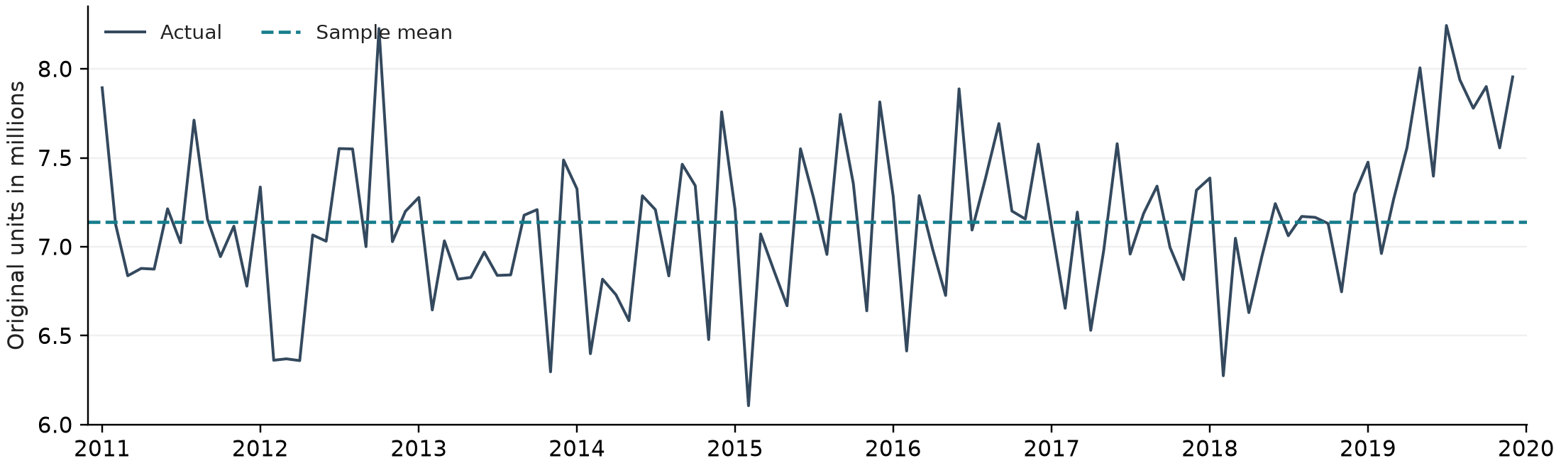
Table 3 Direct pre-break tests on the original observations
Test and deterministic terms | Statistic | p-value | Lag or bandwidth | 5% decision
ADF  Constant | -0.2943 | 0.9263 | 12 | Do not reject unit root
KPSS  Constant | 0.5138 | 0.0385 | 3 | Reject stationarity
ADF  Constant and trend | -1.0398 | 0.9385 | 12 | Do not reject unit root
KPSS  Constant and trend | 0.1298 | 0.0800 | 3 | Do not reject trend stationarity
Both ADF specifications use maximum lag 12 and AIC selection, which selects 12; each uses 95 effective observations. KPSS automatic bandwidth selection gives 3 in both specifications.
For stationarity around a constant, ADF fails to reject the unit root (p = 0.9263) and KPSS rejects stationarity (p = 0.0385). Taken together, these tests do not support level stationarity of the unadjusted pre-break series at 5%.
With a linear trend, ADF still fails to reject a unit root (p = 0.9385), while KPSS does not reject trend stationarity at 5% (p = 0.0800). This combination is inconclusive; it is not affirmative evidence of trend stationarity. A visually flat series or an insignificant trend coefficient would not, by itself, settle the integration question.

