Noncomp Efficiency Ratio
Model Development Documentation
22 October 2026

1 Executive Summary

1.1 Model Overview
The Noncomp Efficiency Ratio (EF) Model provides quarterly projections of operating costs relative to income under alternative macroeconomic scenarios. EF is expressed as a decimal ratio. The selected specification is an autoregressive distributed lag model estimated in ratio levels. It combines lagged EF (the ratio observed one quarter earlier), lagged unemployment changes (quarterly unemployment-rate changes observed one quarter earlier, in percentage points) and a post-TARP period indicator (zero before 2014Q1 and one afterward). This document records the conceptual basis, estimation decisions, development data, performance assessment and operating controls for the model.

1.2 Business Purpose
EF expresses operating costs relative to income. A higher ratio indicates greater cost per unit of income and therefore weaker operating efficiency, holding the accounting definition constant. Projecting EF supports expense and profitability planning and provides a consistent measure for comparing baseline and stressed economic conditions.

1.3 Intended Uses
Model outputs support quarterly planning, stress testing and comparison of operating efficiency under alternative macroeconomic scenarios. The current implementation produces quarterly ratio forecasts. Any downstream conversion to expense dollars requires a separately supplied income forecast with a compatible accounting definition.

1.4 Development Summary
Development began with 60 quarterly EF observations and 22 macroeconomic candidates spanning 2011Q1 through 2025Q4. Two observations in 2017 were smoothed using documented local averages. A level-and-trend break analysis characterized the historical transition around 2014Q1. Macro selection then began with a dynamic equation containing a linear trend. The trend coefficient had p > 0.05; it was removed and the retained equation was re-estimated on the same development sample.

1.5 Final Model Structure
Table 1.1 Final model variable summary
Variable | Description | Construction
Lagged EF | Smoothed efficiency ratio observed one quarter earlier | EF(t−1)
FLBR_B.IUSA  U.S. unemployment rate | Lagged quarterly unemployment-rate change, in percentage points | FLBR_B.IUSA(t−1) − FLBR_B.IUSA(t−2)
D  Post-TARP period indicator | Adjustment for the historical post-TARP period | 0 through 2013Q4; 1 from 2014Q1
Table 1.1 summarizes the three explanatory terms retained with a constant in the final equation. Together they represent EF persistence, lagged labor-market conditions and the historical period adjustment. Future forecasts use this structure re-estimated through 2025Q4; out-of-time performance uses coefficients fixed at the 2023Q3 development cutoff.

1.6 Performance and Out of Time Results
Table 1.2 Key performance measures
Measure | Development model | Full-history refit
Estimation period | 2011Q3–2023Q3 | 2011Q3–2025Q4
Observations | 49 | 58
Adjusted R² | 0.8265 | 0.8212
Fitted RMSE in EF percentage points | 2.833 | 2.822
Table 1.2 summarizes the development fit and the subsequent full-history refit. Their comparable fit supports carrying the selected structure into future scenario forecasting. Development estimates are used for the separate out-of-time assessment.
The development model improves on the corresponding persistence benchmarks under both one-step and recursive out-of-time evaluation over 2023Q4–2025Q4. Unemployment, output-gap (the percentage difference between actual and potential real GDP) and real GDP (inflation-adjusted gross domestic product) specifications have closely comparable adjusted R² values. Unemployment produces the lowest one-step error; GDP produces the lowest recursive error. The final choice combines these results with the direct economic interpretation of labor-market deterioration.

1.7 Scenario and Sensitivity Summary
S1 represents the Baseline scenario and S4 supplies the alternative higher-unemployment path. Nine-quarter forecasts cover 2026Q1–2028Q1. Both begin with the same EF forecast because the first quarter uses a common historical unemployment change. S4 subsequently produces higher EF as the scenario unemployment changes enter the equation. Parallel upward and downward shifts in unemployment produce symmetric forecast responses that decay over time.

1.8 Overlay Summary
No overlay has been implemented.

1.9 Key Assumptions
The specification assumes that EF reporting remains comparable, lagged EF continues to capture persistence and the positive relationship between unemployment changes and EF remains informative over the projection horizon.

1.10 Key Strengths
Its principal strengths are a transparent dynamic structure, a common sample for all 22 macro candidates, explicit trend assessment, traceable preprocessing and reproducible scenario calculations. The full-history unemployment coefficient remains close to its development estimate.

1.11 Limitations
The model forecasts an aggregate cost-to-income ratio. Separate expense and income projections are needed to attribute changes to specific business initiatives. Forecasts depend on the supplied macroeconomic paths and on continued comparability of EF reporting. The development and forecast-evaluation samples are finite, and the evaluation period informed specification selection. Challenger comparisons, forecast-error review and subsequent forecasting vintages provide the corresponding performance controls.

1.12 Governance and Ownership
The model is governed under applicable Model Risk Management standards and SR 26-2 guidance. Performance is subject to periodic review, monitoring, and validation. Material changes to methodology, assumptions, inputs, implementation, or intended use require review and approval through established governance processes.

1.13 Executive Conclusion
The final model combines lagged EF, lagged unemployment-rate changes and a post-TARP indicator in a transparent quarterly forecasting framework. The development sequence assesses the time trend explicitly and retains the re-estimated specification without that term. Historical fit, residual and stability diagnostics, out-of-time assessment and scenario testing support this model choice. Its economic interpretation and reproducible implementation provide a clear basis for planning and stress-test projections.

2 Model Theory and Design

2.1 Business Purpose and Conceptual Framework
The model links quarterly operating efficiency to its recent history and the economic environment. Cost and income components adjust at different speeds. Staffing, technology and servicing commitments can persist after customer activity or revenue conditions change. This adjustment pattern motivates a dynamic specification in which the previous quarter’s EF captures continuity in the operating cost base and income generation.

2.2 Business Context and Structural Transition
The historical series covers the early TARP-related period and subsequent operating conditions. The boundary beginning in 2014Q1 is treated as a fixed development assumption. A post-TARP indicator permits a shift in the conditional level of EF. The initial descriptive regression also allows the time slope to change at that boundary, enabling the early and later portions of the series to be examined separately.
The indicator summarizes a historical regime difference. Its coefficient may reflect several contemporaneous changes in the business and operating environment. The analysis therefore uses the boundary as a modeling convention and does not assign the entire estimated shift to a causal effect of TARP repayment.

2.3 Modeling Philosophy
Specification selection balances statistical evidence, economic interpretation and forecast behavior. All macro candidates are evaluated on the same calendar and under common transformation and entry rules. The initial dynamic equation includes a trend so that its incremental contribution can be assessed explicitly. The subsequent reduction removes the unsupported trend term while preserving the selected macroeconomic relationship and re-estimating all retained coefficients.

2.4 Rationale for Modeling EF in Levels
Ratio-level modeling preserves the quantity used in planning and allows each forecast to be carried directly into the next quarter. The level-and-trend break regression provides a preliminary description of deterministic movements. Residual ADF and KPSS diagnostics support the working representation of fluctuations around those fitted paths. The dynamic model is then assessed on its own conditional specification, residual behavior and forecasting performance.
The static break regression and the ARDL have different conditioning information. A significant trend in a regression without lagged EF does not require a significant additional time trend once lagged EF is present. Removal of the dynamic trend is based on its estimated contribution within the ARDL and the performance of the reduced equation. Ordinary residual diagnostics retain the inferential qualification described in Section 3.3.

2.5 Persistence and Macroeconomic Transmission
The autoregressive coefficient measures the persistence of EF after controlling for the period indicator and unemployment change. Its positive estimate indicates that a higher lagged EF raises the conditional next-quarter value. Because the coefficient is below one, the response to a temporary disturbance decays across successive quarters when the other inputs are held fixed.
Unemployment provides an interpretable measure of broad labor-market conditions. Deterioration can coincide with reduced customer activity and income pressure, while parts of the operating cost base adjust more slowly. A positive coefficient on lagged unemployment change is consistent with a higher cost-to-income ratio under those conditions. This interpretation describes an aggregate predictive association; separate expense and income equations would be required to identify the underlying channels.

2.6 Final Specification and Forecast Mechanics
In the equation below, t is the quarterly time index, starting at one in 2011Q1. U is the unemployment rate represented by FLBR_B.IUSA. Δ denotes a quarterly difference, so ΔU(t−1) = U(t−1) − U(t−2). The parameters c, δ, φ and λ are the intercept, post-TARP indicator coefficient, lagged-EF coefficient and lagged unemployment-change coefficient, respectively. The error ε(t) represents unexplained quarterly variation in EF.
$${EF}_{t} = c + δD_{t} + φ{EF}_{t−1} + λΔU_{t−1} + ε_{t}$$
Table 2.1 Specification definitions
Term | Definition | Expected behavior
EF(t) | Smoothed quarterly EF, in decimal ratio units | Forecast target
D(t) | Post-TARP indicator beginning in 2014Q1 | Conditional period adjustment
EF(t−1) | Lagged EF | Positive persistence below one
ΔU(t−1) | FLBR_B.IUSA(t−1) − FLBR_B.IUSA(t−2) | Positive effect on EF
ε(t) | Unexplained quarterly EF variation | Centered residual variation
Table 2.1 links each term in the forecasting equation to its definition and expected behavior. Lagged EF carries recent operating conditions forward, while lagged unemployment changes transmit the macroeconomic scenario into the forecast.
The macro input remains in percentage-point units, while EF remains in decimal ratio units. Recursive forecasts set future innovations to zero and use the preceding EF forecast as the next lagged dependent variable.

2.7 Alternative Macroeconomic Explanations
The output gap (FGAP_B.IUSA) and real GDP growth, calculated from FGDP$_B.IUSA, provide plausible activity-based explanations of efficiency. Their adjusted R² values are close to the unemployment specification, so in-sample fit alone offers little separation. Unemployment is retained for the main forecasting model because it combines competitive fit, the lowest one-step forecast error and a direct interpretation of deteriorating economic conditions. The GDP advantage under recursive evaluation remains part of the challenger evidence in Section 6.3.4.

2.8 Assumptions
Table 2.2 Assumptions inventory
Assumption
Historical and future EF ratios use comparable cost and income definitions.
Lagged EF remains informative, and the effects of temporary shocks decay over time.
Labor-market deterioration retains a positive conditional association with EF throughout the forecast horizon.
The post-2014 period remains an applicable reference regime for forecasting.
S1 and S4 unemployment paths have correct scenario labels, consistent units and aligned quarter-end dates.
A common set of linear coefficients provides an adequate approximation over the forecast horizon.
Table 2.2 states the assumptions used when applying the model. They provide a common basis for preparing inputs, interpreting scenario forecasts and reviewing whether the selected relationships remain applicable.

2.9 Limitations and Mitigants
The selected equation uses a small number of parameters relative to the available development observations. Inference is conditional on the fitted specification; the candidate-selection process is also considered through economic interpretation, challenger analysis and forecast evaluation. Subsequent forecasting vintages extend the evidence beyond the period used during development.
The documented smoothing affects EF and its subsequent lag. Original values are retained, and the adjustment is applied explicitly in code. Original-data sensitivity, leave-one-out analysis and influence statistics provide traceable checks of how preprocessing and individual observations affect the estimates.
Business initiatives, accounting changes and different expense or revenue dynamics can alter EF without a corresponding unemployment movement. Scenario forecasts are conditional on supplied paths and omit future innovations. They provide point projections rather than a complete probability distribution. These risks call for comparison with business plans, forecast-error monitoring and documented review of any proposed management adjustment.

2.10 Design Conclusion
The selected framework uses a limited number of economically interpretable terms and preserves a direct link between the historical regression and scenario projections. The design is supported by comparable challenger fit, residual diagnostics and forecast testing. Continued use should be accompanied by data, assumption and performance reviews.

3 Model Estimation

3.1 Overview of the Estimation Process
We first describe the historical level and trend. We then build a forecasting equation that includes lagged EF. We screen the macro candidates with a trend in place. After assessing the trend coefficient, we re-estimate the chosen equation. The final model then receives forecast and diagnostic testing.

3.2 Historical Level and Trend Break Analysis
The first regression allows the historical trend line to change in 2014Q1. It includes a time counter t, the period indicator D, and their interaction D × t. The counter starts at one in 2011Q1. It equals 13 in 2014Q1. The interaction D × t is zero before 2014Q1 and equals t afterward. In this regression, α is the prebreak intercept, θ is the difference between the postbreak and prebreak intercepts, β is the prebreak slope, γ is the slope change, and u(t) is the residual.
$${EF}_{t} = α + θD_{t} + βt + γD_{t} × t + u_{t}$$
Table 3.1 Full-history level and trend estimates
Term | Coefficient | Std error | t statistic | p value
Constant α | 0.603727 | 0.019710 | 30.630 | 1.143e-36
Intercept difference θ | 0.066791 | 0.023626 | 2.827 | 0.0065
Prebreak slope β | 0.014080 | 0.002678 | 5.258 | 2.364e-06
Slope change γ | −0.016607 | 0.002699 | −6.154 | 8.542e-08
Table 3.1 reports the level-and-trend break regression fitted to all 60 smoothed quarters. The level difference, prebreak trend and slope-change coefficients have p < 0.05. These estimates describe a change in the historical fitted path at the selected boundary.
Figure 3.1 Smoothed EF and the fitted historical trend
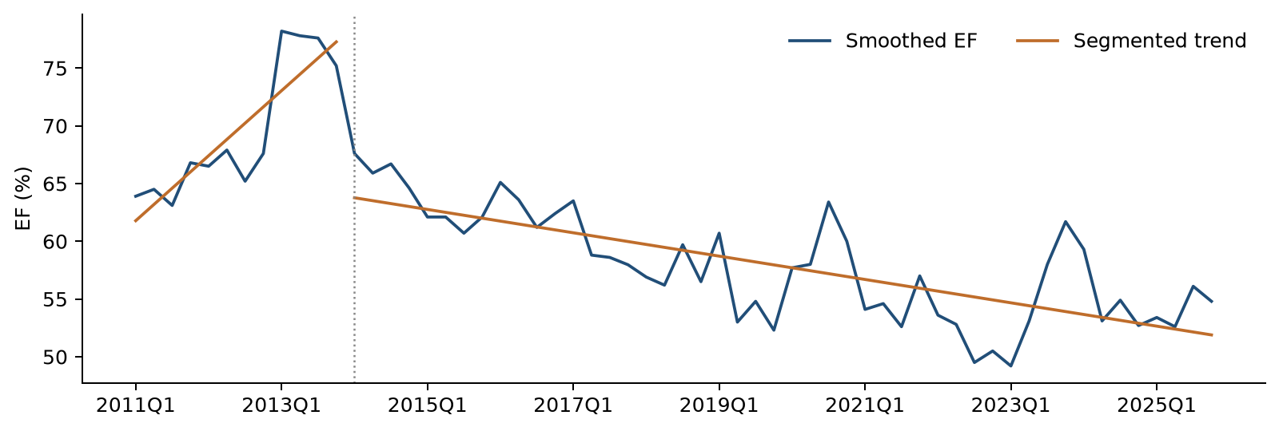
The fitted line rises before 2014Q1 and declines afterward. Separate lines allow the historical level and direction to change at the selected boundary.
The fitted slope is positive before 2014Q1 and negative afterward. These historical paths provide the starting description of EF behavior. The forecasting equation then adds lagged EF to capture adjustment over time.

3.3 Residual Stationarity Assessment
ADF and KPSS diagnostics assess the residual process after fitting the level-and-trend break regression.
ADF evaluates a unit-root null, while KPSS evaluates a stationarity null. The reported ADF p values are below 0.05 and KPSS does not reject stationarity. Taken together, the results support the working representation of EF around fitted level-and-slope breaks.
Table 3.2 Residual stationarity checks
Sample | Check | Statistic | p value
Through 2023Q3 | ADF | −5.2240 | < 0.0001
Through 2023Q3 | KPSS | 0.0446 | > 0.10
Through 2025Q4 | ADF | −4.7569 | < 0.0001
Through 2025Q4 | KPSS | 0.1044 | > 0.10
Table 3.2 reports complementary residual diagnostics for the development and full-history periods. ADF has p < 0.05 and KPSS has p > 0.05 in each sample, supporting stationary fluctuations around the fitted level-and-trend break paths.
These results are supporting residual diagnostics using ordinary test reference distributions. Formal inference that incorporates estimation of the break regression requires break-adjusted calibration.

3.4 Candidate Universe and Data Transformations
The candidate pool contains 22 macro series. Six use quarter-to-quarter log changes, which measure relative movement. The other 16 use changes in their original units. Every change is lagged one quarter. This gives every candidate the same 49 development observations from 2011Q3 through 2023Q3.

3.5 Forward Selection Framework
Forward selection adds one macro at a time. Each remaining candidate is fitted alongside the variables already in the equation. The starting equation contains a constant, D, t and lagged EF. A candidate must pass all four checks below.
Table 3.3 Entry rules used in each selection round
Check | Rule | What it checks
Coefficient p value | Below 0.05 | Evidence that the added macro contributes to the fitted equation
VIF | Below 10 | Multicollinearity among explanatory variables
Durbin–Watson | 1.5 to 2.5 | Serial-dependence screening convention
Jarque–Bera p value | Above 0.05 | Residual normality screening based on skewness and kurtosis
Table 3.3 applies a common entry standard to every candidate. Among eligible candidates, the lowest coefficient p-value wins. Ties use higher adjusted R² and then the fixed source-column order. Information criteria are recorded for comparison; they do not determine entry or rank candidates in this selection process.
The search stops when all remaining candidates fail at least one rule.

3.6 ARDL with Trend and Subsequent Reestimation
The development sequence starts with a constant, the post-TARP indicator, a linear time trend and lagged EF. Each of the 22 transformed and one-quarter-lagged macro candidates is tested on the same 49 development quarters under the entry rules in Section 3.5. FLBR_B.IUSA enters first with p < 0.05. After unemployment enters, the strongest remaining addition has p > 0.05, so the search retains one macroeconomic variable.
Table 3.4 Model Variable Definitions
Variable Name | Economic Interpretation
EF(t) | Smoothed quarterly efficiency ratio, measuring operating costs relative to income.
EF(t−1)  Lagged EF | Efficiency ratio observed one quarter earlier; captures persistence in operating efficiency.
D(t) | Post-TARP period indicator; zero through 2013Q4 and one from 2014Q1.
t | Quarterly time index beginning at one in 2011Q1; tests an additional deterministic time trend in the initial ARDL.
ΔFLBR_B.IUSA(t−1) | Lagged quarterly change in the U.S. unemployment rate, measured in percentage points; the retained macroeconomic driver.
ΔFGAP_B.IUSA(t−1) | Lagged quarterly change in the output gap, measured in percentage points; an economic-activity challenger.
Δln FGDP$_B.IUSA(t−1) | Lagged quarterly log change in real GDP; a broad-growth challenger.
Table 3.4 defines the dependent variable, the retained explanatory variables and the terms used in the trend and challenger assessments. The macro labels retain the original provider codes so that estimates can be traced directly to the inputs.
The selected trend-augmented equation is shown below. The coefficient b measures the additional linear time-trend contribution. Conventional OLS covariance and two-sided Student-t tests are used throughout.
$${EF}_{t} = c + δD_{t} + bt + φ{EF}_{t−1} + λΔU_{t−1} + ε_{t}$$
Table 3.5 Selected ARDL with a Trend
Term | Coefficient | p value
Constant | 0.271984 | 0.0010
Period indicator D | −0.034941 | 0.0206
Linear time trend t | −0.000807 | 0.1719
Lagged EF | 0.634474 | < 0.0001
Lagged ΔUnemployment | 0.006204 | 0.0330
Table 3.5 shows that the additional time trend has p > 0.05, while lagged unemployment change has p < 0.05. This result supports removing the trend and retaining the selected macroeconomic driver.

Trend Assessment and Specification Reduction
We remove the time trend and keep D, lagged EF and lagged ΔUnemployment. We then estimate all coefficients again on the same 49 quarters. A transition pulse is omitted throughout the ARDL analysis.
$${EF}_{t} = c + δD_{t} + φ{EF}_{t−1} + λΔU_{t−1} + ε_{t}$$
Table 3.6 Final Development Model
Term | Coefficient | p value
Constant | 0.193795 | 0.0008
Period indicator D | −0.043633 | 0.0020
Lagged EF | 0.738292 | < 0.0001
Lagged ΔUnemployment | 0.006417 | 0.0289
Table 3.6 reports the re-estimated equation after trend removal. All retained coefficients have p < 0.05. The lagged-EF coefficient is positive and below one, and the lagged unemployment-change coefficient is positive. All coefficients are re-estimated in the restricted specification. Appendix C provides the corresponding standard errors and t-statistics for each estimation stage. Taken together, these results support choosing the specification without a linear time trend as the final model.
For the remainder of this document, the final model refers to the ARDL specification without a linear time trend.

3.7 Challenger Comparison and Final Specification Selection
Table 3.7 Three No-Trend Alternatives
Candidate | Coefficient | p-value | Adjusted R² | BIC | Validation RMSE
FLBR_B.IUSA  Unemployment rate  Lagged quarterly change | 0.006417 | 0.0289 | 0.826462 | -194.638 | 0.02783
FGAP_B.IUSA  Output gap  Lagged quarterly change | -0.006066 | 0.0267 | 0.826998 | -194.790 | 0.02906
FGDP$_B.IUSA  Real GDP  Lagged quarterly log change | -0.575334 | 0.0277 | 0.826748 | -194.719 | 0.02878
Table 3.7 compares the three no-trend equations on the same 49 development quarters. Their historical fit is very close. Unemployment has the lowest one-step validation error. Validation RMSE is the one-step OOT RMSE in EF ratio units.
The similar adjusted R² values support consideration of forecast behavior and economic interpretation when selecting the main macroeconomic driver. The comparison uses the same target variable, estimation calendar and forecast window for each alternative.
We retain unemployment because its fit is comparable, its one-step error is lowest, and its economic meaning is direct. The complete screening records remain available.
After unemployment is retained in the no-trend model, the strongest remaining addition has a p-value greater than 0.05. The final equation therefore keeps one macroeconomic variable.

3.8 Full History Reestimation and Coefficient Interpretation
After development testing, we keep the chosen variables and re-estimate their weights using all 58 usable quarters through 2025Q4. These updated weights drive the S1 and S4 forecasts. Historical forecast-error scores continue to use the earlier development weights.
Table 3.8 Full-History Coefficients for Future Forecasting
Term | Coefficient | p value
Constant | 0.194684 | 0.0003
Period indicator D | −0.045338 | 0.0010
Lagged EF | 0.736985 | < 0.0001
Lagged ΔUnemployment | 0.006314 | 0.0288
Table 3.8 reports the full-history estimates used for the future scenario forecasts. All retained terms have p < 0.05, and their signs remain consistent with the development estimates. The unemployment coefficient remains positive and close to its development estimate.
$${EF}_{t} = 0.194684 − 0.045338D_{t} + 0.736985{EF}_{t−1} + 0.006314ΔU_{t−1} + ε_{t}$$
The numerical equation above applies the full-history coefficients to the same final specification. A larger lagged unemployment increase raises the conditional EF forecast, and lagged EF carries that effect into subsequent quarters with gradual decay.

3.9 Estimation Conclusion
Forward selection identifies unemployment as the macroeconomic driver in the trend-augmented equation. The additional trend has p > 0.05, and re-estimation without it retains significant coefficients and the expected signs. Challenger comparisons support unemployment through its comparable historical fit, lower one-step validation error and direct economic interpretation. The final specification therefore retains a constant, the post-TARP indicator, lagged EF and lagged unemployment change. The full-history refit supplies the coefficients for forward scenario analysis.

4 Model Development Data

4.1 Purpose and Scope of Development Data
The development dataset links a single quarterly EF series to a common history of potential macroeconomic drivers. The data architecture preserves original inputs, records each transformation and distinguishes historical estimation from future scenario assumptions. All available quarters within the specified calendar are retained after the documented 2017 adjustment; no random sampling is applied.

4.2 Development Sample
The historical files contain 60 quarters from 31 March 2011 through 31 December 2025. The development cutoff is 2023Q3, followed by a nine-quarter out-of-time period. Differencing the macro input and then applying a one-quarter lag makes 2011Q3 the first common ARDL observation.
Table 4.1 Sample construction
Analysis | Period | Observations
Full-history static break regression | 2011Q1–2025Q4 | 60
Development static break regression | 2011Q1–2023Q3 | 51
ARDL selection and development estimation | 2011Q3–2023Q3 | 49
Out-of-time forecast assessment | 2023Q4–2025Q4 | 9
Fixed-specification full-history refit | 2011Q3–2025Q4 | 58
Table 4.1 separates the historical analysis, development estimation, out-of-time evaluation and full-history refit. Each sample follows the same quarterly calendar, with the first usable ARDL date determined by the lagged macro transformation.

4.3 Quarterly Frequency Selection
Quarterly frequency aligns the EF observations and macroeconomic inputs and is consistent with the quarterly frequency used by the Compensation Model. This common timing supports coordinated forecasting and comparison across the two modeling components.

4.4 Internal EF Data
The file inputs/ef.csv contains Quarter (the quarter-end date) and EF in decimal ratio units. The model uses the supplied accounting ratio, with the documented 2017 smoothing applied in code.

4.5 External Macro and Scenario Data
The file inputs/macro.csv contains the same quarter-end calendar and 22 original provider-coded columns. The universe covers labor conditions, output, income and compensation, rates, credit conditions and sentiment. All candidates begin in 2011Q1. Appendix A records the descriptions, units and transformations for every source code.
The separate files scenarios/S1.csv and scenarios/S4.csv contain nine future FLBR_B.IUSA unemployment levels, expressed in percent. S1 is the Baseline path. Scenario observations remain outside the historical inputs and cannot enter estimation. The code joins them to the historical unemployment anchors only when constructing future lagged changes.

4.6 Data Lineage and Preparation
Table 4.2 External Data Inventory
Economic Theme | Representative Variables | Business Purpose
Labor market | FLBR_B.IUSA  U.S. unemployment rate | Capture labor-market conditions associated with operating efficiency.
Economic activity | FGDP$_B.IUSA — Real GDP  FGAP_B.IUSA — Output gap | Measure broad growth and the position of the economy relative to potential output.
Compensation and income | Average hourly earnings; unit labor costs; Employment Cost Index; finance and insurance wages; per capita income | Represent labor-cost and income conditions relevant to cost and revenue adjustment.
Interest rates | Federal funds rate; two-year and ten-year Treasury rates | Describe the interest-rate environment affecting banking income and activity.
Banking activity | Commercial-bank total assets; loans and leases | Measure the scale of banking-sector activity.
Confidence and financial conditions | Consumer confidence; small-business optimism; equity-market volatility; high-yield bond spread | Capture sentiment, uncertainty and credit conditions.
Future scenarios | S1 and S4 paths for FLBR_B.IUSA | Provide separate baseline and alternative unemployment assumptions for recursive EF forecasts.
Table 4.2 groups the external inputs by economic theme and explains their business purpose. The historical pool supports candidate screening, while the separate S1 and S4 files supply forward unemployment paths.
Table 4.3 Data Lineage Diagram
Final Variable | Source Files | Description | Transformation Steps | Final Formula | Model Role
EF(t) | inputs/ef.csv | Quarterly efficiency ratio | Replace the two 2017 values with original-data local averages (Table 4.5). | Smoothed EF(t) | Dependent variable
EF(t−1) | inputs/ef.csv | Lagged smoothed EF | Smooth EF, then lag one quarter. | EF(t−1) | EF persistence
D(t) | Quarter in historical inputs | Post-TARP indicator | Set the indicator from quarter-end dates. | 0 before 2014Q1; 1 thereafter | Period adjustment
ΔU(t−1)  FLBR_B.IUSA | inputs/macro.csv | Lagged unemployment-rate change | Difference U, then lag one quarter. | U(t−1) − U(t−2) | Retained macro driver
Scenario ΔU(t−1)  FLBR_B.IUSA | scenarios/S1.csv; scenarios/S4.csv; inputs/macro.csv | Scenario unemployment-rate change | Join each scenario to historical U; difference and lag separately. | U(t−1) − U(t−2) | Recursive forecast input
Table 4.3 traces the final-model variables from source files through their transformations to their role in estimation or forecasting. The macro lineage is limited to the retained unemployment driver; the full candidate dictionary appears in Appendix A.
The preparation sequence is deterministic. The program validates schemas and dates, retains the original EF values, calculates smoothing, aligns the macro history, constructs transformations and then forms the common estimation samples. All six log-change series must have positive source values. Transformations are calculated from the complete quarterly calendar.

4.7 Data Preparation Process

4.8 Data Quality Review
Table 4.4 Data Quality Review Results
Review Area | Assessment Performed | Result
Completeness | Reviewed data availability across all development periods. | No missing EF or macro observations on the required historical calendar.
Consistency | Checked source schemas, numerical values, units and duplicate dates. | Inputs satisfy the documented schema, unit and uniqueness checks.
Time-Series Alignment | Verified internal and external datasets were aligned to a common quarterly timeline. | Historical variables are aligned; scenario dates follow the specified forecast calendar.
Trend Reasonableness | Reviewed historical EF movements and identified unusual local observations. | The two 2017 observations receive the documented local-average adjustments.
Data Preparation Review | Reviewed the smoothing formulas, macro transformations and lag alignment; checked original input preservation. | Calculated features follow the stated formulas and quarterly alignment; source inputs remain unchanged.
Outlier Review | Reviewed the documented 2017 EF adjustments and retention of other historical quarters. | Both affected quarters remain in the sample after smoothing; other EF observations are unchanged.
Table 4.4 summarizes the completed data checks and their outcomes. Completeness, calendar alignment, explicit transformations and source preservation support consistent construction of the model inputs.

4.9 Missing Data Review and Inclusion or Exclusion Decisions
The supplied historical EF and macro files contain no missing observations on the required quarterly calendar. No additional quarter is excluded for missing data or outlier treatment. Both adjusted 2017 observations remain in the estimation history.
The sample loses two initial observations because the lagged macro change requires two historical levels. This is a transformation requirement rather than a missing-data adjustment. The first two EF values remain available as historical anchors. No additional quarter is removed from the smoothed development or full-history ARDL sample.

4.10 Outliers Assessment and Adjustment Process
Two sharp EF movements in 2017 are treated as potential local outliers. The selected development series replaces each point with a three-quarter average based exclusively on original values. This reduces the local discontinuity while preserving both observations and their calendar positions.
Table 4.5 Documented EF Smoothing
Quarter | Original EF | Original observations averaged | Adjusted EF
2017Q3 | 0.508 | 2017Q2, 2017Q3, 2017Q4 | 0.586000
2017Q4 | 0.662 | 2017Q3, 2017Q4, 2018Q1 | 0.579667
Both replacements use the original series values. The adjusted 2017Q3 value is not used in the 2017Q4 average. Table 4.5 records each original value, the neighboring quarters used and the resulting adjusted value. The calculation is applied in code, leaving the input file unchanged. These centered historical averages precede the out-of-time evaluation. All other EF observations, including the pandemic period, remain unchanged.

4.11 Data Relevance and Sufficiency
The dataset is considered relevant because the target variable and primary explanatory drivers originate directly from the business process being modeled. The sample is also considered sufficient because it spans multiple economic cycles and includes materially different interest-rate, liquidity, and operating environments. The inclusion of both benign and stressed periods enhances confidence that estimated relationships represent persistent patterns rather than isolated events.

4.12 External Data Appropriateness
The external variables provide objective measures of economic conditions relevant to operating efficiency. Labor-market indicators describe employment conditions, output measures capture economic activity, compensation and income series describe cost and spending conditions, and financial variables characterize the banking environment. Candidates are assessed for statistical contribution, economic interpretation and forecast performance.
The retained unemployment series supplies a consistent historical driver and a directly corresponding scenario input. S1 and S4 use the same variable definition and units as the historical data. Their separate paths allow the model to translate alternative labor-market conditions into comparable EF forecasts. The common provider-coded history and explicit transformations support traceability and repeatable use.

4.13 Data Assumptions and Limitations
The development dataset is assumed to be complete, accurate and consistent throughout the observation period. Reporting definitions for EF are assumed to remain materially comparable over time. Provider-coded macroeconomic data are assumed to be reliable and representative of economic conditions relevant to EF. Historical observations, including the COVID-19 period and subsequent economic adjustment, remain in the estimation samples. The two documented 2017 EF observations are smoothed using local averages calculated from original values.
EF and the macroeconomic history summarize the observed operating and economic environment. Future business developments, service changes, pricing initiatives and management actions may introduce variation beyond those historical relationships. Challenger analysis, OOT testing and periodic review assess the continued relevance of the data and the documented smoothing assumptions.

4.14 Development Data Conclusion
The development dataset provides a complete quarterly history for the selected modeling period and covers different operating and economic conditions. Original inputs are preserved, the two EF adjustments are documented, and all features are calculated on a common calendar. Quality checks and reproducible transformation records support the dataset’s use for estimation, historical forecast assessment and scenario analysis.

5 Linkages with Other Models

6 Model Testing

6.1 Testing Framework
Model testing evaluates the statistical adequacy, stability, forecast accuracy and economic reasonableness of the Noncomp EF model. The framework separates development-sample results from out-of-time results, then assesses scenario behavior and sensitivity in distinct sections.
In-sample testing uses the 49 development quarters from 2011Q3 through 2023Q3. Out-of-time testing uses frozen development coefficients over 2023Q4–2025Q4. The full-history refit in Section 3.8 supplies the coefficients for forward S1 and S4 scenarios. Forecast-error tables identify their reporting units.

6.2 In-Sample Results

6.2.1 In-Sample Performance Assessment
Table 6.1 summarizes development-sample fit. The model captures the broad historical movement in EF, and the residual-error measures quantify the remaining quarterly variation on the common estimation sample.
Table 6.1 In-Sample Performance Metrics
Metric | Development
Observations | 49
R-squared | 0.8373
Adjusted R-squared | 0.8265
RMSE in EF ratio units | 0.02833
Residual standard error | 0.02956
These metrics use the final development equation with an intercept and three explanatory terms. Full-history re-estimation is documented separately in Section 3.8.
Figure 6.1 Actual versus Fitted Values
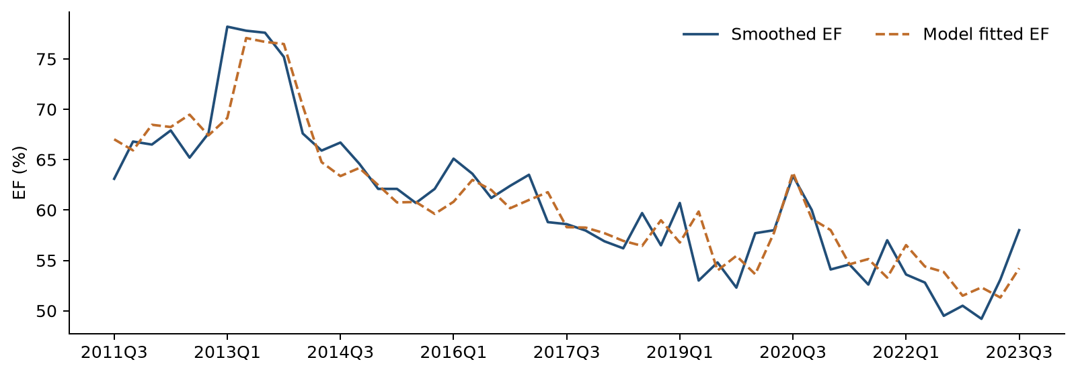
Smoothed actual EF and fitted EF over the development period. The fitted series uses observed lagged EF and the development coefficients.

6.2.2 Coefficient Significance Testing
The initial ARDL includes the post-TARP indicator, a linear trend, lagged EF and lagged unemployment change. The additional trend has p > 0.05 and is removed. The retained equation is re-estimated on the same development observations.
Table 6.2 shows that all retained coefficients have p < 0.05. The unemployment-change coefficient is positive, consistent with higher costs relative to income during weakening labor-market conditions. The lagged-EF coefficient is positive and below one, indicating persistence with a declining response to a temporary disturbance. The post-TARP indicator captures the conditional period difference at the fixed boundary.
Table 6.2 Development Coefficient Estimates
Variable | Coefficient | Std error | t statistic | p value | 95% CI
Intercept | 0.193795 | 0.053801 | 3.602 | 0.0008 | [0.085434, 0.302155]
D | −0.043633 | 0.013267 | −3.289 | 0.0020 | [−0.070354, −0.016912]
Lagged EF | 0.738292 | 0.076265 | 9.681 | < 0.0001 | [0.584685, 0.891898]
Lagged ΔUnemployment | 0.006417 | 0.002844 | 2.257 | 0.0289 | [0.000689, 0.012144]
Standard errors, two-sided Student-t p-values and confidence intervals use conventional OLS covariance. The estimates refer to the selected final development specification.

6.2.3 Multicollinearity Assessment
Table 6.3 reports variance inflation factors for the development equation. All values are well below the screening limit of 10, supporting limited multicollinearity among the retained explanatory variables.
Table 6.3 Variance Inflation Factors
Variable | Development
D | 1.6032
Lagged EF | 1.6114
Lagged ΔUnemployment | 1.0065
The intercept is excluded from the VIF assessment.

6.2.4 Residual Diagnostics
Table 6.4 assesses serial dependence and residual distributional shape. Ljung–Box tests at four and eight quarterly lags and the Jarque–Bera test have p > 0.05. These results support the residual properties assessed for the final development model.
Table 6.4 Residual Diagnostic Statistics
Diagnostic | Development statistic | Development p
Ljung Box 4 | 5.2946 | 0.1515
Ljung Box 8 | 9.0562 | 0.2486
Jarque Bera | 2.5865 | 0.2744
Durbin Watson | 2.1954 | —
Ljung–Box reference degrees of freedom allow for one fitted autoregressive term. The Durbin–Watson statistic lies within the development screening range. Because lagged EF is an explanatory variable, DW is used as a descriptive measure, with Ljung–Box providing the reported serial-dependence tests.
Figure 6.2 Residuals over Time
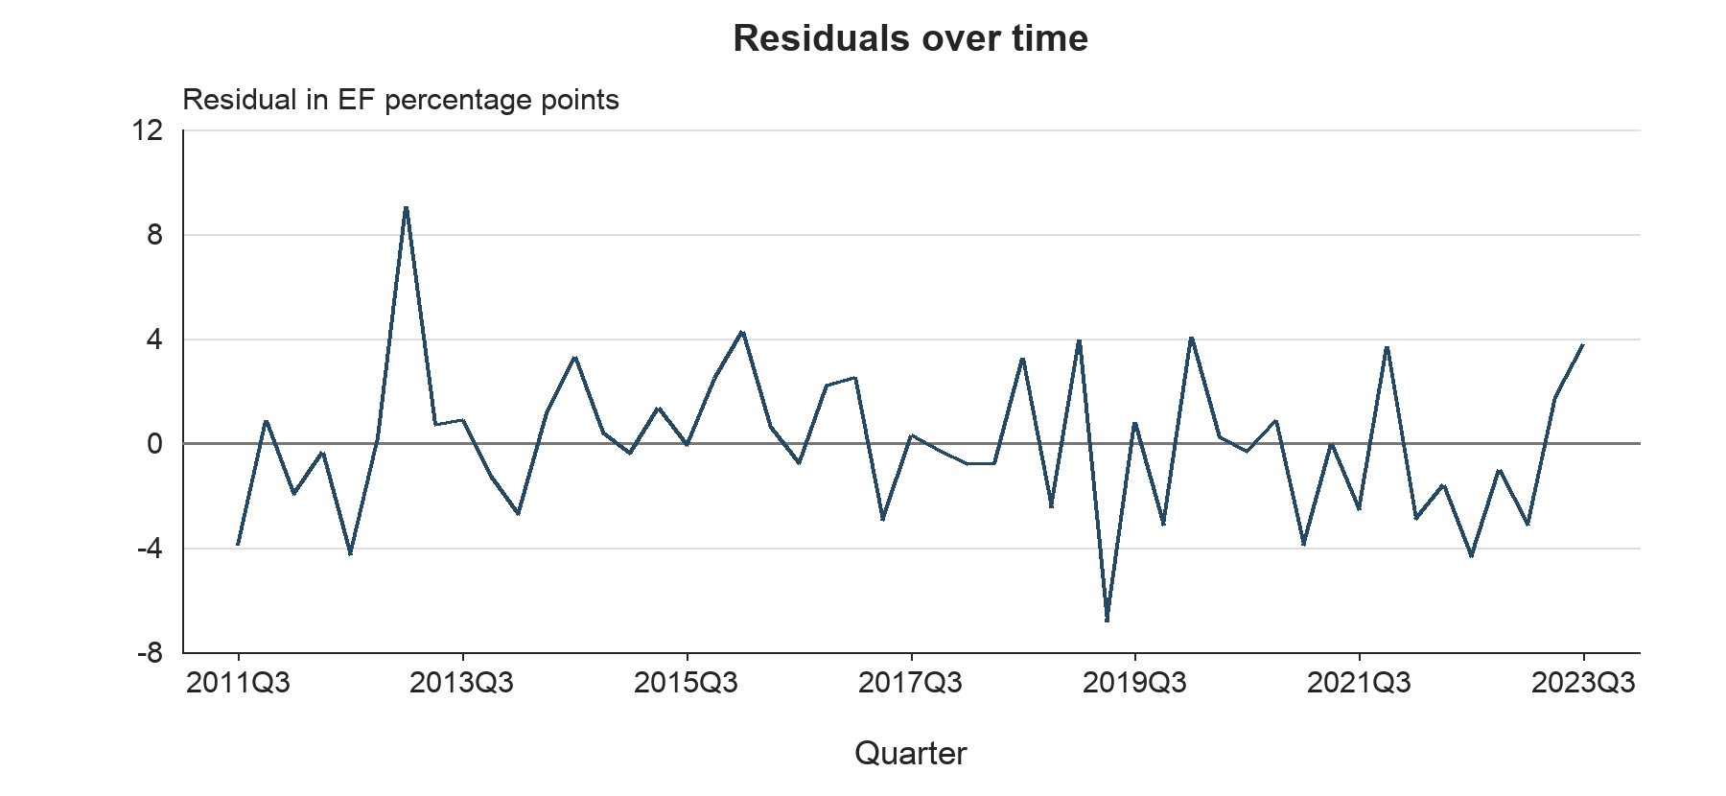
Figure 6.2 shows development residuals fluctuating on both sides of zero without a sustained upward or downward trend. Ljung–Box tests have p > 0.05 and provide supporting evidence on serial dependence.
Figure 6.3 Residuals versus Fitted EF
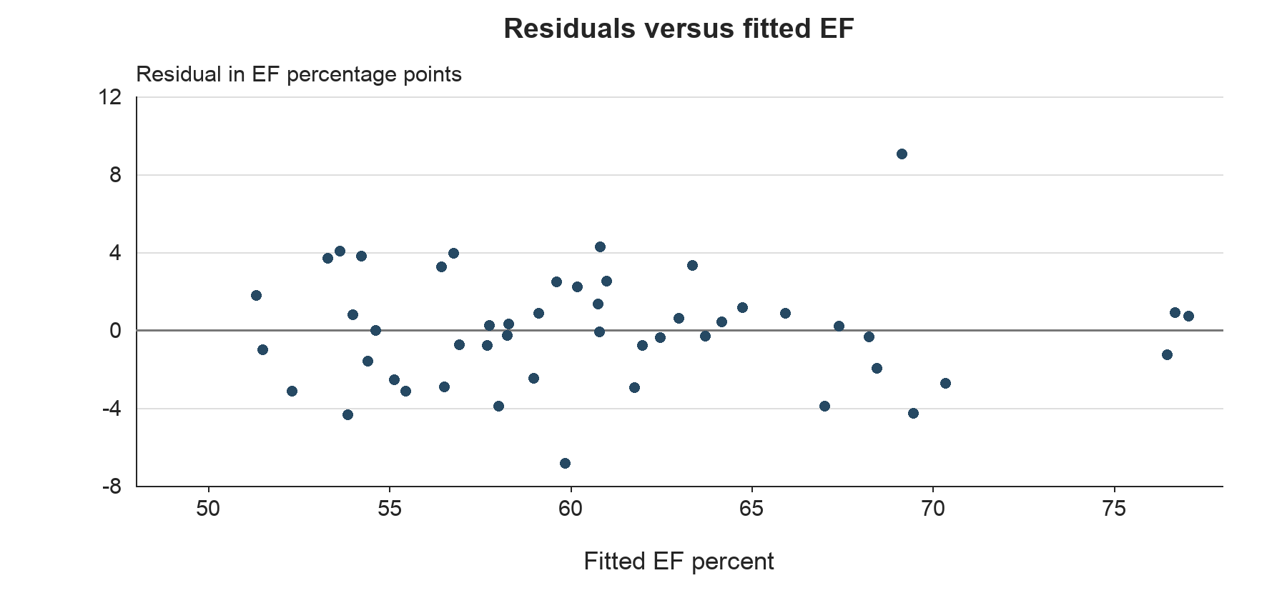
Figure 6.3 shows residuals dispersed around zero across the fitted EF range, without a pronounced curved pattern. This pattern supports the linear conditional specification used for forecasting.
Figure 6.4 Normal Q–Q Plot
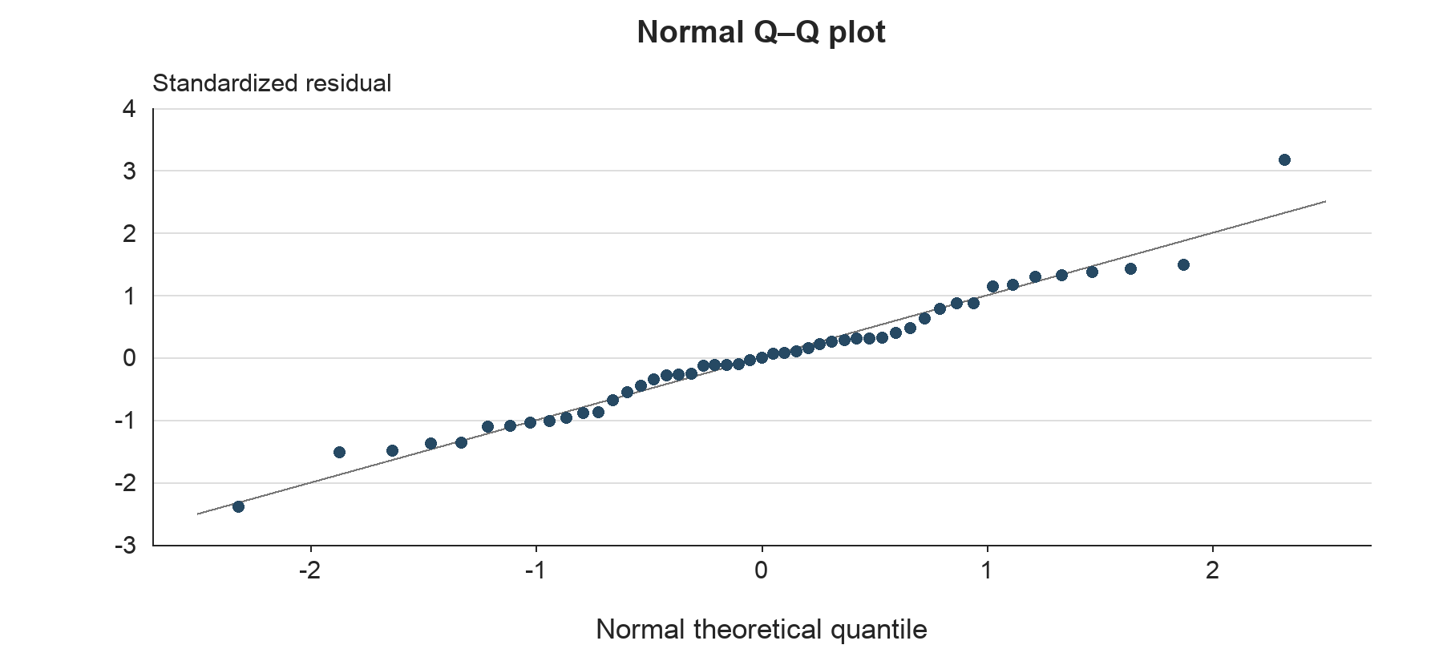
Figure 6.4 shows most standardized residuals close to the normal reference line. The Jarque–Bera test has p > 0.05, providing complementary support for the assessed residual distribution.

6.2.5 Evaluation of Statistical Assumptions
The statistical assessment combines time-series behavior, collinearity, serial dependence, residual distribution and dynamic persistence. Table 6.5 brings these findings together for the final development equation.
Table 6.5 Statistical Assumption Assessment
Assessment area | Evidence | Interpretation
Time-series behavior | Final development residual ADF p < 0.0001 and KPSS p > 0.10 | Supportive residual diagnostics
Multicollinearity | Maximum nonconstant VIF of 1.6114 | Limited shared information
Serial dependence | Ljung-Box p > 0.05 at lags 4 and 8 | No rejection at 5%
Residual normality | JB p = 0.2744 | No rejection at 5%
Dynamic persistence | Lagged EF coefficient of 0.7383 | Temporary effects decay
Economic interpretation | Positive coefficient on lagged unemployment change | Consistent with cost-to-income pressure
The reported diagnostics support the assessed specification. Conventional OLS inference assumes an appropriate conditional mean and error process. The preliminary break-regression residual diagnostics are interpreted as described in Section 3.3.

6.2.6 Stability Assessment
Stability assessment examines whether cumulative development residuals indicate a change in the fitted relationship. Table 6.6 reports the OLS-residual CUSUM result.
Table 6.6 CUSUM Stability Results
Sample | CUSUM statistic | p value
Development | 0.7016 | 0.7086
CUSUM has p > 0.05 and does not reject stability over the development sample. This result supports the retained specification alongside the residual and forecast evidence.
A sequential rolling-window re-estimation is reserved for subsequent monitoring. The completed historical forecasting assessment below keeps the development coefficients fixed and evaluates one-step and recursive predictions.

6.3 Out-of-Time Results

6.3.1 Out-of-Time Testing Framework
Out-of-time testing uses 2023Q4 through 2025Q4. Coefficients are frozen at their development estimates through 2023Q3. One-step forecasts use the actual EF from the preceding quarter. Recursive forecasts begin with actual 2023Q3 EF and then substitute the previous forecast into the lagged-EF term. The first-quarter predictions are identical under the two methods.
Both forecast methods use realized historical macro inputs. The scores therefore evaluate EF forecasts conditional on the observed macro path. The nine-quarter period is the development validation window used during specification review. Full-history coefficients are used separately for future S1 and S4 projections.

6.3.2 Forecast Performance and Interpretation
Table 6.7 reports the final model’s out-of-time forecast errors. One-step forecasts achieve lower RMSE and MAE than the recursive forecasts, demonstrating the benefit of updating lagged EF as new observations become available. Both methods improve on their corresponding persistence benchmarks.
Table 6.7 OOT Forecast Performance
Forecast method | RMSE in EF pp | MAE in EF pp | Mean error in EF pp
Final ARDL one step | 2.783 | 2.304 | −0.837
Final ARDL recursive | 3.728 | 3.481 | −2.319
Error is actual EF minus forecast EF. Negative mean errors indicate average overprediction. Persistence uses the previous actual EF for one-step forecasts and fixed 2023Q3 EF for recursive forecasts.
Figure 6.5 Out-of-Time Actual and Forecast EF
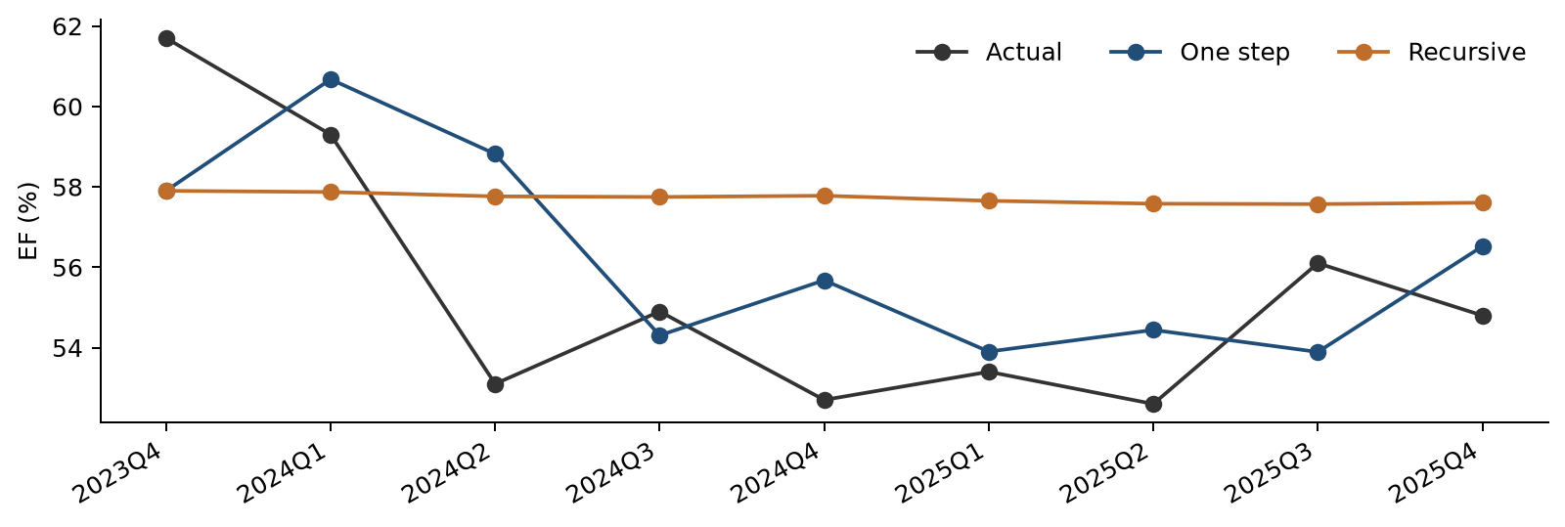
Quarterly actual EF compared with frozen-coefficient one-step and recursive forecasts over the nine-quarter OOT period.
Figure 6.5 compares actual EF with both forecast paths. One-step predictions incorporate the latest observed EF and follow quarter-to-quarter movements more closely. The recursive path is smoother and exhibits average overprediction over this evaluation period, as reflected in the signed errors in Table 6.7.

6.3.3 Forecast Behavior and Root Cause Assessment
The difference between one-step and recursive performance is consistent with the model’s forecast mechanism. One-step forecasts incorporate each newly observed EF level. Recursive forecasts propagate the previous prediction, so an initial level discrepancy can persist through the lagged-EF coefficient. Small subsequent unemployment changes provide limited additional movement in the recursive path.
The historical error pattern provides a specific focus for forecast monitoring. Any attribution to pricing, expense management or accounting changes requires a review of the underlying income and expense components. The statistical results establish the observed forecast behavior; business review determines its operational explanation.

6.3.4 Benchmarking and Challenger Assessment
Published Federal Reserve PPNR methodology provides a reference for linking bank performance to macroeconomic conditions and recent performance measures. Its 2025 model descriptions include autoregressive and panel-regression specifications for revenue and expense ratios. The Noncomp EF specification follows this general approach of combining persistence with a macroeconomic driver. Quantitative comparisons below use models fitted to the same Noncomp data.
Source: Federal Reserve, 2025 Supervisory Stress Test Methodology, Descriptions of Supervisory Models, Pre-provision Net Revenue.
Table 6.8 compares the principal macro alternatives on the same development sample and OOT quarters. Their adjusted R² values are closely comparable. FLBR_B.IUSA produces the lowest one-step RMSE, while FGDP$_B.IUSA produces the lowest recursive RMSE.
Table 6.8 Internal Challenger Model Comparison
Macro | Adjusted R² | One-step RMSE | Recursive RMSE | Selection
FLBR_B.IUSA | 0.8265 | 0.02783 | 0.03728 | Selected
FGAP_B.IUSA | 0.8270 | 0.02906 | 0.03643 | Challenger
FGDP$_B.IUSA | 0.8267 | 0.02878 | 0.03501 | Challenger
RMSE values are in EF ratio units. Each model contains an intercept, D, lagged EF and one lagged transformed macro variable.
FLBR_B.IUSA is retained based on its comparable historical fit, lower one-step validation error and direct labor-market interpretation. The GDP and output-gap models remain useful challengers for monitoring multi-quarter forecasting performance.

6.4 Scenario Testing

6.4.1 Scenario Framework
Scenario testing uses the fixed final specification re-estimated through 2025Q4. S1 is the original Baseline unemployment path. S4 remains a separate unemployment path. Forecasts cover 2026Q1 through 2028Q1, begin with actual 2025Q4 EF, hold D at one and recursively use each predicted EF in the following quarter.
The macro input is the lagged quarterly percentage-point change in FLBR_B.IUSA. Both scenarios therefore produce the same EF forecast in 2026Q1 because that quarter uses the shared unemployment change from 2025Q3 to 2025Q4. Scenario-specific changes first affect EF in 2026Q2. The 2028Q1 unemployment input would enter EF in 2028Q2, beyond the displayed horizon.

6.4.2 Scenario Results and Reasonableness Assessment
Table 6.9 presents the unemployment assumptions and corresponding recursive EF projections. The two forecasts begin together because they use the same historical lagged unemployment change. S4 subsequently produces higher EF as its larger unemployment increases enter the model. Its EF path moderates later as unemployment changes become smaller and earlier effects decay.
Table 6.9 Scenario Inputs and Recursive EF Forecasts
Quarter | S1 FLBR_B.IUSA % | S4 FLBR_B.IUSA % | S1 EF % | S4 EF %
2026Q1 | 4.333 | 6.565 | 55.395 | 55.395
2026Q2 | 4.267 | 7.900 | 55.686 | 57.096
2026Q3 | 4.170 | 8.566 | 55.933 | 57.856
2026Q4 | 4.303 | 8.936 | 56.095 | 57.994
2027Q1 | 4.513 | 9.191 | 56.360 | 57.909
2027Q2 | 4.623 | 9.359 | 56.604 | 57.774
2027Q3 | 4.703 | 9.429 | 56.720 | 57.619
2027Q4 | 4.710 | 9.456 | 56.787 | 57.443
2028Q1 | 4.680 | 9.428 | 56.790 | 57.287
Figure 6.6 S1 and S4 Macro Paths and EF Forecasts
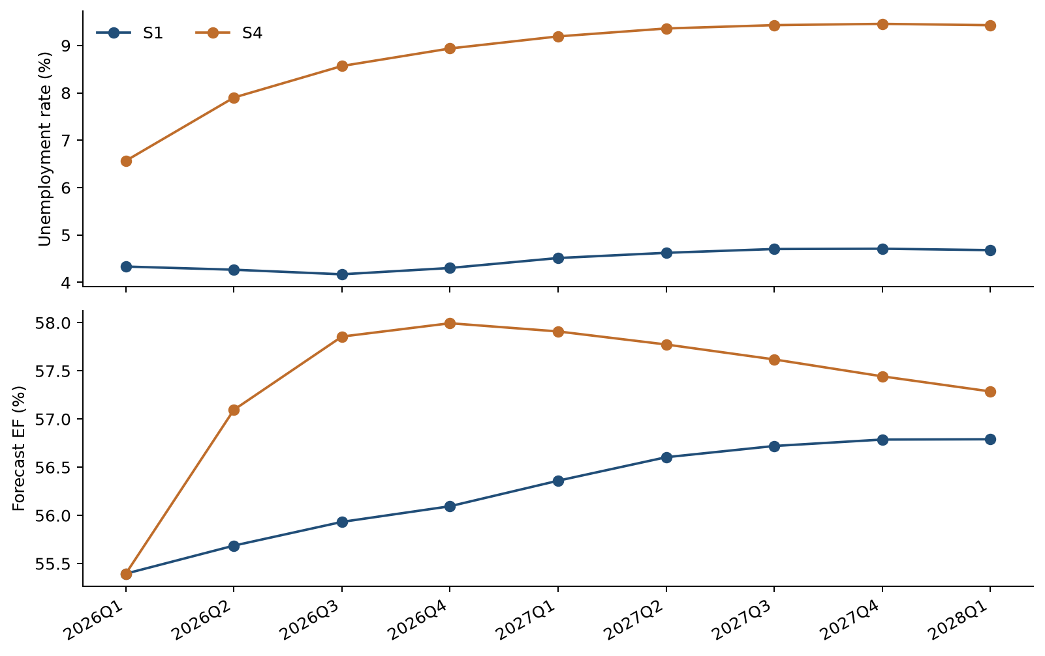
Figure 6.6 places the unemployment paths above the corresponding recursive EF forecasts. The timing of the separation follows the one-quarter macro lag. Higher EF represents greater costs relative to income and provides the expected direction of the stress response.
The paths remain within the historical EF range and exhibit bounded responses under the supplied scenarios. The positive unemployment coefficient gives an economically interpretable direction of stress. The later narrowing of the paths follows from using unemployment changes together with a lagged-EF coefficient below one. Scenario forecasts are conditional point estimates and carry no assigned scenario probabilities.

6.4.3 Overlay Summary
No management overlay is applied to the historical forecasts or the S1 and S4 projections. The outputs retain the estimated model response. Any proposed overlay would require a documented business rationale, separate calibration and approval.
If a recurring bias leads to a proposed overlay, its rationale should identify the relevant business development, quantify its expected EF impact and distinguish that adjustment from model re-estimation. Approval should specify the adjustment method, application period, monitoring criteria and conditions for withdrawal. Unadjusted model forecasts should remain available for comparison.

6.5 Sensitivity Analysis
Sensitivity testing applies a parallel increase or decrease of one percentage point to every future FLBR_B.IUSA level, separately for S1 and S4. Historical levels remain unchanged. Quarterly changes and their one-quarter lags are recalculated before the recursive forecasts are generated. This isolates the response to a higher or lower unemployment path while preserving the model coefficients and all other inputs.
Table 6.10 Sensitivity to a Parallel Unemployment Level Shift
Quarter | EF effect of +1 pp | EF effect of −1 pp
2026Q1 | 0.0000 | 0.0000
2026Q2 | 0.6314 | −0.6314
2026Q3 | 0.4653 | −0.4653
2026Q4 | 0.3429 | −0.3429
2028Q1 | 0.0746 | −0.0746
Table 6.10 reports the incremental EF effects in percentage points. Upward and downward unemployment shifts produce symmetric responses. The effects are identical around S1 and S4 because the forecasting equation is linear, and their gradual decay follows the lagged-EF coefficient.
Figure 6.7 Unemployment Path Sensitivity
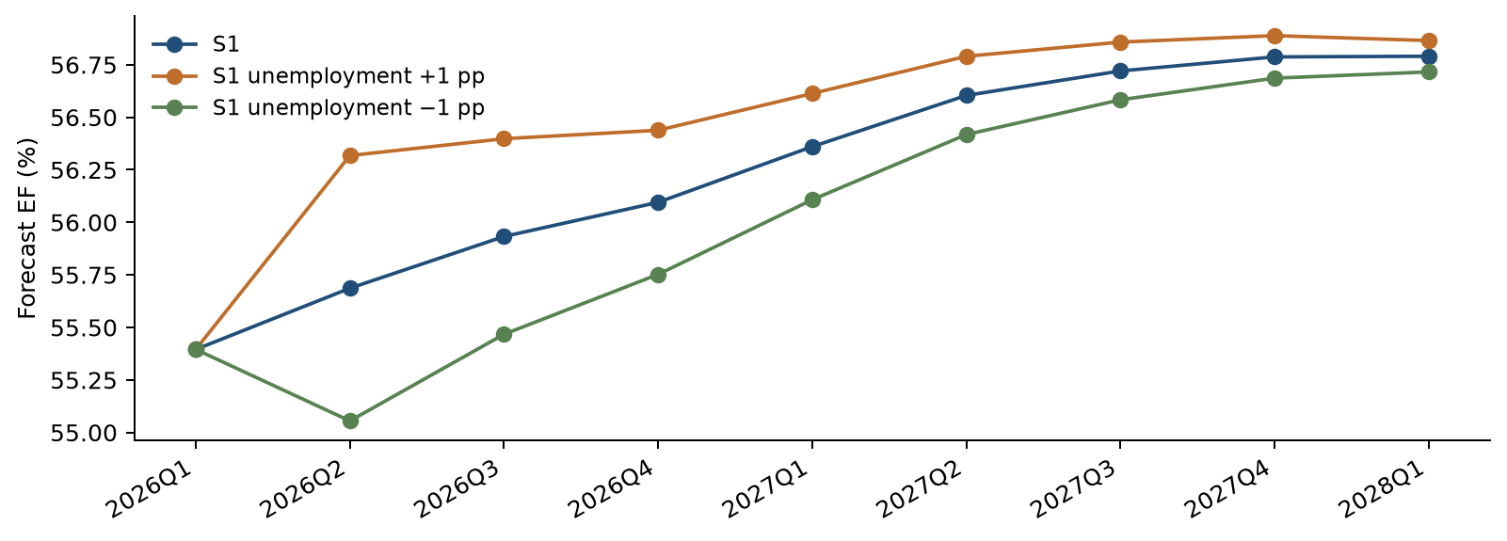
Figure 6.7 compares S1 forecasts under the original unemployment path and parallel upward and downward shifts. Separation begins after the one-quarter macro lag, then narrows as the initial change is carried forward through the autoregressive term.

6.6 User Review and Acceptance
User review addresses the model results, assumptions, forecast behavior and testing outcomes. The review focuses on the economic interpretation of the selected driver, consistency with observed operating performance, the treatment of the two 2017 observations and the distinction between one-step, recursive and scenario forecasts. S1 and S4 labels and input assumptions are included in this review.
The development workflow produces CSV records for estimation, diagnostics and forecasts. Formal production User Acceptance Testing (UAT) and business sign-off remain pending. Before production implementation, UAT will verify that the implemented model reproduces the approved development results, incorporates the required inputs, generates the expected outputs and follows the documented procedures and governance requirements.

6.7 Testing Conclusion
The testing results support the reduced ARDL as the final Noncomp EF forecasting specification. Development fit, coefficient significance, multicollinearity assessment, residual diagnostics and CUSUM provide consistent evidence for the assessed model properties. OOT testing evaluates the same fixed specification beyond the estimation period. Scenario and sensitivity results follow the expected economic direction and lag structure.
Unemployment combines comparable challenger fit with the lowest one-step validation error and a direct labor-market interpretation. The distinct OOT, scenario and sensitivity assessments provide a transparent basis for interpreting model forecasts and reviewing their performance over time.

7 Model Implementation

7.1 Implementation Platform and Calculation Flow
The implementation is a standalone Python package named Noncomp_EF_Code_and_Data_20261022. The main program is noncomp_ef_model.py. It reads the two historical CSV inputs and the separate scenario files. It then prepares the data, screens candidates, estimates the equations and writes the results to CSV.
The code calculates the two EF adjustments from the original input. It calculates each macro transformation and lag from the common quarterly history. Selection and the decision on the trend are recalculated each time the program runs.

7.2 Implementation Controls
Table 7.1 Controls in the current package
Control | Program behavior
Input schema | Checks the expected columns and quarter-end dates
Data completeness | Stops for missing, duplicate or nonnumeric observations
Data units | Checks EF ratio units and unemployment percent bounds
Log changes | Requires positive levels for the six log-change series
Output protection | Protects a nonempty result directory unless overwrite is requested
Scenario driver | Stops scenario forecasting if selection requires an unsupported macro
Traceability | Records source variable codes, calculation settings and labeled forecast outputs
Original inputs | Checks that input contents are unchanged during the run
Table 7.1 summarizes the controls embedded in the implementation. They check input structure, dates and units, protect source data and keep the calculation outputs traceable.
The current calendar is fixed at 2011Q1–2025Q4, with future scenarios through 2028Q1. Extending that calendar requires a reviewed code update.

7.3 Running the Model
Install the dependencies in requirements.txt, then run noncomp_ef_model.py. The program calculates the historical analysis and scenario forecasts directly from the supplied CSV inputs. Default paths are relative to the script, so it can also be launched from another working directory.
New calculations are written to results. The example_outputs folder contains calculated examples from the supplied data. The history-only option runs the historical analysis without reading scenario files. Input checks and output-directory protection are applied by the main program.

7.4 Forecast Output Identification
The primary scenario results use the full-history coefficient set. The package also exports development-coefficient scenario results for comparison. Each row identifies the scenario and the coefficient sample. The operator should select full_history when producing the main future forecast.

8 Model Monitoring

9 Procedures

10 Governance

11 Appendix Information

11.1 Appendix A Variable Dictionary
The original source codes appear below. L means a quarter-to-quarter log change. Δ means a change in the original level units. Every transformed value is lagged one quarter. The code exports the corresponding descriptive feature names in macro_dictionary.csv.
Table 11.1 All 22 macro candidates
Source code | Description | Level unit | Type
FAHEFI_B.IUSA | Financial activities average hourly earnings | USD per hour | L
FPCNBULC_B.IUSA | Nonfarm business unit labor costs | Index 2017=100 | L
FECICPQ_B.IUSA | Private industry total compensation Employment Cost Index (ECI) | Index Dec 2005=100 | L
FRFED_B.IUSA | Federal funds rate | Percent per annum | Δ
FRGT2Y_B.IUSA | Two year Treasury constant maturity rate | Percent per annum | Δ
FRGT10Y_B.IUSA | Ten year Treasury constant maturity rate | Percent per annum | Δ
FLBR_B.IUSA | Unemployment rate | Percent | Δ
FCBC_B.IUSA | Consumer confidence index | Index 1985=100 | Δ
FSBINQ_B.IUSA | Small business normalized optimism index | Index 1986=100 | Δ
FGDP$_B.IUSA | Real gross domestic product | Billion chained 2017 USD | L
FGAP_B.IUSA | Real GDP versus potential GDP output gap | Percent | Δ
FBBACBQ_B.IUSA | Commercial banks total assets | Billion USD | L
FBBABLLCBQ_B.IUSA | Commercial banks loans and leases in bank credit | Billion USD | L
FCBOEVIXQ_B.IUSA | CBOE S&P 500 volatility index period average | Index | Δ
FIRHYBOASQ_B.IUSA | High yield bond option adjusted spread | Percentage points | Δ
FPCNBCPH_B.IUSA | Nonfarm business hourly compensation | Index 2017=100 | Δ
FLBOPQ_B.IUSA | Total nonfarm job openings | Million jobs | Δ
FYPEW52Q_B.IUSA | Finance and insurance wages and salaries | Billion USD | Δ
FGDP52Q_B.IUSA | Finance and insurance gross product originating | Billion USD | Δ
FE52_B.IUSA | Finance and insurance employment | Million | Δ
FYPCPIQ_B.IUSA | Per capita income | USD | Δ
FECICCQ_B.IUSA | All civilian workers total compensation Employment Cost Index (ECI) | Index Dec 2005=100 | Δ
Table 11.1 provides the complete macro dictionary, preserving source names, descriptions, units and transformation choices. The six L variables use natural-log differences. The other 16 use level differences. Every transformed candidate is lagged one quarter, and quarterly input values are used as supplied.

11.2 Appendix B Feature Selection Documentation
This table compares the first round with and without a trend. All first-round candidates pass the VIF, DW and JB checks. Their coefficient p values therefore determine first-round eligibility in this data set. The full CSV logs also contain every later-round trial.
Table 11.2 First-round screening results
Source code | With-trend p | Eligible | No-trend p | Eligible
FAHEFI_B.IUSA | 0.0832 | No | 0.4811 | No
FPCNBULC_B.IUSA | 0.4092 | No | 0.4072 | No
FECICPQ_B.IUSA | 0.1455 | No | 0.0473 | Yes
FRFED_B.IUSA | 0.1077 | No | 0.0756 | No
FRGT2Y_B.IUSA | 0.1104 | No | 0.0770 | No
FRGT10Y_B.IUSA | 0.3984 | No | 0.1839 | No
FLBR_B.IUSA | 0.0330 | Yes | 0.0289 | Yes
FCBC_B.IUSA | 0.3444 | No | 0.3969 | No
FSBINQ_B.IUSA | 0.4743 | No | 0.4813 | No
FGDP$_B.IUSA | 0.0372 | Yes | 0.0277 | Yes
FGAP_B.IUSA | 0.0344 | Yes | 0.0267 | Yes
FBBACBQ_B.IUSA | 0.1108 | No | 0.1613 | No
FBBABLLCBQ_B.IUSA | 0.1477 | No | 0.1072 | No
FCBOEVIXQ_B.IUSA | 0.5231 | No | 0.4135 | No
FIRHYBOASQ_B.IUSA | 0.4122 | No | 0.2863 | No
FPCNBCPH_B.IUSA | 0.1046 | No | 0.1655 | No
FLBOPQ_B.IUSA | 0.3242 | No | 0.3320 | No
FYPEW52Q_B.IUSA | 0.7491 | No | 0.7032 | No
FGDP52Q_B.IUSA | 0.1698 | No | 0.2203 | No
FE52_B.IUSA | 0.2432 | No | 0.2830 | No
FYPCPIQ_B.IUSA | 0.1610 | No | 0.1604 | No
FECICCQ_B.IUSA | 0.3887 | No | 0.1135 | No
Table 11.2 documents first-round eligibility under both trend treatments. FLBR_B.IUSA enters the with-trend sequence. The independent no-trend search selects FGAP_B.IUSA. Both searches stop after one macro enters, and the main development sequence retains unemployment after trend removal.

Inference following variable selection
A coefficient p value below 0.05 provides evidence that the coefficient differs from zero under the fitted model assumptions. These p values describe each fitted equation. The candidate search itself adds uncertainty, so economic meaning and forecast checks are also used in the final choice.

11.3 Appendix C Regression Outputs
The tables report conventional OLS standard errors, t statistics and two-sided Student-t p values. The development specification, its trend-augmented predecessor and the full-history refit remain separately identified.
Table 11.3 ARDL with trend through 2023Q3
Term | Estimate | Std error | t statistic | p value
Constant | 0.271984 | 0.077499 | 3.510 | 0.0010
Period indicator D | −0.034941 | 0.014548 | −2.402 | 0.0206
Linear time trend t | −0.000807 | 0.000581 | −1.389 | 0.1719
Lagged EF | 0.634474 | 0.106243 | 5.972 | < 0.0001
Lagged ΔUnemployment | 0.006204 | 0.002819 | 2.201 | 0.0330
Table 11.3 supplies the detailed OLS output for the initial trend-augmented ARDL. The additional trend has p > 0.05, while the selected unemployment change has p < 0.05.
Table 11.4 Final ARDL through 2023Q3
Term | Estimate | Std error | t statistic | p value
Constant | 0.193795 | 0.053801 | 3.602 | 0.0008
Period indicator D | −0.043633 | 0.013267 | −3.289 | 0.0020
Lagged EF | 0.738292 | 0.076265 | 9.681 | < 0.0001
Lagged ΔUnemployment | 0.006417 | 0.002844 | 2.257 | 0.0289
Table 11.4 records the development estimates after trend removal. All retained coefficients have p < 0.05, with signs consistent with the final model’s economic interpretation.
Table 11.5 Final ARDL through 2025Q4
Term | Estimate | Std error | t statistic | p value
Constant | 0.194684 | 0.050779 | 3.834 | 0.0003
Period indicator D | −0.045338 | 0.012983 | −3.492 | 0.0010
Lagged EF | 0.736985 | 0.071876 | 10.254 | < 0.0001
Lagged ΔUnemployment | 0.006314 | 0.002810 | 2.247 | 0.0288
Table 11.5 reports the full-history refit of the final specification. Its coefficient signs remain consistent with development, and these estimates drive the forward S1 and S4 projections.
The development equation has 45 residual degrees of freedom. The with-trend equation has 44. The full-history equation has 54. All three use conventional OLS covariance.

The period indicator in the two regressions
The level-and-trend regression uses D together with D × t. Its D coefficient compares the two line intercepts. At the 2014Q1 boundary, the fitted separation is θ + 13γ. This measures the difference between the fitted lines at the same date.
The ARDL uses D with lagged EF and the macro change. Its D coefficient describes the period difference after holding those inputs fixed. The two coefficients serve different regression specifications.

11.4 Appendix D Forecast Evaluation
Table 11.6 Actual EF and OOT forecasts
Quarter | Actual EF % | One-step EF % | Recursive EF %
2023Q4 | 61.700 | 57.901 | 57.901
2024Q1 | 59.300 | 60.676 | 57.871
2024Q2 | 53.100 | 58.818 | 57.763
2024Q3 | 54.900 | 54.305 | 57.748
2024Q4 | 52.700 | 55.677 | 57.779
2025Q1 | 53.400 | 53.903 | 57.653
2025Q2 | 52.600 | 54.441 | 57.581
2025Q3 | 56.100 | 53.893 | 57.570
2025Q4 | 54.800 | 56.520 | 57.605
Table 11.6 provides the quarterly values underlying the OOT forecast-error measures. The first forecast uses actual 2023Q3 EF. Later recursive forecasts use earlier predictions, while one-step forecasts update the EF lag with the latest actual observation.

11.5 Appendix E Evidence Inventory
Table 11.7 Key Evidence Files
File or file group | Use in this MDD
macro_dictionary.csv | Macro names, descriptions, units and transformations
historical_data_and_features.csv; ef_smoothing.csv | Raw and smoothed EF, dates and calculated inputs
coefficients_static_*.csv; static_contrasts.csv | Historical level and trend estimates
static_residual_stationarity_*.csv | ADF and KPSS for the fitted historical lines
selection_*.csv | All candidate trials and screening decisions
coefficients_ardl_with_trend.csv | Initial ARDL and the trend decision
coefficients_final_*.csv | Development and full-history final coefficients
candidate_comparison.csv | Unemployment, output-gap and GDP comparison
diagnostics_*.csv; final_residual_stationarity_*.csv | Final-model diagnostics
oot_forecasts.csv; oot_metrics.csv | Historical forecast paths and errors
scenario_ef_forecasts.csv; scenario_macro_paths.csv | Labeled S1 and S4 paths
scenario_sensitivity.csv; one_sd_macro_shock.csv | Unemployment sensitivity results
influence.csv; leave_one_out.csv; raw_ef_sensitivity_metrics.csv | Observation influence and preprocessing sensitivity
Table 11.7 links each analysis to its CSV calculation records. Calculated examples reside in example_outputs; new runs write to results. Scenario records identify the scenario and coefficient sample.

