Federal Funds and Treasury Yields in the Quarterly Other Expense Model
The final model pairs the federal funds rate with the 10-year Treasury yield to predict year-over-year growth in quarterly adjusted Other expense. The Treasury yield replaced commercial bank assets after the asset coefficient reached 5% significance in 3 of 24 rolling windows. The Treasury coefficient was negative in 23 windows and significant in 6. Over the nine holdout quarters, mean absolute error was $13.97 million one step ahead and $16.37 million on the recursive path.

Quarterly expense from 2011 to 2025
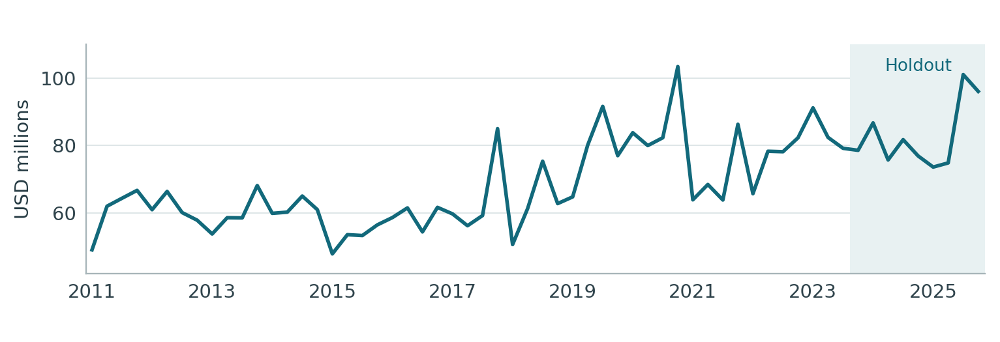
Figure 1. Smoothed quarterly expense in USD millions. The shaded holdout begins in 2023 Q4.
Monthly Adj_Other equals Other_Month_Actual_num less the signed Card_Month_Actual_num. March 2011, January 2019, September 2020, July 2023 and November 2023 each use the mean of the two neighboring months. The quarterly amount sums the three smoothed monthly values.

Stationarity of the target
The expense level fails the joint stationarity criterion. All three changes pass. The year-over-year log change measures growth against the same quarter of the prior year and is the dependent variable in this specification.
Target form | N | ADF stat. | ADF p | KPSS stat. | KPSS p
Level | 51 | −0.814 | 0.8148 | 0.827 | <0.01
First difference | 50 | −6.563 | <0.0001 | 0.051 | >0.10
QoQ log change | 50 | −6.390 | <0.0001 | 0.053 | >0.10
YoY log change | 47 | −4.134 | 0.0009 | 0.110 | >0.10
Both tests use an intercept. ADF chooses up to four lags by AIC. KPSS uses bandwidth four. A form passes when ADF rejects a unit root at 5% and KPSS does not reject level stationarity at 5%.

Expense growth and the estimation sample
Yₜ is quarterly smoothed Adj_Other expense in USD millions. The model predicts gₜ, the log change from the same quarter of the preceding year.
$g_{t} = 100 ln(Y_{t} / Y_{t−4})$
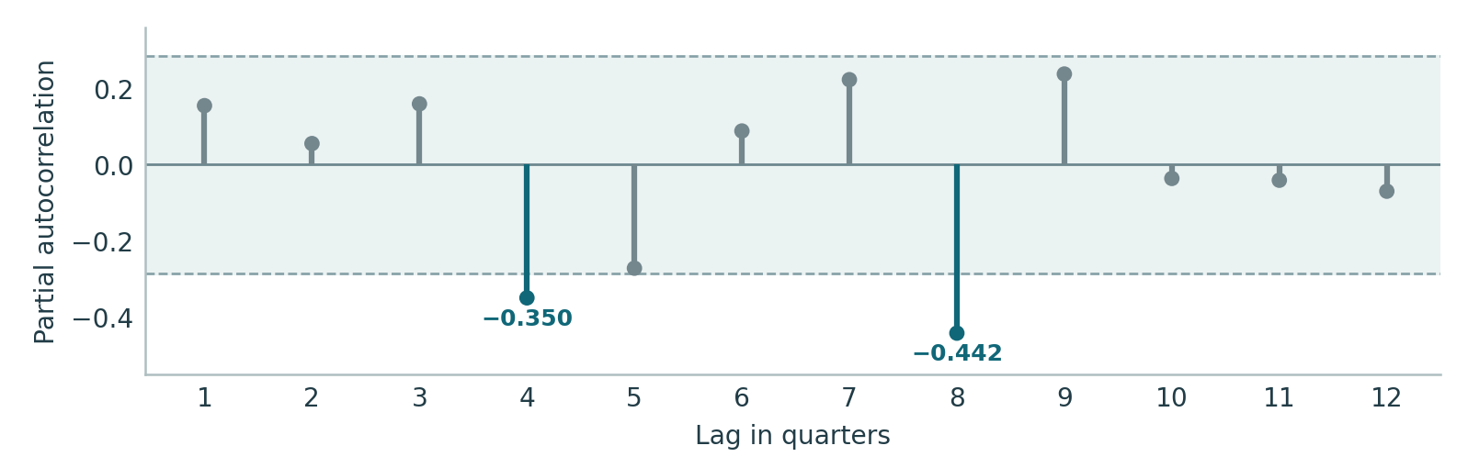
Figure 2. Yule–Walker partial autocorrelations use 47 in-sample expense-growth observations. Shading marks approximate pointwise 95% white-noise bounds of ±0.286.
The partial autocorrelations at lag 4 (−0.350) and lag 8 (−0.442) cross the pointwise bounds. The starting specification retains the intercept and lag 4, which measures expense growth one year earlier.

Quarter coverage
Use | Period | Quarters
Target and macro stationarity tests | 2011 Q1–2023 Q3 | 51 in levels
Expense growth available for the PACF | 2012 Q1–2023 Q3 | 47
Common estimation sample for every trial | 2013 Q1–2023 Q3 | 43
Out-of-time forecast evaluation | 2023 Q4–2025 Q4 | 9
For the first regression observation in 2013 Q1, lagged expense growth compares 2012 Q1 with 2011 Q1. The same 43 outcomes are available in every round.
Target source. Other_Monthly_to_Quarterly.xls, Quarterly Output, smoothed Adj_Other. All 60 quarterly amounts match Other_Quarterly_Target_List.xlsx.

Stationarity of the macro candidates
The 15 supplied quarterly series were tested in level, first difference, quarter-over-quarter log change and year-over-year log change. Each statistic uses the 51 transformed observations dated 2011 Q1–2023 Q3. Earlier quarterly levels initialize the changes. A form qualifies when ADF p < 0.05 and KPSS p ≥ 0.05.
Macro series | Level | First difference | QoQ log | YoY log
Bank assets | .965 / <.01 | .002 / >.10 | .002 / >.10 | .319 / >.10
Bank deposits | .885 / <.01 | .061 / >.10 | .042 / >.10 | .061 / >.10
Bank loans and leases | .989 / <.01 | .001 / >.10 | .001 / >.10 | .063 / >.10
Consumer credit outstanding | .865 / <.01 | .045 / >.10 | .122 / >.10 | .087 / >.10
Credit card delinquency, top 100 banks | .074 / .040 | .693 / .057 | .588 / >.10 | .156 / .094
C&I delinquency, top 100 banks | .013 / >.10 | .008 / >.10 | .013 / >.10 | .247 / >.10
Credit card charge-offs | .136 / .036 | .197 / .062 | .336 / >.10 | .110 / >.10
Business bankruptcies | .030 / <.01 | .506 / .035 | .493 / >.10 | .178 / >.10
Personal bankruptcies | .228 / <.01 | .004 / >.10 | .002 / >.10 | .410 / >.10
VIX | .095 / >.10 | <.001 / >.10 | <.001 / >.10 | .146 / >.10
High-yield spread | .018 / .086 | <.001 / >.10 | <.001 / >.10 | .078 / >.10
Federal funds rate | .305 / .037 | .035 / >.10 | .005 / >.10 | .017 / >.10
10-year Treasury yield | .643 / >.10 | .008 / >.10 | <.001 / >.10 | .015 / >.10
Final demand services PPI | 1.000 / <.01 | .049 / .052 | .035 / .082 | .819 / .052
Core CPI | 1.000 / <.01 | .477 / .020 | .393 / .029 | .718 / .022
Cells show ADF p / KPSS p. Bold cells pass both tests. ADF uses an intercept with AIC lag selection up to four quarters. KPSS tests level stationarity with bandwidth four. Decisions use full precision.

Eligible transformations
Eleven series contributed 24 eligible forms, comprising two levels, ten first differences, ten quarterly log changes and two annual log changes. Testing each at lags 1, 2 and 4 produced 72 first-round candidates.
Macro source. Other_Quarterly_Macro_List.xlsx, Quarterly Macro, Moody’s Scenario Consistent Baseline (August 2026). The worksheet covers 2009 Q1–2028 Q1. Services PPI first appears in 2010 Q1. All macro values enter at their published quarterly frequency.

Forward selection
Every regression includes the intercept and expense growth L4. Statistical eligibility requires a two-sided entry p < 0.05, maximum VIF < 10 and Durbin–Watson from 1.5 to 2.5 inclusive. Qualifying terms are ranked by p-value, then BIC. Each macro series may enter once. Round two also applies the bank asset exclusion described below. Jarque–Bera is checked on the final fit.
Round | Trials | Passed | Decision | Model R²
Start | — | — | Intercept and expense growth L4 | 8.95%
1 | 72 | 9 | Federal funds rate, YoY log change L4 | 26.39%
2 | 63 | 5 | 10-year Treasury yield, QoQ log change L2 | 34.55%
3 | 48 | 0 | Stop. Lowest remaining p = 0.07737. | 34.55%

Candidates passing the statistical criteria
Round | Rank | Macro series | Form | Lag | Entry p
1 | 1 | Federal funds rate | YoY log | L4 | 0.00375
1 | 2 | Bank loans and leases | First diff. | L2 | 0.00466
1 | 3 | Bank loans and leases | QoQ log | L2 | 0.01240
1 | 4 | 10-year Treasury yield | QoQ log | L2 | 0.02528
1 | 5 | High-yield spread | First diff. | L2 | 0.02932
1 | 6 | High-yield spread | QoQ log | L2 | 0.03485
1 | 7 | 10-year Treasury yield | YoY log | L4 | 0.03619
1 | 8 | Bank assets | QoQ log | L4 | 0.04305
1 | 9 | Bank deposits | QoQ log | L4 | 0.04378
2 | 1 | Bank assets | First diff. | L2 | 0.01299
2 | 2 | Bank assets | QoQ log | L2 | 0.02450
2 | 3 | 10-year Treasury yield | QoQ log | L2 | 0.03348
2 | 4 | Bank loans and leases | First diff. | L2 | 0.03364
2 | 5 | Personal bankruptcies | QoQ log | L2 | 0.04787
Bold rows identify the retained term. Rank counts transformations and lags. Passed counts statistical qualifications before the stability decision.
Bank assets occupied the first two places in round two. The first-difference coefficient was significant in 3 of 24 training windows. The review excluded the asset series across all transformations and retained Treasury, the second distinct macro and third term (p = 0.03348). With both rates retained, none of the 48 remaining terms qualified. The lowest p was 0.07737 for services PPI, first difference L1.

Final model specification
Fₜ is the U.S. federal funds rate (FRFED_B.IUSA). Tₜ is the U.S. 10-year constant-maturity Treasury yield (FRGT10Y_B.IUSA). Both are quarterly observations of annual interest rates, in percent and seasonally unadjusted. The predictors measure relative log changes in those rates.
$f_{t} = 100 ln(F_{t} / F_{t−4})$
$h_{t} = 100 ln(T_{t} / T_{t−1})$
$ĝ_{t} = 3.68245 − 0.43685 g_{t−4} + 0.05312 f_{t−4} − 0.26526 h_{t−2}$
$Ŷ_{t} = Y_{t−4} exp(ĝ_{t} / 100)$
Holding the other terms fixed, a ten-log-point increase in the lagged federal funds change corresponds to 0.53 additional log points of predicted expense growth. A ten-log-point increase in the lagged Treasury yield change corresponds to 2.65 fewer log points.
Term | Estimate | Std. error | 95% interval | p-value
Intercept | 3.68245 | 2.28604 | [−0.9415, 8.3064] | 0.11528
Expense growth (one year earlier) | −0.43685 | 0.13686 | [−0.7137, −0.1600] | 0.00279
Federal funds rate (one year earlier) | 0.05312 | 0.01791 | [0.0169, 0.0893] | 0.00513
10-year Treasury yield (two quarters earlier) | −0.26526 | 0.12035 | [−0.5087, −0.0218] | 0.03348

Fit and residual diagnostics
Training N | R² | Adjusted R² | DW | Max. VIF | Final JB p | BG(1) p
43 | 0.3455 | 0.2951 | 2.076 | 1.102 | 0.5001 | 0.7490
Conventional OLS standard errors, Student-t p-values and pointwise intervals use 39 residual degrees of freedom. BG(1) is the lag-one Breusch–Godfrey F-test. Coefficient p-values are conditional on the selected specification.

Performance in the final nine quarters
Coefficients are fixed at their 2023 Q3 estimates. The one-step forecasts update the expense history each quarter. The recursive path feeds its predicted expense amounts into later lags. Both use lagged macro observations from the August 2026 vintage, which postdates the holdout.
Forecast | MAE | RMSE | MAPE | Mean error
One-step | 13.97 | 15.96 | 17.00% | 6.43
Recursive | 16.37 | 18.09 | 20.45% | 12.98
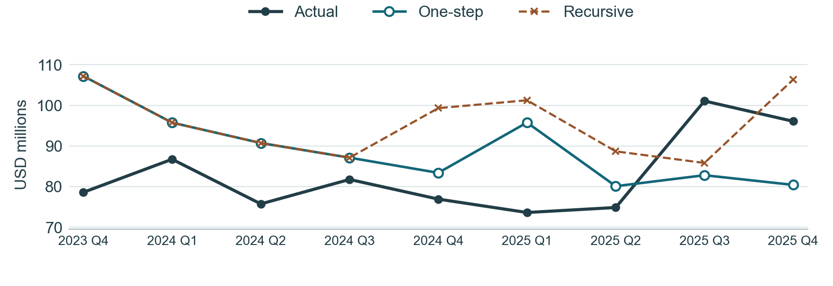
Figure 3. The two paths coincide through 2024 Q3. Beginning in 2024 Q4, the recursive path uses its forecast from the same quarter of the preceding year.
Quarter | Actual | One-step | Error | Recursive | Error
2023Q4 | 78.59 | 107.19 | 28.60 | 107.19 | 28.60
2024Q1 | 86.72 | 95.74 | 9.01 | 95.74 | 9.01
2024Q2 | 75.73 | 90.72 | 14.98 | 90.72 | 14.98
2024Q3 | 81.75 | 87.11 | 5.36 | 87.11 | 5.36
2024Q4 | 76.91 | 83.38 | 6.47 | 99.31 | 22.40
2025Q1 | 73.62 | 95.76 | 22.14 | 101.24 | 27.63
2025Q2 | 74.85 | 80.10 | 5.25 | 88.67 | 13.82
2025Q3 | 101.07 | 82.79 | −18.27 | 85.81 | −15.25
2025Q4 | 96.07 | 80.41 | −15.66 | 106.34 | 10.27
Error equals forecast minus actual. Amounts, MAE, RMSE and mean error are in USD millions. MAPE is the mean absolute percentage error.
Both paths had their largest absolute error in 2023 Q4, overpredicting expense by $28.60 million. The recursive path overpredicted eight of nine quarters and its mean error was +$12.98 million.

Rolling coefficient stability
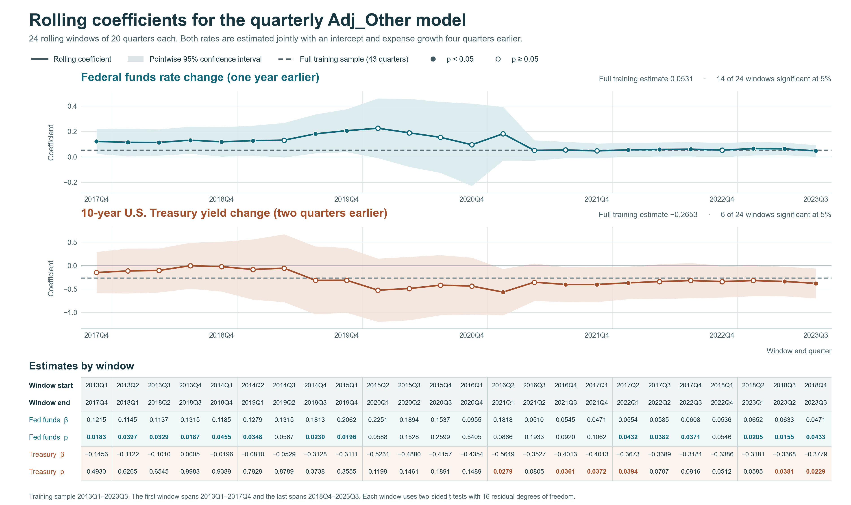
Figure 4. Each point is dated at the end of its 20-quarter window. Shading is a pointwise 95% confidence interval. A filled point marks p < 0.05. Dashed lines show full-training estimates.

Estimates for all 24 rolling windows
Each window estimates four coefficients with 16 residual degrees of freedom. The federal funds coefficient is positive in all 24 windows and significant in 14. The Treasury coefficient is negative in 23 windows and significant in 6. Adjacent windows share 19 quarters.
Window | Fed funds  coef. | 95% interval | p | Treasury  coef. | 95% interval | p
2013Q1–2017Q4 | 0.1215 | [0.0234, 0.2195] | 0.0183 | −0.1456 | [−0.5857, 0.2944] | 0.4930
2013Q2–2018Q1 | 0.1145 | [0.0061, 0.2229] | 0.0397 | −0.1122 | [−0.5915, 0.3671] | 0.6265
2013Q3–2018Q2 | 0.1137 | [0.0105, 0.2169] | 0.0329 | −0.1010 | [−0.5705, 0.3685] | 0.6545
2013Q4–2018Q3 | 0.1315 | [0.0250, 0.2381] | 0.0187 | 0.0005 | [−0.4909, 0.4919] | 0.9983
2014Q1–2018Q4 | 0.1185 | [0.0027, 0.2343] | 0.0455 | −0.0196 | [−0.5519, 0.5127] | 0.9389
2014Q2–2019Q1 | 0.1279 | [0.0103, 0.2455] | 0.0348 | −0.0810 | [−0.7244, 0.5624] | 0.7929
2014Q3–2019Q2 | 0.1315 | [−0.0042, 0.2673] | 0.0567 | −0.0529 | [−0.7774, 0.6716] | 0.8789
2014Q4–2019Q3 | 0.1813 | [0.0284, 0.3342] | 0.0230 | −0.3128 | [−1.0376, 0.4120] | 0.3738
2015Q1–2019Q4 | 0.2062 | [0.0376, 0.3748] | 0.0196 | −0.3111 | [−1.0043, 0.3821] | 0.3555
2015Q2–2020Q1 | 0.2251 | [−0.0094, 0.4596] | 0.0588 | −0.5231 | [−1.1981, 0.1519] | 0.1199
2015Q3–2020Q2 | 0.1894 | [−0.0781, 0.4569] | 0.1528 | −0.4880 | [−1.1652, 0.1892] | 0.1461
2015Q4–2020Q3 | 0.1537 | [−0.1252, 0.4326] | 0.2599 | −0.4157 | [−1.0580, 0.2267] | 0.1891
2016Q1–2020Q4 | 0.0955 | [−0.2281, 0.4190] | 0.5405 | −0.4354 | [−1.0440, 0.1732] | 0.1489
2016Q2–2021Q1 | 0.1818 | [−0.0293, 0.3930] | 0.0866 | −0.5649 | [−1.0600, −0.0697] | 0.0279
2016Q3–2021Q2 | 0.0510 | [−0.0286, 0.1306] | 0.1933 | −0.3527 | [−0.7535, 0.0480] | 0.0805
2016Q4–2021Q3 | 0.0545 | [−0.0100, 0.1191] | 0.0920 | −0.4013 | [−0.7732, −0.0293] | 0.0361
2017Q1–2021Q4 | 0.0471 | [−0.0112, 0.1055] | 0.1062 | −0.4013 | [−0.7758, −0.0269] | 0.0372
2017Q2–2022Q1 | 0.0554 | [0.0019, 0.1089] | 0.0432 | −0.3673 | [−0.7144, −0.0202] | 0.0394
2017Q3–2022Q2 | 0.0585 | [0.0036, 0.1134] | 0.0382 | −0.3389 | [−0.7100, 0.0321] | 0.0707
2017Q4–2022Q3 | 0.0608 | [0.0041, 0.1174] | 0.0371 | −0.3181 | [−0.6938, 0.0576] | 0.0916
2018Q1–2022Q4 | 0.0536 | [−0.0012, 0.1084] | 0.0546 | −0.3386 | [−0.6791, 0.0020] | 0.0512
2018Q2–2023Q1 | 0.0652 | [0.0115, 0.1190] | 0.0205 | −0.3181 | [−0.6505, 0.0143] | 0.0595
2018Q3–2023Q2 | 0.0633 | [0.0138, 0.1129] | 0.0155 | −0.3368 | [−0.6528, −0.0209] | 0.0381
2018Q4–2023Q3 | 0.0471 | [0.0016, 0.0927] | 0.0433 | −0.3779 | [−0.6962, −0.0597] | 0.0229
Bold p-values are below 0.05. Confidence intervals and two-sided tests use the Student-t distribution within each window.
The Treasury coefficient ranges from −0.56486 to +0.00050. Its one positive estimate is close to zero (2013 Q4–2018 Q3, p = 0.99830). Eighteen intervals include zero. In the last window, 2018 Q4–2023 Q3, the Treasury coefficient is −0.37793 (p = 0.02285).

Appendix First round candidate tests
Each row is a qualifying transformation. Each cell reports the p-value for adding one lag to the intercept and year-over-year expense growth L4. All 72 trials use 2013 Q1–2023 Q3.
Macro | Transformation | R1 L1 | R1 L2 | R1 L4
Bank assets | First diff. | 0.0585 | 0.3413 | 0.0691
Bank assets | QoQ log | 0.0687 | 0.3891 | 0.0430
Bank deposits | QoQ log | 0.1625 | 0.7623 | 0.0438
Bank loans and leases | First diff. | 0.9089 | 0.0047 | 0.3783
Bank loans and leases | QoQ log | 0.8964 | 0.0124 | 0.4753
Consumer credit outstanding | First diff. | 0.8468 | 0.4862 | 0.0669
C&I delinquency, top 100 banks | Level | 0.3875 | 0.5082 | 0.9653
C&I delinquency, top 100 banks | First diff. | 0.6708 | 0.2952 | 0.8073
C&I delinquency, top 100 banks | QoQ log | 0.7345 | 0.2551 | 0.9542
Personal bankruptcies | First diff. | 0.1647 | 0.4848 | 0.1064
Personal bankruptcies | QoQ log | 0.1683 | 0.4213 | 0.2068
VIX | First diff. | 0.9105 | 0.2290 | 0.9596
VIX | QoQ log | 0.9801 | 0.2311 | 0.8502
High-yield spread | Level | 0.7024 | 0.6510 | 0.1175
High-yield spread | First diff. | 0.9074 | 0.0293 | 0.6152
High-yield spread | QoQ log | 0.8509 | 0.0349 | 0.6274
Federal funds rate | First diff. | 0.3088 | 0.6779 | 0.1731
Federal funds rate | QoQ log | 0.3185 | 0.1553 | 0.2047
Federal funds rate | YoY log | 0.2719 | 0.1758 | 0.0037
10-year Treasury yield | First diff. | 0.9386 | 0.1574 | 0.1127
10-year Treasury yield | QoQ log | 0.5440 | 0.0253 | 0.1111
10-year Treasury yield | YoY log | 0.8111 | 0.6061 | 0.0362
Final demand services PPI | First diff. | 0.4594 | 0.5475 | 0.2793
Final demand services PPI | QoQ log | 0.4186 | 0.4772 | 0.3172
Bold entries pass the statistical criteria. Decisions use unrounded statistics.

Appendix Second and third round candidate tests
Round two tests 63 terms with the federal funds term in place. Round three tests 48 terms after retaining Treasury and removing commercial bank assets from further consideration. L1, L2 and L4 denote lags in quarters.
Macro | Transformation | R2 L1 | R2 L2 | R2 L4 | R3 L1 | R3 L2 | R3 L4
Bank assets | First diff. | 0.3565 | 0.0130 | 0.6102 | — | — | —
Bank assets | QoQ log | 0.3338 | 0.0245 | 0.4649 | — | — | —
Bank deposits | QoQ log | 0.7851 | 0.0534 | 0.8919 | 0.3149 | 0.3946 | 0.7522
Bank loans and leases | First diff. | 0.7228 | 0.0336 | 0.8693 | 0.8586 | 0.1332 | 0.7797
Bank loans and leases | QoQ log | 0.5342 | 0.0752 | 0.9667 | 0.5738 | 0.3053 | 0.9940
Consumer credit outstanding | First diff. | 0.9550 | 0.2046 | 0.8409 | 0.4759 | 0.9025 | 0.7301
C&I delinquency, top 100 banks | Level | 0.3902 | 0.4273 | 0.7993 | 0.5589 | 0.4046 | 0.3303
C&I delinquency, top 100 banks | First diff. | 0.8812 | 0.3730 | 0.9160 | 0.5959 | 0.9978 | 0.8201
C&I delinquency, top 100 banks | QoQ log | 0.9640 | 0.3183 | 0.9844 | 0.5376 | 0.8457 | 0.8822
Personal bankruptcies | First diff. | 0.3192 | 0.1026 | 0.7628 | 0.1173 | 0.5621 | 0.9080
Personal bankruptcies | QoQ log | 0.4348 | 0.0479 | 0.7472 | 0.1936 | 0.3391 | 0.5749
VIX | First diff. | 0.8337 | 0.2946 | 0.7976 | 0.9097 | 0.4542 | 0.5848
VIX | QoQ log | 0.9916 | 0.2781 | 0.7147 | 0.9917 | 0.3750 | 0.4855
High-yield spread | Level | 0.6540 | 0.9294 | 0.1409 | 0.1999 | 0.2748 | 0.2085
High-yield spread | First diff. | 0.6226 | 0.0503 | 0.9676 | 0.8218 | 0.2239 | 0.7610
High-yield spread | QoQ log | 0.7746 | 0.0776 | 0.9011 | 0.8878 | 0.2951 | 0.7169
10-year Treasury yield | First diff. | 0.9182 | 0.0994 | 0.2806 | — | — | —
10-year Treasury yield | QoQ log | 0.8326 | 0.0335 | 0.2448 | — | — | —
10-year Treasury yield | YoY log | 0.9033 | 0.9787 | 0.5682 | — | — | —
Final demand services PPI | First diff. | 0.3804 | 0.6711 | 0.4605 | 0.0774 | 0.1825 | 0.1840
Final demand services PPI | QoQ log | 0.3995 | 0.7276 | 0.4992 | 0.0851 | 0.2082 | 0.2203
Bold entries pass the statistical criteria. Decisions use unrounded statistics. A dash marks a retained or excluded series.

Round two choice on matched samples
Second macro | R² | Significant windows | One-step MAE | Recursive MAE
Bank assets | 37.29% | 3 / 24 | 14.76 | 18.56
10-year Treasury yield | 34.55% | 6 / 24 | 13.97 | 16.37
MAE is in USD millions. Both models include federal funds and expense growth L4. Significance counts refer to the second macro and use the same 24 training windows.

