PNFP Bonus Ratio ARDL Model Report
  - Macro Screening and Rolling Coefficients Excluding SNV
Updated 4 October 2026. Training: 2012Q2 to 2022Q4. Holdout: 2023Q1 to 2025Q4. Pandemic dummy: 2020Q1 to 2021Q1.

Executive Summary
Excluding SNV_Pay_Avg and all its transformations leaves 22 candidate series. Repeating the unchanged training-only screen selects lagged unemployment and lagged high yield OAS in levels, with the fixed own lag and pandemic dummy. Training adjusted R² is 0.359. Holdout RMSE is 4.043 percentage points, compared with 5.166 in the prior SNV model and 5.056 in the same-dummy AR(1) benchmark.
The selected structure and forecasts reproduce the earlier U/HY specification. None of the seven additional source-code series enters the final model. Both selected macros are significant under OLS and HAC in the 43-quarter training fit, but HY is significant in only one of the 32 main rolling windows by OLS and seven by HAC. Consistent signs do not establish stable coefficient magnitudes or precision.

Data and Target Definition
Sample | Dates | Observations
Raw quarterly history | 2011Q1 to 2025Q4 | 60
Common training sample | 2012Q2 to 2022Q4 | 43
Holdout sample | 2023Q1 to 2025Q4 | 12
Fixed structure full refit | 2012Q2 to 2025Q4 | 55

$R(t) = \frac{Bonus(t)}{Compensation(t) − Bonus(t)}; y(t) = 100 × R(t)$
The dependent variable remains the ratio level. The shared start preserves comparability with the bonus YoY challenge, which needs five quarters of lag history. D equals one in 2020Q1–2021Q1 and zero otherwise. There is no acquisition split, acquisition dummy or quarter exclusion.
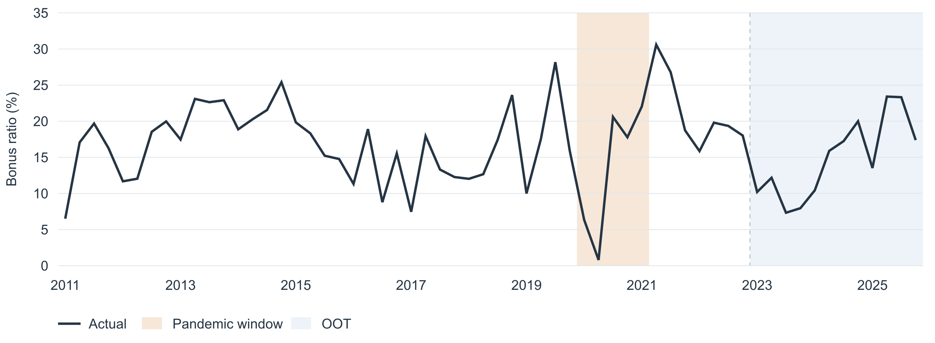
Figure 1 Bonus ratio history with the pandemic window and holdout period shaded.

Stationarity and Transformation Rules
Transformation choices and variable selection use training data only. ADF includes a constant, no trend, a maximum of four lags and AIC lag selection. KPSS includes a constant and automatic bandwidth. A transform is eligible only when ADF p < 0.05 and KPSS p > 0.05. The first passing form in the stated order is used for each family, not the form with the best regression fit.
Target test | Statistic | p value | Lags | Effective n
ADF | -4.4166 | 0.0003 | 0 | 42
KPSS | 0.1443 | >0.100 | 2 | 43

The ratio passes both tests and remains in levels. This is a stationary dynamic regression in ARDL form; no cointegration or error-correction relation is estimated. Macro tests use lagged regressor dates 2012Q1–2022Q3, 43 observations before ADF lag adjustment.
Candidate group | Fixed transformation order
Earnings, ULC, ECI, GDP, assets, loans | Quarterly log growth, then four-quarter log growth
Rates, unemployment, confidence, optimism, gap, HY | Level, then quarterly first difference
VIX | Level, then log level, then quarterly log growth
Seven additional series excluding SNV | Level, then quarterly first difference

$First difference(t) = X(t) − X(t − 1)$
$LogGrowth(k, t) = 100 × ln(\frac{X(t)}{X(t − k)}); k = 1 or 4$
The additional-series rule remains provisional and does not assume a dollar, rate or index interpretation. A separate sensitivity run uses quarterly then four-quarter log growth for these seven positive series. Positivity makes that calculation feasible but does not establish economic appropriateness. SNV is excluded from both policies before stationarity testing and model selection.
The main run tests 45 macro transformations across 22 families. 21 forms pass jointly, yielding 18 eligible families after choosing one form per family. The target and bonus challenge are tested separately. KPSS endpoint p values are bounds, not exact probabilities. Small-sample unit-root tests and automatic bandwidth choices make eligibility a screening rule, not proof of stationarity.

Candidate Pool Screening Results
All 22 active candidates are listed below. “Eligible” means admitted to forward selection, not retained in the final regression. Every eligible macro enters at lag one. The seven additional series retain their source codes. SNV_Pay_Avg is excluded from the current pool, data features and all fitted specifications.
Family | Transform shown | ADF p | KPSS p | Disposition
earnings | QoQ log growth | 0.0116 | >0.100 | Eligible
ulc | QoQ log growth | 1.53e-15 | >0.100 | Eligible
eci | YoY log growth | 0.9970 | 0.0109 | Joint gate failed
fed | First difference | 0.4653 | >0.100 | Joint gate failed
t2y | First difference | 0.2008 | >0.100 | Joint gate failed
t10y | First difference | 0.0006 | >0.100 | Eligible
unemp | Level | 0.0319 | 0.0874 | Selected
confidence | First difference | 0.0002 | >0.100 | Eligible
optimism | First difference | 1.36e-08 | >0.100 | Eligible
gdp | QoQ log growth | 1.27e-13 | >0.100 | Eligible
gap | First difference | 2.65e-13 | >0.100 | Eligible
assets | QoQ log growth | 0.0005 | >0.100 | Eligible
loans | QoQ log growth | 0.0082 | >0.100 | Eligible
vix | QoQ log growth | 0.0012 | >0.100 | Eligible
hy | Level | 0.0073 | >0.100 | Selected
FPCNBCPH | First difference | 3.45e-12 | 0.0507 | Eligible
FLBOPQ | First difference | 0.0002 | >0.100 | Eligible
FYPEW52Q | First difference | 3.39e-16 | >0.100 | Eligible
FGDP52Q | First difference | 1.18e-05 | >0.100 | Eligible
FE52 | First difference | 0.0001 | >0.100 | Eligible
FYPCPIQ | First difference | 2.44e-12 | >0.100 | Eligible
FECICCQ | First difference | 0.9913 | <0.010 | Joint gate failed

For failed families, the last attempted transform is shown; no earlier form passed. ECI, fed, t2y and FECICCQ fail the joint gate. The other six additional series pass in first differences but are not selected. FPCNBCPH passes narrowly with KPSS p = 0.0507. Full tests and regression trials remain in the companion workbook.

Model Selection and Estimation
The intercept, own first lag and current-quarter dummy are fixed controls. Entry requires classical OLS Student-t p < 0.05, maximum nonconstant VIF < 10, DW between 1.5 and 2.5, and Jarque–Bera p > 0.05. Passing additions rank by smallest p, then highest adjusted R², then name. Forward selection stops after two macros; no backward deletion or exhaustive lag search is performed.
Round | Added variable | Entry p | Adjusted R²
1 | Unemployment lag 1 | 0.0030 | 0.2777
2 | High yield OAS lag 1 | 0.0195 | 0.3590

$y(t) = 13.945314 + 0.174008 × y(t − 1)$
$+ 1.932517 × U(t − 1) − 2.172253 × HY(t − 1) − 5.589544 × D(t) + e(t)$
U is unemployment in percent units. HY is the high yield option-adjusted spread in percentage-point units, not basis points. Both regressors use quarterly levels lagged one quarter. Coefficients and forecast errors are on the y = 100R scale.
Term | Coefficient | OLS SE | OLS p | HAC p | HAC 95% interval
Intercept | 13.945314 | 4.913260 | 0.0072 | 0.0051 | [4.447024, 23.443603]
Own ratio lag 1 | 0.174008 | 0.143376 | 0.2324 | 0.1426 | [-0.061269, 0.409284]
Unemployment lag 1 | 1.932517 | 0.466536 | 0.0002 | 0.0001 | [1.004795, 2.860239]
High yield OAS lag 1 | -2.172253 | 0.890549 | 0.0195 | 0.0151 | [-3.899070, -0.445437]
Pandemic dummy | -5.589544 | 2.482878 | 0.0302 | 0.0282 | [-10.549713, -0.629376]

HAC uses four lags, the Bartlett kernel, finite-sample correction and t probabilities. Both macros and D are significant at 5% under OLS and HAC. The own lag is not significant in training but is retained by design. All intervals and p values are nominal and not selection-adjusted.
Diagnostic | Value | Diagnostic | Value
n / residual df | 43 / 38 | R² / adjusted R² | 0.4201 / 0.3590
DW | 1.9016 | Maximum VIF | 1.7143
Jarque–Bera p | 0.3152 | Breusch–Pagan p | 0.4206
BG lag 1 F p | 0.8875 | BG lag 4 F p | 0.7524

DW is retained for consistency with the Cardfee screen. With a lagged dependent variable, BG is the more relevant supplementary serial-correlation diagnostic; it does not reject at 5%. These checks do not establish coefficient stability or causality.

Training Fit and Holdout Performance
Evaluation | n | RMSE | MAE
Training fitted values | 43 | 4.446 | 3.474
Holdout fixed one step | 12 | 4.043 | 3.479
Holdout conditional recursive | 12 | 4.255 | 3.706
Holdout expanding estimation | 12 | 4.022 | 3.489

All errors are ratio percentage points. Fixed one-step forecasts use coefficients estimated through 2022Q4, actual lagged y and lagged macro inputs. Recursive forecasts replace lagged y with its previous prediction, conditional on realized macro paths. Expanding forecasts refit coefficients on past observations without reselecting variables.
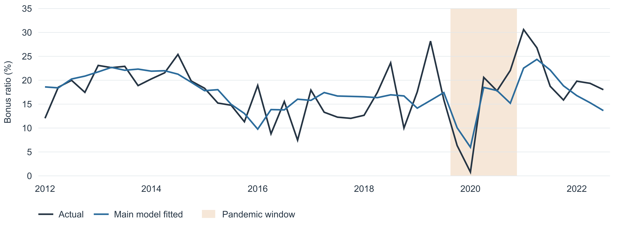
Figure 2 Training actual ratio and fitted values after excluding SNV.
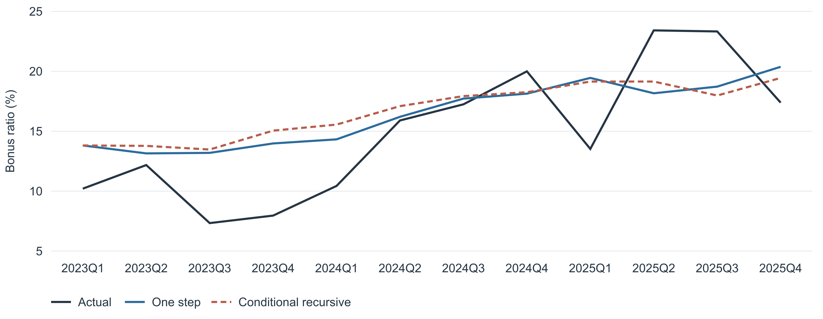
Figure 3 Holdout actual ratio, fixed one-step forecast and conditional recursive forecast.
The lower holdout RMSE is a historical comparison on the same 12 observations. The holdout was already examined in earlier exploratory work, so this is revised-data pseudo-out-of-sample evidence, not untouched prospective validation.

Benchmark and Transformation Sensitivity
Specification | Adj R² | OOT RMSE | OOT MAE
22 candidates excluding SNV with D | 0.359 | 4.043 | 3.479
Prior 23 candidate pool with SNV and D | 0.393 | 5.166 | 4.167
Earlier U and HY with D | 0.359 | 4.043 | 3.479
AR(1) with D | 0.115 | 5.056 | 4.274
22 candidates excluding SNV without D | 0.292 | 3.849 | 3.269
Added log growth sensitivity with D | 0.359 | 4.043 | 3.479

RMSE is 21.7% lower than the prior SNV model and 20.0% lower than AR(1) with D. The no-dummy branch selects the same macros and has a lower RMSE of 3.849; D remains in the primary model by design, not because the holdout prefers it.
Using quarterly then annual log growth for the seven additional series yields 25 stationary forms and 18 eligible families. It selects the same U/HY structure and produces identical primary coefficients and forecasts. This checks one alternative transformation policy without changing the main rule after examining holdout performance.

Bonus Growth Challenge
Lagged bonus YoY log growth remains unselected (OLS p = 0.7570). Adding it gives holdout RMSE 4.119. Current bonus growth is not used because bonus is already the target numerator. A lag avoids same-quarter overlap but does not establish exogeneity.

Fixed Structure Sensitivity
Rows excluded | n | U coef | U p | HY coef | HY p
Exclude dummy quarters | 38 | 1.372 | 0.0271 | -1.930 | 0.0370
Exclude highest Cook D | 42 | 2.287 | 1.70e-05 | -3.295 | 0.0015

Both macro signs and OLS significance survive these checks. The highest Cook-distance observation is 2016Q2 (D = 0.405). Original calendar lags and the selected structure are retained. D is omitted when its five response quarters are removed; HAC is not computed across calendar gaps.

Rolling Coefficient Diagnostics
The selected structure is re-estimated in 24-quarter windows, moving one quarter at a time across 2012Q2–2025Q4. The 32 windows end from 2018Q1 through 2025Q4. No variables or transformations are reselected. Twenty- and 28-quarter windows provide sensitivity checks. Windows ending after 2022Q4 use holdout outcomes and are descriptive diagnostics, not additional holdout forecasts.
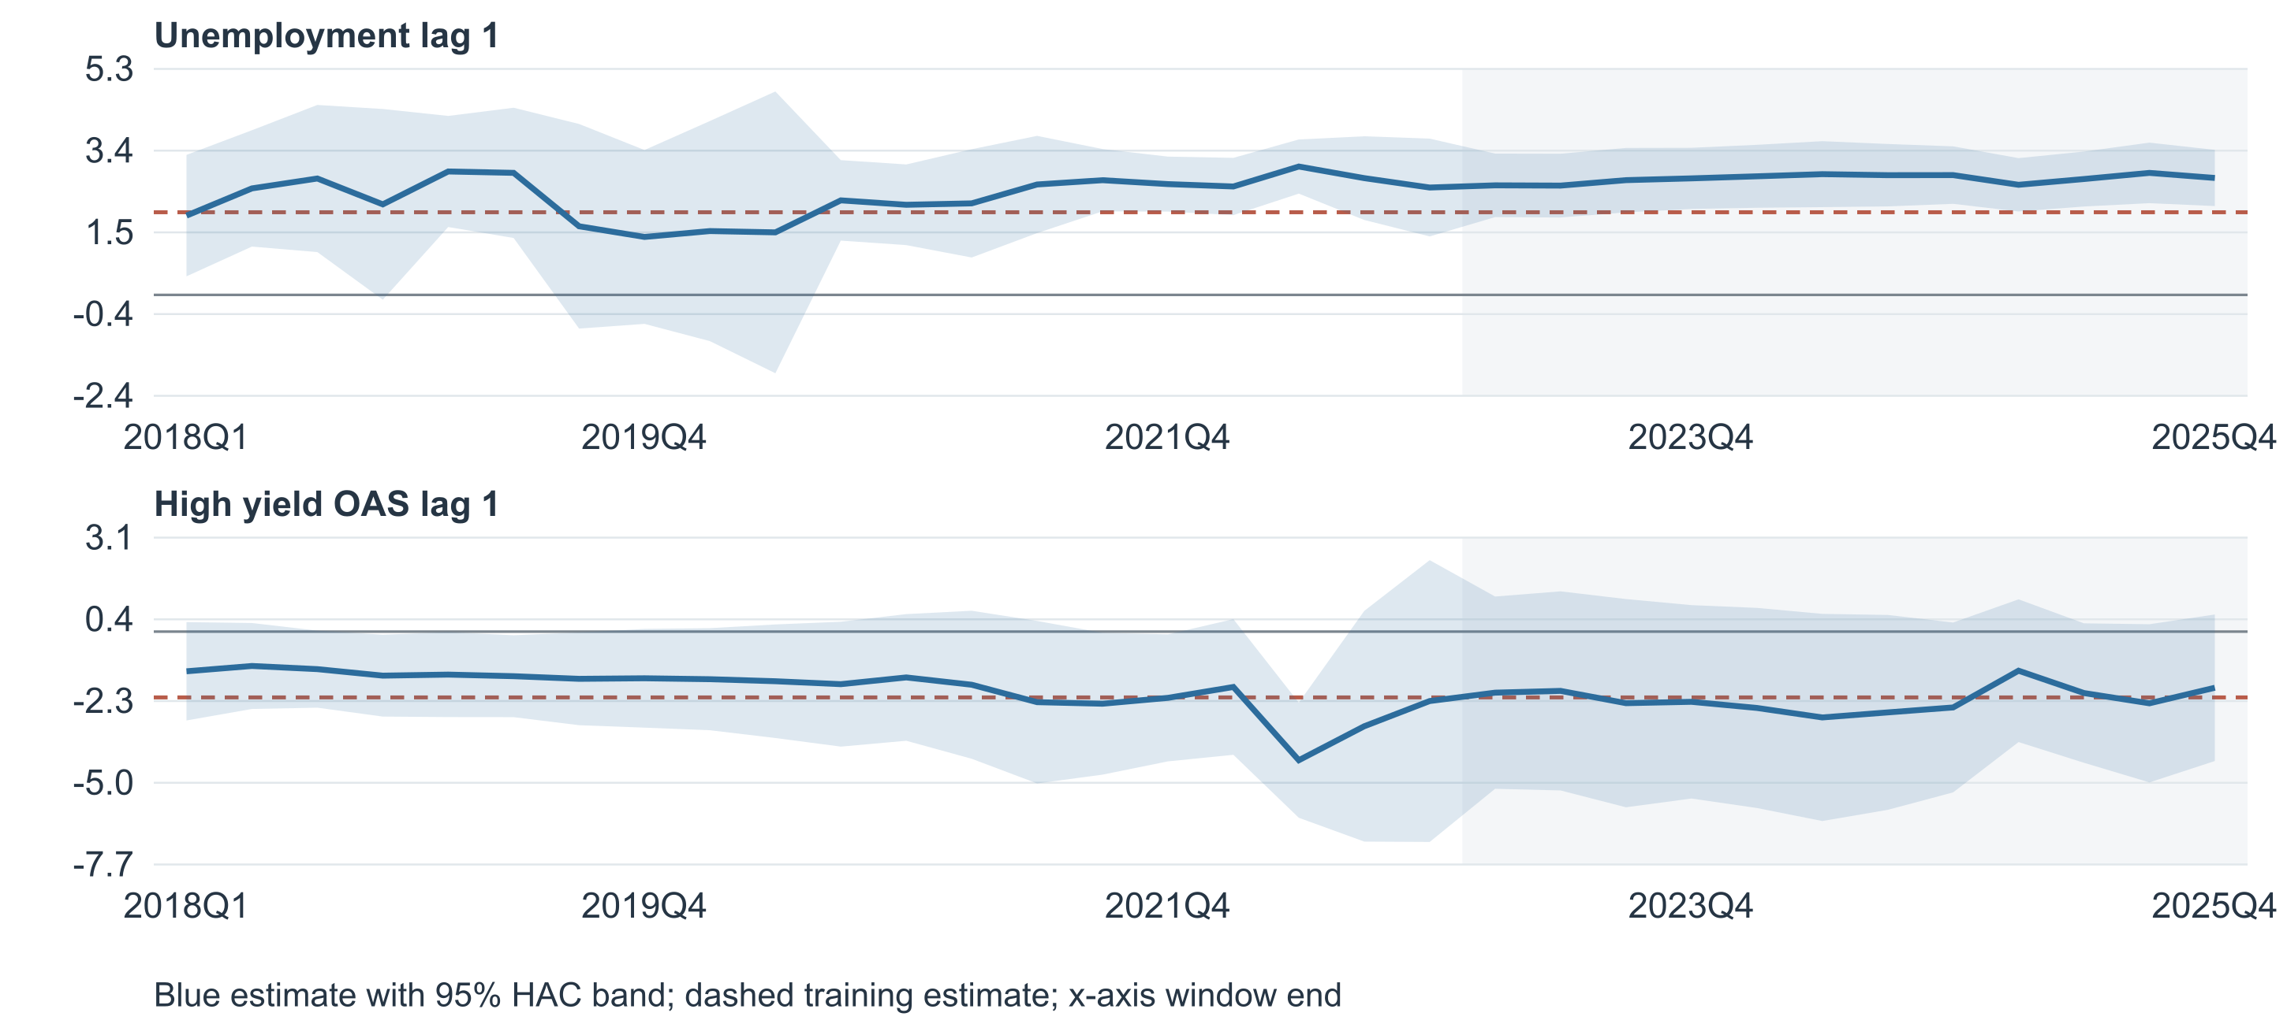
Figure 4 Rolling macro coefficients with pointwise 95% HAC bands. Gray marks post-training window ends.
Term | Range | Expected sign | OLS p below 5% | HAC p below 5%
U positive | 1.355 to 3.001 | 32/32 | 28/32 | 27/32
HY negative | -4.245 to -1.135 | 32/32 | 1/32 | 7/32

Unemployment is positive in all 32 main windows, with OLS significance in 28 and HAC significance in 27. HY is negative in all 32, but significant in only one by OLS and seven by HAC. Its final-window coefficient is -1.853, with OLS p = 0.2010 and HAC p = 0.1253. Sign consistency is stronger than evidence of a precisely stable HY effect.
HAC uses the same four-lag correction and t inference. Intervals are pointwise, not simultaneous, and do not account for selection. Adjacent windows overlap heavily; significance counts are not independent replications. An all-zero D is omitted from that window and its coefficient is unavailable, not zero.

Rolling Controls and Window Sensitivity
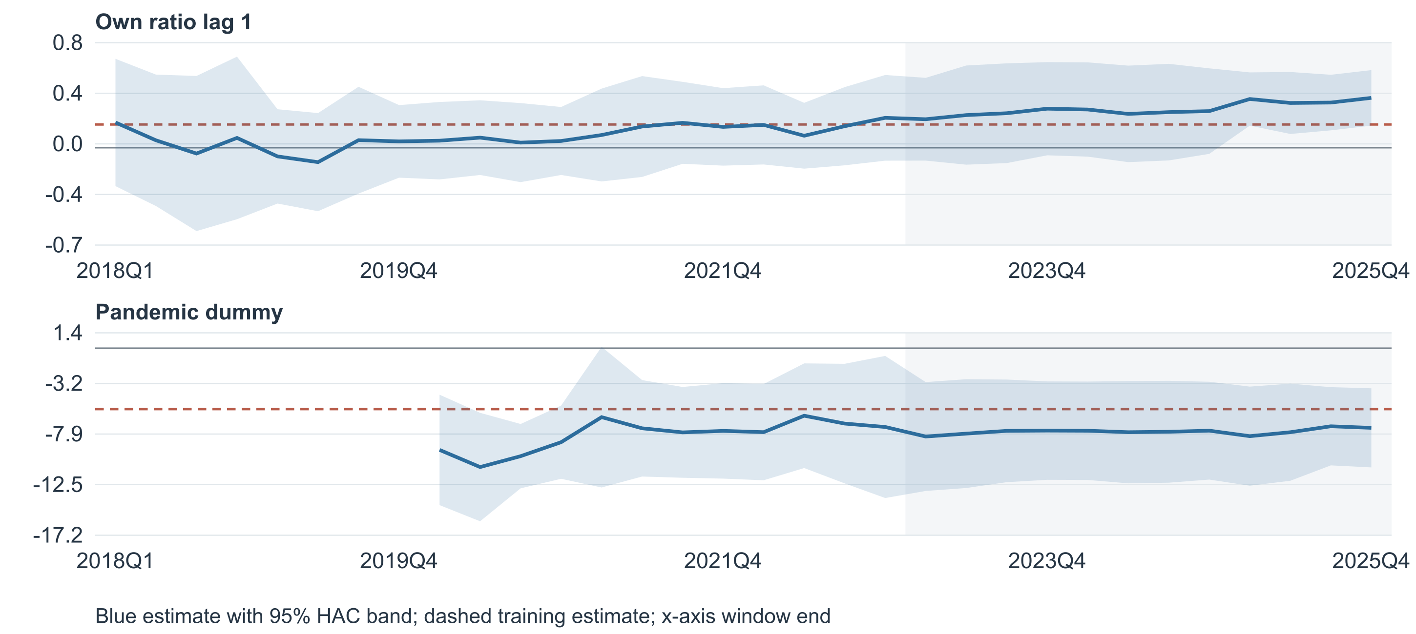
Figure 5 Rolling own-lag and pandemic coefficients. Early windows have no identifiable pandemic coefficient.
The own-lag coefficient ranges from -0.108 to 0.373, with three negative main-window estimates. D is negative in all 24 identifiable main windows, ranging from -10.906 to -6.195 ratio percentage points. Eight main windows contain no dummy-on quarter.
Window | Term | Range | Expected sign | OLS sig | HAC sig
20 | U positive | -4.889 to 4.343 | 33/36 | 28/36 | 30/36
20 | HY negative | -5.177 to 0.576 | 34/36 | 1/36 | 7/36
24 | U positive | 1.355 to 3.001 | 32/32 | 28/32 | 27/32
24 | HY negative | -4.245 to -1.135 | 32/32 | 1/32 | 7/32
28 | U positive | 1.689 to 2.797 | 28/28 | 26/28 | 28/28
28 | HY negative | -3.316 to -1.586 | 28/28 | 2/28 | 18/28

The 20-quarter windows include three negative U estimates and two positive HY estimates. At 24 and 28 quarters, U remains positive and HY remains negative throughout. HY is not significant at 5% in the last window for any of the three lengths under either OLS or HAC; the 28-quarter last-window HAC p value is 0.0508, just above the cutoff.
The first identifiable pandemic windows contain only one or two dummy-on observations; one can produce leverage of one. The last 20-quarter window also contains just one dummy-on quarter. These intervals need particular caution. Rolling paths are not a formal global parameter-equality test, and the model should not be described as fully stable.

Full History Refit and Interpretation Limits
After freezing the chosen structure, coefficients are re-estimated on 55 quarters through 2025Q4. These descriptive full-history estimates are not used for fixed-coefficient holdout forecasts.
Term | Full-refit coefficient | OLS p | HAC p
Intercept | 12.033673 | 0.0021 | 0.0006
Own ratio lag 1 | 0.227551 | 0.0578 | 0.0198
Unemployment lag 1 | 2.091491 | 1.16e-05 | 2.24e-06
High yield OAS lag 1 | -2.214257 | 0.0049 | 0.0029
Pandemic dummy | -5.269632 | 0.0292 | 0.0166

Statistic | Value | Statistic | Value
n / residual df | 55 / 50 | Adjusted R² | 0.4039
DW | 2.0122 | JB p | 0.1194
Max VIF | 1.6762 | BG lag 4 F p | 0.6702

Economic Interpretation
In training, a one-percentage-point increase in prior-quarter unemployment is associated with a 1.933-point higher bonus ratio, holding the other regressors fixed. A one-percentage-point increase in prior-quarter HY OAS is associated with a 2.172-point lower ratio. These are conditional historical associations, not causal labor-market or credit-spread effects. The dummy estimates an intercept shift within its specified five quarters.

Selection and Data Limitations
There are 43 training observations, 45 macro transformation tests and 35 forward trials in the default branch. Reported p values do not adjust for this search. The two-macro cap and diagnostic thresholds do not guarantee forecast accuracy. Although the seven coded additions are not selected, their definitions, units and original quarterly aggregation remain unconfirmed, so their provisional transformation policy remains a limitation.
MoreVars uses an August 2026 baseline vintage. Dates through 2025Q4 are retained, but revised observations and source forecast values do not reconstruct information available at each historical date. The added file has no vintage or release-calendar metadata. A one-quarter lag does not guarantee real-time availability.
The holdout has been examined across earlier specifications and dummy-window revisions. All holdout dummy values are zero, so it cannot validate another pandemic regime. No acquisition control, seasonal-dummy search, prediction interval or post-2025 scenario forecast is introduced. Linear predictions are not constrained to be nonnegative.
Removing SNV restores the earlier U/HY result under the unchanged selection procedure. The lower RMSE relative to the SNV model is useful historical evidence, but independent future observations are needed for a stronger forecast-validation claim. Rolling HY uncertainty remains material.

Holdout Detail and Data Provenance
Quarter | Actual | One step | Recursive | Expanding | One-step error
2023Q1 | 10.208 | 13.810 | 13.810 | 13.810 | -3.602
2023Q2 | 12.177 | 13.151 | 13.777 | 12.992 | -0.974
2023Q3 | 7.335 | 13.194 | 13.473 | 12.948 | -5.859
2023Q4 | 7.960 | 13.980 | 15.048 | 13.403 | -6.021
2024Q1 | 10.435 | 14.321 | 15.555 | 13.147 | -3.886
2024Q2 | 15.900 | 16.203 | 17.094 | 14.912 | -0.304
2024Q3 | 17.245 | 17.722 | 17.930 | 16.936 | -0.477
2024Q4 | 19.996 | 18.136 | 18.255 | 17.499 | 1.860
2025Q1 | 13.522 | 19.448 | 19.145 | 19.125 | -5.927
2025Q2 | 23.414 | 18.167 | 19.146 | 17.057 | 5.247
2025Q3 | 23.326 | 18.721 | 17.979 | 18.496 | 4.605
2025Q4 | 17.386 | 20.376 | 19.445 | 20.480 | -2.990

Actual, forecasts and errors are on the y = 100R scale. Error is actual minus forecast. One-step coefficients are frozen at 2022Q4; expanding estimation uses only observations preceding each forecast quarter.

Source Files and Deduplication
PNFP_Monthly_Quarterly.xlsx supplies compensation and bonus from Quarterly!A1:D61. Monthly totals reconcile to quarterly amounts within 2.98 × 10⁻⁸ source units. MoreVars_Quarterly.xlsx supplies its 15 series from Quarterly!C10:Q69 and definitions from Variables!A1:F16. Those quarterly values are read directly without re-averaging.
macro_data_2011Q1_2025Q4.xlsx supplies seven active additions from Sheet1 columns D, F, G, H, I, J and K, rows 2–61. Column B, SNV_Pay_Avg, is excluded. FAHEFI and FLBR overlap MoreVars and use the MoreVars version. FECICCQ columns K and L are identical, so only K is retained. The 2025Q4 unemployment alternative is 4.450273224 versus the retained 4.45; other overlap differences are tiny rounding differences.

Reproducibility
PNFP_Bonus_Ratio_ARDL_No_SNV.xlsx contains the 22-family quarterly inputs, formula-based target and transformations, complete tests and selection trials, estimates, holdout results and all 96 rolling regressions. Historical comparison rows from the prior SNV model are explicitly labeled and do not re-enter the current candidate pool. OLS agrees with an independent statsmodels ARDL fit; rolling results agree with RollingOLS. Report metrics are recomputed from full-precision coefficients.
Statistical estimates and screening decisions are saved results. Editing spreadsheet input values recalculates the target and transformations but does not refit models or update p values, selection, forecasts or rolling estimates. Source workbooks and prior reports remain unchanged.

