Bank Efficiency Ratio ARDL Model Development Report
2011Q1 to 2025Q4
Dependent variable Bank efficiency ratio ER Model ARDL Validation period 2023Q4 to 2025Q4

Key Findings
The ER series covers 60 quarters. The model development process applies quarterly macroeconomic transformations, a TARP dummy, a defined estimation sample, and a consistent lag structure. The final ARDL specification retains one lag of ER and one lag of the quarterly change in the unemployment rate.
The macro pool contains 22 variables. Statistical screening identifies output gap, unemployment, and GDP as the closest candidates. Output gap has a marginal in sample advantage, but unemployment is the preferred final variable because it is easier to interpret and its validation RMSE of 0.02693 is lower than 0.02833 for gap and 0.02810 for GDP.
Metric | Result | Interpretation
Estimation observations | 49 | 2011Q2 to 2023Q3 excluding 2017Q4
Adjusted R squared | 0.7912 | The model explains about 79 percent of in sample variation
Durbin Watson | 1.8124 | No clear evidence of first order residual autocorrelation
Jarque Bera p value | 0.8691 | Residual normality is not rejected
Validation RMSE | 0.02693 | One step forecasts from 2023Q4 to 2025Q4

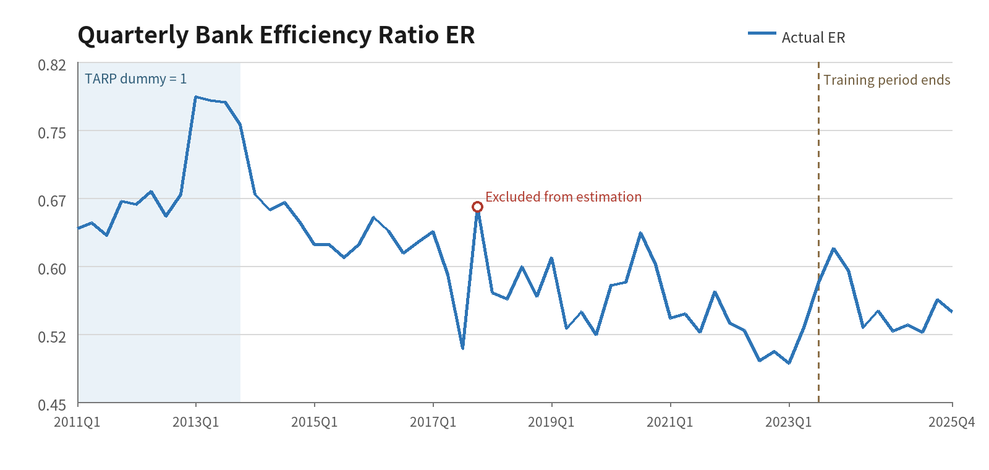
Figure 1 ER history and sample periods

Data and Model Specification

ER Data
The quarterly ER series covers 2011Q1 to 2025Q4. Values are expressed as decimals, so 0.55 corresponds to 55 percent. The series is used in levels because the model captures its persistence through the one quarter lag of ER.

Macroeconomic Transformations
Variable type | Variables | Quarterly transformation
Dollar amounts and indexes | earnings, ulc, eci, gdp, assets, loans | ln(Xt) - ln(Xt-1)
Rates and other level variables | fed, t2y, t10y, unemp, confidence, optimism, gap, vix, hy | Xt - Xt-1

Macro Pool
The macro pool contains 22 variables. Fifteen are core macroeconomic indicators and seven are additional scenario variables. Every candidate is transformed according to its economic type before the one quarter lag is applied.
Category | Count | Variables
Core macro variables | 15 | earnings, ulc, eci, fed, t2y, t10y, unemp, confidence, optimism, gdp, gap, assets, loans, vix, hy
Additional macro variables | 7 | FPCNBCPH, FLBOPQ, FYPEW52Q, FGDP52Q, FE52, FYPCPIQ, FECICCQ

The seven additional series begin in 2011Q1. After calculating a quarterly change and applying one lag, the common sample for all 22 candidates begins in 2011Q3 and contains 48 observations. The final unemployment model uses 49 observations because the unemployment series supports the 2011Q2 model observation.

Dummy and Sample
- The TARP dummy equals 1 from 2011Q1 through 2013Q4 and equals 0 from 2014Q1 onward.
- The estimation period is 2011Q2 through 2023Q3. The first quarter is lost to the lag.
- The 2017Q4 dependent variable observation is excluded from estimation, but its ER value remains the lag for 2018Q1.
- The nine quarters from 2023Q4 through 2025Q4 form the validation period.

Final ARDL Model
$${ER}_{t} = 0.1611 + 0.0481D_{t} + 0.7138{ER}_{t-1} + 0.0065{ΔUnemp}_{t-1} + e_{t}$$
Delta Unemp is the quarterly percentage point change in the unemployment rate. Holding the TARP dummy and ER persistence constant, the coefficient of 0.0065 associates a one percentage point increase in unemployment with an increase of about 0.0065 in ER one quarter later, or approximately 0.65 percentage points. This is a conditional association and should not be interpreted as a causal effect.
Term | Coefficient | p value | Interpretation
Constant | 0.1611 | 0.0021 | Long run baseline term
TARP dummy | 0.0481 | 0.0013 | Average ER was higher during the TARP period
ER lag 1 | 0.7138 | <0.001 | ER shows strong quarterly persistence
Unemployment change lag 1 | 0.0065 | 0.0468 | Higher unemployment is associated with higher ER one quarter later

Variable Screening and Model Selection
The constant, TARP dummy, and ER lag 1 remain fixed throughout variable screening. Each of the 22 macroeconomic candidates is transformed according to its economic type and entered with one lag. The table shows the three leading candidates with full coverage of the final estimation period. Each is close to the 5 percent significance threshold, and their in sample fit is very similar.
Candidate | Coefficient | p value | Adjusted R squared | BIC | Validation RMSE
d_gap(-1) | -0.00612 | 0.04521 | 0.791425 | -322.677 | 0.02833
d_unemp(-1) | 0.00651 | 0.04678 | 0.791154 | -322.614 | 0.02693
dlog_gdp(-1) | -0.57670 | 0.04780 | 0.790985 | -322.574 | 0.02810

Selection Decision
A standard best candidate rule selects d_gap(-1) because it has the lowest entry p value, and a BIC rule reaches the same result. The differences among gap, unemployment, and GDP are small. Unemployment is selected for the final specification because it has the lowest validation RMSE and the clearest interpretation for scenario analysis. After unemployment is included, the lowest conditional p value among the remaining candidates is 0.2135, so no additional macro variable enters at the 5 percent threshold.
The selection process therefore has two stages. Statistical screening identifies a small group of comparable candidates, and the final choice uses validation performance and economic interpretation.

A common sample sensitivity screen across all 22 candidates uses 48 observations. On that sample, d_gap(-1) has a p value of 0.0435, dlog_gdp(-1) has a p value of 0.0456, and d_unemp(-1) has a p value of 0.0509. The same three variables remain the leading candidates. The common sample result is used as a sensitivity check because it omits 2011Q2, which is available for the final unemployment model.

Basis for Selecting Unemployment
- The variable is straightforward to explain and can be used directly in macroeconomic scenarios. The sign can also be related clearly to the economic meaning of ER.
- The validation error is lowest. The unemployment model has an RMSE of 0.02693, below 0.02833 for gap and 0.02810 for GDP.
- The model remains parsimonious. No additional candidate meets the 5 percent entry threshold after unemployment is added.
Because the validation period is used to compare candidate models, it should be treated as a model selection sample rather than an untouched final test set. Newly observed quarters can provide a genuinely independent performance test.

Validation Forecast Performance
Both validation forecasts use coefficients fixed over the estimation sample and the same quarterly macroeconomic inputs. The one step forecast uses the observed lagged ER in every quarter and has an RMSE of 0.02693. The recursive forecast uses the actual 2023Q3 ER only as its starting value; beginning in 2024Q1, each forecast uses the preceding forecasted ER as its lag. Its nine quarter RMSE is 0.03114. The higher recursive error reflects the persistence of earlier ER forecast errors through the autoregressive term.
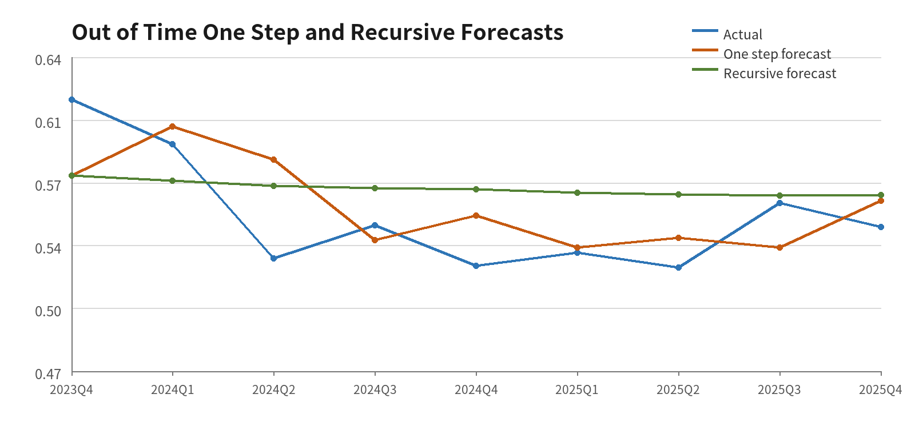
Figure 2 Actual values with one step and recursive forecasts from 2023Q4 to 2025Q4
Quarter | Actual ER | One step | One step error | Recursive | Recursive error
2023Q4 | 0.617 | 0.5757 | +0.0413 | 0.5757 | +0.0413
2024Q1 | 0.593 | 0.6026 | -0.0096 | 0.5731 | +0.0199
2024Q2 | 0.531 | 0.5846 | -0.0536 | 0.5703 | -0.0393
2024Q3 | 0.549 | 0.5410 | +0.0080 | 0.5690 | -0.0200
2024Q4 | 0.527 | 0.5542 | -0.0272 | 0.5685 | -0.0415
2025Q1 | 0.534 | 0.5370 | -0.0030 | 0.5667 | -0.0327
2025Q2 | 0.526 | 0.5422 | -0.0162 | 0.5655 | -0.0395
2025Q3 | 0.561 | 0.5370 | +0.0241 | 0.5652 | -0.0042
2025Q4 | 0.548 | 0.5624 | -0.0144 | 0.5653 | -0.0173

Nine Quarter Forecast Under the S4 Unemployment Scenario
The S4 unemployment path covers nine quarters from 2026Q1 through 2028Q1. The forecast uses the final unemployment ARDL model and starts from the actual 2025Q4 ER of 0.548. From the second forecast quarter onward, the calculation recursively uses the previous quarter's ER forecast. The TARP dummy equals 0 throughout the forecast period.
Because the model uses one lag of Delta Unemp, the 2026Q1 ER forecast uses the actual change in unemployment from 2025Q3 to 2025Q4, which is +0.1167 percentage points. The 2.1154 percentage point increase from 2025Q4 to the S4 value for 2026Q1 enters the model in 2026Q2. For the same reason, the S4 unemployment level for 2028Q1 first affects ER in 2028Q2 and does not affect the final forecast shown here.
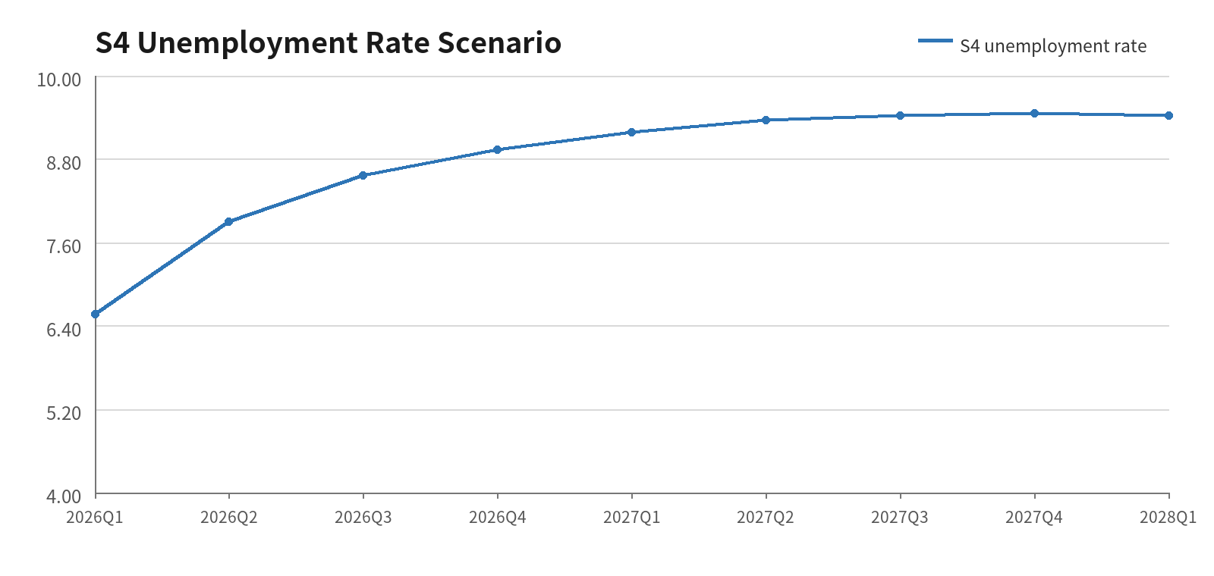
Figure 3 S4 unemployment rate path from 2026Q1 to 2028Q1

Quarter | S4 unemployment rate | Lagged Delta Unemp used | Recursive ER forecast
2026Q1 | 6.565% | +0.1167 | 0.5530
2026Q2 | 7.900% | +2.1154 | 0.5695
2026Q3 | 8.566% | +1.3345 | 0.5763
2026Q4 | 8.936% | +0.6664 | 0.5767
2027Q1 | 9.191% | +0.3700 | 0.5751
2027Q2 | 9.359% | +0.2548 | 0.5732
2027Q3 | 9.429% | +0.1674 | 0.5713
2027Q4 | 9.456% | +0.0703 | 0.5693
2028Q1 | 9.428% | +0.0271 | 0.5676

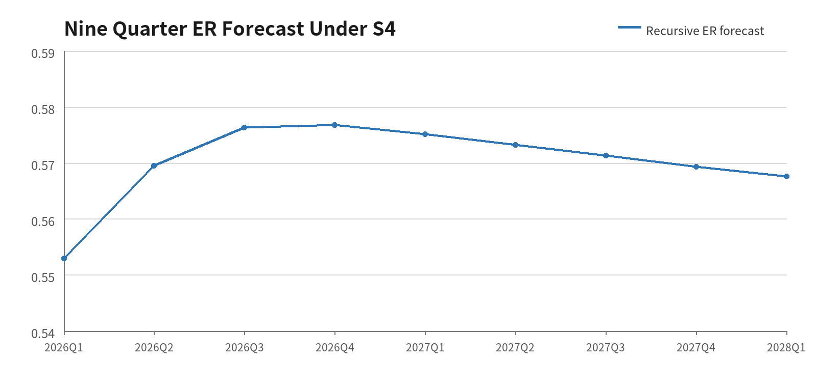
Figure 4 Recursive ER forecast under the S4 scenario
Under S4, ER rises from 0.5530 in 2026Q1 to about 0.5767 in 2026Q4. It then declines gradually as increases in unemployment become smaller, reaching 0.5676 in 2028Q1. The average forecast across the nine quarters is 0.5702. ER is a ratio, so the simple sum of the nine quarterly forecasts does not have a direct economic total interpretation.

Model Limitations and Use
- The macroeconomic coefficient has a p value of 0.0468, close to the 5 percent threshold. Small changes in candidate variables or data vintages may change the selected variable.
- The estimation sample contains only 49 observations. Structural changes, the pandemic period, and macroeconomic data revisions may affect coefficient stability.
- The model uses one lag of the macroeconomic variable and either an observed or forecast ER lag. It supports short term conditional forecasts and does not establish a structural causal relationship.
- The model should be reestimated after each four new quarters, with coefficient stability, residual diagnostics, and rolling forecast errors reported at the same time.

Conclusion
The final unemployment ARDL model balances statistical significance, economic interpretation, and validation error. The specification is parsimonious, and unemployment is more useful than gap or GDP for communication and scenario analysis. Ongoing model governance should retain the candidate set, entry threshold, and validation results so that future updates remain consistent.

Data Sources
ER series Quarterly bank efficiency ratio observations from 2011Q1 through 2025Q4.
Macroeconomic variables Quarterly macroeconomic data from the August 2026 Scenario Consistent Baseline vintage.
S4 forecast path Quarterly unemployment rates from 2026Q1 through 2028Q1.

