Noncomp Efficiency Ratio
Model Development Documentation
19 October 2026

1 Executive Summary

1.1 Model Overview
The Noncomp Efficiency Ratio Model provides quarterly projections of EF under alternative macroeconomic scenarios. The selected specification is an autoregressive distributed lag model estimated in ratio levels. It combines lagged EF, lagged quarterly unemployment changes and a post-TARP period indicator. This document records the conceptual basis, estimation decisions, development data, performance assessment and operating controls for the model.

1.2 Business Purpose and Intended Use
EF expresses operating costs relative to income. A higher ratio indicates greater cost per unit of income and therefore weaker operating efficiency, holding the accounting definition constant. Projecting EF supports expense and profitability planning and provides a consistent measure for comparing baseline and stressed economic conditions. The current implementation produces quarterly ratio forecasts. Any downstream conversion to expense dollars requires a separately supplied income forecast with a compatible accounting definition.

1.3 Development Summary
Development began with 60 quarterly EF observations and 22 macroeconomic candidates spanning 2011Q1 through 2025Q4. Two observations in 2017 were smoothed using documented local averages. A level-and-trend break analysis characterized the historical transition around 2014Q1. Macro selection then began with a dynamic equation containing a linear trend. The trend coefficient had a p value of 0.1719; it was removed and the retained equation was re-estimated on the same development sample.

1.4 Final Model Structure
Table 1.1 Final model variable summary
Variable | Construction | Model role
Lagged EF | Smoothed EF in quarter t−1 | Persistence in operating efficiency
FLBR_B.IUSA | U(t−1) − U(t−2), in percentage points | Lagged labor-market transmission
D | 0 through 2013Q4; 1 from 2014Q1 | Post-TARP period adjustment
The final equation contains a constant and the three terms above. It excludes a deterministic trend and transition pulse. Future forecasts use the same structure re-estimated through 2025Q4, while out-of-time performance is measured using coefficients fixed at the 2023Q3 development cutoff.

1.5 Performance and Out of Time Results
Table 1.2 Key performance measures
Measure | Development model | Full-history refit
Estimation period | 2011Q3–2023Q3 | 2011Q3–2025Q4
Observations | 49 | 58
Adjusted R² | 0.8265 | 0.8212
Fitted RMSE in EF percentage points | 2.833 | 2.822
The development model achieved a one-step out-of-time RMSE of 2.783 EF percentage points and a recursive RMSE of 3.728 percentage points over 2023Q4–2025Q4. Both improve on the corresponding persistence benchmarks. Unemployment, output-gap and GDP specifications have closely comparable adjusted R² values. Unemployment produces the lowest one-step error; GDP produces the lowest recursive error. The final choice combines these results with the direct economic interpretation of labor-market deterioration.

1.6 Scenario and Sensitivity Summary
S1 represents the Baseline scenario and S4 supplies the alternative higher-unemployment path. Nine-quarter forecasts cover 2026Q1–2028Q1. Both begin at 55.395% because the first forecast uses a common historical unemployment change. Terminal EF is 56.790% under S1 and 57.287% under S4. A parallel one-percentage-point increase in future unemployment levels has a maximum incremental effect of 0.631 EF percentage points in 2026Q2, followed by gradual decay.

1.7 Key Assumptions and Strengths
The specification assumes that EF reporting remains comparable, lagged EF continues to capture persistence and the positive relationship between unemployment changes and EF remains informative over the projection horizon. Its principal strengths are a transparent dynamic structure, a common sample for all 22 macro candidates, explicit trend assessment, traceable preprocessing and reproducible scenario calculations. The full-history unemployment coefficient remains close to its development estimate.

1.8 Limitations and Control Approach
The development sample contains 49 usable quarters, and the forecast evaluation contains nine quarters. Individual observations can affect coefficient significance. The model summarizes an aggregate cost-to-income relationship and cannot separately attribute changes to expense or revenue initiatives. These limitations are addressed through challenger comparisons, influence analysis, original-data sensitivity and a proposed monitoring program. The forecast evaluation also informed model selection, so subsequent forecasting vintages will provide additional evidence of performance.

1.9 Implementation and Governance Status
The standalone Python package retains two historical CSV inputs and separate S1 and S4 scenario files. Automated tests and numerical reconciliation support implementation reproducibility. Named ownership, independent validation, production authorization and monitoring thresholds remain subject to the institution’s governance process. Sections 7–10 distinguish implemented calculation controls from proposed operating and oversight arrangements.

2 Model Theory and Design

2.1 Business Purpose and Conceptual Framework
The model links quarterly operating efficiency to its recent history and the economic environment. Cost and income components adjust at different speeds. Staffing, technology and servicing commitments can persist after customer activity or revenue conditions change. This adjustment pattern motivates a dynamic specification in which the previous quarter’s EF captures continuity in the operating cost base and income generation.

2.2 Business Context and Structural Transition
The historical series covers the early TARP-related period and subsequent operating conditions. The boundary beginning in 2014Q1 is treated as a fixed development assumption. A post-TARP indicator permits a shift in the conditional level of EF. The initial descriptive regression also allows the time slope to change at that boundary, enabling the early and later portions of the series to be examined separately.
The indicator summarizes a historical regime difference. Its coefficient may reflect several contemporaneous changes in the business and operating environment. The analysis therefore uses the boundary as a modeling convention and does not assign the entire estimated shift to a causal effect of TARP repayment.

2.3 Modeling Philosophy
Specification selection balances statistical evidence, economic interpretation and forecast behavior. All macro candidates are evaluated on the same calendar and under common transformation and entry rules. The initial dynamic equation includes a trend so that its incremental contribution can be assessed explicitly. The subsequent reduction removes the unsupported trend term while preserving the selected macroeconomic relationship and re-estimating all retained coefficients.

2.4 Rationale for Modeling EF in Levels
Ratio-level modeling preserves the quantity used in planning and allows each forecast to be carried directly into the next quarter. The level-and-trend break regression provides a preliminary description of deterministic movements. Residual ADF and KPSS diagnostics support the working representation of fluctuations around those fitted paths. The dynamic model is then assessed on its own conditional specification, residual behavior and forecasting performance.
The static break regression and the ARDL have different conditioning information. A significant trend in a regression without lagged EF does not require a significant additional time trend once lagged EF is present. Removal of the dynamic trend is based on its estimated contribution within the ARDL and the performance of the reduced equation. Ordinary residual diagnostics retain the inferential qualification described in Section 3.3.

2.5 Persistence and Macroeconomic Transmission
The autoregressive coefficient measures the persistence of EF after controlling for the period indicator and unemployment change. The full-history estimate of 0.736985 implies that a one-percentage-point increase in lagged EF raises the conditional next-quarter value by approximately 0.737 percentage points. Because this coefficient is below one, the response to a temporary disturbance decays across successive quarters when the other inputs are held fixed.
Unemployment provides an interpretable measure of broad labor-market conditions. Deterioration can coincide with reduced customer activity and income pressure, while parts of the operating cost base adjust more slowly. A positive coefficient on lagged unemployment change is consistent with a higher cost-to-income ratio under those conditions. This interpretation describes an aggregate predictive association; separate expense and income equations would be required to identify the underlying channels.

2.6 Final Specification and Forecast Mechanics
$${EF}_{t} = c + δD_{t} + φ{EF}_{t−1} + λΔU_{t−1} + ε_{t}$$
Table 2.1 Specification definitions
Term | Definition | Expected behavior
EF(t) | Smoothed quarterly EF, in decimal ratio units | Forecast target
D(t) | Post-TARP indicator beginning in 2014Q1 | Conditional period adjustment
EF(t−1) | Prior-quarter EF | Positive persistence below one
ΔU(t−1) | FLBR_B.IUSA(t−1) − FLBR_B.IUSA(t−2) | Positive effect on EF
ε(t) | Unexplained quarterly EF variation | Centered residual variation
The macro input remains in percentage-point units, while EF remains in decimal ratio units. Under the full-history estimate, an additional one-percentage-point unemployment increase contributes 0.006314 to EF when its lag enters the equation, equivalent to 0.6314 EF percentage points. Recursive forecasts set future innovations to zero and use the preceding EF forecast as the next lagged dependent variable.

2.7 Alternative Macroeconomic Explanations
The output gap and GDP growth provide plausible activity-based explanations of efficiency. Their adjusted R² values are close to the unemployment specification, so in-sample fit alone offers little separation. Unemployment is retained for the main forecasting model because it combines competitive fit, the lowest one-step forecast error and a direct interpretation of deteriorating economic conditions. The GDP advantage under recursive evaluation remains part of the challenger evidence in Section 3.7.

2.8 Assumptions
Table 2.2 Assumptions inventory
Assumption | Implication for model use | Monitoring evidence
Consistent EF measurement | Historical and future ratios use comparable cost and income definitions | Source reconciliation and definition review
Persistent dynamic relationship | Lagged EF remains informative and temporary shocks decay | Autoregressive coefficient and forecast paths
Stable unemployment transmission | Labor-market deterioration retains a positive conditional association with EF | Coefficient sign, significance and scenario sensitivity
Applicable period adjustment | The post-2014 regime remains a useful reference for forecasting | Residual patterns and structural-change review
Reliable scenario alignment | S1 and S4 levels have correct labels, units and quarter-end dates | Input validation and scenario-vintage reconciliation
Adequate conditional linear approximation | A common set of coefficients represents the forecast horizon | OOT performance, influence and challenger reviews

2.9 Limitations and Mitigants
The limited sample constrains the number of independently estimated effects. The selected equation contains four parameters, with 49 observations in development. Macro selection and the evaluation of several alternatives add model-selection uncertainty beyond individual coefficient p values. The comparison period supplies useful evidence for choosing a specification, while ongoing forecasting will be needed to assess performance on additional observations.
The 2017 smoothing choice changes both the dependent variable and subsequent lagged EF. The package retains original values, applies the adjustment explicitly and reports a same-specification original-data sensitivity. Pandemic unemployment changes also create influential observations. Leave-one-out analysis and influence statistics identify where estimated sensitivity depends most strongly on the historical sample.
Business initiatives, accounting changes and different expense or revenue dynamics can alter EF without a corresponding unemployment movement. Scenario forecasts are conditional on supplied paths and omit future innovations. They provide point projections rather than a complete probability distribution. These risks call for comparison with business plans, forecast-error monitoring and documented review of any proposed management adjustment.

2.10 Design Conclusion
The selected framework uses a limited number of economically interpretable terms and preserves a direct link between the historical regression and scenario projections. The design is supported by comparable challenger fit, residual diagnostics and forecast testing. Continued use should be accompanied by the data, assumption and performance reviews specified in Section 8.

3 Model Estimation

3.1 Overview of the Estimation Process
We first describe the historical level and trend. We then build a forecasting equation that includes prior EF. We screen the macro candidates with a trend in place. After assessing the trend coefficient, we re-estimate the chosen equation. The final model then receives forecast and diagnostic testing.

3.2 Historical Level and Trend Break Analysis
The first regression allows the historical trend line to change in 2014Q1. It includes a time counter t, the period indicator D, and their interaction D × t. The counter starts at one in 2011Q1. It equals 13 in 2014Q1.
$${EF}_{t} = α + θD_{t} + βt + γD_{t} × t + u_{t}$$
Table 3.1 Full-history level and trend estimates
Term | Coefficient | p value
Constant | 0.603727 | < 0.0001
Period indicator D | 0.066791 | 0.0065
Linear time trend t | 0.014080 | < 0.0001
Change in trend D × t | −0.016607 | < 0.0001
The regression uses all 60 smoothed quarterly observations. The time and interaction coefficients show that the fitted slope changes after the selected boundary.
Figure 3.1 Smoothed EF and the fitted historical trend
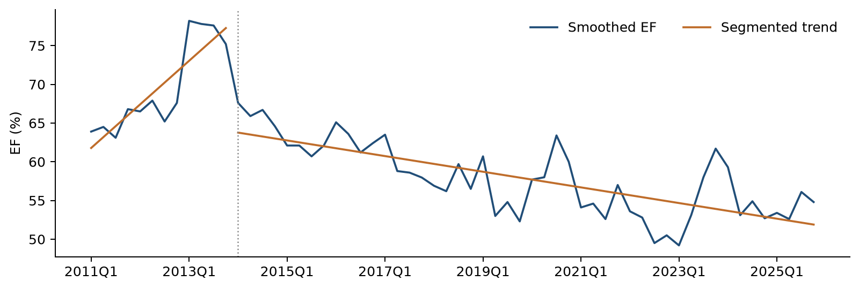
The fitted line rises before 2014Q1 and declines afterward. Separate lines allow the historical level and direction to change at the selected boundary.
Before 2014Q1, the estimated slope is +1.408 EF percentage points per quarter. After the boundary, it is −0.253 percentage points per quarter. These lines summarize the history. The forecasting equation adds prior-quarter EF to represent how the ratio adjusts over time.

3.3 Residual Stationarity Assessment
ADF and KPSS diagnostics assess the residual process after fitting the level-and-trend break regression. The ADF specification contains no additional deterministic term and selects up to four lagged differences by AIC. KPSS uses a constant and an automatic bandwidth. Both the development-only and full-history residuals are examined.
ADF evaluates a unit-root null, while KPSS evaluates a stationarity null. The reported ADF p values are below 0.05 and KPSS does not reject stationarity. Taken together, the results support the working representation of EF around fitted level-and-slope breaks.
Table 3.2 Residual stationarity checks
Sample | Check | Statistic | p value
Through 2023Q3 | ADF | −5.2240 | < 0.0001
Through 2023Q3 | KPSS | 0.0446 | > 0.10
Through 2025Q4 | ADF | −4.7569 | < 0.0001
Through 2025Q4 | KPSS | 0.1044 | > 0.10
Both checks support stationary fluctuations around the fitted level and trend break in each sample. We consider the two results together.
The p values use ordinary residual-test reference distributions. Estimating the break regression can affect those reference values. A formal break-adjusted unit-root conclusion requires a separately calibrated test. The results here serve as supporting diagnostic evidence.

3.4 Candidate Universe and Data Transformations
The candidate pool contains 22 macro series. Six use quarter-to-quarter log changes, which measure relative movement. The other 16 use changes in their original units. Every change is lagged one quarter. This gives every candidate the same 49 development observations from 2011Q3 through 2023Q3.

3.5 Forward Selection Framework
Forward selection adds one macro at a time. Each remaining candidate is fitted alongside the variables already in the equation. The starting equation contains a constant, D, t and prior-quarter EF. A candidate must pass all four checks below.
Table 3.3 Entry rules used in each selection round
Check | Rule | What it checks
Coefficient p value | Below 0.05 | Evidence that the added macro contributes to the fitted equation
VIF | Below 10 | Multicollinearity among explanatory variables
Durbin–Watson | 1.5 to 2.5 | Serial-dependence screening convention
Jarque–Bera p value | Above 0.05 | Residual normality screening based on skewness and kurtosis
These are the Consumer and Debit Cardfee screening rules. The lowest coefficient p value wins among eligible candidates. Ties use higher adjusted R² and then the fixed source-column order.
The search stops when all remaining candidates fail at least one rule. The DW range is a screening convention. Ljung–Box tests provide the final check for error patterns across quarters.

3.6 ARDL with Trend and Subsequent Reestimation
The initial ARDL includes a constant, the post-TARP indicator, a deterministic linear trend, lagged EF and the macro selected by forward screening. Conventional OLS covariance and two-sided Student-t tests are used throughout. No HAC adjustment or transition pulse is included.
$${EF}_{t} = c + δD_{t} + bt + φ{EF}_{t−1} + λΔU_{t−1} + ε_{t}$$
FLBR_B.IUSA enters in the first round with p = 0.0330. After it enters, the lowest remaining candidate p value is 0.2229. The search therefore ends with one macro.
Table 3.4 Selected ARDL with a trend
Term | Coefficient | p value
Constant | 0.271984 | 0.0010
Period indicator D | −0.034941 | 0.0206
Linear time trend t | −0.000807 | 0.1719
Prior quarter EF | 0.634474 | < 0.0001
Prior quarter unemployment change | 0.006204 | 0.0330
The trend p value is 0.1719. It exceeds the 0.05 decision threshold. Unemployment remains below the threshold.

Trend assessment and specification reduction
We remove the time trend and keep D, prior EF and prior unemployment change. We then estimate all coefficients again on the same 49 quarters. A transition pulse is omitted throughout the ARDL analysis.
Table 3.5 Final development model
Term | Coefficient | p value
Constant | 0.193795 | 0.0008
Period indicator D | −0.043633 | 0.0020
Prior quarter EF | 0.738292 | < 0.0001
Prior quarter unemployment change | 0.006417 | 0.0289
All retained coefficients have p values below 0.05. The prior-EF coefficient is 0.7383. The unemployment-change coefficient is positive at 0.006417.
The historical trend regression and the ARDL answer different questions. The first describes the broad path of EF. The second asks what helps predict EF after the prior quarter’s ratio is included. Once prior EF is present, the additional linear trend contributes little evidence in this sample.
The restricted equation re-estimates all coefficients after trend removal. This avoids carrying the with-trend estimates into a different specification. Appendix C provides the corresponding standard errors and t statistics for each estimation stage.

3.7 Challenger Comparison and Final Specification Selection
Table 3.6 Three no-trend alternatives
Source code | Adjusted R² | Macro p | One-step RMSE in EF pp | Recursive RMSE in EF pp
FLBR_B.IUSA | 0.826462 | 0.0289 | 2.783 | 3.728
FGAP_B.IUSA | 0.826998 | 0.0267 | 2.906 | 3.643
FGDP$_B.IUSA | 0.826748 | 0.0277 | 2.878 | 3.501
All three equations use the same 49 quarters. Their historical fit is very close. Unemployment has the lowest one-step error. GDP has the lowest recursive error. Here, pp means percentage points.
The adjusted R² values differ by less than 0.001 across the three specifications. Their similar fit supports consideration of forecast behavior and economic interpretation when choosing the main macro. Forecast errors are reported in EF percentage points for comparability with business outcomes.
A separate forward search that starts without a trend selects FGAP_B.IUSA. The main sequence selects FLBR_B.IUSA while the trend is present, then removes the trend. We retain unemployment because its fit is comparable, its one-step error is lowest, and its economic meaning is direct. The complete screening records remain available.
After unemployment is retained in the no-trend model, the strongest remaining addition has p = 0.1122. This is the private compensation index FECICPQ_B.IUSA. The final equation therefore keeps one macro.

3.8 Full History Reestimation and Coefficient Interpretation
After development testing, we keep the chosen variables and re-estimate their weights using all 58 usable quarters through 2025Q4. These updated weights drive the S1 and S4 forecasts. Historical forecast-error scores continue to use the earlier development weights.
Table 3.7 Full-history coefficients for future forecasting
Term | Coefficient | p value
Constant | 0.194684 | 0.0003
Period indicator D | −0.045338 | 0.0010
Prior quarter EF | 0.736985 | < 0.0001
Prior quarter unemployment change | 0.006314 | 0.0288
The unemployment coefficient remains positive and has p = 0.0288. Its estimate changes only slightly, from 0.006417 to 0.006314.
$${EF}_{t} = 0.194684 − 0.045338D_{t} + 0.736985{EF}_{t−1} + 0.006314ΔU_{t−1} + ε_{t}$$
A one-percentage-point increase in the relevant unemployment change raises fitted EF by about 0.631 percentage points. This describes the estimated historical relationship. Actual business responses can vary with the operating environment.

4 Model Development Data

4.1 Purpose and Scope of Development Data
The development dataset links a single quarterly EF series to a common history of potential macroeconomic drivers. The data architecture preserves original inputs, records each transformation and distinguishes historical estimation from future scenario assumptions. All available quarters within the specified calendar are retained after the documented 2017 adjustment; no random sampling is applied.

4.2 Historical Sample and Quarterly Frequency
The historical files contain 60 quarters from 31 March 2011 through 31 December 2025. Quarterly frequency aligns the supplied EF observations and macro series. The development cutoff is 2023Q3, followed by a nine-quarter out-of-time period. Differencing the macro input and then applying a one-quarter lag makes 2011Q3 the first common ARDL observation.
Table 4.1 Sample construction
Analysis | Period | Observations
Full-history static break regression | 2011Q1–2025Q4 | 60
Development static break regression | 2011Q1–2023Q3 | 51
ARDL selection and development estimation | 2011Q3–2023Q3 | 49
Out-of-time forecast assessment | 2023Q4–2025Q4 | 9
Fixed-specification full-history refit | 2011Q3–2025Q4 | 58

4.3 Internal EF Data
The file inputs/ef.csv contains Quarter and EF. EF is supplied in decimal ratio units, so 0.548 represents 54.8%. The model accepts the reported ratio and does not reconstruct its accounting numerator or denominator. The confirmed 2020Q3 value is 0.634. Reconciliation of the ratio definition to the institution’s financial reporting should form part of operational onboarding and subsequent source-data review.

4.4 External Macro and Scenario Data
The file inputs/macro.csv contains the same quarter-end calendar and 22 original provider-coded columns. The universe covers labor conditions, output, income and compensation, rates, credit conditions and sentiment. All candidates begin in 2011Q1; earlier values are neither added nor inferred. Appendix A records the descriptions, units and transformations for every source code.
The separate files scenarios/S1.csv and scenarios/S4.csv contain nine future FLBR_B.IUSA unemployment levels, expressed in percent. S1 is the Baseline path. Scenario observations remain outside the historical inputs and cannot enter estimation. The code joins them to the historical unemployment anchors only when constructing future lagged changes.

4.5 Data Lineage and Preparation
Table 4.2 Data lineage and transformation inventory
Source | Transformation | Model use or output
inputs/ef.csv | Retain raw EF; calculate two local averages; create EF(t−1) | Dependent variable and autoregressive term
inputs/macro.csv | Align quarter ends; apply log or level differences; lag one quarter | 22 candidate features on a common sample
Quarter | Set t = 1 in 2011Q1; set D = 1 from 2014Q1; construct D × t | Static break analysis and deterministic controls
scenarios/S1.csv and S4.csv | Combine with historical unemployment anchors; difference and lag | Scenario macro paths and recursive EF forecasts
Estimated coefficients | Keep development and full-history fits separately identified | OOT scores and future forecasting coefficients
The preparation sequence is deterministic. The program validates schemas and dates, retains the original EF values, calculates smoothing, aligns the macro history, constructs transformations and then forms the common estimation samples. All six log-change series must have positive source values. Transformations are calculated from the complete quarterly calendar before the sample is restricted.

4.6 Outlier Assessment and Adjustment
Two sharp EF movements in 2017 are treated as potential local outliers. The selected development series replaces each point with a three-quarter average based exclusively on original values. This reduces the local discontinuity while preserving both observations and their calendar positions.
Table 4.3 Documented EF smoothing
Quarter | Original EF | Original observations averaged | Adjusted EF
2017Q3 | 0.508 | 2017Q2, 2017Q3, 2017Q4 | 0.586000
2017Q4 | 0.662 | 2017Q3, 2017Q4, 2018Q1 | 0.579667
The second replacement uses the original 2017Q3 value of 0.508. The calculation is applied in code, leaving the input file unchanged. These centered averages use adjacent historical quarters and constitute a retrospective preprocessing choice. Both adjustments precede the out-of-time evaluation. All other EF observations, including the pandemic period, remain unchanged. Section 6.8 reports the effect of fitting the same equation to original EF.

4.7 Data Quality and Inclusion Criteria
Table 4.4 Input quality controls
Review area | Current evidence or implemented control
Completeness | 60 observations in each historical file; all 22 macro columns available over the common calendar
Calendar consistency | Quarter-end date checks and exact historical and scenario calendar requirements
Uniqueness | Duplicate dates are rejected before estimation
Numeric integrity | Missing and nonnumeric observations are rejected
Unit consistency | EF decimal-ratio checks and unemployment percent-range checks
Transformation validity | Positive-level requirement for log-change candidates
Source preservation | Input checksums before and after execution; calculated features exported separately
The sample loses two initial observations because the lagged macro change requires two historical levels. This is a transformation requirement rather than a missing-data adjustment. The first two EF values remain available as historical anchors. No additional quarter is removed from the smoothed development or full-history ARDL sample.

4.8 Data Relevance and Sufficiency
The history includes the early TARP-related period, subsequent normalization, the pandemic and later macroeconomic adjustment. These environments provide useful variation for estimating persistence and macro sensitivity. The modest number of quarterly observations favors a parsimonious equation and limits the precision of inference about rare events. The candidate pool offers a broad macro comparison, but it contains no separate bank-specific expense, revenue or management-action series.

4.9 Data Assumptions and Limitations
The analysis assumes that historical EF observations are comparable over time and that provider-coded macro units are consistent. The package establishes reproducibility from the supplied files; independent reconciliation to upstream accounting systems and archival economic vintages remains an operating control. A change in EF definition, macro vintage or scenario methodology should be assessed before results are compared across releases.
The two smoothing adjustments introduce judgment into development data. Their formulas, original values and forecast consequences are explicitly retained. Future revisions to the preprocessing rule require a new comparison against the original series, because smoothing affects both the response and the lagged response used by the ARDL.

5 Linkages with Other Models

5.1 Upstream Dependencies
Historical EF and the 22-series macro dataset are the direct estimation dependencies. Future projections additionally depend on externally supplied S1 and S4 unemployment paths. These paths are treated as fixed conditional inputs. The EF package does not estimate unemployment or modify the economic scenario construction.

5.2 Downstream Use and Reconciliation
The model produces quarterly EF ratios for use in planning and scenario comparison. A downstream expense projection would combine EF with a compatible income forecast. That conversion, its accounting reconciliation and any interaction with other planning models require separate documentation. The current package has no automated dependency on a deposit or card-fee forecast.

5.3 Dependency Change Controls
Each run should identify the EF reporting definition, macro-data vintage, scenario labels and scenario release date. The input and output manifests record file hashes. Changes to an upstream feed should trigger reconciliation of transformed values and forecast differences, followed by review of whether re-estimation or scenario-only refresh is appropriate.

6 Model Testing
The testing program evaluates the final reduced ARDL through historical fit, conventional coefficient inference, residual diagnostics, challenger forecasts and scenario sensitivity. Results are considered jointly. Sections 3.6 and 11.3 provide coefficient significance evidence; the tests below focus on the behavior of the selected forecasting specification.

6.1 In Sample Performance Assessment
Table 6.1 Final-model fit
Measure | Development | Full history
Usable quarters | 49 | 58
Adjusted R² | 0.8265 | 0.8212
Fitted error RMSE in EF pp | 2.833 | 2.822
The development equation accounts for about 82.6% of historical variation after allowing for its number of variables. This describes fit within the estimation sample. Later-quarter forecast results provide a separate check.
Figure 6.1 Actual and fitted EF in the development sample
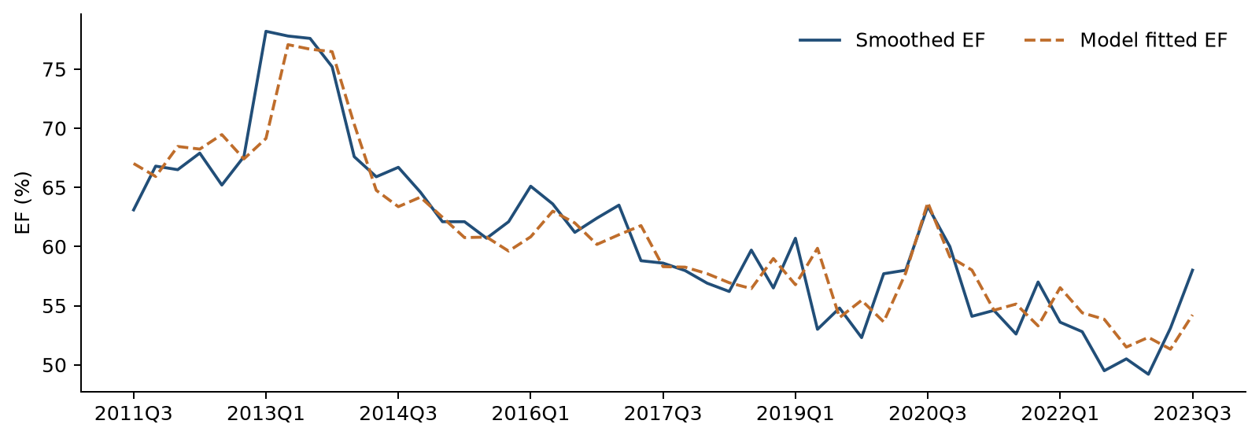
The fitted values follow the broad decline in EF and much of the quarterly movement. Some individual quarters have larger differences. Forecast testing evaluates how the equation performs after the development period.

6.2 Residual Diagnostics and Statistical Assumptions
Residual testing assesses serial dependence, distributional shape and parameter stability. Ljung–Box tests are evaluated at four and eight quarterly lags, Jarque–Bera assesses normality and CUSUM evaluates cumulative residual instability. The reporting threshold is 5%. Durbin–Watson is retained as a descriptive statistic because the equation includes a lagged dependent variable.
Table 6.2 Serial correlation diagnostics
Check | Development statistic | Development p | Full-history statistic | Full-history p
Ljung Box 4 | 5.2946 | 0.1515 | 6.7614 | 0.0799
Ljung Box 8 | 9.0562 | 0.2486 | 10.3557 | 0.1693
Durbin Watson | 2.1954 | — | 2.1631 | —
Ljung–Box uses lags 4 and 8 with one autoregressive degree of freedom deducted. Neither sample rejects the no-autocorrelation null at 5%. The full-history four-lag p value of 0.0799 warrants continued monitoring.
DW is close to two in both samples. It provides a simple description of consecutive errors. The code reports its statistic without a p value because the equation contains prior EF.
Table 6.3 Normality and cumulative stability diagnostics
Check | Development statistic | Development p | Full-history statistic | Full-history p
Jarque Bera | 2.5865 | 0.2744 | 1.9093 | 0.3849
CUSUM | 0.7016 | 0.7086 | 0.8039 | 0.5379
Neither Jarque–Bera nor CUSUM rejects its null at the 5% threshold in either sample. These results support the assessed residual properties and parameter stability within the available history.
Table 6.4 Stationarity of the final-model residuals
Sample | ADF statistic | ADF p | KPSS statistic | KPSS p
Development | −7.9090 | < 0.0001 | 0.1697 | > 0.10
Full history | −5.4416 | < 0.0001 | 0.2068 | > 0.10
The residual stationarity checks also support a stable pattern. Their ordinary diagnostic interpretation follows the discussion in Section 3.
Maximum VIF is 1.611 in development and 1.641 in the full-history fit. These low values indicate limited overlap among the explanatory variables. The prior-EF coefficient is below one in both fits, so the response to a temporary shock fades over time.

6.3 Out of Time Testing Framework and Results
The evaluation covers 2023Q4 through 2025Q4. All model weights stay fixed at their development estimates. One-step forecasts use the actual EF observed in the previous quarter. Recursive forecasts begin with actual 2023Q3 EF and then use each forecast to calculate the next quarter.
Both methods use the macro values observed during the evaluation period. These results show performance conditional on those macro values. This nine-quarter window was also reviewed when choosing the final macro.
Figure 6.2 Actual EF and historical forecasts
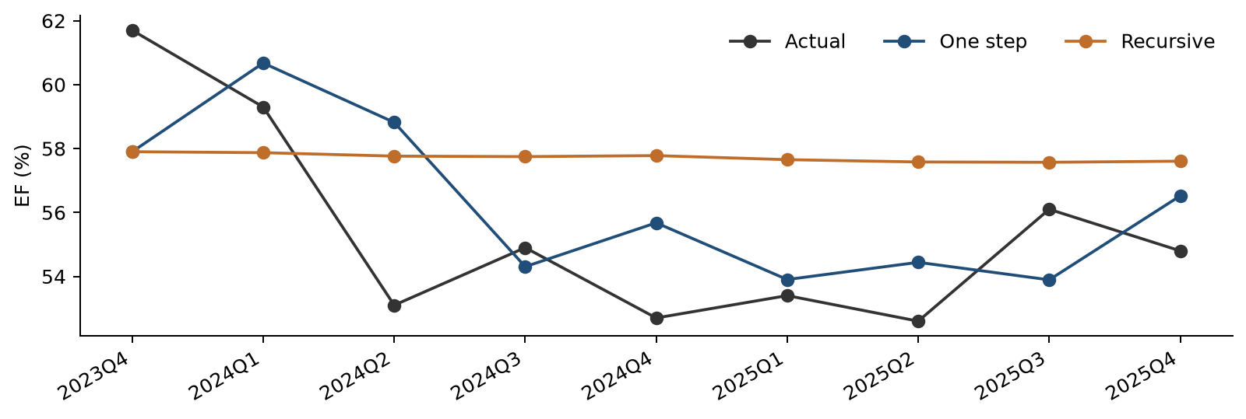
The one-step forecast responds to each new actual EF value. The recursive forecast follows a smoother path because it carries its own earlier predictions forward. The two methods share the first forecast.
Table 6.5 Forecast errors and simple comparisons
Forecast method | RMSE in EF pp | MAE in EF pp
Final model one step | 2.783 | 2.304
Final model recursive | 3.728 | 3.481
Prior actual EF each quarter | 3.001 | —
Keep 2023Q3 EF unchanged | 3.962 | —
Development-period average | 6.241 | —
The final model improves on both persistence comparisons. MAE is the average size of the errors. RMSE gives more weight to large errors. Both are shown in EF percentage points.
Unemployment’s one-step RMSE is 2.783 percentage points, compared with 2.906 for the output gap and 2.878 for GDP. For recursive forecasts, GDP is lower at 3.501 percentage points. The final choice considers these results together with historical fit and economic interpretation.

6.4 Scenario Testing and Economic Reasonableness
S1 is the original Baseline path. S4 supplies a higher unemployment path. The model starts from actual 2025Q4 EF of 54.8%. It uses the full-history coefficients and forecasts nine quarters through 2028Q1. Each EF forecast becomes the prior-quarter input for the next calculation.
Figure 6.3 Scenario unemployment and the resulting EF forecasts
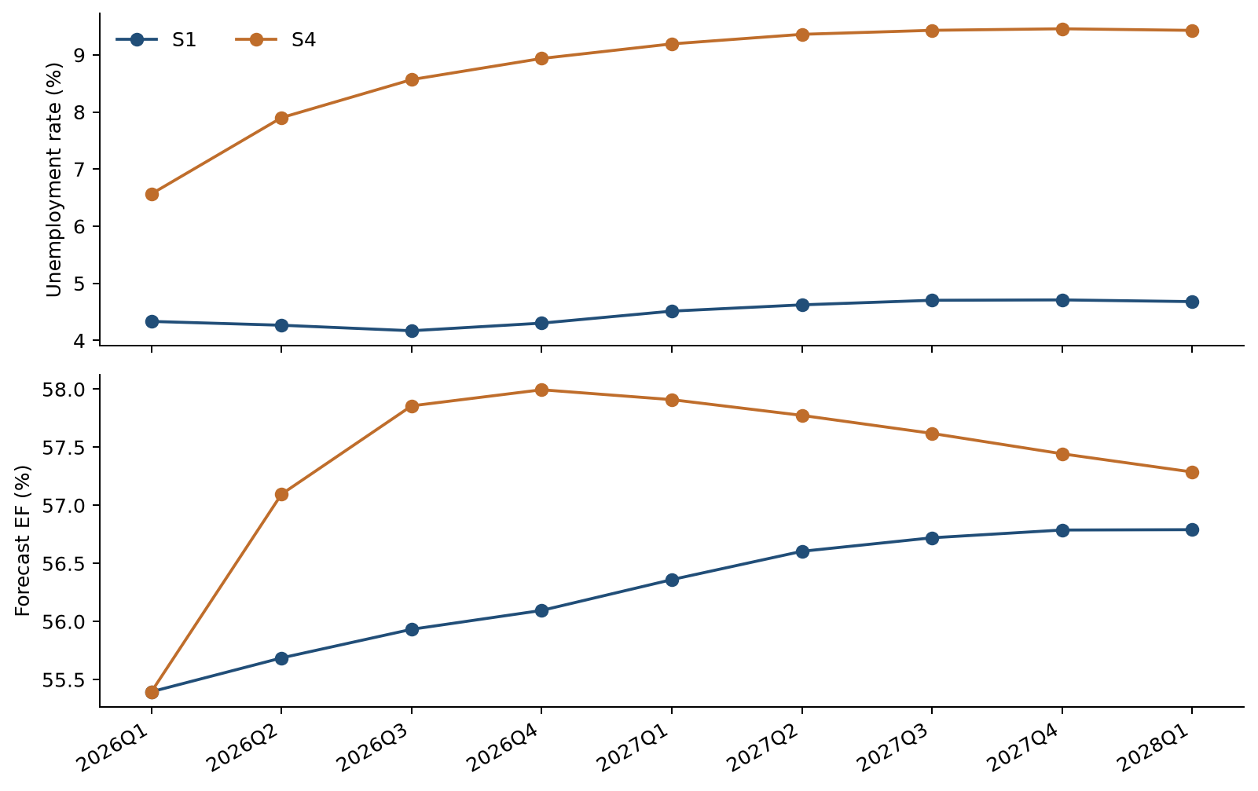
The upper panel shows the two unemployment paths. The lower panel shows the associated EF forecasts. The larger early unemployment increases under S4 produce a higher EF path from 2026Q2 onward.

Forecast timing and scenario separation
The 2026Q1 equation uses the unemployment change from 2025Q3 to 2025Q4. That historical change is shared by S1 and S4. The two first-quarter EF forecasts therefore both equal 55.395%. The different future unemployment paths first affect EF in 2026Q2.
The model responds to unemployment changes. Under S4, the quarterly increases become smaller. Unemployment peaks in 2027Q4 and then edges lower. The EF response eases later in the horizon. These forecasts describe the supplied economic paths and carry no assigned scenario probability.

6.5 Quarterly Scenario Results
Table 6.6 Nine-quarter scenario inputs and forecasts
Quarter | S1 unemployment % | S4 unemployment % | S1 EF % | S4 EF %
2026Q1 | 4.333 | 6.565 | 55.395 | 55.395
2026Q2 | 4.267 | 7.900 | 55.686 | 57.096
2026Q3 | 4.170 | 8.566 | 55.933 | 57.856
2026Q4 | 4.303 | 8.936 | 56.095 | 57.994
2027Q1 | 4.513 | 9.191 | 56.360 | 57.909
2027Q2 | 4.623 | 9.359 | 56.604 | 57.774
2027Q3 | 4.703 | 9.429 | 56.720 | 57.619
2027Q4 | 4.710 | 9.456 | 56.787 | 57.443
2028Q1 | 4.680 | 9.428 | 56.790 | 57.287
By 2028Q1, S1 EF is 56.790% and S4 EF is 57.287%. The 2028Q1 unemployment assumption would enter the EF equation in 2028Q2, one quarter beyond the displayed forecast.

6.6 Unemployment Path Sensitivity
The sensitivity test moves every future unemployment level up or down by one percentage point. For example, an S1 value of 4.333% becomes 5.333% in the upward case. Historical unemployment remains unchanged. We recalculate the quarterly changes and their lags before forecasting.
The same test is applied separately to S1 and S4. The fitted relationship is linear, so the incremental effect is equal around the two scenario paths. The first effect appears in 2026Q2. Later effects shrink as the previous EF response passes through the model.
Table 6.7 Selected sensitivity effects
Quarter | EF effect of +1 pp unemployment | EF effect of −1 pp unemployment
2026Q1 | 0.000 pp | 0.000 pp
2026Q2 | 0.631 pp | −0.631 pp
2026Q3 | 0.465 pp | −0.465 pp
2028Q1 | 0.075 pp | −0.075 pp
The largest effect is 0.631 EF percentage points in 2026Q2. By 2028Q1, it has declined to about 0.075 percentage points. The downward shift has the opposite sign.

6.7 Dynamic Shock Response
Figure 6.4 EF forecasts under the S1 unemployment sensitivity
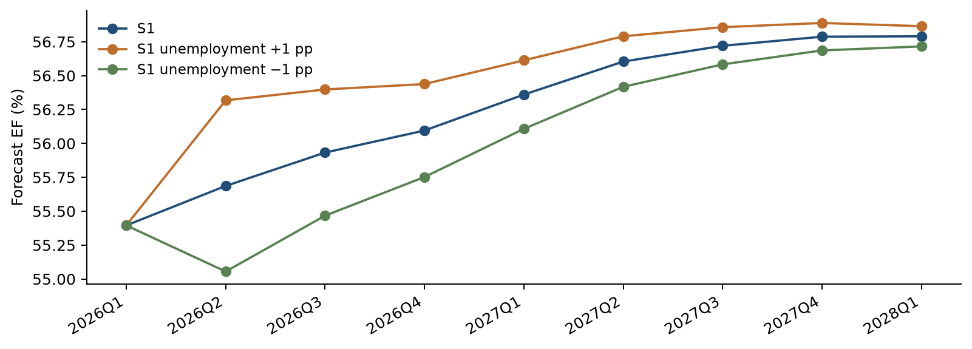
A higher unemployment path raises the EF forecast after the one-quarter delay. The separation then narrows. The permanent level shift creates one extra change at the forecast boundary, followed by the same quarterly changes as the original path.

Standard deviation shock calibration
An additional impulse-response calculation scales the macro shock to the historical standard deviation of unemployment changes, 1.505 percentage points. The resulting initial EF response is 0.951 percentage points when the shock enters the equation. With other inputs held fixed, the effect decays geometrically at the autoregressive rate of 0.737 per quarter.

6.8 Preprocessing Sensitivity and Observation Influence
Table 6.8 Same equation fitted to smoothed and original EF
EF series | Adjusted R² | One-step RMSE in EF pp | Recursive RMSE in EF pp
Smoothed EF | 0.8265 | 2.783 | 3.728
Original EF | 0.7188 | 2.827 | 3.919
The original-EF check keeps the same variables. The smoothed series gives closer fit and somewhat lower forecast errors. This comparison makes the effect of preprocessing visible.

Observation influence assessment
We also remove one development observation at a time and estimate the same equation again. The unemployment coefficient stays positive. It ranges from 0.005680 to 0.007907. Its p value ranges from 0.0132 to 0.2392. This shows that significance can depend on individual quarters even when the estimated direction stays the same.
2013Q1 has the largest Cook’s distance, a measure of how much an observation can affect the fitted coefficients. 2020Q3 has high leverage because of its unusual macro input. All observations remain in the main model. These quarters should receive attention when the model is refreshed.

7 Model Implementation

7.1 Implementation Platform and Calculation Flow
The implementation is a standalone Python package named Noncomp_EF_Code_and_Data_20261019. The main program is noncomp_ef_model.py. It reads the two historical CSV inputs and the separate scenario files. It then prepares the data, screens candidates, estimates the equations and writes the results to CSV.
The code calculates the two EF adjustments from the original input. It calculates each macro transformation and lag from the common quarterly history. Selection and the decision on the trend are recalculated each time the program runs.

7.2 Implementation Controls
Table 7.1 Controls in the current package
Control | Program behavior
Input schema | Checks the expected columns and quarter-end dates
Data completeness | Stops for missing, duplicate or nonnumeric observations
Data units | Checks EF ratio units and unemployment percent bounds
Log changes | Requires positive levels for the six log-change series
Output protection | Protects a nonempty result directory unless overwrite is requested
Scenario driver | Stops scenario forecasting if selection requires an unsupported macro
Traceability | Writes input and output file checksums
Original inputs | Checks that input contents are unchanged during the run
The current calendar is fixed at 2011Q1–2025Q4, with future scenarios through 2028Q1. Extending that calendar requires a reviewed code update.

7.3 Implementation Verification
The package was installed and run in a clean Python environment. It was also run from a directory outside the package. All 16 automated tests passed. The checks cover smoothing, dates, coefficient calculations, screening rules, forecast timing, scenario calculations and input protection.
A separate reconciliation compared the package with the latest experiment results. All 47 checks passed across 4,413 numerical values. The largest absolute difference was about 1.7 × 10⁻¹², within floating-point precision. The package includes the verification records and calculated reference outputs.

7.4 Forecast Output Identification
The primary scenario results use the full-history coefficient set. The package also exports development-coefficient scenario results for comparison. Each row identifies the scenario and the coefficient sample. The operator should select full_history when producing the main future forecast.

8 Model Monitoring

8.1 Purpose and Monitoring Philosophy
Ongoing monitoring should assess whether the model remains suitable for its documented forecasting use as new data and business conditions emerge. The review should cover input quality, forecast accuracy, parameter behavior, assumption validity and the consequences of known limitations. Statistical signals should be evaluated alongside operational developments and changes in the EF accounting definition.
The arrangements in this section are proposed operating requirements. The model owner and responsible model-risk function should approve the schedule, responsibilities and quantitative alert levels before production use. The current package provides development reference values and reproducible calculations to support that decision.

8.2 Roles and Responsibilities
Table 8.1 Proposed monitoring responsibilities
Role | Responsibility
Model owner | Review monitoring results, assess materiality, sponsor remediation and maintain the approved intended use
Developer or monitoring analyst | Prepare inputs, calculate metrics, investigate exceptions and retain analysis and version records
Model users | Assess scenario reasonableness, reconcile outputs to planning assumptions and report changes in business practice
Independent reviewer or model-risk function | Challenge methodology, assumptions and remediation; review material changes under the applicable policy

8.3 Monitoring Frequency
Input validation and forecast reasonableness checks should accompany every model run. Quarterly outcomes analysis should begin when new actual EF observations become available. A semiannual performance review should consolidate forecast errors, coefficient behavior and diagnostic results. An annual comprehensive assessment should revisit preprocessing, the structural boundary, the candidate universe and continued business relevance. Material changes in data, business conditions or scenario construction should prompt an additional review.

8.4 Input and Output Stability
Input review should reconcile source definitions, calendar coverage, units, revisions and scenario identity. Unemployment changes should be compared with development-period variation, with unusual values investigated for economic plausibility and processing errors. Output review should compare S1 and S4 levels, their separation and changes from the prior forecast vintage. Attribution should distinguish new actual EF, revised unemployment assumptions and coefficient changes.

8.5 Forecast Accuracy and Parameter Monitoring
Outcomes analysis should preserve the forecast origin and horizon of each prediction. One-step errors should be assessed separately from fixed-origin recursive errors. RMSE, MAE and signed errors should be compared with the corresponding persistence benchmark over the same quarters. The original nine-quarter references are 2.783 EF percentage points for one-step RMSE and 3.728 for recursive RMSE. These are development benchmarks; alert tolerances should be calibrated to the institution’s use and forecast-error materiality.
Coefficient review should track the unemployment sign and magnitude, the autoregressive coefficient and the post-TARP adjustment. A sign reversal in unemployment, an autoregressive estimate at or above one, or a material change in scenario sensitivity should trigger investigation. Changes in statistical significance should be considered together with estimation-window size and influence analysis. Recalibration should retain a frozen comparison against the previous approved version.

8.6 Assumptions and Limitation Monitoring
Each review should revisit EF definition stability, the relevance of the post-2014 regime and the assumption that unemployment changes remain an informative macro driver. The original-EF sensitivity and influential-quarter assessment should be repeated following material data extensions. Additional expense or revenue information may justify a revised specification if business changes weaken the existing aggregate relationship.

8.7 Metrics and Investigation Triggers
Table 8.2 Proposed investigation framework
Area | Review signal | Required assessment
Data integrity | Missing, duplicated or misaligned quarters; changed units | Resolve source or processing issue before forecast use
Forecast performance | Deterioration relative to the matched-horizon benchmark or persistent signed errors | Review sample size, forecast vintage and business developments
Residual properties | Ljung–Box, JB or CUSUM p below 0.05 | Investigate timing, outliers and omitted dynamics
Parameter behavior | Unemployment sign reversal or autoregressive coefficient ≥ 1 | Assess economic rationale, stability and recalibration need
Scenario behavior | Unexplained forecast changes or inconsistent S1/S4 labels | Reconcile inputs, lag construction and coefficient set
Assumptions | Material EF definition or operating-regime change | Evaluate model-use restrictions and redevelopment
The diagnostic thresholds retain the development conventions. Forecast-error and business-materiality tolerances require owner approval. A threshold breach initiates investigation and a documented decision; corrective action should reflect the cause and its effect on the intended use.

8.8 Escalation and Remediation
The monitoring analyst should document the exception, reproduce the affected result and distinguish data, implementation and model-design causes. The model owner should determine its materiality and the appropriate response. Material findings should be referred to the responsible model-risk function and affected users before the forecasts are relied upon. Responses may include data correction, a controlled rerun, coefficient recalibration, a documented adjustment or redevelopment.
Each issue record should identify the affected versions and forecasts, the responsible reviewer, the agreed action and the closure evidence. If a forecast adjustment is introduced, monitoring should retain both the unadjusted model path and the adjusted path, test the ongoing basis for the adjustment and specify when it will be reconsidered.

9 Procedures

9.1 Run Preparation
Use a version-controlled copy of Noncomp_EF_Code_and_Data_20261019. Preserve inputs/macro.csv and inputs/ef.csv in their original form. Confirm the 2011Q1–2025Q4 historical calendar, all 22 provider columns and EF ratio units. Confirm that scenarios/S1.csv and scenarios/S4.csv carry the correct nine-quarter unemployment paths. Record the data and scenario vintages before execution.

9.2 Execution
Install the dependencies listed in requirements.txt in the selected Python environment. Run the main program from the package or specify its absolute path. The supplied package resolves its default inputs relative to the program and writes CSV outputs to a designated results directory. Use a new directory for each controlled run; an existing nonempty directory is protected unless overwrite is explicitly requested.
Install dependencies: python -m pip install -r requirements.txt
Run the model: python noncomp_ef_model.py
Run automated tests: python -m unittest discover -s tests -v

9.3 Output Review and Release
Review run_summary.csv for 22 candidates, 49 development observations, 58 full-history observations, the selected macro and the trend decision. Inspect the selection logs, coefficient tables, residual diagnostics and OOT metrics. For the main future forecasts, select coefficient_sample = full_history. Confirm equal S1 and S4 EF forecasts in 2026Q1 and the first sensitivity response in 2026Q2.
Retain the code release, dependency versions, input manifest, output manifest, test results and reviewer decision with the forecast deliverables. The README documents command-line options and the output inventory. Extension of the fixed historical or scenario calendar requires a reviewed code change and a new reconciliation run.

10 Governance

10.1 Purpose and Current Status
Governance should establish accountability for model use, implementation integrity, monitoring and change management. The present documentation records the developed model and its implementation evidence. Production ownership, independent validation status and institutional approval should be recorded through the organization’s model-risk process before operational reliance.

10.2 Ownership and Independent Review
The model owner should maintain the intended use, review limitations and approve remediation within the applicable delegation of authority. The developer should maintain methodology documentation, calculations, tests and supporting evidence. Users should assess whether forecasts remain consistent with the planning context and report material changes in business assumptions.
Independent review should challenge conceptual soundness, the treatment of the historical break, residual-test interpretation, macro selection, smoothing, OOT assessment and scenario mechanics. Implementation review should reconcile the approved equation to the executable code. Automated testing and numerical reconciliation provide reproducibility evidence; independent validation and formal user acceptance require their own review records.

10.3 Change Management
Changes should be assessed for their effect on model purpose, design, data, implementation and forecast behavior. Material examples include changing the EF definition, 2017 smoothing rule, 2014Q1 boundary, macro candidate universe, transformation rules, selection thresholds, final regressors, scenario timing or deployment platform. Changes to monitoring triggers or intended use should also be documented and reviewed.
Table 10.1 Minimum change control record
Field | Required documentation
Change identification | Version, date, author and affected files
Rationale and scope | Business or technical reason and affected model components
Materiality assessment | Expected impact on coefficients, diagnostics, forecasts and intended use
Verification | Tests, reconciliation, sensitivity and challenger evidence as applicable
Review decision | Reviewer, approval status, conditions and implementation date
Post-change monitoring | Follow-up actions, responsible role and review timing

10.4 Expert Judgment and Forecast Adjustments
The historical smoothing rule is the documented judgmental adjustment to development data. Current forecasts follow the estimated equation without a management overlay. Any future overlay should have a specific business rationale, quantified effect, approval record and review date. Both the original and adjusted projections should remain available, enabling users and reviewers to distinguish model output from subsequent judgment.

11 Appendix Information

11.1 Appendix A Variable Dictionary
The original source codes appear below. L means a quarter-to-quarter log change. Δ means a change in the original level units. Every transformed value is lagged one quarter. The code exports the corresponding descriptive feature names in macro_dictionary.csv.
Table 11.1 All 22 macro candidates
Source code | Description | Level unit | Type
FAHEFI_B.IUSA | Financial activities average hourly earnings | USD per hour | L
FPCNBULC_B.IUSA | Nonfarm business unit labor costs | Index 2017=100 | L
FECICPQ_B.IUSA | Private industry total compensation ECI | Index Dec 2005=100 | L
FRFED_B.IUSA | Federal funds rate | Percent per annum | Δ
FRGT2Y_B.IUSA | Two year Treasury constant maturity rate | Percent per annum | Δ
FRGT10Y_B.IUSA | Ten year Treasury constant maturity rate | Percent per annum | Δ
FLBR_B.IUSA | Unemployment rate | Percent | Δ
FCBC_B.IUSA | Consumer confidence index | Index 1985=100 | Δ
FSBINQ_B.IUSA | Small business normalized optimism index | Index 1986=100 | Δ
FGDP$_B.IUSA | Real gross domestic product | Billion chained 2017 USD | L
FGAP_B.IUSA | Real GDP versus potential GDP output gap | Percent | Δ
FBBACBQ_B.IUSA | Commercial banks total assets | Billion USD | L
FBBABLLCBQ_B.IUSA | Commercial banks loans and leases in bank credit | Billion USD | L
FCBOEVIXQ_B.IUSA | CBOE S&P 500 volatility index period average | Index | Δ
FIRHYBOASQ_B.IUSA | High yield bond option adjusted spread | Percentage points | Δ
FPCNBCPH_B.IUSA | Nonfarm business hourly compensation | Index 2017=100 | Δ
FLBOPQ_B.IUSA | Total nonfarm job openings | Million jobs | Δ
FYPEW52Q_B.IUSA | Finance and insurance wages and salaries | Billion USD | Δ
FGDP52Q_B.IUSA | Finance and insurance gross product originating | Billion USD | Δ
FE52_B.IUSA | Finance and insurance employment | Million | Δ
FYPCPIQ_B.IUSA | Per capita income | USD | Δ
FECICCQ_B.IUSA | All civilian workers total compensation ECI | Index Dec 2005=100 | Δ
The six L variables use natural-log differences. The other 16 use level differences. The quarterly input values are used as supplied.

11.2 Appendix B Feature Selection Documentation
This table compares the first round with and without a trend. All first-round candidates pass the VIF, DW and JB checks. Their coefficient p values therefore determine first-round eligibility in this data set. The full CSV logs also contain every later-round trial.
Table 11.2 First-round screening results
Source code | With-trend p | Eligible | No-trend p | Eligible
FAHEFI_B.IUSA | 0.0832 | No | 0.4811 | No
FPCNBULC_B.IUSA | 0.4092 | No | 0.4072 | No
FECICPQ_B.IUSA | 0.1455 | No | 0.0473 | Yes
FRFED_B.IUSA | 0.1077 | No | 0.0756 | No
FRGT2Y_B.IUSA | 0.1104 | No | 0.0770 | No
FRGT10Y_B.IUSA | 0.3984 | No | 0.1839 | No
FLBR_B.IUSA | 0.0330 | Yes | 0.0289 | Yes
FCBC_B.IUSA | 0.3444 | No | 0.3969 | No
FSBINQ_B.IUSA | 0.4743 | No | 0.4813 | No
FGDP$_B.IUSA | 0.0372 | Yes | 0.0277 | Yes
FGAP_B.IUSA | 0.0344 | Yes | 0.0267 | Yes
FBBACBQ_B.IUSA | 0.1108 | No | 0.1613 | No
FBBABLLCBQ_B.IUSA | 0.1477 | No | 0.1072 | No
FCBOEVIXQ_B.IUSA | 0.5231 | No | 0.4135 | No
FIRHYBOASQ_B.IUSA | 0.4122 | No | 0.2863 | No
FPCNBCPH_B.IUSA | 0.1046 | No | 0.1655 | No
FLBOPQ_B.IUSA | 0.3242 | No | 0.3320 | No
FYPEW52Q_B.IUSA | 0.7491 | No | 0.7032 | No
FGDP52Q_B.IUSA | 0.1698 | No | 0.2203 | No
FE52_B.IUSA | 0.2432 | No | 0.2830 | No
FYPCPIQ_B.IUSA | 0.1610 | No | 0.1604 | No
FECICCQ_B.IUSA | 0.3887 | No | 0.1135 | No
The with-trend search selects FLBR_B.IUSA. The independent no-trend search selects FGAP_B.IUSA. Both searches stop after one macro enters. The main development sequence retains unemployment after removing the trend.

Inference following variable selection
A coefficient p value below 0.05 provides evidence that the coefficient differs from zero under the fitted model assumptions. These p values describe each fitted equation. The candidate search itself adds uncertainty, so economic meaning and forecast checks are also used in the final choice.

11.3 Appendix C Regression Outputs
The tables report conventional OLS standard errors, t statistics and two-sided Student-t p values. The development specification, its trend-augmented predecessor and the full-history refit remain separately identified.
Table 11.3 ARDL with trend through 2023Q3
Term | Estimate | Std error | t statistic | p value
Constant | 0.271984 | 0.077499 | 3.510 | 0.0010
Period indicator D | −0.034941 | 0.014548 | −2.402 | 0.0206
Linear time trend t | −0.000807 | 0.000581 | −1.389 | 0.1719
Prior quarter EF | 0.634474 | 0.106243 | 5.972 | < 0.0001
Prior quarter unemployment change | 0.006204 | 0.002819 | 2.201 | 0.0330
Table 11.4 Final ARDL through 2023Q3
Term | Estimate | Std error | t statistic | p value
Constant | 0.193795 | 0.053801 | 3.602 | 0.0008
Period indicator D | −0.043633 | 0.013267 | −3.289 | 0.0020
Prior quarter EF | 0.738292 | 0.076265 | 9.681 | < 0.0001
Prior quarter unemployment change | 0.006417 | 0.002844 | 2.257 | 0.0289
Table 11.5 Final ARDL through 2025Q4
Term | Estimate | Std error | t statistic | p value
Constant | 0.194684 | 0.050779 | 3.834 | 0.0003
Period indicator D | −0.045338 | 0.012983 | −3.492 | 0.0010
Prior quarter EF | 0.736985 | 0.071876 | 10.254 | < 0.0001
Prior quarter unemployment change | 0.006314 | 0.002810 | 2.247 | 0.0288
The development equation has 45 residual degrees of freedom. The with-trend equation has 44. The full-history equation has 54. All three use conventional OLS covariance.

The period indicator in the two regressions
The level-and-trend regression uses D together with D × t. Its D coefficient compares the two line intercepts. At the 2014Q1 boundary, the fitted separation is θ + 13γ, which equals −0.149105 in ratio units. This measures the difference between the fitted lines at the same date.
The ARDL uses D with prior EF and the macro change. Its D coefficient describes the period difference after holding those inputs fixed. The two coefficients serve different regression specifications.

11.4 Appendix D Forecast Evaluation and Diagnostic Settings
Table 11.6 Actual EF and OOT forecasts
Quarter | Actual EF % | One-step EF % | Recursive EF %
2023Q4 | 61.700 | 57.901 | 57.901
2024Q1 | 59.300 | 60.676 | 57.871
2024Q2 | 53.100 | 58.818 | 57.763
2024Q3 | 54.900 | 54.305 | 57.748
2024Q4 | 52.700 | 55.677 | 57.779
2025Q1 | 53.400 | 53.903 | 57.653
2025Q2 | 52.600 | 54.441 | 57.581
2025Q3 | 56.100 | 53.893 | 57.570
2025Q4 | 54.800 | 56.520 | 57.605
These are the values behind the historical forecast-error measures. The first forecast uses actual 2023Q3 EF. Later recursive forecasts use earlier predictions.

Technical test settings
Table 11.7 Calculation settings
Check | Setting
ADF residual diagnostic | No added constant or trend; AIC selects zero to four lags
KPSS residual diagnostic | Constant; automatic bandwidth; p above 0.10 reported as a bound
Ljung–Box | Lags 4 and 8; one autoregressive degree of freedom deducted
Jarque–Bera | Error skewness and kurtosis; chi-square reference with 2 degrees of freedom
CUSUM | OLS residuals; adjustment for the number of estimated coefficients
VIF | Maximum across all explanatory variables other than the constant
Student-t inference | Residual degrees of freedom equal observations minus estimated coefficients
The same settings are used in the code package and this document. Test statistics and p values are stored at full precision in the CSV outputs.

11.5 Appendix E Evidence Inventory and Version Control
The supporting package is Noncomp_EF_Code_and_Data_20261019.zip. Numerical results correspond to the full experiment report dated 19 October 2026 and the package’s verified reference outputs. The evidence inventory below supports traceability from documented conclusions to calculation records.
Table 11.8 Key evidence files
File or file group | Use in this MDD
macro_dictionary.csv | Macro names, descriptions, units and transformations
historical_data_and_features.csv; ef_smoothing.csv | Raw and smoothed EF, dates and calculated inputs
coefficients_static_*.csv; static_contrasts.csv | Historical level and trend estimates
static_residual_stationarity_*.csv | ADF and KPSS for the fitted historical lines
selection_*.csv | All candidate trials and screening decisions
coefficients_ardl_with_trend.csv | Initial ARDL and the trend decision
coefficients_final_*.csv | Development and full-history final coefficients
candidate_comparison.csv | Unemployment, output-gap and GDP comparison
diagnostics_*.csv; final_residual_stationarity_*.csv | Final-model diagnostics
oot_forecasts.csv; oot_metrics.csv | Historical forecast paths and errors
scenario_ef_forecasts.csv; scenario_macro_paths.csv | Labeled S1 and S4 paths
scenario_sensitivity.csv; one_sd_macro_shock.csv | Unemployment sensitivity results
influence.csv; leave_one_out.csv; raw_ef_sensitivity_metrics.csv | Observation influence and preprocessing sensitivity
verification folder | Numerical reconciliation and standalone execution checks
Files are stored in reference_outputs for the supplied snapshot and in results after a new run. Scenario rows identify both the scenario and coefficient sample.

Version verification
PACKAGE_MANIFEST.csv records release-level file checksums. input_manifest.csv and output_manifest.csv identify the contents of each calculation run. Combined with software versions in run_summary.csv and the retained source files, these records support version traceability and reproducible execution.

