OCC Ratio Time Series Analysis
OCC exposure relative to headcount and total assets | 2011 Q1 to 2025 Q4
This report examines whether OCC exposure shows a persistent trend after scaling it by headcount and total assets. The main result is asymmetric: OCC exposure per employee rises steadily, while OCC exposure as a share of assets does not follow one stable downward trend. The apparent full-sample decline in OCC/assets is largely associated with the 2019 Q1 acquisition or consolidation breakpoint.

Executive Summary
- OCC/assets fell from 3.54 basis points in 2011 Q1 to 2.67 basis points in 2025 Q4. A single full-sample trend is −0.067 basis points per year, but the separate pre- and post-2019 slopes are small and statistically weak.
- OCC/headcount rose from 1,892 to 3,387 per employee over the same period, a 79.0% increase. The fitted trend is +122 per employee per year, with R² = 0.940.
- Between 2018 Q4 and 2019 Q1, assets increased 42.7%, OCC exposure increased 23.8%, and headcount increased 15.8%. OCC/assets fell 13.3%, while OCC/headcount rose 6.9%.
- The ratio identity explains the divergence: OCC/headcount equals OCC/assets multiplied by assets/headcount. Assets per employee increased 137.2% from 2011 Q1 to 2025 Q4, more than offsetting the 24.5% decline in OCC/assets.
- Since 2023 Q1, both ratios have generally moved upward. OCC/assets rose at an estimated 0.095 basis points per year and OCC/headcount rose about 180 per employee per year, although both eased during 2025.

Data and Method
The analysis uses 60 quarterly observations from 2011 Q1 through 2025 Q4. OCC is treated as an exposure or asset stock. The two primary ratios are defined as follows:
- OCC/assets = quarter-end OCC exposure divided by quarter-end total assets, expressed in basis points.
- OCC/headcount = quarter-end OCC exposure divided by quarter-end SNV headcount, expressed as exposure per employee.
Linear trends are estimated separately for the full sample, the period before 2019 Q1, the period from 2019 Q1 onward, and recent subsamples. Reported t-statistics use Newey-West standard errors with four quarterly lags. These regressions summarize direction and stability; they do not establish causality or a forecasting model.

OCC Relative to Total Assets
The full-sample series slopes downward, but the decline is not well described by one continuous linear process. OCC/assets was 3.42 basis points in 2018 Q4 and 2.97 basis points in 2019 Q1. That 0.45 basis point drop accounts for much of the visual separation between the early and later parts of the sample.
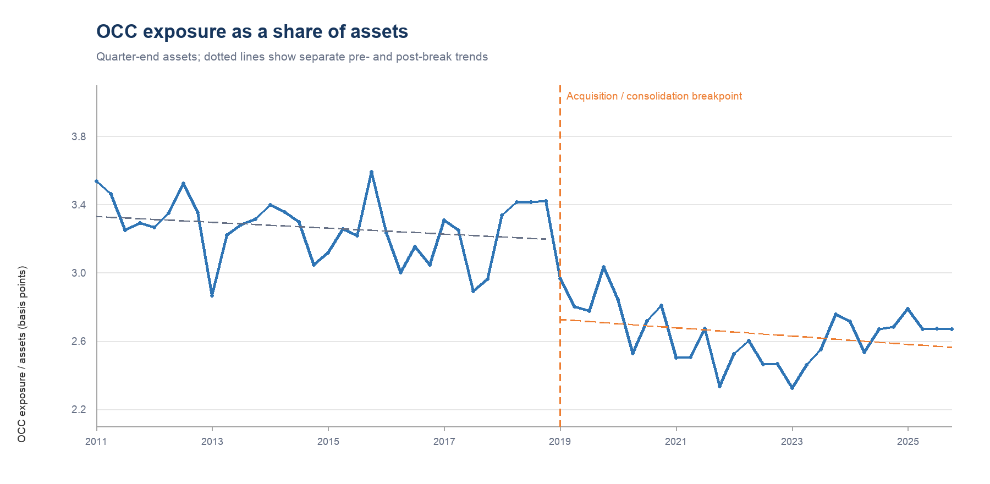
Figure 1 OCC exposure as a share of quarter-end assets
Period | Slope / year (bps) | R² | HAC t | Reading
Full sample 2011 Q1–2025 Q4 | -0.067 | 0.665 | -8.42 | Downward in aggregate
Pre-break 2011 Q1–2018 Q4 | -0.017 | 0.050 | -1.12 | Weak negative slope
Post-break 2019 Q1–2025 Q4 | -0.024 | 0.083 | -1.10 | Weak negative slope
Recent 2023 Q1–2025 Q4 | 0.095 | 0.413 | 2.77 | Moderate positive slope
Table 1 Linear trend estimates for OCC/assets
The pre-break slope is −0.017 basis points per year with R² = 0.050, and the post-break slope is −0.024 basis points per year with R² = 0.083. Neither segment supports a strong, stable decline. By contrast, the series rises after its 2023 Q1 low of 2.32 basis points. The recent slope is positive, although the ratio remained below its 2011 level at the end of 2025.

OCC Relative to Headcount
OCC/headcount has a much clearer trend. The ratio rose before and after the acquisition breakpoint. Its full-sample increase is therefore not an artifact of the 2019 level change, although the breakpoint shifted the series upward.
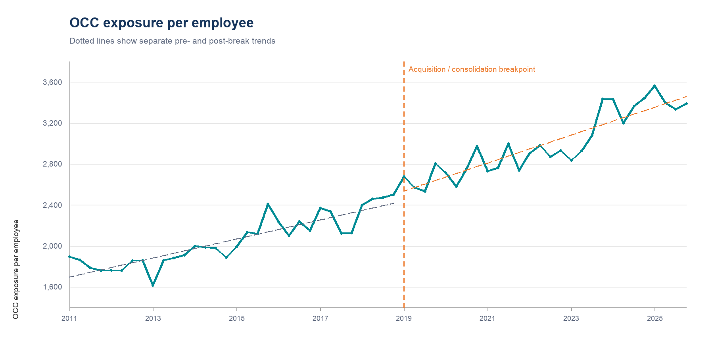
Figure 2 OCC exposure per employee
Period | Slope / year | R² | HAC t | Reading
Full sample 2011 Q1–2025 Q4 | 121.556 | 0.940 | 19.02 | Strong positive slope
Pre-break 2011 Q1–2018 Q4 | 92.978 | 0.794 | 9.27 | Persistent increase
Post-break 2019 Q1–2025 Q4 | 136.382 | 0.811 | 12.37 | Persistent increase
Recent 2023 Q1–2025 Q4 | 179.531 | 0.514 | 3.18 | Positive, more volatile
Table 2 Linear trend estimates for OCC/headcount
The fitted full-sample trend is +122 units of exposure per employee per year. The pre-break and post-break estimates are +93 and +136, respectively, and both have high explanatory power. OCC/headcount reached a sample high of 3,563 in 2025 Q1 before falling to 3,387 in 2025 Q4. The 2025 pullback should therefore be read as a moderation from a high level rather than evidence that the long-run trend has reversed.

Why the Ratios Move Differently
The two ratios are linked by an accounting identity:
OCC / headcount = (OCC / assets) × (assets / headcount)
From 2011 Q1 to 2025 Q4, assets per employee increased 137.2%, while OCC exposure as a share of assets declined 24.5%. The expansion in assets per employee was large enough to raise OCC exposure per employee by 79.0%. This decomposition is the central economic interpretation of the data.
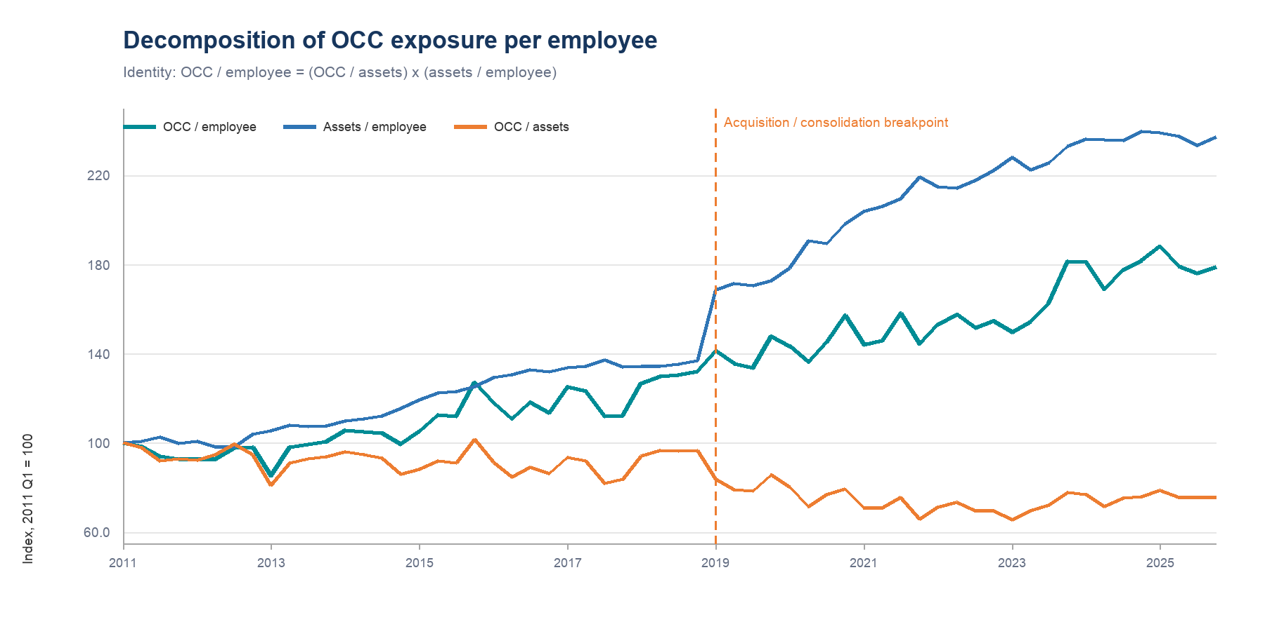
Figure 3 Indexed decomposition of OCC exposure per employee
The full-sample correlation between OCC/assets and OCC/headcount is −0.72, but that negative relationship is mainly a regime effect. Within the pre-2019 and post-2019 periods, the correlations are only 0.19 and 0.08. Since 2023 Q1, however, the two ratios have moved together closely, with a correlation of 0.97. Recent increases in OCC/headcount therefore reflect both a higher OCC share of assets and higher assets per employee.

The 2019 Acquisition Break
The transition from 2018 Q4 to 2019 Q1 changes the level and interpretation of both series. The simultaneous jumps in assets, OCC exposure, and headcount are consistent with a possible acquisition or consolidation effect. Ratios reduce the scale effect, but they do not remove a potential change in business mix.
Measure | 2018 Q4 | 2019 Q1 | Change
Total assets | 32.67 bn | 46.63 bn | +42.7%
OCC exposure | 11.17 mm | 13.83 mm | +23.8%
Headcount | 4,466 | 5,173 | +15.8%
OCC / assets | 3.42 bps | 2.97 bps | -13.3%
OCC / headcount | 2,502 | 2,674 | +6.9%
Assets / headcount | 7.32 mm | 9.01 mm | +23.2%
Table 3 Quarter-over-quarter change at the acquisition breakpoint
Because assets grew much faster than OCC exposure, OCC/assets fell sharply at the breakpoint. OCC/headcount increased because OCC exposure grew faster than headcount. A trend estimated across the full sample therefore combines three effects: gradual movement within each regime, the 2019 level shift, and changes in business composition.

Recent Readings
Quarter | OCC / assets (bps) | OCC / HC | Assets / HC (mm)
2021 Q4 | 2.33 | 2,736 | 11.73
2022 Q4 | 2.47 | 2,931 | 11.88
2023 Q4 | 2.76 | 3,434 | 12.47
2024 Q4 | 2.68 | 3,441 | 12.83
2025 Q1 | 2.79 | 3,563 | 12.78
2025 Q4 | 2.67 | 3,387 | 12.68
Table 4 Selected recent observations
The strongest recent change occurred during 2023. From 2022 Q4 to 2023 Q4, OCC/assets rose about 11.7% and OCC/headcount rose 17.2%. In 2025, both ratios eased from first-quarter highs. This pattern supports continued monitoring but does not yet establish a new downward regime.

Interpretation and Monitoring Implications
The two ratios answer different management questions and should be monitored together.
- OCC/assets measures exposure intensity relative to the balance sheet. It is most useful for assessing whether OCC is becoming a larger or smaller component of total assets.
- OCC/headcount measures exposure supported per employee. It is sensitive to operating leverage, staffing levels, and changes in assets per employee.
- Assets/headcount is the bridge between the two ratios. A rise in OCC/headcount does not imply that OCC has become a larger share of assets when assets per employee are rising faster.
For monitoring, the preferred dashboard should show all three series: OCC/assets, OCC/headcount, and assets/headcount. It should also mark the 2019 Q1 break and avoid fitting one trend line across the entire history without a regime indicator.
A practical alert framework would compare each quarter with the same quarter one year earlier and with a four-quarter moving average. A simultaneous rise in OCC/assets and OCC/headcount is more informative than a change in either ratio alone. A rise in OCC/headcount accompanied by a flat or falling OCC/assets ratio points instead to balance-sheet growth per employee.

Limitations
- The acquisition interpretation is based on the identified 2019 Q1 event; the dataset does not separately quantify purchase accounting, business mix, or reporting-scope changes.
- Headcount is observed quarterly and may not equal full-time-equivalent staffing or average staffing during the quarter.
- The trend regressions are descriptive. They do not control for macroeconomic conditions, portfolio mix, seasonality beyond simple quarterly inspection, or changes in OCC definitions.
- Using a three-month average asset denominator instead of quarter-end assets changes OCC/assets by only 0.020 basis points on average, with a maximum difference of 0.079 basis points. The main conclusions are therefore insensitive to the asset denominator choice.

Conclusion
OCC/headcount has a clear upward long-run trend, while OCC/assets is better characterized by a 2019 level break followed by a relatively flat and recently rising range. The apparent contradiction is explained by the growth in assets per employee. The most useful interpretation is therefore not that OCC exposure has uniformly intensified across the balance sheet, but that each employee now supports materially more assets and OCC exposure than in 2011. The recent rise in both ratios deserves attention, although the easing during 2025 suggests stabilization rather than continued acceleration.
Source and notes Quarterly data supplied in the workbook, Quarterly sheet, 2011 Q1–2025 Q4. OCC is treated as an exposure stock. Calculations use quarter-end assets unless stated otherwise. Values may differ slightly because of rounding.

