Noncomp Expense
Model Development Documentation
12 November 2026

1 Executive Summary

1.1 Model Overview
Non-interest expense includes compensation expense (Total employment expense - TOTEMPEX), Occupancy expense (Occupancy, Equipment and Software Expense - TOTOCCEQ) and other expenses (“Total Other Expenses - TOTOTHEX”). Compensation expense was modeled separately. In this model, there are two segments, one covering Occupancy expense and another covering other expense. The data for both segments were pulled from the general ledger (GL) in the L SNV statement.
Occupancy expense is projected using a qualitative approach based on bank asset size.
We use a quarterly regression to forecast adjusted Other noninterest expense (Other). Within Other, Accounting supplies “Amort. of intangibles - AMORTINT.” The Capital Stress Testing team covers “Foreclosed Real Estate Expense, Net - REPOREC.”

1.2 Business Purpose
Occupancy expense covers the bank’s premises, equipment and software. Its ratio to assets shows how these costs change as the bank grows.
Other covers operating costs such as deposit processing and professional services. Its quarterly expense ratio shows how much the bank spends on those activities per dollar of average assets.

1.3 Intended Uses
Use the Occupancy expense forecast for baseline planning and for management’s internal stress scenario.
Use the Other regression to project the quarterly expense ratio under the S1 and S4 Treasury yield paths. Use the projected quarterly average assets to convert the baseline ratio to dollars.

1.4 Development Summary
We reviewed quarterly Occupancy expense and asset balances from 2011Q1 through 2025Q4. The FCB acquisition increased assets in 2019Q1 and lowered the expense-to-assets ratio. We used the post-acquisition history to set the expense rates and the baseline asset growth trend. We tested the expense rate and asset trend separately.
For Other, we subtracted signed Card expense from monthly Other expense. We smoothed five months with one-time charges and calculated the quarterly expense ratio. The in-sample period ran from 2011Q1 through 2023Q3. We screened 15 macroeconomic variables at lags of zero, one and two quarters. Only the current-quarter change in the 10-year Treasury yield met both screening criteria. The final regression also includes the FCB acquisition, fourth-quarter and 2020 COVID indicators.

1.5 Final Model Structure

1.5.1 Occupancy expense
We apply an annualized expense rate to the sum of the three monthly asset balances and divide by 12. The baseline rate is the post-acquisition average of 0.315%. The internal stress rate is 0.279%. Management expects branch consolidation and lease renegotiation to lower expense per dollar of assets under stress.

1.5.2 Other Noninterest Expense
Table 1.5 Final model variable summary
Variable | Description | Construction
ΔYₜ  10-year Treasury yield change | Current-quarter change in the 10-year Treasury yield, in percentage points | Yield in quarter t less yield in quarter t−1
Pₜ  Post-acquisition indicator | Adjustment for the change in the expense ratio after the FCB acquisition | 0 through 2018Q4 and 1 from 2019Q1 onward
Qₜ  Fourth-quarter indicator | Recurring fourth-quarter expense effect | 1 in each fourth quarter and 0 otherwise
Cₜ  2020 COVID indicator | Adjustment to the expense ratio during the 2020 COVID period | 1 in 2020Q1–2020Q4 and 0 otherwise
Table 1.5 defines the four explanatory variables in the Other regression. The dependent variable is adjusted quarterly Other expense in basis points of average assets. The forecast equation below uses the full-history coefficients estimated over 2011Q1–2025Q4.
$${R̂}_{t} = 20.7924 - 7.0975P_{t} + 1.8430Q_{t} + 1.8979C_{t} - 2.4303{ΔY}_{t}$$

1.6 Performance and Out of Time Results
For Occupancy expense, we applied the historical expense rate to actual assets in each of the eight test quarters. The quarterly absolute percentage error averaged 1.5%. Total estimated expense was 1.2% below actual expense. The separate asset-trend forecast exceeded the actual 2025Q4 asset balance by 7.7%.
Table 1.2 Key performance measures for the Other regression
Measure | Development model | Full-history refit
Estimation period | 2011Q1–2023Q3 | 2011Q1–2025Q4
Observations | 51 | 60
Adjusted R² | 0.7023 | 0.7437
Fitted RMSE in basis points | 2.121 | 2.047
Table 1.2 compares the two fits of the Other regression. The Treasury coefficient changed from −2.46 to −2.43 basis points per percentage point of yield change. We used the in-sample coefficients for the backtest and the full-history coefficients for S1 and S4.
The Other backtest covered 2023Q4–2025Q4. The root mean squared error was 1.72 bp. The mean absolute error was 1.53 bp. Forecast expense exceeded actual expense in eight quarters and by $54.76 million in total. The sign screen also used observed expense ratios from this period.

1.7 Scenario and Sensitivity Summary
The quarterly Other expense ratio averages 14.03 bp under S1 and 14.28 bp under S4 over 2026Q1–2028Q1. The largest gap occurs in 2026Q3. The S4 ratio reaches 16.87 bp, compared with 13.50 bp under S1. Raising each quarterly change in the S1 Treasury yield by 5 or 15 bp lowers each quarterly expense ratio by 0.12 or 0.36 bp, respectively. A decrease of the same size raises the expense ratio by the same amount.

1.8 Overlay Summary
No overlay has been implemented.

1.9 Key Assumptions
We use data from 2019Q1 onward because the bank’s asset base changed in that quarter. The lower stress rate reflects management’s expectation that branch consolidation and lease renegotiation would reduce Occupancy expense per dollar of assets.
For Other, we use the arithmetic mean of the three monthly asset balances projected for the same quarter by the Occupancy expense model. Both Treasury paths start from the observed 2025Q4 yield. Each subsequent change uses the previous yield on the same path.

1.10 Key Strengths
Occupancy expense has historically moved with bank assets. Its ratio to assets was relatively stable after the FCB acquisition. In the backtest, the historical rate closely tracked actual expense when applied to actual assets.
The Other regression separates the effect of Treasury yield changes from the acquisition, seasonal and COVID effects. The Treasury coefficient remained close to its in-sample estimate when we extended the sample through 2025Q4.

1.11 Limitations
The Occupancy expense baseline uses an asset trend that includes strong growth through mid-2023. Assets were broadly flat thereafter. The lower stress rate assumes that the bank can reduce its premises costs under stress.
The Other regression forecasts recurring expense. Estimating a large acquisition cost requires information about the individual transaction. The macroeconomic sign screen also used observations from the backtest period.

1.12 Governance and Ownership
The model is governed under applicable Model Risk Management standards and SR 26-2 guidance. Performance is subject to periodic review, monitoring, and validation. Material changes to methodology, assumptions, inputs, implementation, or intended use require review and approval through established governance processes.

1.13 Executive Conclusion
The Occupancy expense model applies a historical expense rate to projected bank assets. The rate backtest supports this approach. Management’s internal stress scenario projects lower expense as assets decline and the bank reduces premises costs.
The Other regression forecasts the quarterly expense ratio from the change in the 10-year Treasury yield and three calendar indicators. Historical tests support the selected Treasury term. The full-history estimates link the S1 and S4 yield paths to quarterly expense forecasts.

2 Model Theory and Design

2.1 Occupancy expense

2.1.1 Historical Relationship to Bank Asset Size
The dollar amount of Occupancy expense grew over the years as the bank grew and prices rose. As bank asset size grows, the ratio of Occupancy expense to assets can remain relatively stable within a given period. Figure 2.1 shows both series. Quarterly expense rose from $29.83 million in 2011Q1 to $49.45 million in 2025Q4, while the annualized expense ratio fell from 0.408% to 0.321%.
Notably, the ratio dropped in 2019Q1 when FCB was acquired. Average assets grew from $32.51 billion to $46.12 billion, a 41.9% increase. Quarterly expense grew more modestly, from $34.26 million to $38.39 million, or 12.1%. As a result, the annualized ratio fell from 0.422% to 0.333%. This is consistent with savings from operating synergies as the combined bank supported a larger asset base.
The ratio dropped again during the first year of COVID, when large-scale remote work began. Annual Occupancy expense grew from $161.91 million in 2019 to $169.66 million in 2020, even as the mean of the four quarterly annualized ratios fell from 0.344% to 0.323%. After the merger, the annualized ratio averaged 0.315% through 2025Q4.
Figure 2.1 Quarterly Occupancy expense in dollars and as an annualized percentage of assets, 2011Q1–2025Q4
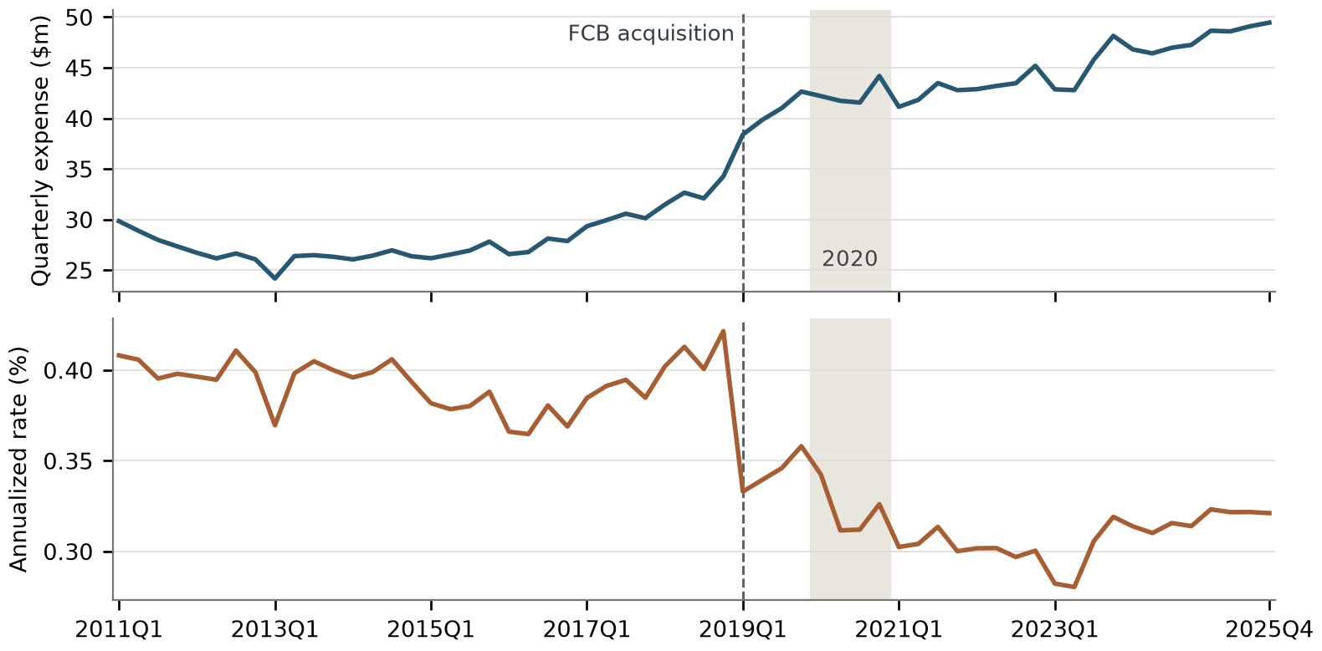
The upper panel plots recorded quarterly expense in millions of dollars. The lower panel plots the annualized expense ratio, calculated as four times quarterly expense divided by the average of that quarter’s three monthly asset balances. The dashed line marks the FCB acquisition and the shaded area marks calendar 2020.

2.1.2 Expense Rate and Historical Stress Experience
Asset size is the driver of Occupancy expense. The correlation is 0.98 over the full history and 0.78 from 2019Q1 onward. The coefficient of variation of the post-2019 expense rate is 5.7%. The projection applies a constant annualized rate to the asset path in each case. For quarter t, E is quarterly expense, B is the sum of the three monthly asset balances and A is their arithmetic mean. The rate r is expressed as a decimal.
$$r_{t} = 12 × E_{t} / B_{t}$$
$$Ê_{s,t} = B_{s,t} × r_{s} / 12 = A_{s,t} × r_{s} / 4$$
Assets and Occupancy expense both fell during the 2011Q1–2012Q3 contraction. The expense rate stayed near 0.41%. This experience supports a decline in assets under stress. The lower stress expense rate reflects management’s expectations for branch and lease costs.
Table 2.1 Historical drawdown from 2011Q1 to 2012Q3
Measure | Observed value
Asset size change | −11.3%
Occupancy expense change | −10.7%
Annualized expense rate at the peak | 0.408%
Annualized expense rate at the trough | 0.411%

2.2 Other Noninterest Expense

2.2.1 Business Purpose and Conceptual Framework
The largest items within Other include deposit processing fees, professional services fees (accounting, legal and consulting), and regulatory costs. The model scales adjusted Other by average assets. Multiplying the projected quarterly ratio by average assets converts the forecast back to dollars.

2.2.2 Business Context and Structural Transition
When scaled by assets, the Other expense ratio moved to a lower level after the FCB acquisition. The ratio fell from 19.31 bp in 2018Q4 to 14.04 bp in 2019Q1 as the acquisition increased assets. It averaged 21.24 bp before the acquisition quarter and 14.33 bp thereafter. During COVID, lower travel costs reduced the travel component of the ratio. The 2020 COVID indicator captures the net effect across all expense categories after accounting for the other regressors.

2.2.3 Modeling Philosophy
We selected the Other regression based on statistical evidence, business interpretation and forecast behavior. We tested each macroeconomic variable over the same quarters and with the same calendar controls. We considered the direction and significance of each coefficient. We also tested whether the prior quarter’s Other expense ratio added predictive information.

2.2.4 Rationale for Modeling the Ratio in Levels
The target is the unannualized quarterly expense ratio. Stationarity checks on the regime-adjusted development series support estimation in levels. The forecast can therefore be converted directly to dollars, and a coefficient expresses the change in basis points for a one-unit movement in an input.

2.2.5 Persistence and Macroeconomic Transmission
During stress, FDIC fees and legal costs typically increase, while other expenses, such as subscription fees, remain stable. Restrictions on travel and lower donations can offset some of the higher costs. Accounting for all these movements, the fee ratio may not be dramatically higher during stress. The negative Treasury-change coefficient raises the projected ratio when yields fall. Across the nine forecast quarters the S4 mean exceeds S1 by 0.25 bp.

2.2.6 Final Specification and Forecast Mechanics
R is the quarterly expense ratio in basis points. P equals one from 2019Q1 onward. Q equals one in each fourth quarter. C is the 2020 COVID indicator. ΔY is the quarterly change in the 10-year Treasury yield in percentage points. The equations below give the full-history ratio forecast and its dollar conversion. A is the average of the three monthly asset balances for the quarter.
$${R̂}_{t} = 20.7924 - 7.0975P_{t} + 1.8430Q_{t} + 1.8979C_{t} - 2.4303{ΔY}_{t}$$
$${Other}_{s,t} = A_{s,t} × {R̂}_{s,t} / 10,000$$

2.2.7 Alternative Macroeconomic Explanations
Only the current-quarter change in the 10-year Treasury yield met both screening criteria. No other variable or lag met both criteria. Table 11.3 shows the screening results.

2.2.8 Assumptions
The Other regression uses the quarterly change in the 10-year Treasury yield. A rise of 0.30 percentage points lowers the projected expense ratio by 0.73 bp, all else equal. The FCB acquisition indicator equals one in every forecast quarter. The fourth-quarter indicator adds 1.84 bp in each fourth quarter. The 2020 COVID indicator equals zero throughout the forecast period.
To convert the projected ratio to dollars, we use the average of the three monthly asset balances projected for the same quarter by the Occupancy expense model. A ratio of 15 bp applied to average assets of $1 billion gives quarterly Other expense of $1.5 million.

2.2.9 Limitations and Mitigants
M&A costs contributed to the recent increase in Other expense. The regression does not estimate the cost of a large acquisition.

2.2.10 Design Conclusion
We model the quarterly Other expense ratio in levels. The three indicators account for the FCB acquisition, fourth-quarter seasonality and the 2020 COVID period. The current-quarter Treasury yield change links the forecast to the interest rate scenario. We use the same equation for S1 and S4.

3 Model Estimation

3.1 Occupancy expense

3.1.1 Calibration of the Expense Rate
The asset base shifted in 2019Q1. The 28 quarters from 2019Q1 through 2025Q4 establish the baseline expense rate and the variability of that rate. The baseline rate is the arithmetic mean of the annualized quarterly ratios. We calculate the sample standard deviation across the same 28 quarterly rates. The internal stress rate is the mean less two sample standard deviations. It is close to the observed low of 0.280% in 2023Q2.
Table 3.1 Occupancy expense calibration
Measure | Value
Post-2019 mean annualized rate | 0.315%
Post-2019 standard deviation | 0.018 percentage points
Internal stress rate | 0.279%
Post-2019 minimum rate | 0.280% (2023Q2)
Mean quarterly asset increase from 2019Q1 to 2025Q4 | $1.72 billion
Mean three-month asset sum over 2024–2025 | $180.95 billion

3.1.2 Baseline and Internal Stress Projections
The baseline asset path begins with the 2025Q4 three-month asset sum of $184.8 billion. Each quarter adds $1.72 billion, the average increase across the 27 intervals since 2019Q1. Applying the baseline expense rate gives $49.0 million in 2026Q1, compared with $49.5 million of actual expense in 2025Q4.
Management’s internal stress case begins with the 2024–2025 average asset sum of $180.95 billion. The selected 12% decline rounds up the largest historical drawdown of 11.27%. Together with the lower starting balance, this places assets 13.8% below the 2025Q4 level. The decline is held at 12% for six quarters, then reduced to 9%, 6% and 3% in the final three quarters.
Table 3.2 Quarterly asset sums and Occupancy expense projections
Quarter | Baseline assets ($bn) | Internal stress assets ($bn) | Baseline expense ($m) | Internal stress expense ($m)
2026Q1 | 186.5 | 159.2 | 49.0 | 37.1
2026Q2 | 188.3 | 159.2 | 49.4 | 37.1
2026Q3 | 190.0 | 159.2 | 49.9 | 37.1
2026Q4 | 191.7 | 159.2 | 50.3 | 37.1
2027Q1 | 193.4 | 159.2 | 50.8 | 37.1
2027Q2 | 195.1 | 159.2 | 51.2 | 37.1
2027Q3 | 196.9 | 164.7 | 51.7 | 38.3
2027Q4 | 198.6 | 170.1 | 52.1 | 39.6
2028Q1 | 200.3 | 175.5 | 52.6 | 40.8
The first four quarters total $198.5 million in the baseline case and $148.2 million in the internal stress case. Over the nine quarters, the corresponding totals are $456.8 million and $341.0 million. The totals use the underlying balances and rates before rounding the quarterly amounts shown in Table 3.2.

3.2 Other Noninterest Expense

3.2.1 Overview of the Estimation Process
We calculated adjusted quarterly expense as a share of average assets. We tested the expense ratio for stationarity after accounting for the acquisition and the 2020 COVID period. We estimated the candidate regressions over the in-sample period. We then tested the prior quarter’s ratio. We held the selected specification fixed for the backtest and full-history fit.

3.2.2 Post-Acquisition Level Shift
The FCB acquisition indicator equals zero before 2019Q1 and one from 2019Q1 onward. Its in-sample coefficient is −6.72 bp. Holding the other variables constant, the estimated quarterly Other expense ratio is 6.72 bp lower in the post-acquisition period.

3.2.3 Residual Stationarity Assessment
The target diagnostic first removes an intercept, the post-2019 indicator and the 2020 COVID indicator on the development sample. The ADF test selects zero augmentation lags by AIC and rejects a unit root. The KPSS level test with four Bartlett lags falls below its 5% critical value. The model therefore retains the quarterly ratio in levels.
Table 3.3 In-sample stationarity tests
Series and test | Statistic | Result
Adjusted Other target, ADF | −5.9171 | p < 0.0001
Adjusted Other target, KPSS | 0.1792 | 5% critical value 0.463
Quarterly Treasury change, ADF | −4.9796 | p < 0.0001

3.2.4 Candidate Universe and Data Transformations
We applied one transformation to each macroeconomic variable. Quarterly log growth equals 100 times the change in the natural logarithm from the previous quarter. A quarterly rate change is measured in percentage points. Variables entered in levels use their observed quarterly values. Table 3.4 lists all 15 candidates.
Table 3.4 Candidate macroeconomic variables and transformations
Variable Name | Description | Transformation
FBBACBQ | Commercial bank assets | Quarterly log growth
FBBLDPCBQ | Commercial bank deposits | Quarterly log growth
FBBABLLCBQ | Commercial bank loans and leases | Quarterly log growth
FCCALLQ | Consumer credit outstanding | Quarterly log growth
FBCFDELLCCQ | Consumer credit card delinquency rate | Level
FBCFDELLIQ | Commercial and industrial loan delinquency rate | Level
FBCFCOFCCQ | Consumer credit card charge-off rate | Level
FBKBQ | Business bankruptcies | Quarterly log growth
FBKP | Personal bankruptcies | Quarterly log growth
FCBOEVIXQ | CBOE Volatility Index (VIX) | Quarterly log growth
FIRHYBOASQ | High-yield option-adjusted spread | Quarterly change in percentage points
FRFED | Federal funds rate | Quarterly change in percentage points
FRGT10Y | 10-year Treasury yield | Quarterly change in percentage points
FPPIXFD42Q | Producer Price Index for final-demand services | Quarterly log growth
FCPIULIE | Consumer Price Index excluding food and energy | Quarterly log growth

3.2.5 Macroeconomic Variable Screening
We tested 15 macroeconomic variables. For each variable, we tested the current-quarter value and lags of one and two quarters. This gave 45 candidate regressions. Each regression included the same three calendar indicators.
The sign rule required three estimates to have the same nonzero sign. The first two were the correlations between the candidate variable and the Other expense ratio in the in-sample and backtest periods. The third was the coefficient on the candidate variable in the in-sample regression.
Seventeen candidate regressions met the sign rule. Only the current-quarter change in the 10-year Treasury yield also met the significance criterion. Its two-sided HAC p-value was 0.0069, below the 0.10 cutoff.
Table 3.5 Entry rules and the retained Treasury specification
Entry measure | Requirement | Current Treasury change
Training correlation | Common nonzero sign | −0.261
Evaluation correlation | Common nonzero sign | −0.498
Partial regression slope | Same sign as both correlations | −2.4577 bp per pp
Two-sided HAC test | p < 0.10 | p = 0.0069

3.2.6 Lagged-Target Test and Final Estimation
The coefficient on the prior quarter’s Other expense ratio was not statistically significant (HAC p = 0.5643), so we omitted that term from the final regression. We estimated the following equation using all 51 in-sample quarters. The fitted ratio is expressed in basis points.
$${R̂}_{t} = 20.7097 - 6.7156P_{t} + 2.1743Q_{t} + 1.5095C_{t} - 2.4577{ΔY}_{t}$$
Table 3.6 Final development regression, 2011Q1–2023Q3
Term | Estimate | Two-sided HAC p-value
Intercept | 20.7097 | <0.0001
FCB acquisition indicator | −6.7156 | <0.0001
Fourth-quarter indicator | 2.1743 | 0.0046
2020 COVID indicator | 1.5095 | 0.0945
10-year Treasury yield change | −2.4577 | 0.0069
We estimated the regression by ordinary least squares. For inference, we used Newey–West standard errors with two lags and Bartlett weights. The tests use two-sided normal probabilities. The Treasury coefficient is measured in basis points of expense ratio per percentage point of yield change.

3.2.7 Full-History Reestimation and Coefficient Interpretation
We re-estimated the same regression using data through 2025Q4. Table 3.7 shows both sets of estimates. The coefficient on the change in the 10-year Treasury yield remained close to its in-sample estimate. We used the full-history coefficients for both the S1 and S4 forecasts.
Table 3.7 Other regression coefficients by estimation period
Term | In-sample estimate  2011Q1–2023Q3 | Full-history estimate  2011Q1–2025Q4
Intercept | 20.7097 | 20.7924
FCB acquisition indicator | −6.7156 | −7.0975
Fourth-quarter indicator | 2.1743 | 1.8430
2020 COVID indicator | 1.5095 | 1.8979
10-year Treasury yield change | −2.4577 | −2.4303

3.2.8 Estimation Conclusion
Only the current-quarter change in the 10-year Treasury yield met both the sign and significance criteria. The coefficient on the prior quarter’s Other expense ratio was not statistically significant, so we omitted that term. The final regression includes an intercept, the Treasury yield change, the FCB acquisition indicator, the fourth-quarter indicator and the 2020 COVID indicator.
We used the coefficients estimated over 2011Q1–2023Q3 for the historical backtest. We then re-estimated the same equation using the full history through 2025Q4. We used the full-history coefficients for the S1 and S4 forecasts and for the S1 sensitivity analysis.

4 Model Development Data

4.1 Occupancy expense

4.1.1 Historical Expense and Asset Data
We developed the Occupancy expense model using the bank’s historical expense and total asset balances. Historical expense comes from the Occupancy, Equipment and Software Expense line (TOTOCCEQ) in the L SNV general ledger statement. The workbook ooc_updated1.xls contains 60 quarterly observations from 2011Q1 through 2025Q4. The accompanying Occupancy report gives the backtest results and the baseline and internal stress forecasts.
For each quarter, we summed the three monthly expense amounts. We also summed the three monthly asset balances. We divided quarterly expense by the quarterly asset sum and multiplied by 12 to calculate the annualized expense rate.

4.1.2 Historical Periods Used in Development
Bank assets and Occupancy expense moved closely together over the historical period. When the bank acquired FCB in 2019Q1, assets grew faster than Occupancy expense. The expense rate fell and remained relatively stable after the acquisition. We therefore used the post-acquisition quarters to set the forecast rates.
Table 4.1 Historical periods used for Occupancy expense
Period | Use
2011Q1–2012Q3 | Measure the observed decline in assets from peak to trough. Use that decline to set the size of the asset reduction under internal stress.
2019Q1–2025Q4 | Calculate the mean and sample standard deviation of the 28 quarterly annualized expense rates. Use the mean as the baseline rate. Use the mean less two standard deviations as the internal stress rate. Use the average quarterly increase in assets to project baseline assets.
2019Q1–2023Q4 | For the expense-rate backtest, calculate the mean of the 20 quarterly annualized expense rates. For the asset-trend backtest, calculate the average quarterly increase in assets over the same period.
2024Q1–2025Q4 | Expense-rate backtest: Apply the earlier mean rate to actual assets and compare estimated expense with actual expense. Asset-trend backtest: Compare projected assets with actual assets. Internal stress starting balance: Take the mean of the eight quarterly asset sums.
The historical data also show a limitation of the baseline asset projection. Assets grew through mid-2023 and then remained broadly flat. The average increase over the full post-acquisition period therefore exceeds the growth observed near the end of the sample.

4.2 Other Noninterest Expense

4.2.1 Purpose and Scope of Development Data
We used monthly Other and Card expenses and the bank’s quarterly average assets to calculate the historical expense ratio. We used quarterly macroeconomic series to evaluate potential drivers of the ratio.

4.2.2 Development Sample
The expense history covers January 2011 through December 2025. We used all 180 monthly observations to calculate 60 quarterly expense ratios. The in-sample period was 2011Q1–2023Q3. The backtest covered 2023Q4–2025Q4. The macroeconomic history starts in 2009Q1 and supplies earlier observations for quarterly changes and lags.

4.2.3 Quarterly Frequency Selection
We measured expense and average assets over the same three months. The macroeconomic series and seasonal indicators use the same quarterly calendar.

4.2.4 Internal Model Data
The file expense_history.csv contains monthly Other expense (Other_Month_Actual_num) and Card expense (Card_Month_Actual_num) in dollars from January 2011 through December 2025. We subtract Card expense using its reported sign, adjust the five months in Table 4.5 and sum the monthly amounts by quarter.
The file asset_history.csv gives quarterly average assets in dollars (Average Asset_SNV) from 2011Q1 through 2025Q4. We divide adjusted quarterly Other expense by average assets and multiply by 10,000 to express the ratio in basis points. For the S1 dollar forecast, we use average_assets_bn from occupancy_baseline.csv. This field is the arithmetic mean of the three monthly asset forecasts from the Occupancy expense workbook for the same quarter, in billions of dollars.

4.2.5 External and Scenario Data
The file macro_history.csv contains quarterly levels for 15 macroeconomic series from 2009Q1 through 2025Q4. We apply the transformations in Table 3.4. In the 2011Q1–2023Q3 development sample, we test each series in the current quarter and at lags of one and two quarters.
The final model uses the quarterly change in the 10-year U.S. Treasury yield. For S1, macro_baseline.csv supplies the August 2026 baseline yield (FRGT10Y_B.IUSA) from 2026Q1 through 2028Q1. For S4, macro_s4.csv supplies the Moody’s January 2026 downside yield (FRGT10YQ_S4.IUSA) through 2028Q4. We use its first nine quarters to match S1. For both scenarios, we measure the first change from the observed 2025Q4 yield of 4.10%. Changes are in percentage points.

4.2.6 Data Lineage and Preparation
Table 4.2 groups the external inputs by economic theme. The historical variables support screening. The two forward Treasury paths supply the inputs for S1 and S4.
Table 4.2 External data inventory
Economic Theme | Representative Variables | Business Purpose
Banking activity | Bank assets, deposits, loans and leases, consumer credit | Measure the scale of banking and credit activity.
Credit conditions | Card and commercial delinquency, card charge-offs, bankruptcies | Describe credit conditions that can affect professional services and regulatory expenses.
Prices | Final-demand services PPI, core CPI | Describe changes in the cost of services and other operating inputs.
Market conditions | VIX, high-yield spread | Describe market volatility and the cost of credit.
Interest rates | Federal funds rate, 10-year Treasury yield | Measure changes in the interest rate environment.
Forward scenarios | S1 and S4 10-year Treasury yield paths | Supply quarterly yield changes for the Other forecasts.
Table 4.3 Data lineage for the final Other regression
Final Variable | Source Files | Description | Transformation Steps | Final Formula | Model Role
Other ratio (R) | expense_history.csv  asset_history.csv | Adjusted expense divided by average assets | Subtract signed Card. Smooth the five designated months. Sum each quarter. | 10,000 × adjusted quarterly expense / average assets | Dependent variable (bp)
FCB indicator (P) | Quarter date | Post-acquisition period | Identify quarters from 2019Q1 onward. | 1 from 2019Q1, else 0 | Level change
Q4 indicator (Q) | Quarter date | Fourth quarter | Identify the last quarter of each year. | 1 in Q4, else 0 | Seasonality
2020 COVID indicator (C) | Quarter date | 2020 COVID period | Identify the four quarters of 2020. | 1 in 2020, else 0 | Period effect
Treasury change (ΔY) | macro_history.csv | 10-year Treasury yield | Subtract the previous quarter’s yield. | Y(t) − Y(t−1) | Historical macro driver
Scenario Treasury change | macro_history.csv  macro_baseline.csv  macro_s4.csv | S1 or S4 yield | Start from the 2025Q4 yield. Difference each path separately. | Y(t) − Y(t−1) on each path | Forecast input
We calculated the quarterly expense ratio from monthly records. We formed macroeconomic changes and lags using the full quarterly history before aligning each series to the expense ratio. Table 3.4 gives the transformation for each candidate.

4.2.7 Data Preparation Process
need to be added

4.2.8 Data Quality Review
Table 4.4 Other data quality review results
Review Area | Assessment Performed | Result
Completeness | Checked monthly Other and Card amounts and quarterly average assets. | All 180 monthly pairs and all 60 asset balances are present.
Consistency | Checked dates, numeric fields, signed Card amounts and asset denominators. | Dates are unique within each input file. Each asset denominator is positive.
Time-series alignment | Aligned quarterly macroeconomic variables and lags with the target. Checked S1 and S4 coverage. | All 45 candidate series cover the 60 target quarters. Both Treasury paths cover the nine forecast quarters.
Trend reasonableness | Reviewed the quarterly expense ratio around the FCB acquisition. | Average assets rose in 2019Q1 and the adjusted expense ratio declined.
Data preparation | Reviewed the inputs to each monthly adjustment and the quarterly aggregation. | Each designated month has an original net expense value on both sides. Each quarterly total uses three monthly amounts.
Outlier review | Reviewed the five months with documented one-time items. | All five months remain in the history. Each uses the mean of its two original neighboring net expenses.
The expense and asset records cover the full model period. The macroeconomic series align with the expense ratio on the same quarterly calendar.

4.2.9 Missing Data and Inclusion Decisions
Four services PPI values are missing in 2009. They precede the observations needed for the model. The historical inputs cover all 51 in-sample quarters and all nine backtest quarters. S4 supplies the Treasury series used in the final equation.

4.2.10 Outlier Assessment and Adjustment
Five months had documented one-time items. In March 2011, the bank booked a $20 million restructuring charge, an $8 million open commitment reserve and $2 million in nonperforming loan (NPL) expense. January 2019 included costs associated with the FCB merger. September 2020 included a $45 million goodwill impairment. In July 2023, the bank booked a $35 million loan loss write-down for a medical office and an $18.5 million restructuring charge for early retirement. November 2023 included a special FDIC assessment.
For each of the five months, we replaced net Other expense with the mean of its two original neighboring monthly values. Tables 4.5 and 4.6 show the five adjustments and the associated events.
Table 4.5 Adjustments to monthly net Other and quarterly ratio
Month | Prior ($m) | Original ($m) | Next ($m) | Revised ($m) | Impact (bp)
2011-03 | 12.149 | 59.756 | 22.201 | 17.175 | −14.56
2019-01 | 19.784 | 67.520 | 18.195 | 18.989 | −10.52
2020-09 | 23.090 | 67.257 | 38.131 | 30.611 | −6.88
2023-07 | 36.074 | 78.958 | 24.559 | 30.317 | −8.12
2023-11 | 26.306 | 74.237 | 26.084 | 26.195 | −7.96
For January 2019, the original net expense was $67.520 million. We replaced it with $18.989 million, the mean of the December 2018 and February 2019 net expenses. The replacement reduced the quarterly ratio by 10.52 bp. Table 4.6 identifies the business event for each adjustment.
Table 4.6 Business events associated with the Other expense adjustments
Adjustment month | Business explanation
March 2011 | $20 million restructuring charge, $8 million open commitment reserve and $2 million in NPL expense.
January 2019 | FCB merger in Jan 2019.
September 2020 | $45 million goodwill impairment in Sept 2020.
July 2023 | $35 million loan loss write-down for a medical office and $18.5 million restructuring for early retirement in Jul 2023.
November 2023 | A special FDIC assessment in Nov 2023.

4.2.11 Data Relevance and Sufficiency
The target uses the bank’s recorded Other expense, signed Card expense and average assets. These inputs measure spending relative to the bank’s size. The history covers the FCB acquisition, the 2020 COVID period and different interest rate environments. It also includes repeated fourth quarters. This coverage supports estimation of the acquisition, seasonal and Treasury effects.

4.2.12 External Data Appropriateness
Bank assets, deposits and loans describe the scale of banking activity. Delinquencies, charge-offs and bankruptcies measure credit stress, which can affect legal and regulatory expense. Consumer and producer price indexes describe the cost environment for purchased services. Interest rates, credit spreads and market volatility describe financial conditions. We evaluated these variables as potential drivers. Only the current-quarter change in the 10-year Treasury yield met both screening criteria.

4.2.13 Data Assumptions and Limitations
We assume that reporting definitions for Other expense, Card expense and average assets are comparable across the historical period. We use the signed Card amount as reported. We use the mean of the two adjacent original net amounts for the five designated months. A quarter-end replacement uses the following month’s observation. The 2020 COVID period remains in the sample.
S1 and S4 come from different vintages. The first two scenario quarters had already ended when the August 2026 S1 data were issued. The S1–S4 comparison reflects both scenario assumptions and the information available at each release.

4.2.14 Development Data Conclusion
The internal records cover the expense and asset history needed to calculate the quarterly Other ratio. The external series align with the target over the in-sample and backtest periods. Together, these data support macroeconomic variable selection, estimation of the final regression and evaluation of its quarterly forecasts.

5 Linkages with Other Models
No linkage with other model.

6 Model Testing

6.1 Occupancy expense
We tested two assumptions behind the Occupancy expense forecast. The first was that the historical expense rate could estimate quarterly expense when asset balances were known. The second was that the historical increase in assets could be used to project future balances. We used 2019Q1–2023Q4 to estimate the rate and the asset trend. We tested both over 2024Q1–2025Q4.

6.1.1 Expense Rate Backtest
We calculated the average annualized Occupancy expense rate over the calibration period. We applied this rate to actual asset balances in each of the eight test quarters. We compared estimated expense with recorded expense. The mean absolute percentage error was 1.5%. Total estimated expense was 1.2% below actual expense. The historical rate tracked quarterly expense closely when actual asset balances were available.

6.1.2 Asset Trend Backtest
We calculated the average quarterly increase in assets over the calibration period. Starting from 2023Q4, we used that increase to project assets for the next eight quarters. The projected asset balance for 2025Q4 was 7.7% above the actual balance. Assets had grown during much of the calibration period and were broadly flat during the test period. Extending the earlier trend therefore overstated asset growth.
Table 6.1 Occupancy expense and asset trend backtest results
Measure | Period | Result
Mean absolute percentage error for expense using actual assets | 2024Q1–2025Q4 | 1.5%
Total estimated expense compared with actual expense | 2024Q1–2025Q4 | 1.2% below actual
In-sample mean absolute percentage error for expense | 2019Q1–2025Q4 | 4.3%
Projected asset balance compared with actual balance | 2025Q4 | 7.7% above actual

6.1.3 Internal Stress Scenario
During the historical contraction from 2011Q1 to 2012Q3, assets fell by 11.3% and Occupancy expense fell by 10.7%. The expense rate remained broadly stable. This experience supports projecting lower dollar expense when the bank’s asset base contracts.
Management also assumes that branch consolidation and lease renegotiation would reduce expense per dollar of assets under internal stress. The selected annualized stress rate of 0.279% is close to the lowest rate observed after the FCB acquisition, 0.280%. With a smaller asset base and a lower expense rate, projected Occupancy expense totals $341.0 million over nine quarters under internal stress, compared with $456.8 million under baseline.

6.2 Other Noninterest Expense

6.2.1 Testing Framework
We evaluated the selected regression on its 51 in-sample quarters. We held those coefficients fixed for the nine-quarter backtest. The sign screen used the nine observed expense ratios to select the Treasury variable. The backtest therefore measures performance after variable selection, conditional on observed yields and average assets.

6.2.2 In-Sample Results

6.2.2.1 In-Sample Performance Assessment
The in-sample R² is 0.7261 and adjusted R² is 0.7023. The fitted root mean squared error is 2.12 bp. The mean absolute error is 1.71 bp. Figure 6.1 shows the acquisition-related shift and the fourth-quarter expense pattern.
Figure 6.1 Actual and fitted Other expense ratios in development
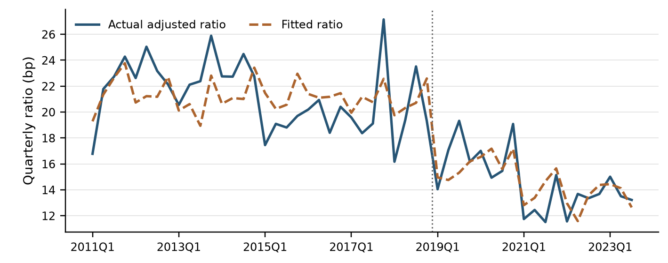

6.2.2.2 Coefficient Significance Testing
The Treasury change has HAC standard error 0.9101 and p = 0.0069. The estimated post-2019 effect is −6.7156 bp and the fourth-quarter effect is +2.1743 bp. The coefficient on the 2020 COVID indicator is +1.5095 bp (p = 0.0945). These three indicators are prespecified controls. Appendix C reports coefficients, standard errors and intervals.

6.2.2.3 Multicollinearity Assessment
We calculated a variance inflation factor for each predictor over the 51 in-sample quarters. The values range from 1.03 to 1.26. The Treasury value of 1.11 indicates little overlap with the calendar indicators.
Table 6.2 Development variance inflation factors
Predictor | VIF
2019Q1 onward | 1.209
Fourth quarter | 1.032
2020 COVID indicator | 1.257
10-year yield change | 1.108

6.2.2.4 Residual Diagnostics
Residuals are actual less fitted bp. The Ljung–Box tests at four and eight lags have p-values of 0.1473 and 0.0987, respectively. The Jarque–Bera test has p = 0.5310. The time plot, fitted-value plot and normal quantile plot show how the summary statistics relate to the individual quarterly observations.
Table 6.3 Development residual and stability tests
Diagnostic | Statistic | p-value
Durbin–Watson | 1.551 | —
Ljung–Box Q(4) | 6.791 | 0.1473
Ljung–Box Q(8) | 13.403 | 0.0987
Jarque–Bera | 1.266 | 0.5310
OLS-residual CUSUM | 1.336 | 0.0564
Figure 6.2 Quarterly Other development residuals
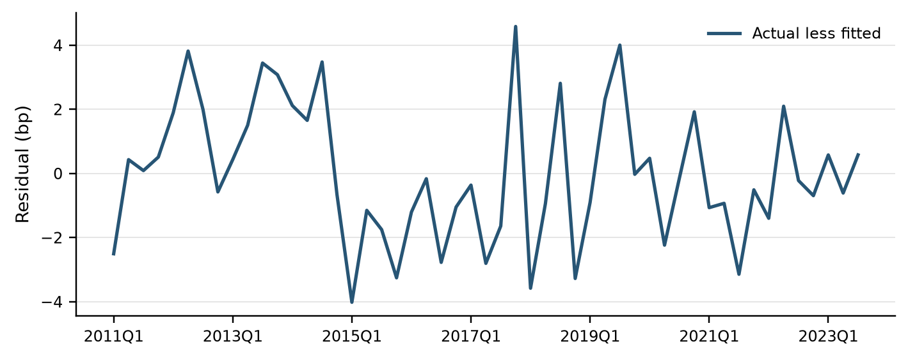
Figure 6.3 Other residuals against fitted expense ratios
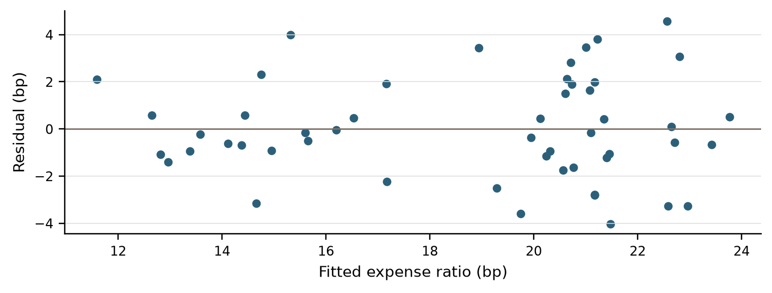
Figure 6.4 Normal quantile plot of Other development residuals
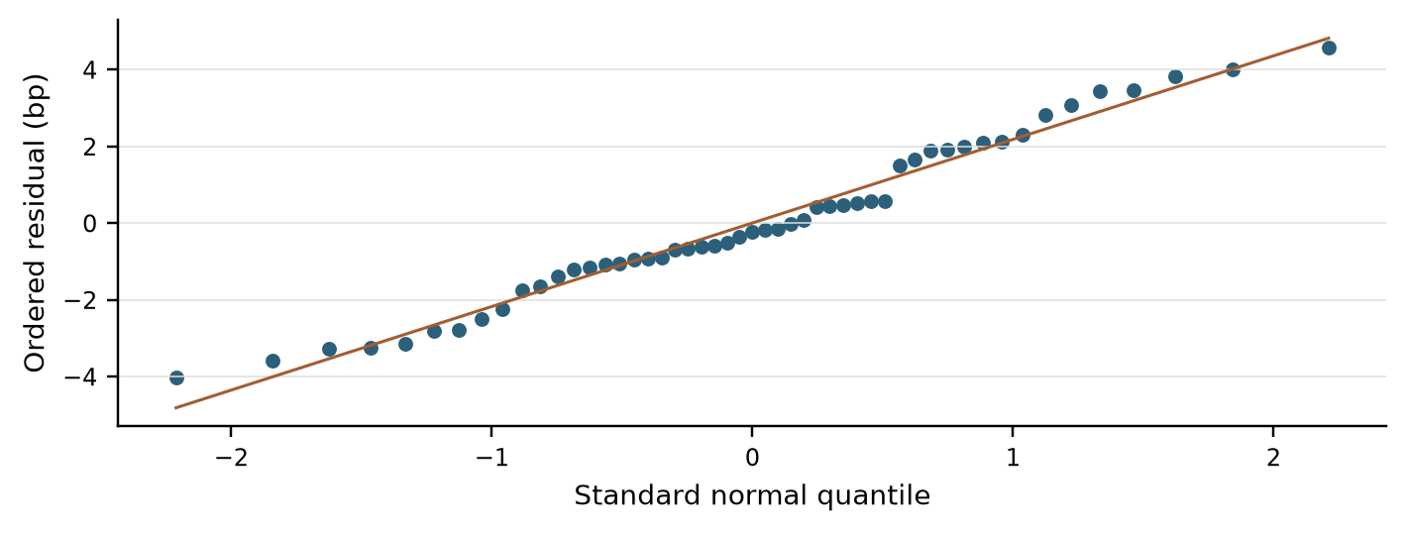

6.2.2.5 Evaluation of Statistical Assumptions
The adjusted expense ratio passed the stationarity tests. The highest variance inflation factor was 1.26. The Ljung–Box tests at four and eight lags did not detect serial dependence at the 5% level. We used HAC standard errors to allow for heteroskedasticity and short-run dependence.

6.2.2.6 Stability Assessment
The CUSUM test gave a p-value of 0.0564. The Treasury coefficient was −2.46 in the in-sample regression and −2.43 in the full-history regression. Extending the estimation period had little effect on the estimated response to Treasury yield changes.

6.2.3 Out-of-Time Results

6.2.3.1 Out-of-Time Testing Framework
We held the coefficients fixed at the 2023Q3 cutoff. For each of the next nine quarters, we calculated the ratio directly from the observed Treasury yield change and the three calendar indicators. Each quarterly prediction is independent of the previous quarter’s forecast. We used actual quarterly average assets to convert each ratio to dollars.

6.2.3.2 Forecast Performance and Interpretation
The backtest root mean squared error was 1.72 bp. The mean absolute error was 1.53 bp. Actual less predicted averaged −1.01 bp. Total predicted expense was $800.06 million and actual adjusted Other expense was $745.30 million. The forecast exceeded actual expense in eight quarters.
Figure 6.5 Out-of-time actual and frozen-coefficient Other forecasts
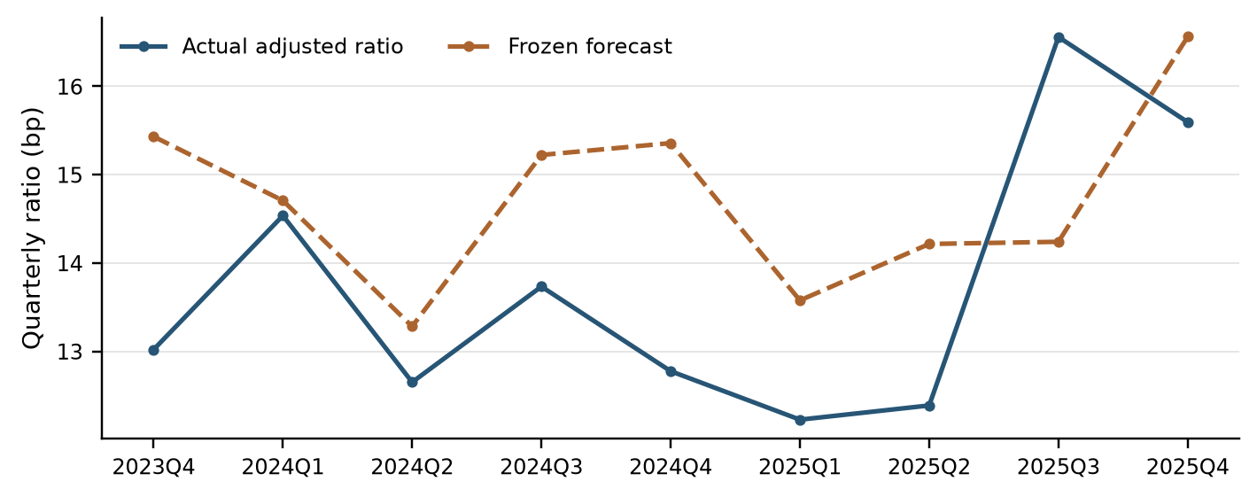

6.2.3.3 Forecast Behavior and Root Cause Assessment
The largest overprediction in bp occurs in 2024Q4 (2.58 bp). Actual expense intensity was 12.77 bp against a 15.36 bp forecast that included the fourth-quarter uplift. The largest underprediction occurs in 2025Q3, when actual reached 16.56 bp against 14.24 bp projected. Reviewing ratio errors first separates spending variance from the size of the balance sheet.

6.2.4 Scenario Testing

6.2.4.1 Scenario Framework
Both scenarios start from the observed 2025Q4 Treasury yield of 4.10%. We calculated each quarterly change from the preceding yield on the same path. We used the full-history coefficients for every quarter. The fourth-quarter effect applies in 2026Q4 and 2027Q4.
Table 6.4 Scenario Treasury inputs and Other expense ratios
Quarter | S1 yield (%) | S4 yield (%) | S1 change (pp) | S4 change (pp) | S1 ratio (bp) | S4 ratio (bp)
2026Q1 | 4.200 | 4.092 | 0.1000 | −0.0083 | 13.45 | 13.72
2026Q2 | 4.420 | 4.093 | 0.2200 | 0.0011 | 13.16 | 13.69
2026Q3 | 4.500 | 2.786 | 0.0800 | −1.3065 | 13.50 | 16.87
2026Q4 | 4.470 | 2.413 | −0.0300 | −0.3728 | 15.61 | 16.44
2027Q1 | 4.420 | 2.263 | −0.0500 | −0.1507 | 13.82 | 14.06
2027Q2 | 4.400 | 2.664 | −0.0200 | 0.4010 | 13.74 | 12.72
2027Q3 | 4.370 | 3.056 | −0.0300 | 0.3924 | 13.77 | 12.74
2027Q4 | 4.360 | 3.265 | −0.0100 | 0.2086 | 15.56 | 15.03
2028Q1 | 4.370 | 3.464 | 0.0100 | 0.1994 | 13.67 | 13.21

6.2.4.2 Scenario Results and Reasonableness Assessment
Figure 6.6A shows the Treasury yield levels. Figure 6.6B shows the Other expense ratio forecasts. The largest forecast difference occurs in 2026Q3. The S4 Treasury yield falls by 1.3065 percentage points while the S1 yield rises by 0.0800 points. The projected Other expense ratio is 16.87 bp under S4 and 13.50 bp under S1. The S4 yield starts to recover in 2027Q2, and the S4 ratio falls below the S1 ratio. The nine-quarter average is 14.28 bp under S4 and 14.03 bp under S1.
Figure 6.6A 10-year Treasury yield paths under S1 and S4
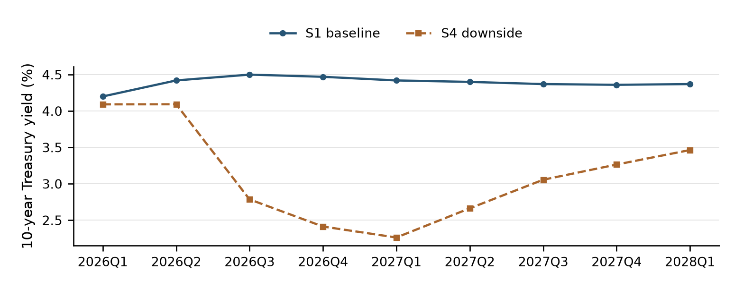
Figure 6.6B Nine-quarter Other expense ratio forecasts under S1 and S4
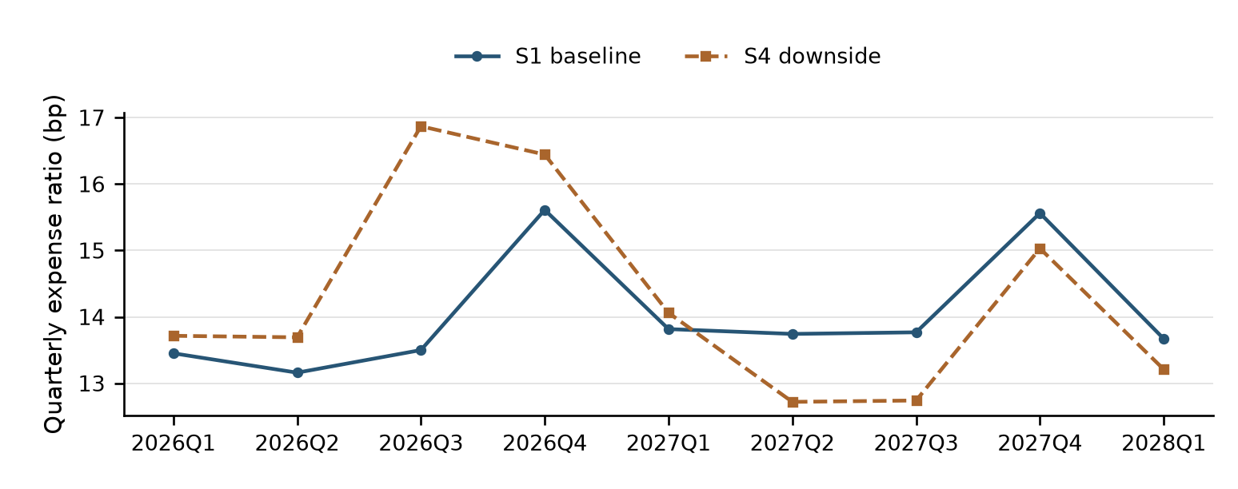

6.2.4.3 Overlay Summary
No overlay is applied to the Other forecasts. Table 6.4 reports the ratios calculated from the fitted equation and the S1 and S4 Treasury paths.

6.2.5 Sensitivity Analysis
We added a fixed shock of −15, −5, +5 or +15 bp to each quarterly change in the S1 Treasury yield. Each sensitivity path starts from the observed 2025Q4 yield. The shocks accumulate in the yield level over nine quarters. The expense ratio responds to each quarter’s change. We used the full-history coefficients for all four paths.
Table 6.5 Other expense sensitivity to changes in the S1 Treasury path
Shock to each quarterly yield change (bp) | 2028Q1 Treasury yield (%) | Nine-quarter mean expense ratio (bp) | Quarterly difference from S1 (bp)
−15 | 3.02 | 14.40 | +0.36
−5 | 3.92 | 14.15 | +0.12
0 (S1 baseline) | 4.37 | 14.03 | 0.00
+5 | 4.82 | 13.91 | −0.12
+15 | 5.72 | 13.67 | −0.36
Figure 6.7 Other expense ratios under shocks to the quarterly S1 Treasury yield change
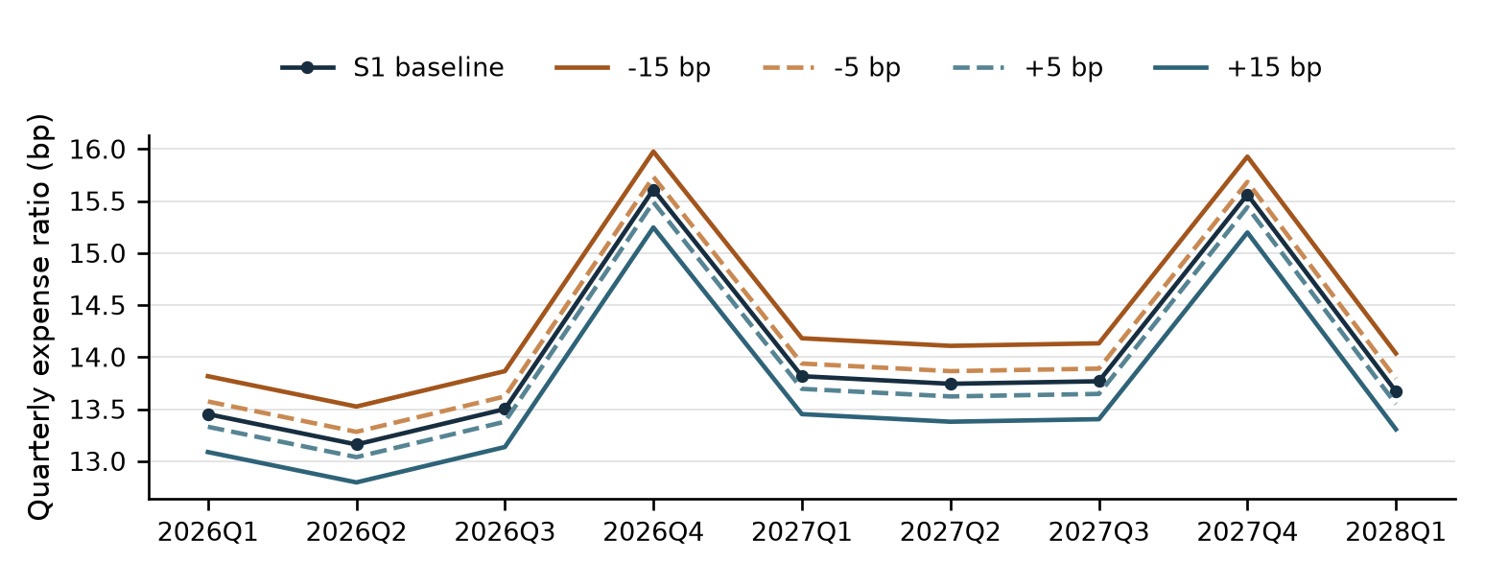
A 5 bp increase in each quarterly yield change lowers each quarterly expense ratio by 0.12 bp. A 15 bp increase lowers it by 0.36 bp. Negative shocks raise the ratio by the same amounts. The fourth-quarter expense effect appears in every path.

6.2.6 User Review and Acceptance
User review focuses on whether the Other expense forecasts are consistent with the bank’s operating experience. Users review the adjustments to the five unusual expense months, the change in the expense ratio after the FCB acquisition, and the fourth-quarter seasonal effect. They also review how the projected expense ratio responds to changes in the 10-year Treasury yield under S1 and S4.
For production acceptance, the review covers the Treasury yield path for each scenario and the coefficients used for forecasting. It also covers the conversion from the quarterly expense ratio to dollars. That calculation uses the average of the three monthly asset balances projected for the same quarter. The acceptance record should document the outcome of user acceptance testing and business sign-off.

6.2.7 Testing Conclusion
The testing results support the final Other expense regression. Only the current-quarter change in the 10-year Treasury yield met both screening criteria. Its coefficient was negative and similar in size in the development and full-history estimates. The prior quarter’s expense ratio added no significant explanatory power.
We used the development coefficients for the nine-quarter backtest. The mean absolute error was 1.53 basis points, and the model overestimated expense in eight quarters. We used the full-history coefficients for S1, S4 and the sensitivity tests. The largest scenario difference occurred in 2026Q3, when the decline in the S4 Treasury yield raised the projected expense ratio 3.37 basis points above S1. The sensitivity tests showed the same direction of response. A larger quarterly yield increase lowered the projected expense ratio. A larger decline raised it.

7 Model Implementation
Model is yet to be implemented. During Implementation stage, this section will be addressed.

8 Model Monitoring

9 Procedures
Model is yet to be implemented. During Implementation stage, this section will be addressed.

10 Governance

11 Appendix Information

11.1 Appendix A Variable Dictionary
Table 11.1 defines the expense and asset measures. Table 11.2 lists the input files for Other. Table 3.4 lists the 15 macroeconomic candidates and their transformations.
Table 11.1 Model inputs, derived variables and units
Field | Units | Definition
date_ym | YYYYMM | Quarter-end month
Month_Actual_num | USD per quarter | Quarterly Occupancy expense E
BS_Month_Actual_num | USD, three-month sum | Sum of monthly balances B
BS | USD, quarterly average | Average assets A = B/3
pct | Annualized decimal | 12 × E / B
h | Quarter number | 1 through 9 following 2025Q4
Haircut | Decimal share | 0.12 in Q1–Q6, then 0.09, 0.06, 0.03
Adjusted Other | USD per quarter | Sum of three monthly Other amounts after signed Card removal and the specified peak-month replacements.
R | Unannualized bp | 10,000 × quarterly adjusted Other / A.
ΔY | Percentage points | Current 10-year Treasury yield less its preceding quarterly level on the same path.
P, Q, C | 0 or 1 | P marks 2019Q1 onward, Q marks each fourth quarter, and C is the 2020 COVID indicator for 2020Q1–2020Q4.
The variable names in Table 3.4 take the suffix _B.IUSA in the historical macroeconomic data. The forward Treasury paths use the same quarterly frequency and units.
Table 11.2 Other input files and coverage
File | Coverage | Use
expense_history.csv | 2011-01–2025-12 | 180 raw Other and signed Card pairs
asset_history.csv | 2011Q1–2025Q4 | 60 SNV average asset balances
macro_history.csv | 2009Q1–2025Q4 | 15 macro series in source levels
macro_baseline.csv | 2026Q1–2028Q1 | S1 future macro levels
macro_s4.csv | 2026Q1–2028Q4 | S4 Treasury levels, first nine used
History and S1 use FRGT10Y_B.IUSA. S4 uses FRGT10YQ_S4.IUSA. Both yield series enter in percent per annum. A move from 4.0 to 4.3 is a +0.30 percentage-point model input.

11.2 Appendix B Feature Selection Documentation
Asset size is the driver in the qualitative Occupancy expense approach. The historical basis for this choice is presented in Section 2.1.
Table 11.3 gives the two-sided HAC p-value for each candidate regression. A plus sign indicates that the in-sample correlation, backtest correlation and in-sample slope share the same sign. An asterisk indicates that the variable also met the 0.10 significance criterion.
Table 11.3 Complete candidate screen, two-sided HAC p-values
Candidate | Current | Lag 1 | Lag 2
Commercial bank assets | 0.7245 | 0.6122 | 0.3428 +
Commercial bank deposits | 0.9473 | 0.6071 | 0.4972 +
Bank loans and leases | 0.3028 | 0.4397 | 0.9808
Consumer credit outstanding | 0.7000 + | 0.9723 + | 0.6811
Consumer card delinquency | 0.1586 | 0.1804 | 0.2208
Commercial and industrial delinquency | 0.2553 | 0.4183 | 0.6135
Consumer card charge-offs | 0.4236 | 0.4668 | 0.4525
Business bankruptcies | 0.8947 | 0.4078 | 0.2401
Personal bankruptcies | 0.9157 | 0.4777 + | 0.5887 +
VIX | 0.3105 | 0.2981 + | 0.3385 +
High-yield option-adjusted spread | 0.9178 | 0.7751 | 0.4534 +
Federal funds rate | 0.1847 | 0.8501 | 0.9115 +
10-year Treasury yield | 0.0069 + * | 0.3912 + | 0.6674
Final-demand services PPI | 0.0961 | 0.8135 + | 0.3630 +
Core CPI | 0.1969 + | 0.3277 + | 0.2658 +

11.2.1 Inference Following Variable Selection
The p-value measures the significance of the slope in each candidate regression. The selection rule also uses the signs of the in-sample and backtest correlations. The current-quarter Treasury change met both criteria. The nine-quarter errors measure performance after this selection.

11.3 Appendix C Regression Outputs
The assumptions and rates for Occupancy expense appear in Section 3.1.
Table 11.4 shows the test of the prior quarter’s ratio. Table 11.5 gives the complete in-sample estimates used in the historical backtest. Table 3.7 compares those coefficients with the full-history coefficients used for forecasting.
Table 11.4 Test of the prior quarter’s Other expense ratio
Term | Estimate | HAC SE | p-value | 95% low | 95% high
Intercept | 19.0114 | 2.9935 | <0.0001 | 13.1443 | 24.8784
2019Q1 onward | −6.3033 | 1.0458 | <0.0001 | −8.3531 | −4.2536
Fourth quarter | 2.0203 | 0.8254 | 0.0144 | 0.4025 | 3.6381
2020 COVID indicator | 1.5724 | 0.8801 | 0.0740 | −0.1526 | 3.2974
10-year yield change | −2.0305 | 1.0091 | 0.0442 | −4.0083 | −0.0526
Prior-quarter ratio | 0.0857 | 0.1486 | 0.5643 | −0.2056 | 0.3769
Table 11.5 Final in-sample estimates used for the historical backtest
Term | Estimate | HAC SE | p-value | 95% low | 95% high
Intercept | 20.7097 | 0.5385 | <0.0001 | 19.6543 | 21.7651
2019Q1 onward | −6.7156 | 0.7602 | <0.0001 | −8.2056 | −5.2256
Fourth quarter | 2.1743 | 0.7672 | 0.0046 | 0.6707 | 3.6780
2020 COVID indicator | 1.5095 | 0.9026 | 0.0945 | −0.2596 | 3.2785
10-year yield change | −2.4577 | 0.9101 | 0.0069 | −4.2415 | −0.6740
The confidence intervals use two-lag HAC standard errors and normal critical values. The test of the prior quarter’s ratio uses 50 observations. The final in-sample regression uses 51.

11.3.1 Interpretation of the 2019Q1 Period Indicator
The FCB acquisition indicator measures the difference in the quarterly expense ratio beginning in 2019Q1. Its estimated effect is −6.72 bp in the in-sample regression and −7.10 bp in the full-history regression, holding the other variables constant.

