Quarterly OREO Rate Model Evaluation
We recommend against adopting a macroeconomic autoregressive distributed lag (ARDL) model for the annualized OREO rate. A commercial real estate price term qualified in the estimation sample, but its coefficient weakened as early observations left the sample. Across nine held-out quarters, its one-step mean absolute error was 9.11 basis points (bp), compared with 1.71 bp for carrying forward the last observed rate.

Rate definition and historical behavior
For segment NonIE_OREO_SNV, we treated the monthly other real estate owned (OREO) amount as a flow and MGT as the monthly exposure balance. We summed signed OREO amounts within each calendar quarter, divided by average monthly MGT, and multiplied by four to annualize. In basis points, this equals 120,000 times the three-month OREO sum divided by the three-month MGT sum.
Period | Quarters | Mean (bp) | Median (bp) | Range (bp) | Negative
2011 Q1–2017 Q4 | 28 | 368.34 | 170.10 | 25.25 to 1,340.72 | 0
2018 Q1–2025 Q4 | 32 | 3.19 | 1.07 | −1.91 to 15.59 | 6
2023 Q4–2025 Q4 | 9 | 2.58 | 0.12 | −0.33 to 12.58 | 3
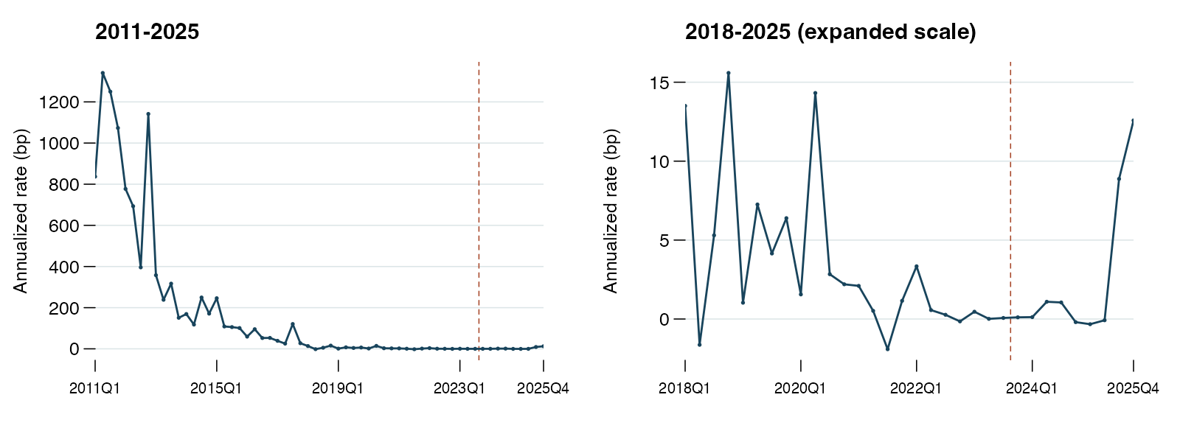
Figure 1. The right panel expands the vertical scale from 2018 onward. The dashed line marks the start of the nine-quarter holdout.
The median fell from 170.10 bp to 1.07 bp. Mean quarterly OREO fell from 11.84 million to 0.36 million in source units, while average monthly MGT rose from 1.58 billion to 4.95 billion. MGT rose 87.0% between December 2018 and January 2019. The source does not establish whether a portfolio change contributed to that jump.

Estimation and validation periods
The 180 monthly records yield 60 quarterly rates. We used 2011 Q1–2023 Q3 for development, the same 39-quarter estimation window as Other for the primary regression (2014 Q1–2023 Q3), and 2023 Q4–2025 Q4 for forecast evaluation.

Screening the macroeconomic variables
We tested 20 U.S. series through 2023 Q3. A transformation qualified when the augmented Dickey–Fuller (ADF) test rejected a unit root at 5% and KPSS did not reject stationarity around a constant. The ADF test included an intercept and used AIC to select up to four lags. KPSS used bandwidth four.
Series | Mnemonic² | Full history | From 2018
Mortgages in foreclosure | FXMBAFI | — | —
Foreclosure starts | FMBAFS | Change | —
Mortgages past due | FMBAD | Change | Change
Residential real estate delinquency¹ | FBCFDELLRRQ | — | —
Commercial real estate delinquency¹ | FBCFDELLRCQ | — | —
Commercial real estate price index | FCREPI | Log growth | Log growth
Value-weighted CRE price index | FCREPVWI | Log growth | Log growth
Flow of Funds CRE price index | FZFL075035503Q | Log growth | —
FHFA purchase-only home price index | FHOFHOPIPOQ | — | —
Case-Shiller 20-metro home prices | FHCLHP1TI20Q | Log growth | —
Distressed share of repeat home sales | FDISTRESSSHARE | — | —
Distressed single-family home sales | FDISTRESSQ | Log growth | Log growth
Personal bankruptcies | FBKP | Log growth | —
Business bankruptcies | FBKBQ | — | —
Unemployment rate | FLBR | Change | Change
Unemployed persons | FLBU | Log growth | Log growth
Residential consumer credit delinquency | FCCDRA | — | —
First mortgage delinquency | FCCDRF | — | —
Lenders tightening CRE standards | FXSLASREQ | Change | —
Lenders tightening mortgage standards | FXSLASHMQ | Level | Change
¹ Top 100 commercial banks. ² All mnemonics carry the suffix _B.IUSA. A dash means no eligible transformation. CRE denotes commercial real estate.
For percentage series, we tried the level first and then the quarterly arithmetic change. For the remaining series, the order was level, quarterly log growth, then arithmetic change. Each series contributed at most one transformation. Twelve qualified across the full development period and seven qualified when testing began in 2018 Q1.

Target transformation and forward selection
The quarterly rate crossed zero. Arithmetic differences retained the negative observations and allowed forecasts to be converted back to a rate in bp. The one-quarter change passed both stationarity tests. The level gave mixed evidence, and the four-quarter change failed the joint rule.
Target | N | ADF statistic | ADF p | KPSS statistic | Joint rule
Rate level | 51 | −5.497 | <0.0001 | 0.764 | Fail
One-quarter change | 50 | −7.841 | <0.0001 | 0.170 | Pass
Four-quarter change | 47 | −1.895 | 0.3352 | 0.653 | Fail
The 5% KPSS critical value is 0.463. Statistics above it reject level stationarity.

Forward selection
We retained the first lag of the rate change and tested each eligible macro series at lags 1, 2 and 4. The second target lag had a coefficient of 0.1130 (p = 0.4045) in the prior specification and was removed before repeating the screen. Entry required a two-sided p-value below 0.05 for the added term, maximum variance inflation factor (VIF) below 10, and Durbin–Watson (DW) between 1.5 and 2.5. The lowest qualifying p-value determined entry.
Round | Terms tested | Passed | Selection
1 | 36 | 1 | Flow of Funds CRE price growth, lag 2
2 | 33 | 0 | Selection stopped

Estimated equation
Let r denote the annualized rate in bp and g the quarterly change in the log CRE price index multiplied by 100. A one-point rise in g two quarters earlier was associated with a 4.97 bp lower change in the rate, conditional on the prior quarter’s rate change.
${Δr}_{t} = −1.3385 − 0.4704 {Δr}_{t−1} − 4.9706 g_{t−2}$
Term | Estimate | Std. error | OLS p
Intercept | −1.3385 | 6.2283 | 0.8311
Rate change, lag 1 | −0.4704 | 0.1096 | 0.0001
CRE price growth, lag 2 | −4.9706 | 2.0691 | 0.0216
39 quarters. Adjusted R² = 0.394, DW = 2.12, maximum VIF = 1.01. The four-lag Breusch–Godfrey p-value was 0.464. The Jarque–Bera p-value was 0.047.
The CRE term’s p-value was 0.022 under ordinary least squares, 0.077 using HC3 standard errors, and 0.044 using four-lag Newey–West standard errors. The Holm-adjusted p-value across the 36 first-round tests was 0.777.

Out of sample forecast performance
We froze coefficients at 2023 Q3. One-step predictions use observed rate history through the preceding quarter. Recursive predictions start from the same origin and feed predicted rates back into the model. Both paths use the supplied lagged macro series. Errors are measured on the annualized rate level.
Model | One-step MAE | One-step RMSE | Recursive MAE | Recursive RMSE
Last observed rate | 1.71 | 3.27 | 2.69 | 5.13
Zero | 2.71 | 5.16 | 2.71 | 5.16
Trailing four-quarter mean | 2.57 | 4.60 | 2.68 | 5.11
Same quarter last year | 2.80 | 5.04 | 2.79 | 5.19
Rate change AR(1) | 9.80 | 10.46 | 30.76 | 35.13
AR(1) plus CRE growth | 9.11 | 13.36 | 21.51 | 23.16
All errors in bp. MAE is mean absolute error. RMSE gives more weight to larger misses. This revision reuses the nine quarters evaluated with the previous two-lag specification.
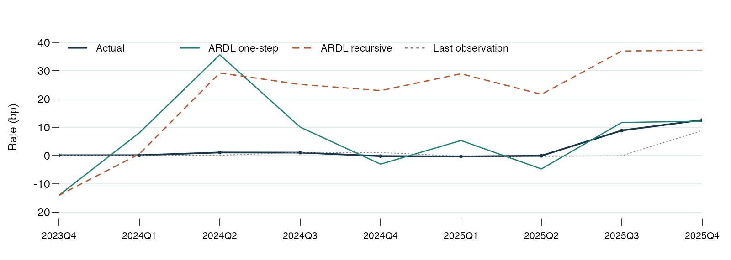
Figure 2. Actual rates and forecasts for the nine held-out quarters. The dotted line carries forward the most recent observation for each one-step forecast.
Quarter | Actual | Last rate, one-step | ARDL, one-step | ARDL, recursive
2023Q4 | 0.11 | 0.07 | −14.04 | −14.04
2024Q1 | 0.12 | 0.11 | 8.05 | 0.56
2024Q2 | 1.09 | 0.12 | 35.62 | 29.20
2024Q3 | 1.05 | 1.09 | 10.05 | 25.14
2024Q4 | −0.20 | 1.05 | −3.03 | 22.95
2025Q1 | −0.33 | −0.20 | 5.32 | 28.91
2025Q2 | −0.08 | −0.33 | −4.73 | 21.64
2025Q3 | 8.88 | −0.08 | 11.69 | 36.94
2025Q4 | 12.58 | 8.88 | 12.15 | 37.23
In 2024 Q2 the model predicted 35.62 bp one step ahead against an actual rate of 1.09 bp. By 2025 Q4 its one-step prediction of 12.15 bp was close to the actual 12.58 bp, while the recursive path reached 37.23 bp. Recursive forecasts averaged 18.37 bp above actual.

Rolling coefficient stability
We re-estimated the same three coefficients in 20 successive windows of 20 quarters each. The CRE slope changed from −8.36 to +0.23 bp per growth point. It was significant at 5% in 2 windows and turned positive in the last two. Adjacent windows share 19 observations.
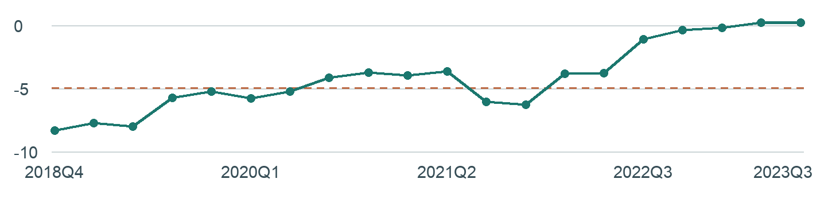
Figure 3. Estimated CRE slope against the last quarter in each window. The dashed line marks the full estimation-window coefficient of −4.97.
Window start | Window end | Intercept | Rate change L1 | CRE growth L2 | CRE p
2014Q1 | 2018Q4 | −1.40 | −0.47 | −8.36 | 0.0351
2014Q2 | 2019Q1 | −2.05 | −0.51 | −7.73 | 0.0766
2014Q3 | 2019Q2 | 0.04 | −0.49 | −8.02 | 0.0604
2014Q4 | 2019Q3 | −6.45 | −0.46 | −5.75 | 0.1200
2015Q1 | 2019Q4 | −6.91 | −0.51 | −5.23 | 0.1502
2015Q2 | 2020Q1 | −7.94 | −0.42 | −5.78 | 0.0925
2015Q3 | 2020Q2 | −2.12 | −0.25 | −5.25 | 0.0584
2015Q4 | 2020Q3 | −2.85 | −0.37 | −4.14 | 0.1821
2016Q1 | 2020Q4 | −4.37 | −0.38 | −3.77 | 0.2006
2016Q2 | 2021Q1 | −1.83 | −0.37 | −3.99 | 0.1564
2016Q3 | 2021Q2 | −2.33 | −0.35 | −3.68 | 0.1801
2016Q4 | 2021Q3 | 3.07 | −0.16 | −6.09 | 0.0428
2017Q1 | 2021Q4 | 3.73 | −0.13 | −6.29 | 0.0562
2017Q2 | 2022Q1 | 2.30 | −0.25 | −3.83 | 0.1808
2017Q3 | 2022Q2 | 3.35 | −0.27 | −3.79 | 0.1789
2017Q4 | 2022Q3 | −4.95 | −0.36 | −1.11 | 0.5381
2018Q1 | 2022Q4 | −0.33 | 0.11 | −0.39 | 0.6163
2018Q2 | 2023Q1 | −0.75 | −0.26 | −0.22 | 0.7619
2018Q3 | 2023Q2 | −0.47 | −0.54 | 0.20 | 0.7099
2018Q4 | 2023Q3 | −0.43 | −0.57 | 0.23 | 0.6808
L1 is the prior quarter’s rate change. L2 is the quarterly log growth of the CRE price index two quarters earlier. P-values are conditional on the selected specification.
Splitting the sample at 2018 Q1 gave a CRE slope of −10.50 in the first 16 estimation quarters and −0.38 in the last 23. The HC3 Wald test jointly rejected equality of the intercept and both slopes at the 5% level (p = 0.042).

