Quarterly Deposit Fee Rate Model
Quarterly data from 2011Q1 to 2025Q4
Research report dated 5 November 2026

1 Model and validation findings
The final AR(1) model retains lagged changes in consumer sentiment and commercial and industrial (C&I) loans, a common trend and two event indicators. A third macro variable, M1, passed forward selection. Its coefficient turned negative for nine consecutive rolling windows, and the stability review led to its removal.
Both forecast paths underestimated the fee rate in every OOT quarter. Updating the lagged rate each quarter limited the average shortfall to 0.02183 pp. Allowing forecasts to feed into the next quarter increased the average shortfall to 0.05571 pp.
Table 1 Final model fit and forecast errors
Evaluation | Quarters | RMSE (pp) | MAE (pp)
IS one-step fit | 47 | 0.01187 | 0.00875
OOT one-step | 9 | 0.02368 | 0.02183
OOT recursive | 9 | 0.06105 | 0.05571

2 Target and sample
The annualized fee rate divides four times quarterly deposit fee revenue by average deposits. Average deposits equal the sum of the three monthly balances divided by three. Rebuilding both quantities from the target workbook gave a maximum absolute difference of zero across all 60 quarters.
Period or unit | Treatment
Model target | 100 × Quarterly_rate. A stored value of 0.004 corresponds to 0.4%.
2011Q1–2023Q3 | 51 in-sample (IS) quarters for trend work and stationarity screening.
2012Q1–2023Q3 | 47 common observations for the baseline and all macro regressions.
2023Q4–2025Q4 | Same nine out-of-time (OOT) quarters as in the prior evaluation. The M1 decision uses the IS rolling results.
Changes and errors | Percentage points (pp). Relative errors such as MAPE are in percent.

3 Two declines in the historical rate
The two largest in-sample quarterly declines came from different movements in fee revenue and average deposits. In early 2019 the denominator expanded sharply while fee revenue rose slightly. In the second quarter of 2020, fee revenue contracted as average deposits continued to grow.
Figure 1 Annualized fee rate and the start of the holdout
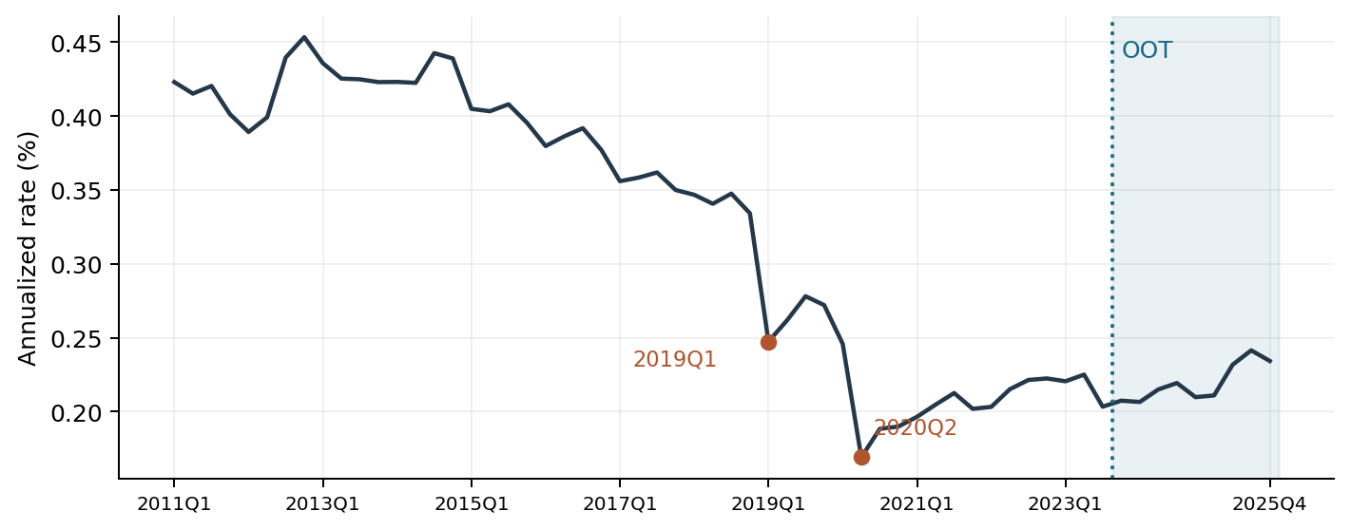
Table 2 Event quarters and the components of the rate
Quarter | Fee rate (%) | Change (pp) | Fee revenue QoQ | Avg deposits QoQ
2018Q4 | 0.33418 | -0.01328 | -1.05% | 2.88%
2019Q1 | 0.24739 | -0.08680 | 2.50% | 38.47%
2019Q4 | 0.27204 | -0.00601 | -2.29% | -0.14%
2020Q1 | 0.24580 | -0.02624 | -7.33% | 2.56%
2020Q2 | 0.16912 | -0.07668 | -23.20% | 11.62%
2020Q4 | 0.18990 | 0.00156 | 6.26% | 5.39%

By 2019Q4, average deposits remained 35.82% above 2018Q4, while fee revenue was up 10.57%. A merger with different consolidation dates for balances and fees could explain part of the gap. Verification would require the effective date and the scope of fee consolidation.
Between 2019Q4 and 2020Q2, the rate fell 0.10292 pp. The model treats 2019Q1 as a single-quarter pulse and 2020 as a four-quarter level effect. Both indicators are zero throughout OOT.

4 Trend specification
Time starts at 1 in 2011Q1. The common-trend fit falls by 0.00534 pp per quarter. In 2019Q1 the rate was 0.05331 pp below trend (p = 0.1011). In 2020 the rate averaged 0.07304 pp below trend (p < 0.0001). All coefficient inference uses conventional nonrobust OLS standard errors.
Figure 2 Trend fits and residuals on all 51 IS quarters
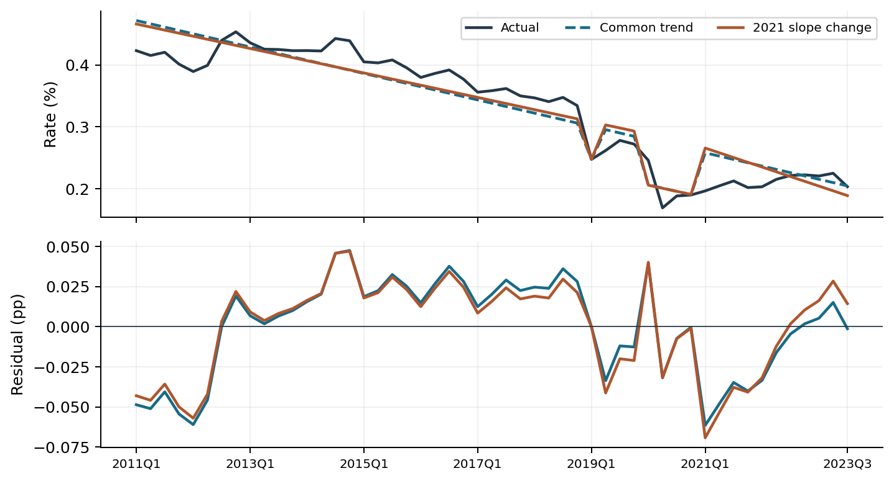
Table 3 Nested comparison on an identical sample
Trend | Adj. R² | RMSE (pp) | AIC | BIC | DW
Common slope | 0.8841 | 0.03018 | -204.32 | -196.59 | 0.472
2021Q1 hinge | 0.8852 | 0.02972 | -203.90 | -194.24 | 0.542

The hinge is zero through 2020Q4 and increases by one each quarter from 2021Q1. The estimated change is −0.00274 pp per quarter (F = 1.45, p = 0.235). Both information criteria favor the common slope. Its DW of 0.472 indicates persistent residuals, motivating the lagged rate.
A separate comparison lets 2011Q1–2018Q4 and 2021Q1–2023Q3 have their own intercepts. Their slopes are −0.00287 and +0.00181 pp per quarter (difference p = 0.0135). This compares two windows at different starting levels. The full-sample hinge instead requires a continuous underlying trend when the COVID indicator expires.

5 Autoregression and macro selection
With both event indicators and the common trend fixed, adding last quarter’s actual rate reduced IS RMSE from 0.02658 to 0.01364 pp on the same 47 quarters. DW rose from 0.638 to 2.103. The baseline AR coefficient was 0.72208 and the largest non-intercept VIF was 8.23.
At 2021Q1 the static trend overestimated the rate by 0.05792 pp. The one-quarter lag reduced that error to 0.01103 pp because the low fee rate in 2020Q4 carried forward even as the COVID indicator switched off.
Table 4 Screening rules and samples
Step | Rule
Transformation | Test level first. For positive amounts and indices, next test the quarterly log change, then the first difference. For rates or series with nonpositive IS values, next test the first difference.
Stationarity | Use the first transform with ADF p < 0.05 and KPSS p > 0.05 over 51 IS quarters. Both include a constant. ADF uses AIC up to 4 lags and KPSS uses automatic bandwidth.
Candidate set | 24 of 33 variables qualified: 3 levels, 14 log changes and 7 first differences. Lags of 1, 2 and 4 quarters yielded 72 terms. The 2010 history initializes changes and lags.
Entry and ranking | Added-term p < 0.05, maximum VIF over all non-intercept terms < 10 and DW between 1.5 and 2.5 inclusive. Take the smallest passing p; BIC and feature name break ties.
Stopping | One lag per macro series, at most three macro terms. Calculate JB once for the resulting model after the round decision.

Table 5 Forward selection on the 47-quarter sample
Round | Added log change | Pass / tried | Entry p | Max VIF | DW | JB p
1 | Consumer sentiment, L4 | 4 / 72 | 0.0263 | 8.764 | 2.027 | <0.0001
2 | C&I loans, L2 | 5 / 69 | 0.0130 | 8.872 | 2.235 | 0.0407
3 | M1, L1 | 5 / 66 | 0.0034 | 9.459 | 1.998 | 0.5532

The third addition reached the prespecified cap. The early rounds’ low JB p-values describe residual shape and did not affect the ranking. Entry p-values are conditional on the terms already present in that round.

6 Rolling coefficients of the three selected macros
The three selected macro terms enter each rolling regression together with the AR(1) baseline. The 20-quarter window advances one quarter at a time across the 47 IS observations. All 28 windows had full rank after omitting any event indicator that was zero throughout that window.
Figure 3 Rolling estimates and 95% intervals, by window end
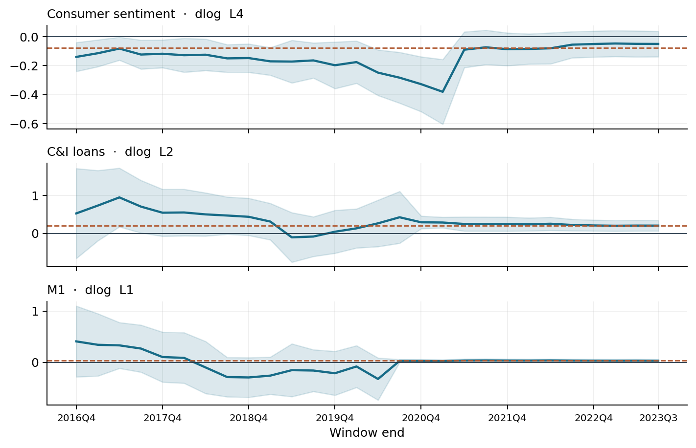
Table 6 Signs and significance across 28 windows
Lagged log change | Full IS | Rolling range | Positive | Negative | p < 0.05
Consumer sentiment, L4 | -0.0773 | -0.380 to -0.047 | 0 | 28 | 18
C&I loans, L2 | 0.1998 | -0.102 to 0.953 | 26 | 2 | 14
M1, L1 | 0.0344 | -0.322 to 0.410 | 19 | 9 | 13

The dashed line marks each full-IS coefficient. Shading gives the conventional 95% interval for each window. Sentiment stayed negative in all 28 windows. C&I loans stayed positive in 26, although the size of the estimate varied.
M1 was negative in all nine windows ending from 2018Q2 through 2020Q2. The last 13 estimates were positive and individually significant. All 28 intervals include the positive full-IS estimate (p = 0.00335). The sign pattern in these overlapping windows gives a descriptive reason to remove M1. We dropped it and re-estimated the remaining coefficients.

7 Final model equation and specification
The dependent variable is the annualized deposit fee rate in percent. Ordinary least squares estimates all seven coefficients on the same 47 quarters, 2012Q1–2023Q3. The equation below rounds the estimates to six decimals. Predictions use full precision.
Estimated equation
$y_{t} = 0.125838 − 0.001542 t − 0.077610 P_{t} − 0.040147 D_{t}$
$+ 0.741625 y_{t−1} − 0.078974 s_{t−4} + 0.160726 c_{t−2} + ε_{t}$
Time t starts at 1 in 2011Q1 and increases by 1 each quarter. P equals 1 in 2019Q1 only. D equals 1 in 2020Q1–2020Q4. Both indicators equal zero in other quarters. The lagged rate is the prior quarter’s annualized percentage rate.
The lowercase terms s and c are quarterly natural-log changes in consumer sentiment and C&I loans. For quarter t, the sentiment input is ln(S[t−4] / S[t−5]) and the loan input is ln(C[t−2] / C[t−3]), using the respective index and loan levels. Both log changes are unscaled.
Table 7 Final coefficients and conventional OLS inference
Regressor | Estimate | SE | p | 95% interval | VIF
Intercept | 0.125838 | 0.03065 | 0.0002 | 0.0639 to 0.1878 | —
Quarterly trend | -0.001542 | 0.00038 | 0.0002 | -0.0023 to -0.0008 | 7.66
2019Q1 pulse | -0.077610 | 0.01319 | <0.0001 | -0.1043 to -0.0510 | 1.03
2020 indicator | -0.040147 | 0.00851 | <0.0001 | -0.0574 to -0.0229 | 1.60
Fee rate, lag 1 | 0.741625 | 0.06168 | <0.0001 | 0.6170 to 0.8663 | 8.87
Consumer sentiment, L4 | -0.078974 | 0.02966 | 0.0111 | -0.1389 to -0.0190 | 1.18
C&I loans, L2 | 0.160726 | 0.06184 | 0.0130 | 0.0357 to 0.2857 | 1.29

Holding other inputs fixed, a 0.01 increase in the sentiment log change four quarters earlier corresponds to a 0.00079 pp decrease in the current fee rate. The same increase in loan log growth two quarters earlier corresponds to a 0.00161 pp increase. The p-values and intervals are nominal and conditional on the chosen specification.

8 Final in-sample fit and residuals
Figure 4 Final one-step fit and residuals on the 47 IS quarters
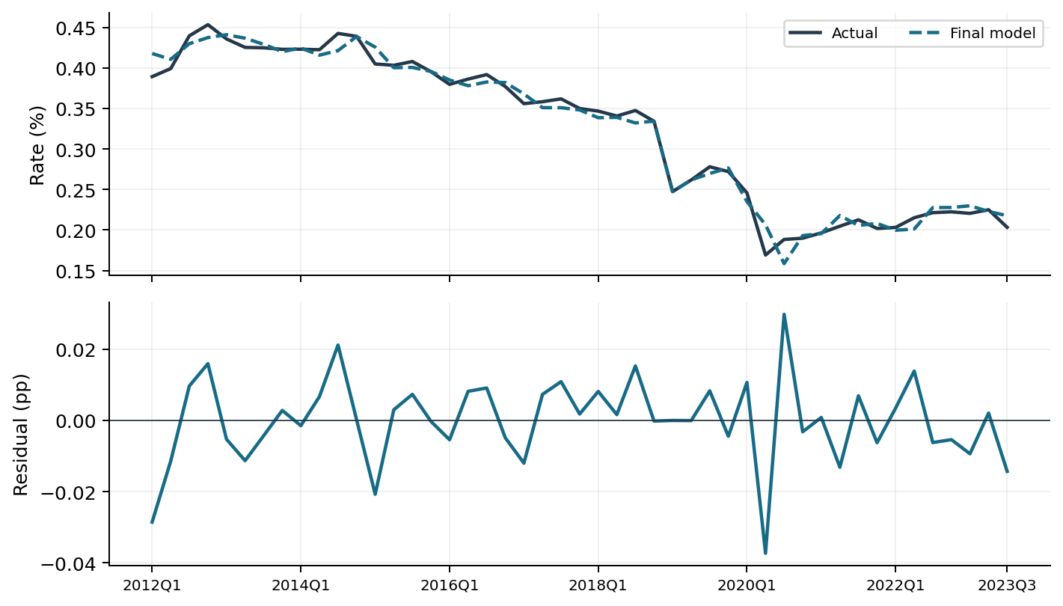
Table 8 In-sample fit before and after the M1 decision
Specification | Adj. R² | RMSE (pp) | AIC | BIC | DW | Max VIF
Three selected macros | 0.9842 | 0.01062 | -277.87 | -263.07 | 1.998 | 9.459
Two final macros | 0.9807 | 0.01187 | -269.37 | -256.42 | 2.235 | 8.872

Removing M1 increased IS RMSE and raised both information criteria. The nominal partial F test gives F(1, 39) = 9.77 (p = 0.00335). The final specification accepts this loss of historical fit to retain the two terms with the most consistent signs in the rolling review.
Breusch–Godfrey LM p-values are 0.116 at one lag and 0.061 at four lags. The Jarque–Bera normality test gives p = 0.0407 and the Breusch–Pagan variance test gives F-test p = 0.0011. Both flag departures from the assumptions behind conventional OLS inference.
The largest defined Cook’s distance is 1.024 in 2020Q2. The single-quarter pulse fits 2019Q1 exactly. Its unit leverage makes deletion-based influence measures undefined for that observation.

9 Final model performance over nine OOT quarters
Coefficients are fixed at their IS estimates. One-step forecasts use the previous actual fee rate. The recursive path starts from the same 2023Q3 actual (0.20332%) and feeds each forecast into the next quarter. Both paths use realized lagged macro data, so the recursive results are conditional on the observed macro path.
Figure 5 Actual fee rate and final-model forecasts
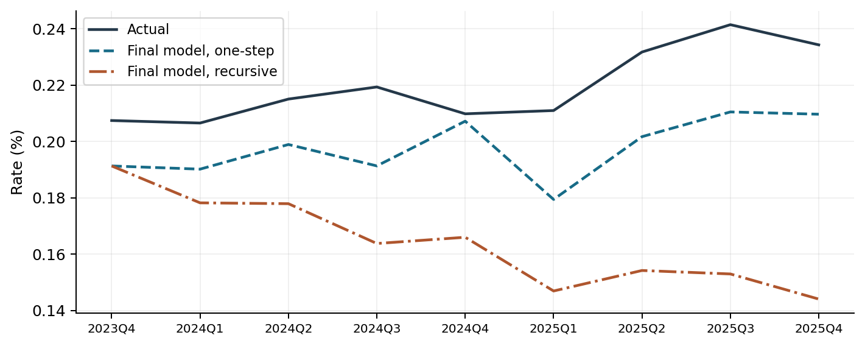
Table 9 Errors over 2023Q4–2025Q4
Forecast | RMSE (pp) | MAE (pp) | Bias (pp) | MAPE | Below actual
One-step | 0.02368 | 0.02183 | -0.02183 | 9.83% | 9 / 9
Recursive | 0.06105 | 0.05571 | -0.05571 | 24.89% | 9 / 9

Table 10 Quarterly forecasts and errors (forecast minus actual)
Quarter | Actual (%) | One-step (%) | Error (pp) | Recursive (%) | Error (pp)
2023Q4 | 0.20739 | 0.19126 | -0.01613 | 0.19126 | -0.01613
2024Q1 | 0.20651 | 0.19013 | -0.01637 | 0.17817 | -0.02834
2024Q2 | 0.21501 | 0.19888 | -0.01613 | 0.17787 | -0.03715
2024Q3 | 0.21930 | 0.19129 | -0.02802 | 0.16374 | -0.05557
2024Q4 | 0.20978 | 0.20717 | -0.00261 | 0.16596 | -0.04382
2025Q1 | 0.21094 | 0.17938 | -0.03156 | 0.14688 | -0.06406
2025Q2 | 0.23171 | 0.20166 | -0.03005 | 0.15416 | -0.07756
2025Q3 | 0.24142 | 0.21044 | -0.03098 | 0.15293 | -0.08849
2025Q4 | 0.23426 | 0.20964 | -0.02462 | 0.14401 | -0.09025

The two forecasts coincide in the first quarter. By 2025Q4, the one-step shortfall was 0.02462 pp. Carrying forward the prior recursive error at the estimated AR weight of 0.7416 added 0.06563 pp, for a total shortfall of 0.09025 pp.

