Occupancy Cost
Occupancy cost is modeled as a ratio to total bank asset size. Both historical series are recorded quarterly, with each observation equal to the sum of the three monthly values in that quarter (for example, 2025Q4 is the sum of October, November and December 2025). The historical ratio is defined as the quarterly occupancy expense divided by the quarterly asset size, annualized by multiplying by 12. Projected occupancy expense is obtained by applying a calibrated ratio to a projected asset path under each scenario.
Figure 1 Historical Bank Asset Size
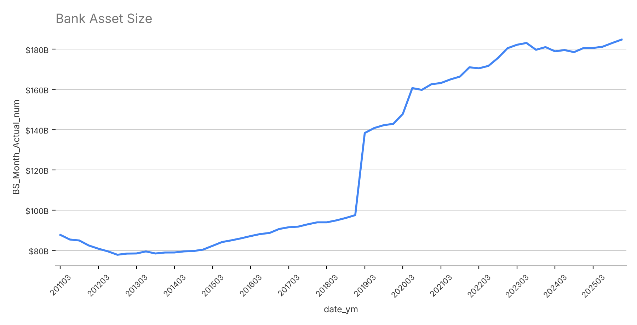
Bank asset size declined from $87.7B in 2011Q1 to $77.8B in 2012Q3 before recovering to its prior peak by 2016Q2. A structural level shift occurred in 2019Q1, when total assets moved from $97.5B to $138.4B within a single quarter. Following the shift, assets grew steadily through mid-2023 and have since remained in a relatively flat range of approximately $179B to $185B, ending 2025Q4 at $184.8B.
Figure 2 Historical Occupancy Cost to Bank Asset Size Ratio
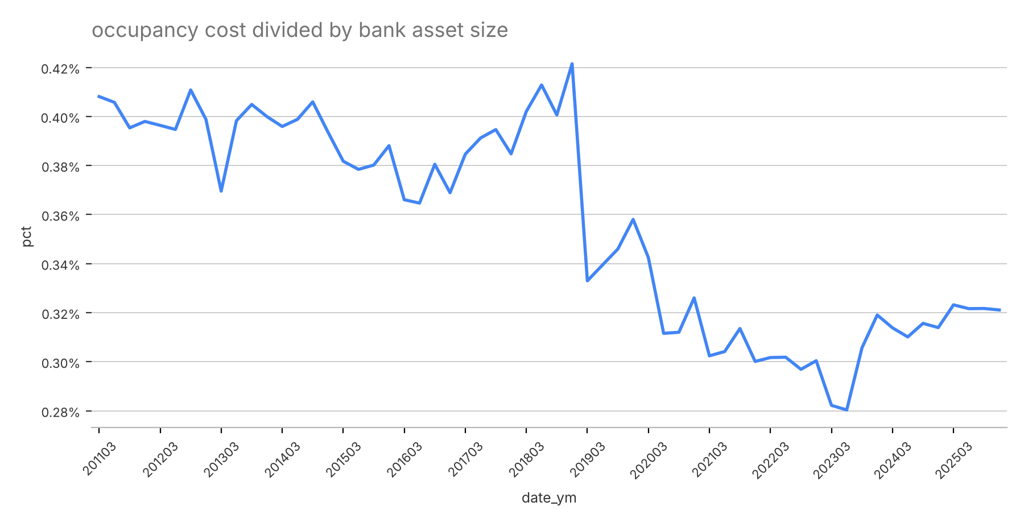
The occupancy cost ratio fluctuated between roughly 0.365% and 0.422% before 2019 and dropped sharply in 2019Q1, as the asset base expanded considerably faster than occupancy expense. Since 2019 the ratio has ranged between 0.280% (2023Q2) and 0.358% (2019Q4), and has stabilized around 0.321% over the most recent quarters. Because the 2019Q1 shift represents a change in the level of the series rather than normal variation, the ratio is calibrated on the post-2019 window (2019Q1 through 2025Q4, 28 quarters). Baseline uses the post-2019 average and stress uses the average less two standard deviations:
Table 1 Occupancy Cost Calibration Statistics
Metric | Value
Baseline ratio (post-2019 average) | 0.315%
Standard deviation (post-2019) | 0.018%
Stress ratio (average – 2 std) | 0.279%
Post-2019 minimum observed ratio (2023Q2) | 0.280%
Average quarterly asset increase (2019Q1 – 2025Q4) | $1.72B
Average asset size (2024–2025) | $180.95B
Maximum historical drawdown (2011Q1 – 2012Q3) | -11.27%
Stress asset decline (selected) | -12.0%
Effective stress decline relative to 2025Q4 | -13.8%
Driver Justification and Backtesting
Bank asset size is selected as the driver of occupancy expense because the two series move closely together. The correlation between quarterly occupancy expense and asset size is 0.98 over the full sample and 0.78 over the post-2019 period. The post-2019 ratio is also stable, with a coefficient of variation of 5.7% (standard deviation of 0.018% against a mean of 0.315%), supporting a structure in which occupancy expense is projected as asset size multiplied by a constant ratio. The 2019Q1 level shift reflects a structural change in the asset base rather than normal variation, so only post-2019 observations are used to calibrate the ratio.
Two backtests were performed using 2019Q1–2023Q4 as the calibration window and 2024Q1–2025Q4 as the test window. For the ratio method, the ratio calibrated on 2019Q1–2023Q4 (0.314%) was applied to actual 2024–2025 asset size to predict occupancy expense. The out-of-sample mean absolute percentage error (MAPE) is 1.5% and the cumulative error over the eight test quarters is -1.2%, compared with an in-sample MAPE of 4.3% over 2019Q1–2025Q4, indicating that the ratio method predicts occupancy expense accurately once the asset path is known. For the asset trend, the average quarterly increase calibrated on 2019Q1–2023Q4 ($2.25B) was extrapolated forward eight quarters, producing a predicted 2025Q4 asset size of $199.1B against an actual value of $184.8B, an overstatement of 7.7%. This reflects the flattening of asset growth after 2023 and is noted as a limitation of the baseline asset projection.
Table 2 Driver and Backtest Results
Test | Result
Correlation: occupancy expense vs. asset size (full sample) | 0.98
Correlation: occupancy expense vs. asset size (post-2019) | 0.78
Ratio coefficient of variation (post-2019) | 5.7%
Ratio method: out-of-sample MAPE (2024Q1 – 2025Q4) | 1.5%
Ratio method: out-of-sample cumulative error | -1.2%
Ratio method: in-sample MAPE (2019Q1 – 2025Q4) | 4.3%
Asset trend: 2025Q4 forecast error | +7.7%
Asset Size Projection
Baseline bank asset size is projected by applying a linear trend extrapolation to the 2025Q4 asset size of $184.8B (the sum of the October, November and December 2025 monthly balances). The 2025Q4 observation is used as the starting point because it is the most recent actual quarter, so the forecast continues directly from the latest observed balance sheet. The trend is defined as the average quarterly asset increase observed since 2019Q1, calculated as the change in asset size between 2019Q1 and 2025Q4 divided by the 27 quarters elapsed, or approximately $1.72B per quarter. For each forecast quarter, the projected asset size equals the 2025Q4 asset size plus the quarterly increase multiplied by the number of quarters elapsed since the forecast start date. The resulting 2026Q1 baseline occupancy expense of $49.0MM transitions smoothly from the 2025Q4 actual of $49.5MM.
Stress asset size is anchored to the average asset size observed over 2024–2025 ($180.95B) rather than a single quarter. Asset size has been broadly flat since 2023, ranging between approximately $179B and $185B, so the eight-quarter average represents the current stable level of the balance sheet and avoids anchoring the stress path to the movement of any individual quarter. The 2024–2025 average is 2.1% below the 2025Q4 asset size, so the starting point itself adds to the severity of the stress.
A 12% stress decline is applied to this starting point. The largest historical peak-to-trough drawdown in the series is 11.27%, observed between 2011Q1 and 2012Q3. The stress decline is set at 12%, rounding the observed drawdown up so that the stress covers the worst historical experience with a modest buffer. Combined with the lower starting point, the effective decline relative to the 2025Q4 asset size is approximately 13.8%. The stressed asset size is calculated as:
Stress Asset Size = 2024–2025 Average Asset Size × (1 – 12%)
Historical experience supports a stress in which occupancy expense declines together with the asset base. During the 2011Q1–2012Q3 drawdown, asset size fell by 11.3% and occupancy expense fell by 10.7%, while the occupancy cost ratio remained essentially unchanged (0.408% at the peak and 0.411% at the trough), as shown in Table 3.
Table 3 Historical Stress Episode (2011Q1 – 2012Q3)
Metric | Value
Asset size change | -11.3%
Occupancy expense change | -10.7%
Occupancy cost ratio at peak (2011Q1) | 0.408%
Occupancy cost ratio at trough (2012Q3) | 0.411%

The stressed asset size is assumed to remain at the full 12% decline through Q6. Beginning in Q7, the stress impact gradually unwinds through a linear recovery path, with one-quarter of the initial decline restored each quarter, resulting in effective declines of -9%, -6%, and -3% in Q7, Q8, and Q9, respectively. This produces a smooth and evenly distributed recovery profile over the final three forecast quarters, consistent with the ramp presented in Table 5.
Table 4 Bank Asset Size Path (in $B, quarterly sum of monthly balances)
 | 2026Q1 | 2026Q2 | 2026Q3 | 2026Q4 | 2027Q1 | 2027Q2 | 2027Q3 | 2027Q4 | 2028Q1
Baseline | 186.5 | 188.3 | 190.0 | 191.7 | 193.4 | 195.1 | 196.9 | 198.6 | 200.3
Stress | 159.2 | 159.2 | 159.2 | 159.2 | 159.2 | 159.2 | 164.7 | 170.1 | 175.5
Table 5 Stress Asset Decline Ramp
 | 2026Q1 | 2026Q2 | 2026Q3 | 2026Q4 | 2027Q1 | 2027Q2 | 2027Q3 | 2027Q4 | 2028Q1
Asset decline | -12% | -12% | -12% | -12% | -12% | -12% | -9% | -6% | -3%
Occupancy Expense Projection
Baseline projections apply the projected asset path in Table 4 together with the post-2019 average occupancy cost ratio of 0.315%. Stress projections apply the stressed asset path together with a stress ratio of 0.279%, corresponding to the post-2019 average less two standard deviations. The stress ratio reflects management judgment that, under severe conditions, the bank would take actions to reduce its physical footprint, such as branch consolidation, lease renegotiation and broader expense reduction programs, lowering occupancy expense per dollar of assets. The selected level is consistent with observed experience: it is approximately equal to the lowest post-2019 ratio of 0.280% (2023Q2) and corresponds to roughly the lower bound of a 95% range around the post-2019 average, so the stress ratio remains within the historically observed range rather than extrapolating beyond it. Because the ratio is annualized, quarterly occupancy expense is calculated as projected quarterly asset size multiplied by the ratio and divided by 12.
Table 6 Occupancy Expense Path (in $MM)
 | 2026Q1 | 2026Q2 | 2026Q3 | 2026Q4 | 2027Q1 | 2027Q2 | 2027Q3 | 2027Q4 | 2028Q1
Baseline | 49.0 | 49.4 | 49.9 | 50.3 | 50.8 | 51.2 | 51.7 | 52.1 | 52.6
Stress | 37.1 | 37.1 | 37.1 | 37.1 | 37.1 | 37.1 | 38.3 | 39.6 | 40.8

First-year expense is calculated as the sum of the first four quarterly forecasts (2026Q1 through 2026Q4), and the 9-quarter projection as the sum of all quarterly forecasts presented in Table 6. Under the baseline scenario, projected occupancy expense is approximately $198.5MM for the first year and $456.8MM over the full 9-quarter forecast horizon. Under the stress scenario, projected occupancy expense is approximately $148.2MM for the first year and $341.0MM over the full forecast horizon. For reference, actual quarterly occupancy expense in 2025 averaged approximately $48.9MM, or $195.8MM for the full year.
Key Assumptions
- The 2019Q1 level shift in asset size reflects a structural change in the balance sheet, so the ratio and the baseline growth trend are calibrated on post-2019 data only.
- Occupancy expense is assumed to scale proportionally with bank asset size at a stable ratio over the forecast horizon, supported by the high correlation between the two series and the 1.5% out-of-sample MAPE of the ratio method.
- The 2024–2025 average asset size is assumed to represent the current stable level of the balance sheet and is used as the stress starting point.
- The 12% stress decline, rounded up from the 11.27% maximum historical drawdown, is assumed to be a reasonable proxy for a severe contraction in the asset base.
- The stress ratio of average less two standard deviations is a management judgment reflecting expected footprint reduction actions under stress, and is consistent with the lowest ratio observed since 2019.
Limitations & Weaknesses
- The stress decline is anchored to a single historical drawdown episode (2011Q1 – 2012Q3) rather than a scenario-linked macroeconomic relationship.
- The stress ratio is based on management judgment rather than a historical stress observation; during the 2011Q1 – 2012Q3 drawdown the ratio remained broadly unchanged, so the reduction in the ratio under stress depends on the bank executing footprint reduction actions.
- The linear baseline trend is estimated over a period that includes strong growth from 2019 to 2023, while assets have been broadly flat since 2023. Backtesting shows that a trend calibrated on 2019Q1–2023Q4 would have overstated 2025Q4 asset size by 7.7%, so the baseline path may overstate near-term growth.

