ENGR 491

Software Exercise 5

By:

David Nguyen

#93696433

Dec 7th, 2021

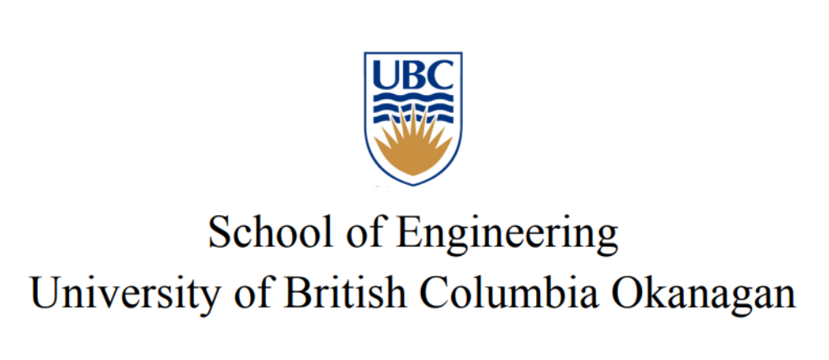

**Introduction**

This software exercise looked at investigating the boundary layer separation of turbulence flow and the reattachment length in a backwards-facing step. The four different turbulence models used were Spalart-Allmaras, k-e turbulence model, k-ω turbulence model, and the k-ω shear stress transport (SST). The computed results will be compared with the experimental data obtained by Pitz and Daily (1983) to determine with turbulence model will achieve the best results. Additionally, the sensitive of the reattachment length will be tested by changing the relative boundary conditions.

**Results and Discussion**

**1)** From observations in figure 1&2 blow for the computed results in x/h = 0 and x/h = 3, the three turbulence models SST, k-e, and k-w(KO) seem to achieve a similar accuracy when compared with the experimental data. The most accuracy turbulence model out of the three is KO turbulence model because its results plot is the closest one to the experimental results plot. The turbulence model that achieved the worst accuracy is the Spalart-Allmaras turbulence model.

Figure 1&2: Computed and Experimental Results of Streamwise Velocity at the Normalized Distance x/h = 0 and x/h 3

**2)** The most accurate turbulence model is KO model when compared with the experiment reattachment location xr/h = 7. As can be seen in the figure 3 below, the KO model showed that the reattachment location is achieved at approximately x/h = 7.

Figure 3: Computed and Experimental Results of Streamwise Velocity at the Normalized Distance x/h = 0 and x/h 3

**3)** Below are plots to identify the sensitivity of the reattachment length xr/h to relative boundary conditions for each turbulence model. Starting with the KE turbulence model, when the dissipation rate is increased so does the reattachment length, however, when the kinetic energy is increased the reattachment length will decrease from observing the figure 4 and 5 below.

Figure 4&5: Reattachment Length and Dissipation Rate and Kinetic Energy

For the SST turbulence model, when kinetic energy is increased the reattachment length will decrease. However, the reattachment length did not decrease when changing its specific dissipation rate for this turbulence model. This could mean that for this turbulence model, the reattachment length might not be too sensitive to the change in the specific dissipation rate boundary condition. The observations were made from the figure 6 and 7 below.

Figure 6&7: Reattachment Length and Kinetic Energy and Specific Dissipation Rate

For testing the sensitivity of the reattachment length of the SA turbulence model, we looked changing the turbulence viscosity boundary condition. Here A similar observation can be made to the previous case where the reattachment length is not too sensitive to the changing of the turbulence viscosity boundary condition.

Figure 8: Reattachment Length and Turbulence Viscosity