Running On Empty
City Of War
A Multiplayer Tank Game
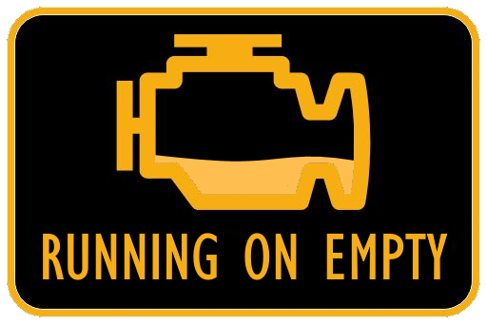

Version 1.00

All work Copyright © 2018 by Running On Empty.
All rights reserved.

Shariq Adtani, Mathew Gordon, Victor Skierski
October 12th 2018

Table of Contents
Version History ------------------------------------------------------------------------------------- page 03
Theme/Setting/Genre ---------------------------------------------------------------------------- page 04
Core Gameplay Mechanics ---------------------------------------------------------------------- page 04
Targeted Platforms -------------------------------------------------------------------------------- page 04
Project Scope --------------------------------------------------------------------------------------- page 04
Influences ------------------------------------------------------------------------------------------- page 04
Elevator Pitch --------------------------------------------------------------------------------------- page 05
Project Description -------------------------------------------------------------------------------- page 05
Camera ----------------------------------------------------------------------------------------------- page 05
Controls ---------------------------------------------------------------------------------------------- page 05
Game World ---------------------------------------------------------------------------------------- page 05
Levels ------------------------------------------------------------------------------------------------- page 05
Game Progression --------------------------------------------------------------------------------- page 06
Scoring ----------------------------------------------------------------------------------------------- page 06
Assets -------------------------------------------------------------------------------------------------- page 06
Extra Concepts ----------------------------------------------------------------------------------------page 07

Version History
2018-10-09: Collaboration on our main idea. Planned out requirements. Added more if extra time available. Decided upon game design.

- Theme/Setting/Genre
- Top down multiplayer tank combat game

- Core Gameplay Mechanics
- Moving tanks (players) with the use of controllers
- A tank hit by projectile will score the one who shot it with a point
- A time limit will keep track of how long a gameplay session will last

- Targeted Platforms
- PC

- Project Scope
- Game Time Scale
  - Time to make: about 4 months

- Team Size
  - Shariq Adtani
  - Mathew Gordon
  - Victor Skierski

- Influences
- Combat (1977) Atari 2600 Game
  - The game's concept is entirely based around Combat's gameplay

- Any top down shooter game
  - As it's core gameplay, this game is a top down shooter

- Elevator Pitch
- A simple quick pace top down shooter where players control tanks and shoot at each other to score points within a given time limit. The multiplayer element is local to the machine where each player will use a separate controller.

- Project Description
- This game is a simple multiplayer tank game where each player will navigate a premade map in order to shoot and hit other players in order to score points. Each game has a time limit and when it ends, the player with the highest score will win. The multiplayer is local to the machine and the camera shows all players at once and is stationary at the top of the map. Keyboard and controller input will be used in menus whereas game control will only be external controllers.

- Camera
- Top down but slightly off centre to demonstrate 3D rendered world

- Controls
- Forward moves the tank
- left/right spin tank in respective direction
- Fire button shoots projectile

- Game World
- The game world takes place on a premade map with walls that need to be navigated

- Levels
- There are no levels, instead there are different maps to choose from

- Game Progression
- There is no game progression as the point is to get the highest score before time runs out

- Scoring
- When a player is hit with a projectile, the player who shot it scores a point
- A win is determined by a players highest score once the time limit ends

- Assets
- 3D
  - 4 different tanks
  - Buildings
  - Bullet
- Sounds
  - Explosion
  - Engine
  - Movement
  - Shooting
- Art
  - Cell shading
  - Background
  - Splash screen, menus, and title

- Extra Concepts
- Powerups
- Different graphical design
- Bouncing bullets
- Multiple maps
- Different tank designs
- Ranking

