Group 2: Nichakon Itthikun, Matias Ruonala, Andrei Vlassenko
Turbo Analysis 9000

Midway Report
Hardware 2
School of ICT
Metropolia University of Applied Sciences
18 April 2024
Abstract
Instructions (REMOVE WHEN READY): The abstract is a brief summary of the complete project report. It includes a brief introduction of your topic, methods, project work, results, and conclusions. The abstract is the first part of the report but typically written last. A suitable length for the abstract is half a page to one page.
The meaning of the abstract is to give a reader an overall view of your research/project. After reading the abstract, the reader can also decide if they should read the rest of the report.
Write the abstract in past tense. If you can summarize the whole project, it has already been finished. Do not introduce any new material in the abstract.
Version history

Contents
1 Introduction 1
2 Theoretical Background 1
3 Methods and Material 2
4 Implementation 2
5 Group Work Summary 3
5.1 Midway Summary 3
5.2 Final Summary 3
6 Conclusions 4
References 5
Appendices
Appendix 1: Introducing Figures and Other Items
Appendix 2: Using Appendices

Introduction
This report presents the Hardware 2 course project focused on the development of a heart rate analysis system. The primary objective of this project is to create a comprehensive heart rate detection and analysis system that is seamlessly connected to a cloud platform.
Throughout the project, various aspects of IoT device development are explored, including considerations for limited processing capabilities, user interface design, and the handling of raw sensor data.
The project goal is to learn the challenges and requirements inherent in IoT devices through the development of software components such as graphical user interface, heart rate algorithms, and cloud connectivity features.

The introduction should answer the following questions:
- What is the topic of your project?
- What is your project trying to solve?
- Why are you doing the project?
- What are the goals for the project?

Theoretical Background
The PPG sensor produces an analog signal which is then translated into digital signal using Raspberry Pi Pico W’s built-in 16-bit Analog to Digital Converter (ADC). The 16-bit ADC maps the 0-3.3V analog input signal into 65536 quantization levels (0x0000 - 0xFFFF). The ADC value is read with 250Hz polling rate, or once every 4 milliseconds. Signal filtering and rising edge detection algorithms are then applied to count the peak-to-peak intervals (PPI) of heart rate and those values are then translated into Beats-Per-Minute (BPM) and HRV Analysis parameters.
The Background section should answer the following questions:
- What are heart rate and heart rate variability (HRV)? In what units are they measured?
- What physiological phenomena are associated with heart rate and HRV?
- What are the typical values or minimum and maximum rates for the measurements? Is the range of values the same for everyone?
- What kind of a signal does the sensor used in the project produce? How can it be used for measuring heart rate or HRV?

Methods and Material
The tools each member of group used during developing differs from member to member. Matias Ruonala used mainly command line text editor Neovim for writing firmware and mpremote for flashing the device and executing code. Filtering algoritms and peak detection algoritms were first developed in python, and their performance was evaluated visually with python module matplotlib. The algorithm analysis is written as a jupyter notebook, and a pdf export of it is appended to this document (Appendix 1).

Implementation
Instructions (REMOVE WHEN READY): This section discusses the final system your team developed during the project. In this section you must describe the finished system as well as the algorithms you developed for the heart rate and HRV measurements. This section must also include a system diagram. Explain what happens in each part of the system.

Include the following:
- System: The final end-to-end system, including devices and connections.
- Algorithms: The developed algorithms used for calculating heart rate and heart rate variability.
- Data: How much data was collected and for how long? Where and how was the data processed?

Group Work Summary
Instructions (REMOVE WHEN READY): In this section you will write a summary of what each group member has done in the project. You will write two summaries: One midway through the project and another at the end of the project. Eqach group member should write their own part in the summaries.

Midway Summary
So far every member of group has focused primarily on the course’s weekly assignments and writing proof of concept code as ways to get familiar with micropython, the OLED display and the Raspberry Pi Pico in general.
Our group has planned a code structure and devided it in roughly three parts. Nichakon Itthikun will be in charge of the UI: interrupt handlers and everything that is drawn on the screen. Andrei Vlassenko will handle the devices network connection as well as construction of API calls and parsing of the responses. Matias Ruonala will focus further on HRV Analysis and heart rate detection algorithms.
We consider implementing history functionality to be trivial task (assuming appending text into a file is similar to how it is done in Python) and it is done by whoever has free time. We have designed the syntax how data is stored in history file, and parsing the file line by line using string splitting should be easy.
We have discussed on what interfaces we will need, e.g. how to pass HRV analysis results as method call parameters for screen drawing, or how captured PPI data is passed for API request constructor. More details of the program architecture will be provided in the final report.
Each member of our group has completed weekly assignments on their own. In addition to the assignments:
Matias Ruonala has designed the basic concept for a radial menu. He has researched signal processing, and is now experimenting with rising edge detection and filtering algorithms. Ruonala is documenting his process in a jupyter notebook (appendix 1).
Nichakon Itthikun has created a start-up animation to be displayed on the OLED screen. She is currently working on the graphical functions and user interaction methods. In upcoming weeks Itthikun will device an interface that other parts of code can easily display data on screen, as well as further enhancing the visual properties of the product.
Andrei Vlassenko developed a working prototype to display a cardiogram and BPM, and has experimented with live signal filters, normalization, and amplifiers to achieve a more aesthetic cardiogram. He is now working on API call constructor.

Final Summary
Write this summary of your group work at the end of the project. The summary should include the following:
- The name of each group member with a short summary of what they have done towards completing the project so far.
  - The contribution can for example relate to:
    - Programming
    - Background research
    - Writing the project report
    - Preparing the project presentation
- An evaluation of the overall performance of your group during the project.

Conclusions
Instructions (REMOVE WHEN READY): In the conclusions section, you should wrap up the report and evaluate how well the original goals of the project were achieved.
The section should answer the following questions:
- How well did the project go?
- Were the goals reached?
- What kind of problems occurred during the project? How did you handle them?
- What limitations does your prototype measurement system have?
- How could the work be improved or continued in the future?

References
Instructions (REMOVE WHEN READY): Use one of the referencing systems below. Remove the one that you do not use.

Vancouver (numbering) system:
- Mitchell, John Arnold & Thomson, Magdalena. 2017. A guide to citation. London: London Publishings.
- Davies, Barbara; Jameson, Peter & Smith, John. 2013. Advanced economics. Oxford: Oxford University Press.

Introducing Figures and Other Items
Add figures, graphs, diagrams, code snippets, equations, tables, and other items into your text to make it more interesting and clearer to read.
All items must be introduced in the text. This includes appendices.
- If you cannot explain an item in the text, it probably should not be there.
- A good rule of thumb is to:
  - first introduce the item by its number
  - then present the item
  - lastly, tell the reader what they should pay attention to when examining the item. Explain or interpret the item.
- Each item must have a caption and be clear even without looking at the text.

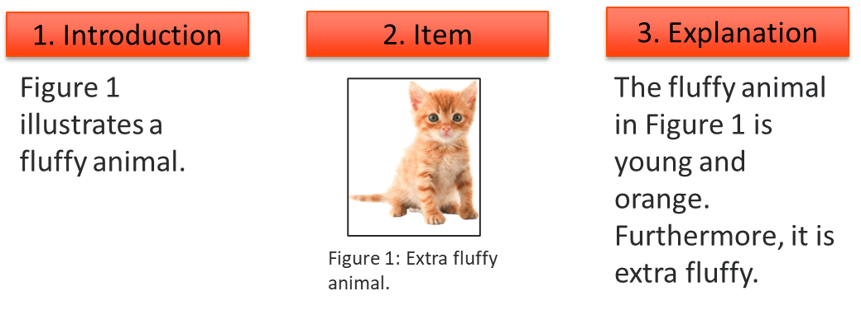

Using Appendices
If an item you want to present does not nicely fit within the text or is larger than half a page, it should be in the appendices. These items could include images, diagrams, code examples, test results or similar. Furthermore, material that provides additional information about the project such as a user manual could be placed in the appendices.
- You may try to resize large items, but make sure the content does not get blurry and the font sizes are large enough to read.
- The content of your report is more important than the length. Do not be afraid of "losing pages”. Use the appendices when you need to.
- The appendices have their own numbering, and the names of the appendices must be manually updated to the table of contents.

Examples of fitting a visual item on a single page:

Good:
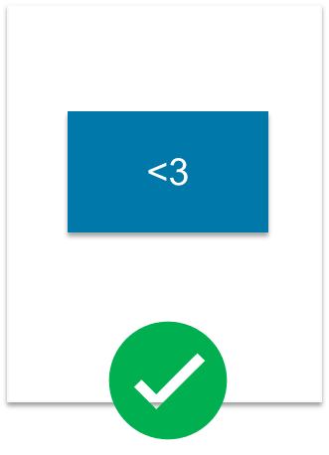

Not good:
