**Step by Step guide on how to add timer and warning massage functionality in the SCORM published output of Rise tool 140 min**

***THIS IS A 140 MINUTE CLASS (3 credits) with a 5 minute pop up warning, giving the student 10 minutes to click ok or the course shuts down.***

**Step 1**

Go to the “***scormcontent***” folder in the package.

**Step 2**

Look for the “***index.html***” file. Open it with any HTML editing tool (**Notepad++, Dreamweaver, Editplus, etc.**).

**Step 3**

Do ***Ctrl+F*** and find “**body**” tag and add below mentioned events in the start of ***body*** tag.

onkeydown="fnResetTime(600);" onmousedown='fnResetTime(600);' onload="fnOnPageLoad();"

*Please see the below screenshot for your reference.*

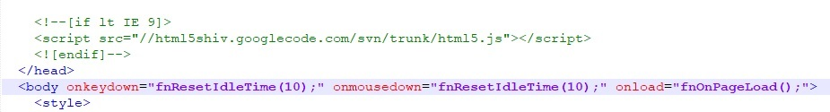

**Note**: Put the actual warning time in seconds in the brackets. Events. Here ***10 seconds*** is the passing parameter. Also update the same time in div with the id “***timerPopupCountDown*”**.

**Step 4**

Do ***Ctrl+F*** and find “***style***” tag and add below mentioned html contents after the end of the ***style*** tag.

<div id="idleDiv" class="bgDisable">

<div id="timerPopup" class="popup">

<div id="timerPopupText" class="popup-text">Hello There! You have been  
 idle for a while now. It's time to get back to the course. To continue, click   
 <b>OK</b> or the course will close in 600 seconds. </div>

<div id="timerPopupCountDown" class="CountDownText">10</div>

<div id="timerPopupOkBtn" class="ok-btn">OK</div>

</div>

</div>

<div id="warningDiv" class="bgDisable">

<div id="warningPopup" class="popup">

<div id="warningPopupText" class="popup-text">You have ONLY spent <span  
 id="hoursLeft">0</span> hours <span id="minutesLeft">0</span> minutes <span   
 id="secondsLeft">0</span> seconds in this course. You must spend 1 hours 15 minutes  
 in this course to receive credit. Do you still want to exit the course?<div>

<div class="btn-wrapper">

<div id="continue-btn" class="continue-btn"   
 onclick="fnHideWarningPopup();">Continue</div>

<div id="exit-btn" class="exit-btn" onclick="fnClose();">Exit</div>

</div>

</div>

</div>

*Please see the below screenshot for your reference.*

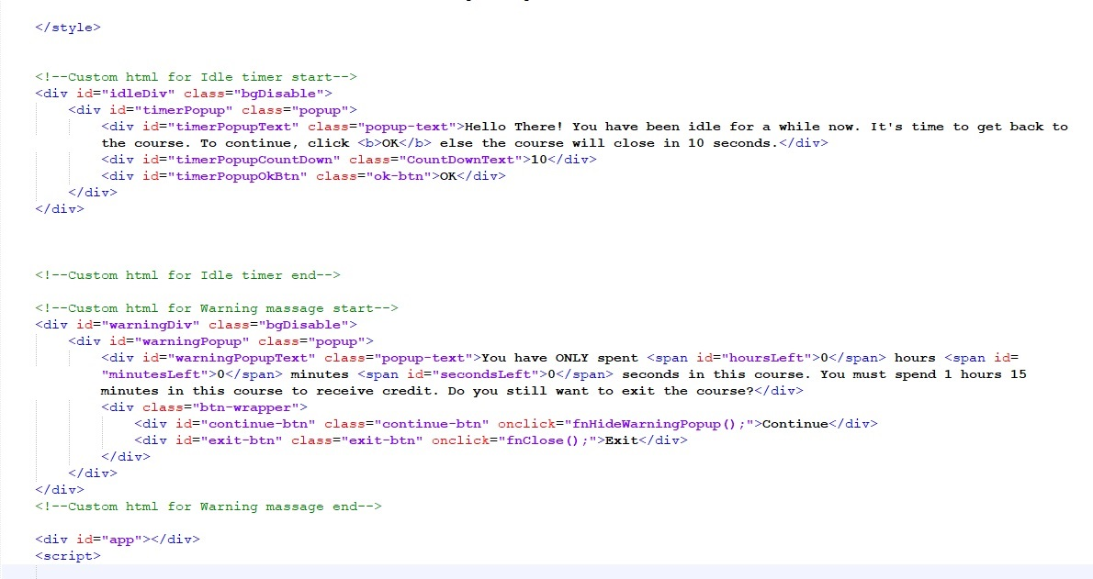

**Note:** Update the total course duration in html text in hours and minutes format.

**Step 5**

Do ***Ctrl+F*** and find “***style***” tag and add these **CSS** before the end of the style tag.

#idleDiv .popup{position: relative;width: 35%;top: 20%;background-color: #fff;padding: 25px;margin:  
 0 auto;text-align:center;}

#idleDiv .CountDownText{margin: 10px;font-size:18px;}

#idleDiv .popup .ok-btn{padding: 5px 15px;background-color: blue;display: inline-block;color:   
 #fff;cursor: pointer;}

#warningDiv .popup{position: relative;width: 35%;top: 20%;background-color: #fff;padding:   
 25px;margin: 0 auto;text-align:center;}

#warningDiv .popup .btn-wrapper{display: flex;margin-top: 30px;justify-content: space-around;}

#warningDiv .popup .continue-btn, #warningDiv .popup .exit-btn{padding: 5px 15px;background-  
 color: blue;display: inline-block;color: #fff;cursor: pointer;}

@media (max-width:767px){

#idleDiv .popup{width: 90%;top: 20%;}

#warningDiv .popup{width: 90%;top: 20%;}

}

*Please see the below screenshot for your reference.*

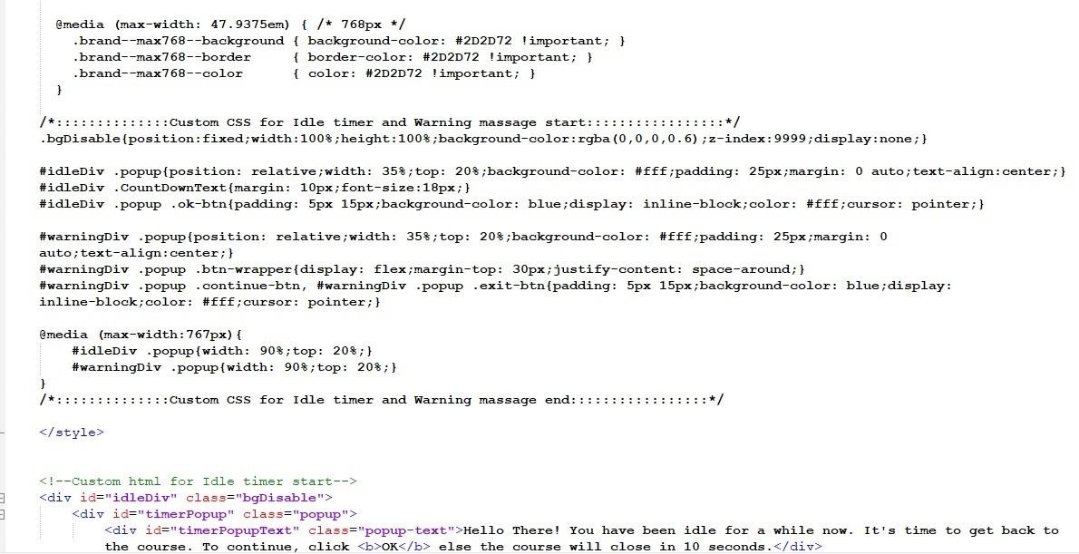

**Note**: You can update the **timer** **popup**, **warning massage**, **text** and **button** color as per the course in the above CSS.

**Step 6**

Do ***Ctrl+F*** and find “***script***” tag and add these JavaScript code under the ***script*** tag.

var courseDetails, courseTotalprogress;

var ua = navigator.userAgent;

var event = (ua.match(/iPad/i) || ua.match(/iPhone/i) || ua.match(/Android/i)) ? "touchstart" : "click";

document.body.addEventListener(event, function(e){fnResetIdleTime(10);});

var idleTimer;

var idleTime = 300000; // Add your timer time in millisecond

var countDownTimer;

var countDownTime = 600; // Add your warning time in second

var isFromCountDown = false;

var courseTimer;

var courseCurrentTime = 0;

var courseTotalTime = 8400; // Add your course duration time in second

var isTimeCompleted = false;

function fnOnPageLoad(){

fnClearCourseTimer();

fnClearIdleTimer();

fnClearCountDownTimer();

fnCheckCourseTime();

fnCheckIdleTime();

}

function fnCheckCourseTime(){

fnClearCourseTimer();

courseTimer = setInterval(fnCalcCourseTotalTime, 1000);

}

function fnCalcCourseTotalTime(){

courseCurrentTime ++;

fnUpdateTime();

if(courseCurrentTime >= courseTotalTime){

isTimeCompleted = true;

fnClearCourseTimer();

courseDetails.Runtime.finish(courseTotalprogress);

}

}

function fnUpdateTime(){

var hh = Math.floor(courseCurrentTime / 3600);

var mm = Math.floor(courseCurrentTime % 3600 / 60);

var ss = Math.floor(courseCurrentTime % 3600 % 60);

document.querySelector("#warningPopup #hoursLeft").innerHTML = hh;

document.querySelector("#warningPopup #minutesLeft").innerHTML = mm;

document.querySelector("#warningPopup #secondsLeft").innerHTML = ss;

}

function fnShowWarningPopup(){

fnClearCourseTimer();

fnClearIdleTimer();

document.getElementById('warningDiv').style.display = 'block';

}

function fnHideWarningPopup(){

isFromCountDown = false;

document.getElementById('warningDiv').style.display = 'none';

fnCheckCourseTime();

fnCheckIdleTime();

}

function fnCheckIdleTime(){

fnClearCountDownTimer();

fnClearIdleTimer();

idleTimer = setInterval(fnShowIdelPopup, idleTime);

}

function fnShowIdelPopup(){

fnClearIdleTimer();

document.getElementById('idleDiv').style.display = 'block';

countDownTimer = setInterval(fnStartCountDown, 1000);

}

function fnStartCountDown() {

countDownTime --;

var tempCount = countDownTime;

if(tempCount<10){

tempCount = "0"+tempCount;

}

document.getElementById('timerPopupCountDown').innerHTML = tempCount;

if(countDownTime == 0){

fnClearCountDownTimer();

fnClose();

}

}

function fnResetIdleTime(tempTime){

fnCheckIdleTime();

document.getElementById('idleDiv').style.display = 'none';

countDownTime = tempTime;

document.getElementById('timerPopupCountDown').innerHTML = countDownTime;

}

function fnGetCurrentCourseTime(){

return courseCurrentTime;

}

function fnClose(){

isFromCountDown = true;

courseDetails.Runtime.exit();

fnHideWarningPopup();

}

function fnClearCourseTimer(){

clearInterval(courseTimer);

}

function fnClearIdleTimer(){

clearInterval(idleTimer);

}

function fnClearCountDownTimer(){

clearInterval(countDownTimer);

}

*Please see the below screenshot for your reference.*

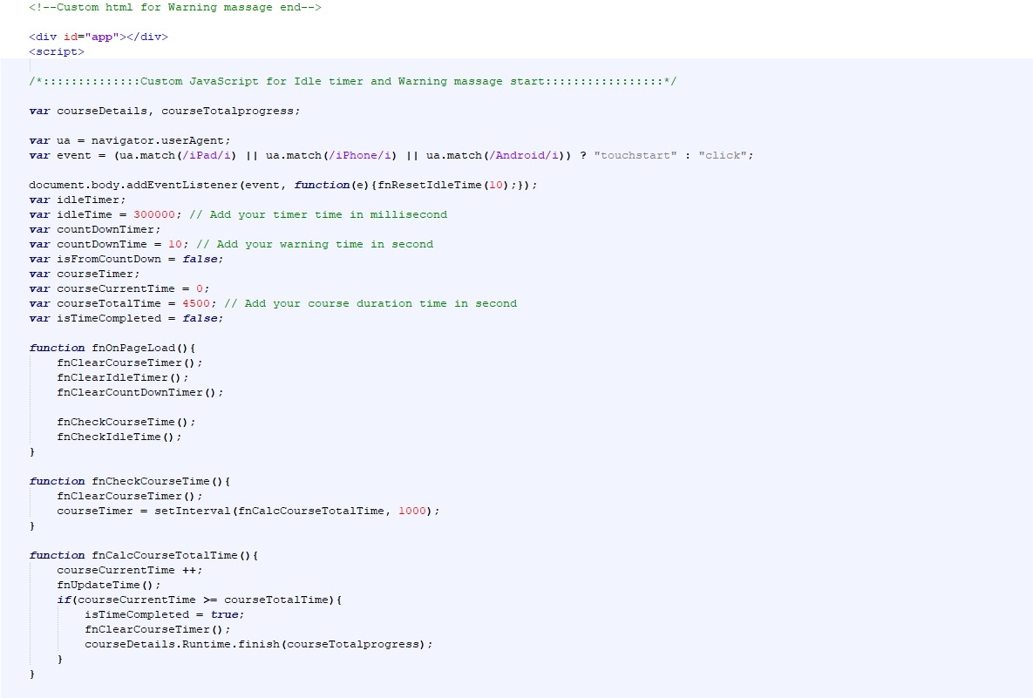

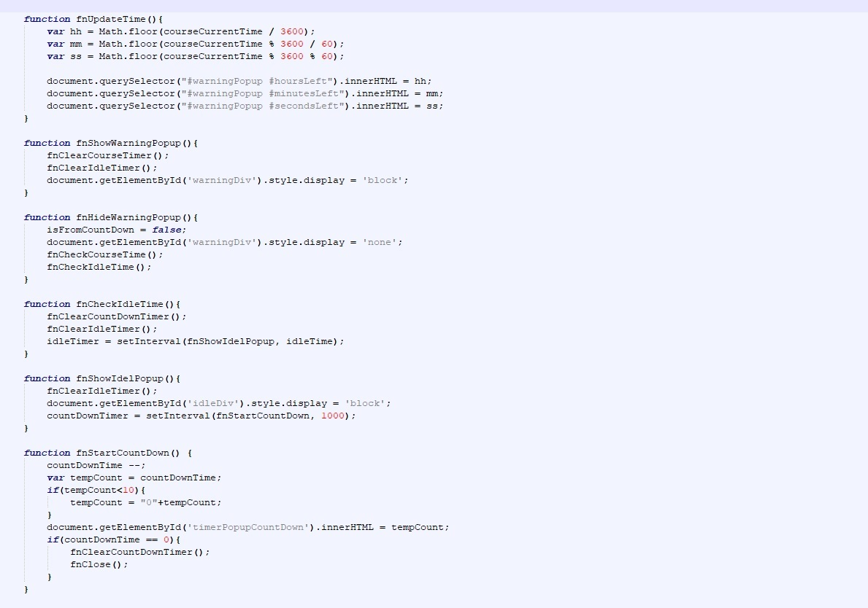

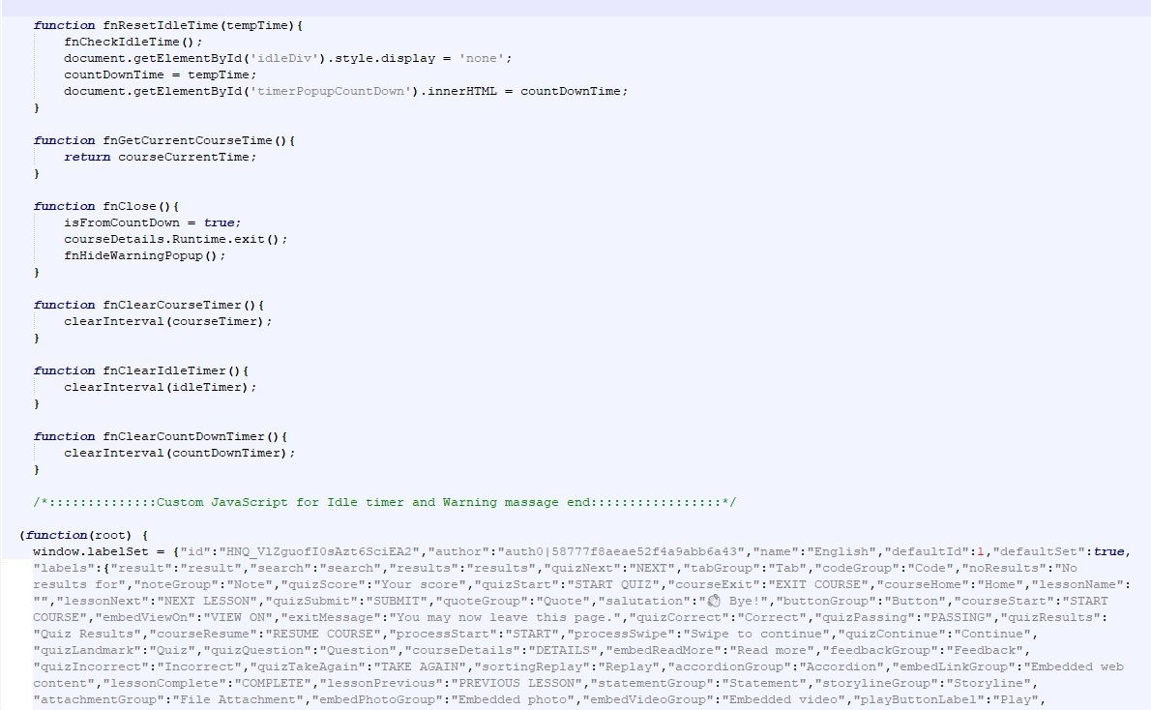

**Note**: You change the value of “***idleTime***”, “***countDownTime***” and “***courseTotalTime***” variables. Here we have kept ***idleTime*** value is ***300000******milliseconds (5 minutes), countDownTime*** valueis ***10 seconds*** and ***courseTotalTime*** value is ***6000 seconds*.**

**Step 7**

Do ***Ctrl+F*** and find “***finish(0)***” function and add below mentioned lines/codes above this function.

Do ***Ctrl+F*** and find “***stuffToPick***” variable and add “***'GetCourseCurrentTime'***” at the end.

(LMSProxy.GetStatus() === 2) ? isTimeCompleted = true : isTimeCompleted = false;

var getCourseTimeLMS = LMSProxy.GetCourseCurrentTime();

if(getCourseTimeLMS === '' || getCourseTimeLMS === ' ' || getCourseTimeLMS === undefined ||   
 getCourseTimeLMS === 'undefined' || getCourseTimeLMS === null){

}else{

courseCurrentTime = parseInt(getCourseTimeLMS);

}

*Please see the below screenshot for your reference*

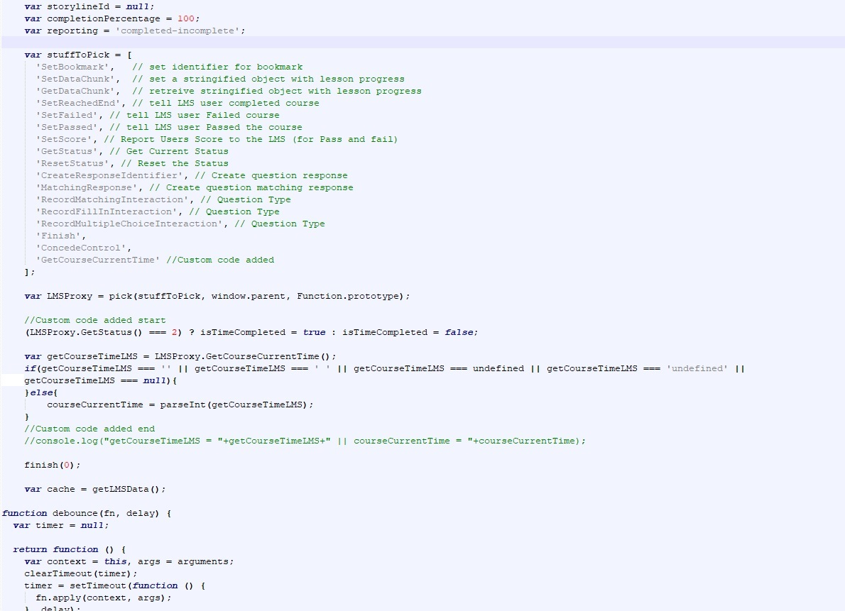

**Step 8**

Do ***Ctrl+F*** and find “***function completeOut(passed, reportParam) {***” function and replace the existing function with below mentioned function.

function completeOut(passed, reportParam) {

var reportType = reportParam || reporting;

if(isTimeCompleted){ //Custom code added

if(passed) {

switch(reportType) {

case 'completed-incomplete':

case 'completed-failed':

LMSProxy.ResetStatus();

LMSProxy.SetReachedEnd();

break;

case 'passed-incomplete':

case 'passed-failed':

LMSProxy.SetPassed();

LMSProxy.SetReachedEnd();

break;

}

} else {

switch(reportType) {

case 'passed-failed':

case 'completed-failed':

if(!isPassed()) {

LMSProxy.SetFailed();

}

break;

}

}

}

}

*Please see the below screenshot for your reference*

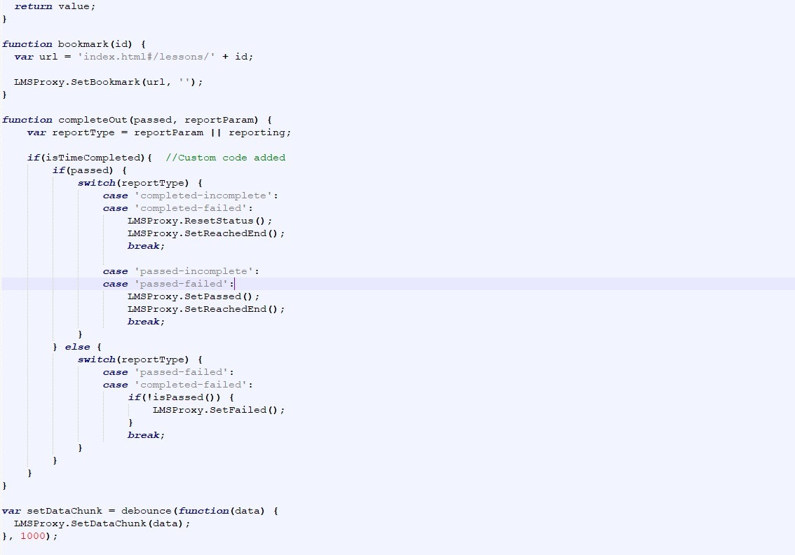

**Step 9**

Do ***Ctrl+F*** and find “***function exit() {***” function and replace the existing function with below mentioned function.

function exit() {

//Custom code added

if(isFromCountDown || isTimeCompleted){

LMSProxy.ConcedeControl();

}else{

fnShowWarningPopup();

}

}

*Please see the below screenshot for your reference*

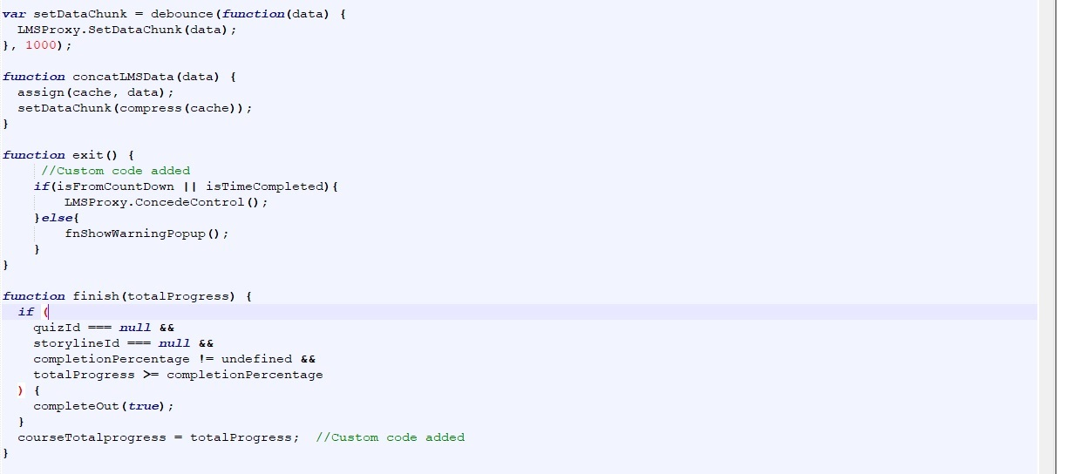

**Step 10**

Do ***Ctrl+F*** and find “***function finish(totalProgress) {***” function and add below mentioned line/code at the end of this function.

courseTotalprogress = totalProgress;

*Please see the below screenshot for your reference*

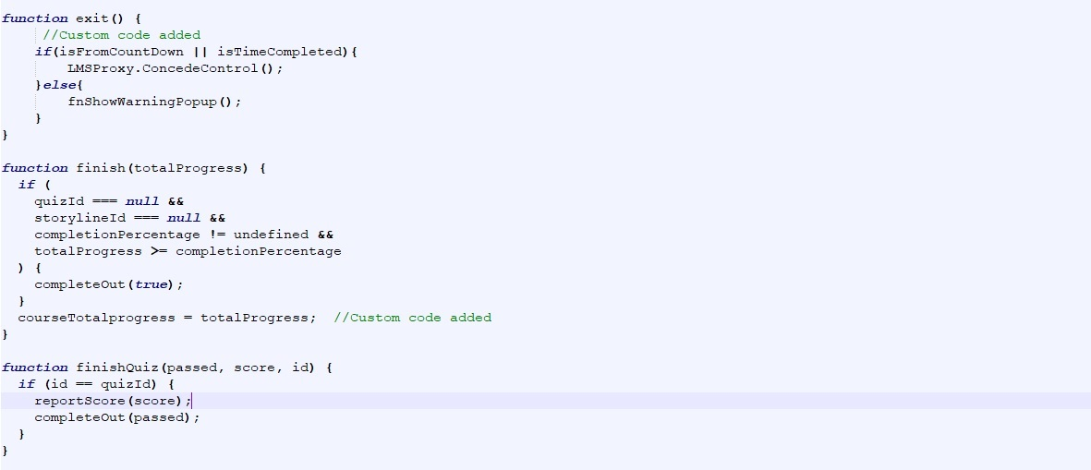

**Step 11**

Do ***Ctrl+F*** and find “***script***” tag and add below mention line/code above the last function close.

courseDetails = root;

*Please see the below screenshot for your reference*

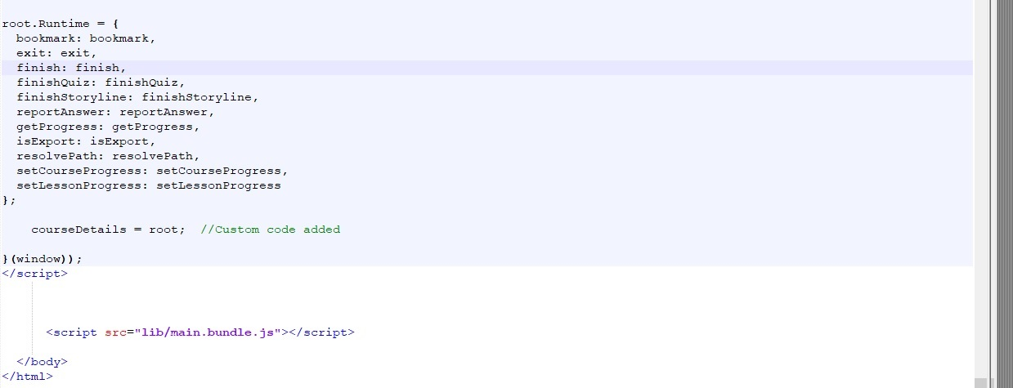

**Step 12**

Save (**Ctrl+S**) and close the **index.html** file.

**Step 13**

Go to the “***scormdriver***” folder in the package. Look for the “***indexAPI.html***” file. Open it with any HTML editing tool (**Notepad++, Dreamweaver, Editplus, etc.**).

**Step 14**

Do ***Ctrl+F*** and find “***strContentLocation***” variable and declare a new variable **“*var getCourseCurrentTimeLMS = “”;*”** above this.

Do ***Ctrl+F*** and find “***function LoadContent() {***” function add replace the existing function with below mentioned function.

function LoadContent() {

//check for bookmark

var bk = GetBookmark(); //Custom code added

if (bk != "") {

//if there is a bookmark, then go to that page

var tempArray = bk.split('~~'); //Custom code added

getCourseCurrentTimeLMS = tempArray[1]; //Custom code added

var bookmark = tempArray[0]; //Custom code added

window.scormdriver_content.document.location.href = "../scormcontent/" +   
 bookmark;

} else {

//if not, go to the start page

window.scormdriver_content.document.location.href = strContentLocation;

}

}

*Please see the below screenshot for your reference*

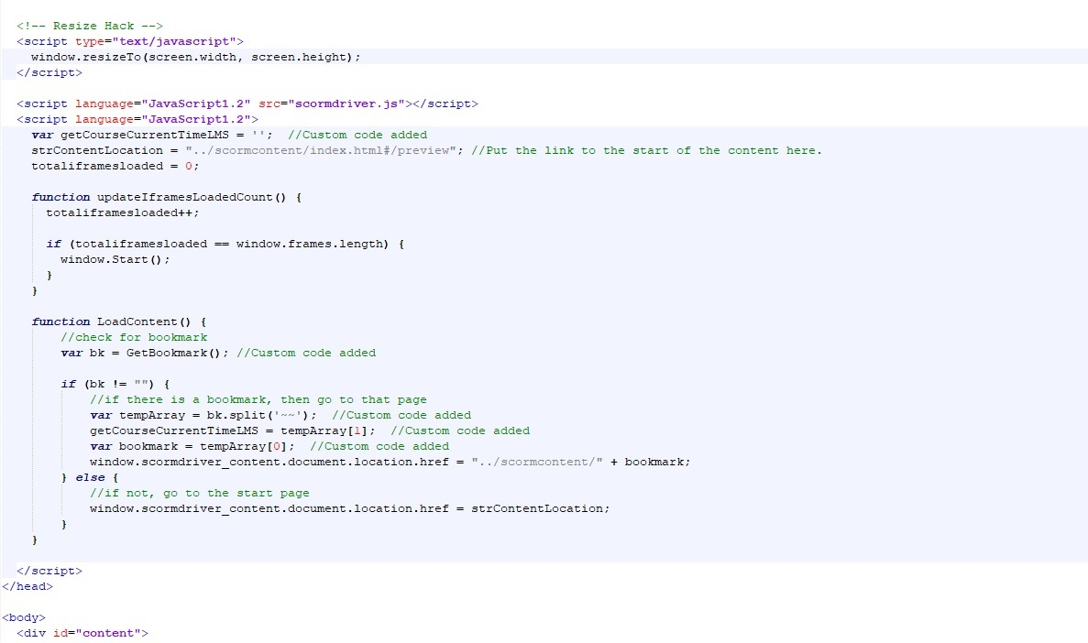

**Step 15**

Look for the “***scormdriver.js***” file. Open it with any HTML editing tool (**Notepad++, Dreamweaver, Editplus, etc.**). code is not readable in this file so you first make it readable by beautifying (<https://beautifier.io/>) the code.

**Step 16**

Do ***Ctrl+F*** and find “***function SCORM2004_GetBookmark() {***” function add a below mentioned function below that function.

function SCORM2004_GetCourseCurrentTime() {

WriteToDebug("In SCORM_GetCourseCurrentTime");

SCORM_ClearErrorInfo();

return getCourseCurrentTimeLMS;

}

*Please see the below screenshot for your reference*

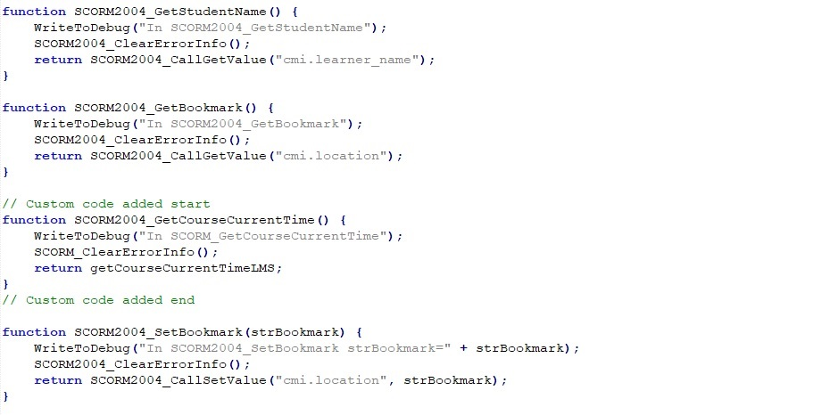

**Step 17**

Do ***Ctrl+F*** and find “***function SCORM_GetBookmark() {***” function add a below mentioned function below that function.

function SCORM_GetCourseCurrentTime() {

WriteToDebug("In SCORM_GetCourseCurrentTime");

SCORM_ClearErrorInfo();

return getCourseCurrentTimeLMS;

}

*Please see the below screenshot for your reference*

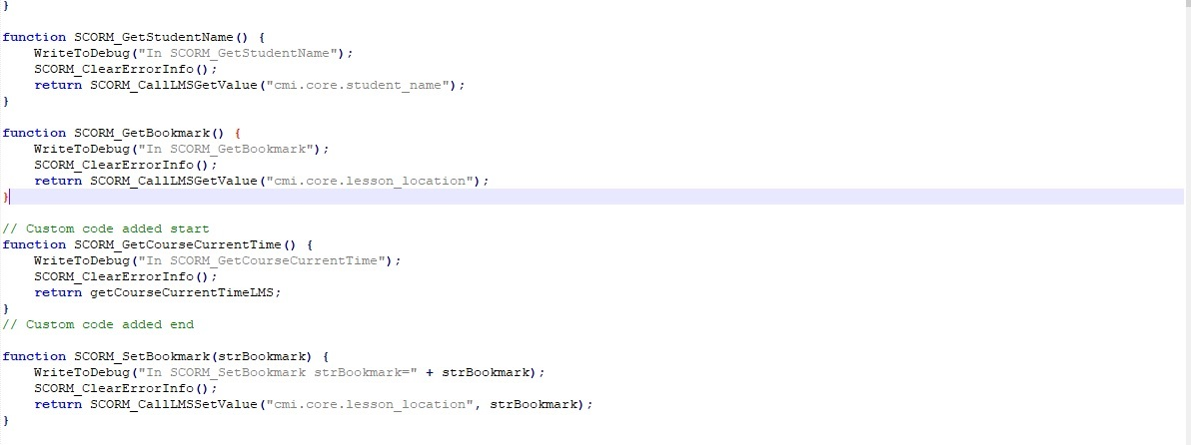

**Step 18**

Do ***Ctrl+F*** and find “***function AICC_GetBookmark() {***” function add a below mentioned function below that function.

function AICC_GetCourseCurrentTime () {

WriteToDebug("In SCORM_GetCourseCurrentTime");

SCORM_ClearErrorInfo();

return getCourseCurrentTimeLMS;

}

*Please see the below screenshot for your reference*

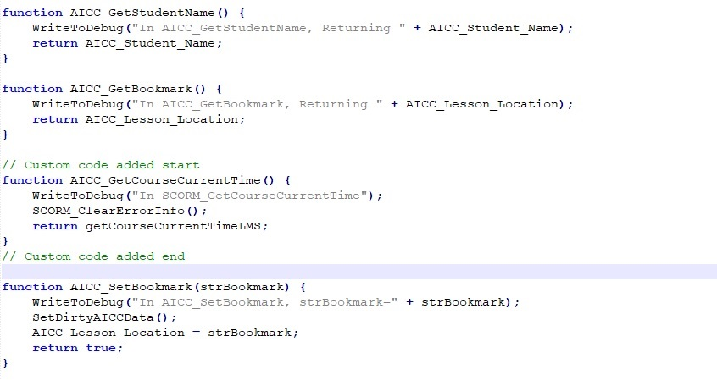

**Step 19**

Do ***Ctrl+F*** and find “***function NONE_GetBookmark() {***” function add a below mentioned function below that function.

function NONE_GetCourseCurrentTime () {

WriteToDebug("In SCORM_GetCourseCurrentTime");

SCORM_ClearErrorInfo();

return getCourseCurrentTimeLMS;

}

*Please see the below screenshot for your reference*

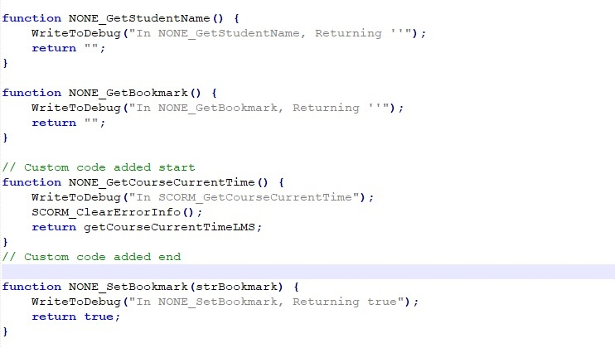

**Step 20**

Do ***Ctrl+F*** and find “***function TCAPI_GetBookmark() {***” function add a below mentioned function below that function.

function TCAPI_GetCourseCurrentTime () {

WriteToDebug("In SCORM_GetCourseCurrentTime");

SCORM_ClearErrorInfo();

return getCourseCurrentTimeLMS;

}

*Please see the below screenshot for your reference*

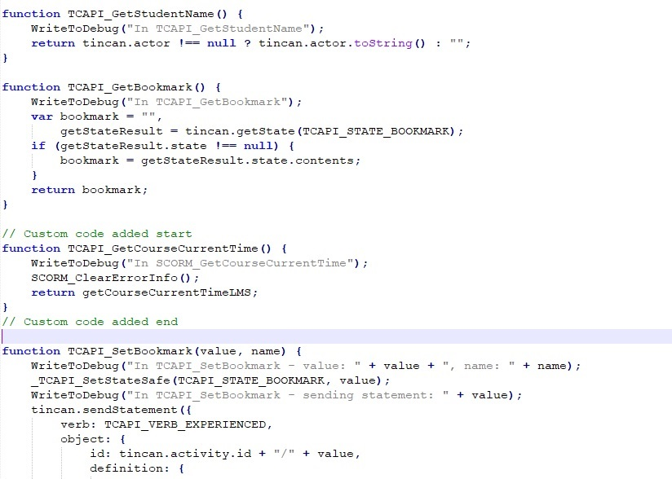

**Step 21**

Do ***Ctrl+F*** and find “***function CMI5_GetBookmark() {***” function add a below mentioned function below that function.

function CMI5_GetCourseCurrentTime () {

WriteToDebug("In SCORM_GetCourseCurrentTime");

SCORM_ClearErrorInfo();

return getCourseCurrentTimeLMS;

}

*Please see the below screenshot for your reference*

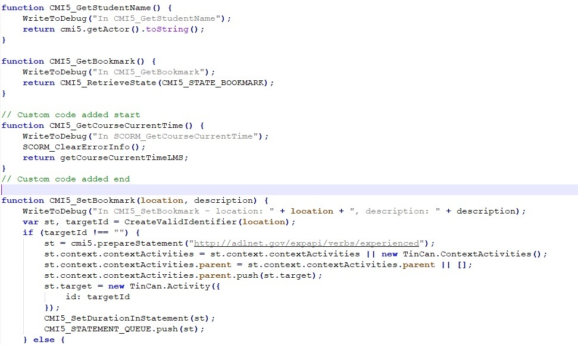

**Step 22**

Do ***Ctrl+F*** and find “***function LMSStandardAPI(strStandard) {***” function add a below mention line/code just before end of the function.

eval("this.GetCourseCurrentTime = " + strStandard + "_GetCourseCurrentTime");

*Please see the below screenshot for your reference*

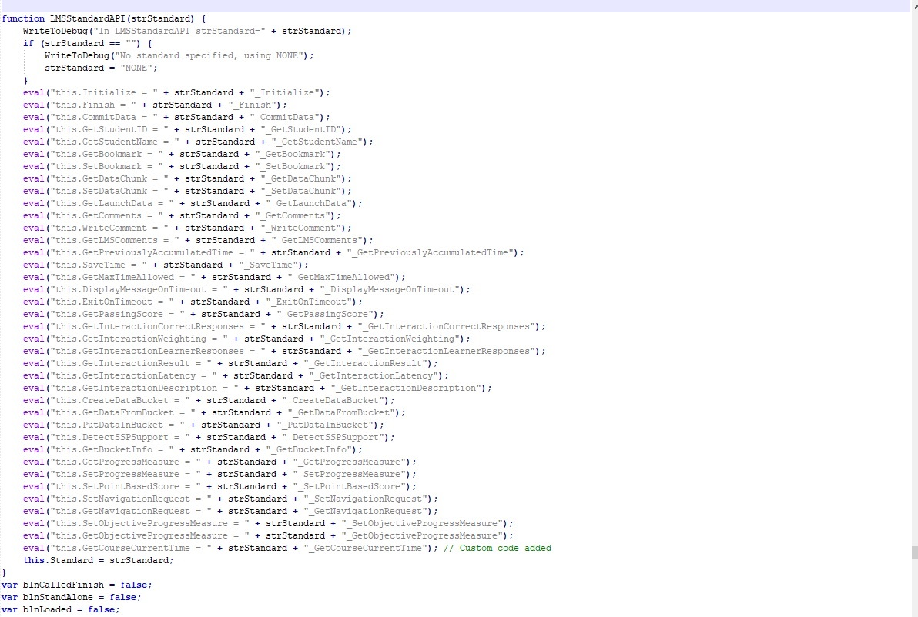

**Step 23**

Do ***Ctrl+F*** and find “***function GetBookmark() {***” function add a below mentioned function below that function.

function GetCourseCurrentTime() {

WriteToDebug("In GetCourseCurrentTime");

ClearErrorInfo();

if (!IsLoaded()) {

SetErrorInfo(ERROR_NOT_LOADED, "Cannot make calls to the LMS before calling  
 Start");

return "";

}

return objLMS.GetCourseCurrentTime();

}

*Please see the below screenshot for your reference*

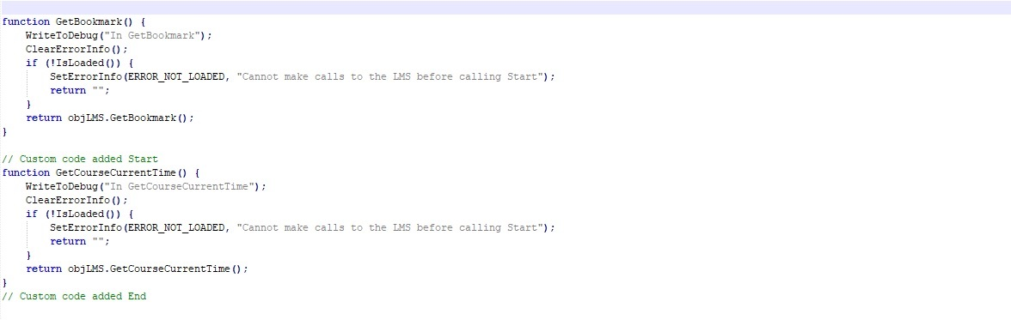

**Step 24**

Do ***Ctrl+F*** and find “***function ConcedeControl() {***” function add a below mention lines/codes in top of the function.

var curTime = document.querySelector("#content-frame").contentWindow.fnGetCurrentCourseTime();

var bkStr = objLMS.GetBookmark();

var newBkStr = bkStr + '~~' + curTime;

objLMS.SetBookmark(newBkStr, '');

*Please see the below screenshot for your reference*

