Homework 3: Enhanced ER Diagram
Art Museum Database Design
CS 5200 — Database Management Systems

1. EER Schema Diagram
The following Enhanced Entity-Relationship diagram captures all entities, attributes, relationships, and specialization hierarchies for the art museum database. Standard Elmasri & Navathe notation is used: rectangles for entities, diamonds for relationships, ellipses for attributes, circles with “d” for disjoint specialization, double lines for total participation, and single lines for partial participation. Underlined attributes denote primary keys.
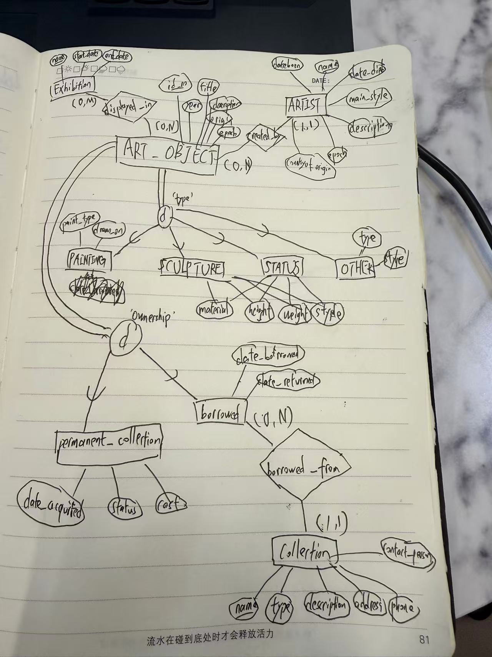
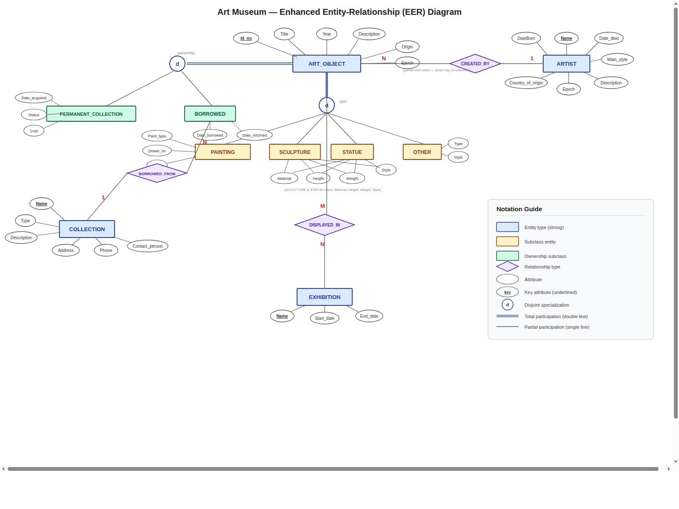
Figure 1: Art Museum EER Schema Diagram

2. Overview
This document presents an Enhanced Entity-Relationship (EER) schema for an art museum database. The design captures information about art objects and their categorizations, artists, exhibitions, and external collections. The schema identifies five entity types (ART_OBJECT and its subclasses, ARTIST, EXHIBITION, COLLECTION) and three relationship types (CREATED_BY, DISPLAYED_IN, BORROWED_FROM), along with two independent specialization hierarchies on ART_OBJECT.

3. Entity Types

3.1 ART_OBJECT (Superclass)
ART_OBJECT is the central entity with attributes: Id_no (primary key), Title, Year (if known), Description, Origin (country/culture), and Epoch. It participates in two independent specialization hierarchies and serves as the hub of the schema.

3.2 ARTIST
ARTIST is a strong entity with attributes: Name (primary key, assumed unique per requirements), DateBorn, Date_died, Country_of_origin, Epoch, Main_style, and Description. ARTIST is modeled as a separate entity rather than a simple attribute because the requirements list multiple properties of artists and one artist can create many art objects.

3.3 EXHIBITION
EXHIBITION is a strong entity with attributes: Name (primary key), Start_date, and End_date.

3.4 COLLECTION
COLLECTION represents external collections the museum interacts with. Attributes: Name (primary key), Type, Description, Address, Phone, and Contact_person.

4. Specialization Hierarchies

4.1 Specialization by Type (Disjoint, Total)
ART_OBJECT is specialized into four subclasses based on type: PAINTING, SCULPTURE, STATUE, and OTHER. This specialization is disjoint because an art object belongs to exactly one type category. It is total because every art object must fall into one of these four categories (OTHER acts as a catch-all). Each subclass has local attributes: PAINTING has Paint_type, Drawn_on, and Style; SCULPTURE and STATUE share Material, Height, Weight, and Style; OTHER has Type and Style.

4.2 Specialization by Ownership (Disjoint, Total)
ART_OBJECT is independently specialized into PERMANENT_COLLECTION and BORROWED. This specialization is disjoint (an object is either owned or borrowed, not both) and total (every object must be one or the other). PERMANENT_COLLECTION has attributes Date_acquired, Status (on display / on loan / stored), and Cost. BORROWED has attributes Date_borrowed and Date_returned.
Note on two independent specializations: These two specializations operate on orthogonal dimensions. An art object is simultaneously categorized by its physical type and by its ownership status. This is a standard EER pattern where a single superclass has multiple independent specialization circles.

5. Relationship Types

5.1 CREATED_BY (ART_OBJECT — ARTIST), N:1, Partial/Partial
This relationship associates art objects with their creator. The cardinality is N:1 (many art objects can be created by one artist, each art object has at most one known artist). Participation is partial on both sides: an art object may have an unknown artist (“if known”), and an artist may not currently have objects in the museum’s collection.

5.2 DISPLAYED_IN (ART_OBJECT — EXHIBITION), M:N
This M:N relationship captures which art objects were displayed in which exhibitions. An exhibition displays many art objects, and an art object can appear in multiple exhibitions over time.

5.3 BORROWED_FROM (BORROWED — COLLECTION), N:1
This relationship links the BORROWED subclass to COLLECTION. Each borrowed object comes from exactly one collection (N:1). The “Collection” attribute mentioned in the requirements is modeled as this relationship, since COLLECTION is described as a separate entity with its own attributes. This avoids redundancy.

6. Assumptions and Justifications
- Artist name uniqueness: The requirements state “The Name is assumed to be unique,” so Name serves as the primary key for ARTIST.
- SCULPTURE vs. STATUE: Although both share identical attribute sets (Material, Height, Weight, Style), they are kept as separate subclasses because the requirements explicitly distinguish them.
- Origin and Epoch on ART_OBJECT: The requirements state these are captured “for each ART_OBJECT,” so they are modeled as superclass attributes, not as a separate entity.
- Collection from which borrowed: The “Collection” listed as an attribute of BORROWED is modeled as the BORROWED_FROM relationship to the COLLECTION entity, avoiding redundant storage of collection details.
- No weak entities: All entities have their own identifying attributes (Id_no, Name), so no weak entity types are needed.
- Total type specialization: The OTHER category ensures completeness—every art object belongs to exactly one of the four type subclasses.
- Single artist per object: CREATED_BY is N:1, assuming each art object has at most one credited artist. If collaborative works needed multiple artists, this would become M:N.

7. Summary
The schema uses two independent specialization hierarchies on ART_OBJECT to cleanly separate the orthogonal dimensions of physical type and ownership status. ARTIST is modeled as a full entity to capture rich artist properties. COLLECTION is likewise a full entity, linked to BORROWED via a relationship rather than being a simple attribute. The DISPLAYED_IN relationship captures historical exhibition data as an M:N association. This design minimizes redundancy, clearly represents all constraints from the requirements, and follows standard EER conventions.

