CS 5200 Database Management Systems

Question 1 — EER Diagram: Small Private Airport (10 pts)\

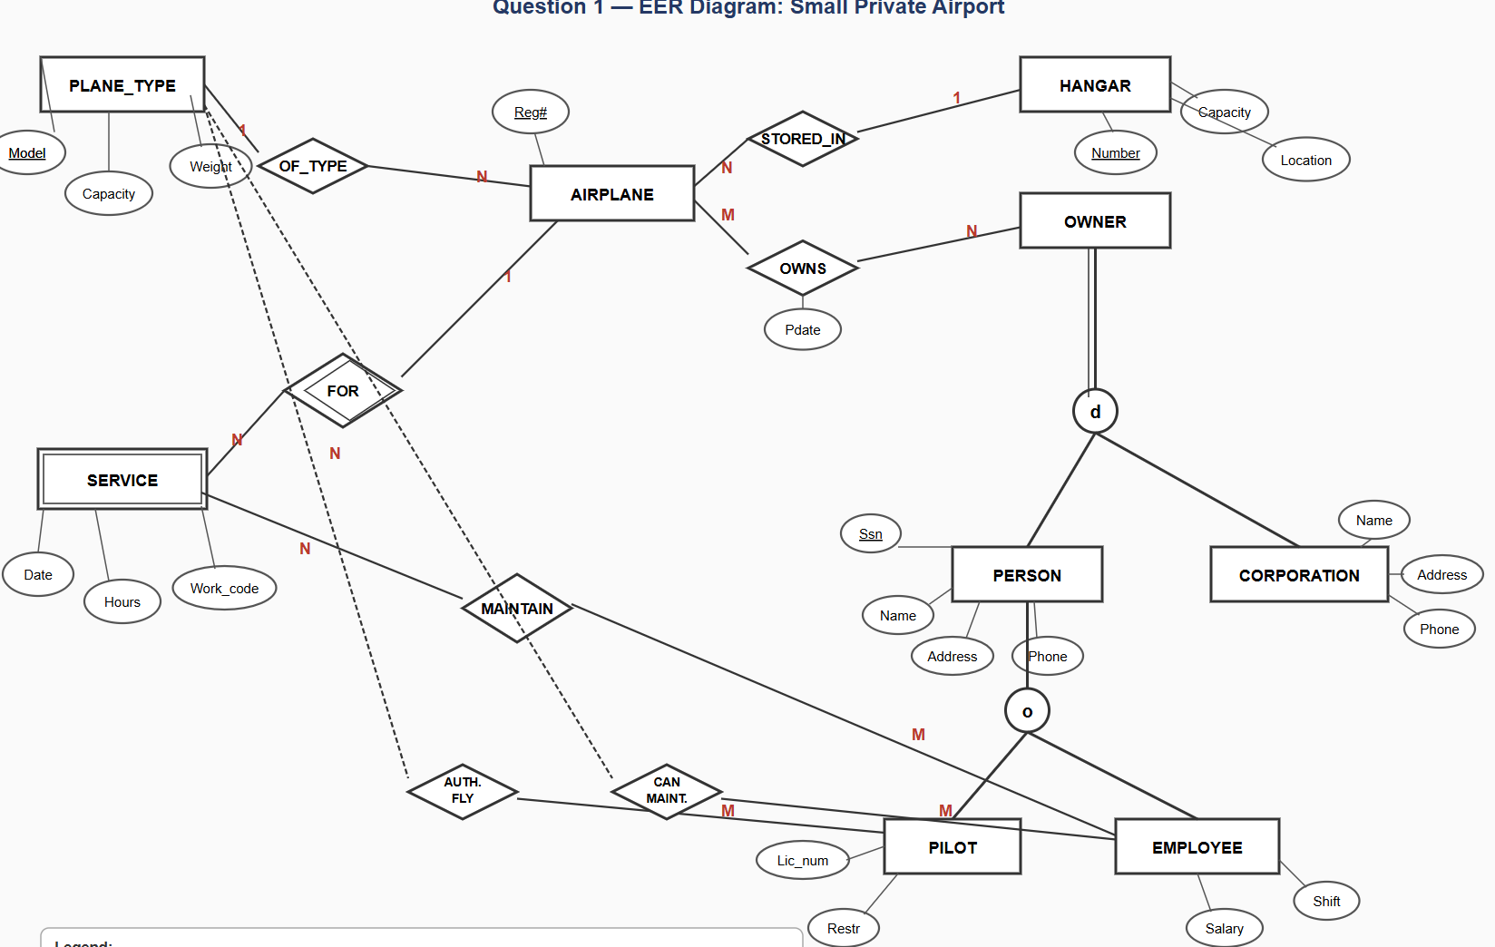

Question 2 — Requirements from Airline ER Diagram (10 pts)

Entities & Attributes
- AIRPORT: Airport_code (PK), City, State, Name
- FLIGHT_LEG: Leg_no (PK), Scheduled_dep_time, Scheduled_arr_time
- FLIGHT: Number (PK), Airline, Weekdays
- AIRPLANE_TYPE: Type_name (PK), Max_seats, Company
- AIRPLANE: Airplane_id (PK), Total_no_of_seats
- LEG_INSTANCE: Date (PK), No_of_avail_seats, Arr_time
- FARE: Code (PK), Amount, Restrictions
- SEAT: Seat_no (PK)
- RESERVATION: Customer_name, Cphone

Requirements
- Each airport has a unique code, and is located in a city and state.
- A flight leg has a scheduled departure and arrival time, and connects exactly one departure airport (1:N) to one arrival airport (1:N).
- An airport can serve as a departure airport for many legs, and as an arrival airport for many legs.
- A flight consists of one or more legs (LEGS relationship, 1:N).
- Each flight leg can have many instances — one per date (INSTANCES, 1:N).
- Each airplane type can be flown from many airports (CAN_LAND, M:N).
- Each airplane belongs to exactly one airplane type (TYPE, N:1).
- An airplane is assigned to leg instances (ASSIGNED, N:M — an airplane can cover many instances, an instance uses one airplane).
- An airplane departs from an airport (DEPARTS, with Dep_time) and arrives at an airport (ARRIVES, with Arr_time).
- A leg instance can have many fares (FARES, 1:N); each fare belongs to one instance.
- A leg instance can have many reservations; each reservation is for exactly one instance (1:N).
- A reservation can include many seats; a seat belongs to exactly one reservation (N:1).

Question 3 — (min,max) Constraints & ADOPTS Relationship (10 pts)

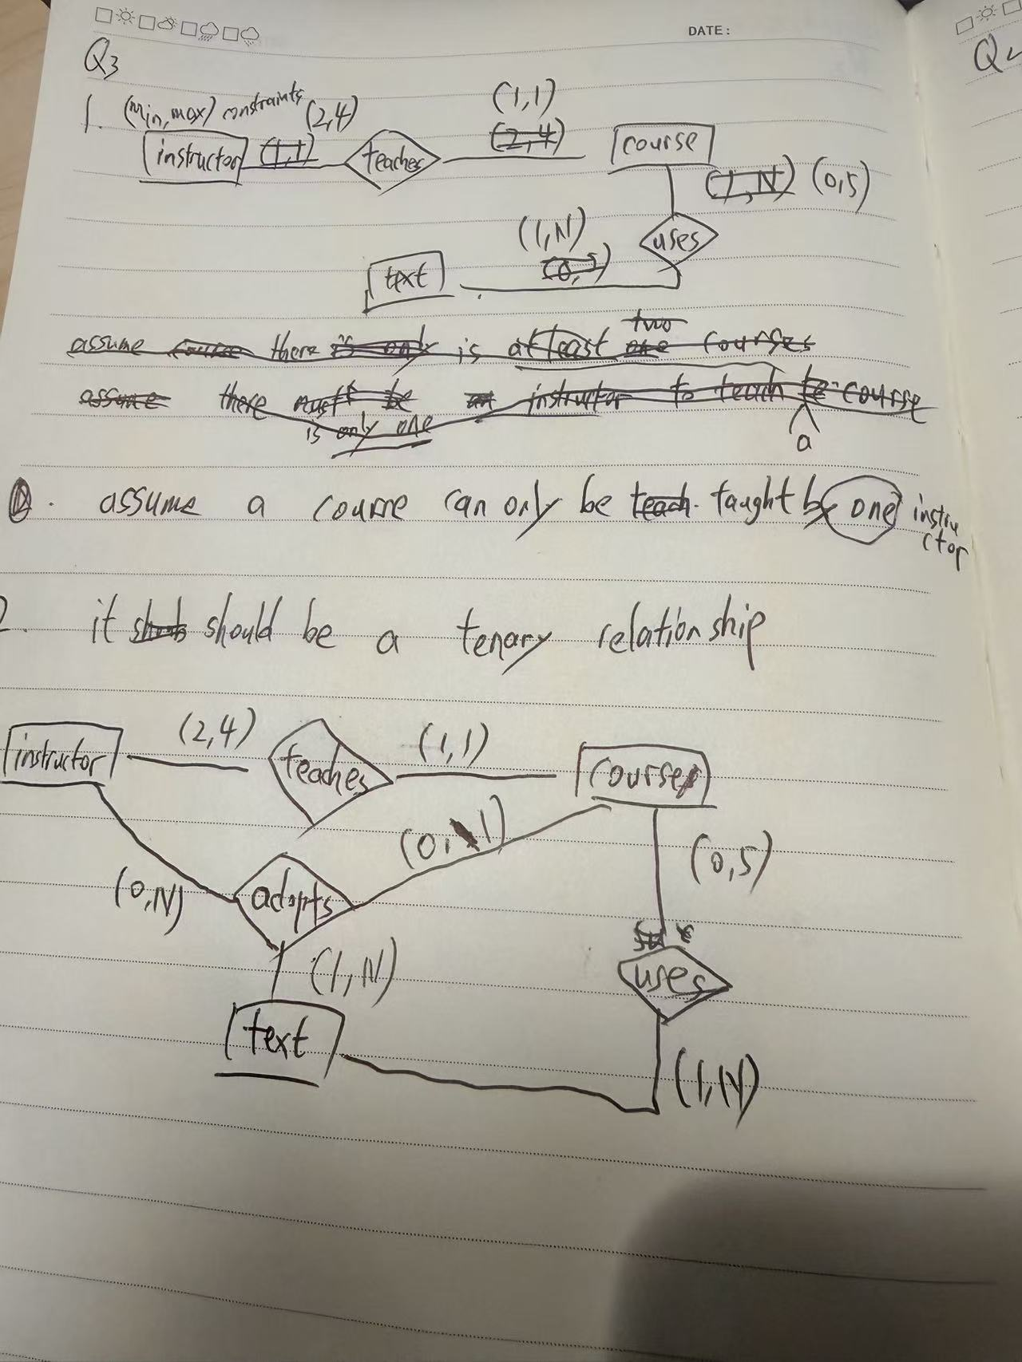

Question 4 — Generalization EER Diagram (10 pts)

Identifying the Generalization
Looking at Figure 3, INSTRUCTOR and STUDENT share common attributes such as Id/Ssn and Name. Applying generalization, we extract a superclass UNIVERSITY_PERSON.

Superclass
- UNIVERSITY_PERSON: Id (PK), Name

Subclasses
- INSTRUCTOR (inherits Id, Name) + specific attributes: Rank, IOffice, IPhone
- STUDENT (inherits Id, Name) + specific attributes: SId, FName, MName, LName, DOB, SName, Addr, Phone, Major

Specialization Constraints
- Completeness: Partial — not every university person must be an instructor or student (e.g., a dean may be classified separately)
- Disjointness: Overlapping (o) — a person could be both an instructor and a student

Question 5 — SQL DDL for LIBRARY Database (10 pts)

Create Tables (in dependency order)
-- 1. PUBLISHER (no foreign keys)
CREATE TABLE PUBLISHER (
Name VARCHAR(50) PRIMARY KEY,
Address VARCHAR(100),
Phone VARCHAR(20)
);

-- 2. LIBRARY_BRANCH (no foreign keys)
CREATE TABLE LIBRARY_BRANCH (
Branch_id INT PRIMARY KEY,
Branch_name VARCHAR(50) NOT NULL,
Address VARCHAR(100)
);

-- 3. BORROWER (no foreign keys)
CREATE TABLE BORROWER (
Card_no INT PRIMARY KEY,
Name VARCHAR(50) NOT NULL,
Address VARCHAR(100),
Phone VARCHAR(20)
);

-- 4. BOOK (references PUBLISHER)
CREATE TABLE BOOK (
Book_id INT PRIMARY KEY,
Title VARCHAR(100) NOT NULL,
Publisher_name VARCHAR(50),
FOREIGN KEY (Publisher_name) REFERENCES PUBLISHER(Name)
ON DELETE SET NULL ON UPDATE CASCADE
);

-- 5. BOOK_AUTHORS (references BOOK)
CREATE TABLE BOOK_AUTHORS (
Book_id INT,
Author_name VARCHAR(50),
PRIMARY KEY (Book_id, Author_name),
FOREIGN KEY (Book_id) REFERENCES BOOK(Book_id)
ON DELETE CASCADE ON UPDATE CASCADE
);

-- 6. BOOK_COPIES (references BOOK, LIBRARY_BRANCH)
CREATE TABLE BOOK_COPIES (
Book_id INT NOT NULL,
Branch_id INT NOT NULL,
No_of_copies INT DEFAULT 0,
PRIMARY KEY (Book_id, Branch_id),
FOREIGN KEY (Book_id) REFERENCES BOOK(Book_id)
ON DELETE CASCADE ON UPDATE CASCADE,
FOREIGN KEY (Branch_id) REFERENCES LIBRARY_BRANCH(Branch_id)
ON DELETE CASCADE ON UPDATE CASCADE
);

-- 7. BOOK_LOANS (references BOOK, LIBRARY_BRANCH, BORROWER)
CREATE TABLE BOOK_LOANS (
Book_id INT NOT NULL,
Branch_id INT NOT NULL,
Card_no INT NOT NULL,
Date_out DATE,
Due_date DATE,
PRIMARY KEY (Book_id, Branch_id, Card_no),
FOREIGN KEY (Book_id) REFERENCES BOOK(Book_id)
ON DELETE CASCADE ON UPDATE CASCADE,
FOREIGN KEY (Branch_id) REFERENCES LIBRARY_BRANCH(Branch_id)
ON DELETE CASCADE ON UPDATE CASCADE,
FOREIGN KEY (Card_no) REFERENCES BORROWER(Card_no)
ON DELETE CASCADE ON UPDATE CASCADE
);

ON DELETE CASCADE → child rows are deleted when the parent row is deleted.
ON DELETE SET NULL → child FK becomes NULL when the parent row is deleted.
Always build parent tables before child tables!

Question 6 — SQL Queries on Student Database (10 pts)

Query 1 — Straight-A Students (grade A in ALL courses)
Logic: find students for whom there does NOT EXIST any grade record that is not 'A'.
SELECT S.Name, S.Major
FROM STUDENT S
WHERE NOT EXISTS (
SELECT *
FROM GRADE_REPORT GR
WHERE GR.Student_number = S.Student_number
AND GR.Grade <> 'A'
);

Key logic: NOT EXISTS + Grade <> 'A'
= There is no course where the grade is not A
= All courses have grade A
Common mistake: WHERE Grade = 'A' only finds students with AT LEAST one A, not ALL A.

Query 2 — Students with No A at All
Logic: find students whose student number does not appear in any 'A' grade record.
SELECT S.Name, S.Major
FROM STUDENT S
WHERE S.Student_number NOT IN (
SELECT GR.Student_number
FROM GRADE_REPORT GR
WHERE GR.Grade = 'A'
);

Question 7 — SQL DML on COMPANY Database (20 pts)

1. Insert new employee Robert Scott
INSERT INTO EMPLOYEE
(Fname, Minit, Lname, Ssn, Bdate, Address, Sex, Salary, Super_ssn, Dno)
VALUES
('Robert','F','Scott','943775543','1972-06-21',
'2365 Newcastle Rd, Bellaire, TX','M',58000,'888665555',1);

2. Insert new project ProductA
INSERT INTO PROJECT (Pname, Pnumber, Plocation, Dnum)
VALUES ('ProductA', 4, 'Bellaire', 2);

3. Insert new department Production
INSERT INTO DEPARTMENT (Dname, Dnumber, Mgr_ssn, Mgr_start_date)
VALUES ('Production', 4, '943775543', '2007-10-01');

Note on insert order: DEPARTMENT must be inserted before EMPLOYEE if Dno is a FK to DEPARTMENT.
Here Dno=1 already exists, so the employee insert is safe.
Always satisfy FK constraints before inserting child rows.

4. Delete WORKS_ON tuples where Essn = '333445555'
DELETE FROM WORKS_ON
WHERE Essn = '333445555';

5. Update manager of Department 5
UPDATE DEPARTMENT
SET Mgr_ssn = '123456789',
Mgr_start_date = '2007-10-01'
WHERE Dnumber = 5;

Question 8 — SQL Queries on Student Database (20 pts)

Query 1 — Senior CS students (Class = 4)
SELECT Name
FROM STUDENT
WHERE Major = 'CS'
AND Class = 4;

Query 2 — Sections taught by King with student count
SELECT S.Course_number,
S.Semester,
S.Year,
COUNT(GR.Student_number) AS Num_students
FROM SECTION S
LEFT JOIN GRADE_REPORT GR
ON S.Section_identifier = GR.Section_identifier
WHERE S.Instructor = 'King'
GROUP BY S.Section_identifier,
S.Course_number,
S.Semester,
S.Year;

Why LEFT JOIN? — To include sections where no students are enrolled yet (COUNT = 0).
Why GROUP BY multiple columns? — SELECT contains Course_number, Semester, Year;
all non-aggregate columns in SELECT must appear in GROUP BY.

Query 3 — Straight-A students (same logic as Q6 Query 1)
SELECT S.Name, S.Major
FROM STUDENT S
WHERE NOT EXISTS (
SELECT *
FROM GRADE_REPORT GR
WHERE GR.Student_number = S.Student_number
AND GR.Grade <> 'A'
);

Query 4 — Insert new student Johnson
INSERT INTO STUDENT (Name, Student_number, Class, Major)
VALUES ('Johnson', 25, 1, 'Math');

Query 5 — Change Smith's class to 2
UPDATE STUDENT
SET Class = 2
WHERE Name = 'Smith';

Quick Reference Summary
Q# | Points | Topic | Key Concept
Q1 | 10 | EER Diagram (from text) | Weak entity, inheritance, relationship attributes
Q2 | 10 | Requirements (from diagram) | Reverse-engineer ER diagram into text
Q3 | 10 | (min,max) + Ternary | ADOPTS needs 3 entities; (min,max) per entity
Q4 | 10 | Generalization EER | Extract superclass from common attributes
Q5 | 10 | SQL DDL | CREATE TABLE + PRIMARY KEY + FOREIGN KEY + triggers
Q6 | 10 | SQL Queries | NOT EXISTS + <> 'A' for universal quantification
Q7 | 20 | SQL DML | INSERT / DELETE / UPDATE with WHERE
Q8 | 20 | SQL Comprehensive | JOIN + GROUP BY + COUNT + NOT EXISTS

