Group Phase 3 - System Setup using GCP
Step 8: Creating Database Server (PostgreSQL on Compute Engine)
8.1 GCP Project Creation
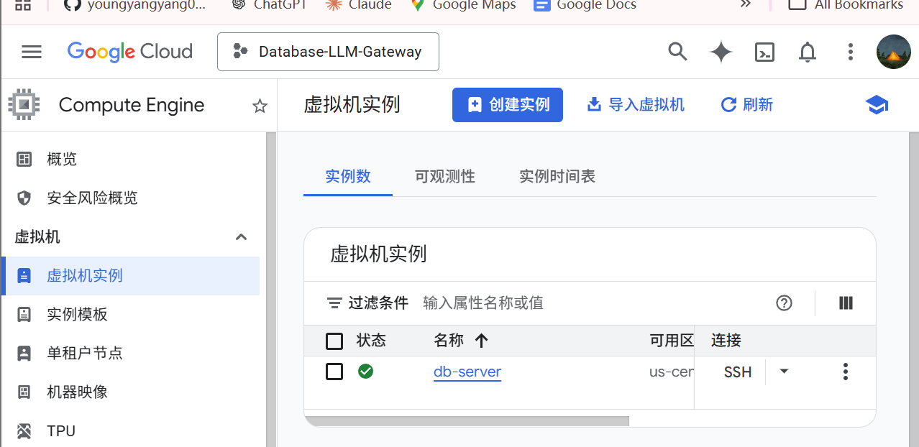A new GCP project named “Database-LLM-Gateway” was created via the GCP Console.
A Compute Engine VM instance named “db-server” was created using Ubuntu 20.04 LTS with machine type e2-medium. This VM serves as the dedicated database server for the project.
8.3 PostgreSQL Installation
PostgreSQL was installed on the Compute Engine VM via SSH. The following commands were used to install and start the database service:
sudo apt update && sudo apt install -y postgresql
sudo systemctl start postgresql && sudo systemctl enable postgresql
The screenshot below confirms PostgreSQL is running successfully on the VM (status: active).
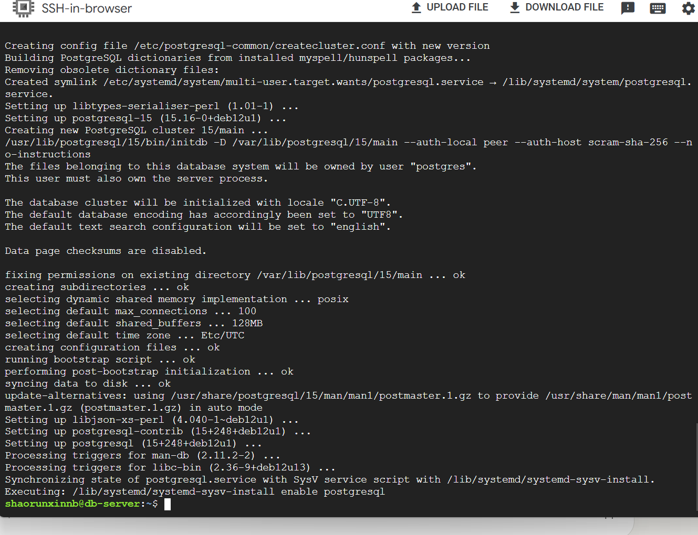
Figure 1: PostgreSQL service status showing active (running) on the Compute Engine VM.
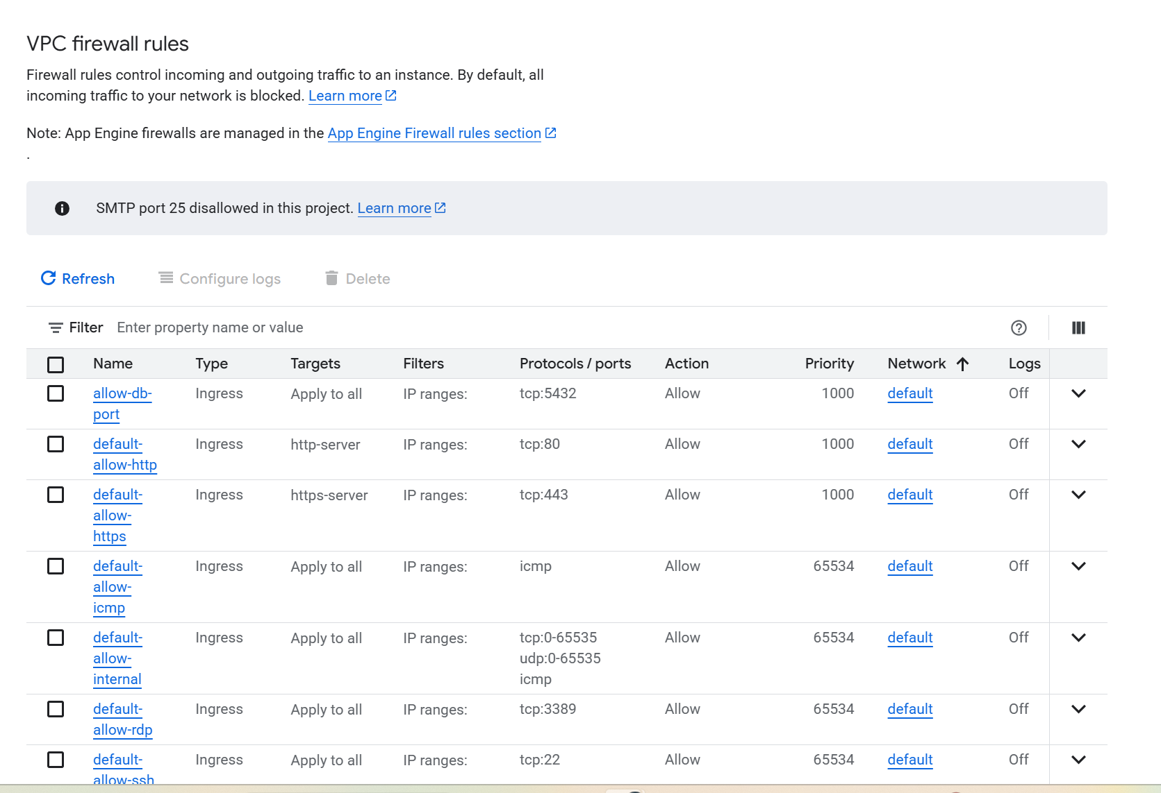
Figure 2: Firewall rule allowing TCP port 5432 for PostgreSQL inbound traffic.
Figure 3: Firewall rule details confirming port 5432 is open.
Step 9: Creating Web Application Server (Spring Boot on App Engine)
9.1 App Engine Setup
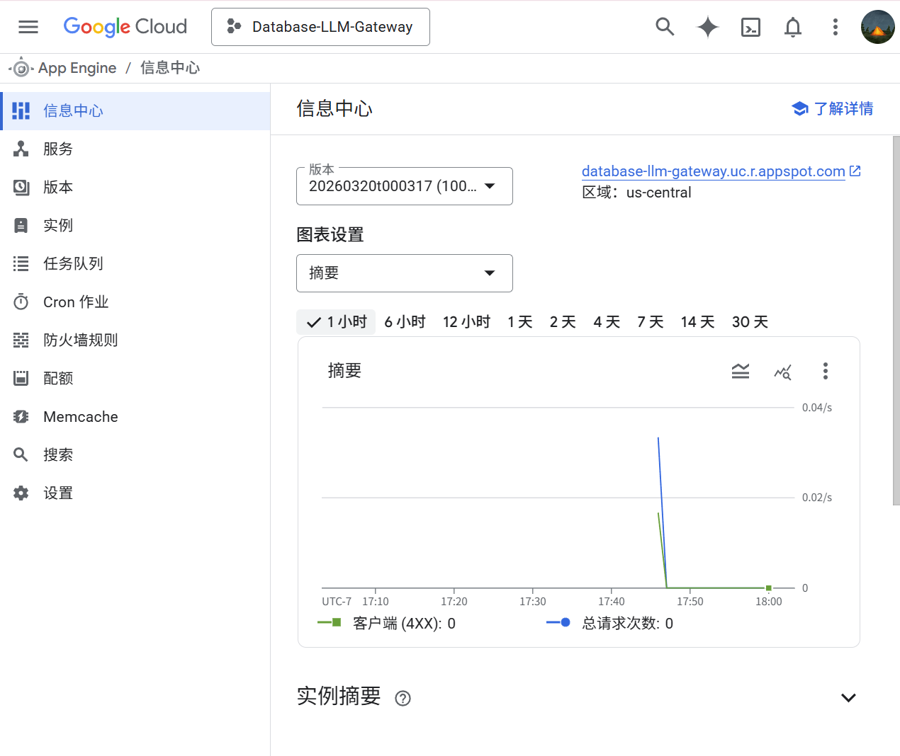Google App Engine was enabled for the project. A Java 17 standard environment application was created in the us-central region to host the Spring Boot web application.
9.2 Spring Boot Application Deployment
A Spring Boot application was built using Spring Initializr with Spring Web, Spring Data JPA, and PostgreSQL Driver dependencies. An app.yaml configuration file was created for App Engine deployment. The application was packaged and deployed using the following commands:
mvn clean package -DskipTests
mvn appengine:deploy
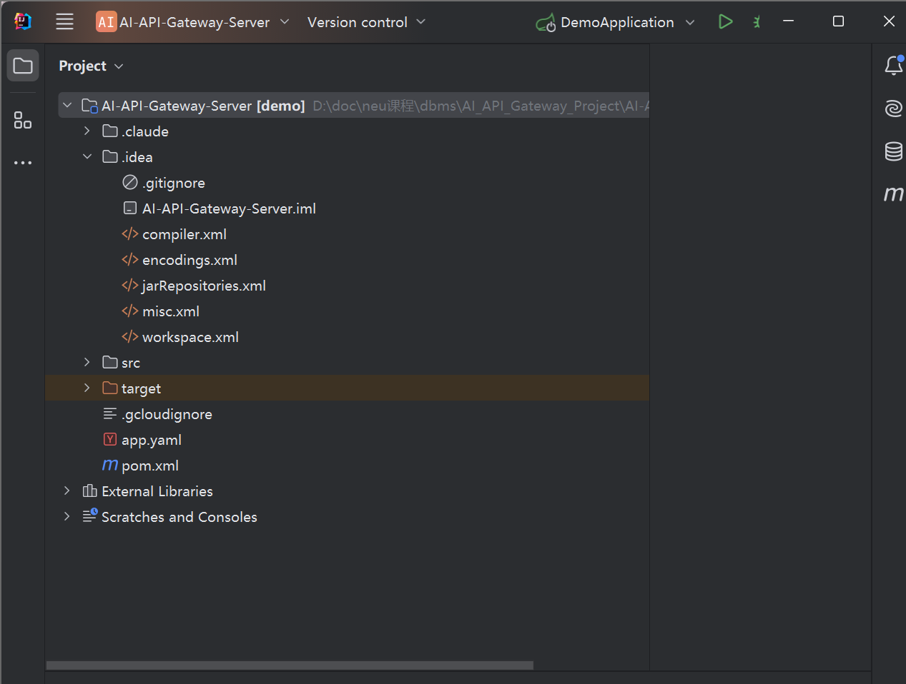
9.3 App Engine Services and Deployed Version
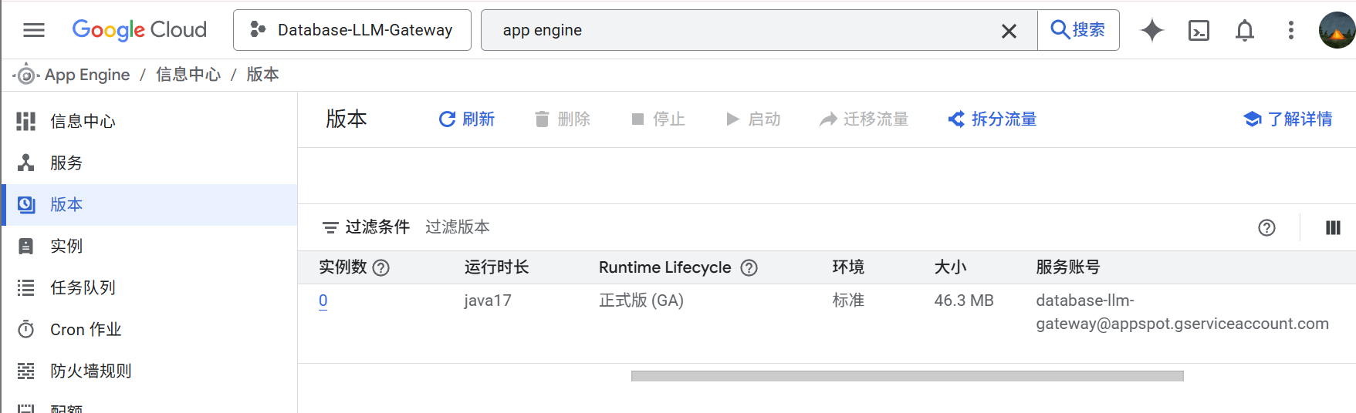9.4 Web Application Running in Browser
After deployment, the application was accessed via the App Engine URL.
https://database-llm-gateway.uc.r.appspot.com/
The screenshot below confirms the web application is live and accessible.
Figure 4: Spring Boot web application running and accessible on App Engine URL.

