A basic framework for simulating the imaging of one-dimensional rotating objects is established

The concepts of Euclidean transformation, rotation matrix, transformation matrix and homogeneous coordinates are very important for camera modeling.

Camera motion is a rigid body motion, which ensures that the length and angle of the same vector in each coordinate system will not change. This transformation is called Euclidean transformation. In this paper, we consider a pure rotational motion. Let a unit orthogonal basis be transformed into a rotation, and then assume that the coordinates of a vector in two coordinate systems are and If both sides of the equation are left multiplied, then:

It is defined as a rotation matrix. From the above derivation, it can be seen that the rotation matrix is an orthogonal matrix with determinant 1, so a special orthogonal group can be defined.

There is also translation transformation in Euclidean transformation, which uses letters to represent translation vector. If the vector passes through one rotation transformation and one translation transformation, the transformed vector can be expressed by the following formula:

After the introduction of rotation and translation, motion can be expressed mathematically. However, if two transformations are carried out, the nonlinear relationship will be presented. Therefore, transformation matrix and homogeneous coordinates should be introduced

By adding the last dimension, homogeneous coordinates are formed, which are called transformation matrices

This is the feature mismatch caused by scale change. In order to achieve scale invariance, it is necessary to add scale factors to the features. For example, Xiaobai sees scale 5 and Xiaohei sees scale 7. When describing, scale invariance can be realized by unifying the scales. This process is called scale normalization.

The so-called principle of rotation invariance and scale invariance is that we transform two images to the same direction and scale before describing a feature, and then describe the feature in this unified standard. Similarly, if the image is transformed to the same affine scale or projection scale before describing a feature, affine invariance and projection invariance can be realized. They are called affine normalization and projected normalization

Summary:

The method of feature matching is to find out the feature detection of the feature first, then describe two feature descriptors respectively, and finally compare the similarity of the two descriptions to determine whether it is the same feature (feature match). If the direction of feature can be determined before feature description, rotation invariant can be realized; if scale can be determined, scale invariant can be realized

The two-dimensional one is very simple,

Suppose that Bai point (x, y) rotates an angle counterclockwise Du around (x0, Y0) and becomes (x ', y'), then

x'-x0=(x-x0)cosa-(y-y0)sina

y'-y0=(x-x0)sina+(y-y0)cosa

perhaps

x-x0=(x'-x0)cosa+(y'-y0)sina

y-y0=-(x'-x0)sina+(y'-y0)cosa

Program running screenshot:

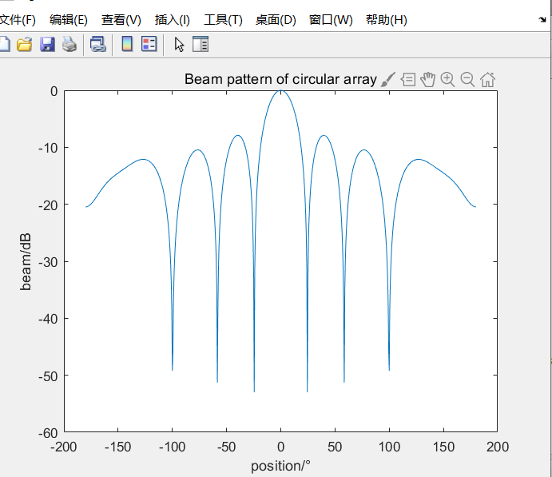

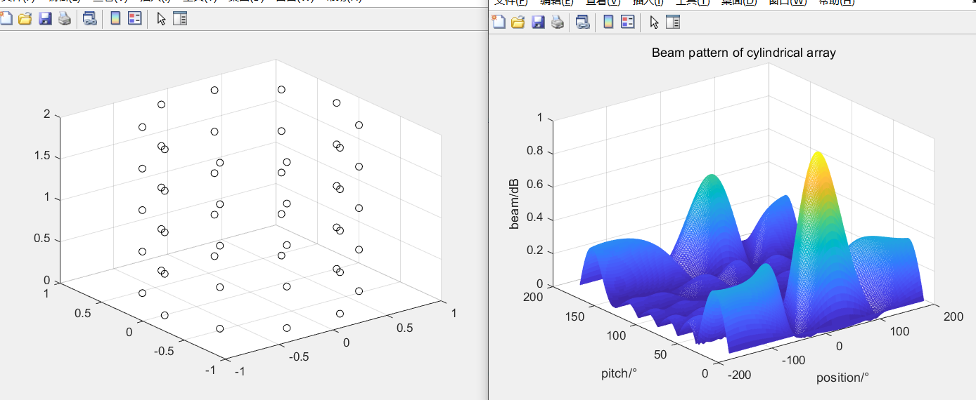

Multi level 3D images were reconstructed from k-space data p20480.7.

The header size is: 145908 bytes p20480.7

Data is stored as complex integers (16 bits): real + imaginary

Store one echo after another, one slice after another, in series.

The data is filled into four boards (one board represents one echo (one TE)), and the size of each board is 256 x 256 x 32.

In this way, we can get the k-space data before and after the image reconstruction.i=imread('aql.bmp');

figure(1);

imshow(i);

title('安琪拉');

t=rgb2gray(i);

j=fft2(t);%进行FFT变换

f=fftshift(j);%进行K空间的修正（可忽略）

f=log(abs(f)+1);%取模值

The pixels in k-space are filled with vectors. We may see a four-dimensional graph, so we take the modulus (absolute value) of K space to get a visual image.

We transform this gray image into FFT (the results of FFT and IFFT are the same), so we can get the k-space data before and after image reconstruction.

i=imread(' aql.bmp ).

figure(1);

imshow(i);

Title ('angela ');

t=rgb2gray(i);

J = FFT 2 (T);%

F = fftshift (J);% for k-space correction (negligible

F = log (ABS (f) + 1);% modulus value

The pixels in k-space are filled with vectors. We may see a four-dimensional graph, so we take the modulus (absolute value) of K space to get a visual image.

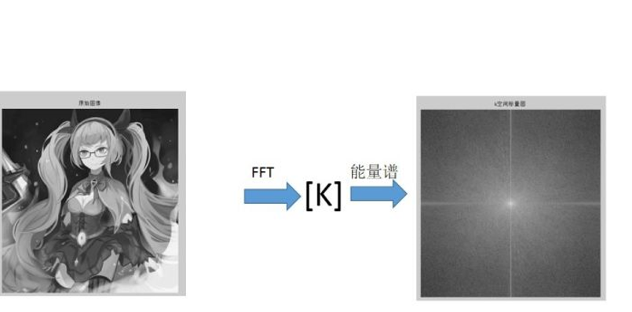

In the past textbooks, the following picture often appears, which shows that K space can be converted into images.

However, the modulus value can not represent the real state of the K space, and the angle (phase) of the vector is lost when taking the modulus value, so the desired image can not be transformed by using energy spectrum. Therefore, the schematic diagram in the previous textbooks can only be used for illustration, not the real K space.

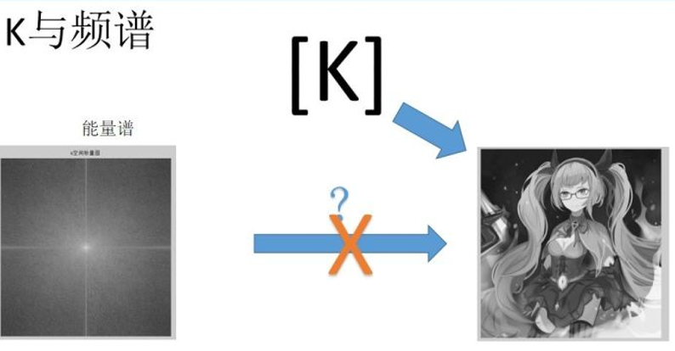



K space in the unit is vector, high school mathematics in learning complex, the teacher told us, vector can be used

In MRI, θ is related to the application of gradient, θ = γ GT, γ is a constant, G is the intensity of gradient and t is the time of gradient application.

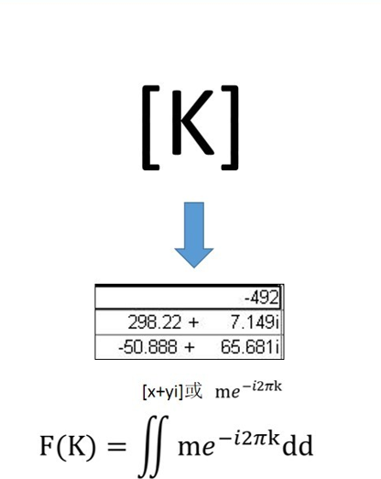 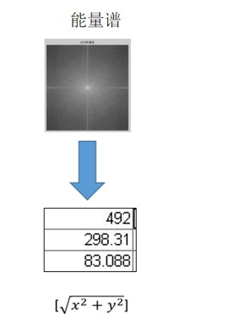

If the elements in K space are quadratically integrated in two directions: real part (frequency coding) and imaginary part (phase coding), an unexpected answer is obtained.

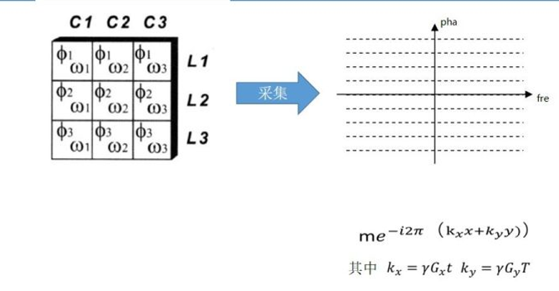

Here's the answer:

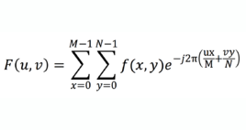

When the wireless power is turned off, the protons will return to their original undisturbed state (aligned with the magnetic field), and in the process emit radio waves, which are received by the receiving coil. Different tissues relax at different rates. For example, fat and water have different relaxation times, so relaxation time can reveal the type of tissue being imaged. There are two relaxation times that can be measured; T1 - the time taken for the magnetic line to relax and T2 - the time taken for the rotation to return to rest.

Multiple radio pulse sequences can be used to highlight or suppress certain tissue types. For example, there is usually no abnormality within the fat, so the fat suppression pulse sequence can be used to remove the signals from the adipose tissue, leaving only the signals from the areas more likely to contain the abnormalities.

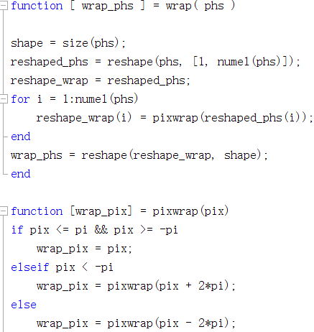

%The inclusion phase angle is in the range of [- pi, PI];

%Input parameters:

%PHS: original phase angle

%Output parameters:

%Wrapping phase angle

