


QNX 7.0 BSP
For R-Car M3 Platforms
User’s Manual: Software
64

R-Car M3

— Preliminary —

All information contained in these materials, including products and product specifications, represents information on the product at the time of publication and is subject to change by Renesas Electronics Corp. without notice. Please review the latest information published by Renesas Electronics Corp. through various means, including the Renesas Technology Corp. website (http://www.renesas.com).

www.renesas.com
Rev.1.00 Mar 2017
Notice
- All information included in this document is current as of the date this document is issued. Such information, however, is subject to change without any prior notice. Before purchasing or using any Renesas Electronics products listed herein, please confirm the latest product information with a Renesas Electronics sales office. Also, please pay regular and careful attention to additional and different information to be disclosed by Renesas Electronics such as that disclosed through our website.
- Renesas Electronics does not assume any liability for infringement of patents, copyrights, or other intellectual property rights of third parties by or arising from the use of Renesas Electronics products or technical information described in this document. No license, express, implied or otherwise, is granted hereby under any patents, copyrights or other intellectual property rights of Renesas Electronics or others.
- You should not alter, modify, copy, or otherwise misappropriate any Renesas Electronics product, whether in whole or in part.
- Descriptions of circuits, software and other related information in this document are provided only to illustrate the operation of semiconductor products and application examples. You are fully responsible for the incorporation of these circuits, software, and information in the design of your equipment. Renesas Electronics assumes no responsibility for any losses incurred by you or third parties arising from the use of these circuits, software, or information.
- When exporting the products or technology described in this document, you should comply with the applicable export control laws and regulations and follow the procedures required by such laws and regulations. You should not use Renesas Electronics products or the technology described in this document for any purpose relating to military applications or use by the military, including but not limited to the development of weapons of mass destruction. Renesas Electronics products and technology may not be used for or incorporated into any products or systems whose manufacture, use, or sale is prohibited under any applicable domestic or foreign laws or regulations.
- Renesas Electronics has used reasonable care in preparing the information included in this document, but Renesas Electronics does not warrant that such information is error free. Renesas Electronics assumes no liability whatsoever for any damages incurred by you resulting from errors in or omissions from the information included herein.
- Renesas Electronics products are classified according to the following three quality grades: “Standard”, “High Quality”, and “Specific”. The recommended applications for each Renesas Electronics product depends on the product’s quality grade, as indicated below. You must check the quality grade of each Renesas Electronics product before using it in a particular application. You may not use any Renesas Electronics product for any application categorized as “Specific” without the prior written consent of Renesas Electronics. Further, you may not use any Renesas Electronics product for any application for which it is not intended without the prior written consent of Renesas Electronics. Renesas Electronics shall not be in any way liable for any damages or losses incurred by you or third parties arising from the use of any Renesas Electronics product for an application categorized as “Specific” or for which the product is not intended where you have failed to obtain the prior written consent of Renesas Electronics. The quality grade of each Renesas Electronics product is “Standard” unless otherwise expressly specified in a Renesas Electronics data sheets or data books, etc.
“Standard”: Computers; office equipment; communications equipment; test and measurement equipment; audio and visual equipment; home electronic appliances; machine tools; personal electronic equipment; and industrial robots.
“High Quality”: Transportation equipment (automobiles, trains, ships, etc.); traffic control systems; anti-disaster systems; anticrime systems; safety equipment; and medical equipment not specifically designed for life support.
“Specific”: Aircraft; aerospace equipment; submersible repeaters; nuclear reactor control systems; medical equipment or systems for life support (e.g. artificial life support devices or systems), surgical implantations, or healthcare intervention (e.g. excision, etc.), and any other applications or purposes that pose a direct threat to human life.
- You should use the Renesas Electronics products described in this document within the range specified by Renesas Electronics, especially with respect to the maximum rating, operating supply voltage range, movement power voltage range, heat radiation characteristics, installation and other product characteristics. Renesas Electronics shall have no liability for malfunctions or damages arising out of the use of Renesas Electronics products beyond such specified ranges.
- Although Renesas Electronics endeavors to improve the quality and reliability of its products, semiconductor products have specific characteristics such as the occurrence of failure at a certain rate and malfunctions under certain use conditions. Further, Renesas Electronics products are not subject to radiation resistance design. Please be sure to implement safety measures to guard them against the possibility of physical injury, and injury or damage caused by fire in the event of the failure of a Renesas Electronics product, such as safety design for hardware and software including but not limited to redundancy, fire control and malfunction prevention, appropriate treatment for aging degradation or any other appropriate measures. Because the evaluation of microcomputer software alone is very difficult, please evaluate the safety of the final products or system manufactured by you.
- Please contact a Renesas Electronics sales office for details as to environmental matters such as the environmental compatibility of each Renesas Electronics product. Please use Renesas Electronics products in compliance with all applicable laws and regulations that regulate the inclusion or use of controlled substances, including without limitation, the EU RoHS Directive. Renesas Electronics assumes no liability for damages or losses occurring as a result of your noncompliance with applicable laws and regulations.
- This document may not be reproduced or duplicated, in any form, in whole or in part, without prior written consent of Renesas Electronics.
- Please contact a Renesas Electronics sales office if you have any questions regarding the information contained in this document or Renesas Electronics products, or if you have any other inquiries.
(Note 1) “Renesas Electronics” as used in this document means Renesas Electronics Corporation and also includes its majority-owned subsidiaries.
(Note 2) “Renesas Electronics product(s)” means any product developed or manufactured by or for Renesas Electronics.

Trademark
- Linux® is a registered trademark or a trademark of Linus Torvalds in the United States and/or other countries.
- ARM® is a registered trademark or a trademark of ARM Company in the United States and/or other countries.
- QNX and Neutrino are registered trademarks of QNX Software Systems Ltd. in certain jurisdictions.
- Windows and Windows Media are registered trademarks of Microsoft Corporation in the United States and other countries.
- Other company names and product names mentioned herein are registered trademarks or trademarks of their respective owners.
- Registered trademark and trademark symbols (® and ™) are omitted in this document

How to Use This Manual

[Readers]
This manual is intended for engineers who develop products which use the R-Car M3 processor.
[Purpose]
This manual is intended to give users an understanding of building, booting up QNX 7.0 OS on R-Car M3 processor and verifying device drivers and to serve as a reference for developing software for systems that use this BSP.
[How to Read This Manual]
It is assumed that the readers of this manual have general knowledge in the fields of electrical engineering, microcontrollers, Linux, and QNX.
→ Read this manual in the order of the CONTENTS.
To understand the functions of a device driver for R-Car M3
→ See the R-Car M3 driver Manual.
To know the electrical specifications of processor for R-Car M3
→ See the R-Car M3 Data Sheet.
[Conventions]
The following symbols are used in this manual.
Data significance: Higher digits on the left and lower digits on the right
Note: Footnote for item marked with Note in the text
Caution: Information requiring particular attention
Remark: Supplementary information
Numeric representation: Binary ... ××××, 0b××××, or ××××B
Decimal ... ××××
Hexadecimal ... 0x×××× or ××××H
Data type: Double word ... 64 bits
Word … 32 bits
Half word ... 16 bits
Byte ... 8 bits

Table of Contents
1. Overview 1
1.1 Features 1
1.2 Scope 1
1.3 Target System 1
1.4 List of Abbreviations and Acronym 2
1.5 Environmental Requirement 2
2. Quick Startup Guide 3
2.1 Requisite 3
2.1.1 Hardware 3
2.1.2 Software 3
2.2 Steps to run QNX 7.0 OS image 3
3. Building QNX 7.0 OS Image 7
3.1 Requisite 7
3.1.1 For Linux Host 7
3.1.2 For Windows Host 7
3.2 Build Mode 7
3.2.1 Single CPU Mode 7
3.2.2 Multi CPU mode 7
3.2.3 Specifying unique MAC address for QNX network driver 7
3.3 Build BSP 8
4. Memory Map 9
5. Write QNX Image To R-Car M3 Salvator-X board 13
5.1 Hardware setup 13
5.2 Write Bootparam, Loader and U-Boot to Hyper Flash 14
5.2.1 Boot files information 14
5.2.2 Dip-Switch 14
5.2.3 Write Bootparam, Loader and U-Boot to Hyper Flash 15
5.3 Download QNX image to RAM 16
5.3.1 Scope 16
5.3.2 Requisite 16
5.3.3 Procedures for writing OS image to RAM using U-boot commands 17
6. Write QNX Image To R-Car M3 StarterKit Board 19
6.1 Hardware setup 19
6.2 Download QNX image to RAM 20
6.2.1 Scope 20
6.2.2 Requisite 20
6.2.3 Procedures for writing OS image to RAM using U-boot commands 21
7. Test drivers 23
7.1 Network 23
7.2 I2C 24
7.2.1 Start Driver 24
7.2.2 Test Driver 24
7.3 Hyper Flash 25
7.3.1 Start Driver 25
7.3.2 Create Flash file system partition 25
7.3.3 Restart driver 25
7.4 USB Driver 25
7.4.1 USB 2.0 Host 25
7.4.2 USB 3.0 Host (Salvator-X Only) 26
7.4.3 USB 2.0 Function (Salvator-X Only) 27
7.5 Audio Driver 28
7.5.1 Test Specifications 28
7.5.1.1 Test overview 28
7.5.1.2 Equipment and Software use 31
7.5.1.3 Test Items 31
7.5.2 Test Procedure 31
7.5.2.1 Playback 31
7.5.2.2 Recording 32
7.6 SD Card Driver 32
7.6.1 Start/stop the driver 32
7.6.2 Write data 34
7.6.3 Read data 34
7.7 MMC Driver 34
7.7.1 Start/stop the driver 34
7.7.2 Write data 37
7.7.3 Read data 37
7.8 Watchdog Timer 38
7.9 VIN capture library (Salvator-X only) 38
7.10 Display driver 39
7.10.1 Start/stop the driver 39
7.10.2 Test driver 39

LIST OF FIGURES
Figure 2-1: Serial log after power-on 4
Figure 2-2 Boot up using u-boot commands 5
Figure 2-3 HDMI monitor displays 6
Figure 4-1 Memory map for useable storages 9
Figure 4-2 Boot Memory map (u-boot boot mode) 10
Figure 4-3 Boot memory map (IPL boot mode) 11
Figure 4-4 QNX RAM Memory map (when QNX is running) 12
Figure 5-1 Serial port setup 13
Figure 5-2 Recommended Environment setup 13
Figure 5-3 U-boot 17
Figure 5-4 QNX 7.0 boot up log 18
Figure 6-1 Serial port setup 19
Figure 6-2 Recommended Environment setup 19
Figure 6-3 U-boot 21
Figure 6-4 QNX 7.0 boot up log 22
Figure 7-1 I2C test 24
Figure 7-2 USB device details 27

LIST OF TABLES

Table 1-1 Environment Requirement 2
Table 5-1 Bootloader files 14
Table 5-2 QSPI mode setting 14
Table 5-3 Hyper Flash mode setting 14
Table 6-1 QSPI mode setting 20
Table 7-1 driver options 28
Table 7-2 Audio file format 31
Table 7-3 Audio test items 31
Table 7-4 Audio record command's options 32
Table 7-5 Describes all display which Display driver supports 39

Overview

Features
This document describes the procedures for reproducing QNX 7.0 image for R-Car M3 platforms and testing drivers on R-Car M3 platforms (Salvator-X and StarterKit boards).
In the case of V.0.0.1 BSP, below drivers/libraries/utilities are supported.
- Startup
- Serial driver
- Audio driver
- Network driver
- I2C driver
- SD Card driver
- DMA libraries
- MMC driver
- SATA driver
- Display driver
- USB 2.0 function driver
- USB 2.0, USB3.0 host driver
- Hyper Flash driver
- Libraries: DMA library, Video Capture library, imr
- Utilities: camera_ctrl, i2c-control
- Support: resource_seed, wdtkick-rcar

Scope
This document scope applies to the evaluation of reproducing QNX 7.0 image and testing QNX BSP drivers for R-Car M3 platforms.

Target System
- Target platform: R-Car M3 platforms (Salvator-X and StarterKit boards) by Renesas Electronics Corporation.
- Target software: QNX SDP 7.0.

List of Abbreviations and Acronym
Abbreviation | Full Form
BSP | Board Support Package
DMA | Direct Memory Access
SDP | Software Development Package
I2C | Inter-Integrated Circuit
SD | Secure Digital
eMMC | embedded Multi Media Card

Environmental Requirement
Table 1-1 Environment Requirement
Equipment | Explanation
Linux Host PC (Optional) | Ubuntu 12.04 LTS is recommended as OS  It is used as building and debugging environment  It is used as TFTP server
Windows Host PC | Windows 7 or XP are recommended as OS  It is used as building and debugging environment.  It is used as TFTP server  Terminal software and VCP driver are executed.
QNX 7.0 SDP SP1 | Install QNX 7.0 SDP SP1 on Windows host if Windows host is used to build.  Install QNX 7.0 SDP SP1 on Linux host if Linux host is used to build.  Please contact to QSSL
Terminal software | Please use one of below software.  1) Hyperterm (included in Windows XP)  2) TeraTerm (prefer latest version)  3) Terminal (included in QNX Momentics IDE)
Virtual Com Port driver | Please install in Windows Host PC.  Execute CP210x_VCP_Win_XP_S2K3_Vista_7.exe to install USB to COM driver. USB becomes virtual COM port on terminal software. Please connect to CN25 (Serial-USB Bridge CP2102) on M3 Solution Board.  (Available at  http://www.silabs.com/products/mcu/Pages/USBtoUARTBridgeVCPDrivers.aspx)
TFTP server software | It is used to download QNX image via U-boot.  It is reference to use TFTP Server built in QNX Momentics IDE.

Quick Startup Guide
This section describes steps needed to run QNX image on R-Car M3 reference platforms.

Requisite

Hardware
- SD card (or MicroSD Card)
- Micro-USB cable for debug
- HDMI monitor and HDMI cable, preferably Lilliput monitor
- Speaker set (optional)
- Microphone (optional)
- USB memory stick (optional)
- Ethernet cable
- Hard disk (optional)

Software
- QNX 7.0 binary image ifs-rcarm3-<board_name>.bin (ifs-rcarm3-starterkit.bin or ifs-rcarm3-salvatorx.bin). If not available, please follow section 3 for how to compile and build it.
- Bootparam, Loader, ARM Trusted Firmware and U-Boot (refer to table 5.1) are already flashed in Hyper Flash. If not available, please follow section 5.2 & 5.3 to build and write those boot files to Hyper Flash.

Steps to run QNX 7.0 OS image
- Prepare a SD Card with FAT32 format then copy ifs-rcarm3-<board_name>.bin image to it.
- Insert the SD Card into CN13 or CN14 on Salvator-X board (or CN6 on StarterKit board). Then connect necessary hardware e.g., micro-USB cable, HDMI monitor, speakers, etc. For detail information, please refer section 5.1 and section 7.
- Check the DIP switch settings are as per DIP switch settings in section 5.3.2 for Salvator-X board (or table 6-1 for StarterKit board).
- Start serial terminal program. For detailed information, please refer section 5.1 for Salvator-X board (or section 6.1 for StarterKit board).
- Power ON the board. From serial terminal program on PC, you will see loader, ARM Trusted Firmware and u-boot be running as below:
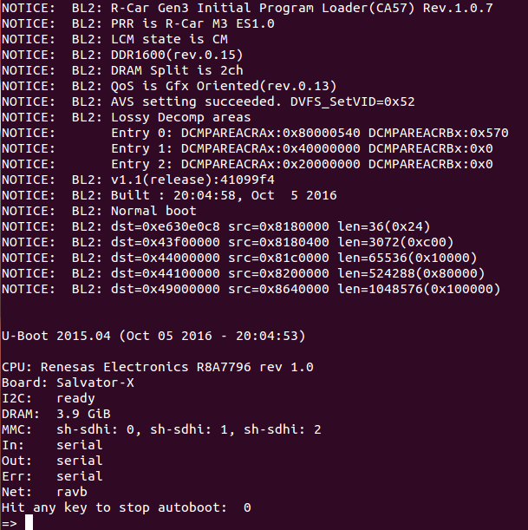
Figure 2-1: Serial log after power-on
- Quickly hit any key on u-boot console then u-boot is ready for input commands. Quickly hitting time is normally within 3 seconds but depends on bootdelay value.
- Run below commands to set and save u-boot environment variables. Those commands will download and run QNX image from SD card.
=> setenv load_run_qnx_sd 'fatload mmc [n] 0x40100000 ifs-rcarm3-<board_name>.bin; go 0x40100000' (CN13 n=0, CN14 n=2 on Salvator-X board, or CN6 n=0 on StarterKit board)
=> setenv bootcmd 'run load_run_qnx_sd'
=> saveenv
- Reset the board and now u-boot copies QNX from SD card to RAM and runs it.
- After QNX boots up, you will see the log in serial as below:
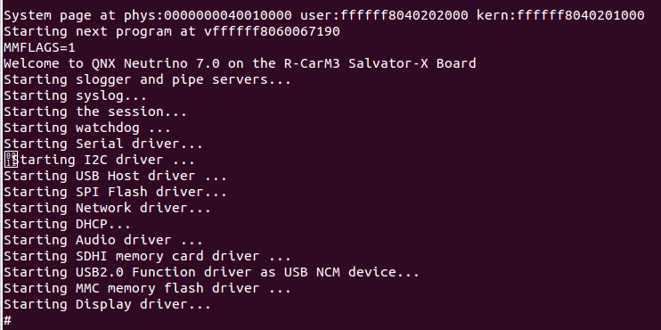
Figure 2-2 Boot up using u-boot commands

- HDMI monitor displays as below:
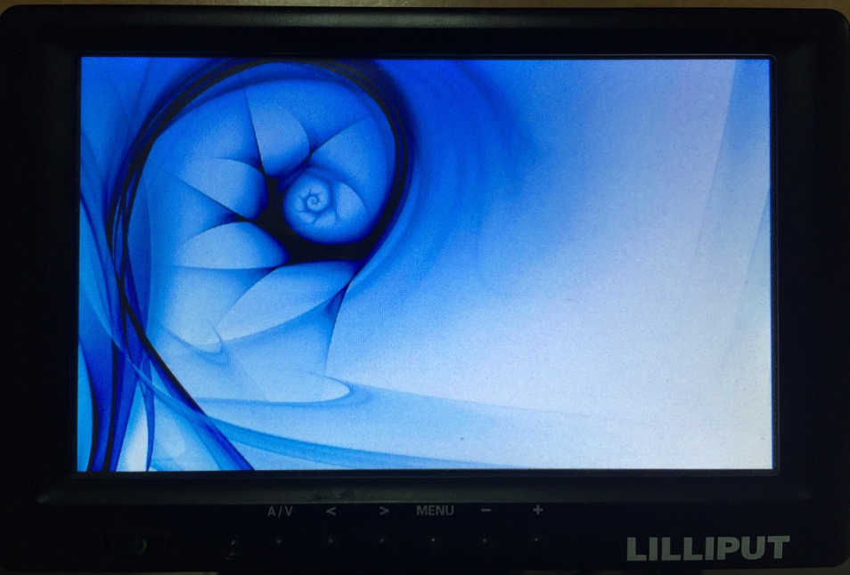
Figure 2-3 HDMI monitor displays

Please look into the section 5 and section 6 of this setup manual to run QNX image using various other methods

Building QNX 7.0 OS Image

Requisite

For Linux Host
- Extract QNX 7.0 BSP for R-Car M3 board (filename: R_CarM3_qnx7_bsp_y_m_d.zip) to a folder on Linux Host PC (e.g., /tmp/R_CarM3_qnx7_bsp_y_m_d)
Note: y, m, d is the release date of the current BSP you’re using.
- QNX SDP 7 package installed on Linux Host PC.

For Windows Host
  - Extract QNX 7.0 BSP for R-Car M3 board (filename: R_CarM3_qnx7_bsp_y_m_d.zip) to a folder on Windows Host PC (e.g., C:/R_CarM3_qnx7_bsp_y_m_d)
Note: y, m, d is the release date of the current BSP you’re using.
- QNX SDP 700 package installed on Windows Host PC.

Build Mode

Single CPU Mode
This mode is used for running QNX image on single CPU mode.
Open “build” file at …/src/hardware/startup/boards/ rcarm3/<board_name>/build, set number of CPUs argument to 1 in startup command.
startup-rcarm3-<board_name> -P <N> -W #(Note: N = number of CPUs. It MUST be 1 for Single CPU mode)

Multi CPU mode
This mode is used for running QNX image on multi CPU mode (maximum 4 CPUs)
Open “build” file at …/src/hardware/startup/boards/rcarm3/<board_name>/build, set number of CPUs argument to <N> in startup command if you want to boot up QNX image on <N> CPUs. Currently, maximum of CPUs can be set is 4.
startup-rcarm3-<board_name> -P <N> -W #(Note: N = number of CPUs. It may be 1, 2, 3 or 4)
Currently, R-Car M3 SoC supports maximum 2 cores Cortex-A57 and 4 cores Cortex-A53.

Specifying unique MAC address for QNX network driver
This mode is used for running QNX image with specified unique MAC address.
Open “build” file at ../R_CarM3_qnx7_bsp_y_m_d/src/hardware/startup/boards/ rcarm3/<board_name>/build, and change the network driver launch command as below:
io-pkt-v6-hc -dravb mac=2e090a00830c, -ptcpip pkt_typed_mem=below4G &
Set MAC address for QNX image by changing “mac” argument with unique value.

Build BSP
For Linux environment
- Make sure build configuration file was already configured as section 3.2.
- To generate the QNX image for R-CarM3 boards, run the following commands from the terminal console on Linux host.
$ cd <QNX_BSP_Root_Directory>
If you are not root user, then run: $sudo bash
$ source <QNX_700_Installed_Directory>/qnx700-env.sh
(Default is /opt/qnx700/qnx700-env.sh)
$ make clean; make all
For Windows environment
- Make sure build configuration file was already configured as section 3.2.
- To generate the QNX image for R-Car M3 boards, run the following commands from the terminal console on Windows host.
- Move to QNX 7.0 Installed Directory and set up environment by running qnx700-env.bat file
C:\qnx700\qnx700-env.bat
- Change to BSP root directory and make QNX image
C:\ R_CarM3_qnx7_bsp_y_m_d>bash
# make clean; make

Memory Map
The following figures show memory map of R-Car M3 QNX 7.0 BSP package.
Note:
- The volume of SDRAM is total 4GB.
- The following regions are used as secure regions. It doesn’t allow U-Boot and kernel to access those regions:
- 63MB from 0x00_43F0_0000 to 0x00_47DF_FFFF is used as a secure region.
- 8KB from 0x00_E630_0000 to 0x00_E630_1FFF in System RAM.
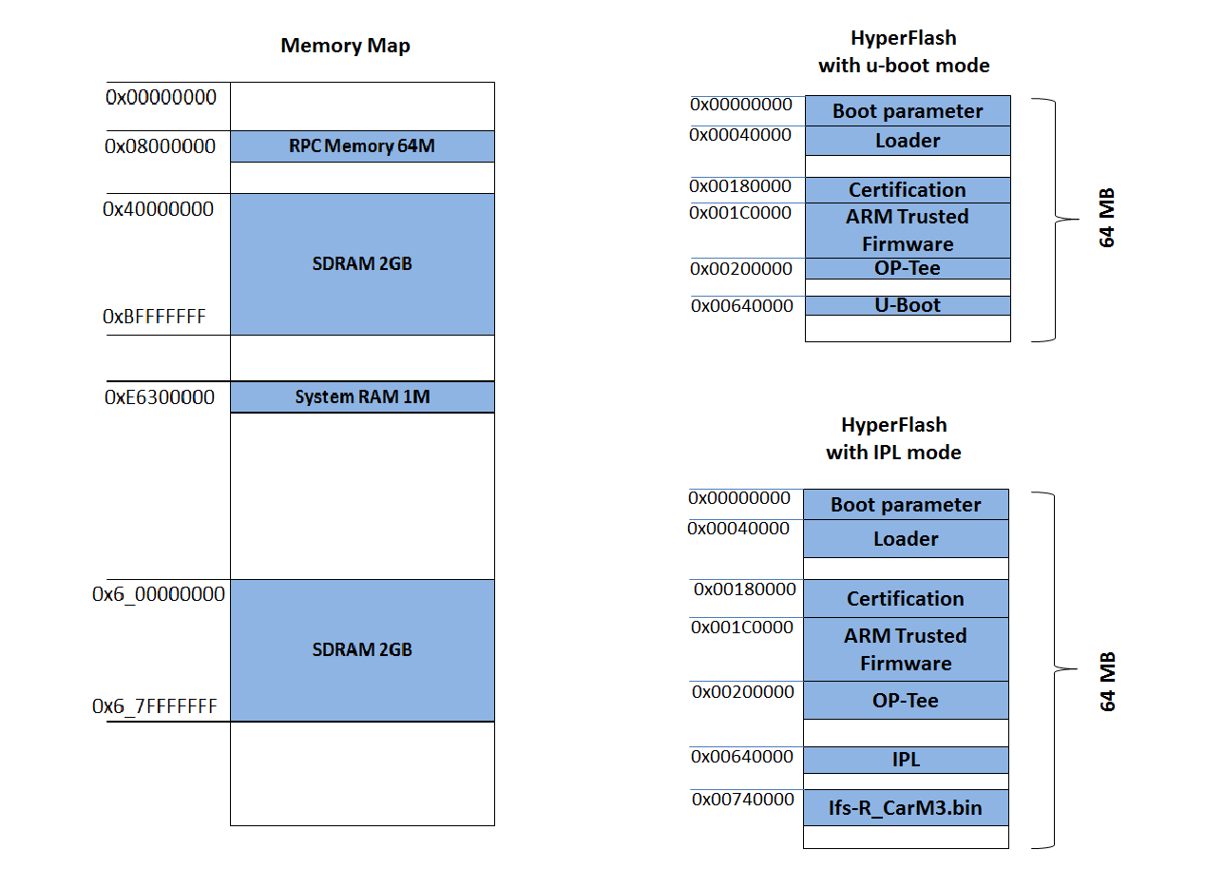
Figure 4-4 Memory map for useable storages

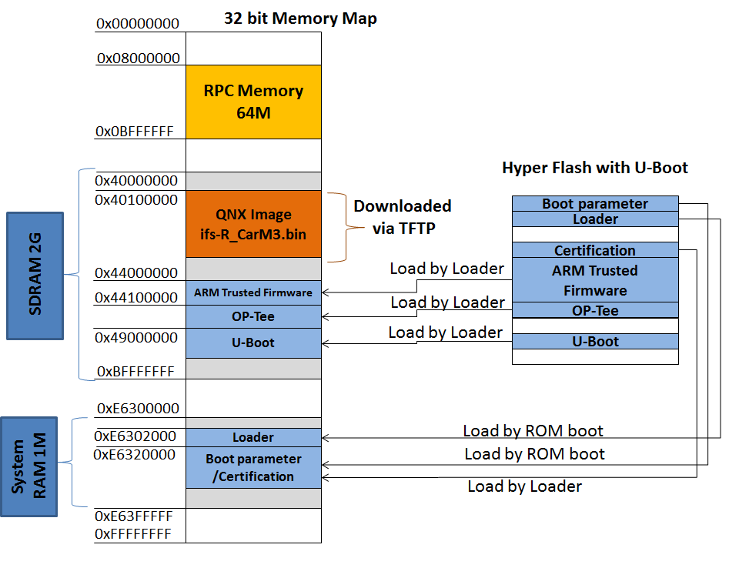
Figure 4-5 Boot Memory map (u-boot boot mode)
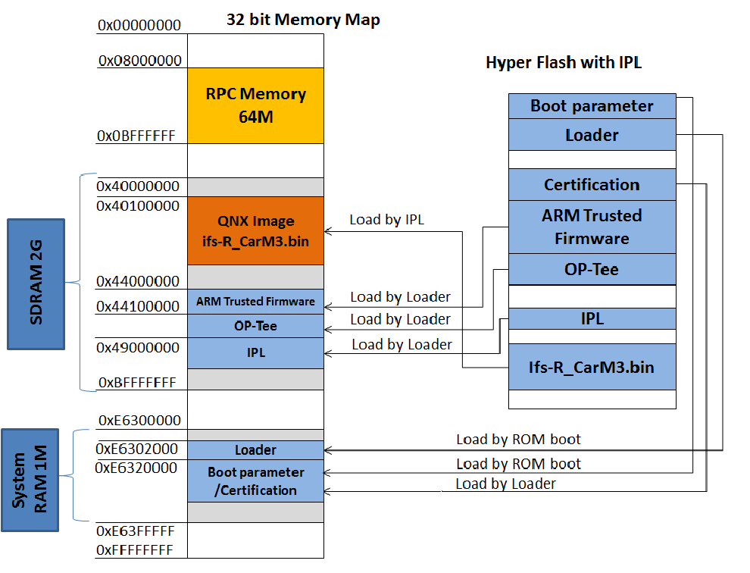
Figure 4-6 Boot memory map (IPL boot mode)

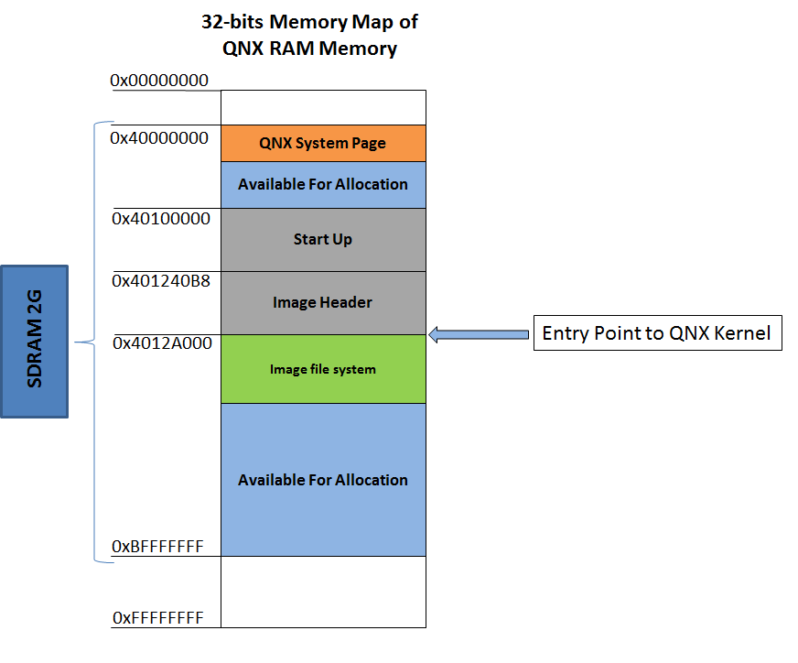
Figure 4-7 QNX RAM Memory map (when QNX is running)

Write QNX Image To R-Car M3 Salvator-X board

Hardware setup
- Start terminal console program on PC host (e.g., Tera Term). Assume that we’re using COM1 port.
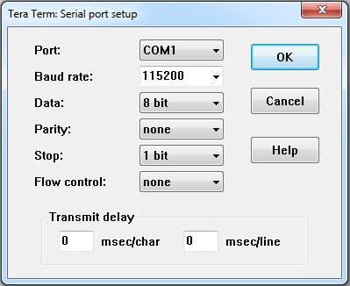
Figure 5-8 Serial port setup
- Connect micro-USB cable to micro USB port (CN25) and to PC.
- Connect Network connector (CN22) to your network.
- Recommended Environment
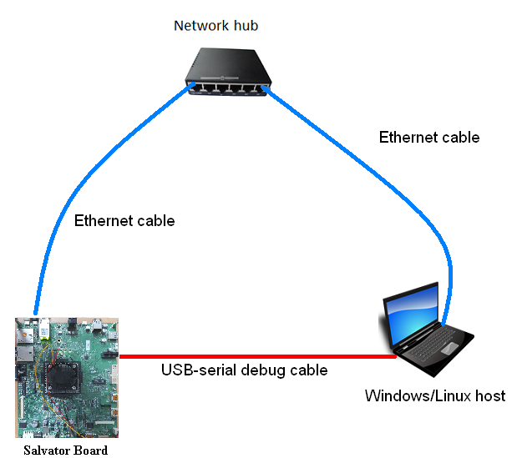
Figure 5-9 Recommended Environment setup

Write Bootparam, Loader and U-Boot to Hyper Flash

Boot files information
Table 5-2 Bootloader files
Filename | Program Top Address | Flash Save Address | Description
bootparam_sa0.srec | 0xE6320000 | 0x000000 | Loader(Boot parameter)
bl2-<board_name>.srec | 0xE6302000 | 0x040000 | Loader
cert_header_sa6.srec | 0xE6320000 | 0x180000 | Loader(Certification)
bl31-<board_name>.srec | 0x44000000 | 0x1C0000 | ARM Trusted Firmware
tee-<board_name>.srec | 0x44100000 | 0x200000 | OP-Tee
u-boot-elf.srec | 0x49000000 | 0x640000 | U-boot
Note: Please contact a Renesas Electronics sales office about bootparam_sa0.srec file.

Dip-Switch
- QSPI Mode
Table 5-3 QSPI mode setting
Switch Number | Switch Name | SoC version | Pin1 | Pin2 | Pin3 | Pin4 | Pin5 | Pin6 | Pin7 | Pin8
SW1 | QSPI-A | - | ON | ON | ON | ON | ON | ON | - | -
SW2 | QSPI-B | - | ON | ON | ON | ON | ON | ON | - | -
SW3 | QSPI-C | - | OFF |  | - | - | - | - | - | -
SW10 | MODESW-A | ES 1.0 | ON | ON | OFF | ON | ON | OFF | ON | ON

- Hyper Flash Mode
Table 5-4 Hyper Flash mode setting
Switch Number | Switch name | SoC version | Pin1 | Pin2 | Pin3 | Pin4 | Pin5 | Pin6 | Pin7 | Pin8
SW1 | QSPI-A | - | OFF | OFF | OFF | OFF | OFF | OFF | - | -
SW2 | QSPI-B | - | OFF | OFF | OFF | OFF | OFF | OFF | - | -
SW3 | QSPI-C | - | ON |  | - | - | - | - | - | -
SW10 | MODESW-A | ES 1.0 | ON | ON | ON | ON | ON | ON | OFF | OFF

- AArch64 Mode
Table 5.4 AArch64 mode setting
Switch Number | Switch name | SoC version | Pin1 | Pin2 | Pin3 | Pin4 | Pin5 | Pin6 | Pin7 | Pin8
SW12 | MODESW-C | ES 1.0 | OFF | ON | ON | ON | ON | ON | ON | ON

Write Bootparam, Loader and U-Boot to Hyper Flash
The following procedure is used to write Bootparam, Loader and U-Boot to Hyper Flash on R-Car M3 Salvator-X board.
Set DIP switch “QSPI” & “AArch64” mode (refer to table 5.2 & 5.4).
Reset board then start Mini Monitor.
Set Dip switch (Select Hyper Flash)
SW1: ALL OFF
SW2: ALL OFF
SW3: ON
SW10: does not need to change
Execute "xls2" command (load program to flash).
Select HyperFlash. Input “3”.
After "SW1 SW2 All OFF! Setting OK? (Push Y key)" is displayed, input "y".
After "SW3 ON! Setting OK? (Push Y key)" is displayed, input "y".
After "Please Input Program Top Address" is displayed, input Program Top Address of bootparam_sa0.srec in table 5.1 (H’E6320000) and "Enter".
After "Please Input Qspi/HyperFlash Save Address" is displayed, input Flash Save Address of bootparam_sa0.srec in table 5.1 (e.g., H’000000) and "Enter".
After "Please send ! ('.' & CR stop load)" is displayed, In case of Tera Term, transmit boot parameter file (bootparam_sa0.srec) by "file -> file transmission(S)".
If there are some data in writing area, "SPI Data Clear(H'FF) Check :H'00000000-0003FFFF Clear OK?(y/n)" is displayed. Then input "y".
After "SAVE SPI-FLASH ....... complete!" is displayed, the prompt returns. It means finish.
Please repeat the xls2 command to write other files to Hyper Flash.
Power OFF
Set dip switch to “Hyper Flash” and “AArch64” Mode (refer to table 5.3 & 5.4).

Download QNX image to RAM

Scope
This section scope applies for downloading QNX image to RAM on board using u-boot TFTP command.

Requisite
Host PC installed a TFTP server (such as tftpd32 from http://tftpd32.jounin.net). Or Linux host configured as TFTP server.
Refer to section 3.3 “Build the BSP” to configure and build the BSP.
Copy “ifs-rcarm3-salvatorx.bin” to TFTP server folder on Host PC.
Launch TFTP server on Windows Host PC, select path to “ifs-rcarm3-salvatorx.bin” image file.
Or Start TFTP server on Linux Host, if TFTP server on Linux host is used.
Set dip switch to “Hyper Flash” and AArch64” mode (refer to table 5.3 & 5.4).

Procedures for writing OS image to RAM using U-boot commands
Figure 5-10 U-boot
Reset R-Car M3 Salvator-X board.
U-boot will come up. Hit any key to abort autoboot.
Set environment variables:
- Set MAC address for R-Car M3 Salvator-X board
=>set ethaddr 2e:09:0a:00:83:0c (depend on the sticker on Ethernet port CN22)
- Set the server IP (IP address of Windows PC run TFTP server) and client IP (the IP address of R-Car M3 Salvator-X board):
=>setenv serverip <serverip>
=>setenv ipaddr <boardip>
- Set the image file name to be downloaded
=>setenv bootfile ifs-rcarm3-salvatorx.bin
- Set the start address of RAM to load image
=>setenv loadaddr 0x40100000
- Download the QNX image to RAM
=>tftp
- Start QNX image
=>go 0x40100000
QNX 7.0 will start up on the board.
Figure 5-11 QNX 7.0 boot up log

Write QNX Image To R-Car M3 StarterKit Board

Hardware setup
- Start terminal console program on PC host (e.g., Tera Term). Assume that we’re using COM1 port.
Figure 6-12 Serial port setup
- Connect micro-USB cable to micro USB port (CN12) and to PC.
- Connect Network connector (CN7) to your network.
- Recommended Environment
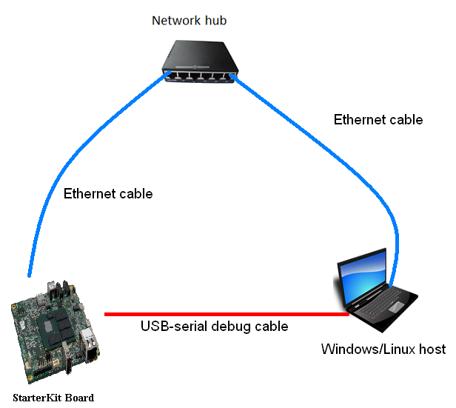
Figure 6-13 Recommended Environment setup

- Dip-Switch
Table 6-5 QSPI mode setting
Switch Number | Switch Name | Pin1 | Pin2 | Pin3 | Pin4
SW1 | QSPI/Hyper Flash SW | ON | - | - | -
SW2 | SOFTSW | OFF | OFF | OFF | OFF
SW6 | MODESW | OFF | OFF | ON | ON
JP1 | QSPI SEL | ON | ON | OFF | ON

Download QNX image to RAM

Scope
This section scope applies for downloading QNX image to RAM on board using u-boot TFTP command.

Requisite
Host PC installed a TFTP server (such as tftpd32 from http://tftpd32.jounin.net). Or Linux host configured as TFTP server.
Refer to section 3.3 “Build the BSP” to configure and build the BSP.
Copy “ifs-rcarm3-starterkit.bin” to TFTP server folder on Host PC.
Launch TFTP server on Windows Host PC, select path to “ifs-rcarm3-starterkit.bin” image file.
Or Start TFTP server on Linux Host, if TFTP server on Linux host is used.
Set dip-switch following the table 6-1.

Procedures for writing OS image to RAM using U-boot commands
Figure 6-14 U-boot
Reset R-Car M3 StarterKit board.
U-boot will come up. Hit any key to abort autoboot.
Set environment variables:
- Set MAC address for R-Car M3 StarterKit board
=>set ethaddr 2e:09:0a:00:83:0c (depend on the sticker on Ethernet port CN7)
- Set the server IP (IP address of Windows PC run TFTP server) and client IP (the IP address of R-Car M3 StarterKit board):
=>setenv serverip <serverip>
=>setenv ipaddr <boardip>
- Set the image file name to be downloaded
=>setenv bootfile ifs-rcarm3-starterkit.bin
- Set the start address of RAM to load image
=>setenv loadaddr 0x40100000
- Download the QNX image to RAM
=>tftp
- Start QNX image
=>go 0x40100000
QNX 7.0 will start up on the board.
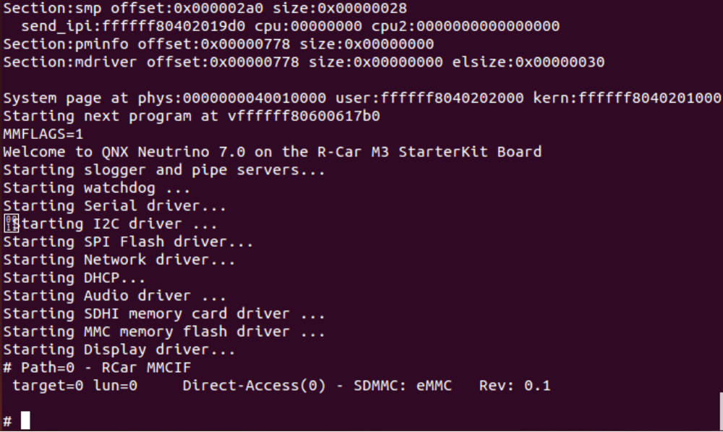
Figure 6-15 QNX 7.0 boot up log

Test drivers

Network
- List all running processes to check whether network is running or not:
# pidin a
pid Arguments
…
12298 io-pkt-v6-hc -dravb mac=020060005200, -ptcpip pkt_typed_mem=below4G
40971 dhclient -nw -lf /tmp/dhclient.leases ravb0
…
#
- If network driver has not run yet, run it by command (using IPv6 networking manager)
# io-pkt-v6-hc -dravb mac=020060005200, -ptcpip pkt_typed_mem=below4G &
If dhcp client has not run yet, run it by
# dhclient -nw -lf /tmp/dhclient.leases ravb0
- View IP address configured by DHCP server
# ifconfig
lo0: flags=8049<UP,LOOPBACK,RUNNING,MULTICAST> mtu 33136
inet 127.0.0.1 netmask 0xff000000
inet6 ::1 prefixlen 128
inet6 fe80::1%lo0 prefixlen 64 scopeid 0x1
ravb0: flags=8a43<UP,BROADCAST,RUNNING,ALLMULTI,SIMPLEX,MULTICAST> mtu 1500
address: 2e:09:0a:00:83:0c
media: Ethernet autoselect (1000baseT full-duplex,flowcontrol)
status: active
inet 10.20.14.68 netmask 0xffffff00 broadcast 10.20.14.255
inet6 fe80::2c09:aff:fe00:830c%ravb0 prefixlen 64 scopeid 0x11
- If IP address is available, test your driver by send echo packets to your server machine.
# ping 10.20.14.10
PING 10.20.14.1 (10.20.14.1): 56 data bytes
64 bytes from 10.20.14.1: icmp_seq=0 ttl=255 time=6 ms
64 bytes from 10.20.14.1: icmp_seq=1 ttl=255 time=0 ms
64 bytes from 10.20.14.1: icmp_seq=2 ttl=255 time=0 ms
64 bytes from 10.20.14.1: icmp_seq=3 ttl=255 time=0 ms
64 bytes from 10.20.14.1: icmp_seq=4 ttl=255 time=0 ms
----10.20.14.1 PING Statistics----
5 packets transmitted, 5 packets received, 0% packet loss
round-trip min/avg/max = 0/0/6 ms variance = 3 ms^2

I2C

Start Driver
- Start driver if it has not run:
# i2c-rcar-A –p<port_address> -i<interrupt_number> --u<unit_number>
e.g., i2c-rcar-A -p0xE6518000 -i320 --u1

Test Driver
- Run command as below:
# i2c-control device=<device name> slave=<slave address> count=<number> data=<data> subaddr=<sub-address> speed=<bus speed> mode=<write/read> <-v>
Option:
- Device name: the path of i2c driver that you want to open. Ex: “/dev/i2c4”.
- Slave address: the address of device.
- Count: number of bytes to be read.
- Data: bytes to be written. In read mode, data byte is accepted 1 byte for sub-address.
- Mode: write or read: mode for write or read data.
- Speed: set bus speed (accept from 50000 to 400000).
- -v : show log and print read data.
Example: Use i2c-control to read from and write to the Versarclock5 5P49V5923A (slave address = 0x6A):
- Write data to the Versarclock5 with format data: data=data0:data1: … :dataN and subaddr=<sub-address>. Write memory address (sub-address = 0x10) and 4 bytes data to the Versarclock5:
# i2c-control device="/dev/i2c4" slave=0x6A data=02:03:0f:01 subaddr=0x10 speed=400000 mode=write -v
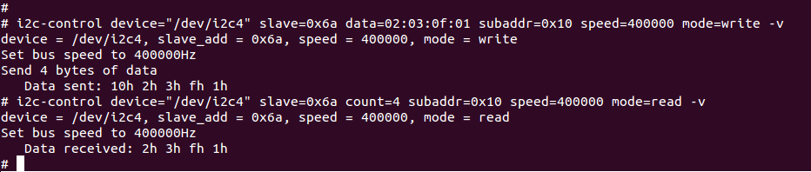
Figure 7-16 I2C test

Hyper Flash

Start Driver
- Start Hyper Flash driver if it was not started automatically when boot up QNX image.
# devf-rcar_qspi

Create Flash file system partition
- Use “flashctl” utility to create/erase/format SPI flash partition. Commands/options are as follows:
# flashctl –p <partition_path> -o <offset> -e –f -v
-e : erase partition
-f : format partition
-v : verbose
- Requisite
Use command “ls /dev/fs0*” to know how many partitions present. Then erase all of those partitions (except the primary partition (fs0p0)) by using below command:
# flashctl –p /dev/fs0p1 -ev
# flashctl -p /dev/fs0p2 -ev
After that, restart SPI Flash driver. We’ll have only one partition (fs0p0).
# slay devf-rcar_qspi
# devf-rcar_qspi &
- Divide Partition
We divide flash disk (fs0) to 2 partitions, the primary partition (dev/fs0p0 with size is 32MB) stores bootparam,SPI loader and u-boot/QNX image. The 2nd partition (dev/fs0p1 with size is 32MB) is for other purposes.
# flashctl -p /dev/fs0 -o 32M -ev
# flashctl -p /dev/fs0p0 -o 32M -fv

Restart driver
- Restart the driver we will have /dev/fs0p1 partition.
# slay devf-rcar_qspi
# devf-rcar_qspi

USB Driver

USB 2.0 Host
When testing USB 2.0 host on StarterKit board, it doesn’t need to set dip-switch setting. In the following procedure, dip-switch setting only applies for Salvator-X board.

- Change SW15 to 1-side to test USB 2.0 host on channel 0.
- Test USB 2.0 host (EHCI)
- If io-usb or devb-umass is running, kill it
# slay io-usb
# slay devb-umass
- Then start EHCI driver:
# io-usb -t memory=/memory/below4G -dehci ioport=0xEE080100,irq=0x8C,\
ioport=0xEE0A0100,irq=0x90,memory=/memory/below4G
- Start mass storage service:
# devb-umass blk noatime,commit=none,maxio=256,cache=10m cam pnp\
mem name=/memory/below4G &
- Plug a USB stick in CN9/CN10A on Salvator-X board (or CN5 on StarterKit board). Mount and test read/write speed:
# mount –tdos /dev/hdXtY /usb
# cp –V /usb/filename /tmp (Read data from USB)
# cp –V /tmp/filename /usb (Write data to USB)
Note:
Replace hdXtY with the actual USB device node created in /dev/.
Slay io-usb function before using USB host with CN9 connector (Salvator-X board) if it is running.
- Test USB 2.0 host (OHCI)
- If io-usb or devb-umass is running, kill it
# slay io-usb
# slay devb-umass
- Start OHCI driver:
# io-usb -t memory=/memory/below4G -dohci ioport=0xEE080000,irq=0x8C,\
ioport=0xEE0A0000,irq=0x90,ioport=0xEE0C0000,irq=0x91,memory=/memory/below4G
- Start mass storage service:
# devb-umass blk noatime,commit=none,maxio=256,cache=10m cam pnp\
mem name=/memory/below4G &
- Plug a USB stick in CN9/CN10A (or CN5 on StarterKit board). Mount and test read/write speed:
# mount –tdos /dev/hdXtY /usb
# cp –V /usb/filename /tmp (Read data from USB)
# cp –V /tmp/filename /usb (Write data to USB)
Note: Replace hdXtY with the actual USB device node created in /dev/.

USB 3.0 Host (Salvator-X Only)
- Test USB 3.0 host (XHCI)
- If io-usb or devb-umass is running, kill it
# slay io-usb
# slay devb-umass
- Start XHCI driver:
# io-usb –dxhci ioport=0xEE000000,irq=0x86,memory=/memory/below4G

- Start mass storage service:
# devb-umass blk noatime,commit=none,maxio=256,cache=10m cam pnp mem name=/memory/below4G &
- Plug a USB 3.0 stick in CN11. Verify USB port speed by running the command below and checking “Upstream Port Speed” property is “Super Speed”:
# usb -vvv
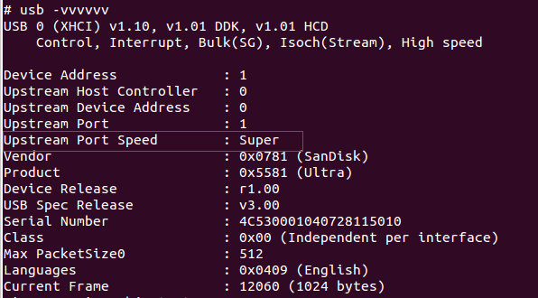
Figure 7-17 USB device details
- Mount and test read/write speed:
# mount –tdos /dev/hdXtY /usb
# cp –V /usb/filename /tmp (Read data from USB)
# cp –V /tmp/filename /usb (Write data to USB)
Note: Replace hdXtY with the actual USB device node created in /dev/.

USB 2.0 Function (Salvator-X Only)
- Please make sure SW15 is on middle side (2-side)
- Connect USB port CN9 on the board with a Ubuntu PC
- If io-usb-dcd is running on the board, kill it
# slay io-usb-dcd
- Then run commands as follows.
# io-usb-dcd -n /dev/otg/io-usb-dcd -d usbncm-hsusb-rcar ioport=0xe6590000,\
irq=139,verbose=10
# mount -Tio-pkt -o verbose=0,path=/dev/otg/io-usb-dcd,protocol=ncm,usbdnet_mac=000022446688,mac=020022446688 devnp-usbdnet.so
# ifconfig ncm0 192.168.0.1
# ulink_ctrl -l 1 -s /dev/otg/io-usb-dcd

- On Ubuntu PC, open Terminal. From Terminal, type “ifconfig -a” to see all network interfaces. Interface “usb0” which represents for USB NCM interface with the board, will appear.
usb0 Link encap:Ethernet HWaddr 00:00:22:44:66:88
inet6 addr: fe80::200:22ff:fe44:6688/64 Scope:Link
UP BROADCAST RUNNING MULTICAST MTU:1500 Metric:1
RX packets:0 errors:0 dropped:0 overruns:0 frame:0
TX packets:25 errors:0 dropped:0 overruns:0 carrier:0
collisions:0 txqueuelen:1000
RX bytes:0 (0.0 B) TX
- Set IP address for “usb0” interface, then try “ping” command to verify data transfer between board and PC.
# ifconfig usb0 192.168.0.2
# ping 192.168.0.1
PING 10.20.14.12 (10.20.14.12) 56(84) bytes of data.
64 bytes from 192.168.0.1: icmp_seq=1 ttl=255 time=1.70 ms
64 bytes from 192.168.0.1: icmp_seq=2 ttl=255 time=1.75 ms
64 bytes from 192.168.0.1: icmp_seq=3 ttl=255 time=1.73 ms

Audio Driver
Audio driver implements all SSI channels. With board, SSI0 and SSI1 are connecting to AK4613VQ CODEC, SSI0 for playback and SSI1 for recording. We can specify HDMI channel used to input audio data.

Test Specifications

Test overview
- To make sure that playback and record processes of audio driver meet its specifications, we need the following applications/utilities:
- A PCM player can play wave & mp3 files
- A PCM recorder can record sound/our voice.
- Launch audio driver
# io-audio -d rcar-ssi [driver options]
Table 7-6 driver options
No | Option | Description
1 | scu=<value> | Specify SCU module used or not, SCU is used by default.  - value=1: SCU is used.  - value=0: SCU is not used.
2 | tx_ssi_num=<value> | Specify SSI channel number used for playback(Single or multi-channel SSI will be specified):  - value=1 or 3 or 4 (by default tx_ssi_num=1)  3 or 4 SSI channels for transmission and reception cannot coexists. But only be able to hear all channels of multi-channel SSI via HDMI in multi-channel SSI transmission.
3 | rx_ssi_num=<value> | Specify SSI channel number used for record (Single or multi-channel SSI will be specified):  - value=1 or 3 or 4 (by default rx_ssi_num=1)  3 or 4 SSI channels for transmission and reception cannot coexists. But Board doesn’t support multi-channel SSI reception.
4 | tx_ssi_idx=<value> | Specify SSI channel index (from 0 to 9) used in playback if Single SSI (tx_ssi_num=1) is specified in #2. Only SSI0 is routed to input of AK4613, but SSI0 to SSI9 can be specified to route to HDMI controller. SSI0 is used by default.
5 | rx_ssi_idx=<value> | Specify SSI channel index (from 0 to 9) in record if Single SSI (rx_ssi_num=1) is specified in #3. Only SSI1 is routed to output of AK4613. SSI1 is used by default.
6 | tx_ssi_mode=<value> | Specify transmission SSI mode:  - value=master : Transmission SSI will output clock signals (by default).  - value=slave : Transmission SSI will input clock signals.
7 | rx_ssi_mode=<value> | Specify reception SSI mode:  - value=master : Reception SSI will output clock signals (by default).  - value=slave : Reception SSI will input clock signals.
8 | tx_voices=<value> | Specify maximum number of playback voices. 2 or 6 or 8 voices will be specified. 2 (stereo) is specified by default.
9 | rx_voices=<value> | Specify maximum number of record voices. 2 or 6 or 8 voices will be specified. 2 (stereo) is specified by default.
10 | tx_bus_format=<value> | Specify bus format for playback:  - value=i2s : Stereo/ multi-channel format (by default)  - value=tdm : TDM format  - value=mono : monaural format
11 | rx_bus_format=<value> | Specify bus format for record:  - value=i2s : Stereo/ multi-channel format (by default)  - value=tdm : TDM format  - value=mono : monaural format
12 | tx_pin_mode=<value> | Specify clock and WS pin mode for playback:  - value=0 : Use pins independently (by default)  - value=1 : Use common pins with another SSI  - value=2 : Use common pins with another SSI and another SSI in master
13 | rx_pin_mode=<value> | Specify clock and WS pins mode for record:  - value=0 : Use pins independently  - value=1 : Use common pins with another SSI  - value=2 : Use common pins with another SSI and another SSI in master (by default)
14 | tx_sample_size=<value> | Specify sample size of bytes for playback. 2 is specified by default.
15 | rx_sample_size=<value> | Specify sample size of bytes for record. 2 is specified by default.
16 | tx_data_align=<value> | Specify data align for playback:  - value=left_align : Left align  - value=right_align : Right align (by default)
17 | rx_data_align=<value> | Specify data align for playback:  - value=left_align : Left align (by default)  - value=right_align : Right align
18 | tx_tdm_mode=<value> | Specify TDM mode for playback if TDM format (tx_bus_format=tdm) is specified in #8:  - value=0 : TDM Extend Mode (by default)  - value=1 : TDM 16ch Mode  - value=2 : TDM Split Mode  - value=3 : TDM Ex-Split Mode
19 | rx_tdm_mode=<value> | Specify TDM mode for record if TDM format (rx_bus_format=tdm) is specified in #9:  - value=0 : TDM Extend Mode (by default)  - value=1 : TDM 16ch Mode  - value=2 : TDM Split Mode  - value=3 : TDM Ex-Split Mode
20 | tx_src_idx=<value> | Specify SCU-SRC channel index (from 0 to 9) used in playback if scu=1 is specified in #1. SRC0 is used by default.
21 | rx_src_idx=<value> | Specify SCU-SRC channel index (from 0 to 9) used in capture if scu=1 is specified in #1. SRC1 is used by default.
22 | tx_cmd_idx=<value> | Specify SCU-CMD channel index (from 0 to 1) used in playback if scu=1 is specified in #1. CMD0 is used by default.
23 | hdmi_idx=<value> | Specify HDMI channel index (from 0 to 1) used. HDMI0 is used by default.
24 | clock_scr=<value> | Specify clock source is used to create clock rates:  - value=internal : Use internal clock S0D4 200MHz  - value=external : Use external clock 22.5792MHz input to AUDIO_CLK_A pin (by default)

- Launch Example:
SSI0 for playback and SSI1 for record via AK4613 CODE:
# io-audio -d rcar-ak4613

Equipment and Software use
- Playback audio file
Table 7-7 Audio file format
Type | Format | File Name
AUDIO | WAVE, 8 kHz
AUDIO | WAVE, 11.025 kHz
AUDIO | WAVE, 16 kHz
AUDIO | WAVE, 22.050 kHz
AUDIO | WAVE, 32kHz
AUDIO | WAVE, 44.1 kHz
AUDIO | WAVE, 48 kHz
AUDIO | mp3
- Test programs (wave, waverec, mmrplay)
We can copy the audio files to a location under /tmp of the target.

Test Items
Table 7-8 Audio test items
No. | Test Item | Test Outline
1 | Playback test | Specify an audio file and make sure that the specified file is replayed.
2 | Record test | Perform recording and make sure that input audio is recorded.

Test Procedure

Playback
- Start audio driver to play/record as described in 6.3.1 (you need to kill io-audio process if it has been started in a different mode already)
- Connect a speaker/headphone to port CN24-Lower on Salvator-X board (or CN8 on StarterKit board).
- Start wave from the command line on the console. Specify the full path for the playback file as a wave argument.
- Check the sound from the speaker by hearing it.
Example: # wave /tmp/44k.wav
- To change volume during playing, focus the terminal window screen on the PC and then:
- Press key ‘q’ to increase left volume
- Press key ‘a’ to descrease left volume
- Press key ‘e’ to increase right volume
- Press key ‘d’ to descrease right volume
- Press key ‘w’to increase left and right volumes concurrently
- Press key ‘s’to descrease left and right volumes concurrently

Recording
- Start audio driver to playback/record as described in 6.4.1 (you need to kill io-audio process if it has been started in a different mode already).
- Connect a speaker/headphone to port CN24-Upper on Salvator-X board (or CN9 on StarterKit board).
- Start waverec from the command line on the console.
Example: # waverec /tmp/1
- To change volume during recording, focus the terminal window screen on the PC and then:
- Press key ‘q’ to increase left volume
- Press key ‘a’ to descrease left volume
- Press key ‘e’ to increase right volume
- Press key ‘d’ to descrease right volume
- Press key ‘w’to increase left and right volumes concurrently
- Press key ‘s’to descrease left and right volumes concurrently
Table 7-9 Audio record command's options
Argument | Description
-r <sampling rate> | Specifies the sampling rate (48000/44100/22050/11025). By default 44100 is used .
-8 | Specifies the 8-bit mode. By default, the 16-bit mode is used.
-a [card#:]<dev#> | Specifies the card number and device number for recording. By default, card 0 and device 0 is specified.
-m | Specifies the monaural recording. By default, the stereo recording is performed.
-t <time> | Specifies the recording time. By default, it is 5 seconds.

- Make sure that record data is created. Then, replay to check the recorded audio.

SD Card Driver

Start/stop the driver
- Start the driver
Start SD card driver if it is not started automatically when boot up QNX. From the console, run the driver as follows:
  - For Salvator-X board:
# devb-sdmmc-rcar_sdhi-salvatorx blk cache=2m cam pnp,bounce=128k mem name=below4G sdio idx=0
And
# devb-sdmmc-rcar_sdhi-salvatorx blk cache=2m cam pnp,bounce=128k mem name=below4G sdio idx=3
  - For StarterKit board:
# devb-sdmmc-rcar_sdhi-starterkit blk cache=2m cam pnp,bounce=128k mem name=below4G sdio idx=0
And
# devb-sdmmc-rcar_sdhi-starterkit blk cache=2m cam pnp,bounce=128k mem name=below4G sdio idx=3
After the driver started successfully, device nodes hdX and hdXtY - with X, Y varying depending on the SD card partition type and whether there is any other block devices are created in /dev/ or not. To check this “run ls /dev” as follows.
# ls dev
bpf mem ptyp7 stdout ttyp4
bpf0 null ramdisk0 tap ttyp5
console otg ramdisk0t77 tap0 ttyp6
crypto pipe screen tap1 ttyp7
dbgmem profiler sem tap2 tun0
hd0 ptyp0 ser1 tap3 tun1
hd0t12 ptyp1 shmem text tun2
i2c2 ptyp2 slog tty tun3
i2c4 ptyp3 snd ttyp0 tymem
io-usb ptyp4 socket ttyp1 zero
i2c4 ptyp5 stderr ttyp2
log ptyp6 stdin ttyp3
In above case, device node hd0 and hd0t12 is created in /dev/
Meaning of X and Y in device node hdXtY is as follows:
- X is device node index.
- Y is partition specifier on SD card.
The following is some partition specifier which QNX supports:
- DOS partition: 6, 11, 12
- QNX4 partition: 77, 78, 79
- QNX6 partition: 177, 178, 179
- Mount the SD card
From the console, “mount” a filesystem on the SD card as follows:
- DOS partition:
# mount –w –tdos /dev/hdXtY /sd
- QNX4 partition:
# mount –w –tqnx4 /dev/hdXtY /sd
- QNX6 partition:
# mount –w –tqnx6 /dev/hdXtY /sd
Replace hdXtY with the actual SD device node created in /dev/
Make sure that a folder with the mount name /sd is created using “ls”.
# ls
bin etc proc sd usr
dev lib sbin tmp var
- Un-mount the SD card
From the console, un-mount the SD card as follows:
# umount /sd
Make sure that the folder /sd disappeared.
- Stop the driver
From the console run command below to stop driver
# slay devb-sdmmc-rcar_sdhi
Make sure that the /dev/hdX and /dev/hdXtY disappeared using “ls /dev” and the devb-sdmmc-rcar_sdhi process is not listed using “pidin”.

Write data
- Start SD card driver
- Mount the SD card to a folder, for example /sd
- Copy a file to the /sd folder
# cp testfile /sd
Make sure that the file exists in SD card and the content of file is correct.

Read data
- Start SD card driver
- Mount the SD card to a folder, for example /sd
- Copy a file from the sd folder
# cp /sd/testfile /tmp
Make sure that the file exists in /tmp folder and file content is the same with original file from SD card.

MMC Driver

Start/stop the driver
- Start the driver
From the console, start the driver as follows if it is not started automatically when boot up QNX:
# devb-sdmmc-rcar_mmcif blk cache=2m cam bounce=128k mem name=below4G sdio idx=0
After the driver is started successfully, a device node hdX is created in /dev/ (X=0,1,2,…). To check this, from the console run “ls /dev” as follows:
# ls dev
bpf null ramdisk0 tap ttyp5
bpf0 otg ramdisk0t77 tap0 ttyp6
console pipe screen tap1 ttyp7
crypto profiler sem tap2 tun0
dbgmem ptyp0 ser1 tap3 tun1
hd0 ptyp1 shmem text tun2
i2c2 ptyp2 slog tty tun3
i2c4 ptyp3 snd ttyp0 tymem
io-usb ptyp4 socket ttyp1 zero
i2c4 ptyp5 stderr ttyp2
log ptyp6 stdin ttyp3
mem ptyp7 stdout
In above case, device node hd0 is created in /dev/
Note that: if partition(s) is (are) created partitions already, beside hdX, device node hdXtY is(are) created in /dev/
- Create partitions on eMMC flash
If partition(s) is (are) created already, you can skip this step, but if you want re-create partitions you should use “fdisk” to delete the existing partitions as below:
#fdisk /dev/hdX delete –a
Please note that, after using “fdisk” to delete the existing partitions, you need to stop and then start again the driver as told in step 1.
To create partitions on eMMC flash, using “fdisk” utility. The following is an example of creating a QNX4, QNX6 or DOS partition on eMMC flash with assuming device node hd0 is created in /dev/ after started the driver.
- QNX4 partition
#fdisk /dev/hd0 add -t 77
- QNX6 partition
#fdisk /dev/hd0 add -t 178
- DOS partition
#fdisk /dev/hd0 add -t 12
If you want to create a partition with size less than size of the flash, you use “-p” option. The following is example of creating a DOS partition and a QNX6 partition using “-p” option, each partition is 50% of the flash:
#fdisk /dev/hd0 add -t 11 –p 50
#fdisk /dev/hd0 add –t 178 –p 50
After run “fdisk”, you will see device node hd0t77 or hd0t178 or hd0t12 beside device node hd0 created in /dev/ and to check this you need to stop then start again the driver as told in step 1 and then “run ls /dev” as follows:
# ls dev
bpf mem ptyp7 stdout ttyp4
bpf0 null ramdisk0 tap ttyp5
console otg ramdisk0t77 tap0 ttyp6
crypto pipe screen tap1 ttyp7
dbgmem profiler sem tap2 tun0
hd0 ptyp0 ser1 tap3 tun1
hd0t178 ptyp1 shmem text tun2
i2c2 ptyp2 slog tty tun3
i2c4 ptyp3 snd ttyp0 tymem
io-usb ptyp4 socket ttyp1 zero
i2c4 ptyp5 stderr ttyp2
log ptyp6 stdin ttyp3
In above case, device node hd0t178 created in /dev/ after using “fdisk” to create a QNX6 partition.
- Format filesystem on the eMMC flash
After created partition, you need to format a filesystem on it.
- QNX4 partition: Use “dinit” to format a QNX4 filesyetem on QNX4 partitions. If “dinit” utility is not available, you need to copy it to /tmp folder. The following is example of formatting QNX4 partition which is created in step 2.
# dinit -h /dev/hd0t77
- QNX6 partition: Use “mkqnx6fs” to format a QNX6 filesystem on QNX6 partitions. If “mkqnx6fs” utility is not available, you need to copy it to /tmp folder. The following is example of formatting QNX6 partition which is created in step 2.
# mkqnx6fs /dev/hd0t178
- DOS partition: Use “mkdosfs” to format a DOS filesystem on DOS partitions. If “mkdosfs” utility is not available, you need to copy it to /tmp folder. The following is example of formatting DOS partition which is created in step 2.
# mkdosfs /dev/hd0t12
- Mount filessystem on the eMMC flash
To access a filessystem on the eMMC flash, you need to “mount” it. The following is example of mounting a filesystem on partition which created and formatted in step 2 and 3.
- QNX4 partition
# mount -w –tqnx4 /dev/hd0t77 /mmc
- QNX6 partition
# mount -w –tqnx6 /dev/hd0t178 /mmc
- DOS partition
# mount -w –tdos /dev/hd0t12 /mmc
Make sure that a folder with the mount name /mmc is created using “ls” command.
# ls
bin etc mmc sbin usr
dev lib proc tmp var
- Un-mount the filesystem on the eMMC flash
From the console, un-mount the filesystem on the eMMC flash as follows:
# umount /mmc
Make sure that the folder /mmc disappears.
- Stop the driver
From the console run command below to stop the driver
# slay devb-sdmmc-rcar_mmcif
Make sure that the /dev/hdX and /dev/hdXtY disappeared using “ls /dev” and the devb-sdmmc-rcar_mmcif process is not listed using “pidin”.

Write data
- Start MMC driver
- Create partition and format filesystem on eMMC flash
- Mount eMMC flash to /mmc folder
- Copy a file to the /mmc folder
# cp –V testfile /mmc
Use option –V to see speed of transfer to eMMC flash. Make sure that the file exists in eMMC flash and the content of file is correct.

Read data
- Start MMC driver
- Create partition and format filesystem on eMMC flash
- Mount eMMC flash to a folder, for example /mmc
- Copy a file from /mmc folder to /tmp folder
# cp –V /mmc/testfile /tmp
Use option –V to see speed of transfer from eMMC flash. Make sure that the file exists in /tmp folder and file content is the same with original file from the eMMC flash.

Watchdog Timer
- If Watchdog Counter becomes overflow then an internal reset will generated after 1 minute from start.
- If the Watchdog Counter is reset periodically, Watchdog Counter will not be overflow and a reset will not be generated.
- The Watchdog Timer is started at the time of starting QNX image. In order to test reset generated by the Watchdog Counter overflow, from console, run below command:
# kill <wdkick_process_id>
Waiting for about 1 minute a reset will occur and u-boot program or QNX OS is restarted.

VIN capture library (Salvator-X only)
- VIN1 support:
  - Connector: RCA
  - Video Interface: ITU-R BT.656
  - Video Standard: PAL/NTSC/SECAM
- VIN0 support:
  - Connector: HDMI
  - Video Interface: ITU-R BT.601/BT.709
  - Video Standard: 720x480p60, 1280x720p60, 1920x1080i60, 720(1440)x480i60, 720x576p50, 1280x720p50, 1920x1080i50, 720(1440)x576i50, 800x600(SVGA)@60, 640x480(VGA)@60, 800x480(WVGA)@60, 1024x768(XGA)@60
- When capture HDMI video from consumer electronic devices which require EDID (Extend Display Identification Data) such as laptop, preferred resolution is set to 1920x1080i60 and camera-ctrl application must be started before connecting HDMI cable. In case of using a HDMI Signal Generator, it is not necessary.
- To test the driver, please run command as below:
- For testing VIN0 on HDMI0 monitor
#camera_ctrl -display=1 -pipeline=5 -device=0 -bsize=[width]x[height] -size=[width]x[height]
- For testing VIN1 on HDMI0 monitor
#camera_ctrl -display=1 -pipeline=5 -device=1 -bsize=[width]x[height] -size=[width]x[height]

- For testing VIN0 on LVDS monitor
#camera_ctrl -display=2 -pipeline=1 -device=0 -bsize=[width]x[height] -size=[width]x[height]
- For testing VIN1 on LVDS monitor
#camera_ctrl -display=2 -pipeline=1 -device=1 -bsize=[width]x[height] -size=[width]x[height]

- For testing VIN0 on VGA monitor
#camera_ctrl -display=3 -pipeline=9 -device=0 -bsize=[width]x[height] -size=[width]x[height]
- For testing VIN1 on VGA monitor
#camera_ctrl -display=3 -pipeline=9 -device=1 -bsize=[width]x[height] -size=[width]x[height]

Note: Please press “Ctrl + C” key to exit “camera_ctrl” application test.

Display driver
Table 7-10 Describes all display which Display driver supports
Number | Type | DU | Pipeline | BSP configuration | Default resolution | Connector
 |  |  |  |  |  | Salvator-X | StaterKit
1 | HDMI0 | DU1 | 5^{*1}, 6, 7, 8 | Main display | 1920x1080 | CN16 | CN4
2 | LVDS | DU0 | 1^{*1}, 2, 3, 4 | Secondary display | 1280x800 | CN18 | X
3 | VGA | DU2 | 9^{*1}, 10, 11, 12 | Secondary display | 1280x720 | CN15 | X
Note:
*1: scaling pipeline

Start/stop the driver
If display driver has not run yet, run it by
#GRAPHICS_ROOT=/usr/lib/graphics/R_CarM3
#LD_LIBRARY_PATH=/usr/lib:/lib:/lib/dll:$LD_LIBRARY_PATH
#screen &
To stop the driver, use “kill <screen process ID>” or “slay screen” then make sure screen process has been terminated.

Test driver
- Connect LVDS monitor to port CN18.
- Connect VGA monitor to port CN15.
- Connect one HDMI monitor to CN16 (HDMI0)
- Make sure that screen has been started.
To each display, run sw-vsync with display=1 or 2 or 3
# sw-vsync –display=[1,2,3] –size=[width]x[height] &
To test scaling on LVDS monitor, run following command:
# yuv-test -format=nv12 -pipeline=1 -display=3 –size=[width]x[height] &
To test scaling on HDMI0 monitor, run following command:
# yuv-test -format=nv12 -pipeline=5 -display=1 –size=[width]x[height] &

REVISION HISTORY | QNX 7.0 BSP for R-Car M3 Platforms

Rev. | Date | Description
Rev. | Date | Page/Section | Summary
1.00 | Mar 3, 2017 | ⎯ | First Edition issued.

QNX 7.0 BSP for R-Car M3 Platforms
User's Manual: Software

Publication Date: | Rev.1.00 | Mar 3, 2017

Published by: Renesas Electronics Corporation

SALES OFFICES

http://www.renesas.com

Refer to "http://www.renesas.com/" for the latest and detailed information.

Renesas Electronics America Inc.
2801 Scott Boulevard Santa Clara, CA 95050-2554, U.S.A.
Tel: +1-408-588-6000, Fax: +1-408-588-6130
Renesas Electronics Canada Limited
1101 Nicholson Road, Newmarket, Ontario L3Y 9C3, Canada
Tel: +1-905-898-5441, Fax: +1-905-898-3220
Renesas Electronics Europe Limited
Dukes Meadow, Millboard Road, Bourne End, Buckinghamshire, SL8 5FH, U.K
Tel: +44-1628-651-700, Fax: +44-1628-651-804
Renesas Electronics Europe GmbH Arcadiastrasse 10, 40472 Düsseldorf, Germany Tel: +49-211-65030, Fax: +49-211-6503-1327
Renesas Electronics (China) Co., Ltd.
7th Floor, Quantum Plaza, No.27 ZhiChunLu Haidian District, Beijing 100083, P.R.China
Tel: +86-10-8235-1155, Fax: +86-10-8235-7679
Renesas Electronics (Shanghai) Co., Ltd.
Unit 204, 205, AZIA Center, No.1233 Lujiazui Ring Rd., Pudong District, Shanghai 200120, China
Tel: +86-21-5877-1818, Fax: +86-21-6887-7858 / -7898
Renesas Electronics Hong Kong Limited
Unit 1601-1613, 16/F., Tower 2, Grand Century Place, 193 Prince Edward Road West, Mongkok, Kowloon, Hong Kong
Tel: +852-2886-9318, Fax: +852 2886-9022/9044
Renesas Electronics Taiwan Co., Ltd.
13F, No. 363, Fu Shing North Road, Taipei, Taiwan
Tel: +886-2-8175-9600, Fax: +886 2-8175-9670
Renesas Electronics Singapore Pte. Ltd.
80 Bendemeer Road, Unit #06-02 Hyflux Innovation Centre Singapore 339949
Tel: +65-6213-0200, Fax: +65-6213-0300
Renesas Electronics Malaysia Sdn.Bhd.
Unit 906, Block B, Menara Amcorp, Amcorp Trade Centre, No. 18, Jln Persiaran Barat, 46050 Petaling Jaya, Selangor Darul Ehsan, Malaysia
Tel: +60-3-7955-9390, Fax: +60-3-7955-9510
Renesas Electronics Korea Co., Ltd.
11F., Samik Lavied' or Bldg., 720-2 Yeoksam-Dong, Kangnam-Ku, Seoul 135-080, Korea
Tel: +82-2-558-3737, Fax: +82-2-558-5141

© 2013 Renesas Electronics Corporation. All rights reserved.
Colophon 1.

QNX 7.0 BSP for R-Car M3 Platforms

