3 Methods Description and the results

* **3.2 Effeteness of Unsupervised machine learning (clustering) by observation**

As mentioned in the introduction section, clustering is one of the unsupervised machine learning method. This section will show the results for selecting facies, fluids, facies with fluids and wells separately. Noticeably, as human can only see the three or less than three dimensional things, all the results in this section are shown after lowering the dimension.

* 3.2.1 Selecting facies (PCA) (Single Well)

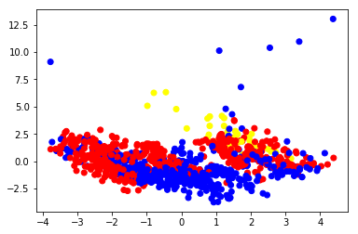

* 3.2.2 Selecting fluids (PCA) (Single Well)

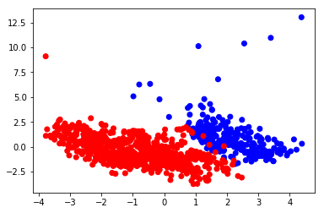

* 3.2.3 Selecting facies with fluids (PCA) (Single Well)

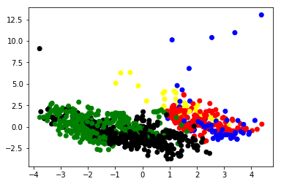

* 3.2.4 Selecting facies with fluids (PCA) (Multi Wells)

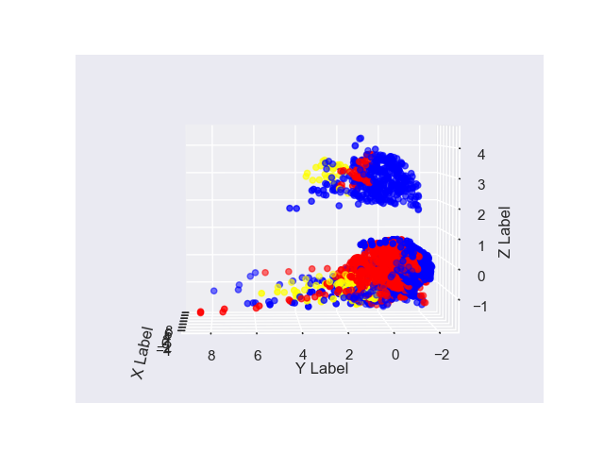

* 3.2.5 Selecting wells (PCA) (Multi Wells)

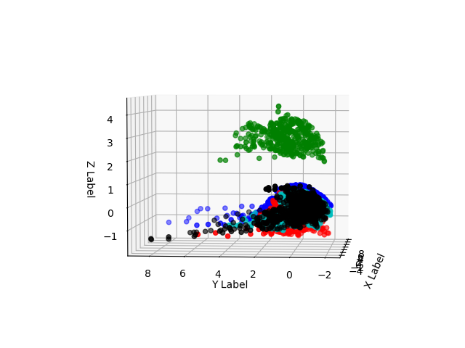

* 3.2.6 Selecting wells (PCA) (one More Multi Wells)

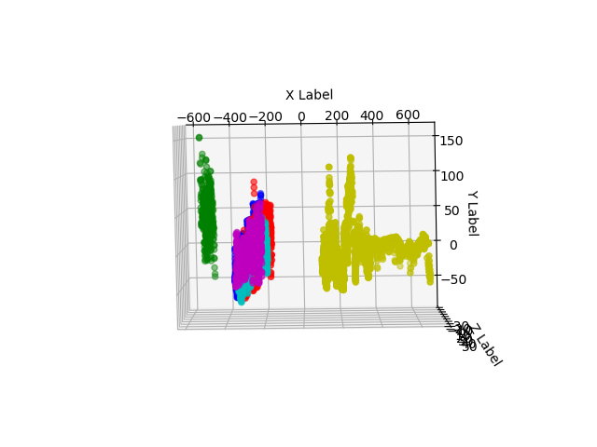

* **3.3 Clustering number selection (single well)**
* 3.3.1 Clustering number selection (by categories)
* 3.3.2 Clustering number selection (by the best K number)

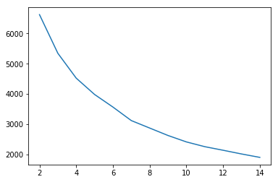

|  |  |  |  |  |  |  |  |  |  |
| --- | --- | --- | --- | --- | --- | --- | --- | --- | --- |
| Number | 2 | 3 | 4 | 5 | 6 | 7 | 8 | 9 | 10 |
| Score | 6624 | 5345 | 4523 | 3983 | 3566 | 3119 | 2872 | 2625 | 2413 |

* **3.1 Input data selection**

Different wells have different kinds of input well-log data for each depth unit. Those input data categories can help scientists to estimate the matter (facies or fluids) types for each depth unit. However, some of the input categories are useless or have less effeteness on matter type estimation. This section will focus on input data selection.

* **3.1.1 Single wells**
* 3.1.1.2 Input data correlations

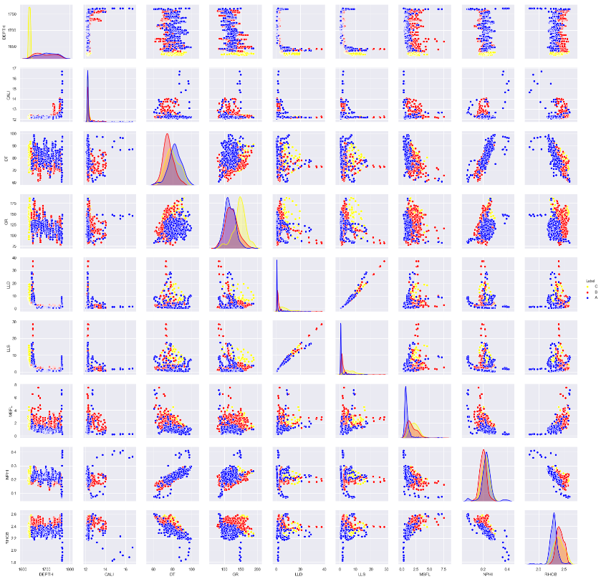

Figure 1.3.1 Input data correlations (single wells)

Figure 1.3.1 shows the correlations between each input category one by one. The color represents the different facies (Lacustrine and paleosol mud, floodplain mudstone and channel sandstone).

* 3.1.1.3 Logistic regression

|  |  |  |  |  |  |  |  |  |  |
| --- | --- | --- | --- | --- | --- | --- | --- | --- | --- |
|  | DEPTH | CALI | DT | GR | LLD | LLS | MSFL | NPHI | RHOB |
| Weights | 0.06540731 | -0.20490059 | -0.99202325 | 0.27874922 | 1.01387764 | -1.51442859 | 1.15717478 | -1.24748841 | -3.56451337 |
| Weights | 1.13719754 | -0.03029435 | 0.6867362 | 0.05459472 | 0.9444873 | -0.12385016 | -0.68960912 | 0.41124826 | 1.68873727 |
| Weights | -3.2547469 | 1.09666476 | 0.09938329 | 0.08917029 | -1.33224463 | 0.83745061 | 0.0253272 | 0.24571485 | 1.03975919 |

* **3.1.2 Multi wells**
* 3.1.2.1 Input data correlations (multi wells)

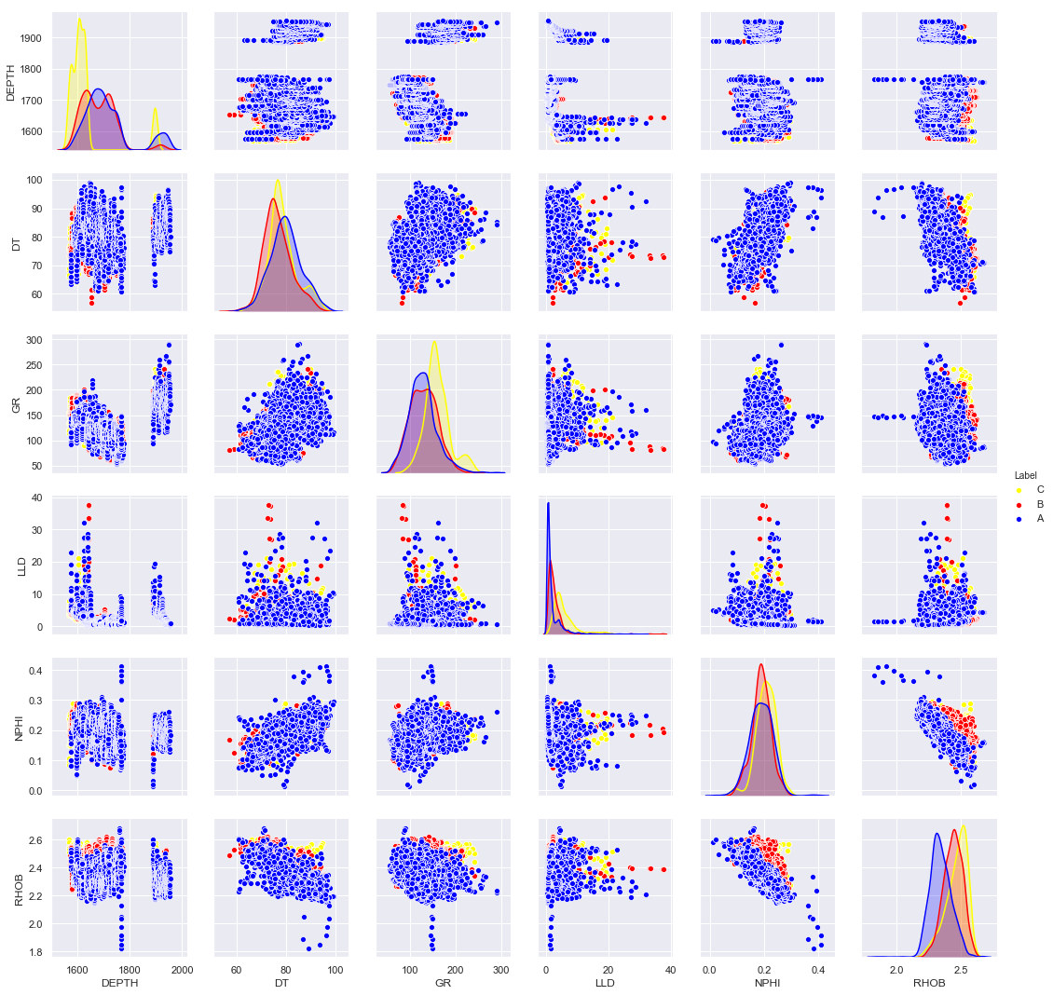

Figure 1.3.1 Input data correlations (5 multi wells)

* 3.1.2.2 Logistic regression

|  |  |  |  |  |  |  |
| --- | --- | --- | --- | --- | --- | --- |
|  | DEPTH | DT | GR | LLD | NPHI | RHOB |
| Weights | 0.36258517 | -0.11776839 | -0.0184775 | -0.19050506 | -2.63032929 | -4.02616705 |
| Weights | -0.09633896 | -0.08903942 | -0.23619461 | -0.06511261 | 1.26371285 | 1.94912398 |
| Weights | -0.95162169 | 0.12162854 | 1.19518554 | 0.61236001 | 0.48844301 | 1.46698523 |

* **3.4 Supervised learning for wells in same oil field**
* 3.4.1 logistic regression

|  |  |  |  |
| --- | --- | --- | --- |
|  | 2 | 3 | 6 |
| correctness | 1078 | 794 | 798 |

* 3.4.2 Improved Logistic regression

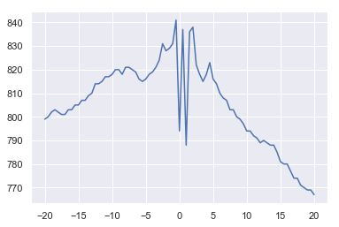

* 3.4.3 Fully connected layers (improvement of logistic regression)

|  |  |  |  |
| --- | --- | --- | --- |
|  | 2 | 3 | 6 |
| correctness | 1072 | 870 | 837 |

Discussion

Conclusion

Future work

## Abstract

## Introduction

### background

* 1. data
  2. methods
  3. Literature review