CP2406 ASSESSMENT 2

WORKING DOCUMENT

**Problem specification**

The problem is to create a traffic simulator according to traffic rules. The simulator needs to include vehicles, roads and traffic lights. You can change some settings of the simulator to simulate various situations.

**Problem decomposition using UML class diagram**

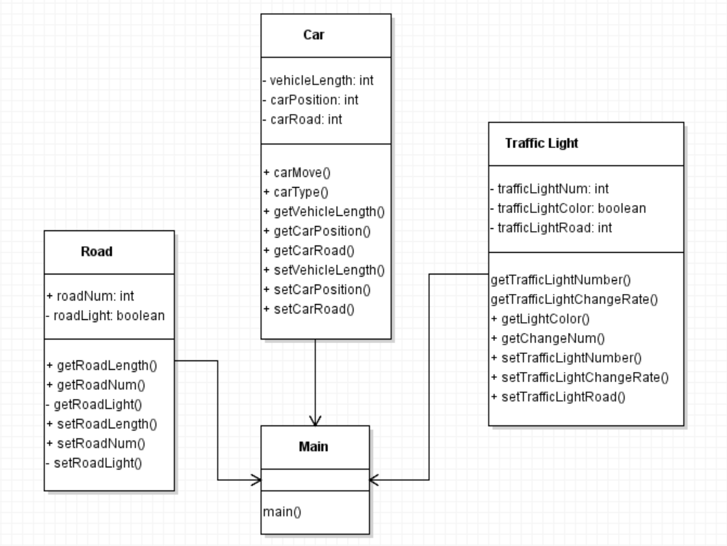

**Class Design**

- Main class

Main is a simulator, and other objects will be created under main. Mainly can control the car level, road level and traffic signal level. The main purpose is to collect all classes and let them interact directly to achieve the simulator effect.

- Car Class

Car objects move between one or two road objects. Use road segments to track their location. The class also adds a driving method that increases the position by one. It is public because the emulator calls it repeatedly.

-Road Class

Length is private so that other objects cannot change its value. A Road object is needed for each of the other classes to be simulated.

-Traffic Light Class

It will be public as Main class repeatedly calls this method. Traffic Light keeps track of its position which is taken by the last Road length segment. The Traffic Light class keeps track of the Road it is on, position and its signal to go.

**Method design:**

- Car Class

The Car class method can be used repeatedly in the simulator to make the Car object move. The method adds one to the position member field.

-Road Class

Length is private so that other objects cannot change its value.

-Traffic Light Class

The method in the Traffic Light class randomly changes the Boolean signal value based on a percentage. It can add to display a string output stating the colour of the traffic light based on Boolean values. In this scenario, true is green whereas false is red.

# **User Stories**

User Story 1

As for the user, I want to develop the simulator customization so I can edit the car, road, and length for that. Priority is high and estimate day is 3 days. For the testing, develop the new city map, add some street, and run the simulation.

User Story 2

As for the user, I want to keep my developed city to use again later so that I make sure not to disappear all of changes for my customized city. Priority is Medium and Estimate time is 2 days. For the testing, after changing the city, press the save button to save the city with name.

User Story 3

As for the user, I want to reload previous developed city to load simulation so that I can play simulation again with different situation like vehicles and rates.

Priority is Low and estimate time is 1 days. Testing is press open button to access the saved city from database.

User Story 4

As for the user, update vehicle rate when I run simulation so that I can control how many vehicles should place on the road. Priority is Medium and Estimate time is 2 days.

For the testing is click the update vehicle rate button to make vehicles faster or slower.

User Story 5

As for the user, I want the stop button to stop the simulator while moving vehicles on the road so that I can terminate running process of simulation. Priority is High and Estimate time is 2 days. For the testing is press stop button and watch all vehicle of termination.

User Story 6

As for the user, I want to avoid collision with other vehicles based on the distance from ahead vehicles so that I can run simulator without any problems.

Priority is High and Estimation time is 3 days. For the testing, watching vehicles carefully when program running simulation.

## **Developer User Stories**

Developer User story 1

As developer can add to change the light and traffic for the user. There are bus and motorbike for this car simulator. Priority is High and Estimate time is 3 days. For the testing, abstract the vehicles class and call some methods to move the cars.

Developer User Story 2

Developers can also stop the cars traffic to avoid collision within front of car, there will be no error at all. Priority is Low and Estimate time is 2 days. As for the testing: get the gab distance from the front of vehicles and call some methods from vehicles.

Developer User story 3

Developer makes the program to save all the data that cannot occur data missing to customers. Priority is High and Estimate time is 3 days. For the testing, save all data as a file at main method and load the data to view the map again.

Developer User story 4

As for the developer, I want to load some of all data that user created so that all data can load and run again after program started. Priority is Medium and Estimate time is 1 day. For the testing, at main method, read the data file from the specific path and load the data

GITHUB: https://github.com/Runzhou-Li/CP2408-Assignment2

