通道数量 | 腔室 | 通道
没明说 | 6mm*500um*100um | 2.5/5/10um*2.5um*250um
200 | 8mm*2mm*90um | 7um*10um*250um
28 | 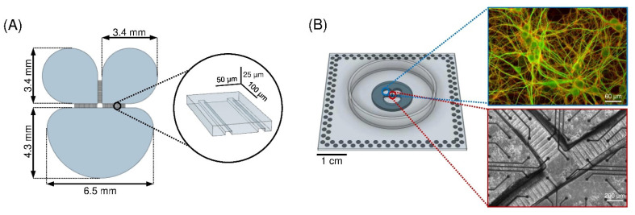 | 10um*5um*250um
101 |  | 2-15um*1.5-6um*500-1500um

