**Appendices**

**Appendix A – Detailed results for SVM and CS-SVM.**

**A.1 Results for the Detection task**

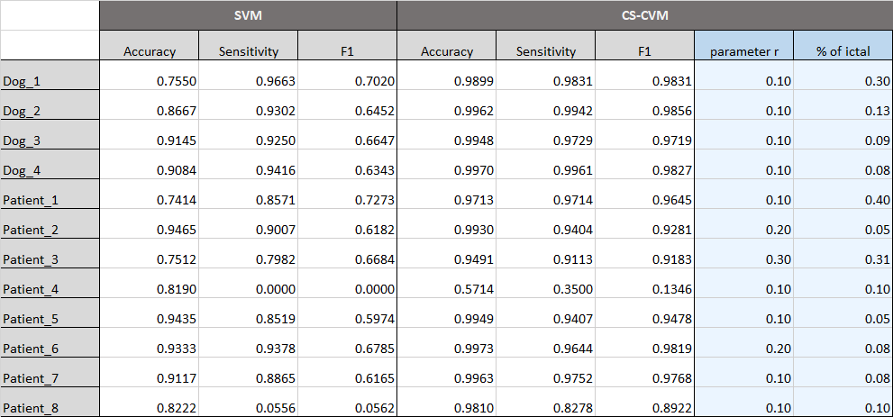

Figure 1. Statistical analyzation for Detection

Figure 2. Confusion Matrices & CR Graph for the optimal parameters

**A.2 Results for the Prediction task**

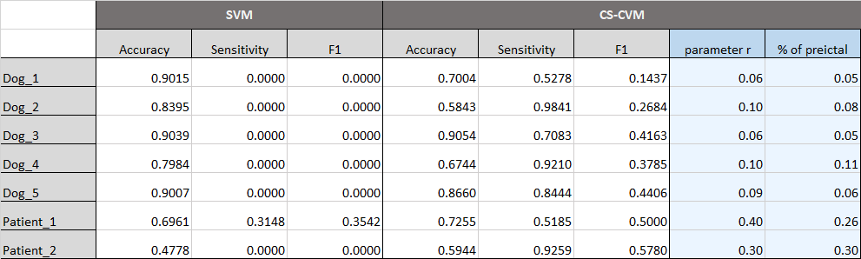

Figure 3. Statistical analyzation for Prediction

Figure 4. Confusion Matrices & CR Graph for the optimal parameters

**Appendix B – Confusion Matrices for LR and ANN.**

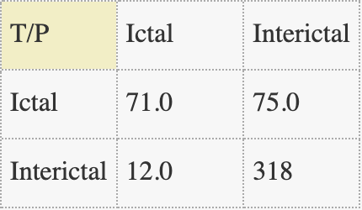 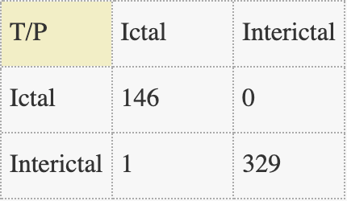

Figure 6. ANN for Dog_1

Figure 5. LR for Dog_1

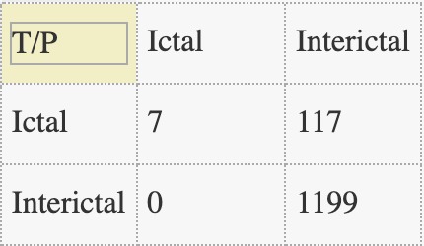 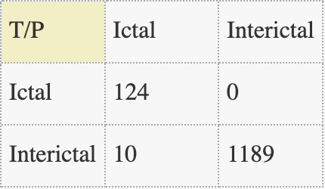

Figure 8. ANN for Patient_8

Figure 7. LR for Patient_8