**HPCSE EX6**

**Ruocheng Han**

Q1:

|  |  |  |
| --- | --- | --- |
|  | **4096_seq** | **8192_seq** |
| **Initial time (s)** | 0.15 | 0.60 |
| **Slapse time (s)** | 3.60 | 25.62 |
| **Eigen_1** | 2232.13 | 4463.98 |
| **Eigen_2** | 665.85 | 1331.61 |
| **Eigen_3** | 316.64 | 633.24 |
| **Eigen_4** | 184.61 | 369.20 |
| **Eigen_5** | 120.805 | 241.59 |



Multithreading of DSYEV have the linear scale up to 4 threads. And 3 or 4 threads multithreading achieve the speedup of 2 – 3 times. However, when further increasing the number of threads, the performance decrease (to 8 threads), and then increase again (up to 24 threads).

Q2:

a)

|  |  |
| --- | --- |
| **NPC** | **Compress ratio** |
| 1 | 12700 % |
| 30 | 900 % |
| 50 | 500 % |
| 100 | 200 % |

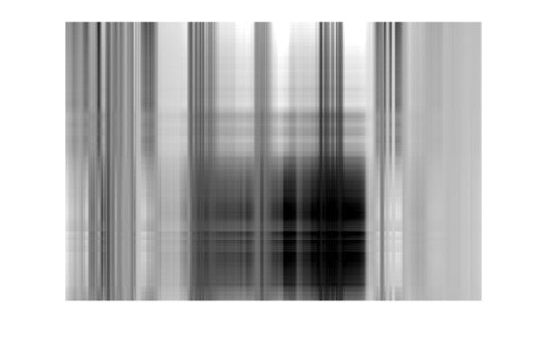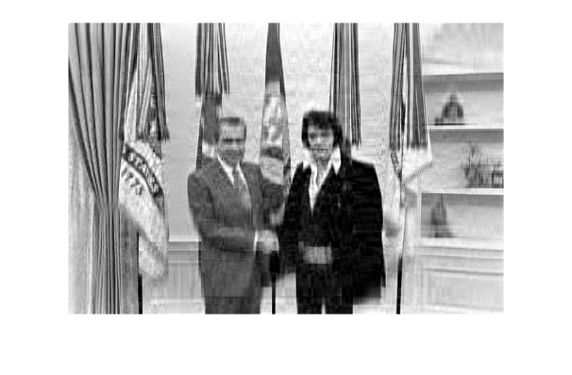

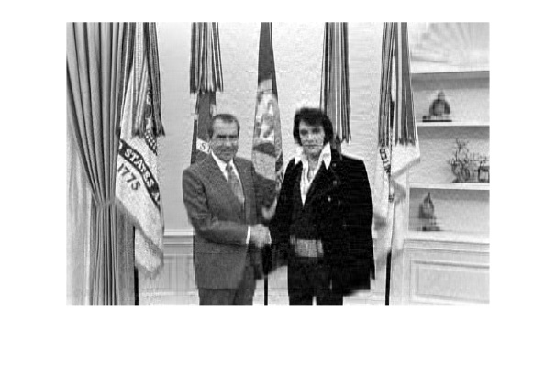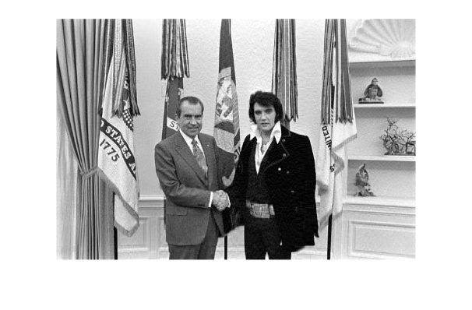

PCA = 1, 30, 50, 100

b)



Top 100 principal components are chosen in each case. “C matrix formation”, “DSYEV” and “PCreduced” are parallelized (Other parts contribute little to the total time).

We can observe that with the increasing of figure size, parallelization can scale up better. Elvis can scale up to 4 threads, while the other two figures can scale up to 24 threads.