AI-Powered Reporter Software - Final Submission
Course: SYSEN 5381 | Deliverable type: Single DOCX | Author: Ruochong Zhu
Project title: Seismic Intel Hub
Note: The writing section below is provided as a complete draft. If your instructor strictly requires non-AI wording, rewrite that section in your own voice before final upload.

1) Writing Component (3+ paragraphs)
This software is an AI-powered earthquake reporting tool that converts raw public API responses into readable analysis and actionable summaries. The system queries the USGS Earthquake Catalog API to retrieve recent earthquake records with configurable filters such as date range, minimum magnitude, result limit, and sort order. Instead of asking users to manually parse complex GeoJSON data, the software normalizes important fields (time, location, magnitude, depth, tsunami flag) and presents them through a usable interface. The primary users are course evaluators and non-technical readers who need fast situational awareness without writing code. In short, the tool solves a practical reporting problem: turning high-volume seismic data into clear, decision-friendly information.
The system integrates three modules into one workflow. First, the API query module (`my_good_query.py`) validates endpoint connectivity and retrieves meaningful multi-row records from USGS using parameterized requests. Second, the web module (`app/main.py`) provides a stable Flask service and exposes `/api/v1/earthquakes` plus `/api/v1/health`; this layer standardizes output into `meta`, `summary`, and `events`, and supports browser-based interaction. Third, the AI reporting module (`lab_ai_reporter.py`) calls the local API, aggregates and compresses the data into a digest (`event_count`, `top_regions`, `daily_counts`, sample events), then sends that digest to a local LLM via Ollama to produce markdown situation reports. The report files are persisted in `reports/`, which creates a reproducible pipeline from raw API response to final narrative output.
The most important engineering challenge was reliability under real deployment conditions. During testing, repeated requests triggered HTTP 429 rate limits from USGS. To address this, the provider layer (`app/providers/usgs.py`) now includes request-parameter caching (TTL=60 seconds) and retry/backoff behavior for 429 responses, including `Retry-After` handling. A second challenge was cross-platform deployment differences: DigitalOcean App Platform and Posit Connect Cloud use different entry conventions and runtime expectations. The project therefore keeps Flask deployment for API hosting and a separate Shiny entrypoint (`shiny_app.py`) for Connect Cloud compatibility. Finally, dynamic UI complexity was reduced to improve stability: default limits were lowered, high-frequency refresh was minimized, and filtering interactions were simplified. These design choices prioritized dependable execution and maintainability over visual complexity, which is a better fit for production-like coursework delivery.

2) Git Repository Links (functional)
- API query script: https://github.com/RuochongZhu/5481/blob/main/my_good_query.py
- Shiny app code: https://github.com/RuochongZhu/5481/blob/main/shiny_app.py
- AI reporting script: https://github.com/RuochongZhu/5481/blob/main/lab_ai_reporter.py
- Main application file: https://github.com/RuochongZhu/5481/blob/main/app/main.py
- USGS provider: https://github.com/RuochongZhu/5481/blob/main/app/providers/usgs.py

3) Screenshots and Outputs
The following screenshots document UI behavior, controls, and error handling (4 items).
Screenshot A - Shiny app interface with controls and data area
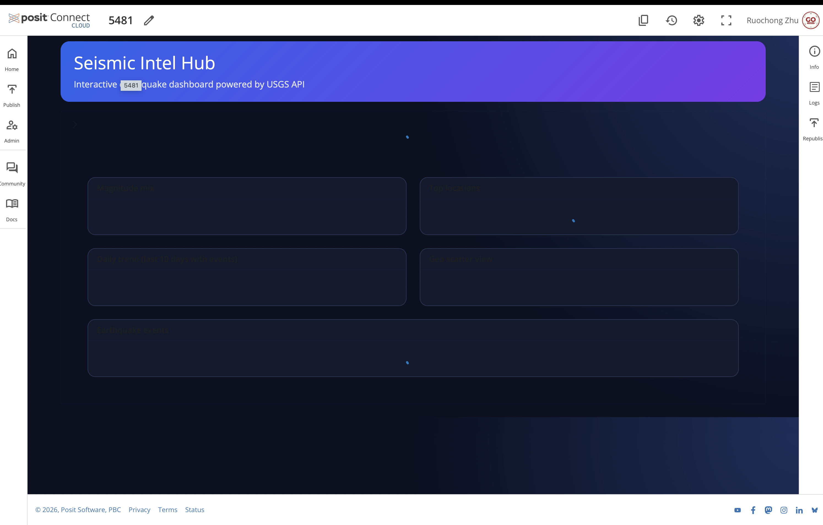
Screenshot B - Data table/input control state (error-handling/debug context)
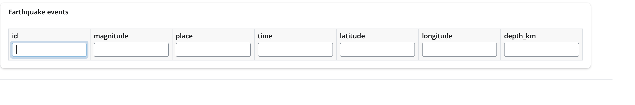
Screenshot C - Posit Connect Cloud publish configuration screen
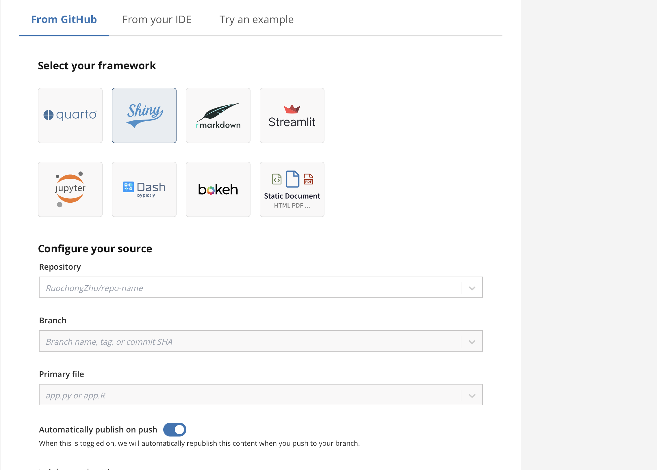
Screenshot D - Posit Connect Cloud home/publish workflow
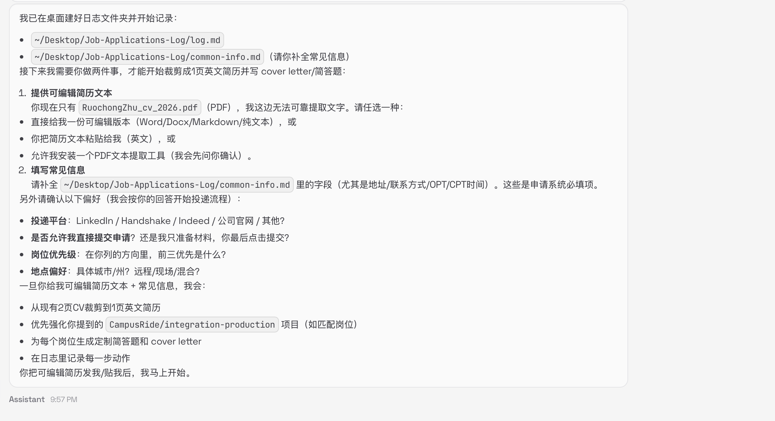
Sample AI-generated report excerpt (`reports/prompt_final_report.md`):
# Earthquake Situation Report
## Executive Summary
The provided data indicates a moderate to high level of seismic activity across various regions globally. The number of earthquakes recorded exceeds the monthly average, with most occurring in Indonesia and the South Pacific.

## Top Signals
* 150 earthquakes were reported within the specified timeframe (2026-02-16).
* The majority of these earthquakes occurred in the following regions:
* Tobelo, Indonesia: 10 earthquakes.
* Mohr, Iran: 6 earthquakes.
* Nikolski, Alaska: 5 earthquakes.
* Tual, Indonesia: 4 earthquakes.
* Kuril’sk, Russia: 4 earthquakes.
* The frequency of earthquakes in these regions is higher than the global average.

## Risk Watch (Next 7 Days)
The following areas are considered to be at risk for significant seismic activity within the next seven days:
* 21 earthquakes with a magnitude of 5.0 or greater were reported, including one under 4 km depth.
* The locations include:

4) Documentation

4.1 Data Summary
Column name | Data type | Brief description
provider | string | Data source identifier (e.g., usgs)
meta.requested | object | Request parameters used for this query
summary.count | integer | Total number of returned events
summary.max_magnitude | float/null | Maximum event magnitude
summary.min_magnitude | float/null | Minimum event magnitude
summary.avg_magnitude | float/null | Average event magnitude
events[].id | string | Unique earthquake event ID
events[].time | string (ISO 8601) | Event timestamp in UTC
events[].place | string | Human-readable location
events[].magnitude | float/null | Magnitude value
events[].latitude | float/null | Latitude coordinate
events[].longitude | float/null | Longitude coordinate
events[].depth_km | float/null | Depth in kilometers
events[].tsunami | boolean | Tsunami indicator
events[].type | string | Event type label
digest.summary.top_regions | array | Top region-frequency tuples for AI summarization
digest.summary.daily_counts | object | Per-day event counts for trend context

4.2 Technical Details
- Public API: USGS Earthquake Catalog API (https://earthquake.usgs.gov/fdsnws/event/1/query)
- API keys: USGS does not require an API key; no secret keys are stored in this repository.
- LLM backend: Ollama local API (`OLLAMA_HOST`, default `http://127.0.0.1:11434`).
- Model setting: `OLLAMA_MODEL` (default `llama3.2:1b`).
- Runtime packages: flask, requests, gunicorn, shiny, pandas.
- Core structure: `my_good_query.py`, `app/main.py`, `app/providers/usgs.py`, `shiny_app.py`, `lab_ai_reporter.py`, `static/`, `reports/`, `tests/`.
- Reliability controls: provider cache (60s TTL) + retry/backoff on 429 responses.

4.3 Usage Instructions (beginner-friendly)
1. Create environment: `python3 -m venv .venv`
2. Activate environment: `source .venv/bin/activate`
3. Install dependencies: `pip install -r requirements.txt`
4. (Optional) Copy env template: `cp .env.example .env`
5. Set runtime variables when needed: `EARTHQUAKE_API_URL`, `OLLAMA_HOST`, `OLLAMA_MODEL`, `REPORT_OUTPUT_DIR`
6. Start API server: `python3 -m app.main`
7. Verify service health: open `http://127.0.0.1:8000/api/v1/health`
8. Run API query script: `python3 my_good_query.py`
9. Ensure Ollama is running and model is available.
10. Run AI report pipeline: `python3 lab_ai_reporter.py`
11. Check outputs in `reports/` (digest + prompt reports + submission description).
End of submission document.

