## Read Me

We aim at predicting PM 2.5 value in Guangzhou using historical data and make a web application to demonstrate our results.

### Data:

* GuangzhouPM20100101_20151231.csv : original data, downloaded from UCI public dataset, containing PM 2.5 historical values in Guangzhou.
* gzpm_cleaned.csv : Cleaned data.

### Python Code:

* 1007final.ipnb include all parts of our analytics and development. The outline of this notebook is as follows:
* 1. Problem Background
* 2. Data Cleaning

## 3.1 Data Modeling - Time Series

## 3.2 Data Modeling – Linear Regression

## 3.3 Data Modeling – Tree-based Regression

## 4. Data Preparation for Web Application Development

## 5. Web Interface Development

### Other Files

* style.css: style sheet for our HTML

### Web Application

Access by entering the URL with following format:localhost:6671/?year-month-day or localhost:6671/?year-month-day-hour

For example: localhost:6671/?2013-01-16-4

* Homepage Demo:

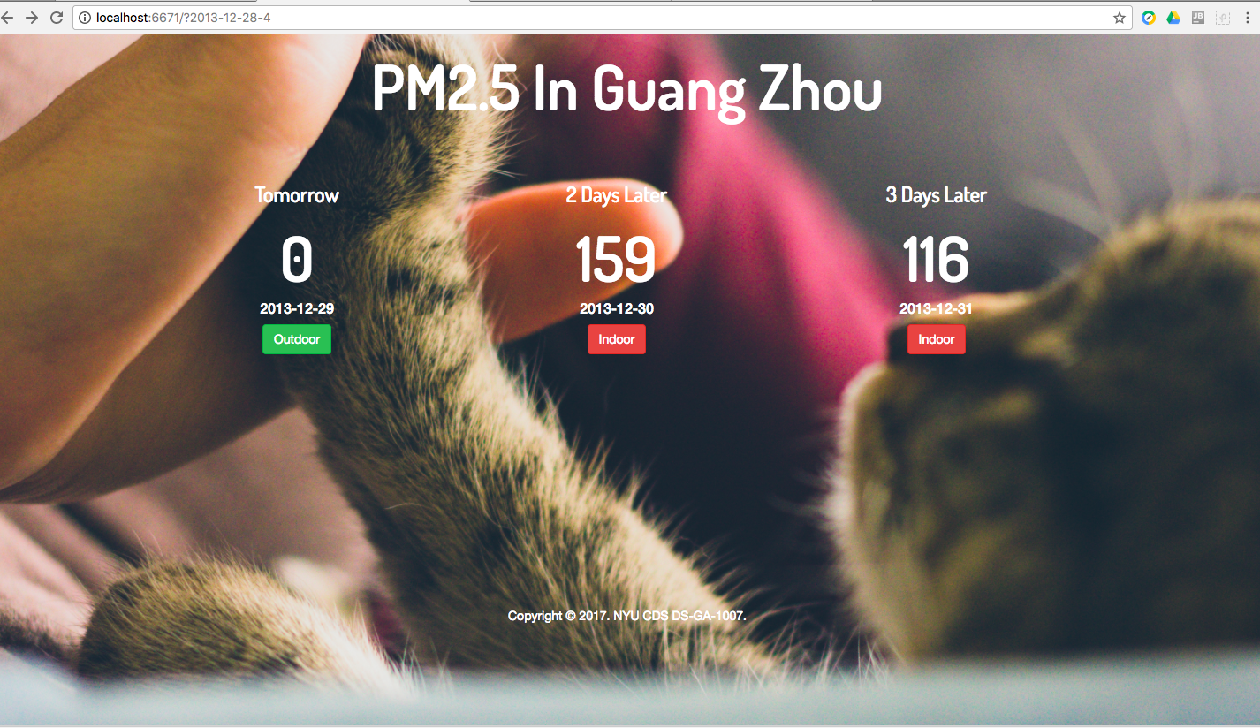

* If PM 2.5 > 100: link to Amazon Website

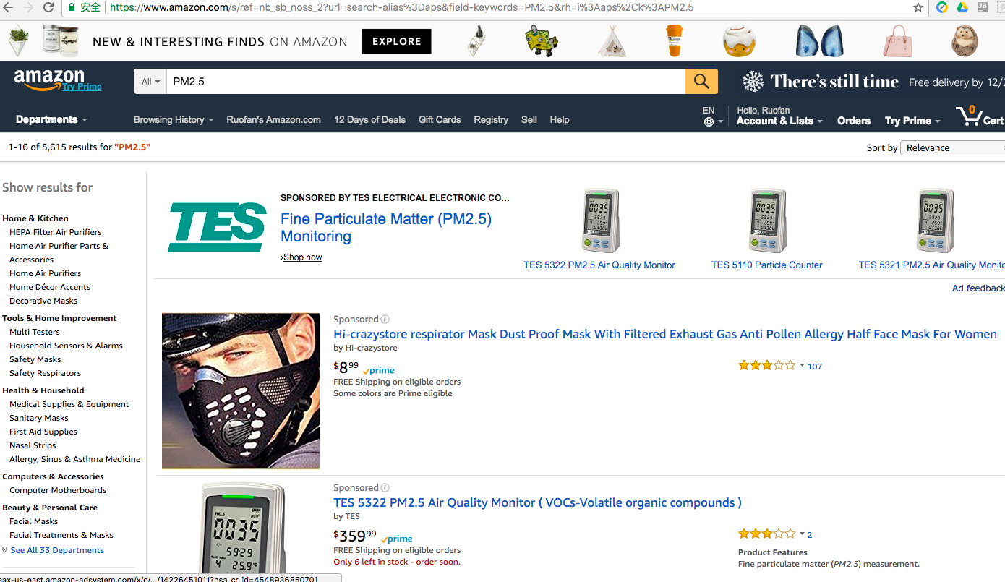

* If PM 2.5 < 100: link to Trip Advisor Guangzhou Site

