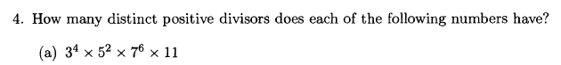

Answer: 5×3×7×2=210



Answer: 7!×4!×2





Answer：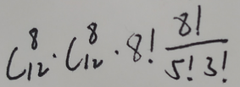

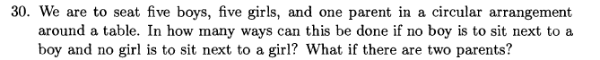

Answer:

One parent: 4!×5!×10

Two parents: 4!×5!×10×9

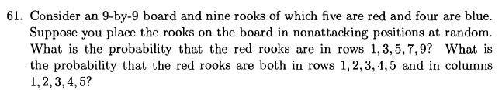

Answer:

1. 9!
2. 4!