**Assignment 3 Ruojun Li**

**Problem 1 output:**

K-means with 3 clusters:

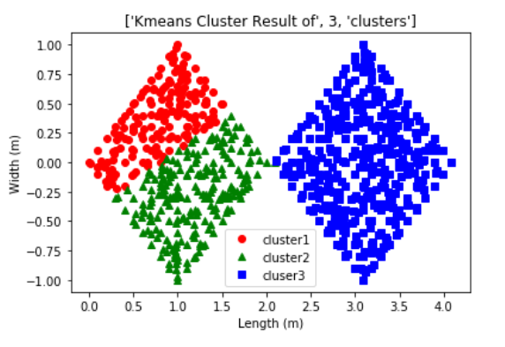

K-means with 2 clusters:

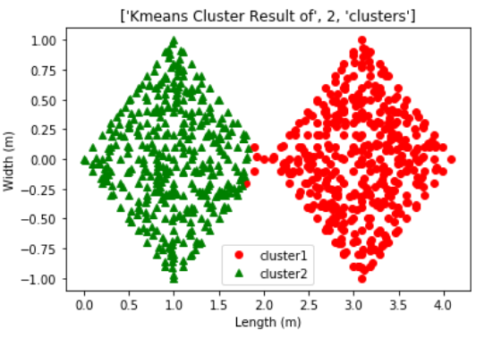

Problem2 output:

Left : Logistic regression’s f-measure vs lambda. Final accuracy is 75%.

Right: Standardization Logistic regression’s f-measure vs lambda. Final accuracy is 100%

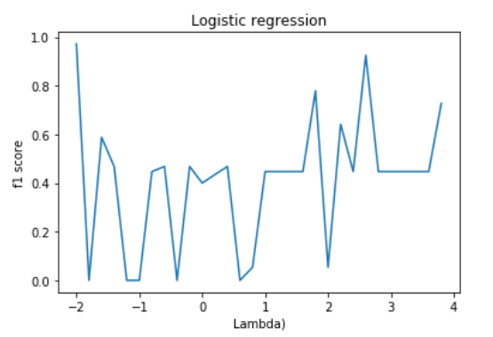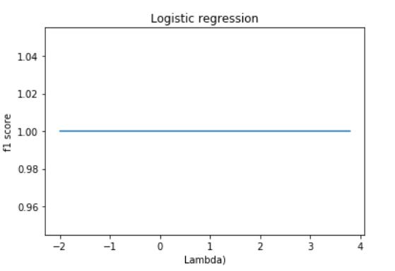

**Problem3 output:**

**a.**

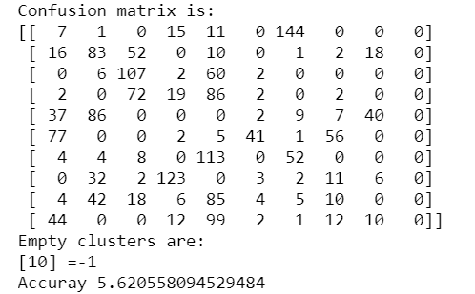

b.

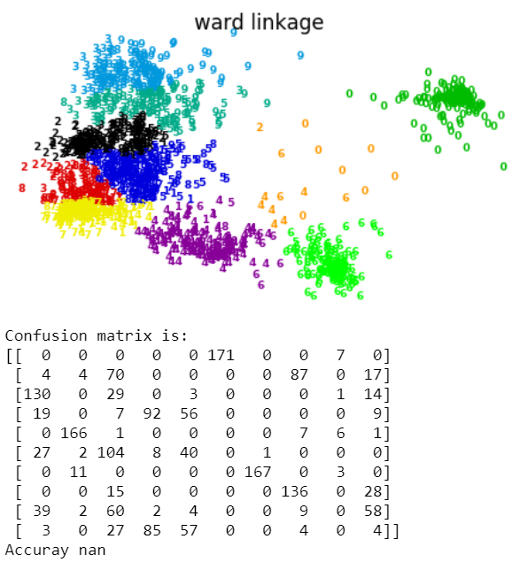

c.

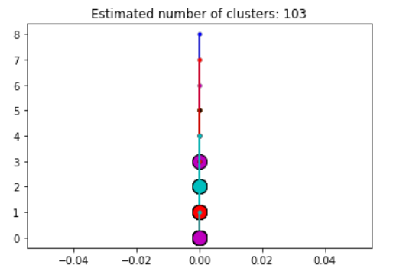

**Problem 4 output:**

a.

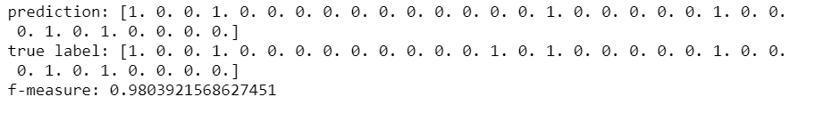

b.

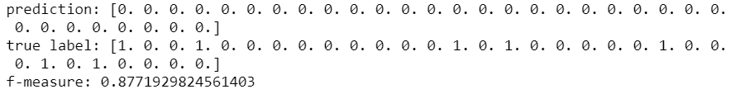

c.

