1. Each group start with home page.



2. Login

3. Explain homepage

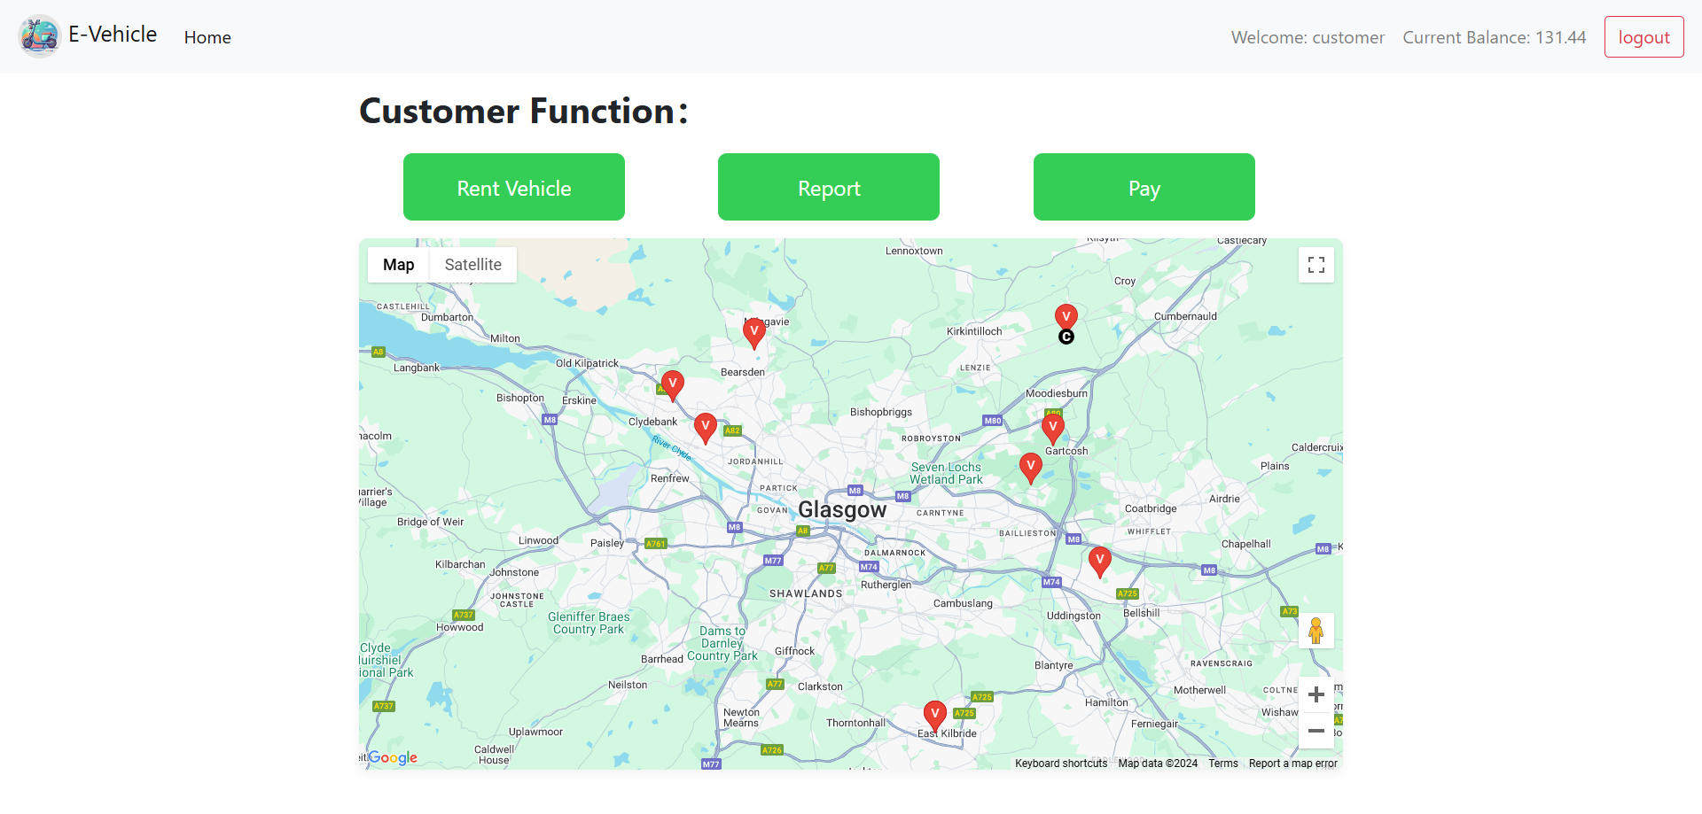

4. Explain each function

Need to show some error handling, and success operation then will redirect to homepage.

5. After the last function, click logout and back to home page.

6. Save record to .mp4 file, at last will take the sounds and use one person’s computer to record the picture.