BIS015L
R上没有空格，用_表达空格：my_numeric NOT my numeric
Lab2
getwd() #identify current working directory

Create new vector: gets: <-
x<-42

Calculate mean:
2, 4, 8
mean(c(2, 4, 8)) #c stands for combine and creates a vector

There are four frequently used `classes` of data:
1. numeric, 2. integer, 3. character, 4. logical.
my_numeric <- 42
my_integer <- 2L #adding an L automatically denotes an integer
my_character <- "universe". (adding quote mark “”)
my_logical <- FALSE

To find out what type of data you are working with, use the `class()` function
is.integer(my_numeric)

Let's convert my_numeric to an integer.
my_numeric2 <- as.integer(my_numeric)

NA values are used to designate missing data. `is.na` or `anyNA` are useful functions when dealing with NAs in data.
my_missing <- NA #NA stands for missing
is.na(my_missing)
mean(new_vector, na.rm = TRUE) #removes NA values

Write a code chunk that divides `pi` by 2. Use the help command `?` to learn how to use the `round` function to limit your result to 4 significant digits.**
y <- pi/2
?round
round(y, digits = 4)

Lab3
A numeric vector:
my_vector <- c(10, 20, 30)
#this makes a new vector.
#each vector is its own column in the data frame. columns=variables

A character vector:
days_of_the_week <- c("Monday", "Tuesday", "Wednesday", "Thursday", "Friday", "Saturday", "Sunday")
# adding quote mark

Create a sequence:
my_vector_sequence <- c(1:100)
my_vector_sequence
[1] 1 2 3 4 5 6 7 8 9 10 11 12 13 14 15 16 17 18 19 20 21 22 23 24 25 26
[27] 27 28 29 30 31 32 33 34 35 36 37 38 39 40 41 42 43 44 45 46 47 48 49 50 51 52
[53] 53 54 55 56 57 58 59 60 61 62 63 64 65 66 67 68 69 70 71 72 73 74 75 76 77 78
[79] 79 80 81 82 83 84 85 86 87 88 89 90 91 92 93 94 95 96 97 98 99 100

We can use `[ ]` to pull out elements in a vector
days_of_the_week[4]
[1] "Thursday"
my_vector_sequence[10]
[1] 10
Example:
We can use operators such as <, >, ==, <==, etc. Show all values in `my_vector_sequence` that are less than or equal to 10.
my_vector_sequence<=10. #it only shows TRUE or FALSE
so
my_vector_sequence[my_vector_sequence <= 10]

Data Frame
Let's build separate vectors that include length (in), weight (oz), and sex of three
Sex <- c("male", "female", "male")
Length <- c(3.2, 3.7, 3.4)
Weight <- c(2.9, 4.0, 3.1)

Use `tibble()` to create a data frame. (Since we work in the tidyverse)
hbirds <- tibble(Sex, Length, Weight)

names(hbirds)
dim(hbirds) #dimension(like 3*3)
str(hbirds) #structure
summary(fish) #careful NA
glimpse(fish)
nrow(fish) #give the number of rows
ncol(fish) #col=variables #give the number of columns
head(fish) #prints the first n rows of the data frame.
`tail()` #prints the last n rows of the data frame.
Use lowercase always!!!!!!!!!!!

#change the name of variables
hbirds <- tibble(sex=Sex, length=Length, weight=Weight)

hbirds[1,] #get the first row only
hbirds[1,3] #[row, column]
hbirds[,3] #only third column

We can use the `$` to access a column (variable) in a data frame
mean(hbirds$length)

Write data to file
write.csv(hbirds, "hbirds_data.csv", row.names=FALSE)
#row.names=FALSE: prevents R from saving row numbers as a fake column in your CSV file

Load the data
Here we import a .csv file. Since we are using the tidyverse, we import the file using `read_csv()`. `readr` is included in the tidyverse set of packages.
hot_springs <- read_csv("hsprings.csv")

Change column classes
class(hot_springs$scientist)

When making plots or performing statistical modeling, it may be important to convert column classes. For example, if a column contains categorical data (e.g., scientist names, treatment groups, etc.) it may be best to convert that column to a factor class.
hot_springs$scientist <- as.factor(hot_springs$scientist)

What are the levels of the springs column?
levels(hot_springs$spring)

table(hot_springs$spring)
Benton Buckeye Travertine
3 3 3

fish <- read_csv("data/Gaeta_etal_CLC_data.csv")
#data/ : tell R where it is. now, fish is in the folder "data"

Lab4
`discrete` quantitative data that only contains integers
`continuous` quantitative data that can take any numerical value
`categorical` qualitative data that can take on a limited number of values

**plot= data + geom_ + aesthetics**.
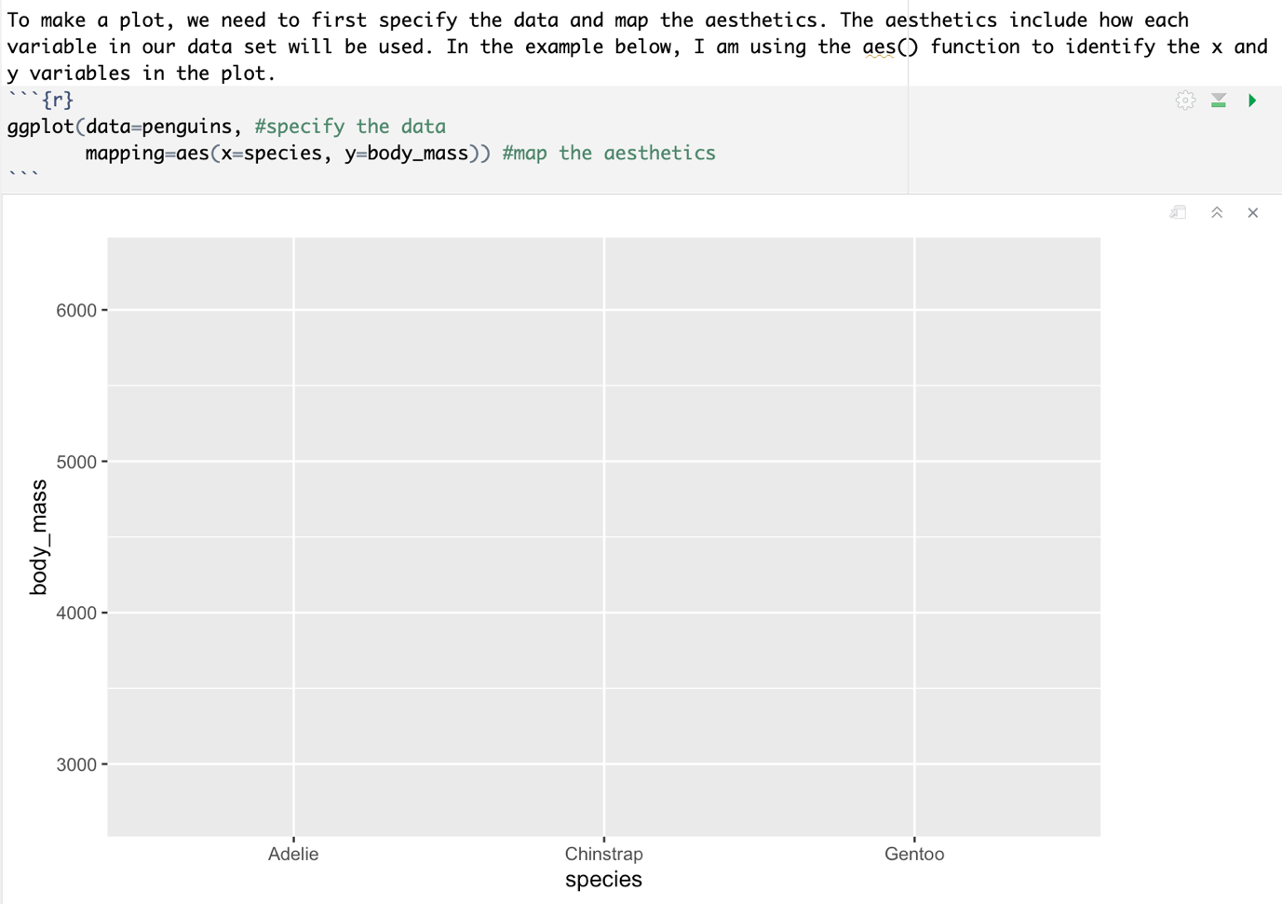

Boxplot:
ggplot(data=penguins, #specify the data
mapping=aes(x=species, y=body_mass))+geom_boxplot() #map the aesthetics #+:layers

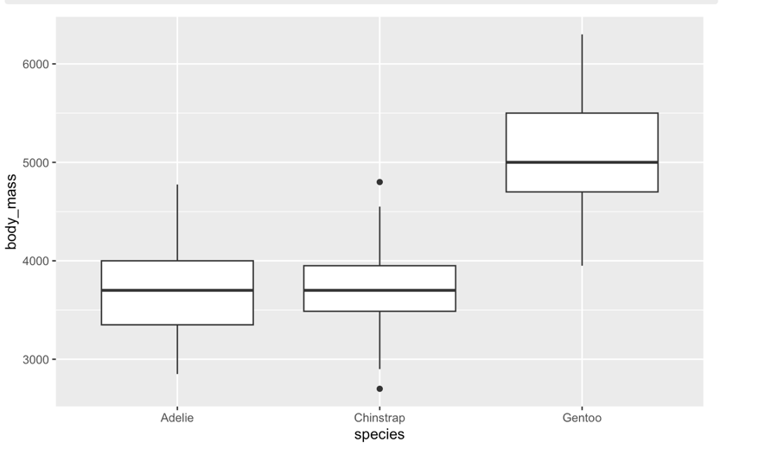

Scatterplots
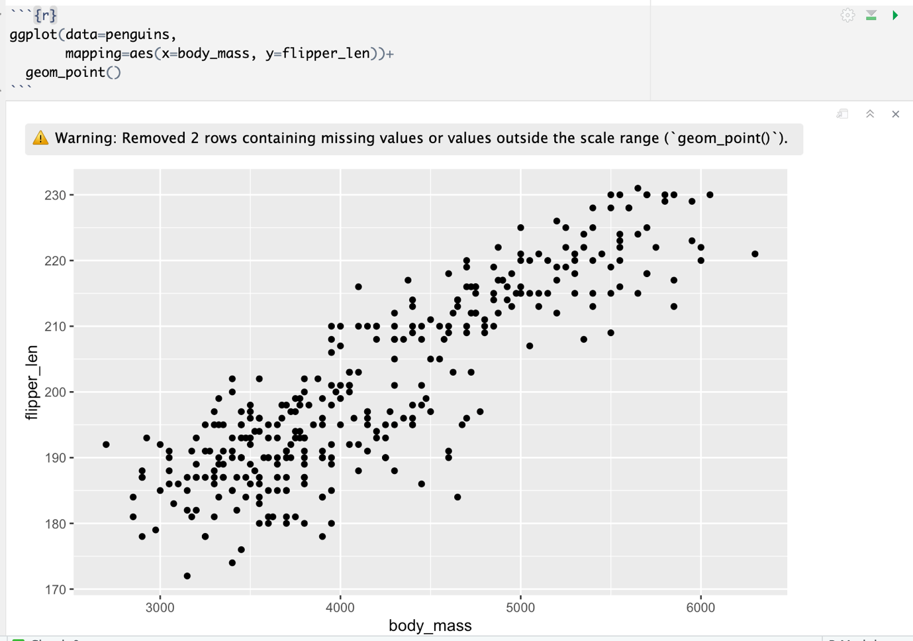
ggplot(data=penguins,
mapping=aes(x=body_mass, y=flipper_len))+
geom_point(na.rm=T). # We can also deal with the NA's explicitly using the `na.rm=T` function.

To add a regression (best of fit) line, we add another layer.
ggplot(data=penguins,
mapping=aes(x=body_mass, y=flipper_len))+
geom_point(na.rm=T)+
geom_smooth(method=lm, se=T) #lm: linear model se: standard error
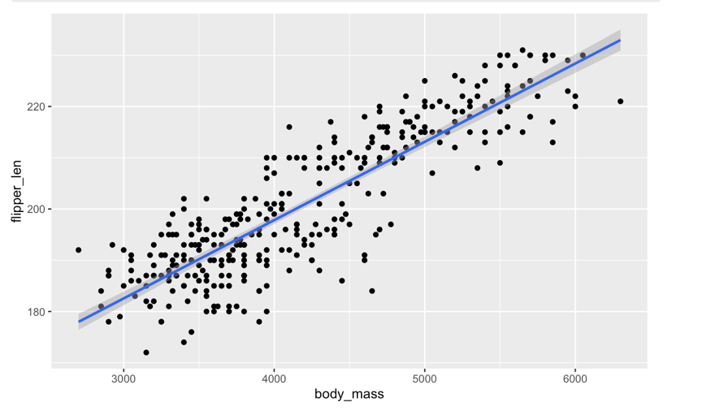

To add color
ggplot(data=penguins,
mapping=aes(x=body_mass, y=flipper_len))+
geom_point(mapping=aes(color=species))+ #mapping:categorical variable, NOT numerical
geom_smooth(method=lm, se=T)
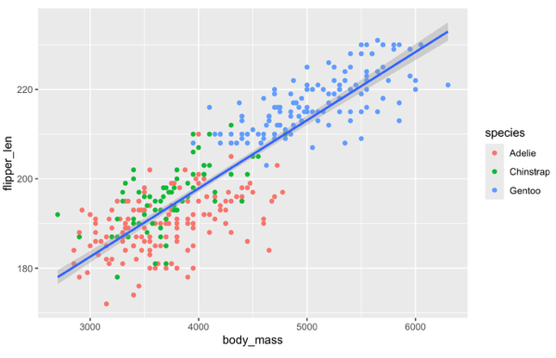

To change the shape
ggplot(data=penguins,
mapping=aes(x=body_mass, y=flipper_len))+
geom_point(mapping=aes(color=species, shape=species))+
geom_smooth(method=lm, se=T)
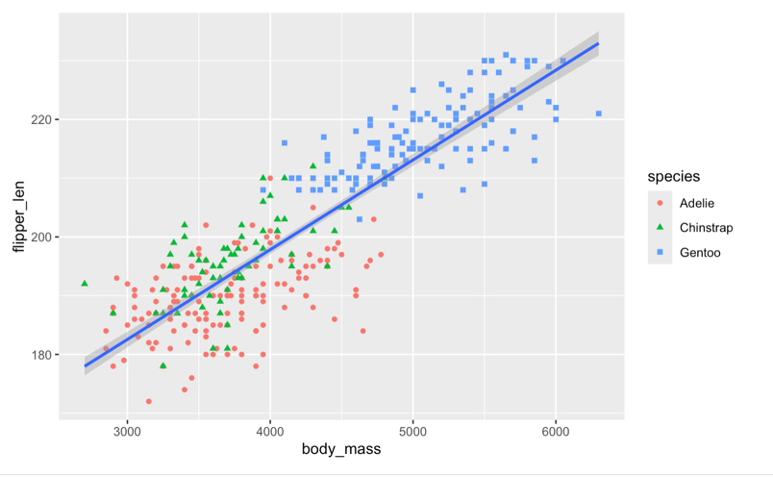

To add titles: labs()
ggplot(data=penguins,
mapping=aes(x=body_mass, y=flipper_len))+
geom_point(mapping=aes(color=species, shape=species))+
geom_smooth(method=lm, se=T)+
labs(title="Body Mass(g) vs. Flipper Length(mm)",
x="Body Mass (g)")
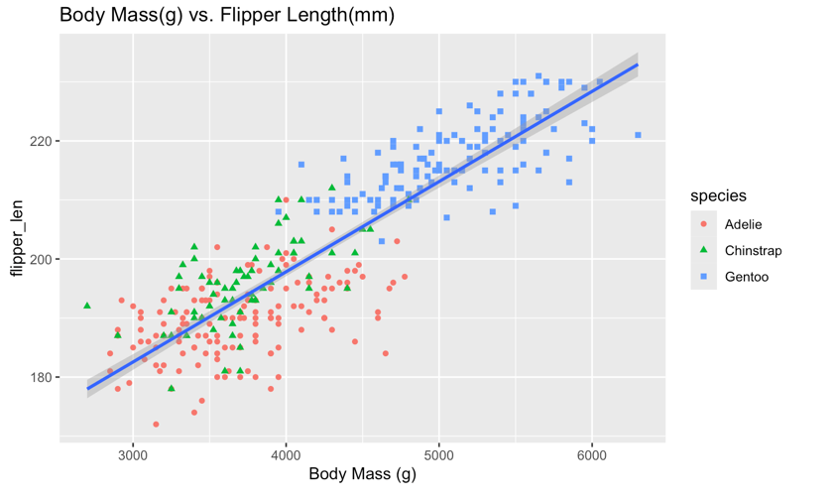
Bar plot: geom_bar()
ggplot(data=penguins,
mapping=aes(x=species))+
geom_bar()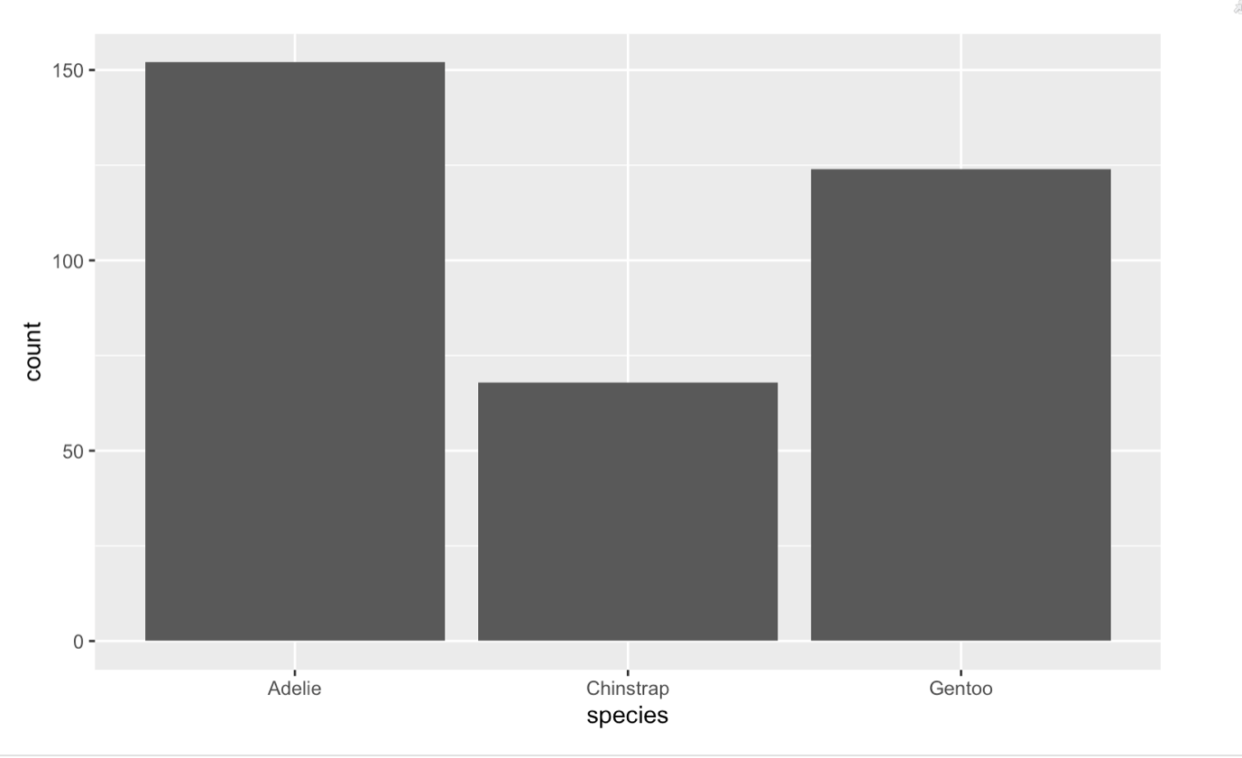

To add color
ggplot(data=penguins,
mapping=aes(x=species))+
geom_bar(mapping=aes(fill=species)) #color:color of the edge #color: the color of edges
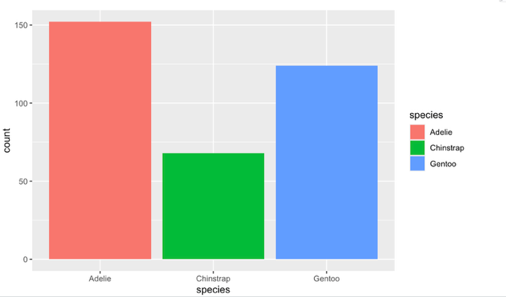
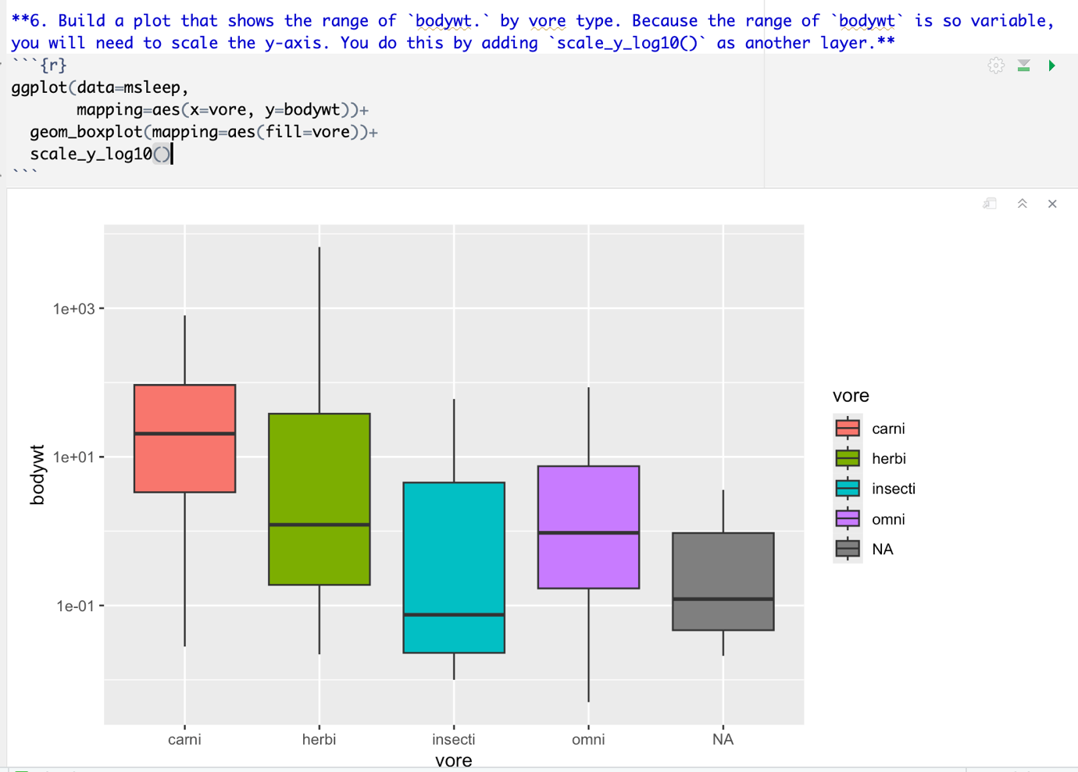

Lab5
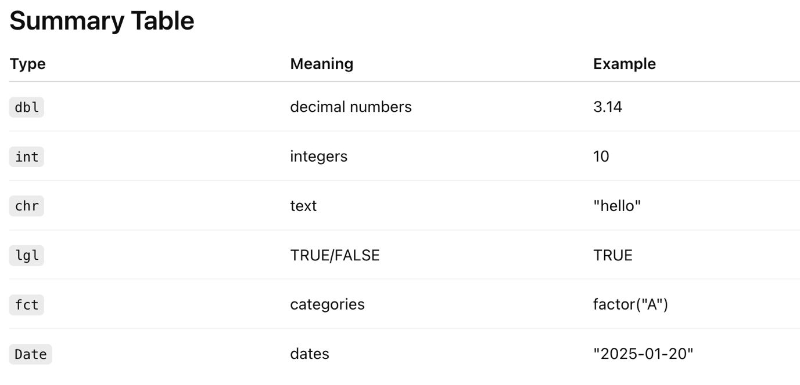

select()
select(): pull out columns of interest from a data frame. (select()is another kind of dataframe)
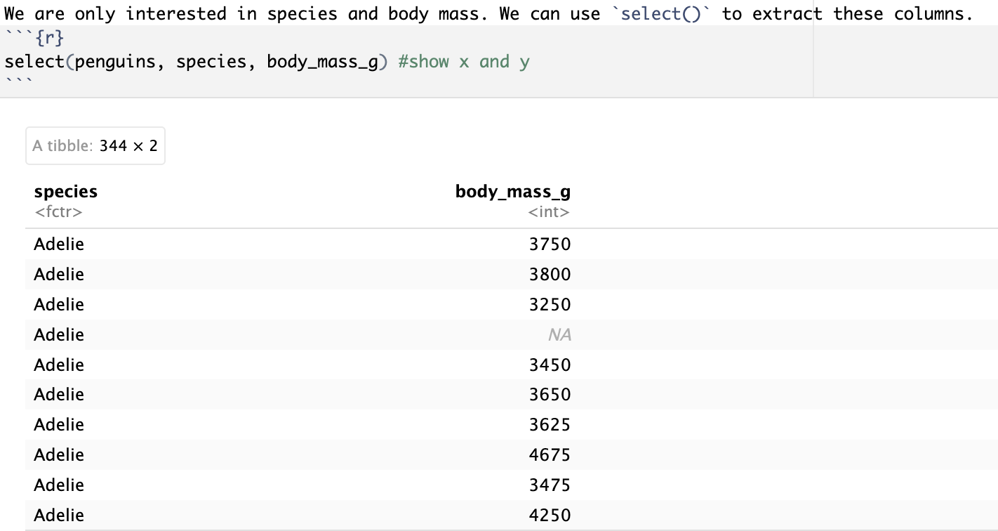

select(penguins, species:flipper_length_mm)
# : stands for between(selects a continuous range of columns, e.x. select data from species to flipper_length_mm)

Remove data
select(penguins, !body_mass_g) #!:remove data
`c()` function to exclude multiple columns.
select(penguins, !c(species, island, year, sex))

select(penguins, contains("mm"))
select(penguins, starts_with("bill"))
select(penguins, ends_with("mm"))
select(penguins, where(is.numeric)) (You can also select columns based on the class of data)
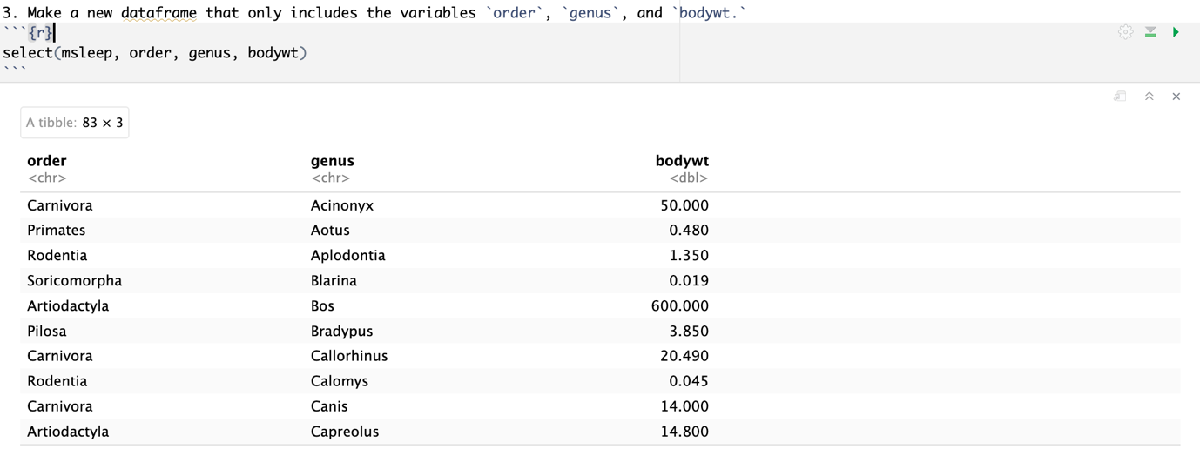
msleep_focused <- select(msleep, order, genus, bodywt) #msleep_focused: output data

Rename
rename(penguins, body_mass=body_mass_g) (new_name=old_name)
select(penguins, species, body_mass=body_mass_g) (rename from within select.)

Relocate
relocate(penguins, length) #:move `length` to be the first column in the dataframe

filter: extract a specific data within row
filter(penguins, species=="Adelie") #(data, column=="row")
filter(penguins, body_mass_g>=5500) (a body mass greater than or equal to 5500g)
filter()` allows all of the expected operators; i.e. >, >=, <, <=, != (not equal), and == (equal).

filter(penguins, species!="Chinstrap") #!: remove "Chinstrap"
filter(penguins, body_mass_g %in% c(5250, 5500)) #look for specific values, 5200 and 5500
filter(penguins, between(body_mass_g, 5250, 5500)) #between: a range from 5250 to 5500
filter(penguins, body_mass_g %in% c(5250, 5300, 5350, 5400, 5450, 5500)) #need to type each specific number we need

filter(penguins, near(body_mass_g, 5400, tol=100)) #tol=tolerate #tol: near(5350-5450) splits to 50 [near a certain data] 5400 加减100
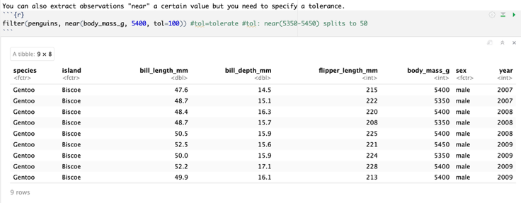
Filter the fish data to include all fish with a scalelength within 0.25 of 8.
filter(fish, near(scalelength, 8, tol=0.25)) 8 加减0.25

Below we extract the Chinstrap penguins that have a body mass greater than 4500g.
filter(penguins, species=="Chinstrap" & body_mass_g> 4500) &: and
filter(penguins, species=="Chinstrap" | body_mass_g> 4500) |: or
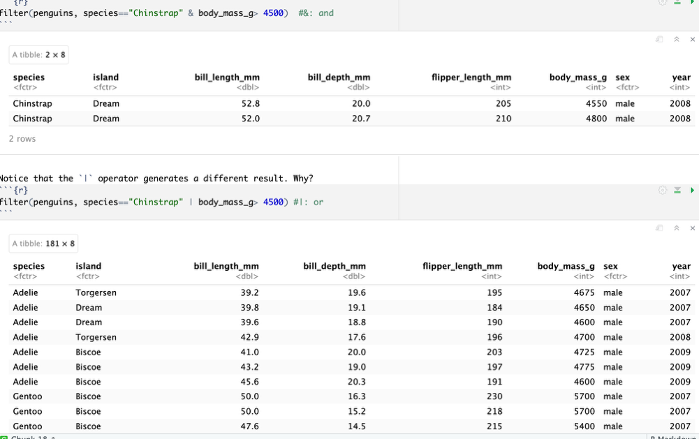
In this case, we filter out the penguins with a body mass over 5000g and a bill length over 50mm or a bill depth over 18mm.
filter(penguins, body_mass_g>5000, (bill_length_mm>50|bill_depth_mm>18))
#,stands for &

Pipes %>%
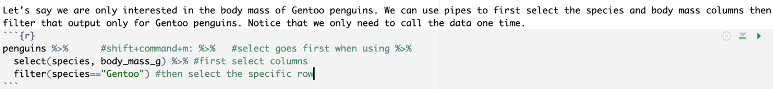
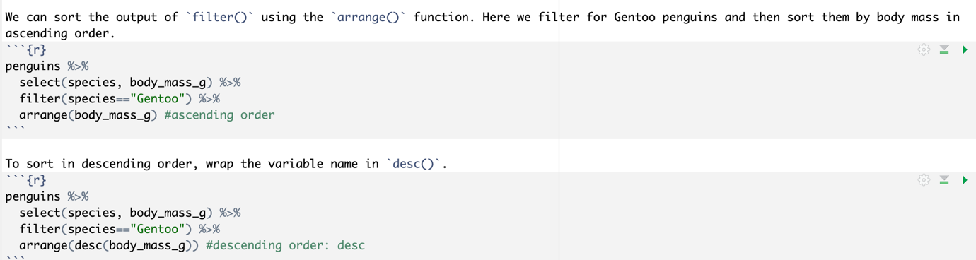

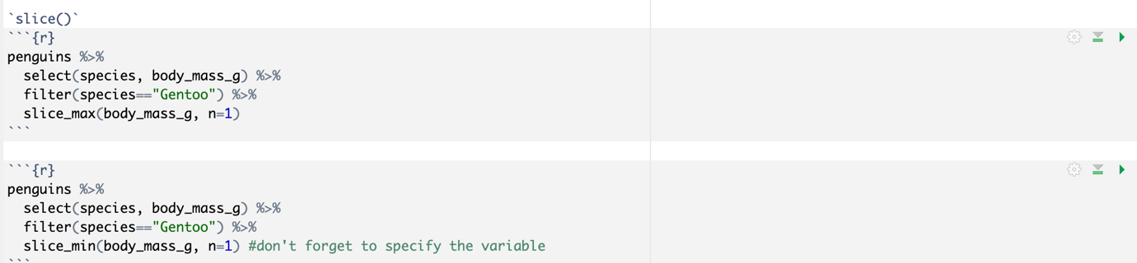
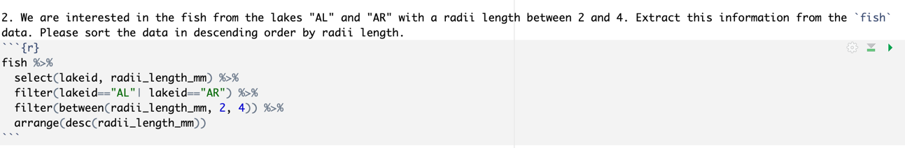
Lab6
Distinct: work for row
penguins %>%
distinct() #meaning: no duplicate
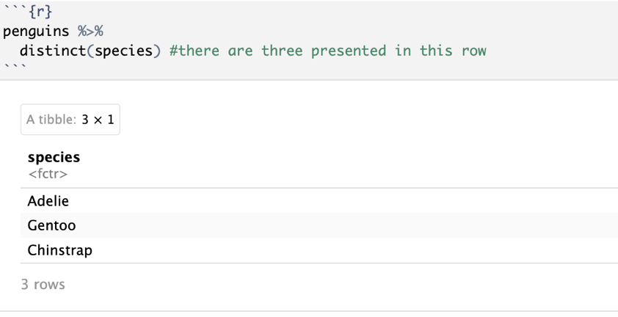
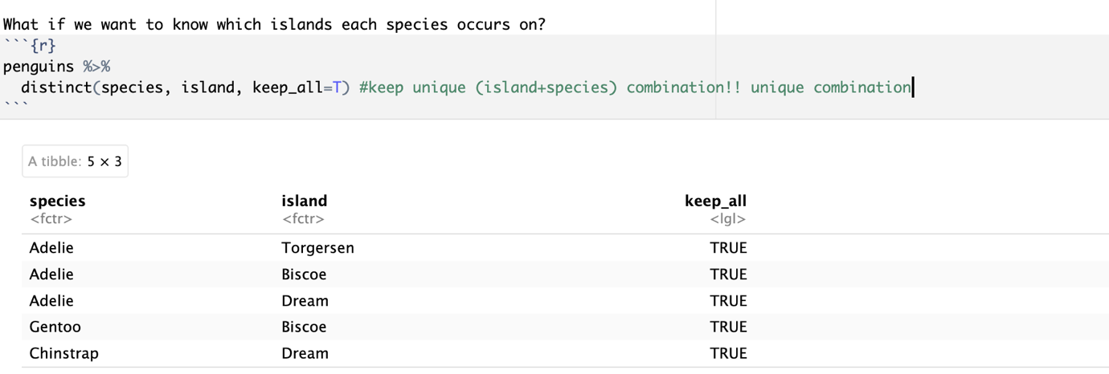

Mutate: create new columns or change existing columns in a data frame.
(keeps original + adds new columns)
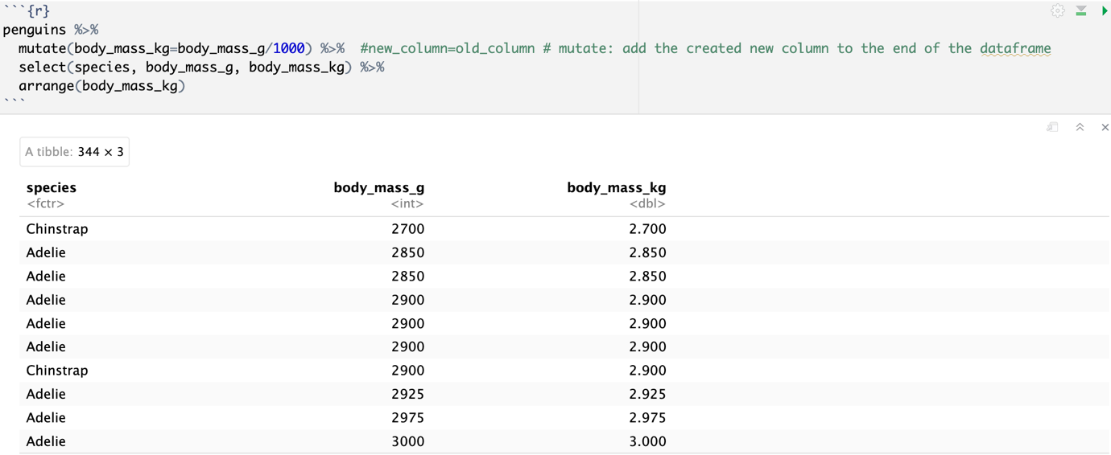

Clean
mammals <- mammals %>%
clean_names(). #fix all of the column names at once

mammals %>%
mutate(across(c("order", "family"), tolower)) #work on specific column

mammals %>%
mutate(across(everything(), tolower)) #change all numeric(dbl) to characters(chr) #be careful with numeric variables

mammals %>%
mutate(across(where(is.character), tolower))

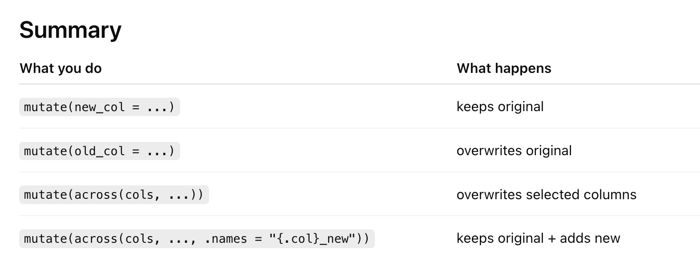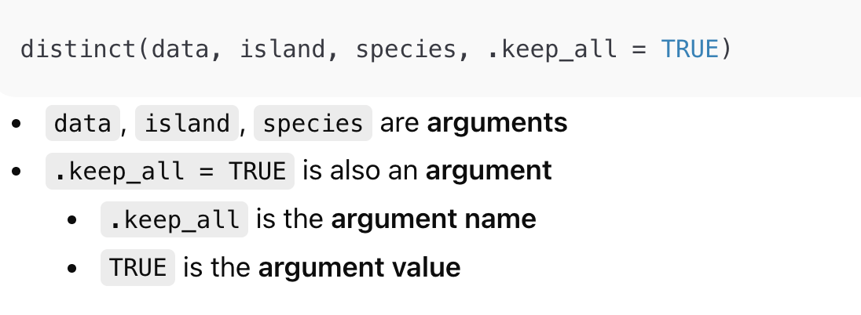

Lab 7
Summarize()
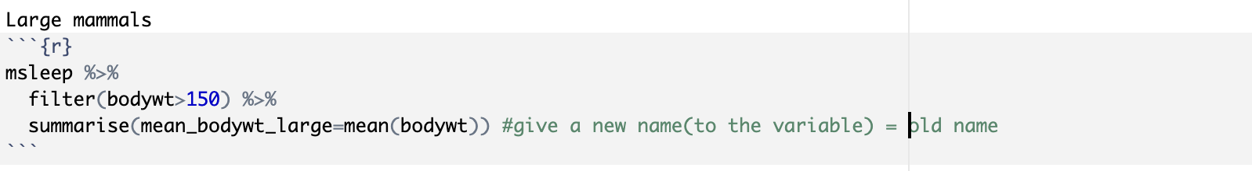

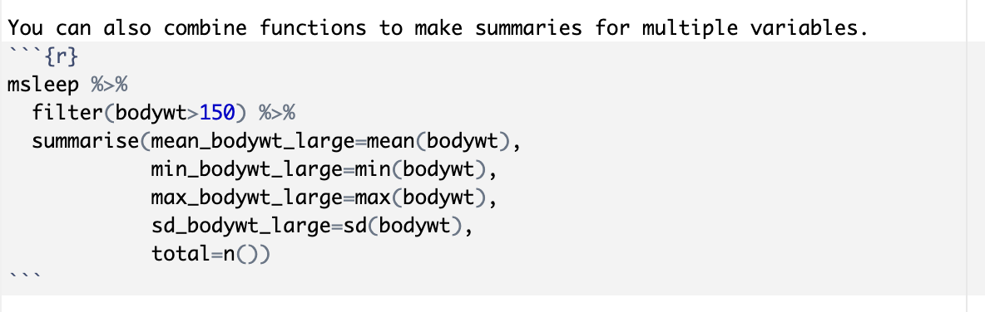

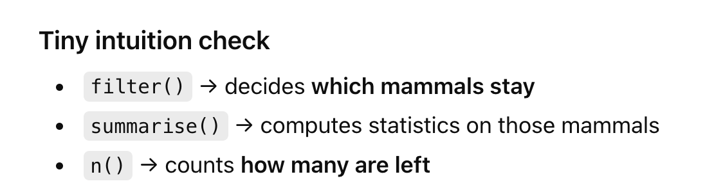

Maybe you want to summarize all of the numeric variables in the data frame. You can use the `where()` function to select only the numeric variables.
msleep %>%
select(where(is.numeric)) %>%
summarise_all(mean)

Don't forget to remove NA's.
msleep %>%
select(where(is.numeric)) %>%
summarise_all(mean, na.rm=T)

msleep %>%
summarize(across(where(is.numeric),
~mean(.x, na.rm=T))) #.x: for every cell

n_distinct(): used in function`summarise` ?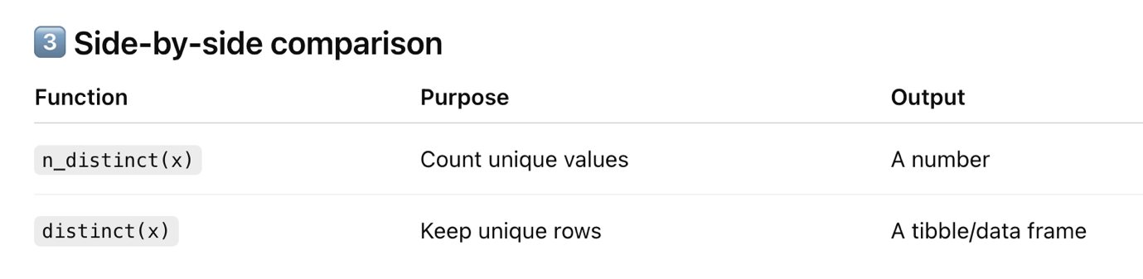

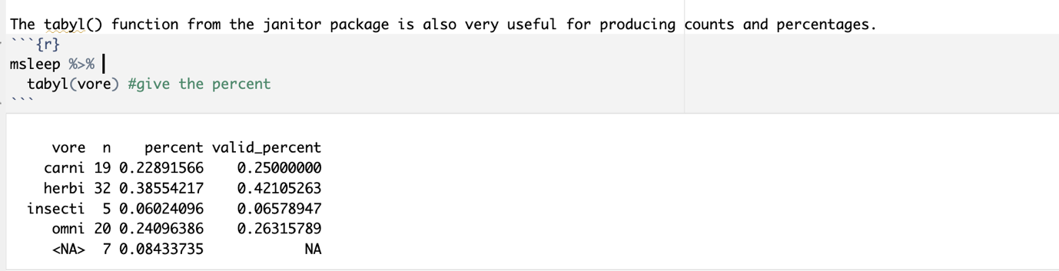

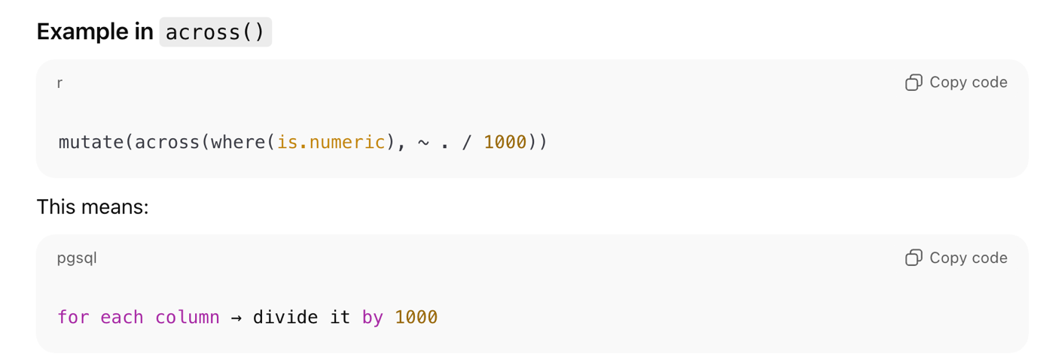

summarise() doesn’t use ~ directly — but helper functions like across() inside summarise do.
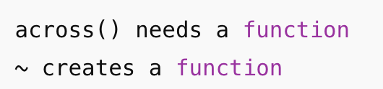

Lab8
group_by
`group_by` go with summarize
Only for categorical variables, not continuous variables
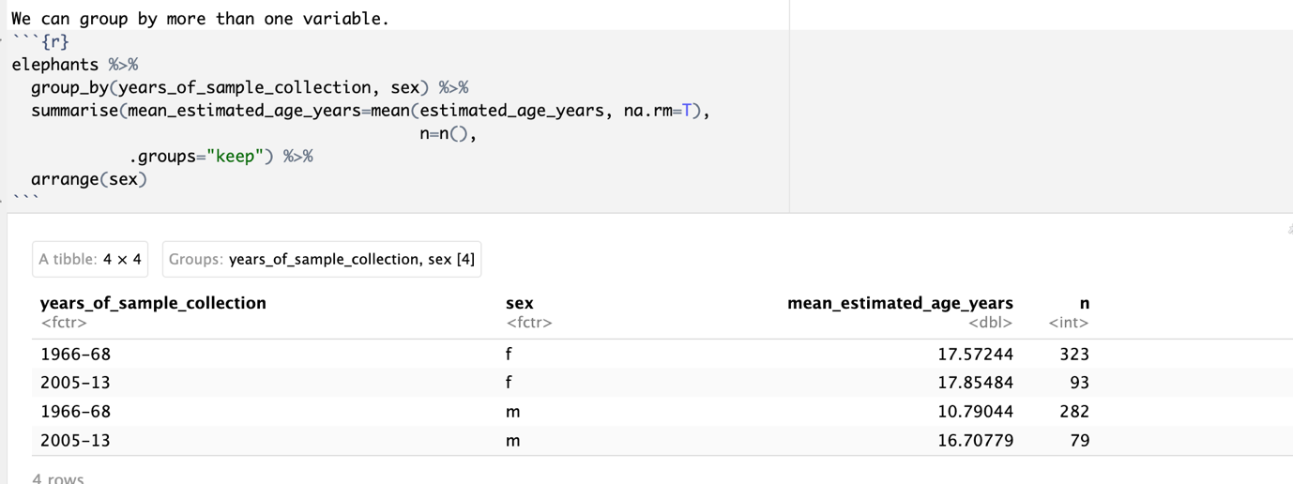

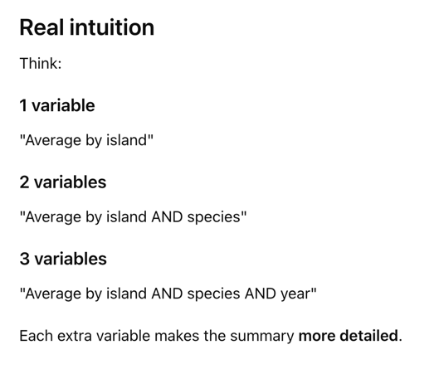
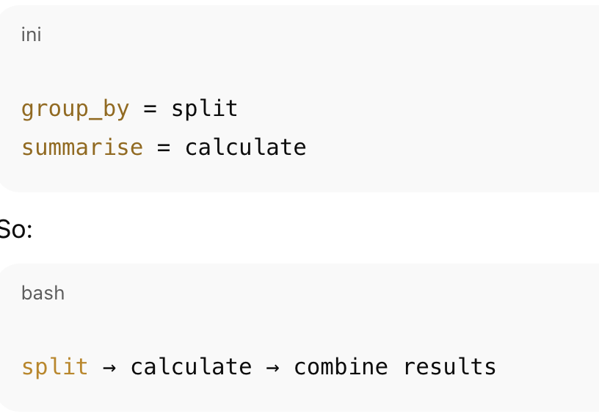
Order:
select → what data we keep
group_by → how to split
filter → which rows inside each group
summarise → calculate

Lab9
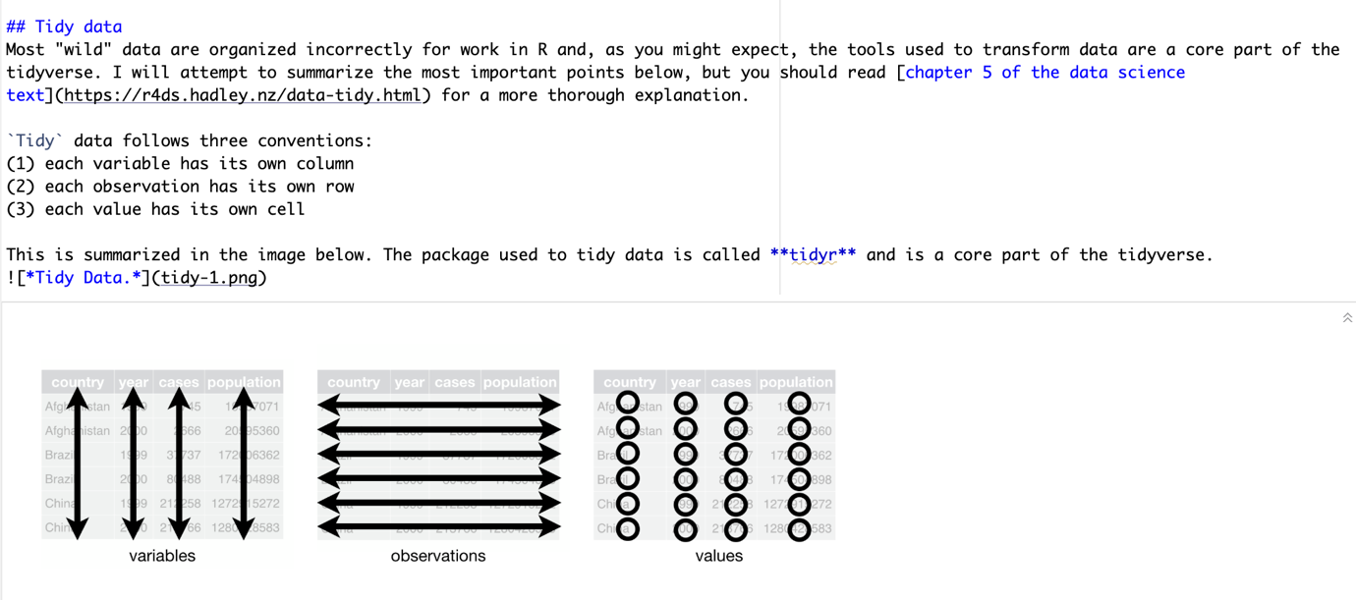
pivot_longer: It reshapes columns into rows.
COLUMN NAMES ARW DATA
Before:
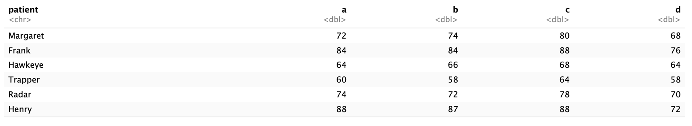
Exclude this column from selection
（-： Do NOT move
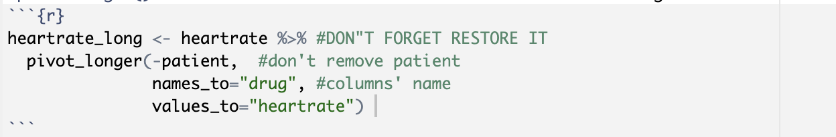

① Move column names → into a new column

② Move column values → into another new column

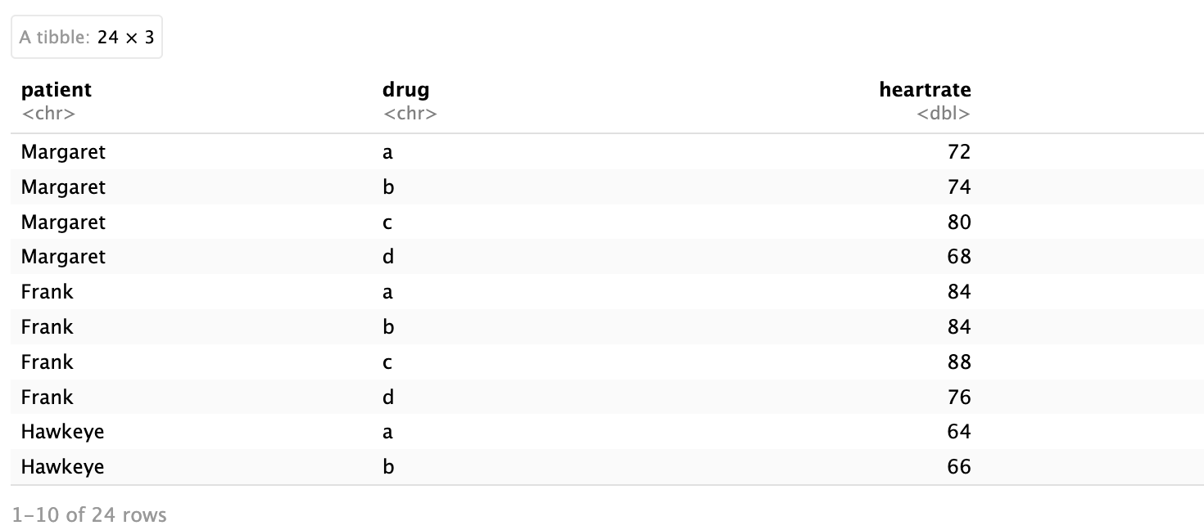

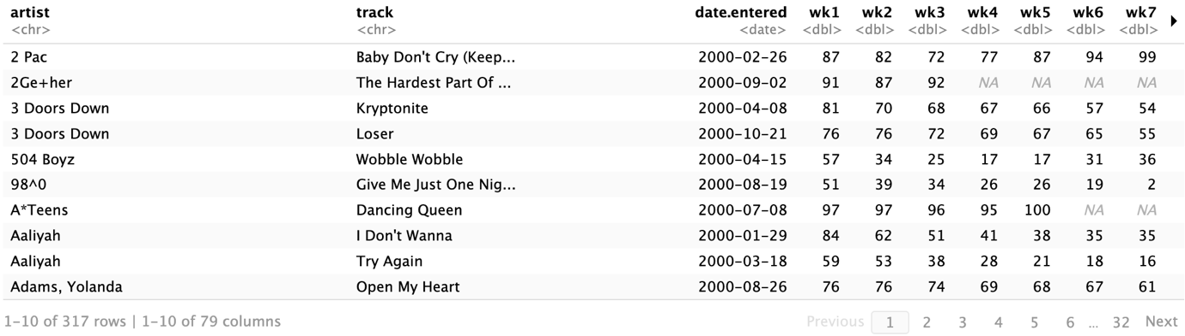
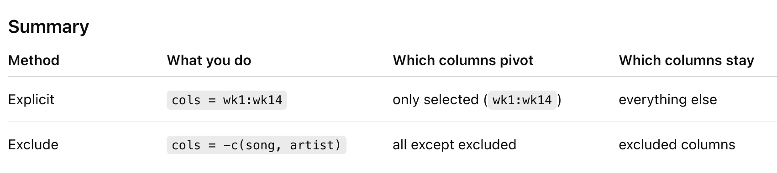
Pivot the columns you choose, or
Pivot the remaining columns after excluding some with -.
要么exclude everything除了pivot，要么只选择要pivot的。
不能只选artist或者track；pivot只是reshape不是select 改变dataframe

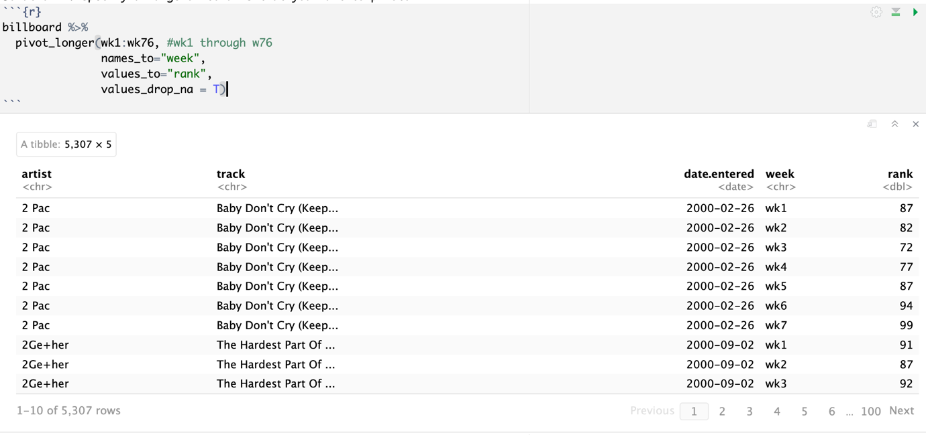
OR
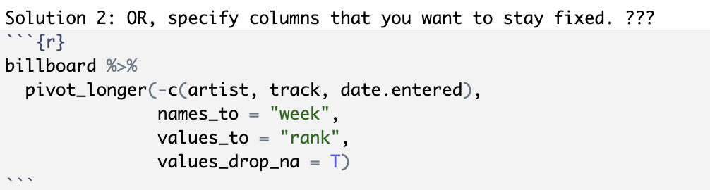
否则一整个row都没了
SOME COLUMN NAMES ARE DATA. (NOT ALL COLUMN NAMES)

identify columns by a prefix, remove the prefix and all NA's
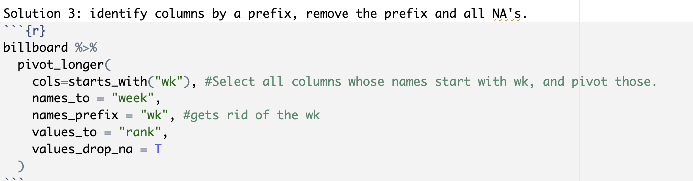

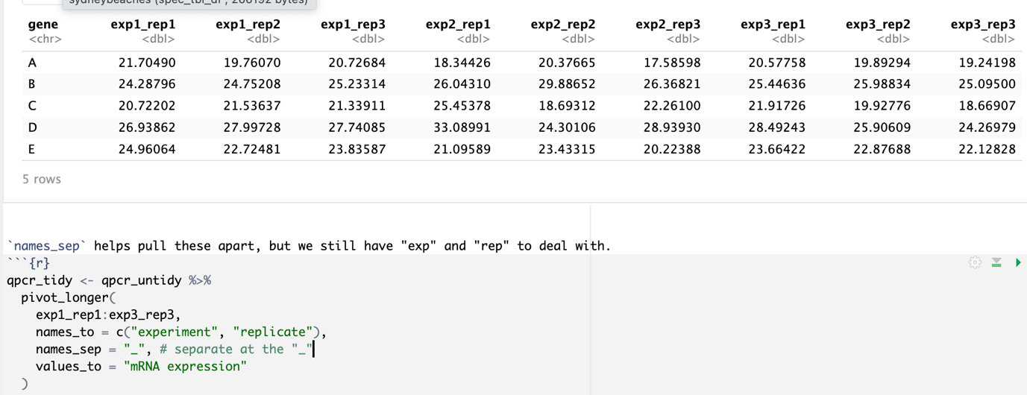
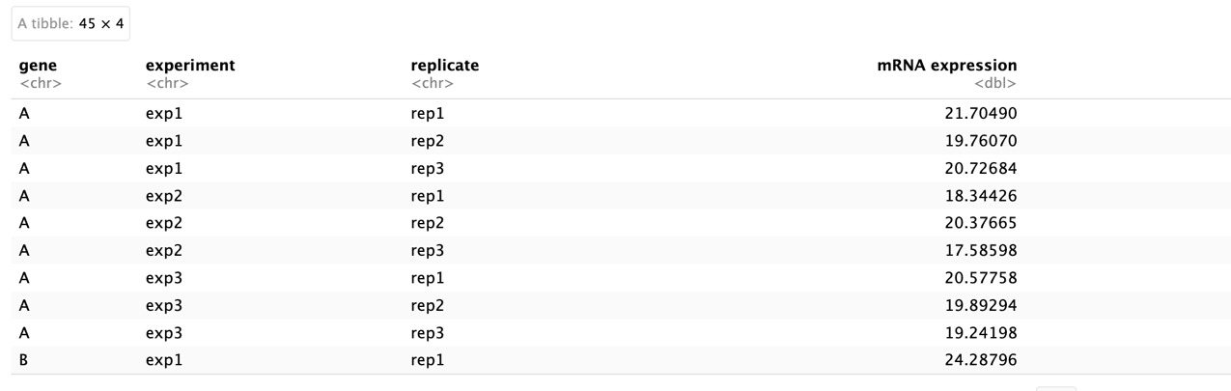
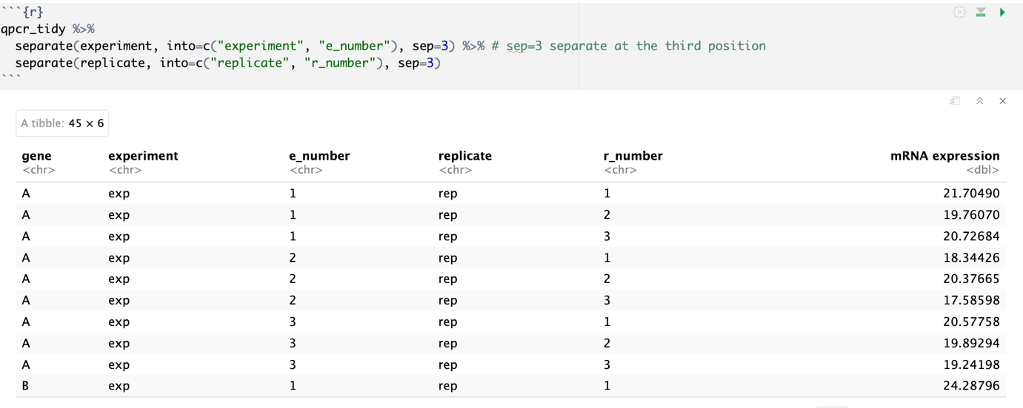
Separate():splits the values inside a column, not the column names. ( split strings inside cells)

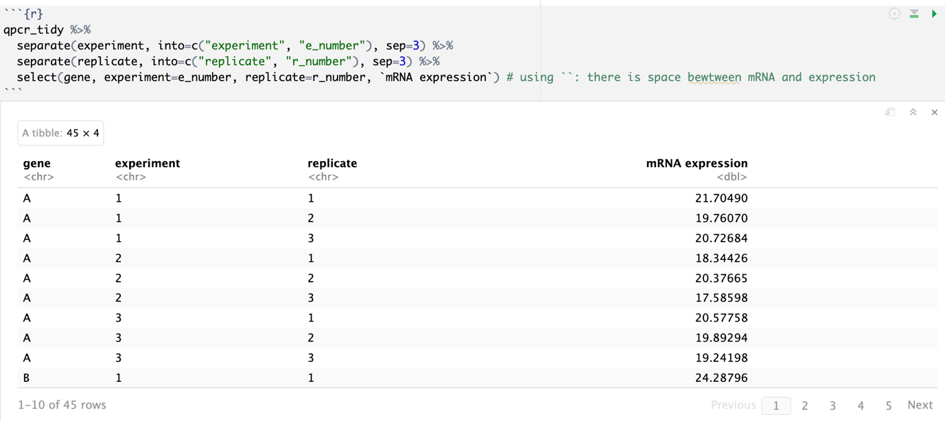
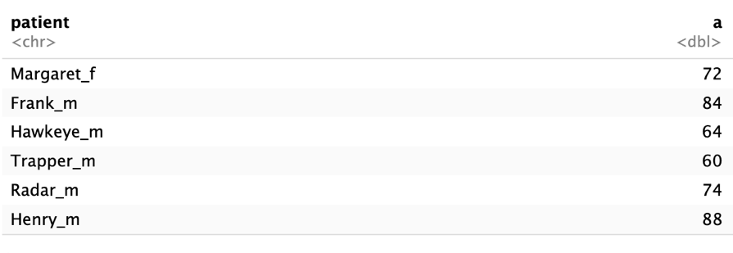
sep = "_" means:
“Use _ as the delimiter (split marker).”
So R:
- finds _
- splits there
- removes it
then ! is the delimiter.
So yes — :, !, _, -, @, #, space, etc. all work.

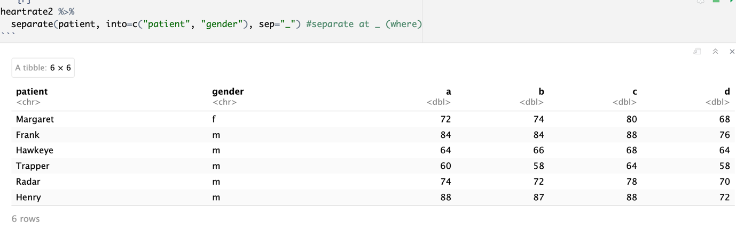
split 1 character from the end (right side)

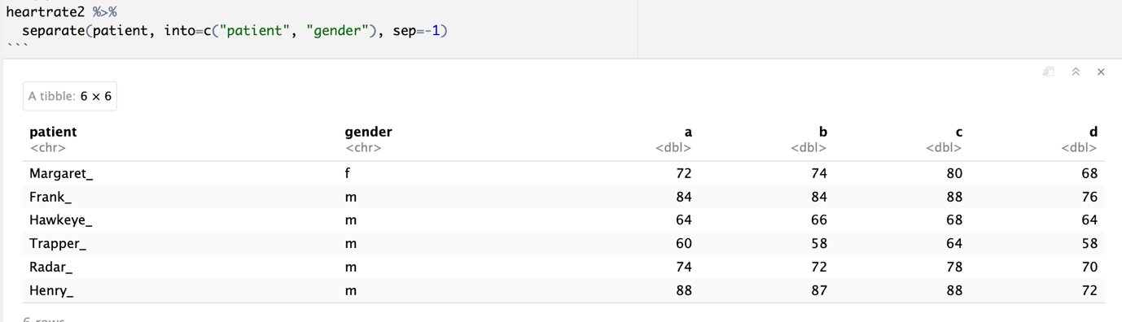
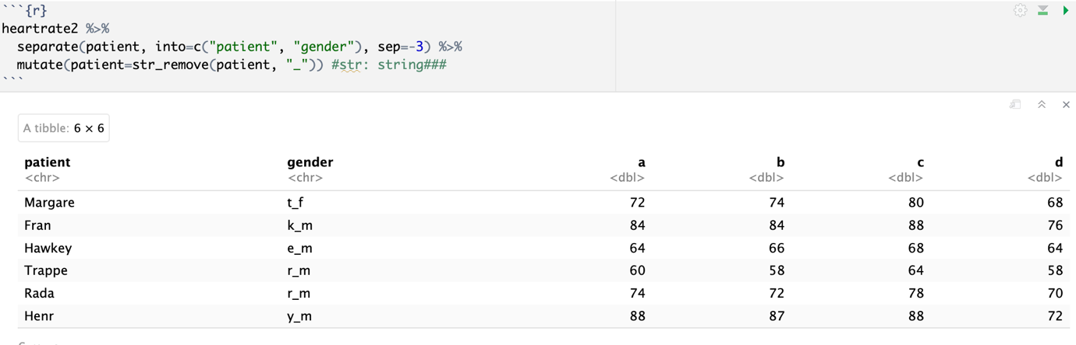

When sep is a number:
- positive → count from the left
- negative → count from the right
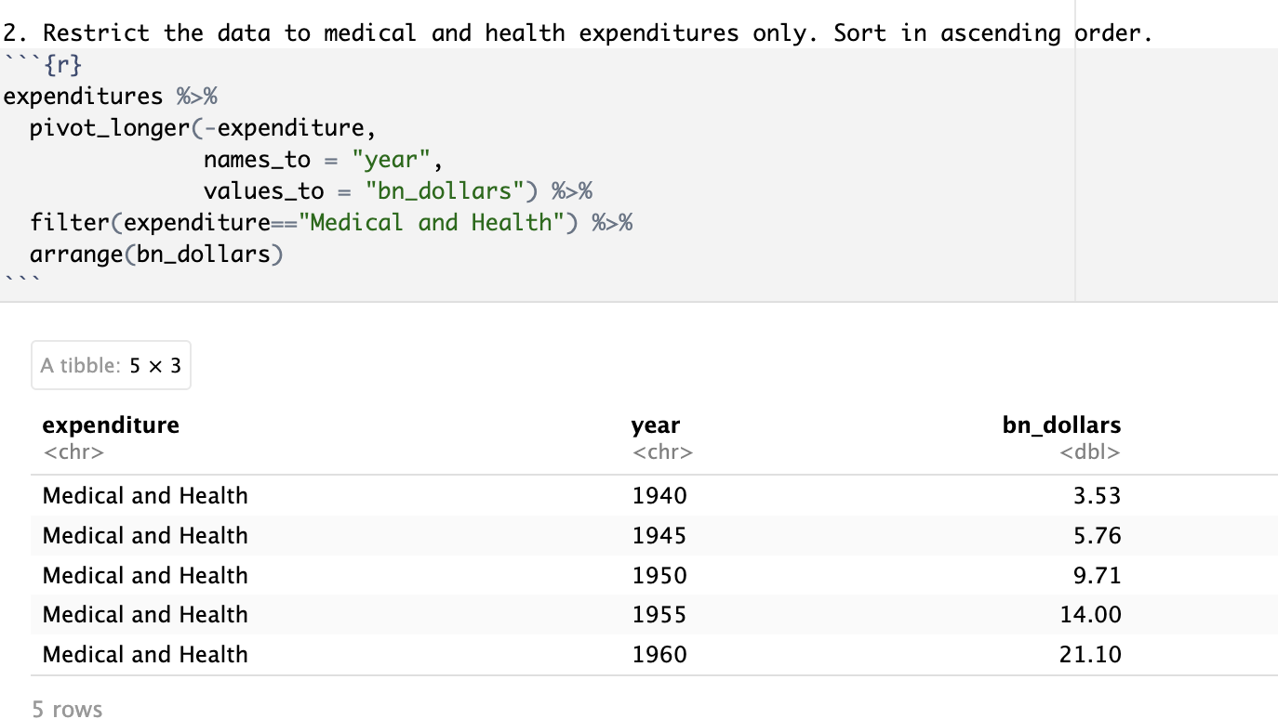

[text data (also called strings) are simply sequences of characters—letters, numbers, symbols, or even spaces—stored as character type. They are used to represent words, sentences, names, or any non-numeric information.
In R:
A column = a vector
A vector = many elements
Each element = one value
A string = one character value (one element)
So: one cell = one string (possibly many characters)

pivot_wider
+ `pivot_wider`(names_from, values_from)
+ `names_from` - Values in the `names_from` column will become new column names
+ `values_from` - Cell values will be taken from the `values_from` column
