Ultra-QuickSort
Time Limit: 7000MS |  | Memory Limit: 65536K
Total Submissions: 39880 |  | Accepted: 14381
Description
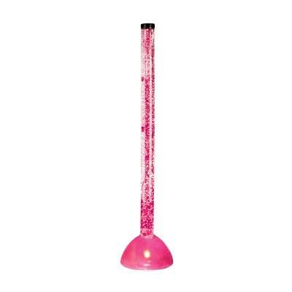
In this problem, you have to analyze a particular sorting algorithm. The algorithm processes a sequence of n distinct integers by swapping two adjacent sequence elements until the sequence is sorted in ascending order. For the input sequence
9 1 0 5 4 ,
Ultra-QuickSort produces the output
0 1 4 5 9 .
Your task is to determine how many swap operations Ultra-QuickSort needs to perform in order to sort a given input sequence.
Input
The input contains several test cases. Every test case begins with a line that contains a single integer n < 500,000 -- the length of the input sequence. Each of the the following n lines contains a single integer 0 ≤ a[i] ≤ 999,999,999, the i-th input sequence element. Input is terminated by a sequence of length n = 0. This sequence must not be processed.
Output
For every input sequence, your program prints a single line containing an integer number op, the minimum number of swap operations necessary to sort the given input sequence.
Sample Input
5
9
1
0
5
4
3
1
2
3
0
Sample Output
6
0
Source
Waterloo local 2005.02.05

#include <iostream>
using namespace std;
long long ans,t[500001],a[500001];
void mergesort(long long s,long long e)
{
//cout<<"!!!"<<endl;
if(s==e) return;
long long mid=(s+e)/2;
mergesort(s,mid);
mergesort(mid+1,e);
long long i=s;long long j=mid+1;long long now=0;
while(i<=mid&&j<=e)
{
if(a[i]<a[j])
{
//ans=ans+j-mid+1;

t[now++]=a[i++];
}
else
{ //int ans1=ans;
ans+=mid-i+1;//找前边比后边数大的数 j在不断移动 找的是j的逆序数对 而左边在前右边在后
//cout<<"a[i]="<<a[i]<<" a[j]="<<a[j]<<endl; cout<<"ans "<<ans<<"="<<ans1<<"+"<<mid<<"-"<<i<<"+1"<<endl;
t[now++]=a[j++];
}
}
while(i<=mid)
t[now++]=a[i++];
while(j<=e)
t[now++]=a[j++];
now=0;
for(long long k=s;k<=e;k++)
a[k]=t[now++];
}
int main()
{
long long n;
while(cin>>n&&n)
{
for(long long i=0;i<n;i++)
cin>>a[i];
ans=0;
mergesort(0,n-1);
/* for(long long i=0;i<n;i++)
cout<<a[i]<<" ";
cout<<endl;
*/ cout<<ans<<endl;
}
return 0;
}

深度搜索是否可行？？
#include <iostream>
using namespace std;
int times=0;
int dfs()
{
/////////////////////////

???如何避免其进入死循环？？？

////////////////////////
}
int main()
{
int a[1000],i,mark;
for(i=0;a[i-1]!=0;i++)
cin>>a[i];
mark=i;
//cout<<a[0]<<" "<<a[1]<<" "<<a[2];
dfs(a[i])
for(i=0;i<mark;i++)
cout<<a[i]<<" ";
cout<<endl;

return 0;
}

朴素的搜索：
#include <iostream>
#include <memory.h>
using namespace std;
int cnt[500001];
int main()
{
int a[500001],i,n,j,sum;
while(cin>>n&&n)
{ for(i=0;i<n;i++)
cin>>a[i];
memset(cnt,0,sizeof(cnt));
//cout<<a[0]<<" "<<a[1]<<" "<<a[2];
sum=0;
for(i=0;i<n;i++)
for(j=i;j<n;j++)
if(a[j]<a[i]) cnt[i]++;
for(i=0;i<n;i++)
sum=sum+cnt[i];
cout<<sum<<endl;

}

return 0;
}

