**Test file**

a+2*(7+b)/



a+2*(7(+b)/3

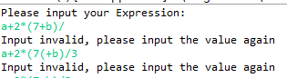

a+2*(7+b)/3

If we type the non-digit character into it will display

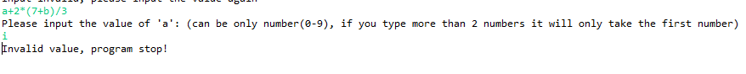

So after correct the input it will looks like

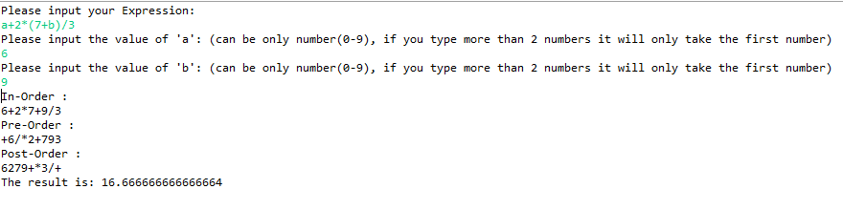

For the other example

