**ECE 233 Project Report**

**Hybrid Digital and Analog Beamforming Design**

**for Large-Scale Antenna Arrays**

**Ruoye Wang | 605625594**

**Yida Chen | 005852117**

**Abstract**

Abstract

TODO change figure number

**System Model**

This project implements a model proposed by the reference paper. This narrowband downlink single-cell multi-user MIMO system model has a two-stage hybrid digital and analog beamforming architecture at the base station (BS) and the user terminals. A picture containing diagram, plan, text, technical drawing

Figure 1: Block diagram of the model proposed by the paper

As the figure above shows, the BS has antennas and RF chains and serves users. Each user is equipped with antennas and RF chains, and requires data streams. The number of data streams required by each user; the total number of data streams .

TODO explain x, y

This project assumes single-user scenario, i.e., . To simplify the notation while preserving the generality, it is assumed that . The project first implements the hybrid beamformer design for the case where to show that, according to Proposition 1, a fully digital beamformer architecture can be realized by a hybrid structure with at least RF chains using a proposed heuristic algorithm. Then the same algorithm is implemented for the case where .

The symbols represent the digital precoder at the BS (size ), the RF precoder at the BS (size ), the digital combiner at the user end (size ), and the RF combiner at the user end (size ). (size ) is the matrix of the complex channel gains from the transmit antennas of the BS to the user (note that since , all can be represented by a single ; the same can be applied to other user-specific quantities in the paper).

**Main Part**

This paper mainly focuses on maximizing the overall spectral efficiency with total transmit power constrained and fully known. This requires us to find the optimal solution for precoders at the transmitter end and the combiners at the receiver end, which can be represented by this formula:

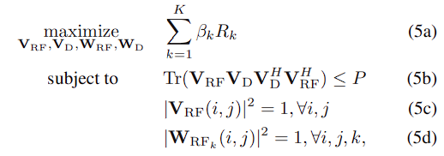

Figure 2: the formula representing the main problem (K=1, disregarding k)

This formula is calculated under the aforementioned cases and . It can be simplified for precoder design:

Figure 3: Precoder design formula

**scenario**

When , can be calculated by:

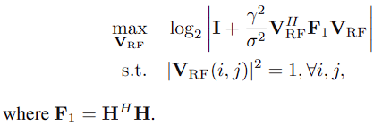

Figure 4: RF precoder design formula

Which is a simplification of Figure. 3 assuming . It is summarized in Algorithm 1:

Figure 5: Algorithm 1 to calculate RF precoder, with infinite resolution phase shifter

The formula to calculate is under the assumption of infinite phase shifters. Since accurate phase shifters can be expensive to implement in real world, they are commonly replaced by cost effective low resolution phase shifters. To simulate such phase shifters, the design of is quantized:

Figure : RF precoder design, with 1-bit resolution phase shifter

Then can be calculated by solving:

Figure 7: Digital precoder design formula

Where and .

We use a water-filling solution (Reference: [Waterfilling](https://zhuanlan.zhihu.com/p/502453127)) to allocate power to each channel so that the overall channel capacity is maximized. The sum of power satisfies:

Figure : Constraint on power allocation

Where the power of the first most efficient channels sum up to use to the largest extend. Since power cannot be negative:

Figure : Formula to calculate allocated power

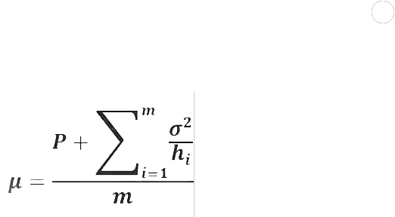Combining the above two formulas, the water level chosen to satisfy the power sum constraints with equality can be represented by:

Figure : Formula to calculate water level

is obtained by iterating through the number of total channels . In each iteration, is calculated using the above formula, and compared with , where represents noise and is the square of right singular value of the SVD result of , since in Figure 6, the matrices are applied twice on both left and right. Similarly, the diagonal elements of are all square roots of . (Reference: Ruifu Donar Li)

The final value of is chosen so that satisfies the power constraint, as the following figure shows:

Figure 11: Water-filling solution

Then the matrix of digital precoder can be calculated using the formula proposed by the paper:

Where is the set of right singular vectors corresponding to the largest singular values of and is the diagonal matrix of allocated powers to each stream.

With designed, the formula in Figure 3 can be simplified to:

Figure : RF combiner design formula

TODO W also quant

Due to its similarity to Figure 4, it can also be solved with Algorithm 1, with replaced by and since is large.

Finally, the optimal digital combiner can be obtained from its MMSE solution:

Figure : Digital combiner design formula

After have been obtained, the performance of the model can be evaluated by its spectral efficiency:

Figure 14: Formula of spectral efficiency

The above process is repeated for a range of SNR, and for each SNR value, spectral efficiency is averaged over 100 Monte Carlo trials.

**scenario**

As stated in the paper, this scenario can still be implemented using the aforementioned process. It is implemented for .

**Results and Discussion**

1. Plot the spectral efficiency vs. SNR in the range −10 dB to 6 dB, assuming a 64 × 16 MIMO system and .

The resulting figure is similar to Fig. 2 in the paper, with ~1.5dB difference on SNR values.

1. Plot the spectral efficiency vs. SNR in the range 0 dB to 30 dB, assuming a 10 × 10 MIMO system, , and phase shifters with 1-bit and infinite resolutions.

TODO discussion

1. Plot the spectral efficiency vs. SNR in the range −10 dB to 6 dB, assuming a 64 × 16 MIMO system, , and phase shifters with 1-bit and infinite resolutions.

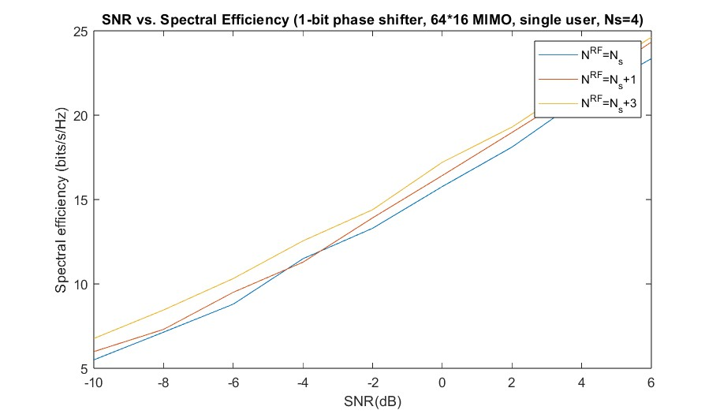

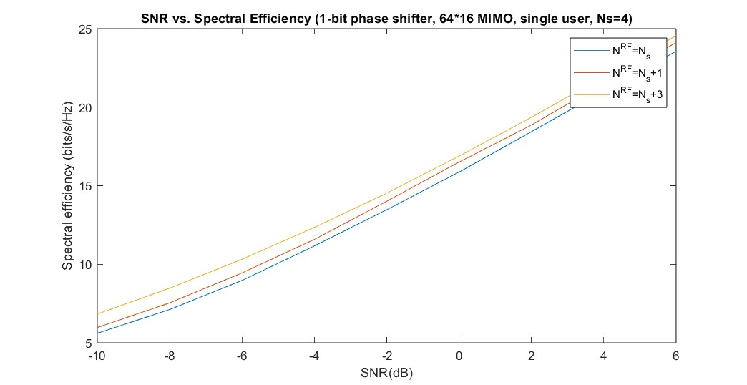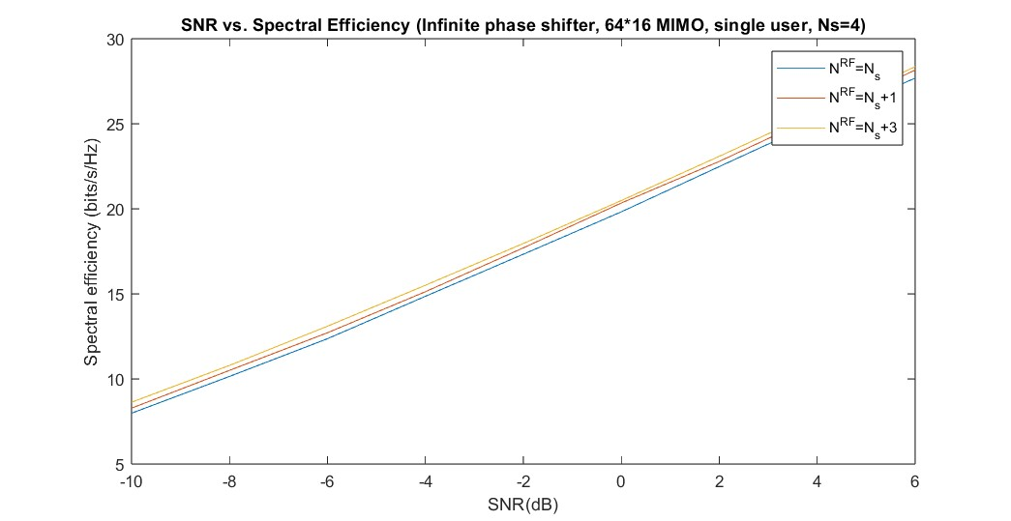TODO discussion

**Conclusion**

Conclusion