Homework 3

Ruoyuan Qian

# Problem 2

## a)

According to Table 1 and Plot 1, the median of survival times in Breast group is significantly different from others whereas the median of Stomach is similar to the median of Bronchus as well as the median of Colon is similar to the median of Ovary. The range and IQR of Breast and Ovary groups are much larger than others, which means they are more dispersed. Furthermore, the sample size of Ovary is much smaller than others.

According to Plot 1 and 2, the distributions of Stomach and Ovary groups are heavily skewed, so median and IQR are more suitable and accurate to be descriptive statistics in the situation.

Table 1 Descriptive statistics of each group

|  |  |  |  |  |  |  |
| --- | --- | --- | --- | --- | --- | --- |
| **ORGAN** | **N** | **Mean** | **SD** | **Median** | **IQR** | **Range** |
| Stomach | 13 | 286 | 346.31 | 124 | 46-396 | 25-1112 |
| Bronchus | 17 | 211.59 | 209.86 | 155 | 72-245 | 20-859 |
| Colon | 17 | 457.41 | 427.17 | 372 | 189-519 | 20-1843 |
| Ovary | 6 | 884.33 | 1098.58 | 406 | 239.75-1039.5 | 89-2970 |
| Breast | 11 | 1395.91 | 1238.97 | 1166 | 723-1692.5 | 24-3808 |

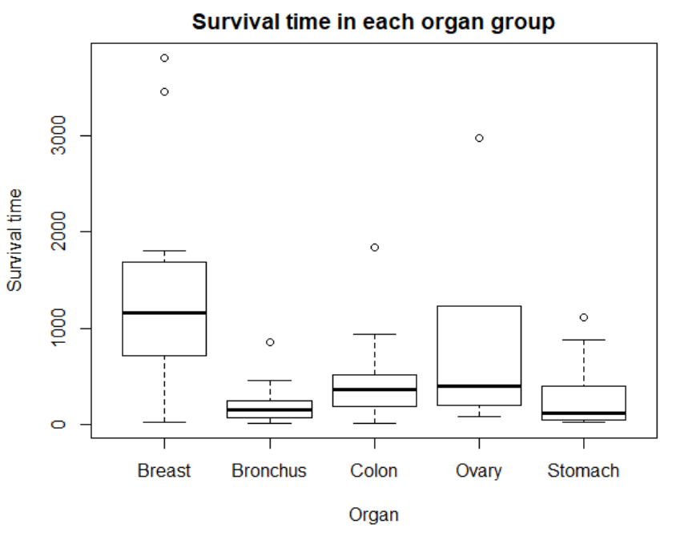

Plot 1 Boxplot of survival times by group

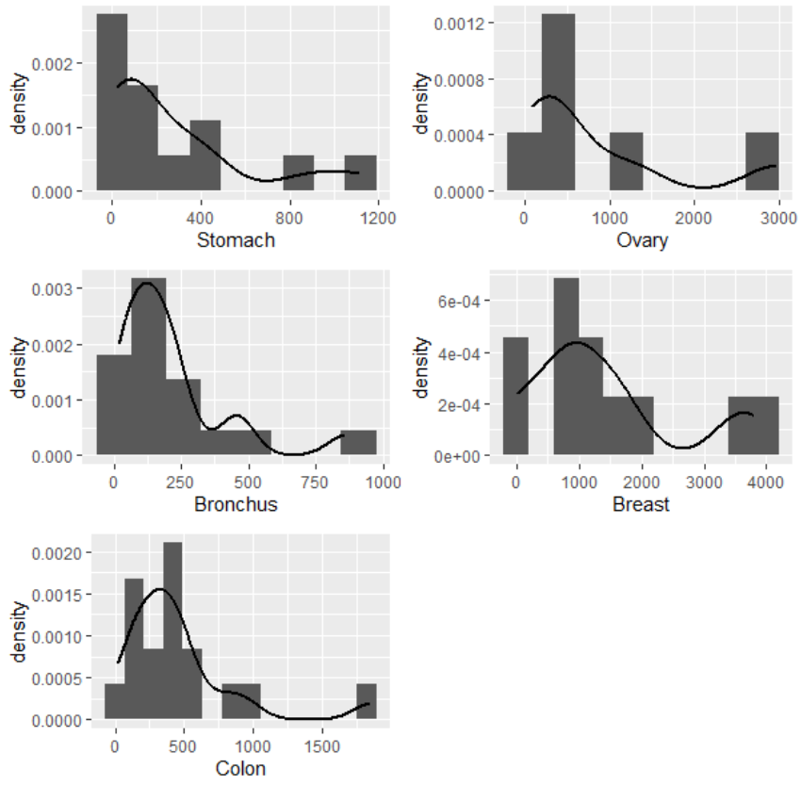

Plot 2 Distributions of organ groups

## b)

(1) Population parameter of interest:

The true means of survival times of 5 organ groups(Stomach: , Bronchus: , Colon: , Ovary: , Breast: ).

(2) Hypothesis:

,

*at least two group means are different*

(3) Significant level: 

(4) Assumption: Normality assumed.

(5) Form of the test statistic and its null distribution:











 under the null hypothesis



Table 2 ANOVA table

|  |  |  |  |  |  |
| --- | --- | --- | --- | --- | --- |
| **Source** | **Df** | **Sum of Square (SS)** | **Mean Sum of Square** | **F-Statistics** | **P-value** |
| Between | 4 | 11535761 | 2883940 | 6.433 | 0.000229 |
| Within | 59 | 26448144 | 448274 |  |  |
| Total | 63 | 37983905 |  |  |  |

(6) Decision rule:

Reject  if 

(7) Interpretation:

Since , we reject the null hypothesis with 0.01 significance level, and we conclude that at least two group means are different.

## c)

Pairwise comparisons:

1. Bonferroni adjustment:

Based on part b), here we have 10 comparisons (). The adjusted significance level is:



We can also adjust *P*-value to do pairwise comparison. Implementing the Bonferroni method through R software, we can get adjusted *P*-values in the Table 3 (the adjusted *P*-values are compared with original significant level, which is 0.01 in this case).

Table 3 *P*-value of pairwise comparisons under Bonferroni adjustment

|  |  |  |  |  |
| --- | --- | --- | --- | --- |
|  | Breast | Bronchus | Colon | Ovary |
| Bronchus | 0.00025 | - | - | - |
| Colon | 0.00608 | 1.00000 | - | - |
| Ovary | 1.00000 | 0.38575 | 1.00000 | - |
| Stomach | 0.00153 | 1.00000 | 1.00000 | 0.75283 |

According to Table 3, at 0.01 significant level, we can conclude that there is significant difference between Breast-Bronchus, Breast-Colon, Breast-Stomach, respectively.

1. Tukey adjustment:

Assume that denotes the comparison between *i* th and *j* th group().

The hypothesis is:



Significant level:



Form the test statistic and its null distribution:



where,  is the overall number of group, is the total number of observation in all groups. *q* represents studentized range distribution in which parameters are k and n-k. We reject the null if . Here we have 10 pairwise comparisons which result in 10 *P*-values:

Table 4 *P*-value of pairwise comparisons under Tukey adjustment

|  |  |  |  |  |
| --- | --- | --- | --- | --- |
|  | Breast | Bronchus | Colon | Ovary |
| Bronchus | 0.000239 | - | - | - |
| Colon | 0.005307 | 0.82084 | - | - |
| Ovary | 0.56309 | 0.227108 | 0.665912 | - |
| Stomach | 0.001396 | 0.998146 | 0.956829 | 0.377292 |

According to Table 4, at 0.01 significant level, we can conclude that there is significant difference between Breast-Bronchus, Breast-Colon, Breast-Stomach, respectively.

1. Dunnett adjustment:

Table 5 *P*-value of pairwise comparisons under Dunnett adjustment

|  |  |
| --- | --- |
| $Breast | p-value |
| Bronchus-Breast | 9.10*10-5 |
| Colon-Breast | 0.00221 |
| Ovary-Breast | 0.36692 |
| Stomach-Breast | 0.00056 |

According to Table 5, at 0.01 significant level, we can conclude that there is significant difference between Breast-Bronchus, Breast-Colon, Breast-Stomach, respectively.

Conclusion:

At 0.01 original significant level, all methods detect identical combinations of comparison, which means all of 3 methods give the same result. For example, take ‘Breast’ group as reference, all methods detect significant difference in Bronchus-Breast, Colon-Breast and Stomach-Breast.

The difference among the three is that Dunnett’s method mainly focuses on the comparisons with pre-defined control arm while the others control for all pairwise comparisons, and Tukey’s method is less conservative than Bonferroni.

## d)

According to Plot 3, all distributions are extremely skewed, and points in all the Q-Q plots are not linear except Colon group. And then Shapiro-Wilk test is performed to test normality as well.

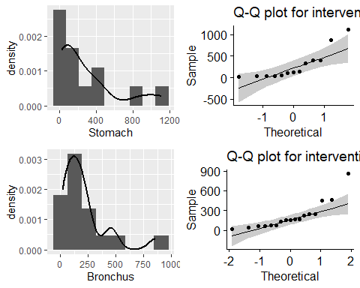

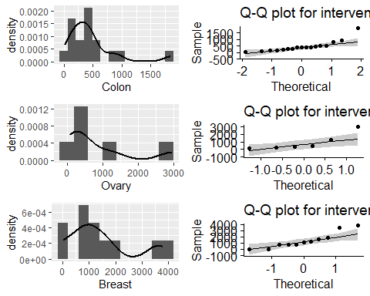

Plot 3 Distributions and Q-Q plots for each Organ group

Shapiro-Wilk test:

Hypothesis:

*The data are sampled from a population having a normal distribution*

*The data are sampled from a population not having a normal distribution*

Table 6 *P*-value of Shapiro-Wilk test for each group

|  |  |
| --- | --- |
| **Data** | **p-value** |
| Stomach | 0.002075 |
| Bronchus | 0.0007186 |
| Colon | 0.0006134 |
| Ovary | 0.029 |
| Breast | 0.07431 |

From the Table 6, we can get the similar conclusion as above, at 0.05 significance level, we reject the null and conclude that there is sufficient evidence that the underlying distributions of all groups are not normal except for Breast group.

As a result, the underlying assumption of ANOVA is questionable.

### i)

Transformation can be done to transform the data into normality.

Kruskal-Wallis (KW) test can be used when the normality is questionable.

### ii)

1. Transformation

Log-transformation is done, density and Q-Q plots are rebuilt based on log-survival times. However, according to Plot 4, the distributions of Stomach and Breast groups are still not normal, so the log-transformation is not suitable in the situation.

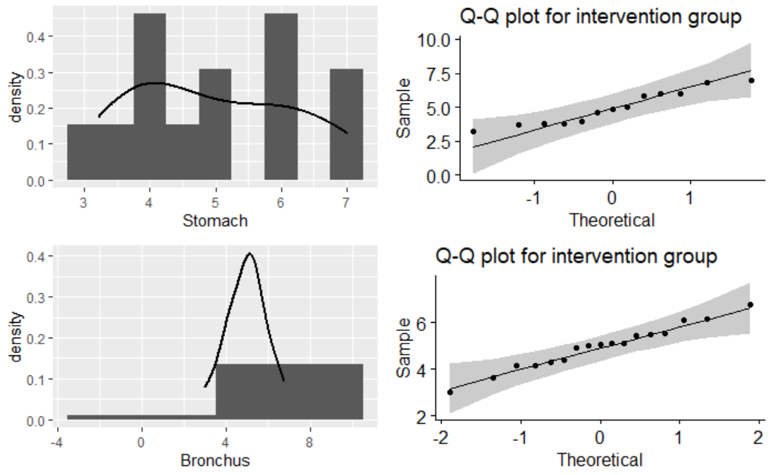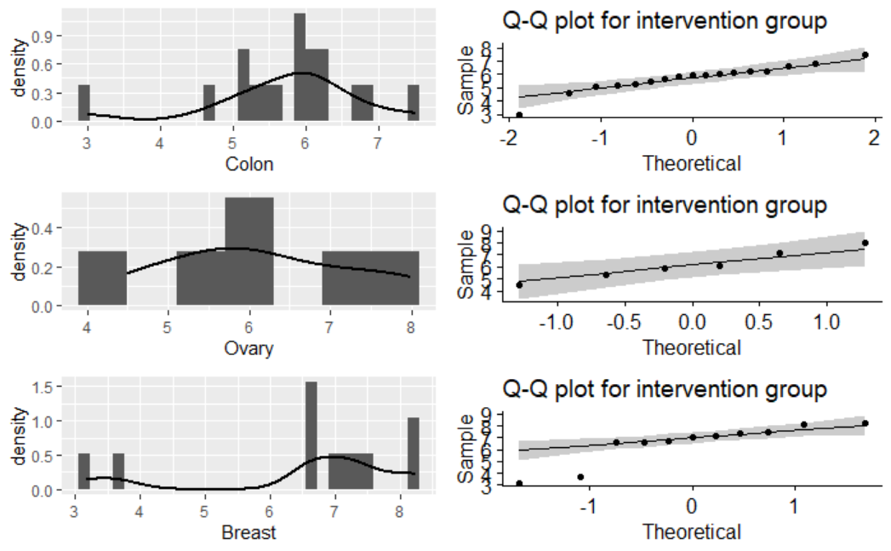

Plot 4 Distributions and Q-Q plots for each Organ group after log-transformation

1. Kruskal-Wallis (KW) test:

KW test can be done by R software.

## Kruskal-Wallis chi-squared = 14.954, df = 4, p-value = 0.004798

Since, we reject the null hypothesis with 0.01 significance level, and we conclude that at least two group medians are different.

1. ANOVA analysis:

The ANOVA analysis can be referred from the Problem 2 b).

Table 2 ANOVA table

|  |  |  |  |  |  |
| --- | --- | --- | --- | --- | --- |
| **Source** | **Df** | **Sum of Square (SS)** | **Mean Sum of Square** | **F-Statistics** | **P-value** |
| Between | 4 | 11535761 | 2883940 | 6.433 | 0.000229 |
| Within | 59 | 26448144 | 448274 |  |  |
| Total | 63 | 37983905 |  |  |  |

Conclusion:

Both of tests(Kruskal-Wallis (KW) test, ANOVA) reject the null and detect the difference among 5 groups. However, the ANOVA deal with the means while Kruskal-Wallis (KW) test deal with the medians.

# Problem 3

## a)

Assume that placebo and iron groups are denoted as Group 1 (non-zinc group), zinc and zinc+iron groups are denoted as Group 2 (non-zinc group). And let *a, b, c, d* denote the original groups: placebo, iron, zinc, zinc+iron, respectively.

Let denotes the average of Group 1, denotes the average of Group 2, *d* denotes the difference in the averages, , ,, denote the sample sizes and means in original groups: placebo and iron, respectively.

,

,

,

## b)

Since, , then we can calculate the standard deviation for each original group:

,

,

,



F test can be conducted to detect if the variancesin placebo (*a*) and iron (*b*) groups are equal.

Population of interest:

The true variance in placebo (*a*) and iron (*b*) groups.

Hypothesis:



With the significant level pre-specified with 0.05, compute the test statistics:

,

 ,

Since , at 0.05 significant level, we fail to reject the null and conclude that the variances of placebo and iron groups are equal.

As the test above, the variances of Group zinc (*c*) and Group zinc+iron (*d*) can be tested similarly.

Hypothesis:



With the significant level pre-specified with 0.05, compute the test statistics:

,

 ,

Since , at 0.05 significant level, we fail to reject the null and conclude that the variances of zinc and zinc+iron groups are equal.

Then we can calculate the variances of Group 1 and Group 2.





## c)

### i)

We have known that ‘true’ effect size is , the ‘true’ variances are , , , , and , in the study two-sided significance test is used：





We need to enroll 87 subjects for each group.

### ii)

We have known that ‘true’ effect size is, the ‘true’ variances are , , , , and , in the study two-sided significance test is used:





We need to enroll 104 subjects for non-zinc group and 52 subjects for zinc group.