Project Development Documentation

Group Members Details
Sr No | Name | Roll Number
1 | Anushka Marcelo | 2511
2 | Riya Bandekar | 2532
3 | Rupali Arlekar | 2535
4 | Samiksha Karapurkar | 2539

Topic of the Mini Project
Blood Bank and Donor Management System

Objective of the Mini Project
The objective of the Blood Bank and Donor Management System is to develop a web-based platform that enables patients, hospitals, and blood banks to quickly find suitable blood donors during emergencies.
The system allows individuals to register as blood donors by providing their blood group, contact details, and location. Patients can search for donors based on blood group and location and submit blood requests when required.
The system stores all donor and request information in a centralized database and provides an admin panel for efficient management of donor records and blood requests.
This project aims to improve communication between donors and patients, reduce response time in emergencies, and make the blood donation process more organized and accessible.
Features of the Website
Donor Registration
Search Donor
Blood Request Form
Donor List Display
Admin Panel
Database Storage
Responsive Website
Admin Authentication
Request Approval & Status Management

Different Web Pages of the Website
1. Home Page
Displays information about blood donation and provides navigation to different sections of the website.
2. About Page
Provides information about the importance of blood donation and explains the purpose and working of the system.
3. Donor Registration Page
Allows users to register as blood donors by entering their personal details, blood group, and contact information.
4. Search Donor Page
Allows patients to search for available donors based on blood group and location, and view matching donor details
5. Blood Request Page
Allows patients or hospitals to submit blood requests by providing patient details, hospital name, and contact information.
6. Contact Page
Provides contact details such as email, phone number, and address for user support and communication.
7. Admin Login Page
Allows the administrator to securely log into the system using authentication credentials
8. Admin Dashboard
Allows the admin to manage donors and blood requests, including viewing records, deleting donors, and approving or rejecting requests.

SYSTEM MODULES
Donor Module
Handles donor registration and stores donor details in the database.
Search Module
Allows users to search donors based on blood group and location.
Request Module
Allows patients to submit blood requests and stores them in the system.
Admin Module
Provides secure access to the admin for managing donors and handling blood requests.

Weekly Project Report
Week 1: 22/02/2026
- Brainstorming and idea discussion
- Finalized project topic
- Identified core features
- Basic UI requirement discussion
Week 2: 02/03/2026
- Installed development environment (XAMPP)
- Setup Apache and MySQL server
- Created database
- Designed database tables
Week 3: 12/03/2026
- Built initial UI pages (Home, Register, Search)
- Implemented Donor Registration form
- Developed Search functionality (by blood group)
- Connected frontend with database
Week 4: 15/03/2026
- Created project folder structure
- Organized files into modules (config, donor, request, css)
- Implemented database connection (database.php)
- Tested form data insertion
Week 5: 21/03/2026
- Developed Blood Request module
- Created Request Form for patients/users
- Implemented form validation (required fields, contact format)
- Stored request data into database
- Displayed success and error messages
Week 6: 31/03/2026
- Developed Admin Panel
- Implemented Admin Login system using sessions
- Created Admin Dashboard
- Built “View Donors” module
- Implemented Delete Donor functionality
- Built “View Requests” module
Week 7: 04/04/2026
- Implemented Request Approval system
- Fixed database column mismatches and errors
- Improved UI and layout (forms, tables, cards)
- Added About and Contact pages
- Improved navigation (clean navbar + footer links)
- Performed system testing and debugging

Erd
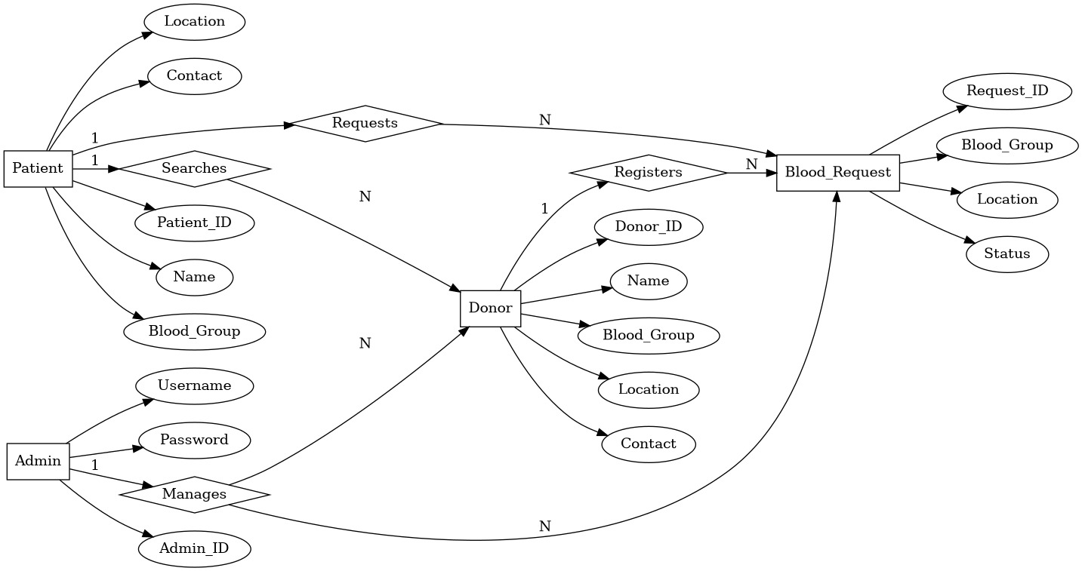
Use case
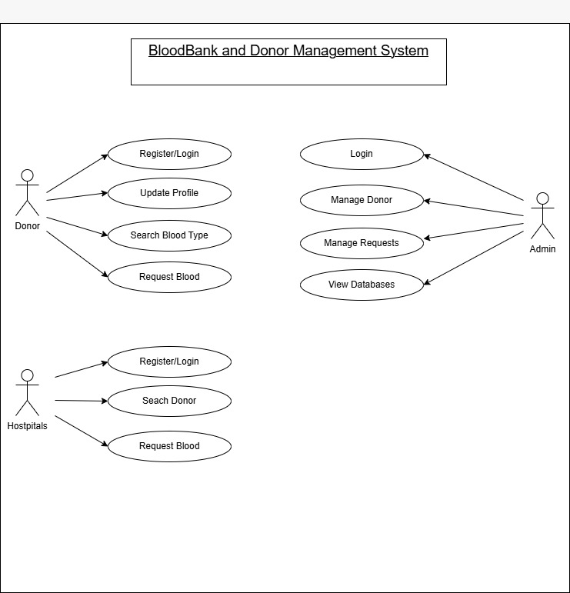
Activity
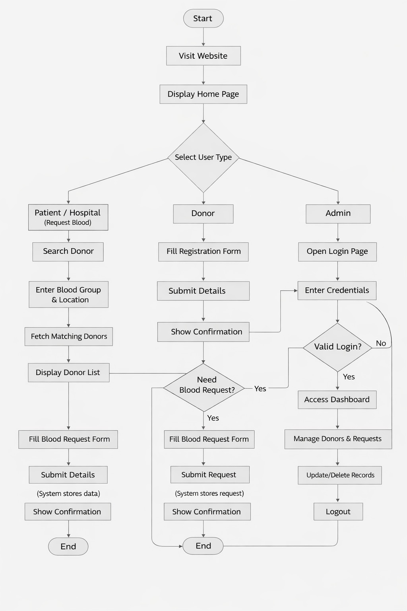
Sequence

