Ex.no:4b | EXPLORATORY DATA ANALYSIS (EDA) – DATA INSPECTION, FILTERING, STATISTICAL ANALYSIS AND CORRELATION

Aim:
To perform data inspection, filtering, sorting, grouping, aggregation, descriptive statistical analysis, and correlation analysis on the Diabetes Prediction dataset using Pandas, and to visualize the analytical results using Matplotlib.
Algorithm:
Algorithm 1: Dataset Inspection
- Import the Diabetes Prediction dataset.
- Display the complete dataset.
- Display the first five records of the dataset.
- Check the dimensions of the dataset.
- Display the data types of the attributes.
- Generate a statistical summary of the numerical attributes.
Algorithm 2: Filtering Diabetic Records
- Select the diabetes attribute.
- Specify the filtering condition as diabetes == 1.
- Apply the condition to the dataset.
- Display the filtered diabetic records.
Algorithm 3: Filtering Female Records
- Select the gender attribute.
- Specify the filtering condition as gender == "Female".
- Apply the condition to the dataset.
- Display the filtered female records.
Algorithm 4: Sorting Data
- Select the blood_glucose_level attribute.
- Apply the sort_values() function.
- Specify descending order.
- Display the sorted records.
Algorithm 5: Statistical Analysis
- Select the blood_glucose_level attribute.
- Calculate the mean.
- Calculate the median.
- Calculate the mode.
- Calculate the standard deviation.
- Display the calculated statistical measures.
Algorithm 6: Grouping and Aggregation
- Select the categorical attribute gender.
- Apply the groupby() function.
- Select the blood_glucose_level attribute.
- Calculate the average blood glucose level.
- Sort the grouped results in descending order.
- Display the grouped results.
Algorithm 7: Visualization
- Select the average blood glucose values grouped by gender.
- Create a bar chart using Matplotlib.
- Add the title and y-axis label.
- Display the graph.
Algorithm 8: Correlation Analysis
- Select the numerical attributes age, bmi, HbA1c_level, blood_glucose_level, and diabetes.
- Apply the corr() function.
- Generate the correlation matrix.
- Display the correlation coefficients between the selected attributes.

# Import libraries

import pandas as pd

import matplotlib.pyplot as plt

import seaborn as sns

# Read dataset

df = pd.read_csv("diabetes_prediction_dataset.csv")

# Display dataset

print(df)

# Display first five records

print(df.head())

# Display shape

print(df.shape)

# Display data types

print(df.dtypes)

# Display statistical summary

print(df.describe())

# Display diabetic records

diabetic = df[df["diabetes"] == 1]

print(diabetic.head())

# Display female records

female = df[df["gender"] == "Female"]

print(female.head())

# Sort by blood glucose level

sorted_df = df.sort_values(
by="blood_glucose_level",
ascending=False
)

print(sorted_df.head())

# Calculate mean

print("Mean :",
df["blood_glucose_level"].mean())

# Calculate median

print("Median :",
df["blood_glucose_level"].median())
# Calculate mode

print("Mode :")

print(df["blood_glucose_level"].mode())

# Calculate standard deviation

print("Standard Deviation :",
df["blood_glucose_level"].std())

# Calculate average blood glucose by gender

gender_avg = df.groupby("gender")[
"blood_glucose_level"
].mean()

print(gender_avg.sort_values(
ascending=False
))
# Plot average blood glucose by gender

gender_avg.sort_values(
ascending=False
).plot(kind="bar")
plt.title(
"Average Blood Glucose Level by Gender"
)
plt.ylabel(
"Average Blood Glucose Level"
)

plt.show()

# Calculate correlation

corr = df[
[
"age",
"bmi",
"HbA1c_level",
"blood_glucose_level",
"diabetes"
]
].corr()

print(corr)

Output:
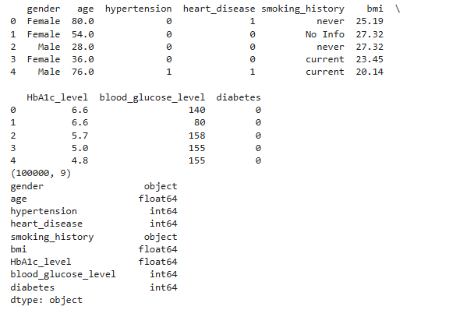
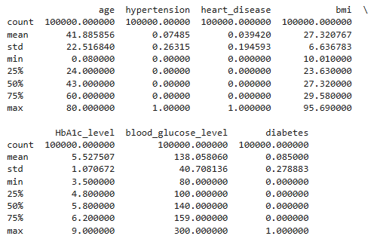

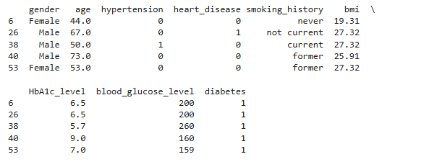
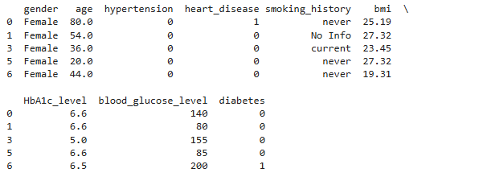

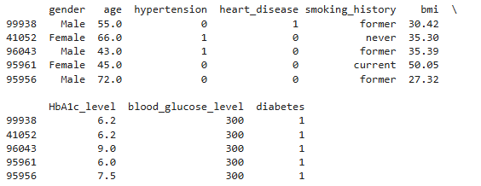
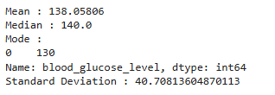
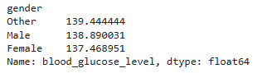
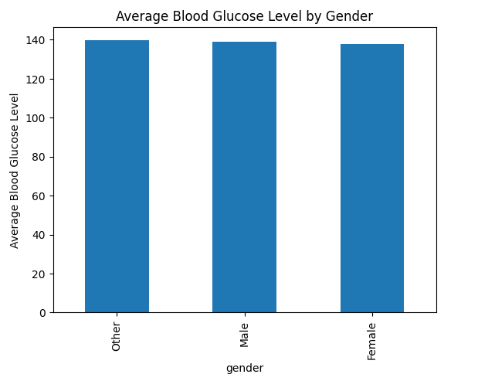
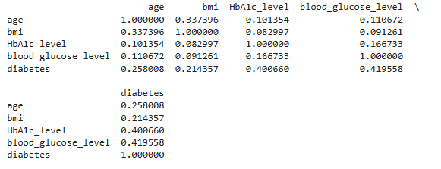

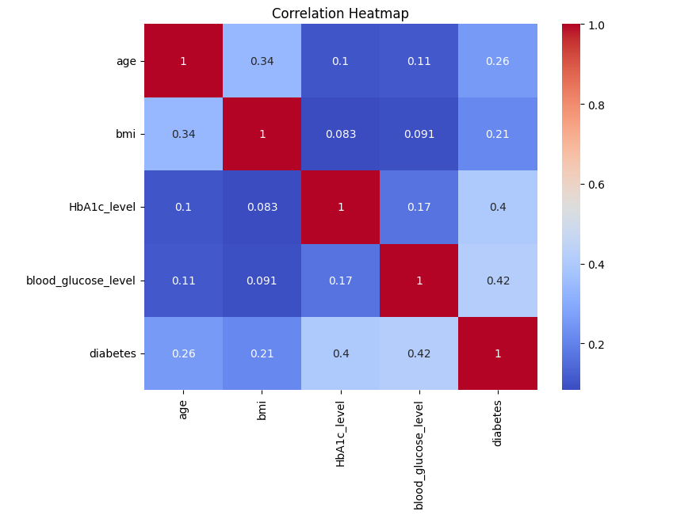
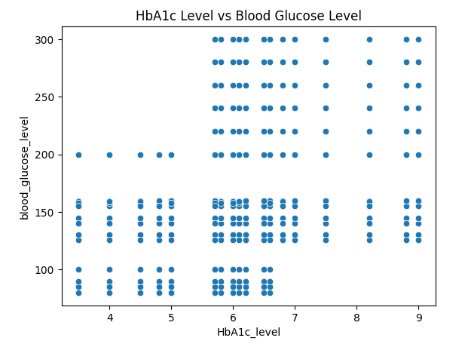
Result:

