**Solent University**

**Web Technologies (COM419)**

**Author: 10336036**

**Tutor: Tendai Mhlanga**

**Date: 1/10/2024**

**Theme Park**

**Contents**

Introduction: 3

Technology: 3

1. HTML and CSS: 3

2. JavaScript: 4

3. Node.js, Express, and EJS 4

4. SQLite3 4

Layouts & Partials: 4

AJAX Implementation: 5

Website Pages: 6

1. Home Page (Landing Page): 6

2. Areas Page: 7

3. FAQ Page: 8

4. Contact Page: 8

5. Rides Page: 9

W3C Compatibility: 10

Legal and Ethical Considerations: 10

Security Measures: 11

Database Structure and Entity-Relationship Diagram (ERD): 11

Responsive Design: 13

Form Validations: 14

Testing and Browser Compatibility: 15

Conclusion and Evaluation: 15

# Introduction:

The report describes the website's progress and promotes a new entertainment park. The website's main purpose is to provide a detailed and engaging overview of the park's themed zones, rides, and attractions from various angles. The website promotes the park and its amenities. Reservations and ticket sales are prohibited. The primary objective of the website is to effectively showcase the park's attractions.

Users of mobile devices, tablets, and desktops can effortlessly navigate the theme park's website. Both adults and children will appreciate the park's vibrant and fanciful design, inspired by Thorpe Park and Paultons Park. This statistic aids parks in attaining objectives. The academic paper encompasses all website technologies. Express, SQLite3, Node.js, JavaScript, HTML, and CSS are incorporated. The manual addresses website architecture, essential components, security, ethical and legal considerations, and WWWC compliance.

# Technology:

Many front-end and back-end technologies were used to build the theme park's website. For an intriguing and engaging user experience, all of this was done. Node.js is optimised for server-side operations, whereas JavaScript is client-side exclusively. HTML and CSS are necessary for website foundations and designs. Additionally, client-side interactive elements employ JavaScript. As a templating engine, EJS lets websites deliver dynamic content. It may also use an SQLite3 database to store park-themed elements, attractions, and contact form submissions.

## HTML and CSS:

The website's structure is constructed using HTML for semantic coherence and organisation. CSS augments aesthetic appeal by facilitating modifications to colour, layout, and animation. CSS variables and media queries guarantee uniform performance across devices, whereas animations such as flashing park hours emphasise essential information.

## JavaScript:

JavaScript, an essential part of website development, enabled interactive elements. This innovation lets us verify forms on the client side, handle user interactions, and change information in real-time without refreshing the page. JavaScript handles contact form validation, theme zone-based real-time ride screening and AJAX-based asynchronous data queries.

## Node.js, Express, and EJS

Server-side programming was done in Node.js. It reduced development time, made code simpler to maintain, and allowed the creation of a full-featured web app using one technology. Express is a simple Node.js web framework for server setup and routing. Encapsulated JavaScript templating engine dynamically built HTML pages. This also streamlined server-to-client data transfer.

## SQLite3

SQLite3 was selected for this project because of its compactness and superior performance in moderate to large-scale applications. The database comprises contact form data, theme park attractions, and themed zone details. SQLite3 streamlines database interactions, delivering high speed and dynamic functionality for an enhanced user experience. This was achievable since the website included these technologies.

# Layouts & Partials:

Websites use modular design to make code more reusable and maintainable. Entity-Job Sharing facilitates shared component partitioning, thereby streamlining code and accelerating page updates. Layouts and partials facilitate the implementation of global design modifications while preserving consistency. The Express application generator standardises file and directory organisation by utilising header.ejs, footer.ejs, and nav.ejs to eliminate code redundancy and enhance code management. With these partials in the main layout file, the website's architecture and appearance will be similar across all pages.

# AJAX Implementation:

AJAX updates a small page without refreshing. This simplifies and speeds up interactions, improving user experience. The theme park's website uses AJAX to collect and display data. Ride and themed website are especially affected.   
JavaScript requests theme zone rides from the server using AJAX. This server returns JSON after searching SQLite for data. Client-side JavaScript instantly modifies the Document Object Model (DOM) to deliver rides without reloading the page after processing this information. Only AJAX apps can use Fetch API. This API replaces XMLHttpRequest with a better one. Fetch API promises code simplification. Below is an AJAX request that is conducted when a user chooses a themed zone:

**Screenshot of JavaScript used in my project:**

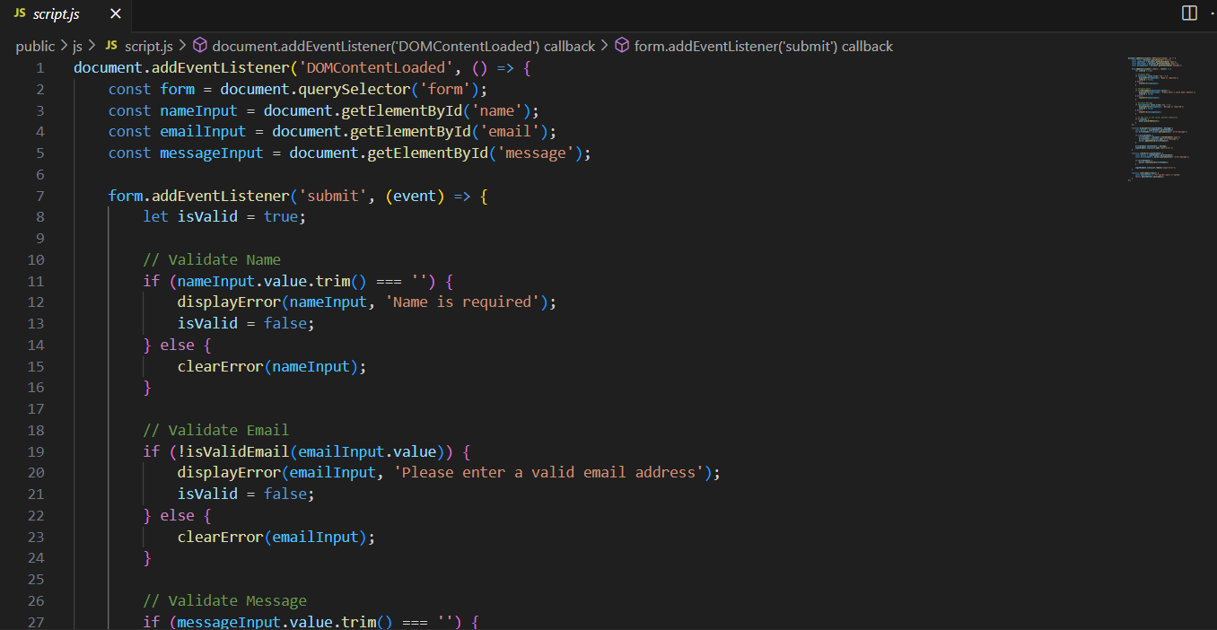

This strategy ensures that the website remains efficient and responsive, with real-time adjustments in response to user inputs.

# Website Pages:

The theme park website consists of several key pages, each designed to provide specific information and functionality. Below is a detailed description of each page and its purpose:

## Home Page (Landing Page):

The homepage serves as the website's initial impression and overview of the theme park, making it essential. The facility accommodates tourists. This banner attracts visitors, provides an overview of the park, and emphasises the most popular attractions. The animation displays the operating hours of the theme park. Visitors can swiftly transition between themed zones and attractions via the website's links. The following website elements are indispensable. An aesthetically pleasing and intuitive homepage design motivates park visitors to investigate. The tone across the site will be consistent with that of the homepage.

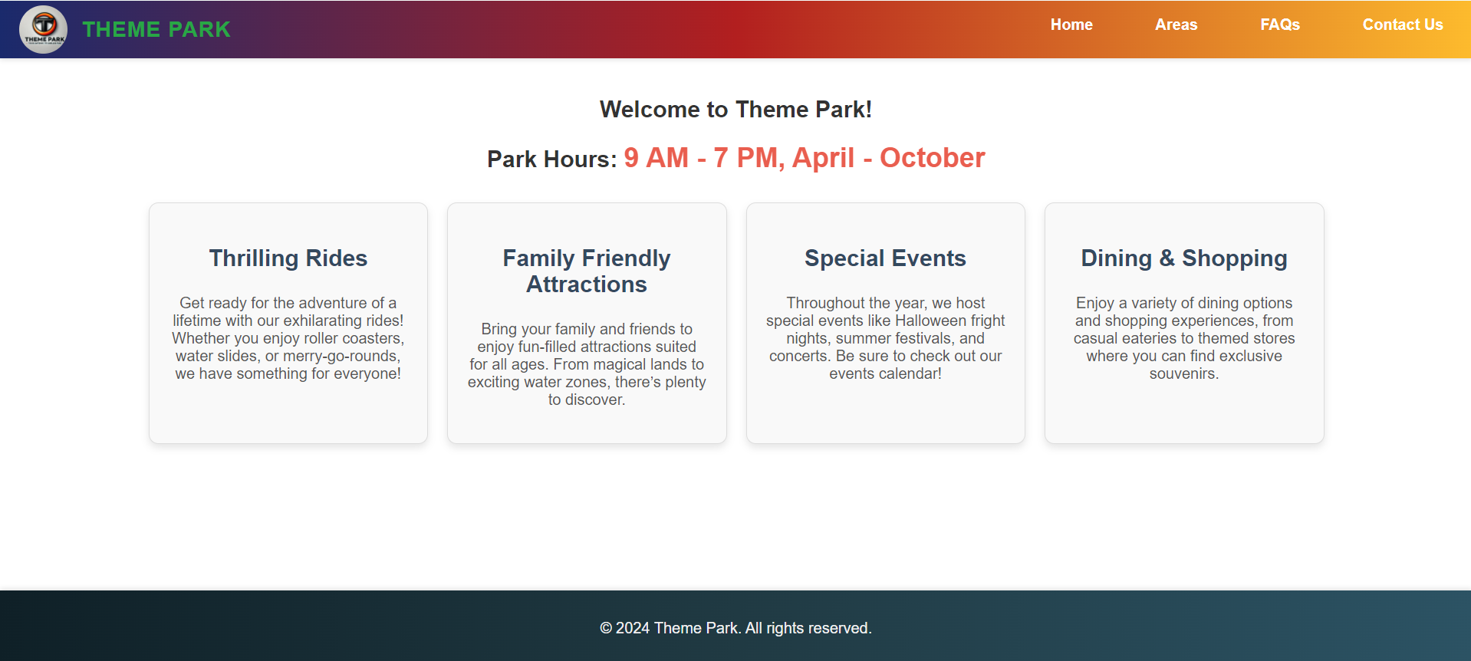

## Areas Page:

The Areas Page provides a detailed look at the various themed areas within the park. Each area is represented with a descriptive card that includes an image, name, and a brief description of the theme. Users can click on a specific area to view the associated rides and attractions, which are dynamically loaded via AJAX. This page emphasises the variety and uniqueness of each area, helping visitors to plan their visit by exploring what each section of the park has to offer.

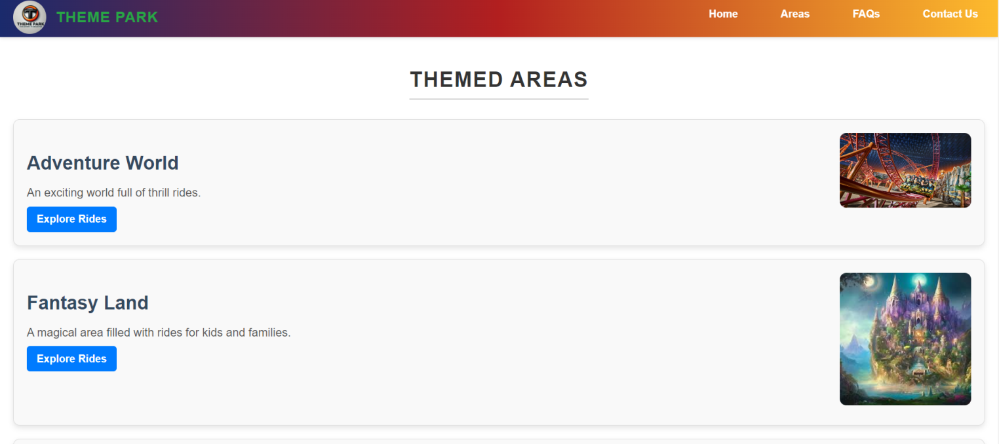

## FAQ Page:

The website features a "Frequently Asked Questions" (FAQ) section that addresses common enquiries related to the theme park. Enquiries pertain to park hours, accessibility, and visitor regulations. Structuring enquiries enhances the website's usability. This navigation is streamlined. This section offers concise, straightforward responses to frequently asked customer support questions regarding the park, aimed at minimising enquiries. 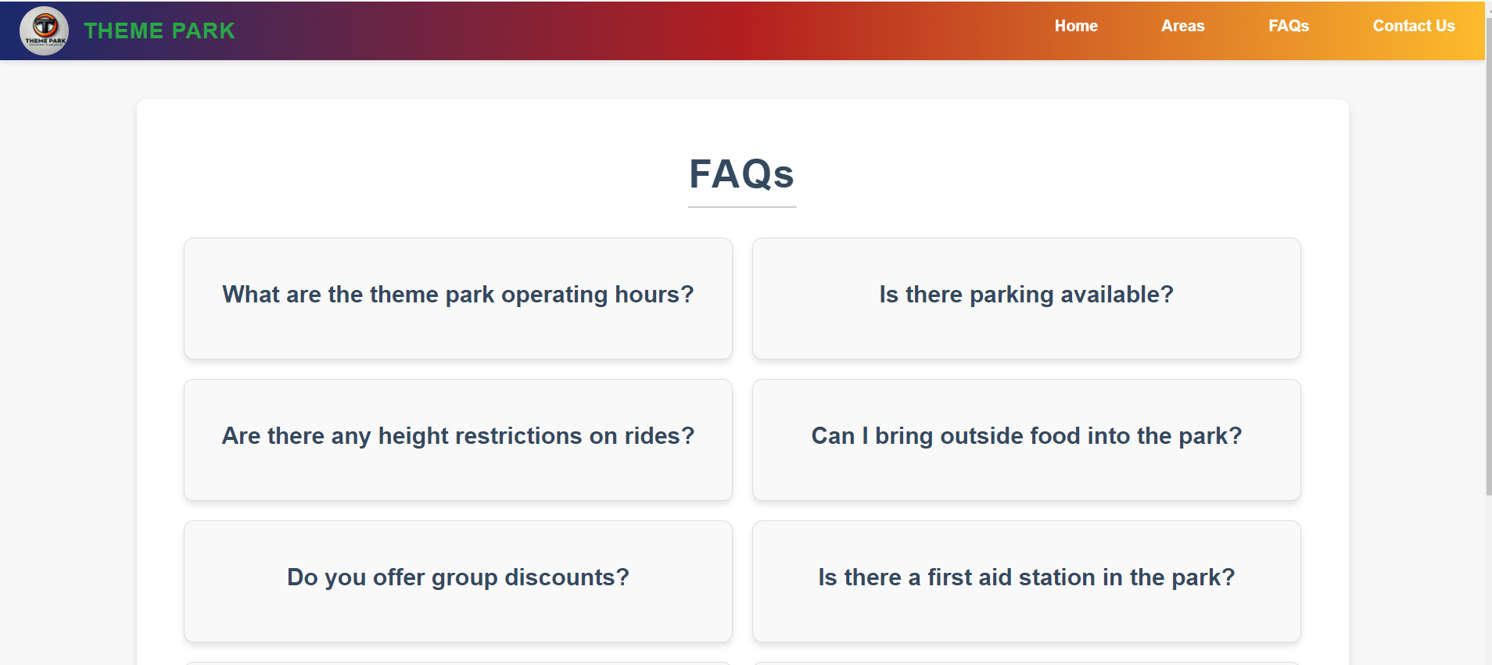

## Contact Page:

Visitors may reach park management through the Contact Page form, which necessitates the provision of name and email. JavaScript verifies the form, and upon submission, a confirmation message is displayed. The page additionally presents the park's telephone number and email for supplementary contact options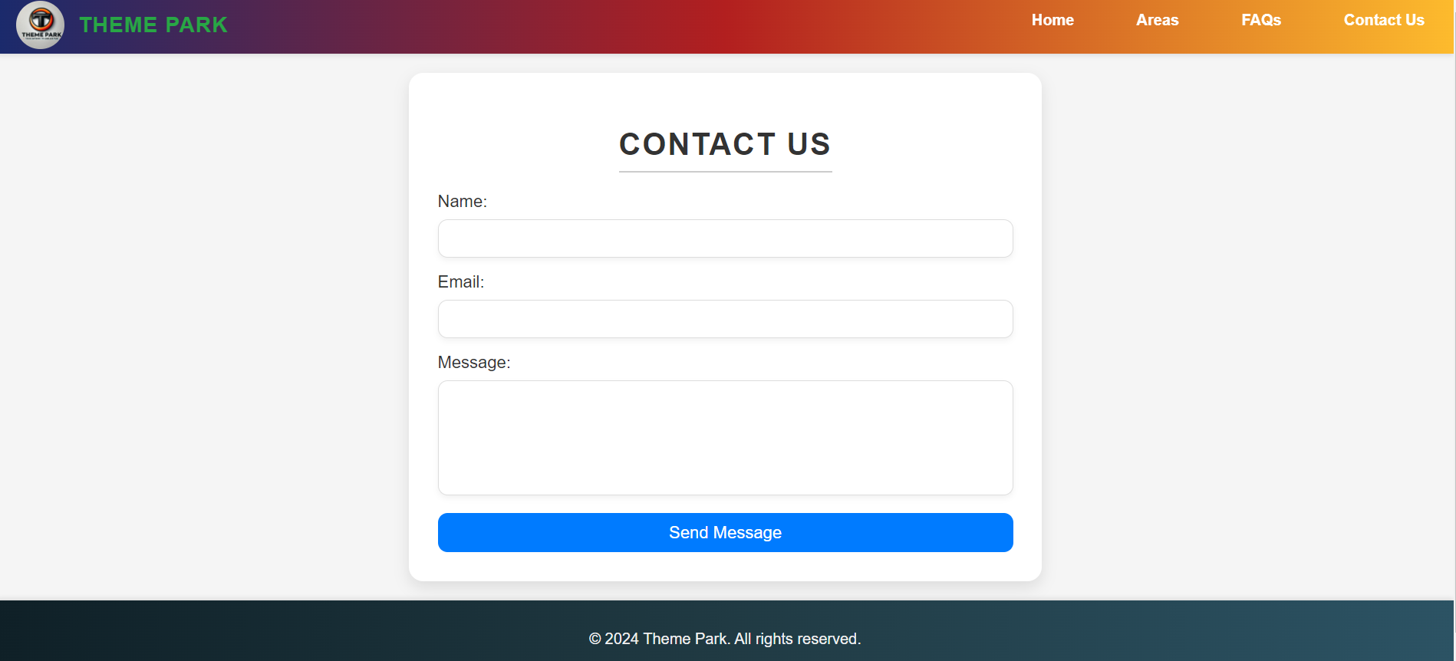

## Rides Page:

The Rides Page presents all amusement park attractions categorised by theme, utilising visually appealing cards that include images, titles, descriptions, and operational status (open or closed). The Areas Page refreshes promptly following user interactions, assisting tourists in choosing attractions for their summer holiday. 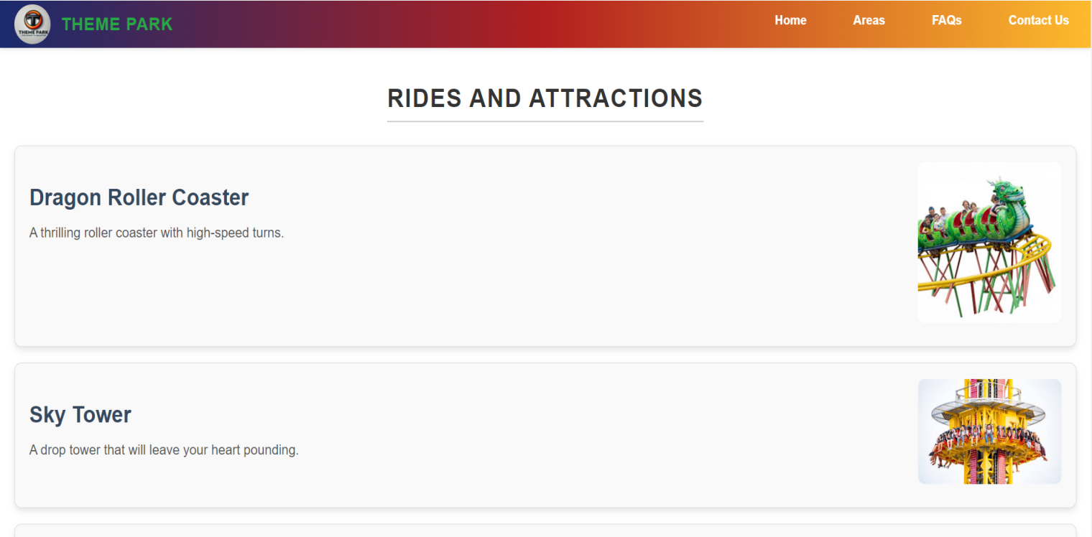

# W3C Compatibility:

W3C validation services assessed the website's HTML and CSS code to ensure web standards compliance. This approach detects and fixes website usability and functionality problems quickly. When implemented, this approach achieves these aims. This code validation guarantees the website works on all devices and browsers. This ensures a uniform user experience across all platforms.

All website pages passed the validation test, proving they met W3C guidelines. The HTML code had no structural issues, and all CSS properties were applied successfully without validation warnings. This devotion to standards improves website usability and accessibility, maintaining its quality. This benefits both parties.

W3C Validation Screenshots:

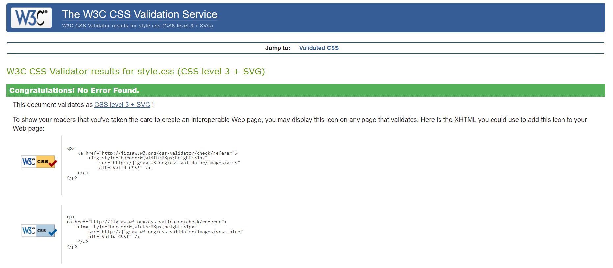

# Legal and Ethical Considerations:

Before launching a public website, it is critical to consider legal and ethical considerations such as media utilisation and user data management. Unsplash and Pexels offer royalty-free images, guaranteeing copyright adherence with appropriate attribution. The website emphasises user privacy by collecting solely names, emails, and messages, which are securely stored in SQLite and disclosed only at the user's request. No personal information is gathered via cookies without consent, in compliance with privacy regulations. The website incorporates accessibility features, including keyboard navigation and a responsive layout, to guarantee usability for all users, including individuals with disabilities.

# Security Measures:

Website development necessitates robust security protocols for user data protection. The theme park's website safeguards against SQL injection, XSS, and data breaches via input validation and sanitisation. Parameterised queries in SQLite mitigate the risks of SQL injection. Generalised server error messages obscure system information, thereby mitigating the risk of exploitation. HTTPS is enabled during development to guarantee encrypted data transmission between the server and users.

# Database Structure and Entity-Relationship Diagram (ERD):

The theme park website contains data on rides, themes, and contact forms. Utilising SQLite. Databases facilitate data acquisition and administration. Essential website functionalities have been enhanced. The architecture of a database influences website performance and scalability. Data is readily and precisely accessible.

The database contains tables for contacts, transportation, and locations. Supplementary tables. Parks feature multifaceted tables. The variables include name, description, and ID. The regions of the theme park are enumerated here. Facilitate the discovery of rides and attractions with this table. The table make various rides and attractions. name, area_id, description, and id. A foreign key associates each ride with its corresponding themed area via area_id. This enables the server to locate a ride to the designated location upon request. Rapid data retrieval and searches may sustain relational websites. Columns in the contact database retain data from the contact form. The aforementioned details include name, email, ID, and message. Theme park personnel may address grievances. Consumer enquiries are presented in a table.

ERD diagram is given below:  
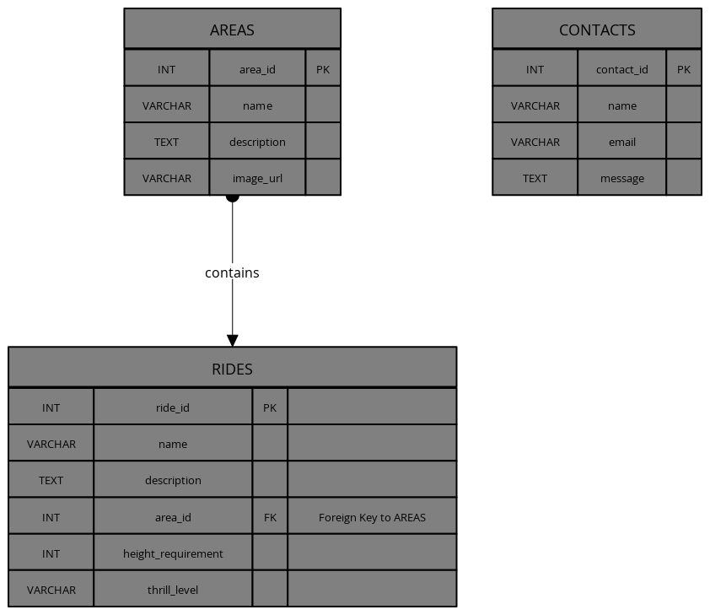

# Responsive Design:

The fully adjustable design enables the website's layout and content to accommodate various devices and screen sizes. CSS regulates font size, margins, and the arrangement of content blocks through media queries. CSS facilitates modifications efficiently. The usability and aesthetics of this website will be compatible with desktops, tablets, and smartphones.

Evaluate the responsiveness of each page across various devices. The layout's versatility ensures optimal viewing in both landscape and portrait modes. CSS grid layouts and percentage-based widths may enhance screen resolution uniformity. Percentages dictate grid widths.

**Responsive Design Screenshot:**

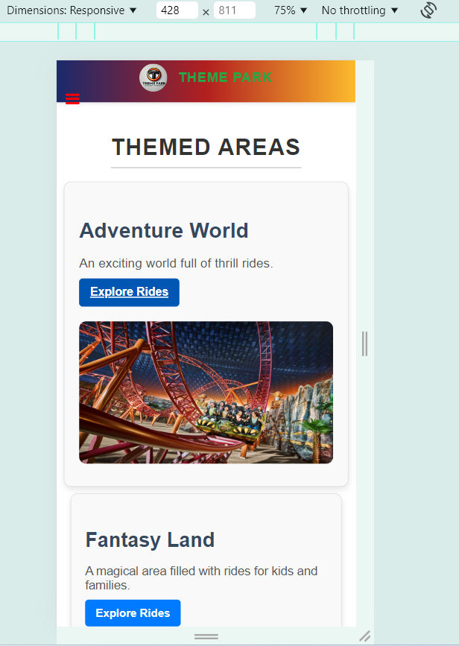

# Form Validations:

JavaScript performs client-side validation of forms, confirming that required fields are completed and that email formats are accurate prior to submission. This diminishes errors and enhances data integrity. Furthermore, Express middleware authenticates server-client interactions, ensuring orderly and secure database management while safeguarding against security vulnerabilities and data integrity concerns.

# Testing and Browser Compatibility:

The website was tested on Firefox, Chrome, Edge, and Safari to verify its functionality across all major browsers. I evaluated each browser for AJAX functionality, form submissions, and responsive design. No significant issues were identified in any browser.

The testing plan included performance evaluations to guarantee the website loads rapidly and reacts promptly to user interactions. Insights into development were obtained from Google Lighthouse's assessments of performance, accessibility, and SEO. Feedback requested enhancements to the website. The website was efficient and user-friendly for numerous visitors.

# Conclusion and Evaluation:

The theme park's website effectively establishes an engaging online presence, highlighting the park's magnificence. Constructed using HTML, CSS, JavaScript, Node.js, and SQLite, it guarantees an optimal user experience while emphasising accessibility, security, and adherence to web standards. Future improvements may encompass HTTPS for secure data transmission and supplementary attraction details. This project illustrates how full-stack development can generate immersive experiences that effectively enhance the theme park's online visibility and attendance. The website has predominantly fulfilled its objectives.