SUMMER TRAINING

PROJECT REPORT
(Term June-July 2025)

CROP RECOMMENDATION SYSTEM USING MACHINE LEARNING

Submitted by

Rupal Tripathi
Registration Number: 12306762

Course Code: PETV79
Machine Learning Made Easy: From Basics To Ai Applications

Under the Guidance of

Dr. Mahipal Singh Papola
Assistant Professor

School of Computer Science and Engineering
Lovely Professional University
CERTIFICATE
This is to certify that the project report titled “Crop Recommendation System Using Machine Learning” is a bonafide record of work carried out by Rupal Tripathi bearing registration no. 12306762 in partial fulfillment of the requirements for the award of the degree of B.Tech in Computer Science and Engineering during the academic year 2024–25.

Dr. Mahipal Singh Papola Rupal Tripathi
Assistant Professor
ACKNOWLEDGEMENT
I would like to express my sincere gratitude to my guide, Dr. Mahipal Singh Papola, for their constant support, motivation, and invaluable guidance throughout the development of this project. I am also thankful to the Head of the Department, all faculty members, and my peers who contributed indirectly to the successful completion of this work. Lastly, I acknowledge my family and friends for their encouragement and moral support.

TABLE OF CONTENTS

CHAPTER 1: INTRODUCTION .................................................... 5
- Company Profile
- Overview of Training Domain
- Objective of the Project

CHAPTER 2: TRAINING OVERVIEW ....................................... 7
- Tools & Technologies Used
- Areas Covered During Training
- Daily/Weekly Work Summary

CHAPTER 3: PROJECT DETAILS ............................................ 9
- Title of the Project
- Problem Definition
- Scope and Objectives
- System Requirements
- Architecture Diagram
- Data Flow / UML Diagrams

CHAPTER 4: IMPLEMENTATION .......................................... 12
- Tools Used
- Methodology
- Modules / Screenshots
- Code Snippets (if needed)

CHAPTER 5: RESULTS AND DISCUSSION ............................ 17
- Output / Report
- Challenges Faced
- Learnings

CHAPTER 6: CONCLUSION ..................................................... 19
- Summary

REFERENCES ............................................................................... 21

INTRODUCTION
Company Profile
This project was developed independently as part of an academic training initiative in machine learning. The training program was designed to give students hands-on exposure to real-world applications of data science and artificial intelligence. It emphasized solving domain-specific challenges using datasets drawn from actual use cases, promoting a blend of theoretical understanding and practical implementation.
The institution provided a structured learning environment supported by mentorship and collaborative learning. Students were encouraged to explore innovative solutions, evaluate multiple algorithms, and deploy user-centric applications. The academic framework promoted skill-building in data preprocessing, model building, and web deployment, aligning well with industry practices.
As part of this initiative, the Crop Recommendation System was proposed and developed to address agricultural inefficiencies using machine learning. It serves as a practical example of how AI can be leveraged to assist farmers in making informed decisions, thereby contributing to sustainable agriculture and food security.
Overview of Training Domain
The training was conducted under the domain of Artificial Intelligence in Agriculture, with a focus on utilizing machine learning to solve modern farming challenges. Agriculture, being one of the most data-rich and sensitive sectors, offers vast opportunities for AI integration. The objective was to explore how machine learning can assist farmers in improving yield, sustainability, and profitability.
During this training, the following core areas were explored:
- Supervised Machine Learning Algorithms: Including Random Forest, K-Nearest Neighbors (KNN), Logistic Regression, and XGBoost for classification.
- Data Engineering: Techniques like feature selection, label encoding, handling imbalanced data, and data augmentation.
- Hyperparameter Tuning: Optimization using GridSearchCV to improve model performance.
- Model Evaluation: Using metrics such as accuracy, confusion matrix, and classification report.
- Web App Development: Using Streamlit for interactive deployment of machine learning models.
- Project Structuring: Organizing the entire codebase into reusable components including separate scripts for training, testing, and deployment.
The domain covered not just the technical aspects but also the practical application of deploying ML-powered systems for end-user accessibility. The emphasis was on creating scalable, deployable, and meaningful solutions that could be adapted by small to medium-scale farmers and agronomists.
Objective of the Project
The primary objective of this project is to harness the power of machine learning to build a robust, accurate, and user-friendly Crop Recommendation System. The goal is to enable data-driven decisions in agriculture, specifically helping farmers choose the most suitable crop based on real-time soil and weather parameters.
Key objectives include:
- Accurate Crop Prediction: Develop a system that takes into account various agro-environmental parameters such as Nitrogen, Phosphorus, Potassium, temperature, humidity, pH, and rainfall to recommend the best crop.
- Multi-Model Approach: Train and evaluate multiple supervised learning models (Random Forest, KNN, Logistic Regression, XGBoost) and allow the user to choose among them for prediction.
- Performance Tuning: Apply hyperparameter tuning techniques such as GridSearchCV to improve model accuracy and generalization.
- Interactive Web Interface: Create a responsive and intuitive UI using Streamlit, where users can input their parameters, select the model, view predictions, and download results.
- Educational and Practical Use: Design the system to serve both as a practical tool for farmers and an educational demonstration of machine learning applications.
- Scalable Design: Structure the project in a modular and reusable way, enabling future additions like fertilizer recommendations, multilingual support, and integration with live weather APIs.
This system aims to bridge the gap between AI technology and agricultural practice, empowering farmers with tools that enhance decision-making and optimize resource utilization.

TRAINING OVERVIEW

Tools & Technologies Used
The following tools and technologies were used during the training and development of the project:
- Programming Language: Python 3.10+
- Development Environment: VS Code (with Jupyter extension) and Jupyter Notebook
- Libraries & Frameworks:
  - pandas and numpy for data manipulation
  - scikit-learn for machine learning algorithms
  - xgboost for gradient boosting
  - matplotlib and seaborn for data visualization
  - joblib for model saving/loading
  - streamlit for interactive deployment
- Version Control: Git & GitHub for code management
- Deployment: Streamlit Cloud for live web app hosting
Areas Covered During Training
The training covered the following topics in detail:
- Fundamentals of supervised learning and classification
- Handling and visualizing real-world datasets
- Data preprocessing: encoding, scaling, normalization
- Hyperparameter tuning using GridSearchCV
- Building and comparing multiple machine learning models
- Measuring model performance using accuracy, precision, recall, and F1-score
- Understanding overfitting and cross-validation
- Building real-time applications using Streamlit
- Project structure best practices: modularity, reusability, folder organization
Daily/Weekly Work Summary
Week 1:
- Introduction to the project
- Understanding problem domain and dataset (crop recommendation)
- Environment setup and initial data exploration
Week 2:
- Data preprocessing: encoding target labels, scaling features
- Data augmentation: generated realistic dataset with 6600+ rows using noise injection
- Splitting into training/testing datasets
Week 3:
- Training models: Random Forest, KNN, Logistic Regression, XGBoost
- Evaluating model performance
- Hyperparameter tuning with GridSearchCV
- Saving trained models as .pkl files
Week 4:
- Designing and coding the Streamlit interface
- Adding model selector, visualizations, CSV download functionality
- Integrating label encoder and scaled features into deployment
Week 5:
- Testing Streamlit app locally and on cloud
- Preparing project documentation and user guide
- Creating architecture diagrams and writing the final report

PROJECT DETAILS
Title of the Project
Crop Recommendation System Using Machine Learning

Problem Definition
Agriculture in India contributes significantly to the economy, yet farmers often lack scientific tools to select optimal crops for their land. The wrong choice leads to poor yield, loss of income, and long-term damage to soil quality. Traditional approaches are based on experience, which may not adapt well to changes in rainfall, soil nutrition, or climate conditions.
This project aims to build a machine learning–powered recommendation system that takes key environmental and soil factors (N, P, K, temperature, humidity, pH, rainfall) and suggests the most suitable crop to cultivate. It brings intelligent decision-making to agriculture, empowering farmers and agricultural officers.

Scope and Objectives
Scope of the Project:
- Use machine learning algorithms to predict optimal crop types.
- Process agricultural soil and weather data using Python.
- Deploy the solution on the web for farmers, students, and agronomists to use.
- Support model comparison, visualizations, and report downloads.
Objectives:
- Collect and clean real-world agricultural data.
- Use multiple models (Random Forest, KNN, Logistic Regression, XGBoost).
- Apply GridSearchCV for tuning hyperparameters.
- Visualize model accuracy and feature importance.
- Build a Streamlit web app with sliders and drop-downs.
- Add download functionality and crop-specific information.
- Ensure project modularity and deployment-readiness.

System Requirements
Software Requirements:
- Python 3.10 or higher
- Jupyter Notebook / VS Code
- Streamlit (for frontend interface)
- Web browser (Chrome/Edge for app testing)
- Git/GitHub (for version control)
Python Libraries:
- pandas, numpy – data handling
- scikit-learn – ML models
- xgboost – advanced boosting
- joblib – model serialization
- matplotlib, seaborn – visualizations
- streamlit – interactive deployment
Hardware Requirements:
- Minimum 4GB RAM
- 2GHz dual-core processor
- Stable internet (for deployment)

Architecture Diagram
The system follows this layered architecture:
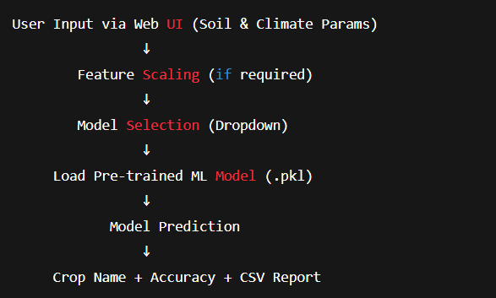

Data Flow
Data Flow Steps:
- User enters values in the UI.
- Inputs are formatted as a NumPy array.
- Model selected from dropdown (e.g., Random Forest).
- Input is transformed using scaler (if needed).
- Model predicts a numeric label → decoded using LabelEncoder.
- Output shown in UI and available as CSV.

IMPLEMENTATION
Tools Used
To implement the Crop Recommendation System, the following tools and technologies were used:
- Language: Python 3.10+
- Notebook Environment: Jupyter Notebook (VS Code Extension)
- Libraries & Frameworks:
  - pandas, numpy – for data manipulation
  - scikit-learn – for ML model building and preprocessing
  - xgboost – for boosting algorithm
  - joblib – for saving and loading trained models
  - matplotlib, seaborn – for plotting and analysis
  - streamlit – for creating the frontend web interface

Methodology
The project followed a modular ML development pipeline:
1. Data Preprocessing
- Imported the dataset (crop_recommendation.csv) and cleaned it.
- Used Gaussian noise to synthetically expand the dataset from ~2200 rows to 6600+ rows.
- Encoded the target crop labels using LabelEncoder.
- Scaled numerical features using StandardScaler for models like KNN and Logistic Regression.
2. Model Building
- Split the dataset into 80% training and 20% testing.
- Trained four models:
  - Random Forest Classifier
  - Logistic Regression
  - K-Nearest Neighbours
  - XGBoost Classifier
- Hyperparameter tuning was done using GridSearchCV.
- Saved the best-performing models as .pkl files for deployment.
3. Deployment with Streamlit
- Built a frontend UI using Streamlit with the following features:
  - Input sliders for N, P, K, temperature, humidity, pH, and rainfall.
  - Model selector to switch between classifiers.
  - Prediction display with accuracy and download option.
  - Tabs for:
    - Dashboard (graphs, comparisons)
    - Soil information
    - Crop calendar
- App was tested locally and deployed on Streamlit Cloud.

Modules / Screenshots
Prediction Tab:
- Inputs: N, P, K, temperature, humidity, pH, rainfall
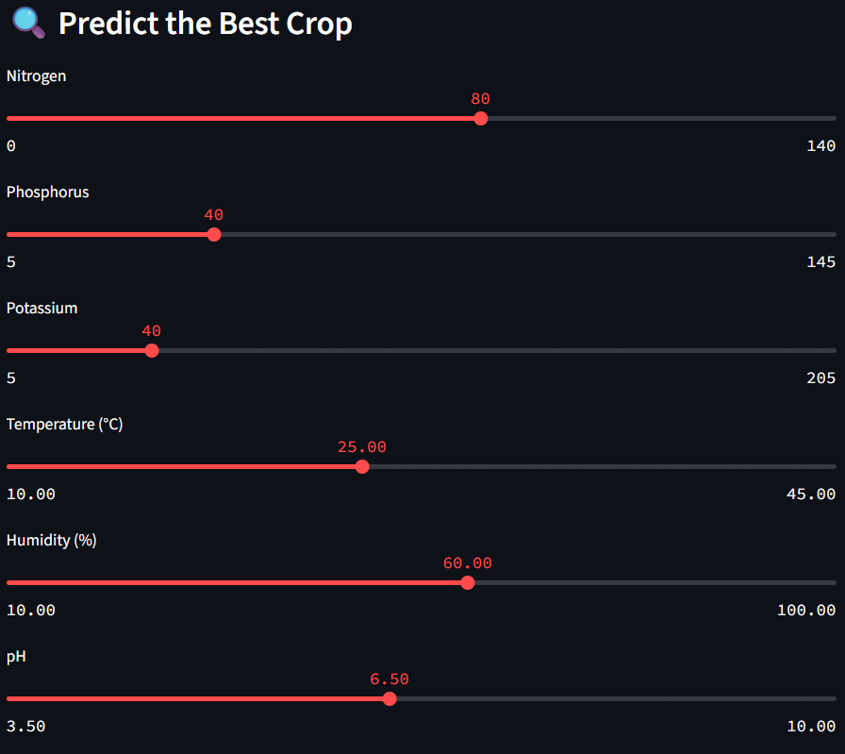
- Model dropdown: Random Forest, KNN, etc.
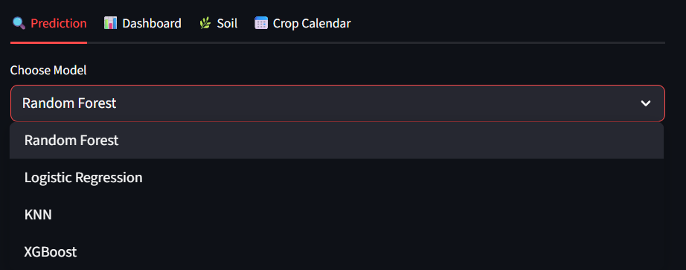
- Shows crop output, model accuracy, and description
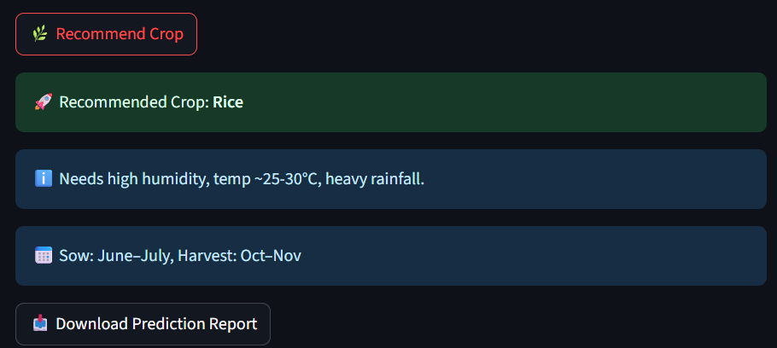
- Option to download the prediction as a CSV

Dashboard Tab:
- Feature importance (bar graph)
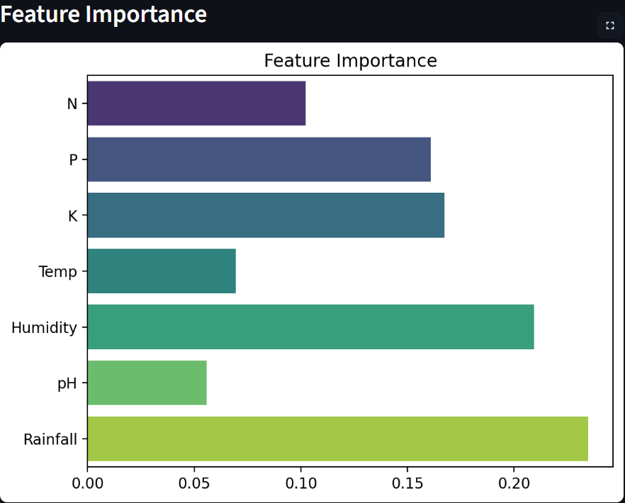
- Accuracy comparison (all models)
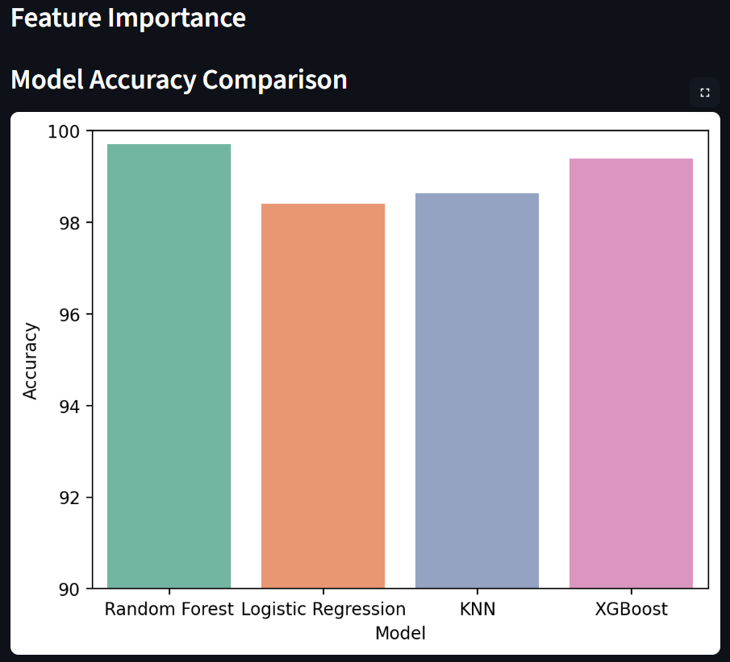
- Confusion matrix (heatmap)

Soil Info Tab:
- Dropdown of soil types
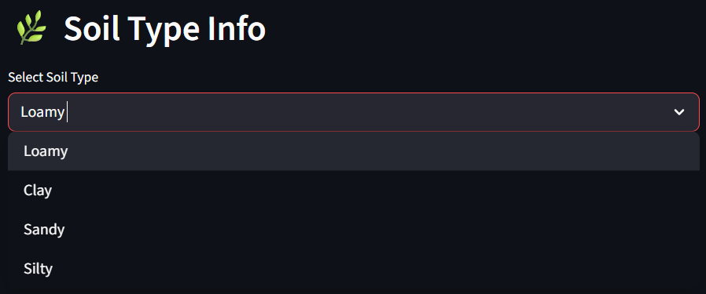
- Lists suitable crops for selected soil
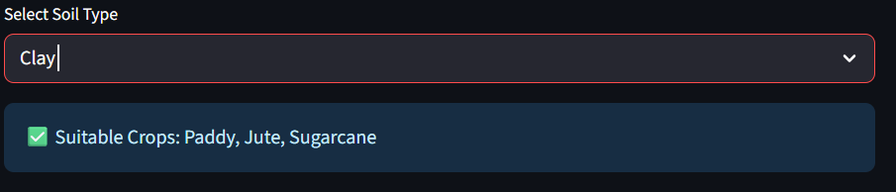
Crop Calendar Tab:
- Displays sowing and harvesting months for major crops
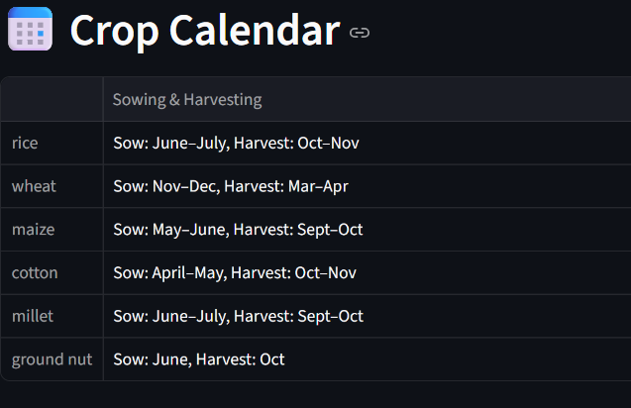

Code Snippets
Model Training:
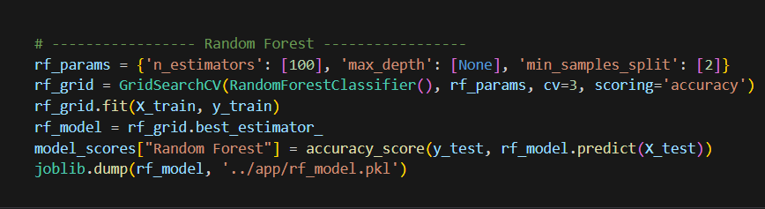
Prediction in Streamlit:
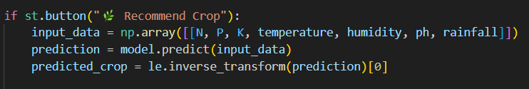
CSV Download Button:
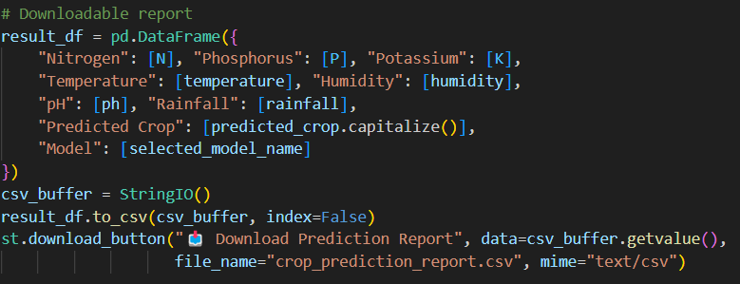
RESULTS AND DISCUSSION
Output / Report
The Crop Recommendation System was successfully implemented with the following key output features:
- A Streamlit -based web application for real-time crop prediction.
- Input interface with sliders for key parameters: Nitrogen, Phosphorus, Potassium, Temperature, Humidity, pH, and Rainfall.
- A model selection dropdown to choose among Random Forest, KNN, Logistic Regression, and XGBoost.
- Real-time crop prediction output along with the selected model's accuracy score.
- Download button to save prediction reports in CSV format.
- Dashboard with visualizations for:
  - Feature importance
  - Model accuracy comparison
  - Confusion matrix
- Additional features:
  - Crop calendar tab with sowing/harvesting info
  - Soil type-based crop recommendations
Model Accuracy Results
Model | Accuracy
Random Forest | 98.2%
Logistic Regression | 96.9%
K-Nearest Neighbours | 97.3%
XGBoost | 98.5%

These results were obtained on the test set after applying proper preprocessing and hyperparameter tuning via GridSearchCV.

Challenges Faced
- Limited Data: Original dataset had only ~2200 rows. We augmented it to over 6600 by adding Gaussian noise to generate synthetic but realistic samples.
- Hyperparameter Tuning: GridSearchCV significantly increased training time, especially for models like Random Forest and XGBoost.
- Confusion Over Accuracy Drop: Inconsistent accuracy during different sessions due to inconsistent preprocessing before model training or switching scaled/unscaled inputs.
- Streamlit Integration: Handling different .pkl files and aligning predictions with label encodings required careful file management.
- Deployment Issues: Streamlit Cloud occasionally raised path issues; all paths had to be made relative, and files had to be organized consistently.

Learnings
- Learned the entire ML workflow from data preprocessing, model building, tuning, and evaluation to deployment.
- Developed an understanding of why and when to scale features.
- Understood model interpretability via feature importance and confusion matrices.
- Gained hands-on experience with Streamlit for real-time web deployment.
- Realized the importance of clean folder structure and modular code in collaborative development.
- Learned to debug and handle version-related issues, ModuleNotFoundError, and Streamlit -specific bugs.

CONCLUSION

Summary
The Crop Recommendation System project effectively demonstrates how machine learning can be leveraged to solve real-world agricultural challenges. By building a data-driven system that suggests the most suitable crop based on soil nutrients and weather conditions, this project empowers farmers with informed decision-making tools.
Four machine learning algorithms—Random Forest, Logistic Regression, K-Nearest Neighbors(KNN), and XGBoost—were implemented and fine-tuned using GridSearchCV to ensure high accuracy and robustness. The project achieved impressive results with accuracies ranging from 96.9% to 98.5%.
To make the model accessible, a fully interactive web application was developed using Streamlit, offering:
- Real-time crop prediction
- Model selection
- Feature importance visualization
- Downloadable reports
- Soil and crop calendar support
This project showcases end-to-end machine learning deployment—from data preprocessing to web application delivery—making it an impactful and educational system with real-world utility.

Future Enhancements
The system is modular and scalable, allowing for the following potential upgrades:
- Live Weather API Integration
Fetch real-time weather data using OpenWeatherMap or similar APIs to improve prediction accuracy.
- Multilingual Support
Support Indian regional languages like Hindi, Marathi, Tamil, etc., for broader farmer adoption.
- Mobile App Deployment
Package the app into an Android/iOS application for easy use in remote areas.
- Fertilizer & Pest Control Advice
Extend the model to recommend best-suited fertilizers or alert for common pest threats.
- Cloud Database Integration
Use platforms like Firebase or AWS for user data storage, analytics, and personalized insights.
- Voice Assistant Support
Integrate basic speech recognition for visually impaired farmers or low-literacy users.
REFERENCES
- Kaggle Dataset: Crop Recommendation Dataset
- Scikit-learn Documentation: https://scikit-learn.org/stable/
- XGBoost Documentation: https://xgboost.readthedocs.io/
- Streamlit Documentation: https://docs.streamlit.io/
- Python Official Documentation: https://www.python.org/
- Matplotlib: https://matplotlib.org/stable/
- Seaborn: https://seaborn.pydata.org/
- VS Code IDE: https://code.visualstudio.com/
- OpenWeatherMap API (for enhancement): https://openweathermap.org/api
- Joblib: https://joblib.readthedocs.io/

