

**Car Price Prediction Project**

Submitted by:

Rupali Bisen

**ACKNOWLEDGMENT**

“This report is dedicated to my parents,family members and friends, who always inspired me in every step to accomplish this study”.

It is a great honor for me to work on the assigned topic

and I feel glad to accomplish the task. Along with my sincerity and interest, there are few people, who really helped me to make this endeavor to be a successful one.

At first, I would like to pass my appreciation, gratitude and thanks to the team

Flip Robo and DataTrained. Their valuable suggestions and ideas in every step

of my work helped me a lot to prepare this report.

I wish to extend my special thanks to my SME, Mentor, career coach for

clearing out my doubts.

Lastly, I would like to acknowledge my referencing the following Internet

resources during the execution of this project.

1. https://www.divaportal.org/smash/get/diva2:546238/FULLTEXT01.pdf

2. https://www8.gsb.columbia.edu/sites/socialenterprise/files/Mobile_Phones_D

elivering_MF_200407.pdf

3. www.kaggle.com

4. towardsdatascience.com

5. www.pluralsight.com

6. www.analyticsvidhya.com

7. www.geeksforgeeks.org

# INTRODUCTION

## • Business Problem Framing

In this project,we have to make carprice valuation model using new machine learning models from new data. Because with the change in market due to covid 19 impact, our client is facing problems with their previous car price valuation machine learning models.

## • Conceptual Background of the Domain Problem

1.Firstly,we will prepare our own dataset using web scraping.

1. After that we will check whether the project is a regression type or a classification type.
2. We will also check whether our dataset is balanced or imbalanced. If it is an imbalanced one, we will apply sampling techniques to balance the dataset.
3. Then we will do model building and check its accuracy.
4. Our main motto is to build a model with good accuracy and for that we will also go for hyperparameter tuning.

## • Review of Literature

I am summarizing my research done on the topic.

▪ I have created my own dataset using web scraping and imported important libraries for my project.

▪ I have created the dataframe.

▪ I have analysed my data by checking its shape, number of columns, presence of null values if any and checking the datatypes.

▪ Then I have done some data cleaning steps,e.g Checking the value counts of the target variable, dropping some irrelevant columns from the dataset, checking correlation between the dependant and independent variables using heatmap, visualizing data using distribution plots, detecting and removing skewness in my data if any, outliers detection using boxplots and removing them, balancing dataset using randomoversampler method, splitting the data into independent and dependant variables and finally scaling the data.

Then I have used 4 regressor models ,out of which LassoRegressor is giving a good accuracy .

# Analytical Problem Framing

## • Mathematical/ Analytical Modeling of the Problem

If you look at data science, we are actually using mathematical models to model (and hopefully through the model to explain some of the things that we have seen) business circumstances, environment etc and through these model, we can get more insights such as the outcomes of our decision undertaken, what should we do next or how shall we do it to improve the odds. So mathematical models are important, selecting the right one to answer the business question can bring tremendous value to the organization.

Here I am using AdaBoostRegressor with accuracy 99% after hyper parameter tuning.

## • Data Sources and their formats

Data Source: The read_csv function of the pandas library is used to read the content of a CSV file into the python environment as a pandas DataFrame. The function can read the files from the OS by using proper path to the file.

Data description: Pandas describe() is used to view some basic statistical details like percentile, mean, std etc. of a data frame or a series of numeric values.

## • Data Preprocessing Done

* I have checked for null values and there are some null values present,I have removed it using SimpleImputer method.
* I have label encoded the object type columns in the dataset.
* I have checked the correlation between dependant and independent variables using heatmap. I have seen most of the independent variables are correlated with each other and the target variable is positively correlated with a very few independent variables.
* I have done some visualization using histogram**.**
* I have checked outliers using boxplots ,but no outliers are present.
* I also have checked for skewness in my data, but the skewness present is very negligible, so I don’t consider it.
* I have splitted the dependant and independent variables into x and y.
* I have scaled the data using StandardScaler method and made my data ready for model building.

• Hardware and Software Requirements and Tools Used ➢ Hardware requirements:

Processor: Intel(R) Core(TM) i5-4210U CPU @ 1.70GHz 2.40 GHz

RAM: 3.92 GB

System type: 64-bit operating system, x64-based processor➢ Software requirements:

Python: One of the most used programming languages Tools used:

Jupyter notebook: Jupyter is a free, open-source, interactive web tool known as a computational notebook where I have written my python codes.

NumPy: NumPy is an open-source numerical Python library. NumPy contains a multi-dimensional array and matrix data structures.

Pandas: Pandas is an open source Python package that is most widely used for data science/data analysis and machine learning tasks. It is built on top of another package named Numpy, which provides support for multi-dimensional arrays.Matplotlib: It is a Python library used for plotting graphs with the help of other libraries like Numpy and Pandas. It is a powerful tool for visualizing data in Python.

Seaborn: It is also a Python library used for plotting graphs with the help of Matplotlib, Pandas, and Numpy.

Scikit-learn: It is probably the most useful library for machine learning in Python.The sklearn library contains a lot of efficient tools for machine learning and statistical modeling including classification, regression, clustering and dimensionality reduction.

Scipy.stats: This module contains a large number of probability distributions as well as a growing library of statistical functions.

# Model/s Development and Evaluation

## • Identification of possible problem-solving approaches (methods)

1.To check the correlation among the data,I have used **heatmap** to visualize it. 2. To get a clear view of the columns visually,I have used **distribution plots**.

1. For checking outliers,I have used **boxplots.**
2. For scaling the data, I have used **StandardScaler** method. 5. For training and testing the data, I have imported **train_test_split** **library** from scikit-learn.

## • Testing of Identified Approaches (Algorithms)

I have used 5 algorithms for testing.

* **Polynomial Regression**- polynomial builds regression or classification models in the form of a tree structure. It breaks down a dataset into smaller

and smaller subsets while at the same time an associated decision tree is incrementally developed.

* **Random Forest Regressor**- In randomforest regression, the output is the property value for the object. This value is the average of the values of k nearest neighbors.
* **Lasso Regression**- An lasso regressor is a meta-estimator that begins by fitting a regressor on the original dataset and then fits additional copies of the regressor on the same dataset but where the weights of instances are adjusted according to the error of the current prediction.
* **LinearRegression**- Linear regression is a [linear](https://en.wikipedia.org/wiki/Linearity) approach for modelling the relationship between a [scalar](https://en.wikipedia.org/wiki/Scalar_(mathematics)) response and one or more explanatory variables (also known as [dependent and independent variables)](https://en.wikipedia.org/wiki/Dependent_and_independent_variables).

## • Run and Evaluate selected models

**LinearRegression():**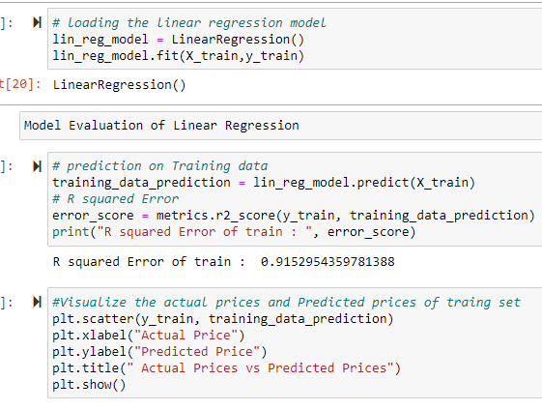

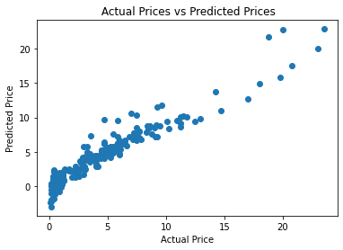

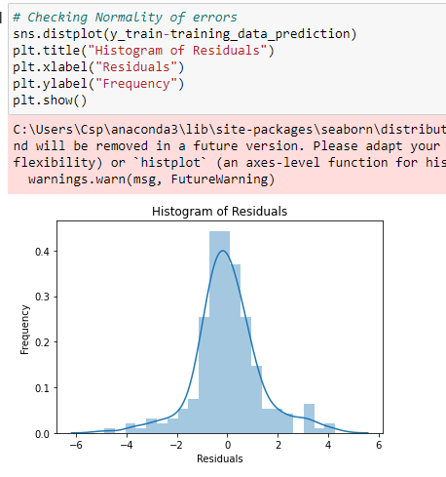

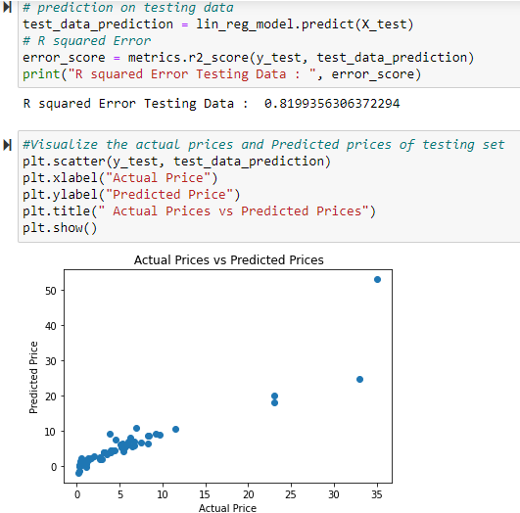

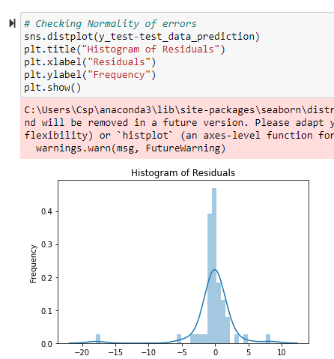

## • Key Metrics for success in solving problem under consideration

## • Visualizations

**Correlation matrix using heatmap**-checking correlation between dependant and independent variables.

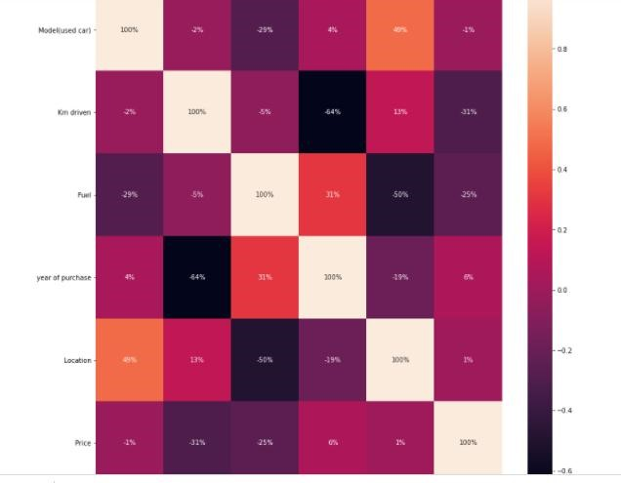

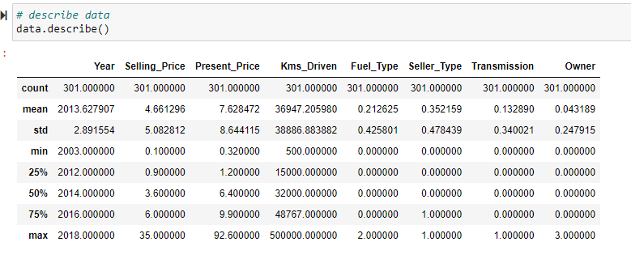

**Boxplots for outlier detection-**

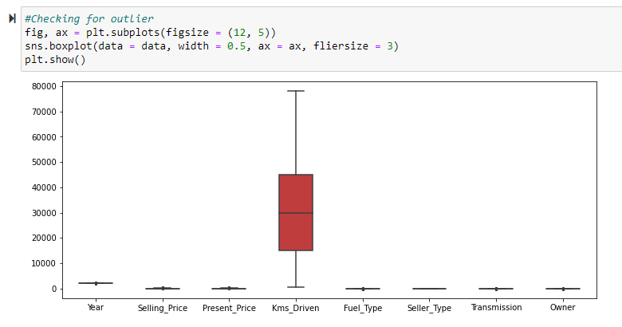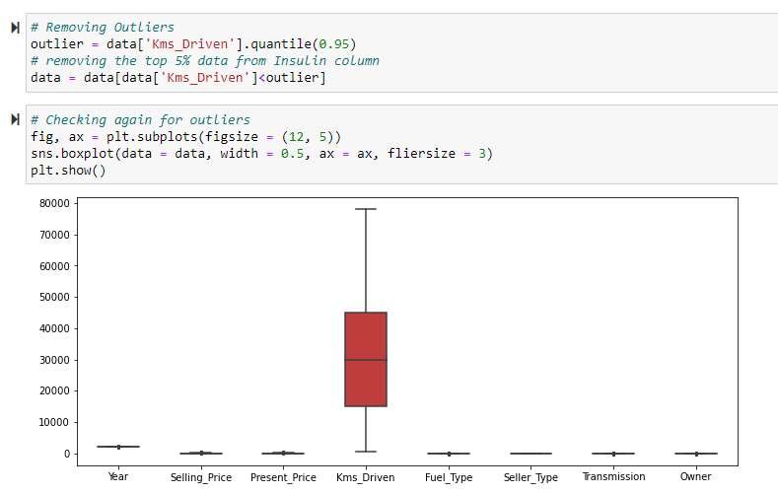

## • Interpretation of the Results

In the visualization part, I have seen how my data looks like using heatmap, boxplot, distribution plots, histogram etc.

In the pre-processing part, I have cleaned my data using many methods like SimpleImputer,LabelEncoder etc.

In the modelling part, I have designed our model using algorithm like AdaBoostRegressor.

The accuracy , Mean Absolute Error, Mean Squared Error, Root Mean Absolute Error are achieved for the model.

# CONCLUSION

## • Key Findings and Conclusions of the Study

The key findings are we have to study the data very clearly so that we are able to decide which data are relevant for our findings. The techniques that I have used are heatmap, SimpleImputer,LabelEncoder etc.

The conclusion of our study is we have to achieve a model with good accuracy and f1-score.

## • Learning Outcomes of the Study in respect of Data Science

We will develop relevant programming abilities. We will demonstrate proficiency with statistical analysis of data. We will develop the ability to build and assess data-based models. We will execute statistical analysis with professional statistical software. The best algorithm for this project according to my work is LassoRegressor because the accuracy that I have achieved is quite satisfactory than the other model.

## • Limitations of this work and Scope for Future Work

The scope for future work is to collect as many data as we can so that the model can be built more efficiently.